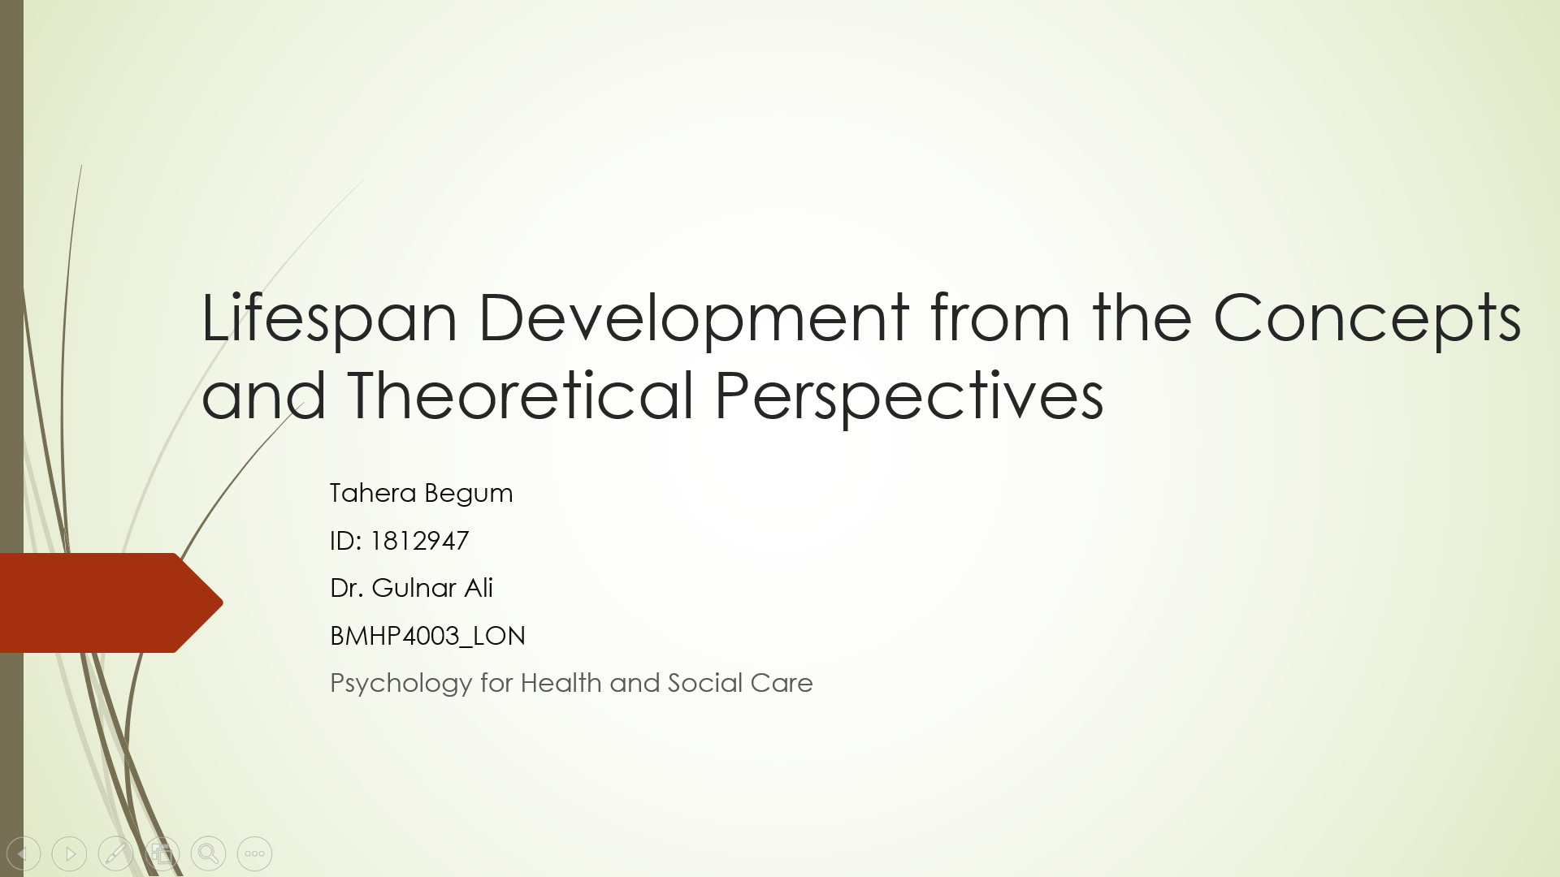
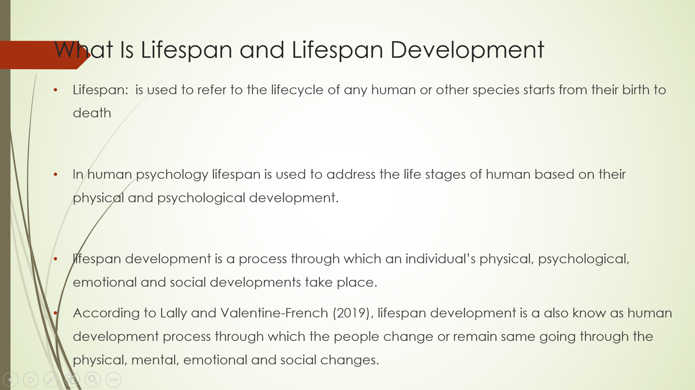

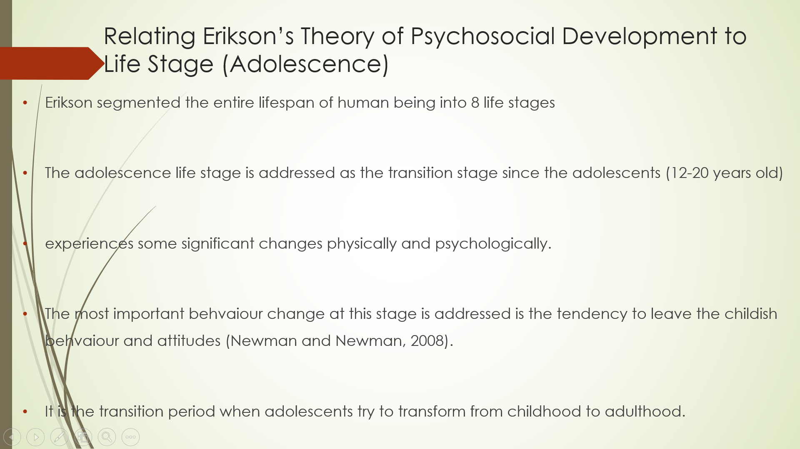
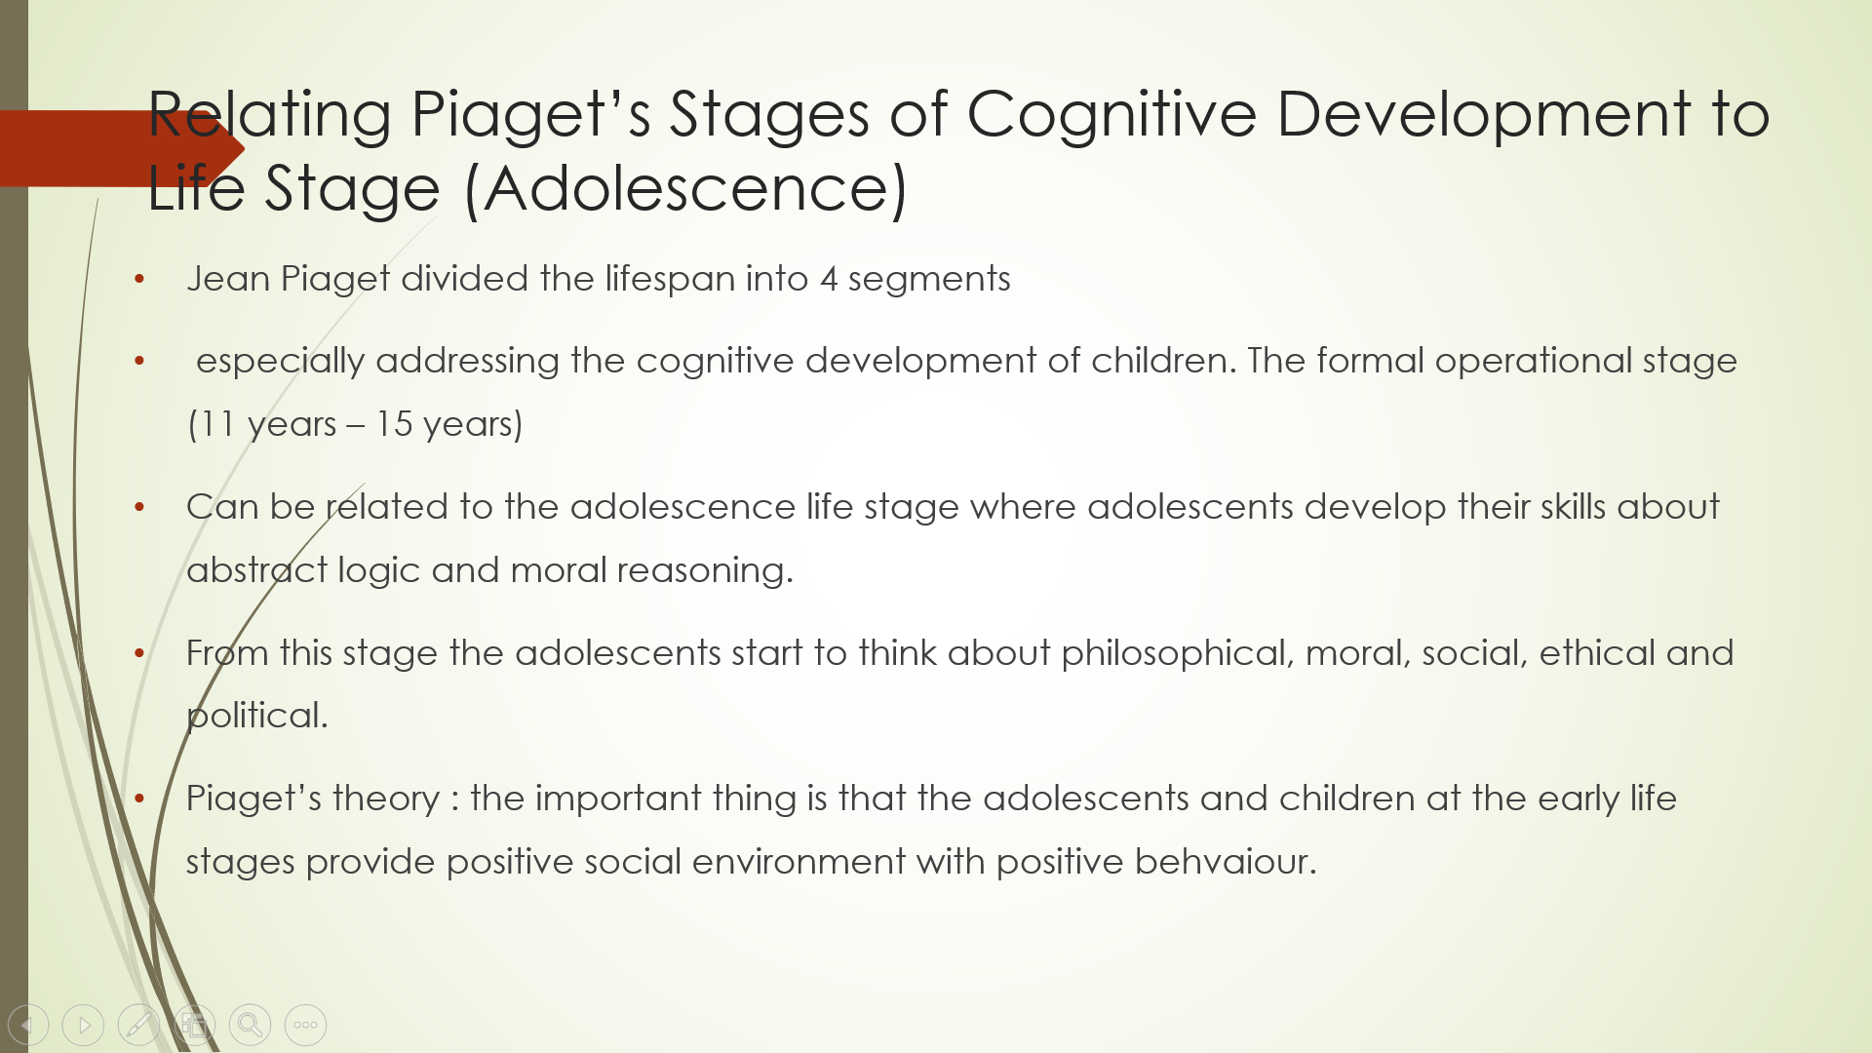
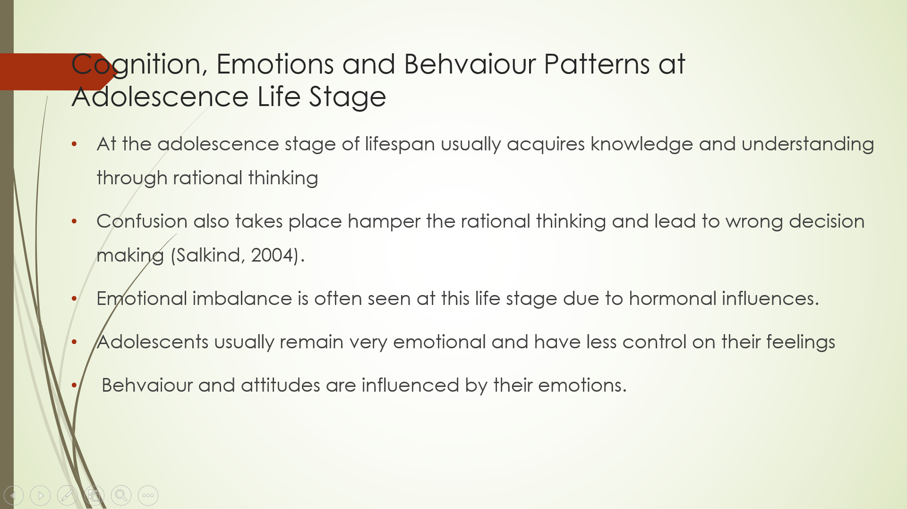

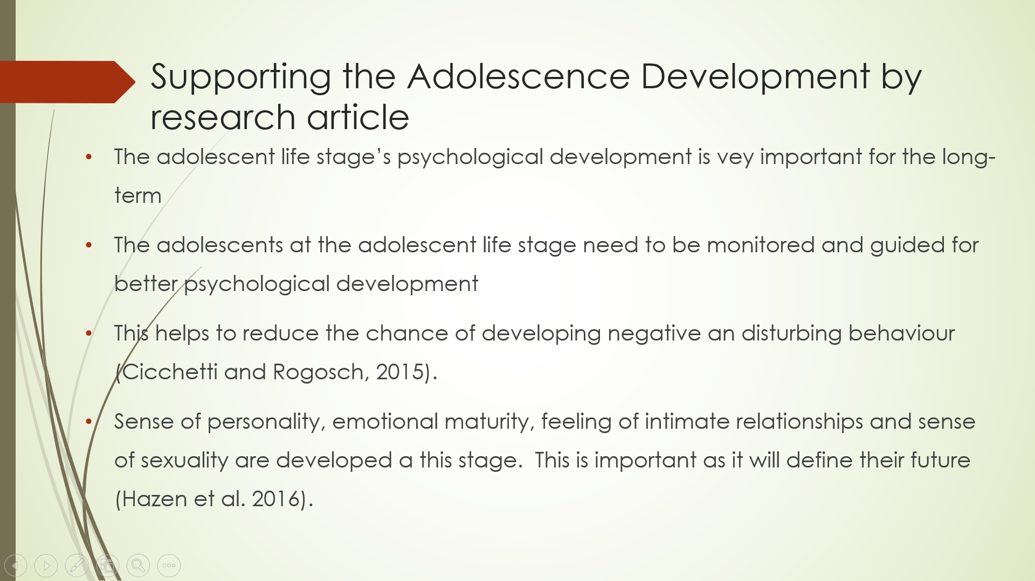
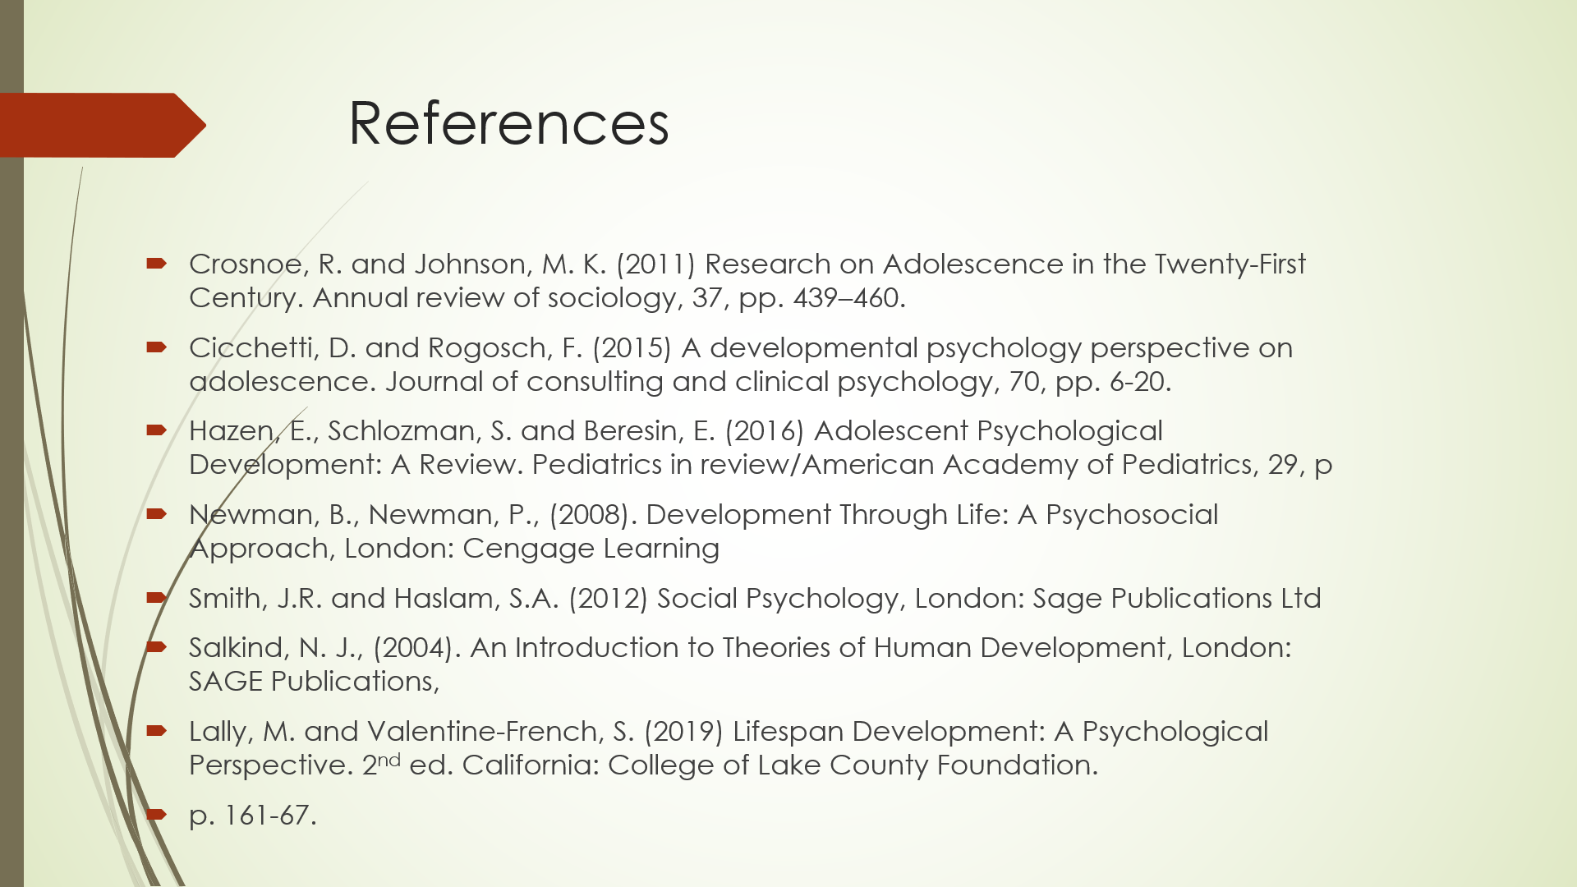



Slide 1:
Lifespan Development from the concept and Theoretical Perspectives.
Tahera Begum
ID: 1812947
Dr. Gulnar Ali
BMHP 4003_LON
Phycology for health and social care

Slide 2: What is lifespan and lifespan development
Lifespan simply refers to the time period from birth to death, but actually the lifecycle of any living species is known as lifespan. From that point of view. In this study the only lifespan focus in the human being is to understand their psychological development which is directly related to their lifespan.
Lifespan development refers to the process of developing life through different activities or stages of life. Some research proves that human development is closely related to lifespan development where the lifespan development concept helps to define and measure the developments including physical, psychological and emotional developments. At different time and stage of lifespan an individual faces different changes in his/her physical, mental and emotional condition. Some changes are possible to address by that individual and some changes are addressed by other surrounding the individual. Through the physical, emotional and mental changes, the individual’s psychological changes take place which is also known as psychological development. The lifespan development theories can help to admit the psychological development effectively that is the main discussion of this presentation.

Slide 3: Relating Erikson’s Theory of Psychosocial Development to Life Stage (Adolescence)
Many psychologists and researchers developed different theories to define the psychological changes of human beings at different time of their lifespan where some theories are stage theories and some are open-ended theories. Similarly some lifespan development theories are static ad some are dynamic. For example, Erik Ekison’s psychological development theory is a stage theory where the psychological development of human takes different shape at different stages and the psychological status are identical from one stage to another. Erikson segmented the entire lifespan of human into 8 life stages. Here the adolescent life stage is chosen to relate this life stage with Erikson’s theory for understanding the psychological development at this life stage.
Identity crisis is the main action takes place at the adolescent life stage. This is the first stage of psychological development, this could also be addressed as the beginning of maturity development as adolescent is the period of physical transformation from childhood to adulthood psychologically and emotionally. Adolescents experience confusion to behave like adults as they often behave like children. This confusion is also addressed in Erikson’s theory as termed as ‘identity crisis’ which means adolescents try to find the right personality through their behaviour and attitudes to make a statement among others as they recognize them as an individual with self-respect and dignity.

Slide 4: Relating Piaget’s Stages of the cognitive Development to life stage ( Adolescence)
The adolescent life stage is related to Piaget’s cognitive development theory, where it is a dynamic theory as the process of psychological development. The behaviour and attitude are different from one individual to another. Piaget’s cognitive development theory is especially developed for making a clear understanding about children’s psychological and behavioural development at their early stages. Piaget segmented the lifespan of human into 4 life stages considering the human psychological development that is cognitive development that means an individual learns all the basics of behaviour and attitudes through these 4 life stages ad rest of the life the learning works as the guidance to develop new behaviour and attitudes responding to different situations.
According to this theory the adolescents belongs to the formal development stage where they learn to thinking of abstract concepts and logical thinking. For example, I personally have three adolescence children, I tell them they should study hard and achieve a good academic record. Now that adolescent will start to think logically. Questions may arise such as, why it is important for the indiviual to study hard and make a good result is it good for the indiviual or for others. As adolescents learn the behaviour and attitudes from their surrounding, it is essential to provide them positive support to so that positive psychological development can be ensured to them.

Slide 5: Cognition emotions and behaviour patterns at adolescence life stage
The cognition of adolescent is quite clear through the discussion of Piaget’s cognitive development theory. He addresses that adolescents may think rationally about the reason of other’s behaviour and attitudes during adopting or learning those but they cannot judge effectively those attitudes and behaviour. So, it is often seen that without proper guidance and support many adolescents adopt wrong and unethical behaviour and attitudes such as self-harm, depressed behaviour, substance misuse etc. This kind of wrong decisions they need to restrain by providing positive support.
Emotional imbalances are often seen at this life stage caused by the confusion and due to biological factors as well. Adolescents’ emotional are sensitive as some adolescents may response positively where others may not in a same situation. Different types of behaviour can be executed by the adolescents that depend on the situation and behaviour of others in that situation.
Slide 6: Supporting the adolescence development by research article
The research study of Crosnoe and Johnson (2011) highlighted the long-term impact of the behaviour developed at adolescent life stage. It’s very important to develop the behaviour at adulthood. Especially the base of psychological development is developed at adolescent life stage that must be strong with positive psychological development suggested in the study.
In many cases it is seen that adolescents demonstrate negative and disturbing behaviour and attitudes addressed in the research by Cicchetti and Rogosch (2015) where the main reason was noticed by the researches was lack of positive psychological support which can be related to wide range of social, demographic and economic factors. So, to reduce the disturbing behaviour researches highly emphasized on providing positive psychological support.
Hazen et al. (2016) highlighted on the relationship of adolescents’ future life behaviour and attitudes with emotional maturity, sense of personality, sense of sexuality and feeling of intimate relationships. All these behaviour and attitudes are started to develop from adolescent life stage. So, it is found one of the most important life stages for human psychological development.
Slide 7: references
Slide 8: Thank you

