  LOCATION Swansea | LLEOLIAD abertawe
LEVEL 4 | LEFEL 4
EXAMINATION PERIOD | CYFNOD ARHOLIADAU
May 2021 | May 2021

MODULE CODE: ACCA4022
COMPUTER ARCHITECTURE and OPERATING SYSTEMS
TIME: 2 Hours
answer all questions

Equipment or materials required – None
- The Candidates are allowed access to a basic 4 function calculator that will be supplied
- The Candidates are not permitted to dictionaries; textbooks/case studies or any other reference materials into the exam room.
Show all your calculations in your exam book

ANSWER ALL FOUR QUESTIONS

QUESTION ONE (30 marks total)

Attempt all of the following. Electronic Calculators are not permitted. Write down and show all your manual calculations in your exam book.

a) Convert the following decimal numbers to Binary (2 marks each)

- 231
- 98

b) Convert the following binary numbers to base 10 (2 marks each)

- 11110001
- 01010101

c) Convert the following hex numbers to binary (2 marks each)

- 7F
- BD

d) Convert the following Hex numbers to decimal (2 marks each)

- A5
- 3F

e) How many different/unique values can be represented by a 16-bit number?
(2 marks)

f) You are required to calculate the file size and upload time of a full colour header graphic of dimensions 1920x1080 pixels where each pixel can be one of 32bit colours. Calculate:
i) The file size if you saved it in a RAW format
(3 marks)
ii) The file size if you saved it as a JPG with a compression ratio of 20:1
(2 marks)
iii) Approximately how long it would take to upload the RAW file if you were using a typical high-speed broadband link with a 20Mb/s transfer speed
(4 marks)

g) What is the:
- Quoted data transfer speed of an 802.11n Wi-Fi link.
(1 mark)
- typical storage capacity of a double layer DVD ROM
(1 mark)
- typical storage capacity of a single layer Blu-Ray disk
(1 mark)

QUESTION 2 (20 Marks Total)
- The image below can be defined as the “Standard Computer Based System”.
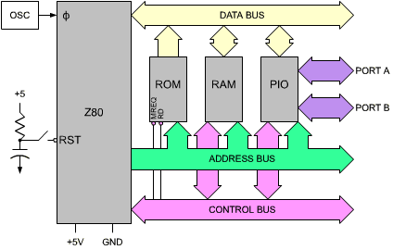

Discuss the role of the following components:

- Address Bus
(2 marks)

- Control Bus
(2 marks)

- Data Bus
(2 marks)

- Busses in a microcomputer system are said to be bi-directional. Which of the busses are considered bi-directional and why?

(4 marks)

- Describe advantages/disadvantages and the limitations of USB

(10 marks)

QUESTION 3 (25 Marks)

- A user has just upgraded their computer system to Windows 10 Professional and has installed 32GB of RAM (4 x 8GB). The user has complained to you that their system is continually running with problems when editing images via Photoshop Cloud Edition i.e. when carrying out any operation on an image it is taking several minutes to complete. The owners of the computer system have asked you for a second opinion. You examine the properties of their system and are presented with the following image:
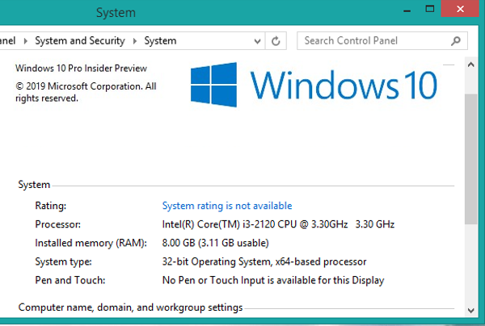

Discuss potential issues and the advice that could be given to the user.
(15 marks)

- Most operating systems will utilise Virtual Memory in their day to day use.

  - What is the purpose of Virtual Memory?
(2 Marks)
  - What is a page fault?
(2 Marks)
  - Define the term “Disk Thrashing
(2 marks)

- Discuss the role of the Task Manager within a typical operating system.
(4 marks)

QUESTION 4 (25 Marks)

- A typical end user has recently installed a new high-speed broadband link at home and want to be as secure as possible when using the connection. Provide and justify a number of steps the user would like to consider in order to be safe at home.
(15 marks)

- Describe the characteristics/limitations of a typical TCP/IP V4 address
(5 mark)

- In the context of a typical network environment, discuss the role of DHCP, its importance and its operation
(5 marks)

