Assessment 2:
Genre Case Study Essay

Discuss the ways in which – and the reasons why – Westerns from the 1960s onwards are seen to draw upon, and to critique, the traditional themes of the genre. You may refer to both the American and the Italian Western in your essay.

The films being discussed within this essay are the following: For A Few Dollars More (1965) directed by Sergio Leone and Dead Man (1995) directed by Jim Jarmusch. It will also look at the films My Darling Clementine (1946) directed by John Ford, High Noon (1952) directed by Fred Zinnemann and The Bravados (1958) directed by Henry King.
The essay shall look at how the Western genre of films from the late 1940s and 1950s, and how they can be considered as misrepresenting the west of America and neglecting historical accuracy – as seen through a colonial viewpoint. In many cases films prior to and made during the same era (as mentioned above), were also made using a colonial perspective and bias towards the white man (the westerner) - for example The Searchers (Ford, J. 1956). The truth about how the ‘west was won’ or conquered was very rarely explored or acknowledged within these films.
Films such as High Noon (Zinnemann, F. 1952) include all the tropes you would expect to find in a Western, yet can be considered to stand out from its contemporaries. For example, the standard elements are present, such as: the Sheriff/lone cowboy, plots for revenge, outlaws, shootouts and the obligatory beautiful woman, in this case played by Grace Kelly. However, this film is about standing up for yourself, in this case the Sherriff played by Gary Cooper, who fights for his beliefs and not giving in to threats. As Buscombe (2006) states, ‘...Carl Foreman was blacklisted after writing the film, High Noon has often been interpreted as an attack on McCarthyism.’
This film could also be seen as once again, Buscombe (2006) puts it, ‘...the necessity for strong individuals to fight the forces of evil, which might in 1952 have included international Communism’. But who was the real threat, once again it is all about the survival of the fittest, dominating you enemies - at any cost. When viewed in a modern context, High Noon (Zinnemann, F. 1952), it is difficult to see why the writer Carl Foreman was blacklisted, as the character of Will Kane (played by Gary Cooper) ‘could just as easily be construed as Senator Joe McCarthy, standing bravely alone against an outlaw gang of Commies’ (Frankel, 2017). The film was called “the most un-American thing I’ve seen in my whole life” by John Wayne; this conservative view aimed to target the film as promoting communist ideals in a time of mistrust in America (cited in Frankel, 2017).
Unfortunately, at the time the film was made, Hollywood was, and to some extent to this day still a right-wing, white male-dominated industry. For the Native American (indigenous population) and women to be represented truthfully and historically correct in their contribution to how the west was won, this was never fully accepted or acknowledged by any of the film’s creators. At the time, it simply did not happen. From viewing this genre of films, the Native Americans were always represented as being drunks, rapists and troublemakers, while women were represented as being weak and needing protection from white men. If they dared to stand up for themselves, they would be quickly put in their place, often violently and sexually, either literally or implied.
In My Darling Clementine (Ford, J. 1946), the film presents how the facts are not truly represented regarding Wyatt Earp, by the director John Ford.
As Buscombe (2006) states, ‘the film is basically a hagiography of a man who in truth was a ruthless opportunist.’ Buscombe (2006) goes on to say that, ‘...the charm and delicacy of Ford’s vision outweigh any historical liberties.’
Also in My Darling Clementine (Ford, J. 1946) Doc Holiday, played by Victor Mature, as mentioned by Buscombe in his book 100 Westerns (2006), did not die at the O.K. Corral. So again, the reality and truth about Earp and what happened at the O.K. Corral were not a true representation of the American west at this time. Ford also saw Earp as a saintly figure, according to Buscombe (2006) he had also claimed to have known Earp. Ebert (2002) states that, ‘He [Ford]..., met the real Wyatt Earp on the set of a movie, and heard the story of the OK Corral directly from him (even so, history tells a much different story than this film).’

Once again, the film medium represents an idyllic viewpoint of the American west, presenting Earp to be someone or something he was not. Earp was being portrayed as a hero, possibly in the eyes of some he may have been. However, this was not a true representation of the man, or of what actually happened at Tombstone in 1881.
Furthermore, as aforementioned in the introduction, the film The Bravados (King, H. 1958) is a revenge Western, and shares themes with High Noon (Zinnemann, F. 1952) - it also features the actor Lee Van Cleef as one of the outlaws (Alfonso Parral).
It has all the tropes you would expect to find in a Western, one of the main plots is focussed on the character of Jim Douglass played by Gregory Peck. His wife is murdered and just as the perpetrators are to be hanged, they escape, kidnaping and then later raping a young girl, Emma, played by Kathleen Gallant. Douglass goes after them, in search of yet again ‘revenge’. The Bravados also has a very similar narrative to The Searchers (Ford, J. 1956). The revenge of the civilised white man over the ‘wild west’ and all it stands for. This could also be seen as the taming of the west and bringing it under their ultimate control.
The Bravados (King, H. 1958), as with most early Westerns, is about good versus evil, the weak women being rescued by the strong white male, Native Americans being misrepresented as drunks and misfits. As with all of the films mentioned so far, the main theme concerns the white male’s dominance over the ‘wild west’ and how people from eastern American desired to colonise and conquer the west. These films are Hollywood’s one-sided account of how the west was won. Agresta, (2013) supports this and states that:

‘…even as decade by decade that history becomes more and more embarrassing to us. In theory, it's a beautiful thing, though in practice it means cowboy movies are easy to bungle, because by now they all take place on contested ground. Every Western must find its own way reconcile itself to the founding contradictions of America.’

The cinema audience began to question the historical accuracy of these earlier Westerns, because, as stated above, they believed the Western film genre went against all that America supposedly stood for - America was supposed to be the land of the free. Many of the Western films were a mythical representation of the reality of the Wild West. It was a myth that the general public was starting question more and more. The truth about how the west was won, and the reality of this period of history, was becoming like the Western films themselves - unfashionable. Kubincanek (2018) states that:

‘Somehow the Western has become a genre dripping with nostalgia. This is partly because it became a relic of Old Hollywood for the most part, dying out in major cinema and moving to television. The storytelling helped create heroes out of killers, marking them as misunderstood men but not without a moral code. With very little variation, the stories continued to end with the heroic cowboy or sheriff bringing justice and “doing the right thing.” These stories are satisfying for many, but they are, like their characters, a myth.’

To oppose this static view of the Western, the ‘Dollars trilogy’, all of which were directed by Sergio Leone, turned what the viewer had perceived as a typical Western to be, completely on its head. As Frayling (1981) states:

‘Sergio Leone’s ‘Dollars’ trilogy comprises a two-level detachment from the Hollywood Western genre. Firstly, as a type of European critical cinema which, using an established cinematic tradition, and without shedding its popular character, and deconstruct and rearrange the images and themes which exemplify the reverence of puritan-liberal Hollywood Westerns, the established bases of the genre.’

Leone moves completely away from the ideology of the Westerns that Hollywood had be producing for decades beforehand. Kubincanek (2018), in regard to the dated Hollywood ideal, states that:

‘They celebrate conservative values like they are the only right way to act when they are far from it. They paint minorities, especially Native Americans and Mexicans, to be the villains who challenge the ideology the cowboys hold dear. When they aren’t the enemy, they’re written in very constricting stereotypes that help continue the negative sentiment towards Mexicans or Native Americans.’

Leone’s films still feature the battle of good versus evil to a degree, and the viewer still experiences revenge. However, this time it is not just about all the elements we expect to see within this genre. As suggested in the title of this trilogy of films, especially the first two, their titles are: A Fistful of Dollars (1964); For a Few Dollars More (1965) and finally The Good, the Bad and the Ugly (1966) - they are all concerned with the ‘dollar’ (money as a symbol of wealth and power) and the need to possess it. Throughout the initial films, we see ‘the man with no name’ (played by Clint Eastwood) killing for money; his circumstances never seem to change no matter how much money he ends up with – his appearance does not change. It is not explained where his ill-gotten gains go, as he remains lonesome, dishevelled and isolated from society – it is unclear why he desires the money – this could be simply for gratification. The trilogy of films might be seen as a celebration of the mighty dollar and the overwhelming need for people to have it, be any means. A view of Capitalist ideals where every person should be able to have what they desire. As Frayling (1981) explains, the trilogy glamorises money,’...celebrating the place that the ‘almighty dollar’ holds over the West.’

For a Few Dollars More (Leone, S. 1965) was very much a film of its time, notably because one of the main characters, El Indio, played by Gian Maria Volontè is seen smoking marijuana in the film, which was the first time that a major character in a big budget film had been seen smoking it on screen. At the time this was a bold step by Leone, but also at the same time it appeared to stereotype Mexicans. In the original script, Gian Maria Volontè character was called ‘Tombstone’, maybe a nod to the Westerns Leone watched as a child. But it may also be a reference to the violence that Tombstone and the gunfight at the O.K. Corral conjures up in the mind of the viewer. Because Volontè’s character is a very violent, he shoots women and children, sets up his own men and then kills them, nothing was beyond him.
The film also critiques the south-western iconography of the church, especially the Roman Catholic Church, Leone pokes fun at it and to a degree mocks it. Leone’s irreverent use of the symbols of the church in the film are presented, especially where El Indio is preaching from the pulpit to his gang in an old abandoned church - planning how they are going to rob a bank in El Paso (see image below).
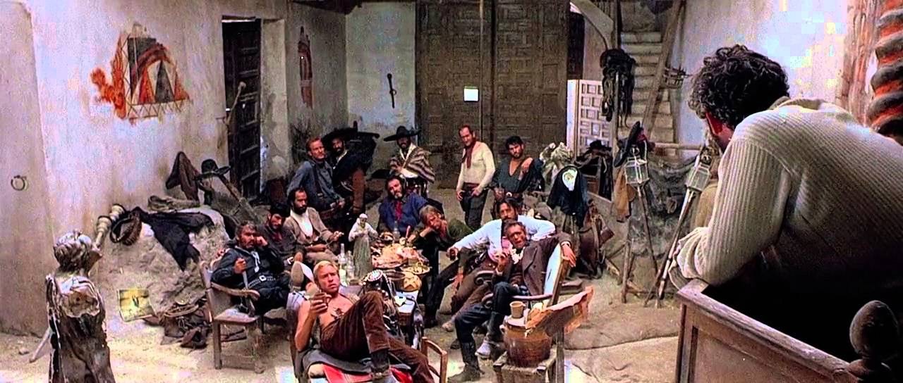
Scene from For a Few Dollars More (Leone, S. 1965)

Also within the film we see a reference to the iconic religious mural The Last Supper (1495–1498) by Leonardo da Vinci, in the scene before El Indio’s gang leave to rob the bank in El Paso.
In earlier Westerns, the church was held in high esteem, and never criticised or ridiculed. The symbol of the Church can be seen to represent the white man’s power, sanctuary, belief and ultimate presence – as opposed to other beliefs, notably the ideals that ‘primitive’ cultures followed (in this case the Native American). In the case of the ‘Dollars trilogy’, this may have been allowed because the film was made outside of the Hollywood production system, and Leone knew he could get away with it.
Even though the film For a Few Dollars More (Leone, S. 1965) presents the tropes you would normally expect to find in a Western, and example of this is revenge, concerning Lee Van Cleef’s character Col. Douglas Mortimer. He seeks revenge for the death of his sister, even if it was by her own hand, he blames El Indio. The character of Col. Douglas Mortimer appears to present a more glamorised version of the gunslinger, he is almost ‘Bond-esque’ with his weaponry and gadgets on display (see image below). Potentially taking influence from the popular Bond movies that superseded the film.

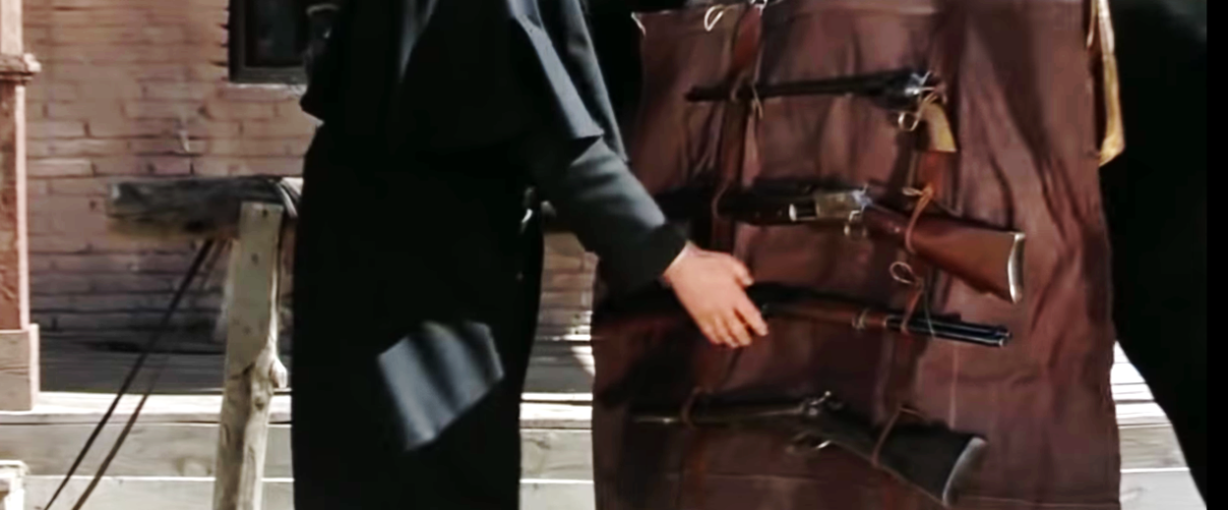
Detail from For a Few Dollars More (Leone, S. 1965)

Lee Van Cleef was not Leone’s first choice, he wanted Henry Fonda and then Charles Bronson, and he almost signed Lee Marvin for the part. This was Van Cleef’s first major role in a feature film, up until now he had only played bit parts. For example in High Noon (Zinnemann, F. 1952) as Jack Colby and Alfonso Parral in The Bravados (King, H. 1958).

The tropes of the lone cowboy and shootouts are seen firstly in Clint Eastwood’s character ‘the man with no name’ or ‘Monco’ in the American cut, and the multiple shootouts - which there are plenty of. This is still very much a European film and a Europeans take on a the American Western genre, because Leone uses tropes from the Italian music hall, where they would like to mock the petty official, the little man, and Leone does it many times in his films. For example, the hotel manager and his wife within For a Few Dollars More (Leone, S. 1965). In one sense Leone is almost making fun of the old time Western, but on the other hand, it could be also seen as a ‘love letter’ to the traditional Western - the Westerns that Leone had grown up with and fantasied over as a boy. This film does critique, but also pays homage to the early Westerns of Hollywood.
The Italians and Leone had reinvented and improved upon the Western format. They had also turned up the violence; viewers were now seeing the effects of a gunshot where beforehand it was all clean cut and not a drop of blood in sight, as in the earlier Westerns.
Thompson (2019) explains, ‘Enter Italian directors, who quickly began to re-interpret the genre for a new decade and more cynical era.’ Early Hollywood Westerns would cut away from the victim, so you were never exposed to the reality of the situation. This was how it was; it was not called the Wild West for nothing. Even though there is still a sense of realism, at points For a Few Dollars More is almost like watching a comic book account, Frayling (1981) comments: ‘Much of the violence has a cartoon quality about it.’
During the 1960’s the Italians had cornered the market and were producing the best Westerns en masse. For a Few Dollars More, according to Thompson (2019) ‘Frequently overshadowed by A Fistful of Dollars and The Good, The Bad, And The Ugly, the middle entry in Leone’s loose trilogy is still a masterpiece of the genre, and for some, the best in the series’.

The final film to be discussed is Dead Man (Jarmusch, J. 1995), although considered within the Western genre, it has been put in what is considered a sub-genre of ‘acid western’.
Rosenbaum (2000) explains:

‘What I partly mean by ‘acid Westerns’ are revisionist Westerns in which American history is reinterpreted to make room for peyote visions and related hallucinogenic experiences, LSD trips in particular. […] Both ‘acid Westerns’ and ‘pot Westerns’ depend on revaluations of white and non-white experience that view certain countercultural habits and styles in relation to models derived from Westerns, but where they differ most, perhaps, is in their generational biases, which lead them respectively to overturn or ironically revise the relevant generic norms.’

Dead Man (Jarmusch, J. 1995) is unlike the traditional Western format which many audiences will have experienced before; it tells a ‘no frills’ account of a time in the American past. The viewer is experienced to some kind of ‘out of body experience’, while questioning: what’s going to happen next? Again, the film still has a very familiar narrative that Westerns, like for example My Darling Clementine (Ford, J. 1946) and The Bravados (King, H. 1958), of revenge - even if it is misplaced. The film focusses on the person that is being chased (William Blake as played by Johnny Depp) for the murder of Robert Mitchum’s character (Mr Dickinson) son (Charlie Dickenson as played by Gabriel Byrne). The character of William Blake can be considered as the anti-hero, who cannot understand what has happened to him. The film also references the white man’s destruction of the American West. As William Blake journeys further and further West to his new appointment as an accountant in Machin, the viewer sees the change in the passengers around him, the environment and a change in the atmosphere of the carriage he sits in. The viewer experiences fur dressed hunters mercilessly shooting the buffalo, which graze alongside the railway track. The title of J. Weston Phippen’s (2016) article 'Kill Every Buffalo You Can! Every Buffalo Dead Is an Indian Gone', highlights this savage practice. Buscombe (2006) explains, ‘ As he journeys further away from civilisation, the passengers boarding the train become more and more wild, finally letting off a fusillade of bullets at some passing buffalo.’

The countryside changes as well as the viewer travels further West with Blake; it seems to become more desolate and maybe more desperate to survive the onslaught of the white man. The white man continues to not only abuse the wilderness and its resources, but the Native American as well. It is the Wild West in its truest, untamed form.
However, it does not come as a shock because the viewer is being prepared for the worst by Jim Jarmusch, through Blake’s journey as the people, landscape and maybe his state of mind change.
Blake is on a journey of discovery, which turns into a journey of self-understanding and spirituality. Blake’s original mission was to make a better life for himself, as seen as a theme in many earlier Westerns. However, his fate is changed by unexpected incident and ‘Blake embarks on his surrealistic journey into nothingness, as he becomes a marked man running from nearly everyone and everything’ (IMDB, 2020). His subsequent relationship with ‘Nobody’ played by Gary Farmer – an indigenous man, is paramount to the story, as Nobody guides Blake through his overwhelming rejection of his fate and this is ‘... juxtaposed with the realities of a truly inescapable destiny’ (IMDB, 2020) - on his journey of self-discovery and ultimate ascension.

There are some that argue the Spaghetti Westerns were a political comment targeted at America, as stated by Welles (2013) ‘The Spaghetti Western often criticised America and its foreign policy using that very country's own iconography, turning the United State's own highly cherished symbolism against itself.’
Was this Leone’s intent while making For a Few Dollars More and the others or were they a love letter to genre that he had grown up with.
The acid Western Dead Man address the history of the American West and give it a more realistic context – as opposed to the colonial bias of the earlier Westerns. It does offer a more truthful impression and respect for Native American and their land.
Word Count 3294

Reference List

Agresta, M. (2013). How the Western Was Lost (and Why It Matters) Available at:
https://www.theatlantic.com/entertainment/archive/2013/07/how-the-western-was-lost-and-why-it-matters/278057/ (Accessed 3 December 2019)

Buscombe, E. (2006) 100 Westerns: BFI Screen Guides. London: BFI

Ebert, R. (2002) The Great Movies. New York: Broadway Books.

Frayling, C. (1981) Spaghetti Westerns, Cowboys and Europeans from Karl May to Sergio Leone: New York: I.B.Tauris.

IMDB (2020) Dead Man (1995) Plot rik <spine@junglist.com> Available at:
https://www.imdb.com/title/tt0112817/plotsummary
(Accessed 15 January 2020)

Kubincanek, E. (2018) Where Westerns Fit in Modern Society. They are more than just a relic, but an opportunity for reinvention. Available at: https://filmschoolrejects.com/westerns-fit-modern-society/ (Accessed 3 December 2019)

Phippen, J.W. (2016) 'Kill Every Buffalo You Can! Every Buffalo Dead Is an Indian Gone' The American bison is the new U.S. national mammal, but its slaughter was once seen as a way to starve Native Americans into submission. Available at: https://www.theatlantic.com/national/archive/2016/05/the-buffalo-killers/482349/
(Accessed 3 December 2019)

Rosenbaum, J. (2000) Dead Man. London: BFI.

Thompson, R. (2019) 10 Greatest Spaghetti Westerns, Ranked. From The Good, The Bad And The Ugly to Once Upon A Time In The West, here are some of the greatest Spaghetti Westerns ever made. Available at: https://screenrant.com/best-greatest-spaghetti-westerns-ever-ranked/ (Accessed 3 December 2019)

Welles, J. (2013) An Essay on the Politics of the Spaghetti Westerns of Sergio Leone.
From The Spaghetti Western Database. Available at: https://www.spaghetti-western.net/index.php/An_Essay_on_the_Politics_of_the_Spaghetti_Westerns_of_Sergio_Leone (Accessed 15 January 2020)

Bibliography

Agresta, M. (2013). How the Western Was Lost (and Why It Matters) Available at:
https://www.theatlantic.com/entertainment/archive/2013/07/how-the-western-was-lost-and-why-it-matters/278057/ (Accessed 3 December 2019)

Ahmadi, A and Ross, A. (2012): Jim Jarmusch's Dead Man, Angelaki: Journal
of the Theoretical Humanities, 17:4, 179-192, Available at: http://dx.doi.org/10.1080/0969725X.2012.747336 (Accessed 02 December 2019)

Bertellini, G. (2004). The cinema of Italy. London: Wallflower.

Brooks, X. (2019) Jim Jarmusch: ‘I’m for the survival of beauty. I’m for the mystery of life’.
Available at: https://www.theguardian.com/film/2019/jul/07/jim-jarmusch-interview-the-dead-dont-die-im-for-the-survival-of-beauty (Accessed 3 December 2019)

Buscombe, E. (2006) 100 Westerns: BFI Screen Guides. London: BFI.

Crowther, B. (1967) Screen: 'For Few Dollars More' Opens:Trans-Lux West Shows New Eastwood Film 2 Rivals in Murder Are Presented as Heroes. Available at: https://www.nytimes.com/1967/07/04/archives/screen-for-few-dollars-more-openstranslux-west-shows-new-eastwood.html (Accessed 3 December 2019)

Ebert, R. (1996) DEAD MAN. Available at: https://www.rogerebert.com/reviews/dead-man-1996 (Accessed 3 December 2019)

Ebert, R. (1967) FOR A FEW DOLLARS MORE. Available at: https://www.rogerebert.com/reviews/for-a-few-dollars-more-1967
(Accessed 3 December 2019)

Ebert, R. (2002) The Great Movies. New York: Broadway Books.

Frankel, G. (2017) High Noon’s Secret Backstory. Available at: https://www.vanityfair.com/hollywood/2017/02/high-noons-secret-backstory (Accessed 15 January 2020).

Frayling, C. (1981) Spaghetti Westerns, Cowboys and Europeans from Karl May to Sergio Leone: New York: I.B.Tauris.

Hall, M K. (2001) Now You Are A Killer of White Men: Jim Jarmusch’s Dead Man and Traditions of Revisionism in the Western, Journal of Film and Video, Winter 2001, Vol. 52,
Number 4, pp.3-14.

Hughes, H. (2009). Aim for the heart: The films of Clint Eastwood. London: I.B. Tauris.

IMDB (2020) Dead Man (1995) Plot rik <spine@junglist.com> Available at:
https://www.imdb.com/title/tt0112817/plotsummary
(Accessed 15 January 2020)

Kubincanek, E. (2018) Where Westerns Fit in Modern Society. They are more than just a relic, but an opportunity for reinvention. Available at: https://filmschoolrejects.com/westerns-fit-modern-society/ (Accessed 3 December 2019)

Macaulay, S. (2019) End of the Road: Jim Jarmusch on His Johnny Depp-Starring Western Death Trip, Dead Man. Available at: https://filmmakermagazine.com/107829-end-of-the-road-jim-jarmusch-on-his-johnny-depp-starring-western-death-trip-dead-man/#.XebJopP7RBx (Accessed 3 December 2019)

McCarthy, T. (1995) Dead Man. Available at: https://variety.com/1995/film/reviews/dead-man-1200441549/ (Accessed 3 December 2019)

Nieland, J. (2001) Graphic Violence: Native Americans and the Western Archive
in Dead Man, CR: The New Centennial Review, Volume 1, Number 2, Fall 2001, pp. 171-200
(Article) DOI https://doi.org/10.1353/ncr.2003.0058

Partridge, J. (2018) Criterion Review: DEAD MAN (1995). Available at: https://cinapse.co/criterion-review-dead-man-1995-ef328301a3db
(Accessed 3 December 2019)

Phippen, J.W. (2016) 'Kill Every Buffalo You Can! Every Buffalo Dead Is an Indian Gone' The American bison is the new U.S. national mammal, but its slaughter was once seen as a way to starve Native Americans into submission. Available at: https://www.theatlantic.com/national/archive/2016/05/the-buffalo-killers/482349/
(Accessed 3 December 2019)

Pelzer, P. (2001) Dead Man-an encounter with the unknown past, Journal of Organizational Change Management, Vol.15 No.1, 2002, pp.48-62. DOI 10.1108/09534810210417375

Rosenbaum, J. (2000) Dead Man. London: BFI.

Taubin, A. (2018) Dead Man: Blake in America. Available at: https://www.criterion.com/current/posts/5619-dead-man-blake-in-america
(Accessed 3 December 2019)

Thompson, R. (2019) 10 Greatest Spaghetti Westerns, Ranked. From The Good, The Bad And The Ugly to Once Upon A Time In The West, here are some of the greatest Spaghetti Westerns ever made. Available at: https://screenrant.com/best-greatest-spaghetti-westerns-ever-ranked/ (Accessed 3 December 2019)

Weiler, AH. (1958) The Bravados' at Paramount; Gregory Peck Stars in Adult Western.
Available at: https://www.nytimes.com/1958/06/26/archives/the-bravados-at-paramount-gregory-peck-stars-in-adult-western.html (Accessed 8 January 2020)
Welles, J. (2013) An Essay on the Politics of the Spaghetti Westerns of Sergio Leone.
From The Spaghetti Western Database. Available at: https://www.spaghetti-western.net/index.php/An_Essay_on_the_Politics_of_the_Spaghetti_Westerns_of_Sergio_Leone (Accessed 15 January 2020)

(2017) For a Few Dollars More Review. Available at: https://www.spaghetti-western.net/index.php/For_a_Few_Dollars_More_Review (Accessed 3 December 2019)

