Applied Leadership and Management in the Workplace
Module Assignment Submission
Student Name: | Janine Davies
Student Number: | 2408610
Module No: | BMSK4014
Module Title: | Problem Solving and Decision Making

Statement of Confirmation of Authenticity
By the act of making this submission, the student declares that this is the work of the student named above. The work has not, in whole or in part, been knowingly presented elsewhere for assessment, or where assessment has been built on a previous assessment, this has been identified. Where materials have been used from other sources it has been properly acknowledged. If this statement is untrue, the student acknowledges that an assessment offence has been committed.
Attention is drawn to the plagiarism and unfair practice policies of both the University and of ILM.

Contents
1: Introduction. 3
2: Definition of a Complex Problem. 4
2.1: Ownership of the Problem. 4
2.2 Scope: Who is Affected and How. 5
2.3: Impact on Individuals, Teams, and the Organisation. 5
2.4: Constraints. 5
3: Problem Analysis. 6
3.1 Brainstorming. 6
3.2 Mind Mapping. 7
3.3 Fishbone Diagram. 8
3.4 The 5 whys. 9
4. Proposing Alternative Solutions. 9
5. Option Evaluation Via Decision Making Techniques. 10
5.1 Cost Benefit Ratio. 10
6. Develop a Detailed Implementation Plan. 11
6.1 Gantt Chart and Implementation Plan. 11
7: Communicate the Plan to Stakeholders. 12
7.1 Stakeholders, Their Interests and Communication Plan. 12
8: Monitor and Review Implementation. 13
Conclusion. 14
References. 15

1: Introduction.
This assignment focuses on a complex operational problem within my cake shop which is waste management. Waste within a food business can occur in many ways, such as spoiled ingredients, excess packaging, overproduction, and poor stock rotation. Left unaddressed, it can lead to profound consequences for profitability, resources, staff workload, and customer satisfaction. Therefore, understanding the root causes of waste and implementing effective strategies to reduce it is essential for improving both efficiency and sustainability in my business.

To thoroughly investigate this problem, I will use a range of problem solving models and tools. These include brainstorming and mind mapping to generate and visually organise ideas. I will also apply the Fishbone Diagram (Ishikawa model) and the 5 Whys technique to explore the deeper causes of the issue, considering factors such as processes, people, equipment, and materials. By identifying who is affected, such as staff, customers, or suppliers, I can understand the wider impact of waste within the business.
To support effective decision making, I will conduct a Grid Analysis to compare viable solutions based on weighted criteria, and a cost benefit analysis to determine which actions are most viable and cost effective. I will also create a Gantt chart to plan and schedule the implementation of the proposed actions. This chart will be used to monitor and review progress, helping me stay on track and make any necessary changes during implementation.

As part of the analysis, I will identify key stakeholders and examine their interests, as well as develop a communication plan to ensure that any changes are clearly communicated and supported across the team. This structured approach will help me recommend practical and sustainable strategies to reduce waste and enhance overall business performance.

2: Definition of a Complex Problem.
A complex problem is one that involves multiple causes, affects various parts of the business, and requires a thoughtful approach to solve, often involving group effort, analysis, and long term planning (Bryan, 2022). In my workplace, the complex problem I am addressing is waste management. In my cake shop a significant amount of waste is produced daily, including excess baking mixes, packaging materials, out of date ingredients, and unsold items. Much of this waste ends up in the landfill, which is both environmentally damaging and costly for the business. Every time I throw away expired ingredients and have leftover bakes and treats, the time, energy, and materials used to make them are wasted which means wasted money. Increased food waste may require more frequent waste collections, which adds to business costs, as commercial waste collections are expensive.

There are also staffing costs to consider, as employees spend extra time cleaning up and disposing of spoiled or surplus goods. More importantly, this issue can damage the shop’s reputation, especially among environmentally conscious customers. If customers notice that we do not manage our waste responsibly, it may discourage them from supporting the business. This can have a knock-on effect on our brand image, particularly in a community that values sustainability.

Stock control also plays a role as overstocking leads to spoilage, and poor rotation and organisation mean ingredients can expire before being used, wasting both stock and storage space. Without tracking or analysing waste, the opportunity to reduce costs through improved ordering and production is missed. The challenge lies in reducing waste, disposing of it responsibly, and implementing a sustainable system that involves all team members without disrupting daily operations.

2.1: Ownership of the Problem.
As the shop owner, I take ownership of the waste management problem because it directly affects the business’s costs, reputation, and compliance. It needs solving to control rising waste disposal expenses, reduce the environmental harm caused by food waste, meet increasing customer demand for sustainable practices, and safeguard the shop’s image. Addressing it also prevents potential health and safety risks, ensures compliance with waste regulations, and supports the long term sustainability of both the business and the wider community.

2.2 Scope: Who is Affected and How.
This issue affects many people who I have listed below.

- Myself as the business owner, due to financial and reputational consequences.
- Staff involved in food preparation, cleaning, and waste management. They may face increased workloads resulting in stress, especially when waste is excessive or procedures are unclear.
- Customers, who may notice wasteful practices or be discouraged to support a business with non sustainable packaging.
- Suppliers, especially those who use excessive packaging which requires more work from us to dispose of or require frequent restocking due to overproduction and expired stock from poor stock rotation.

The local community is affected by more landfill waste and frequent collections, while on a larger scale, wasteful practices apply pressure on the supply chain through excess production, packaging waste, and transport emissions. Inaccurate demand from overproduction and poor stock control amplifies these issues, creating inefficiencies across the industry. Customers may notice waste or be deterred by non sustainable packaging, harming the shop’s reputation and sales. Some suppliers contribute through over packaging, while others support waste reduction with reusable containers. Wasted ingredients mean suppliers must produce and deliver more than necessary, increasing farming demands, resource use, and emissions, while surplus packaging adds strain to manufacturing and recycling systems.

2.3: Impact on Individuals, Teams, and the Organisation.
Poor waste management affects the business on multiple levels. Individuals may feel frustrated or even guilty when waste is excessive, particularly if they lack the training and knowledge to prevent it. Teams can experience confusion and inefficiencies when procedures are unclear or inconsistently followed. At an organisational level, poor waste practices lead to higher waste disposal costs, reputational damage, and missed opportunities to promote the business as environmentally responsible, all of which can contribute to low staff morale, customer dissatisfaction, and operational difficulties.

2.4: Constraints.
Several key constraints make this problem difficult to address. Budget limitations, which is common in small businesses, restrict investment in staff training, new equipment, or sustainable packaging. Time is also a challenge, as staff are often busy during operating hours, leaving little opportunity to sort waste or record relevant information. In addition, there are resource limitations, including a lack of space for recycling bins or storage for reusable materials, as well as limited access to training and support on sustainable waste management practices.

3: Problem Analysis.

3.1 Brainstorming.
I used a brainstorming technique to explore as many potential causes of the waste management problem as possible. Brainstorming encourages quick idea generation, sparks creative thinking, and supports smoother collaboration. Working alone or in a group, it provides an open environment for latest ideas and meaningful progress (Besant, 2022).

Below are some of the contributing factors identified: -

- Overproduction of baked goods.
- No tracking of daily sales vs. production.
- Lack of recycling knowledge.
- Staff unclear on waste disposal procedures.
- Packaging that cannot be reused or recycled.
- Suppliers using excessive packaging.
- Lack of time to sort/separate waste.
- Limited bin space for recycling.
- Overstocking leading to expired ingredients.
- Damaged goods from poor handling.
- Food going stale from being left out.
- No staff incentives to reduce waste.
- Local council restrictions on waste collection.
- Unclear responsibilities for waste management.
- Poor team communication.
- Staff shortages or time pressures.
- Limited equipment (e.g., fridge or bin space).
- Seasonal changes effect customer demand (summer holidays).
- No measurement or tracking of waste levels.

This exercise revealed that the causes of waste stem from internal processes, staff knowledge, supplier behaviour, and lack of systems. It became clear that the problem was not just about throwing things away, but an indication of wider organisational inefficiencies.

3.2 Mind Mapping.
I used mind mapping to visually organise the causes identified through brainstorming. Mind mapping is a useful tool because it allows complex problems to be visually organised into clear categories (Buzan, 2022) This helped me break down the causes of waste into themes such as staff behaviour, production habits, and supplier practices, making it easier to identify patterns, relationships, and areas that needed further analysis. I grouped the causes into key categories:

- Staff Knowledge and Training: Training gaps, unclear responsibilities, time pressures and no incentives.
- Production and Stock: Overproduction, poor forecasting, overstocking, over ordering and weather effecting sales.
- Waste Management Procedures: No tracking, lack of recycling bins, council limitations.
- Packaging and Suppliers: Non-recyclable packaging, excess supplier wrapping and Poor communication.
- Customer Behaviour: No guidance on disposing of packaging, lack of recycling options.
- Resources and Equipment: Limited space for bins and separation of waste.

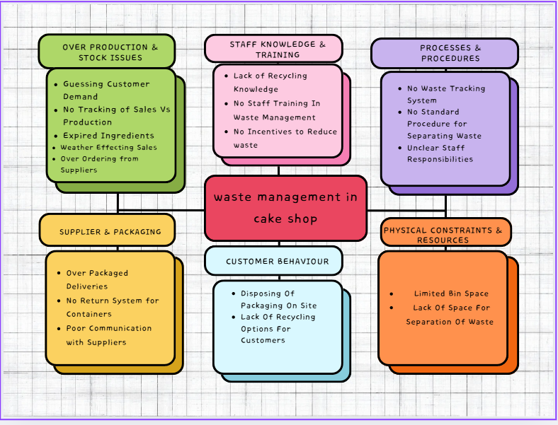
This visual method helped me identify patterns and relationships. It became evident that staff behaviour, production habits, supplier practices, and environmental constraints were connected. The mind map also laid the foundation for applying root cause analysis tools like the Fishbone Diagram and the 5 Whys.

3.3 Fishbone Diagram.
To further investigate the root causes, I used a Fishbone Diagram (also known as an Ishikawa diagram). This tool allows causes to be grouped into structured categories for easier analysis (Hessing, 2014). I used six categories:
- People – Lack of training, unclear responsibilities.
- Processes – No tracking system, poor planning.
- Materials – Overstocked ingredients, damaged goods, excessive packaging from suppliers.
- Environment – Limited bin space, times restraints.
- Suppliers – Excessive packaging, inconsistent deliveries.
- Equipment – Limited refrigeration, only one waste bin.
This analysis showed that the core issue was overproduction created by poor forecasting, lack of information and inconsistent staff practices. These problems were made worse by space and equipment limitations and external packaging waste from suppliers.

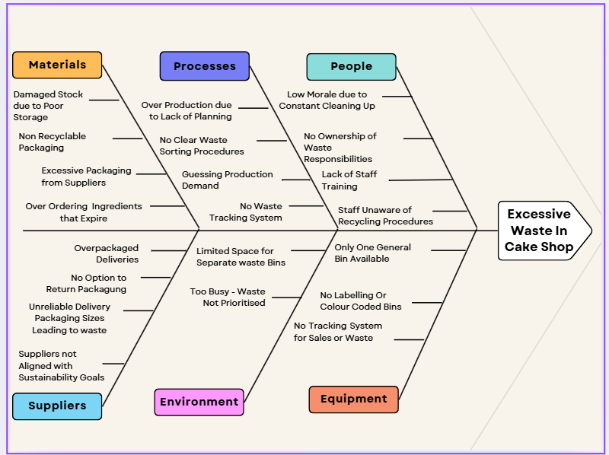
From the Fishbone Diagram, the waste issue in my cake shop is caused by a combination of overproduction, lack of staff training, poor waste procedures, limited resources, and excessive supplier packaging. By categorising these causes, I was able to clearly see how both internal practices and external factors contribute to the problem.

3.4 The 5 whys.
The 5 Whys technique, first developed by Toyota, is a straightforward method for identifying the root cause of a problem by moving past surface symptoms to address the underlying issue (Croft, 2025). The main issue for my business is the overproduction of baked goods.

- Why is there excess cake waste?
Because not all cakes are sold by closing time.
- Why are cakes not being sold?
Because too many are being produced.
- Why are too many being produced?
Because production is not based on customer demand.
- Why is production not based on demand?
Because there is no tracking or forecasting system.
- Why is there no system in place?
Because staff are not trained or equipped with the tools to do so.
This analysis revealed that the root cause of the problem is a lack of staff training and the absence of a system to forecast customer demand.

4. Proposing Alternative Solutions.
Based on my findings, I identified three potential solutions to reduce waste in my cake shop.
Solution 1: Introduce a daily sales log using a spreadsheet, paper record, or existing POS system to track product sales. This low cost option requires no new systems, supports accurate production planning, and depends on staff consistently recording and reviewing data. Risks include the task being overlooked during busy times, the need for regular reviews, and training for accurate recording.
Solution 2: Offer selected items on a pre-order or made to order basis to align production with actual demand, reducing waste from unsold stock. Clear communication to customers is essential, with implications including better stock control and forecasting but requiring extra planning and regular customer updates. Risks include fewer impulse purchases, underestimating demand, and increased admin work.
Solution 3: Provide staff training on stock management, demand forecasting, portion control, and waste reduction. This can improve awareness, confidence, and long-term savings but may incur costs, disrupt operations, and require staff availability outside regular shifts.

5. Option Evaluation Via Decision Making Techniques.
A Grid Analysis considers multiple factors and their importance, making it a valuable tool for complex decision making (admin-modernmeetingstandard, 2025). To help decide which waste reduction strategy to implement first, I conducted a Grid Analysis comparing the three proposed solutions, introducing a sales tracking system, offering a pre-order or made to order model, and providing staff training on stock management and waste reduction. I evaluated each option against four key areas cost, environmental impact, ease of implementation and compliance. Each section was scored on a scale from 1 to 5, with 5 being the most favourable. The weight total, which is shown in brackets, is then multiplied by the individual scores to give a final score, which is shown in total section of the table.
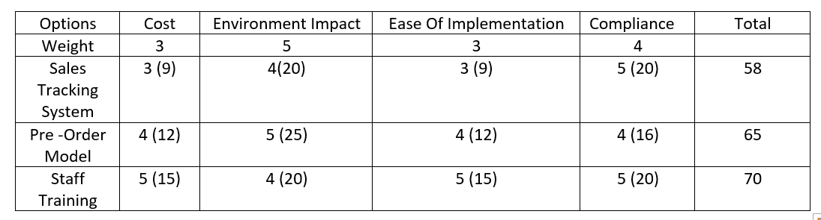
From carrying out this grid analysis, I found that staff training on waste management scored the highest overall, as it is low cost, easy to implement, supports compliance, and offers a strong positive impact on the environment, making it the most practical and effective option for reducing waste in my workplace.

5.1 Cost Benefit Ratio.
The cost benefit ratio compares expected benefits with total costs, showing the return for every £1 spent. It is a key efficiency measure, helping businesses assess value, viability, and resource allocation (Team, 2024). I used this method to evaluate the three highest scoring options from the grid analysis.
The POS system cost £4,017 this was for software, installation, training, and five years of IT support, this generated £4,250 in benefits through reduced errors, better stock visibility, and staffing efficiencies.
The pre-order model cost £2,800 this was calculated for the system setup, marketing, admin time, and staff briefings, this delivered £5,500 in benefits by reducing overproduction and storage costs while increasing customer satisfaction.
The staff training option cost £920 which was broken down into training costs, staff wages, materials, and follow up training sessions and produced £4,250 in benefits through improved stock handling, greater staff awareness, and long term waste reduction.

The table below summarises these results.
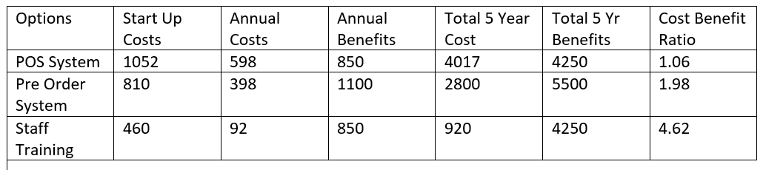

The cost benefit analysis shows that the POS system would cost £4,017 over five years and generate £4,250 in benefits, giving a ratio of 1.06 and a small positive return. The pre-order model would cost £2,800 and deliver £5,500 in benefits, producing a ratio of 1.98 and almost doubling the return on the investment. Staff training would cost £920 and provide £4,250 in benefits, with a ratio of 4.62, making it the most cost effective option and offering the highest return for each pound spent.

6. Develop a Detailed Implementation Plan.

6.1 Gantt Chart and Implementation Plan.
To support the planning and implementation of the chosen waste reduction strategies, I have created a Gantt chart to outline key tasks, assign responsibilities, and set realistic timeframes. Gantt charts are valuable for visually tracking progress, identifying overlaps or delays, and keeping projects organised, helping ensure this initiative stays on track (Ramos, 2021).
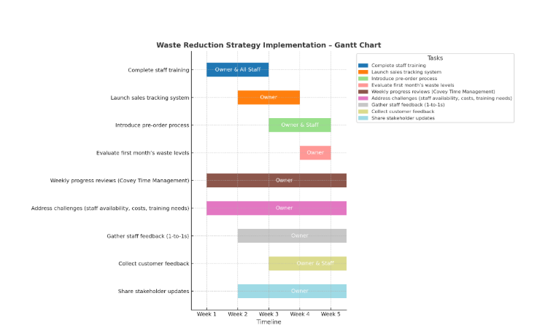

This schedule ensures that training, implementation, and monitoring are conducted in a structured and efficient manner, with clear accountability to support the successful delivery of the waste reduction proposal.

7: Communicate the Plan to Stakeholders.

7.1 Stakeholders, Their Interests and Communication Plan.
Waste management improvements at my cake shop involve several stakeholders with different interests. As the owner, I aim to reduce waste to boost profitability, streamline operations, and protect our reputation. Staff need clear communication on new procedures, training, and tracking expectations, customers value sustainability and transparency, suppliers benefit from consistent orders but may need to adjust packaging or delivery, and the local council expects regulatory compliance. My communication plan includes team meetings, signage for staff, social media, shop displays, and conversations with customers, phone or email contact for suppliers, and official channels for the council. Messages will be clear, relevant, and respectful, ensuring staff feel supported, customers are reassured, and suppliers work together. Progress will be tracked with a Gantt chart, with adjustments made to keep all stakeholders informed and aligned with our waste reduction goals. Strategic communication plans keep businesses running smoothly by delivering the right information to the right people at the right time, ensuring stakeholders stay informed and helping reduce the impact of potential issues (Kaluza, 2024).
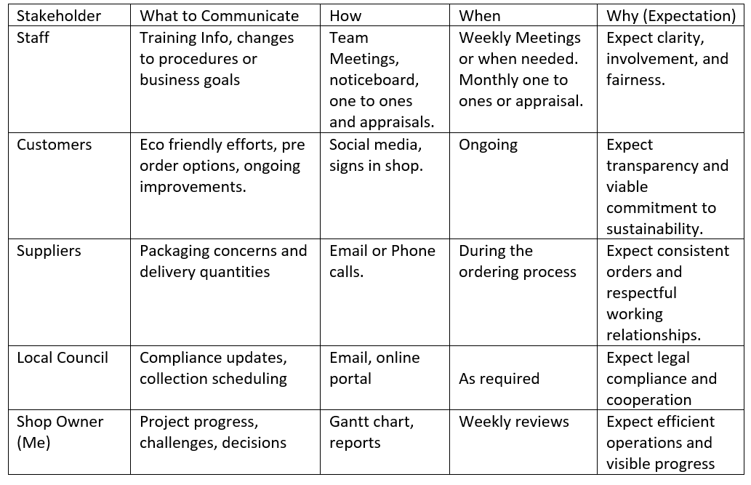
This communication plan will help maintain transparency, encourage teamwork, and ensure that expectations are met throughout the implementation process.

8: Monitor and Review Implementation.
To implement waste reduction strategies effectively, I will follow the Gantt chart outlined earlier to track progress, assign responsibilities, and stay on schedule. Key milestones include staff training, launching the sales tracking system, introducing pre-orders, and evaluating the first month’s waste levels. Weekly reviews will use Covey’s Time Management Matrix to prioritise tasks and manage deadlines (Mueller 2015), see diagram below. This approach enables early issue detection, quick adjustments, and targeted solutions for challenges such as staff availability, costs, or knowledge gaps. Feedback from staff and customers will guide improvements, keeping stakeholders informed and ensuring the project remains realistic, flexible, and focused on reducing waste.

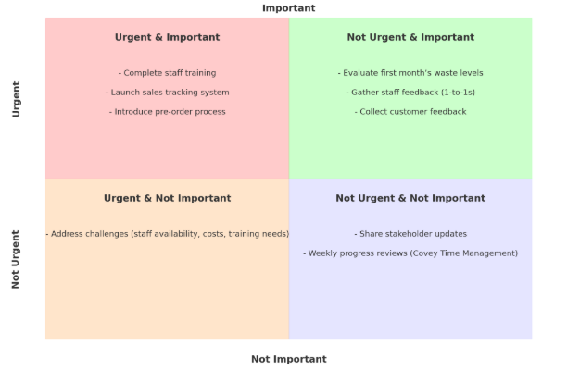
(Covey 2020).

Applying both the Gantt chart and Covey’s Time Management Matrix allowed me to organise tasks clearly, prioritise effectively, and identify potential issues early, giving me confidence that the waste reduction strategies can be implemented on time and with maximum impact.

Conclusion.
Completing this assignment has helped me develop a more structured approach to problem solving, using a range of models and tools to identify and assess solutions for reducing waste in my workplace. I started by brainstorming ideas, then used mind mapping to explore each one in more depth before narrowing them down. A grid analysis, with weighted criteria, allowed me to compare the most viable options. I then applied a cost benefit analysis to the three best solutions produced from the grid analysis to calculate the potential return on each investment. Throughout this process, I learned how different tools can be combined to make evidence based decisions, the importance of considering both financial and non financial factors, and the value of clear communication with stakeholders. The outcome has provided me with a constructive recommendation for waste reduction that balances cost, environmental impact, ease of implementation, and compliance.

References.
admin-modernmeetingstandard. (2025, July 19). Grid Analysis - Definition & Detailed Explanation - Meeting Decision Making Glossary - ModernMeetingStandard.com. Modernmeetingstandard.com. https://modernmeetingstandard.com/grid-analysis/
Besant, H. (2022, July 6). The Journey of Brainstorming. Regent University. https://www.regent.edu/journal/journal-of-transformative-innovation/the-history-of-brainstorming-alex-osborn/
Bryan. (2022, February). What is complex problem-solving and how can I do it? Bryan Lindsley. https://bryanlindsley.com/what-is-complex-problem-solving/
Buzan, T. (2022, January 25). Learn How to Mind Map – Unlock Your Creativity and Organize Ideas. Mind-Map - the World of Mind Mapping. https://mind-map.com/learn-how-to-mind-map/
Croft, D. (2025, January 24). How to Do a 5 Whys Analysis (Step-by-Step). Learn Lean 6 Sigma. https://www.learnleansigma.com/root-cause-analysis/how-to-do-a-5-whys-analysis/
Hessing, T. (2014, April 11). Cause and Effect Diagram (aka Ishikawa, Fishbone). Six Sigma Study Guide. https://sixsigmastudyguide.com/cause-effect-diagram-aka-ishikawa-fishbone-herringbone-fishikawa/
Kaluza, J. (2024, February 23). What Is a Communication Plan? Overview, Importance, and Examples. Dovetail.com. https://dovetail.com/customer-research/what-is-a-communication-plan/
Mueller, S. (2015, October 9). Stephen Covey‘s Time Management Matrix Explained. Planet of Success. https://www.planetofsuccess.com/blog/stephen-coveys-time-management-matrix-explained/
Ramos, D. (2021). The Pros and Cons of Gantt Charts | Smartsheet. Smartsheet. https://www.smartsheet.com/content/gantt-chart-pros-cons
Team, C. (2024, September 18). Benefit-Cost Ratio (BCR). Corporate Finance Institute. https://corporatefinanceinstitute.com/resources/accounting/benefit-cost-ratio-bcr/

