title of the report

Hotel Standards, Reputation Management

and Service Culture

Student Name
Fruzsina Valoczki
Student ID Number
2223630
Module Title
Hospitality and Guest Service Management BMIH4003
Lecturer’s Name
Luciana Suardi
Word Count
1601
Date
07/06/2023

Executive Summary
This academic report examines three key factors that contribute to the success of hotels: service culture, standards, and reputation management. It explores the importance of implementing brand consistency standards across hotels to create a unified brand image. The report also delves into effective strategies for managing reputation, with a specific focus on guest reviews. Additionally, it emphasizes the significance of cultivating a strong service culture within the hotel industry. The report concludes with practical recommendations supported by relevant case studies from well-established hotel brands. By understanding and implementing these recommendations, hotels can enhance their competitiveness and achieve long-term success in the dynamic hospitality market.
Table of Contents
1. Executive Summary 1
2. Introduction 2
3. Hotel Standards 2
3.1. Case Studies: Marriott International & Hilton Hotels 2
4. Reputation Management 3
4.1. Case Studies: Four Seasons Hotels & The Dorchester Collection 3
5. Service Culture 4
5.1. Case Studies: The Ritz-Carlton & Waldorf Astoria Hotels 4
6. Conclusion 5
7. Recommendations 5
8. References 7
9. Appendices 9
Appendix A – Four Seasons London Hotel’s Reviews and Response 9
Appendix B – Dorchester Collection London Hotel’s Reviews and Response 9

Introduction
In this report, I examine three key aspects that contribute to hotel success: service culture, standards, and reputation management. Firstly, I delve into the purpose of brand consistency standards and their implementation across hotels. Next, I discuss effective strategies for reputation management, specifically focusing on the impact of guest reviews. Additionally, I emphasize the significance of service culture, highlighting its unique characteristics and underscoring its importance in the hotel industry. Finally, I conclude with practical recommendations, supported by case studies from the hotel and hospitality sector.

Hotel Standards
To ensure an enjoyable stay for guests while providing a high level of service quality consistently, hotels follow established guidelines known as hotel standards. These encompass multiple facets such as customer experience, cleanliness, amenities offered to the guests along with safety protocols & operational procedures (Browning et al., 2013).
The goal of brand consistency standards in the hotel industry is to create a unified and easily identifiable brand image across all properties belonging to a particular brand. By maintaining consistent branding elements such as logos, colours, design aesthetics, and service offerings, hotels can create a sense of familiarity and trust among guests (Foroudi, 2019). By upholding this sense of harmony, hotels not only meet the expectations of their guests but also establish a clear differentiation from their competitors.
It is crucial to acknowledge, however, that hotel standards can vary across establishments. While industry-wide standards and best practices exist, individual hotel brands usually develop their own unique and distinctive set of brand consistency standards (Olsen et al., 2005). These standards are tailored to the brand's target market, positioning, and desired guest experience. They allow hotels to differentiate themselves, cater to their specific target audience, and emphasize their unique selling points.

3.1. Case Studies: Marriott International & Hilton Hotels
Marriott International stands as an esteemed hotel brand, encompassing a collection of exceptional hotel chains, such as Marriott Hotels, Sheraton, and Ritz-Carlton. Each brand within the Marriott portfolio has its own set of brand consistency standards (Dhir et al., 2019). Marriott Hotels, for example, provides guests with a blend of contemporary design, modern amenities, and personalized service, while Ritz-Carlton sets itself apart by focusing on delivering a luxurious experience filled with elegance and an unwavering commitment to meticulous attention to detail. These different brands under the Marriott umbrella showcase the variation in brand consistency standards within the same hotel company (Braun, 2017).
Similarly, Hilton Hotels & Resorts shines as another prominent player in the hotel industry, encompassing a rich portfolio of distinct brands, including Hilton Hotels & Resorts, DoubleTree by Hilton, and Embassy Suites by Hilton (Phalippou, 2014). Each brand within the Hilton portfolio maintains its distinct brand consistency standards. Hilton Hotels & Resorts places emphasis on providing a premium guest experience, exceptional service, and a wide range of amenities (Lamo, 2019). On the other hand, DoubleTree by Hilton focuses on warm hospitality, comfortable accommodations, and their signature chocolate chip cookies (Kim et al., 2017). These examples illustrate the diverse brand consistency standards implemented by Hilton across its various hotel brands.
These case studies demonstrate that while there may be overarching brand consistency standards within a hotel company, each individual brand within the portfolio has its own specific set of standards tailored to its unique positioning, target market, and guest expectations.

Reputation Management
For hotels to maintain a positive image and improve their guest perception, reputation management is a crucial component (Zhang & Vásquez, 2014). Hotels can effectively manage their reputation by prioritizing exceptional guest experiences, actively engaging with guests through various channels, promptly responding to reviews and feedback, and utilizing reputation management tools to monitor and shape their online presence.
Effective guest reviews management is of paramount importance as positive reviews not only enhance a hotel's reputation but also serve as valuable social proof for potential guests (Gavilan et al., 2018). Hotels should encourage guests to leave reviews, monitor and respond to feedback promptly and professionally, and leverage positive reviews to showcase their strengths and unique offerings.
A hotel's reputation can be severely damaged by negative reviews (Wang & Chaudhry, 2018). They can influence potential guests' perception and decision-making. It is crucial for hotels to address negative reviews promptly, empathetically, and proactively. By demonstrating a willingness to resolve issues and improve guest experiences, hotels can mitigate the impact of negative reviews and showcase their commitment to guest satisfaction.

4.1. Case Studies: Four Seasons Hotels & The Dorchester Collection
The Four Seasons Hotel and Resort brand is renowned worldwide for its luxurious accommodations, exceptional service, and personalized service. They excel in reputation management by consistently delivering unparalleled guest experiences, paying attention to every detail, and ensuring guest satisfaction at every touchpoint (Morgan, 2014). Four Seasons actively engages with guests, values their feedback, and promptly addresses any concerns (See on Appendix A). Their commitment to reputation management has established them as a leading luxury hotel brand worldwide, showcasing the importance of proactive strategies in managing reputation.
In contract, The Dorchester Collection, a prestigious luxury hotel brand, exemplifies effective reputation management (LaTour & Brant, 2022). They consistently deliver exceptional service, engage with guests through personalized experiences, and promptly respond to feedback (See on Appendix B). The Dorchester Collection's commitment to reputation management has helped them cultivate a positive image and attract discerning travellers, reinforcing the importance of proactive reputation management strategies. These case studies highlight the significance of effective reputation management and guest reviews management in establishing and maintaining a positive brand image in the competitive hotel industry.

Service Culture
Service culture refers to the shared values, beliefs, and behaviours within an organization that prioritize delivering exceptional service to customers (Batinić, 2016). It encompasses the mindset, attitudes, and actions of employees, reflecting a commitment to providing a memorable and satisfying customer experience.
While corporate culture encompasses the overall values, norms, and practices within an organization, service culture specifically focuses on the aspects related to service delivery (Lo et al., 2015). Corporate culture may include elements such as communication styles, organizational structure, and decision-making processes, while service culture emphasizes the customer-centric approach and the organization's commitment to service excellence.
In the hotel industry, service culture plays a crucial role in attracting and retaining guests (Dimitriou, 2022). Hotels rely on positive guest experiences and satisfaction to build a strong reputation, differentiate themselves from competitors, and foster guest loyalty. A strong service culture ensures that every employee is aligned with the organization's service standards and actively contributes to creating exceptional guest experiences.

5.1. Case Studies: The Ritz-Carlton & Waldorf Astoria Hotels
Six Senses Hotels, Resorts & Spas and Waldorf Astoria Hotels & Resorts are both esteemed luxury hotel brands that prioritize exceptional service and personalized experiences. Each brand has its own unique approach to service culture, setting them apart in the competitive hospitality industry. Six Senses Hotels, Resorts & Spas focuses on wellness, sustainability, and providing transformative experiences for guests (Silva, 2018). Their service culture is centred around personalized care, attention to detail, and creating lasting memories. From their stunning locations to their holistic wellness offerings, Six Senses delivers an unparalleled level of service and care.

On the other hand, Waldorf Astoria Hotels & Resorts embodies timeless elegance and impeccable service (Demirçiftçi & Kizilirmak, 2016). Their service culture is characterized by delivering personalized experiences and attention to detail. As guests enter a Waldorf Astoria property, they are instantly embraced by an atmosphere of elegance and sophistication. Every detail of their stay is meticulously designed to surpass expectations.
These brands share a mutual emphasis on the significance of service culture in the hotel industry, recognizing its pivotal role in creating unforgettable experiences for guests. By focusing on personalized care, attention to detail, and creating unique experiences, Six Senses Hotels, Resorts & Spas and Waldorf Astoria Hotels & Resorts have earned strong reputations for their exceptional service. Their commitment to service excellence sets them apart and contributes to their success in the luxury hospitality market.

Conclusion
In conclusion, this report explored key aspects of the hotel industry, including hotel standards, reputation management, and service culture. The study highlighted the significance of brand consistency standards in maintaining a unified identity and meeting guest expectations. Effective reputation management, particularly through guest reviews, was identified as crucial for enhancing the hotel's image and differentiating it from competitors. Additionally, the report emphasized the importance of service culture in delivering exceptional experiences and creating a lasting impression on guests. By understanding and implementing these concepts, hotels can strive for excellence and establish a strong position in the competitive hospitality market.

Recommendations
To stay competitive in the hospitality industry, hotels must embrace technology, personalize guest experiences, prioritize sustainability, be flexible and adaptable, and utilize effective digital marketing (Car et al., 2019). These recommendations, based on industry analysis and case studies, help hotels navigate challenges and ensure long-term success. Embracing technology is crucial for enhancing guest experiences and improving operational efficiency. Marriott's mobile check-in and keyless entry systems cater to tech-savvy travellers, streamlining the check-in process and providing convenience (Sharma & Gupta, 2021). Personalization plays a significant role in guest satisfaction. The Ritz-Carlton excels in offering tailored amenities based on individual preferences, making guests feel valued and appreciated (Solomon, 2015). By collecting and utilizing guest data effectively, hotels can deliver unique experiences that cater to specific needs. Sustainability practices are increasingly important. Flexibility and adaptability are essential to overcome challenges. Effective digital marketing strategies help hotels reach and engage with target audiences. Marriott's active engagement on social media platforms and sharing captivating content enhance visibility, attract new customers, and maintain connections with existing clientele. Implementing these recommendations allows hotels to navigate market trends, overcome challenges, and achieve long-term success in the competitive hospitality industry.

References

Batinić, I., 2016. Hotel management and quality of hotel services. Journal of Process Management and New Technologies, 4(1), pp.25-29.

Braun, T.M., 2017. A case study on the emergence of boutique and lifestyle hotels.

Browning, V., So, K.K.F. and Sparks, B., 2013. The influence of online reviews on consumers' attributions of service quality and control for service standards in hotels. Journal of Travel & Tourism Marketing, 30(1-2), pp.23-40.

Car, T., Stifanich, L.P. and Šimunić, M., 2019. Internet of things (iot) in tourism and hospitality: Opportunities and challenges. Tourism in South East Europe, 5, pp.163-175.

Demirçiftçi, T. and Kizilirmak, İ., 2016. Strategic branding in hospitality: Case of Accor Hotels. Journal of Tourismology, 2(1), pp.50-64.

Dhir, S., Sushil, Dhir, S. and Sushil, 2019. Marr

iott Hotels. Cases in Strategic Management: A Flexibility Perspective, pp.147-162.

Dimitriou, C.K., 2022. The critical role that national culture and ethical leadership play in fostering employee commitment to service quality in the hotel industry. Research in Hospitality Management, 12(3), pp. 255-271.

Foroudi, P., 2019. Influence of brand signature, brand awareness, brand attitude, brand reputation on hotel industry’s brand performance. International journal of hospitality management, 76, pp.271-285.

Gavilan, D., Avello, M. and Martinez-Navarro, G., 2018. The influence of online ratings and reviews on hotel booking consideration. Tourism Management, 66, pp.53-61.

Kim, B., Wang, S. and Heo, C.Y., 2017. Sensory marketing in hotels: Understanding of sensory triggers for hotel operations. In The Routledge Handbook of Hospitality Marketing (pp. 245-254). Routledge.

Lamo, E.G., 2019. The Center of Success: A Case Study on Hilton's Company Culture.

LaTour, K.A. and Brant, A., 2022. Social Listening to Create Bespoke Customer Experiences: Best Practices for Hospitality Operators. Cornell Hospitality Quarterly, 63(3), pp.320-333.

Lo, A., Wu, C. and Tsai, H., 2015. The impact of service quality on positive consumption emotions in resort and hotel spa experiences. Journal of Hospitality Marketing & Management, 24(2), pp.155-179.

Morgan, J., 2014. Destination Ambassadors: Examining how Hospitality Companies Value Brand Ambassadorship from Front-Line Employees–A Case Study of Four Seasons Hotels & Resorts. The McMaster Journal of Communication, 11.

Phalippou, L., 2014. Hilton Hotels: A Case Study in Real Estate Private Equity. Available at SSRN 2429357.

Silva, S.D.S.B., 2018. Wellness tourism in Southeast Asia: the case study of Six Senses Hotels Resorts & Spas (Doctoral dissertation).

Sharma, U. and Gupta, D., 2021, July. Analysing the applications of internet of things in hotel industry. In Journal of Physics: Conference Series (Vol. 1969, No. 1, p. 012041). IOP Publishing.

Solomon, M. (2015). Your Customer Service Is Your Branding: The Ritz-Carlton Case Study. [online] Forbes. Available at: https://www.forbes.com/sites/micahsolomon/2015/09/24/your-customer-service-style-is-your-brand-the-ritz-carlton-case-study/?sh=55dfc93455ef [Accessed 3 Jun. 2023].

Olsen, M.D., Chung, Y., Graf, N., Lee, K. and Madanoglu, M., 2005. Branding: Myth and reality in the hotel industry. Journal of Retail & Leisure Property, 4, pp.146-162.

Wang, Y. and Chaudhry, A., 2018. When and how managers' responses to online reviews affect subsequent reviews. Journal of Marketing Research, 55(2), pp.163-177.

Zhang, Y. and Vásquez, C., 2014. Hotels׳ responses to online reviews: Managing consumer dissatisfaction. Discourse, Context & Media, 6, pp.54-64.

Appendices

Appendix A – Four Seasons London Hotel’s Reviews and Response
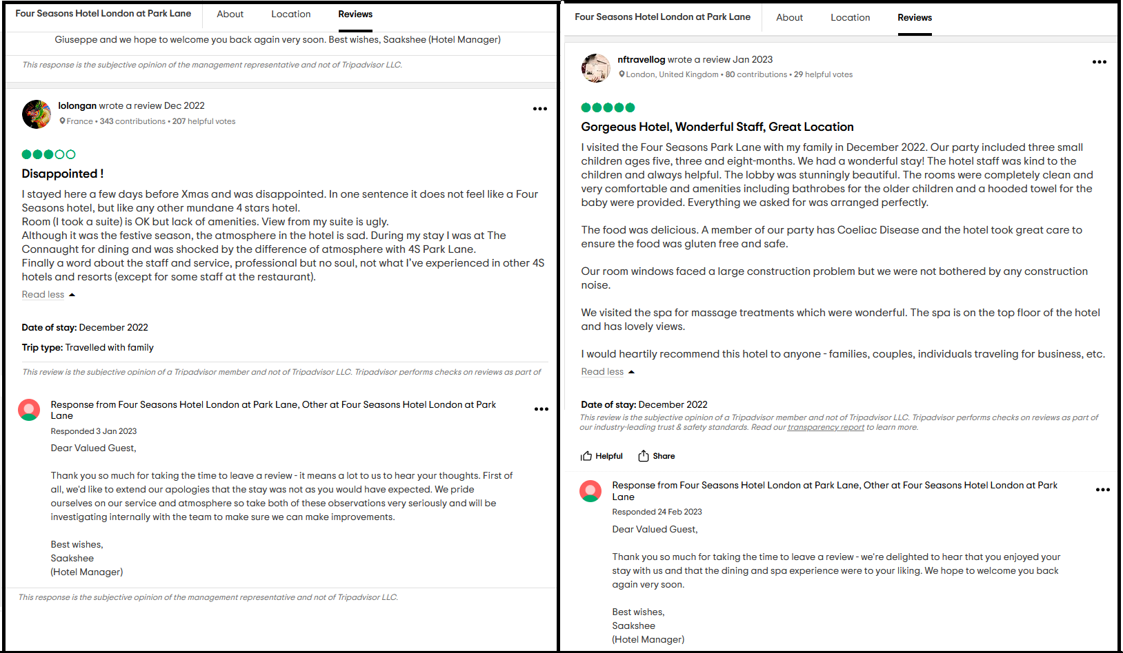

Appendix B – Dorchester Collection London Hotel’s Reviews and Response


