AI STATEMENT
I confirm that I have not presented any AI generated text as my own work. I confirm I have copies of my drafts, notes, and other resources I used before, and after the use of AI tools which I may be asked to provide in evidence.



Certificate of Higher Education in Employability Skills
LEVEL 4

Module Name: Digital Skills for Personal and Professional Growth
Module Code: BMSW4008
Student Name: Mihaela Maxim
Student ID: 2431491
Submission date:15 March 2026

CONTENT PAGE:

Task 1- Market Research, Website and Marketing
Materials Design 2

- Questionnaire Creation and Data Collection 3

  - Key findings 3
  - Target Segmentation 6
  - Branding 6
- Website design and content strategy 7

2.1 SEO Strategy 9
- Marketing Materials 10
3.1 Branded Business Card 10
3.2 Flyer 11
3.3 Video advertising 11
Task 2- Cashflow Forecast and Essay on the
Importance of Excel in the Digital Era 12
Cashflow forecast 13
Essay on the Importance of Excel in the Digital Era 15
Task 3- Advert 18 References-Task 1 20 References-Task 2 22
Appendices 23

Task 1
Market Research, Website and Marketing Materials Design

Word Count-1095
- Questionnaire Creation and Data Collection

Hospitality in the UK faces significant pressures. As the CEO of UK Hospitality explains, “it’s never been harder to turn that top line revenue into a bottom-line profit”, highlighting the importance of differentiating ourselves in this market (Nicholls, 2024). To do this, I have designed a questionnaire to examine spending and cuisine preferences, desires for sustainability and better ways of marketing. This has meant I have identified trends that will shape my restaurant’s concept, branding, website design and marketing strategies, which means Silures will be customer-led, evidence-based and strategically positioned within this competitive sector. I collected responses from 14 people across a range of ages with most aged 25-50 years. This included questions to determine 4 important factors: what customers value most when dining, what cuisine they prefer, sustainability importance and how they discover new venues.

  - Key findings

- Cuisine Preference
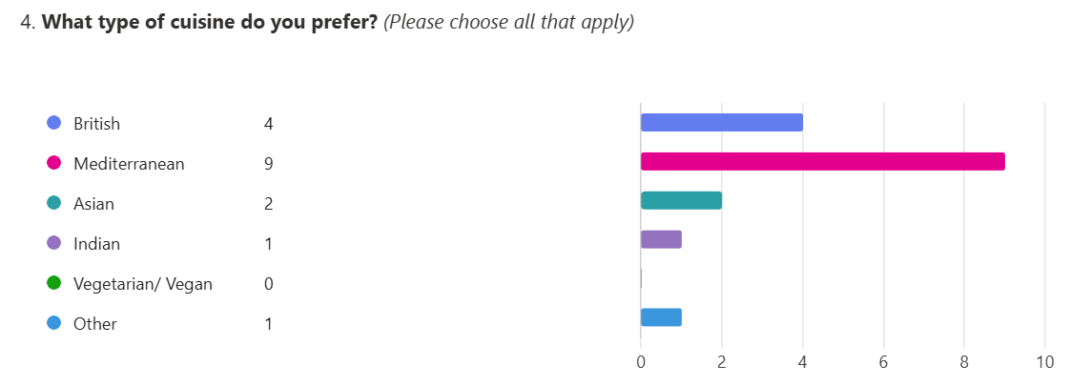

(53%) of the respondents prefer Mediterranean and (24%) British cuisine .This clearly shows that by combining these two cuisines Silures will be in a strong position to meet customer culinary demands.
It also indicates a desire for familiar yet refined flavours. Moreover, Mediterranean food is well known for its freshness, seasonal ingredients and relaxed dining, these are also directly related to sustainability trends (Nutritics,2024). This reflects the idea that our target audience want food that should be “good, clean and fair”, so by incorporating seasonal Welsh ingredients and British classics into Mediterranean-inspired dishes, Silures remains inspired while responding to customer expectations (Petrini, 2007).
Lastly, Wansink (2005) argues that quality focused wording increases perceived taste and value. Therefore, menu descriptions will highlight locally sourced and seasonal ingredients to highlight quality and justify pricing.

- Aspects customers value most when booking a restaurant
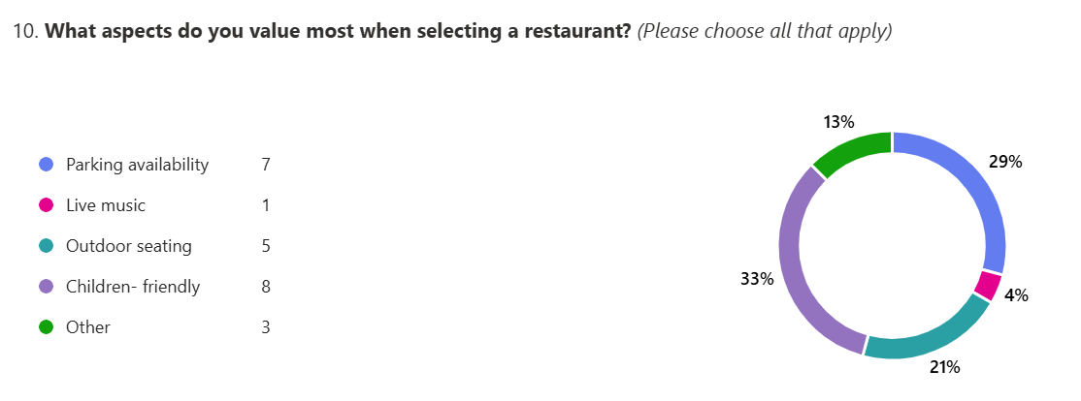

As Kandampully and Suhartanto(2000) states, convenience and accessibility are stronger motivators than entertainment. The most valued aspects of choosing a restaurant are: children friendliness (33%), parking availability (29%) and outdoor seating (21%). This shows that Silures must create a family-friendly environment with a menu and amenities for children. Parking, family friendly and outdoor seating will be highlighted on our website and flyer to ensure our audience is aware of these offerings.

- Sustainability importance
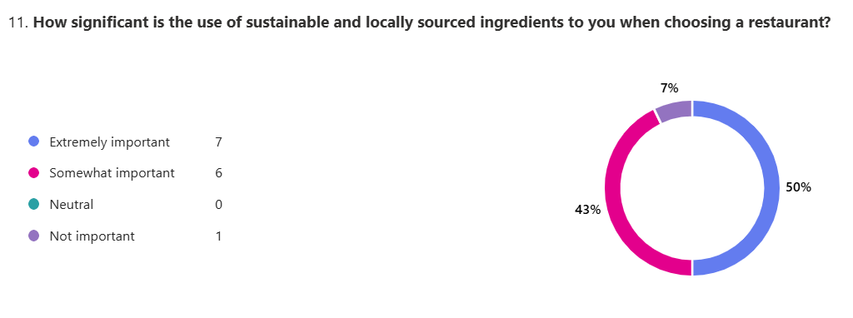

93% of our respondents consider sustainability important .This is unsurprising and reflects the view of Roberts (2025) that customers have a growing awareness of ethical dining practices.
Sustainability will be implemented operationally and promoted within marketing, reinforcing our mission statement: “To provide an exceptional dining experience while promoting sustainability and supporting local community”, and encouraging custom to the restaurant.
There is a strong indication that environmental practices positively influence customer satisfaction and behavioural intentions, thus sustainability messaging will appear across the menus, website content and be promoted on social media (Kang et al., 2012).
- Restaurant discovery
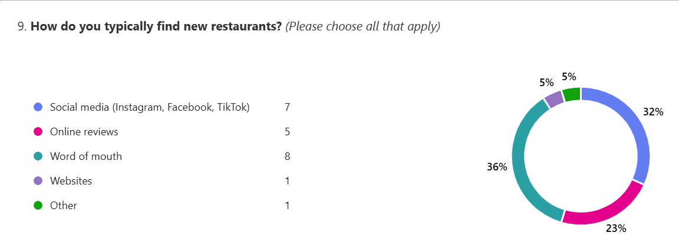

The reliance on word of mouth and social media implies that online presence is vital with strong digital engagement (Chaffey and Ellis-Chadwick, 2019). We will therefore focus on Instagram and Facebook campaigns; influencer launch events and encouraging or incentivising reviews. These campaigns will use visually appealing branded content using the green and beige colour palette.
- Target segmentation

Identifying a target audience is vital for our success as it allows us to identify distinct customer segments and tailor services to meet specific needs (Hooley et al., 2024). Following the questionnaire I have identified three groups:
- “The Affluents” (ages 45-75+, individuals or with families, high income earners, they value premium dining options-food and service)
- “Families” (ages 35-44, they seek restaurants where children are welcomed)
- “Moderns” (ages 25-34, young in outlook, well informed and connected, looking for ‘Instagrammable’ restaurants

- Branding

Branding must resonate with our target audience. Colours representing sustainability, freshness and Wales – particularly green – will be crucial in this, while more neutral tones like beige will bring warmth and sophistication, creating an inviting and elegant identity that resonates with our target audience (Adobe, 2024).


We will use these colours consistently across the website, flyers, business cards and social media graphics as this will strengthen brand recognition and the association of Silures core values like ‘sustainability’, ‘freshness’ and ‘quality’.

- Website design and content strategy
Silures Restaurant and Bar | British and Mediterranean Cuisine | , Penarth, UK
Homepage
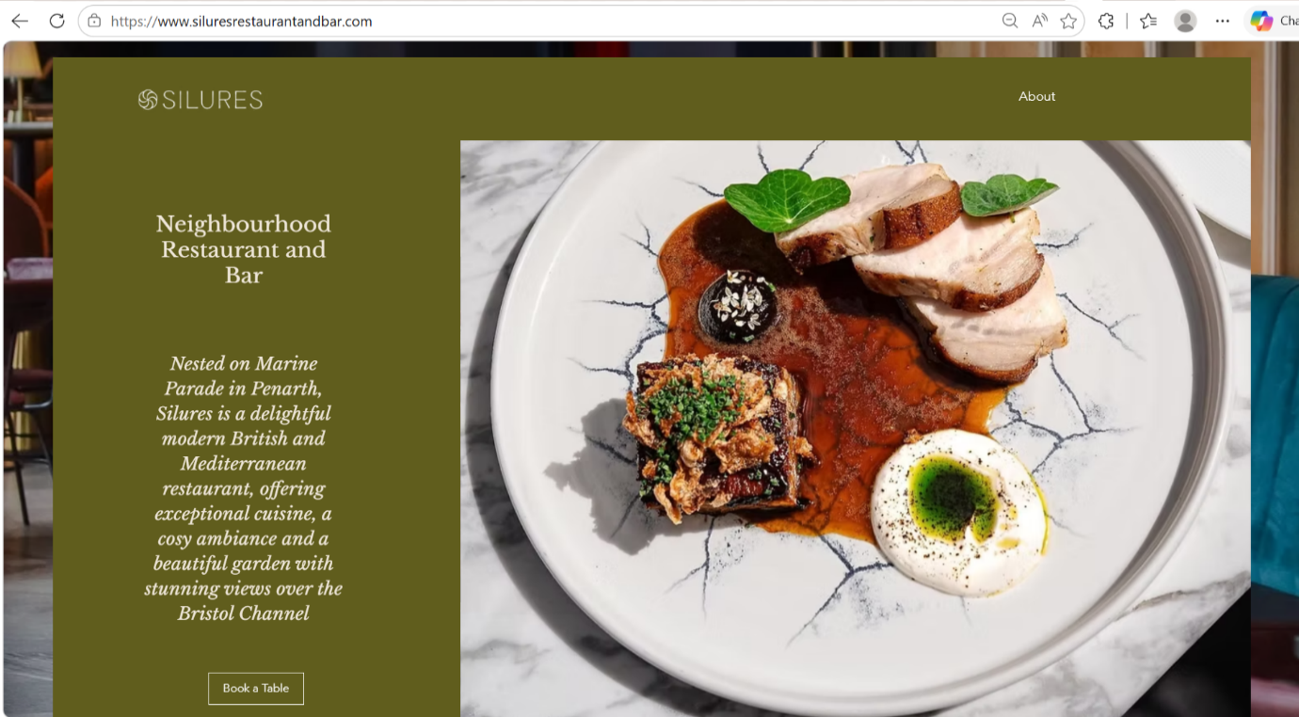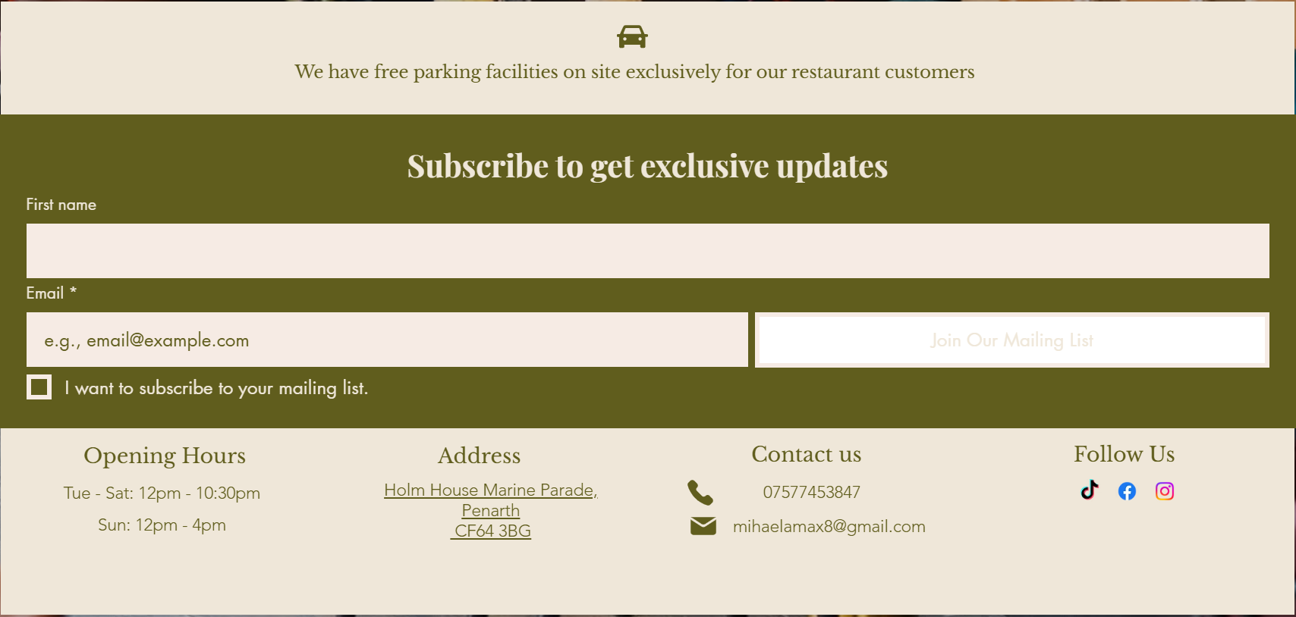

About Page
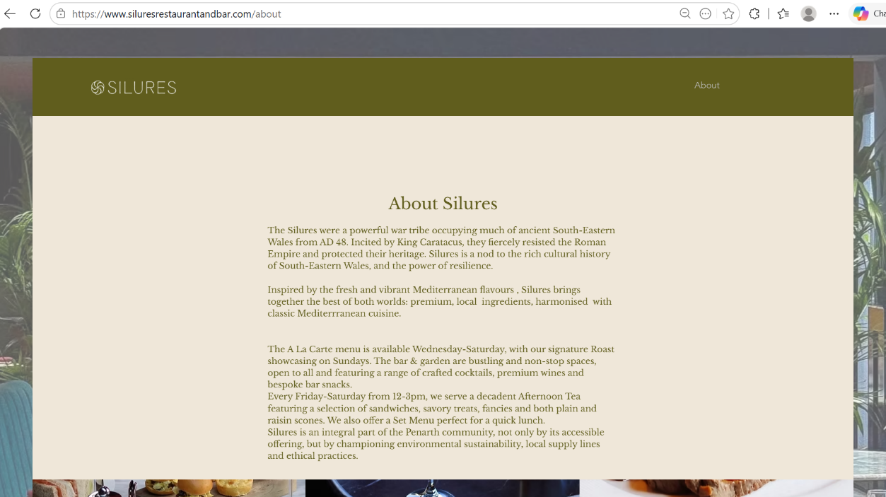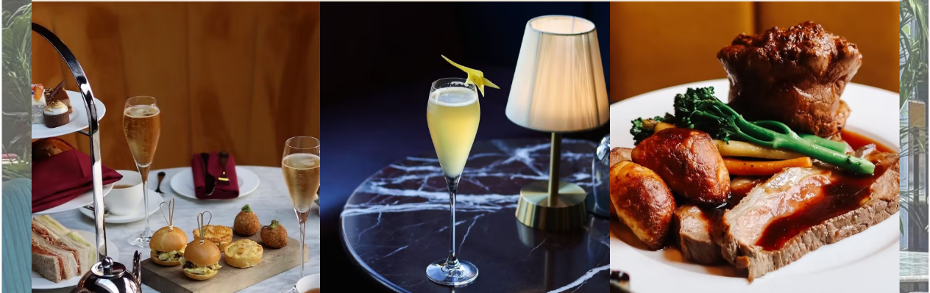

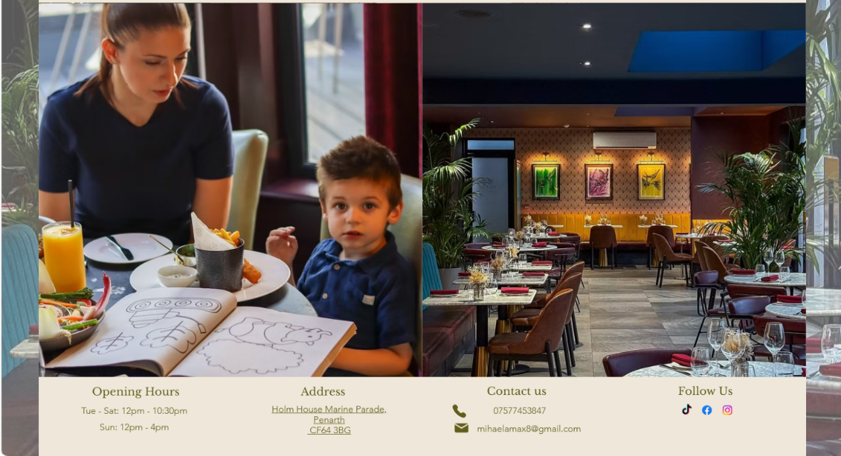

The website must reflect our target audience’s preferences and branding, as effective website design can influence the level of engagement, satisfaction and, importantly, loyalty (Flavian, Gurrea and Orus, 2009). Excellent photography will help showcase the restaurant, food and drink selection, while a good user-interface ensures ease of access for all age-groups to make reservations, access contact information and sign up to newsletter and social media updates.

SEO Strategy

According to Dadwal (2020), Search Engine Optimisation is critical for building brand recognition and can bring a brand to the top of search preferences. To improve the website SEO, I have used:
- On- page optimisation:
- High quality content
- Keywords such: sustainable, Penarth, British and Mediterranean cuisine, family-friendly, Sunday roast, terrace dining, parking, as keywords remain core to improving search visibility (Usmany et al., 2024).
- Heading tags
- Title tag- Silures Restaurant and Bar
- Meta description- Discover Silures Restaurant and Bar, a contemporary dining destination, located in Penarth. Enjoy a unique culinary experience, with stunning views over the Bristol Channel, featuring seasonal dishes inspired by British and Mediterranean cuisine.
- Image Alt Text (description on each image)

- Technical SEO ensures a fast-paced load speed (1615.13ms) and mobile friendliness

- Local SEO integrates Google Maps to increase visibility in Penarth searches.

- Marketing Materials

Business cards-
- High quality image of a signature dish to highlight restaurant’s culinary excellence and attention to detail
- QR code for easy access and link to website

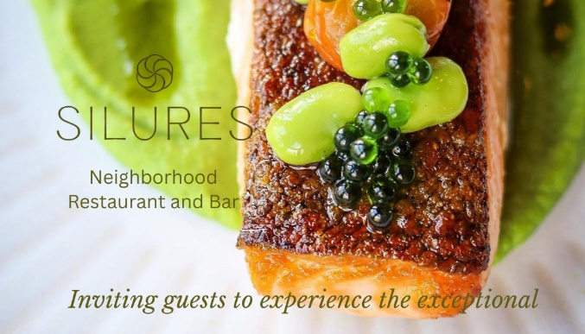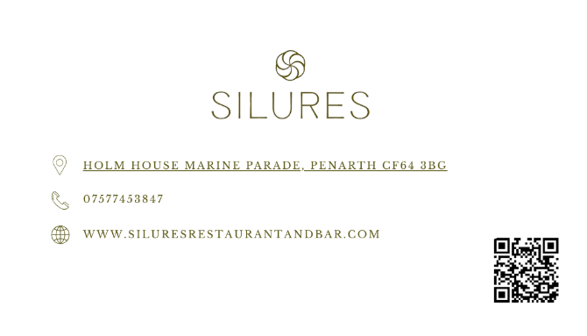

Flyer
- Will target the local community reinforcing our green and beige colour identity
- Includes pictures that highlights Silures offering
- Call to Action to encourage customers to engage and visit the restaurant

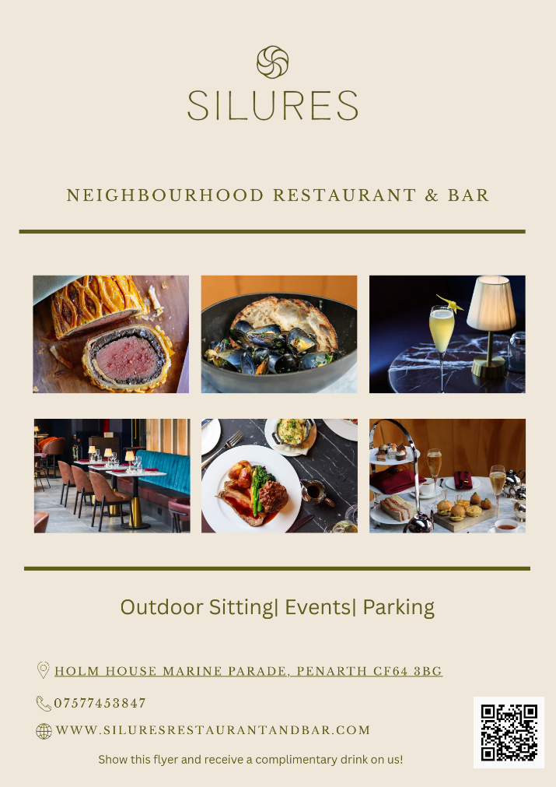
Video advertising content has been shown to “foster brand communication by heightening audience engagement, augmenting brand visibility and nurturing emotional bonds” (Zhou, 2025). Therefore, by showcasing the restaurant, garden, private dining room while highlighting key findings from the questionnaire like family friendly, children’s amenities, sustainability, British and Mediterranean cuisine, celebrations, we will encourage engagement, promote content sharing and attract new customers.

By analysing customer preferences and expectation, Silures can improve its marketing strategies, website and brand awareness. The questionnaire’s insights will help shape Silures offering to better meet target audience’s needs. Focusing on sustainability, offering British and Mediterranean cuisine and creating a family- friendly atmosphere, Silures can boost customer satisfaction and loyalty, increase revenue and be a successful business.

Task 2
Cashflow Forecast and Essay on the Importance of Excel in the Digital Era

Cashflow forecast
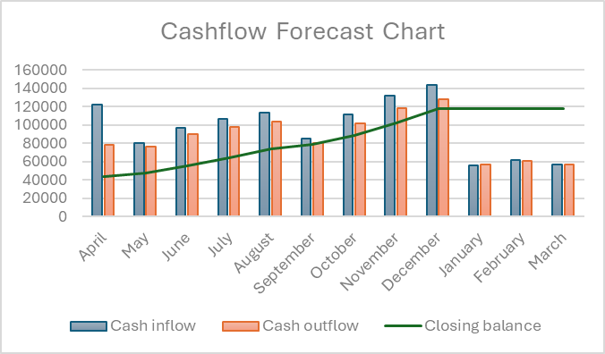

Funding
Silures total investment is £175,000
Startup Costs
The total startup costs (Appendix 2) are £129,133 with a remaining cashflow of £45,867 available for future needs
12 months cashflow forecast
The 12- month cash flow forecast shows that the total cash inflow is estimated to be £1,167,616 and the total cash outflow is £1,050,210
The business is expected to end the year with a closing balance of £117,407 which indicates that Silures can be a viable business.

The Importance of Excel in the Digital Era
Introduction
As we become more data driven, being able to manage and analyse large data sets is essential to business decision-making. Microsoft Excel has consistently remained one of the most widely used tools, with two thirds of all office workers using it at least once per hour due to its flexibility, accessibility, and analytical power (Charlesworth ,2024). Despite more advanced programs available, Excel is still central to financial management, forecasting, and data analysis (Walkenbach, 2013). Regarding the hospitality sector, Excel continues to be central to managing finances and rotas, analysing customer trends, and helping to plan long-term.
Excel is used extensively across the world of business and finance to manage large datasets, calculations, and financial models. Specifically, in professional situations, it is regularly used for analysing cash flow, budgeting, forecasting, and performance reports (Benninga, 2014). Moreover, financial analysts build models in Excel that assess profitability, manage costs, and assess future risks of different products. This widespread use is mainly due to its capability to combine numerical analysis with visualising data, meaning complex information can be clearly communicated (Powell and Baker, 2018).
This is where Excel plays a pivotal role in my business; by managing the financials. Data from sales in differing areas of the restaurant, such as all-day dining, bar service, afternoon tea, and private dining, can be noted and categorised. This allows the revenue generated across these streams to be monitored, compared and extrapolated. Gross profit margins, operating costs, and net profit can all be calculated using formulas, allowing me to make efficient pricing decisions. Financial oversight is vital for any business, however particularly in the hospitality sector where margins are often narrow and operating costs are volatile.
Crucially, Excel is a powerful tool that can use historical sales data to develop financial forecasts that can aid predicting future revenue and expenditures. Forecasting enables the business to plan for seasonal changes. such as increased summer demand. This supports more accurate staffing, purchasing, and cash flow management (Hubbard, 2014). Furthermore, creating best-case, worse-case scenarios improves fiscal resilience and fosters consistency.
Beyond this, Excel supports customer data analysis, which is becoming increasingly useful in modern hospitality. Customer feedback can be collated to help identify dining habits, menu preferences, and service styler. Visualisation allows this data to be analysed efficiently, helping us adapt menus, promotions, and service offerings based on data rather than instinct. Tracking these trends over time provides more data that can be used to further support evidence-based decision-making and reinforces a customer-focused approach.
The continued relevance of Excel is also due to its integration within the wider digital business ecosystem. Many booking and point-of-sale systems allow data to be directly exported, meaning more data can be analysed without expensive specialist software. Indeed, the very fact the Microsoft package costs less than £100 a year is a significant advantage. Moreover, its user-friendly design – combined with the familiarity of Microsoft software – makes it one of the most versatile data analysis tools available on the market.
There is also huge potential for Excel as its importance becomes reinforced by its integration with AI. Recently, Microsoft has introduced AI-driven features such as natural language queries and automated inputs, allowing users to use plain language to analyse (Microsoft, 2023). For our restaurant, this has the potential to help us identify sales trends or unusual fluctuations in revenue more quickly, further aiding long-term planning. Excel also integrates with tools such as Microsoft Power BI, allowing for more advanced data visualisation and AI-supported forecasting. Through this combination we have the potential to enhance our strategic decision-making and business growth.
It is because of all these factors that, across industries, Excel continues to be used extensively. The retail sector use Excel to forecast inventory demand and reduce waste (Laursen and Thorlund, 2016), while start-ups rely on Excel-based financial models when seeking investment (Blank and Dorf, 2012). For the hospitality sector, Excel is similarly depended on to manage bookings, staffing, and financial performance. It is the combination of these examples that demonstrate how Excel remains central to both operational and strategic business functions.
Conclusion
Excel remains a critical tool in the digital era due to its versatility, accessibility, analytical capability, and integration with emerging technologies. For our restaurant, Excel provides an indispensable means for financial management, forecasting, and customer data analysis, enabling us to make evidence-based decisions and ensure long-term sustainability. Not only is Excel important but as it continues to evolve through AI integration, its role in supporting data-driven, customer-focused businesses will only become more significant.

Task 3
Advert

- copy_9845EC4E-F9E7-4D7E-B996-32F8478D9742.mov
- https://youtube.com/shorts/-v7ZXyMkZbg



References
Task 1(Data Analysis Report)
- Adobe (2024). Colour psychology in marketing: How colours influence buyers. Adobe Express. Available at: https://www.adobe.com/uk/express/learn/blog/colour-psychology-in-marketing (Accessed on 1 March 2026).

- Chaffey, D. & Ellis-Chadwick, F., (2019). Digital Marketing: Strategy, Implementation and Practice. 7th ed. Harlow: Pearson.

- Dadwal, S. (2020) Innovations in Technology and Marketing for the Connected Consumer . Hershey, Pennsylvania :, IGI Global. doi:10.4018/978-1-7998-0131-3.

- Flavián, C., Gurrea, R. & Orús, C., (2009). Web design: A key factor for the website success. Journal of Systems and Information Technology, 11(2), pp.168–184, doi:10.1108/13287260910955129.

- Hooley, G.J.,Nicolaud, B., Rudd, J.M. and Lee, N. (2024) Marketing strategy and competitive positioning. Eighth edition. Harlow, England; Pearson.

- Kandampully, J. & Suhartanto, D., 2000. Customer loyalty in the hotel industry: The role of customer satisfaction and image. International Journal of Contemporary Hospitality Management, 12(6), pp. 346–351.

- Kang, K.H., Stein, L., Heo, C.Y. and Lee, S., (2012). Consumers’ willingness to pay for green initiatives of the hotel industry. International Journal of Hospitality Management, 31(2), pp.564–572.

- Nicholls, K (2024) ‘Glimmers of hope’ for hospitality sector says UKHospitality CEO. Public Sector Catering. Available at: https://www.publicsectorcatering.co.uk/news/glimmers-hope-hospitality-sector-says-ukhospitality-ceo (Accessed on 26 February 2026).

- Nutritics (2024) Sustainability matters: What consumers want and how brands can respond. Dublin: Nutritics. Available at: https://www.nutritics.com/en/wp-content/uploads/2025/07/Sustainability-Matters-Part-1_2024_FINAL.pdf (Accessed on 28 February 2026).

- Petrini, C., (2007). Slow Food Nation: Why Our Food Should Be Good, Clean, and Fair. New York: Rizzoli.

- Roberts, I. (2025). Delivering on ‘non-negotiables’: dietary options, sustainability and customer experience - UKHospitality. [online] UKHospitality. Available at: https://www.ukhospitality.org.uk/delivering-on-non-negotiables-dietary-options-sustainability-and-customer-experience/. (Accessed 8 February 2026).

- Usmany, P., Rachmawati, R. & Rembe, E., (2024). The Effectiveness of Search Engine Optimization (SEO) in Marketing: A Meta-Analysis Study. Journal of Economic, Business & Accounting, 7(5), pp.807-811. Available at: https://www.researchgate.net/publication/382953524_The_Effectiveness_Of_Search_Engine_Optimization_SEO_In_Marketing_A_Meta-Anlysis_Study (Accessed on 26 February 2026).

- Wansink, B., Painter, J.E. and Van Ittersum, K., (2005). How descriptive food names bias sensory perceptions in restaurants. Food Quality and Preference, 16(5), pp.393–400.

- Zhou, Y., (2025). The Influence of Social Media Short Videos on Brand Engagement and Communication. Journal of Education, Humanities and Social Sciences, 51, pp.71–76. Available at: https://www.researchgate.net/publication/391610027_The_Influence_of_Social_Media_Short_Videos_on_Brand_Engagement_and_Communication (Accessed on 27 February 2026).

References

Task 2 (Importance of Excel in the Digital Era)

- Benninga, S. (2014) Financial Modelling. 4th edn. MIT Press.

- Blank, S. and Dorf, B. (2012) The Startup Owner’s Manual. K&S Ranch.

- Charlesworth, L. (2024). What is microsoft excel used for and is it still relevant? [online] Kaplan.co.uk. Available at: https://kaplan.co.uk/blog/features/is-microsoft-excel-still-relevant. (Accessed on 01 March 2026)

- Hubbard, D.W. (2014) How to Measure Anything. 3rd edn. Wiley.

- Laursen, G.H.N. and Thorlund, J. (2016) Business Analytics for Managers. Wiley.

- Microsoft (2023) New AI features in Excel. Microsoft 365 Blog.

- Powell, S.G. and Baker, K.R. (2018) Management Science: The Art of Modeling with Spreadsheets. Wiley.

- Walkenbach, J. (2013) Excel Bible. Wiley.

Appendices

Appendix 1- Questionnaire

- Design and Questions

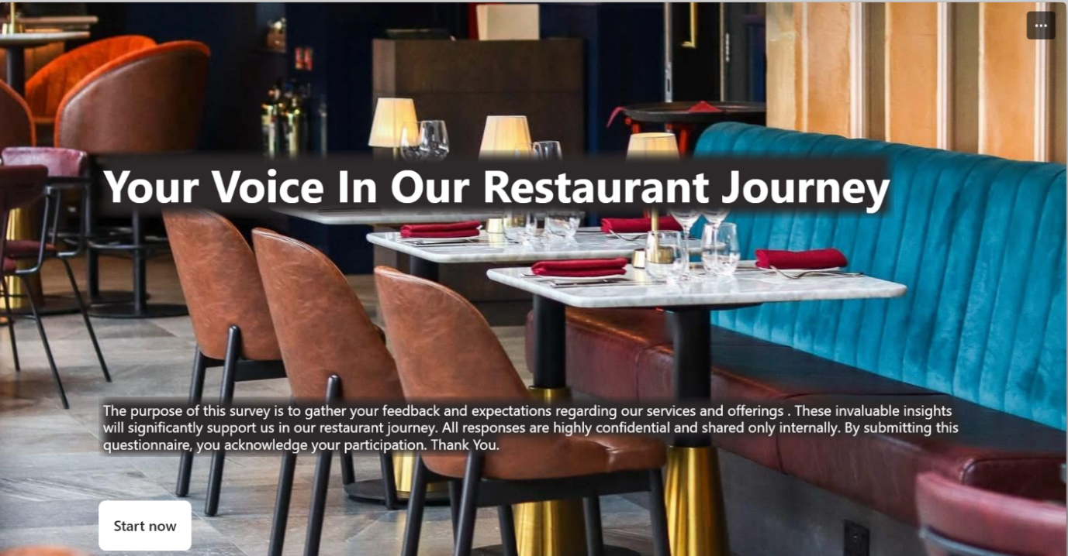
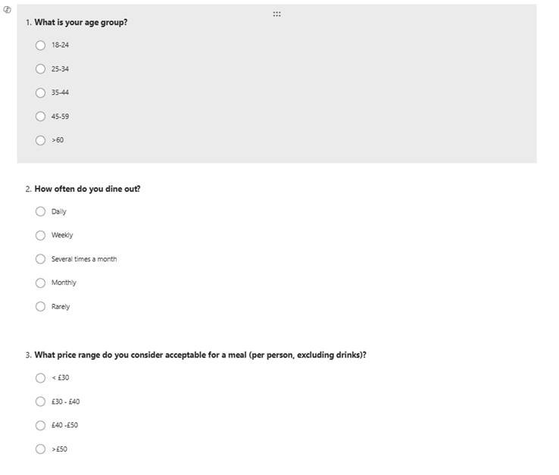
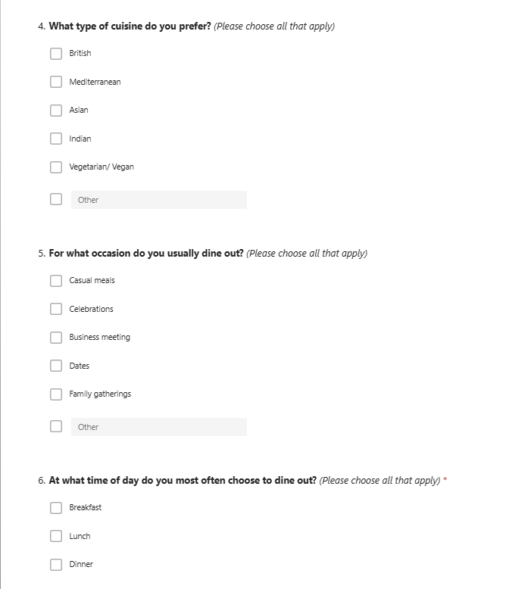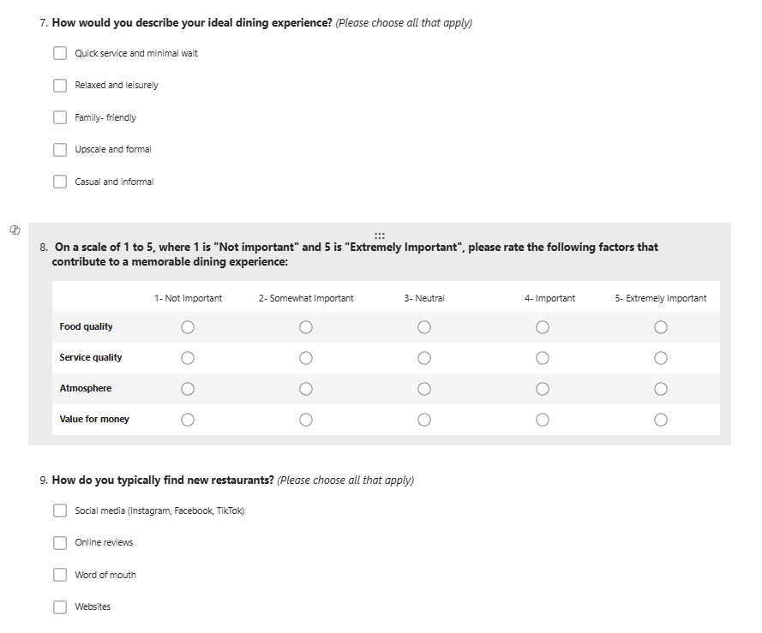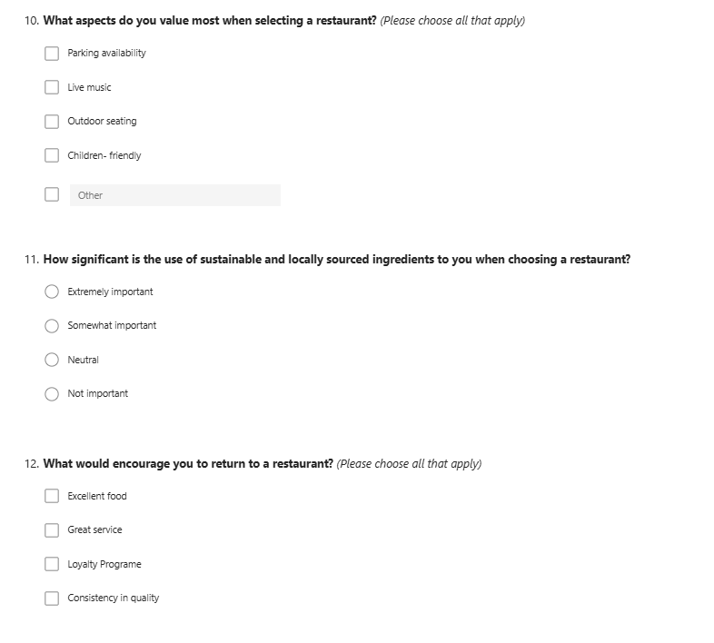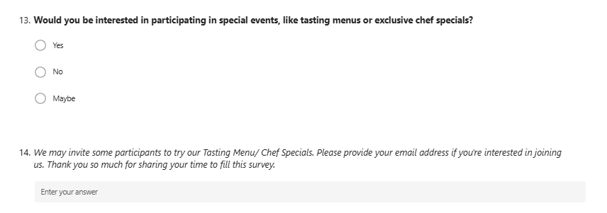

- Results
Your Voice In Our Restaurant Journey – Results

Appendix 2- Forecast cashflow

Start-up costs

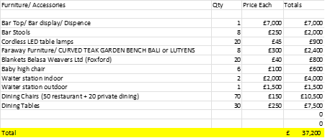

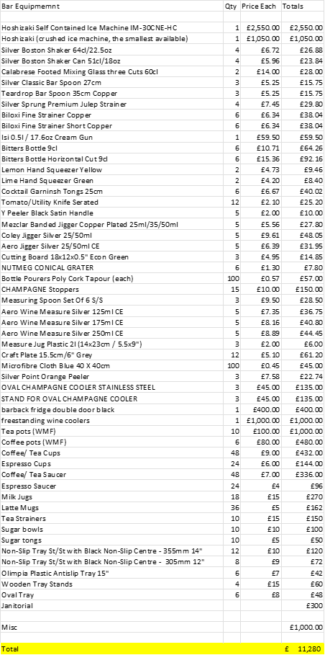
Payroll and Forecast

Forecast by month

