Rate of reaction

STEFAN JAREMA | CHEMISTRY LAB REPORT | ACDB4011

Introduction 1
Results 3
Effect of concentration of HCl on speed of H2 gas on Evolution 3
Effect of temperature on speed of H2 gas evolution 7
Effect of the surface area of Mg on speed of H2 gas evolution 11
Discussion 13
Conclusion 15
References 15
Appendix 16
Materials and Method 16
Effect on HCL concentration on the speed of H2 gas evolution 17
Effect of temperature on the speed of H2 gas evolution 18
Effect of the surface area of Mg on speed of H2 gas evolution 19

Introduction

The purpose of this experiment is to perceive and understand the effect on the rate of reaction based on changes in concentration, temperature, and surface area.
The rate of reaction can be defined by how fast it takes for reactants to be converted into products within a chemical reaction.
Within this experiment the two reactants that will be tested are Magnesium (Mg), and Hydrochloric acid (HCl) and the product, that will be used to determine the rate of reaction, is Hydrogen gas measured in $cm^{3}$or $mL$.
The rate of reaction will be tested off these three variables:
- Concentration of HCl
- Temperature of HCl
- Surface area of Mg

The hypothesis is that increasing the concentration of HCl, temperature of HCl, and surface area of Mg will result in an increased rate of reaction based on prior experience and knowledge of chemical kinetics.

The Equations used to determine the variable’s relationship to the rate of reaction are:
$rate=\frac{∆V_{H2}}{∆t}$ $\left[{cm^{3}}/s\right]$ (Equation one)
$1mL = 1cm^{3}$ (Equation two)
$t_{1}= 50 \sec{}$ (Equation three)

Results

Effect of concentration of HCl on speed of H2 gas on Evolution

[Table 1]
[HCl] | Time to dissolve Mg | Average rate | Instantaneous rate at t=10 | Weight of Mg
1.0M | 220 seconds | $${0.94cm^{3}}/s$$ | $${1.5cm^{3}}/s$$ | 0.079g
1.5M | 130 seconds | $${1.52cm^{3}}/s$$ | $${3.7cm^{3}}/s$$ | 0.096g
2.0M | 70 seconds | $${1.42cm^{3}}/s$$ | $${3.4cm^{3}}/s$$ | 0.074g
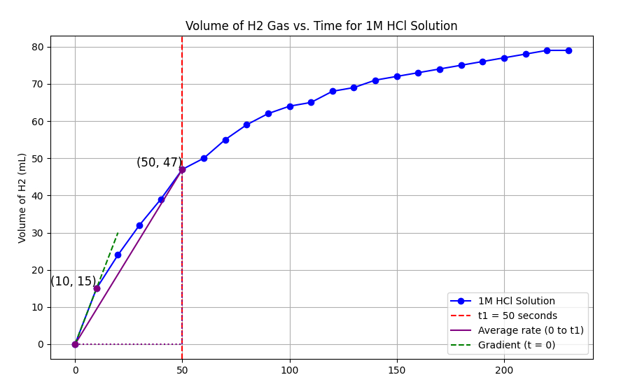[Figure 1 ]
To calculate the Average rate of reaction for 1M HCl solution
$$t_{1}= 50 \sec{}$$

Using (Equation one) and (Equation two)
Average rate = $\frac{V_{H_{2}}\left(t=t_{1}\right) - V_{H_{2}}\left(t-0\right)}{t_{1}-0}$
Average rate = $\frac{47-0}{50-0}$ = $\frac{47}{50}$ ${=0.94cm^{3}}/s$
Using values from the graph $V_{H_{2}}\left(t=10\right)=15mL and V_{H_{2}}\left(t=0\right)=0mL$
Instantaneous rate = ${\frac{15-0}{10} =1.5cm^{3}}/s$

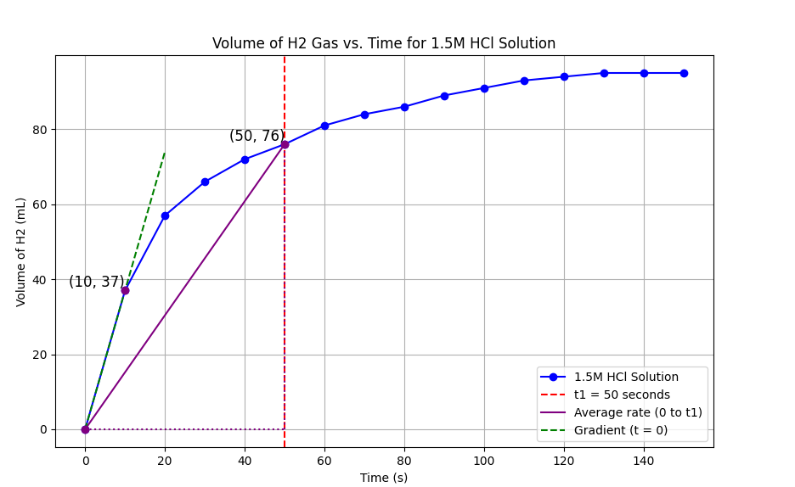[Figure 2]
Average rate = ${\frac{76}{50} = 1.52cm^{3}}/s$
Instantaneous rate =${\frac{37}{10}=3.7cm^{3}}/s$

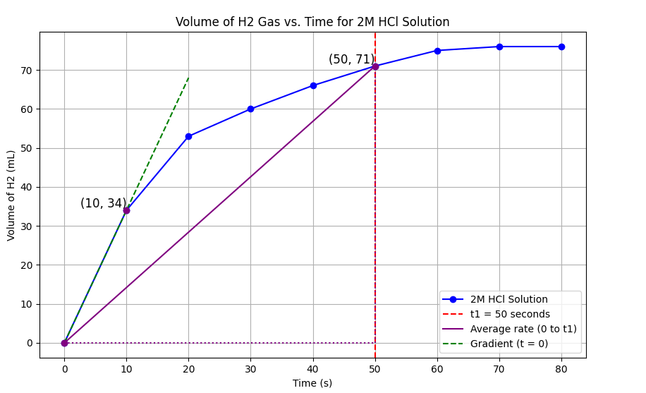[Figure 3]
Average rate = ${\frac{71}{50}=1.42cm^{3}}/s$
Instantaneous rate = ${\frac{34}{10}= 3.4cm^{3}}/s$

The key finding of this experiment should be that by increasing the concentration of HCl it would increase the rate of reaction [1], however from the data that is displayed above, the fastest average rate of reaction and instantaneous rate of reaction took place with the 1.5 M solution of HCl [Figure 2], the assumption is due to the different masses of magnesium used during the experiment.
For this experiment the only variable should have been the concentration of HCl. However, due to some circumstances the weight of the magnesium, which should have been a constant, ended up becoming a second variable. This had an interesting effect on the rate of reaction.

The initial hypothesis was that due to the magnesium having more mass, this was the cause of the increase in reaction. However, due to the results in the third experiment, the current hypothesis is that a byproduct of the magnesium having a higher mass was it also having a larger surface area, which resulted in the increase in the speed of reaction.

Effect of temperature on speed of H2 gas evolution
[Table 2]
Temperature | Time to dissolve Mg | Average rate | Instantaneous rate at t=10
T1 = 25$°C$ | 220 Seconds | $${0.94cm^{3}}/s$$ | $${1.5cm^{3}}/s$$
T2 = 41.5$°C$ | 260 Seconds | $${1.02cm^{3}}/s$$ | $${2.0cm^{3}}/s$$
T3 = 60$°C$ | 200 Seconds | $${1.24cm^{3}}/s$$ | $${2.7cm^{3}}/s$$
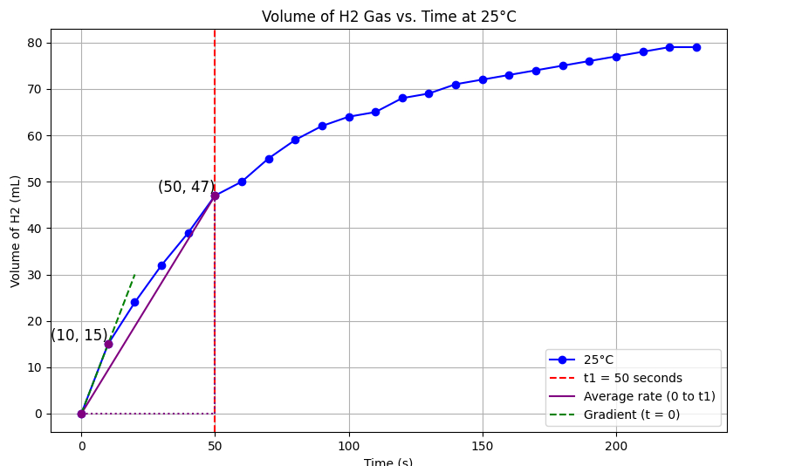[Figure 4]

Average rate = $\frac{47}{50}$ =${0.94cm^{3}}/s$

Instantaneous rate = ${\frac{15}{10} =1.5cm^{3}}/s$

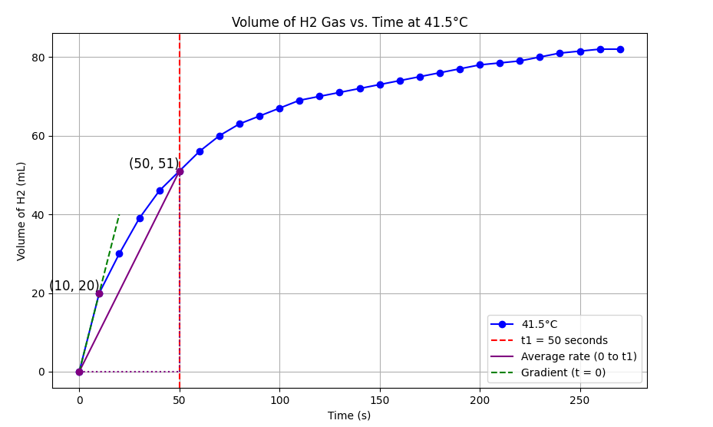[Figure 5]
Average rate = ${\frac{51}{50}= 1.02cm^{3}}/s$
Instantaneous rate = ${\frac{20}{10}= 2cm^{3}}/s$

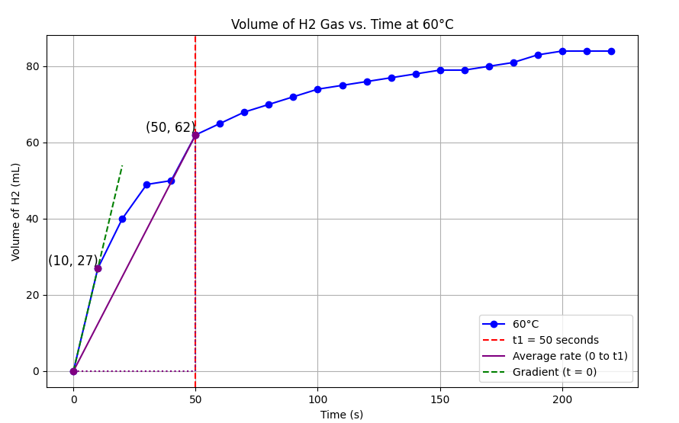[Figure 6]
Average rate = ${\frac{62}{50}= 1.24cm^{3}}/s$
Instantaneous rate = ${\frac{27}{10}= 2.7cm^{3}}/s$

When comparing the three different rates of reaction between the graphs, there is a clear trend suggesting that when you increase the temperature of the HCl, it results in the rate of reaction increasing [Figure 6]. This is because when the reactants are heated, the kinetic energy of the molecules increases. This leads to molecules moving around faster, resulting in more energy when the molecules collide, which in turn increases the rate of reaction. If more molecules hit each other with more energy, the rate of reaction will increase.

Effect of the surface area of Mg on speed of H2 gas evolution
[Table 3]
Surface area | Total Mass | Mols of HCl | Average rate of reaction | Instantaneous rate of reaction  $t=10$
1 Mg ribbon | 0.079g | 1M | $${0.94cm^{3}}/s$$ | $${1.5cm^{3}}/s$$
4 Mg turnings | 0.076g | 1M | 0.72${cm^{3}}/s$ | 1.1${cm^{3}}/s$
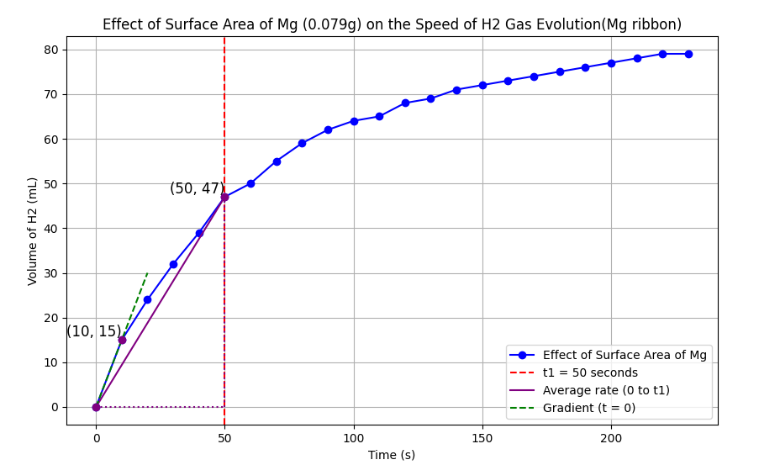[Figure 7]
Average rate of reaction = $\frac{47}{50}$=${0.94cm^{3}}/s$
Instantaneous rate = ${\frac{15}{10}=1.5cm^{3}}/s$

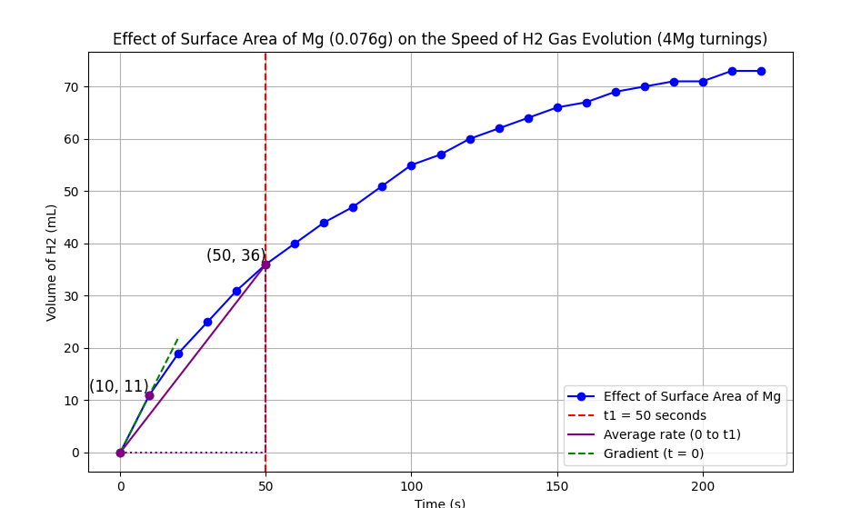[Figure 8]

Average rate of reaction = ${\frac{36}{50}= 0.72cm^{3}}/s$
Instantaneous rate = ${\frac{11}{10}= 1.1cm^{3}}/s$

From the results gathered, it can be seen that the graphs indicate that the 4 Mg turnings [Figure 8] have a slower rate of reaction compared to the 1 Mg ribbon [Figure 7]. However, with further research, the outcome seems to be an anomaly as the total masses of both Mg are within an acceptable margin of difference of 0.004g. The main difference should be the surface areas, with the 4 Mg turnings having the larger surface area compared to the Mg ribbon.

The ideal reaction would have had the Mg with the larger surface area (the turnings) having the faster rate of reaction. This is because increasing the surface area of a reactant increases the frequency of collisions, which, as learned previously, increases the rate of reaction. [2]

Discussion
Throughout this experiment, there have been many flaws. This is due to many different factors, some being improper lab preparation in the form of different masses of Mg when mass should have been constant within a small margin of error. This resulted in flawed data when representing the effect of HCl concentration on the rate of reaction [Table 1].

The next major flaw was the outcome of the final experiment when evaluating the effect of surface area of Mg on the rate of reaction [Table 3], as the results obtained on the day of the experiment were atypical compared to known scientific principles. [1] [3]

This shows the value of reproducible data compounded with the scientific method. If this experiment were only ever conducted once, the idea of the conclusion being wrong would be unfounded, as the data clearly shows the unknown anomaly taking place. However, by being able to do this experiment again and realizing that those results were unreproducible in a consistent manner, it allows you to gather the objective outcome of what should take place during the reaction.
Although unknown what led to the incorrect data, it could be assumed that the bung was improperly placed onto the test tube or just human error recording the data wrong. However, it only further emphasizes the importance of being able to reproduce data. A way to overcome the flaws of the experiment would be for more automation, which results in less human error, and having more time during the experiment to allocate the correct amount of time to each experiment, which in turn would lead to higher quality results.

Where the rate of reaction can be found within the realm of OME is within the classification of what makes an explosive a high vs low explosive. High explosives are defined as any chemical mixture that detonates with a reaction velocity over 5000 feet per second. Low explosives deflagrate rather than detonate. Their reaction velocities are 2000 to less than 3000 feet per second. [4]
Where in the experiments above focused on the rate of reaction when altering Surface area, temperature, and concentration, the main change that effects the rate of reaction within explosives is how tightly packed the reactants are to each other. For example, black powder (low explosive) is made up of $KNO_{3} + C + S$ while RDX (a high explosive) is made up of $C_{7}H_{6}N_{2}O_{5}$. The main difference between these reactants is that the RDX explosive has all its reactants bonded compared to black powder, which has its reactants mixed together.[5]

This directly affects the speed at which molecules hit into each other, which then increases the speed of reaction. This means RDX, with its bonded oxidizer and fuel (oxidizers and fuel are what are needed to make explosives), will have a faster rate of reaction time as the molecules are so tightly packed they will hit each other faster and easier when compared to black powder that has its fuel and oxidizer just mixed together.

Conclusion

To conclude this experiment, the original hypothesis, which stated that by increasing all three of the variables it would increase the rate of reaction, was not found for all the variables such as concentration and surface area as both had unanticipated conclusions. However, as discussed, although the hypothesis was incorrect, it was not unfounded. This is proven by the understanding that the outcomes of the experiments conducted on the 25th of April were anomalies most likely caused by human error.

Based on the findings of the experiment, the idea of understanding the impact of automation of experiments compared to experiments without automation and comparing the level of consistency of results between them to understand how much of a factor human error plays on results is intriguing. One way this could be done would be by looking at experiments conducted before electronic/automation tools were made easily available compared to now and see how that affected their results. Alternatively, the effect of catalysts and seeing how they would affect the rate of reaction would be another interesting avenue to investigate.

References

[1] J. A. Key, "Kinetics," in Introductory Chemistry. Canada: BCcampus, 2014, ch. 17. Available (19/05/2024): https://opentextbc.ca/introductorychemistry/chapter/factors-that-affect-the-rate-of-reactions/#:~:text=Increasing%20the%20concentration%20of%20one,the%20reactants%20and%20surface%20area.

[2] LibreTexts, “Rate of reaction” in Introductory Chemistry. LibreTexts. 2024, Chapter 15, p. 2. [online] Available (19/05/2024): https://chem.libretexts.org/Bookshelves/Introductory_Chemistry/Introductory_Chemistry/15%3A_Chemical_Equilibrium/15.02%3A_The_Rate_of_a_Chemical_Reaction#:~:text=Increasing%20the%20surface%20area%20of,faster%20the%20reaction%20will%20occur

[3] K. J. Laidler. (2023, Apr. 4). "Reaction rate," Encyclopedia Britannica [Online]. Available (19/05/2024): https://www.britannica.com/science/reaction-rate

[4] National Park Service, “Explosives,” in National Park Service Handbook for the Storage, Transportation, and Use of Explosives. Place of publication: National Park Service, 2007, ch. 2. p,27 [online] Available (19/05/2024): https://www.nps.gov/parkhistory/online_books/npsg/explosives/contents.htm

[5] E. Rylott and N. Bruce, “Right on target: using plants and microbes to remediate explosives,” Int. J. Phytoremediation, vol. 21, no. 5, pp. 1-14, May 2019. [Online] Available (19/05/2024): https://www.researchgate.net/publication/332888299_Right_on_target_using_plants_and_microbes_to_remediate_explosives#pf3
Appendix

Materials and Method

Equipment:
- clay triangle
- Bunsen burner
- Ring stand
- Stopwatch/phone
- Long test tube with arm
- Gas syringe
- Rubber bung and delivery tube to fit the test tube
- large beaker for water bath
- Large beaker for reaction mixture
- Pipette and pipette filler
- Two clamp stands
- Test tube holder
- Thermometer
- Graph paper

Chemicals:
- DI water
- Hydrochloric acid (2.0 M and 1.0 M)
- Magnesium turnings (same mass as ribbon)
- Magnesium ribbon cut into 4 cm length and weighed

  - List all materials and equipment.
  - Describe the experimental procedure in a detailed and stepwise manner. (You can use bullet points).

Effect on HCL concentration on the speed of H2 gas evolution

Step 1)
Get four 20mL solutions of HCl with these concentrations: 1M, 1.5M and 2.0M using a pipette to measure the volumes.

Step 2)
Pour into the test tube with arm the HCl with the lowest concentration. (Measure temperature of 1M HCl)

Step 3)
Add a Strip of magnesium ribbon to the test tube making sure to put the bung back on and start the stopwatch.

Step 4)
Record the volume of the Hydrogen gas produced in intervals of ten seconds. (Time till end of gas production, then discard reactant mixture)

Step 5)
Repeat the experiment with all HCl concentrations.

For each concentration of HCl plot the graph V_{H2} vs t showing change in volume H${}_{2}^{}{}$ gas over time.

For every concentration of HCl determine the following:
- Average rate of reaction (between t = 0s and t = t1; use the same t1 for all concentrations)
- Instantaneous rate of reaction at t = 0

Effect of temperature on the speed of H2 gas evolution

Step 1)
Create a water bath place a large beaker filled with water over the Bunsen burner till water temperature increases by about 20$°C$(when compared to the 1M HCl measured previously)

Step 2)
Using a pipette measure 20mL of 1M HCl into three test tubes

Step 3) Place the first test tube containing 1.0 M HCl in the water bath and wait until the acid's temperature matches that of the water bath.

Step 4) Quickly transfer the warmed HCl into the test tube with the arm, add the magnesium ribbon, seal it with the bung, and start the stopwatch.

Step 5) Continue timing until gas production ceases.

Step 6) Discard the reaction mixture into a waste beaker once the reaction is complete.

Step 7) Repeat the experiment for two additional temperatures, ideally 20°C apart.

Plot the graph V_{H2} vs t showing the change in volume of $H_{2}$ gas over time for each temperature.

For every concentration of HCl determine the following:
- Average rate of reaction (between t = 0s and t = t1; use the same t1 for all change in temperature tests)
- Instantaneous rate of reaction at t = 0

Effect of the surface area of Mg on speed of H2 gas evolution
Step 1) Pipette 20 mL of 1 M HCl at room temperature into the test tube with the arm

Step 2) Quickly add the magnesium turnings to the test tube, seal it with the bung while starting the stopwatch.

Step 3) Continue timing until gas production stops.

Step 4) Once the reaction is complete, discard the reaction mixture into a waste beaker.

Plot the graph V_{H2} vs t showing the change in volume of $H_{2}$ over time for each temperature. Determine the:

- Average rate of reaction (between t = 0s and t = t1; use the same t1 for all change in surface area tests)
- Instantaneous rate of reaction at t = 0

