Geographical Information Systems
Contents
Introduction 2
Thematic Mapping Principles 2
Definition of thematic mapping 2
Importance of visual representation in data analysis 2
Considerations for thematic map design 3
Data Visualization in GIS 3
Role of data visualization in GIS 3
Techniques for effective data representation 3
Importance of choosing appropriate visualization methods 3
Thematic Maps and Spatial Queries 4
Overview of thematic maps created in the GIS build. 4
Findings and Analysis 5
Results from thematic mapping and spatial queries 5
Example 2 health deprivation: 5
Discussion on the implications of the findings 8
Health planning considerations 8
Challenges and Limitations 8
Identification of challenges encountered during the GIS build 8
Discussion on limitations of the data and software used 9
Suggestions for improvement and future developments 10
Conclusion 10
Summary of key findings and insights 10
Summary of the importance of thematic mapping and spatial queries in GIS analysis 11
References 11

Introduction
The GIS build project embarked on a comprehensive exploration of spatial data through the development and analysis of Geographic Information System (GIS) maps. This report goes into the results and insights derived from the GIS build, employing thematic mapping and spatial queries to highlight significant findings. Thematic mapping provides a visual representation of various themes such as population density, health, education, and income. The report reveals the principles of thematic mapping and the pivotal role of data visualization within a GIS environment.
Thematic maps created during the GIS build, exemplified through population density and health deprivation analyses in and around Cardiff, showcase the power of visual representation in uncovering spatial patterns and relationships. The discussion emphasizes the importance of selecting appropriate visualization methods, ensuring clear communication of geographic insights, and supporting decision-making processes.
However, the report doesn't shy away from addressing the challenges and limitations encountered during the GIS build, including issues related to outdated data, data quality, and accessibility. The findings underscore the need for continuous improvements in GIS technology, urging enhancements in data quality, spatial resolution, interactivity, and the incorporation of predictive capabilities.
As we navigate through the findings and analysis, it becomes evident that while the GIS build project yielded valuable insights for local health planning in Cardiff, broader implications for the entire region of Wales present complexities that dictate further exploration and refinement of GIS methodologies. The report concludes with suggestions for improvement and future developments, emphasizing the ongoing evolution required to harness the full potential of GIS in unravelling spatial intricacies and informing informed decision-making processes.

Thematic Mapping Principles

Definition of thematic mapping
Thematic maps are specialized maps dedicated to singular topics, emphasizing specific themes, such as population density, rainfall and precipitation levels, and poverty. This is distinct from reference maps, which encompass a variety of elements like roads, topography, and political boundaries [1].

Importance of visual representation in data analysis
Using visual representation enhances our ability of measurable data through the inclusion of visual elements such as charts, graphs, and colours. This is because the brain has a heightened ability of processing visual information with greater ease. The visualization of data helps the discovery of viewing complex trends and patterns that might be challenging to perceive through numerical data alone.
The advantages of data visualization become particularly evident when dealing with large datasets, as analysing a large amount of data can be time-consuming without visual aids. Even if one can extract information from data without resorting to visualization, conveying these insights to others becomes a more challenging task. Using visual representation serves to communicate data and information more effectively. [2]
The GIS identifies areas of interest quickly and empowers its users to explore these areas more thoroughly. The areas of interest could be where there are inconsistencies in scales in adjacent areas or large areas of same scale where differences would be expected.
GIS can integrate data from disparate sources to provide new information, which may have never been considered.

Considerations for thematic map design
The biggest consideration would be to understand which datasets need to be collected to give a meaningful and accurate outcome. This would include at what level the data is collected to give meaningful results, i.e. does a dataset of 1/1000 give meaningful results or does the dataset need to be 1/100. This has further implication relating to cost, storage, and analysis.

Data Visualization in GIS

Role of data visualization in GIS
Data visualization in GIS is essential for explaining complex spatial information into accessible visual representations. It plays a pivotal role in enhancing spatial understanding, supporting decision-making processes, and assisting effective communication. Visualizations, such as maps and charts, aid in recognizing patterns, exploring data interactively, and efficiently analysing large datasets. The role extends to public engagement, making GIS more accessible to non-experts and encouraging community involvement.
The thermal mapping allows the data to be managed at various levels, e.g. at borough level, county level or higher at national level. This means that it can be managed more effectively at the appropriate levels, i.e. borough council or nationally at government level.
Moreover, data visualization in GIS acts as a powerful tool for conveying geographic insights, developing informed decision-making, and communicating complex spatial information to a broader audience.

Techniques for effective data representation
In GIS, effective data visualization is crucial for conveying spatial insights clearly. Following key principles enhances GIS visualizations: simplicity ensures accurate and understandable communication, intuitive visual cues aid comprehension, and the avoidance of distracting elements maintains focus. GIS visualizations should tell a cohesive story, utilizing carefully selected and significant data points. Employing visual hierarchy directs attention effectively through size, colour, and position. Clear and concise labels play a vital role, accurately describing the represented data. Testing visualizations with users ensures their effectiveness, and continuous iteration and improvement align GIS practices with evolving data and insights.

Importance of choosing appropriate visualization methods
Choosing appropriate visualization methods is vital as it significantly influences the effectiveness of conveying information. The right visualization method enhances understanding, making complex data more accessible and insightful. In GIS, where spatial relationships are critical, selecting suitable visualization techniques ensures accurate representation of geographic patterns and trends. Different types of data may require specific methods, such as maps, charts, or graphs, to optimize understanding. Inappropriate visualization choices can lead to misinterpretation and hinder decision-making processes. Therefore, understanding the nature of the data and the intended message is crucial, allowing for the selection of visualizations that align with the characteristics of the information being presented, maximizing the impact of GIS analyses.

Thematic Maps and Spatial Queries
The research I wanted to explore was the correlation between health, education, and income, in rural and urban areas. I choose an area around Cardiff.

Overview of thematic maps created in the GIS build.
Example 1 Population density: A map of population density with hospital and GPs overlaid. Where the population density is higher, there is a higher number of hospitals and GPs. This is true for Cardiff as seen below. There are more densely populated areas along main roads and railways, showing good transport links are important.

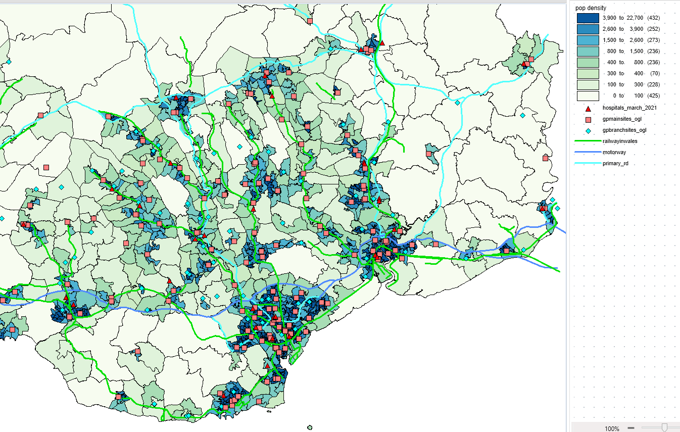
Compared to rural areas where the population density is lower there are fewer hospitals and GPs.
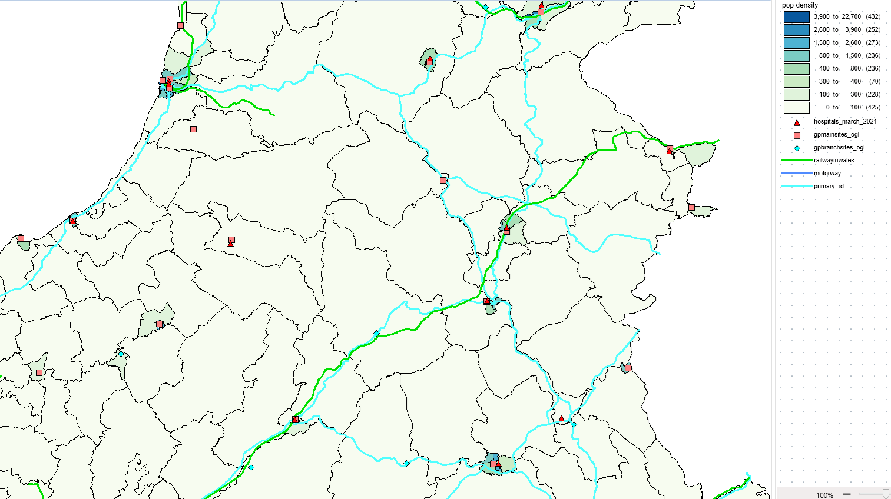

Findings and Analysis

Results from thematic mapping and spatial queries

Example 2 health deprivation:
The maps below show health, education, and income deprivation in the area around Cardiff. The areas in red highlight the area with a high rank, indicating areas that are most deprived.
The maps typically show that where there is poor health, there is also poor education and low income, and where there is good health there is good education and high income. More analysis would be needed to understand these areas better. Age, religion, or environmental factors could sway the data. Of the seven hospitals, five of these are in areas with good health implying that these hospitals are serving the local community well.
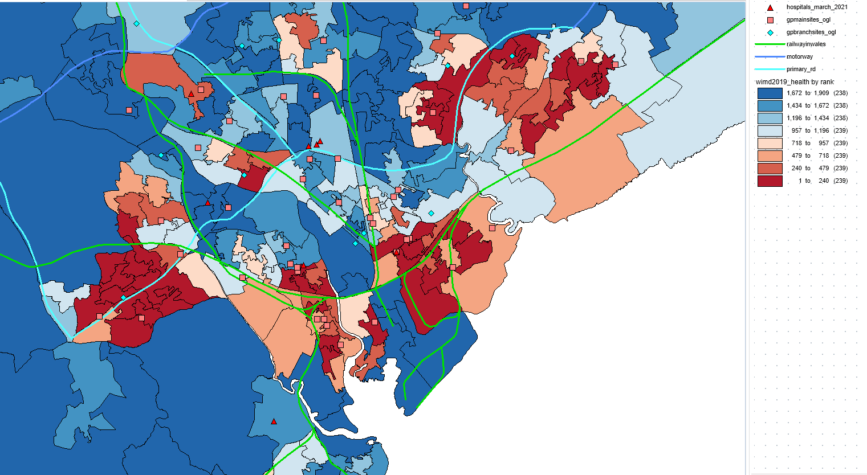
Figure 1 - health, Cardiff
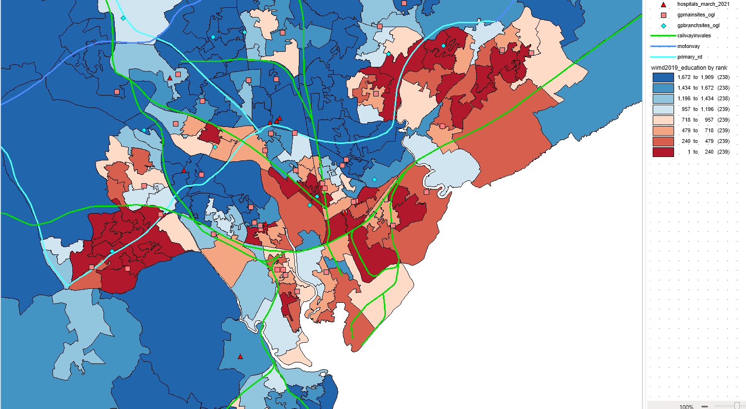
Figure 2 - education, Cardiff
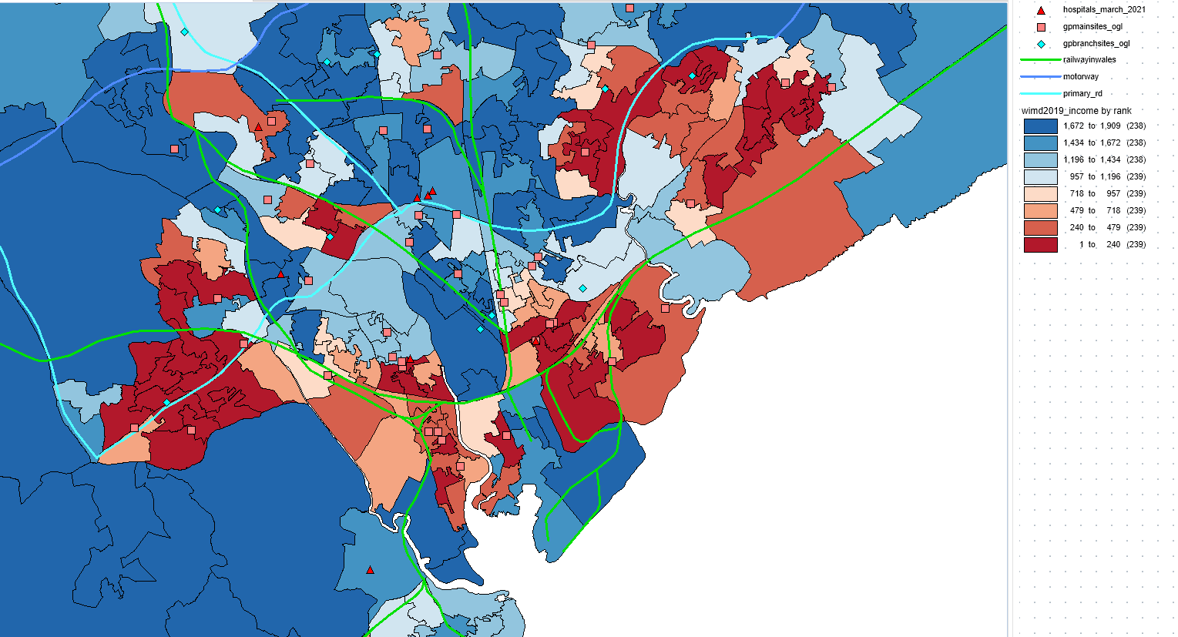
Figure 3 - income, Cardiff
The map below is a more rural area and shows mostly blue indicating areas of low ranks which indicates areas of low deprivation.
Rural Wales shows the same trends as urban Wales, i.e. in areas showing good health there is good education and high income and in areas showing poor health there is poor education and low-income.
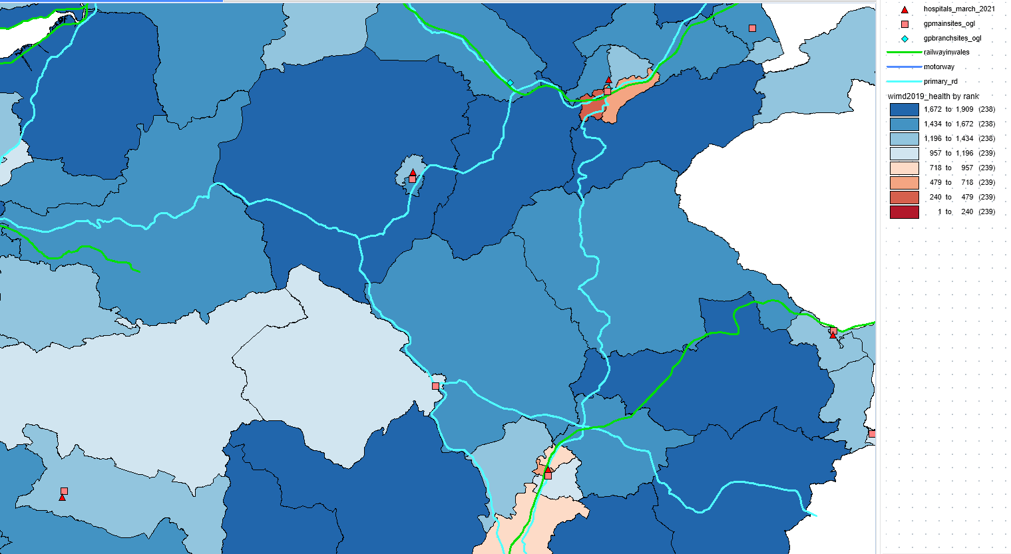
Figure 4 - health, rural
7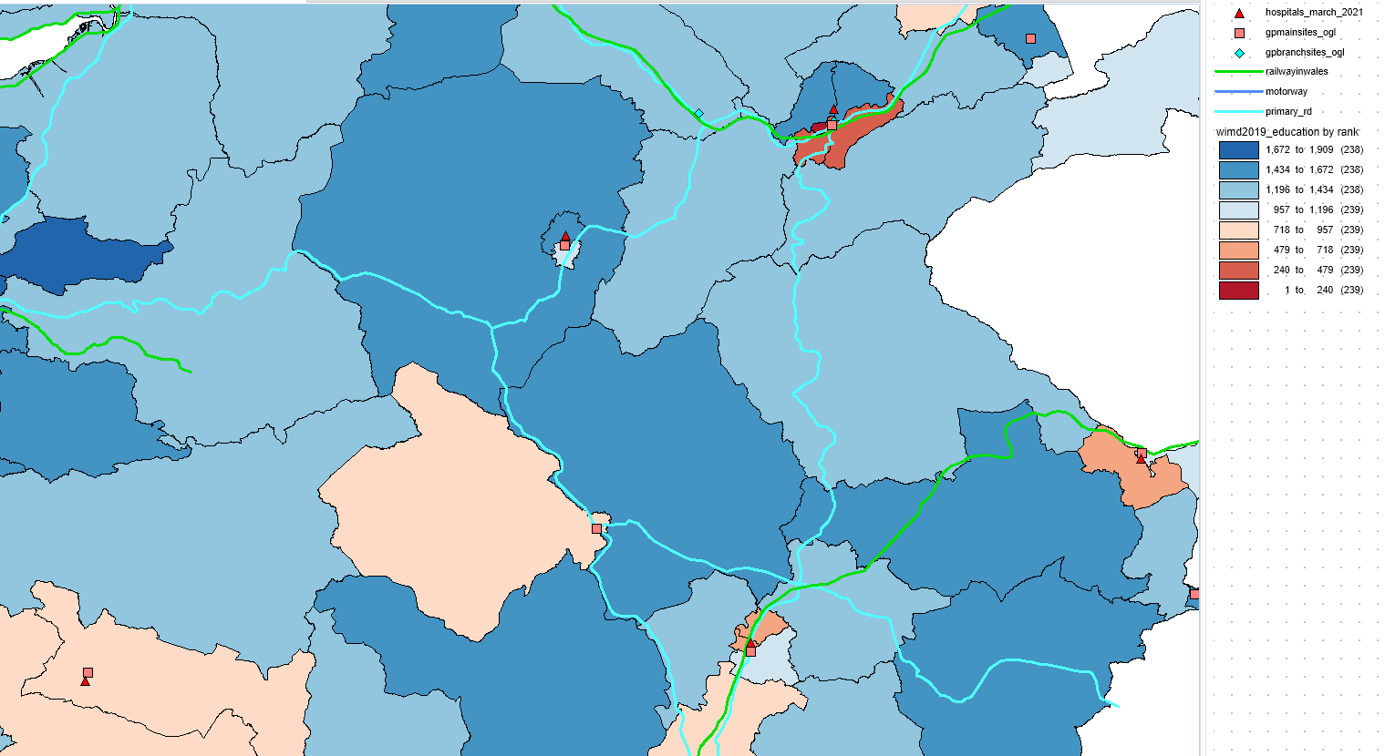
Figure 5 - education, rural
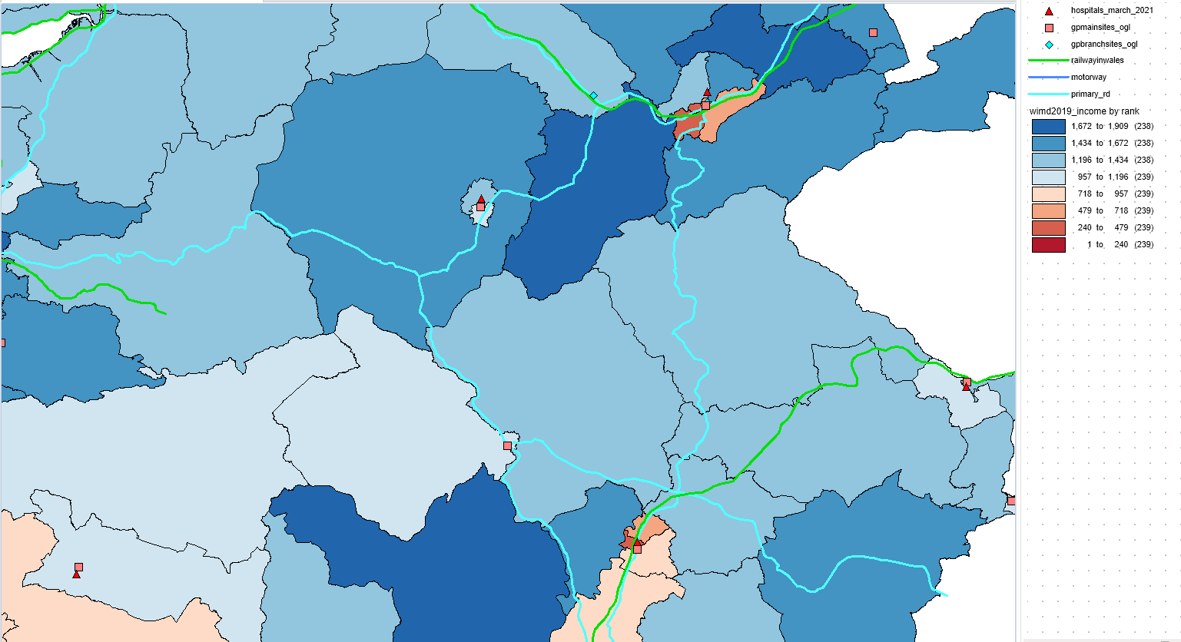
Figure 6 - income, rural

Discussion on the implications of the findings

Health planning considerations
Local Health authorities should look to improve areas where there are high levels of health deprivation. The data suggests that this could be achieved by improving education and creating better paid jobs in these areas.
Over the years there has been much research on the correlation between income and health, and education and health. One example of this is the “Relationship between income and health” from The Health Foundation.
The key findings were “31% of people on the lowest incomes report ‘less than good’ health. In the middle (the fifth income decile) this figure is 22% and for people on the highest incomes the figure is 12%. Across the income spectrum, improving your income is associated with improvements in health.” [3]
Another example is from the “How do our education and skills influence our health?” also from The Health Foundation.
Its key findings were “by the age of 30 those with the highest levels of education are expected to live four years longer than those with the lowest levels of education.” [4]
Both findings are evident on the thematic maps above.

Challenges and Limitations

Identification of challenges encountered during the GIS build
There are many datasets available online to use, but it was challenging having to look through so many before selecting one which I thought would be useful, and then realising it didn’t provide the outcome I was looking for and therefore had to search again. Ideally I wanted to understand why there is a correlation between health, education, and income but the datasets available wasn’t able to do this. In an idealistic world I wanted to understand if health deprivation was linked to age, school attainment and Ofsted ratings, ethnicity and family attributes as this was be more meaningful.

Discussion on limitations of the data and software used
Outcomes
The biggest issue I found was the way that the software handled the datasets. Different datasets gave different outcomes.
Outdated data
Outdated data is the greatest limitation. It compromises the accuracy and relevance of the point that is trying to be made, leading to potentially misleading results and decisions. From the experiences in creating the maps above I was restricted to the datasets available to me. I could not overlay two datasets due to their time spans being different. In industry datasets can created but this is timely and expensive. Alternatively existing datasets can be used but these may not provide sufficient or relevant information.
Quality and quantity
One significant limitation faced when using this data and software lies in data quality and quantity. Some datasets are much larger, i.e. they have a greater number of data points. For example, one dataset for population may have a single density population data point for one area compared to another dataset which may show the same area broken down into many sub-areas each having their own population density data points. This provides better accuracy.
Data Compatibility
This is where there are differences in formats, scales, or coordinate systems across datasets which hold back seamless incorporation. Data comes from difference sources with data file formats e.g. CSV and GPKG. They also have different scales within them, e.g. for age it could be 0-25, 25-50, 50-75, 75-100 or it could be 0-10, 10-20, 20-30 etc. These datasets are both acceptable and realistic. The software handles these differently resulting in different outcomes.
These inconsistencies can impede the ability to conduct comprehensive analyses, requiring additional efforts for adjusting or reformatting the data.
Access to data
Llimited data access poses a barrier. This restricts the availability of critical information for GIS applications. This may be due to the sensitivity of the data to prevent cases being identified at a personal level. Examples of this could be the bullying at school or arsenic attacks due to racism in a small area. The numbers of these may be very small, making personal identification higher. In these cases, access to the data would be restricted to professionals only and a report would be written for the public.
Temporal data
Furthermore, a noteworthy constraint is the inability of the software to effectively handle temporal data. Datasets are only a snapshot in time.
Managing and analysing time-series data is crucial for looking at dynamic changes over time, however it may lack features to perform such analyses seamlessly. This limitation restricts the capacity to uncover temporal trends and patterns, hindering the ability to find comprehensive insights from datasets that change over time. One example of this is population density as people move and cities grow, such is the case for our shorelines due to immigration. Addressing these limitations requires a determined effort in updating data, improving accessibility, and enhancing the temporal analysis capabilities.

Suggestions for improvement and future developments
Out of Date Data
The ability to use out of date data compared to current data would be useful if the software was smart enough to show changes and hence trends. This means old data could be used time and time again and it increased use reduces the cost of initially collecting it. There is currently no functionality to improve out of date data from current data. Out of data may lack details which are only currently available in current data. To backwardly update out of old data could be useful.
Data quality
To enhance future developments in GIS, prioritizing improvements in data quality is vital. This means having to put more effort into ensuring data is not only up to date but also reliable. Improving techniques for collecting and validating data will resolve in more accurate data and analysis.
Use higher spatial resolution
Another crucial area for improvement is the utilization of higher spatial resolution in data acquisition. By focusing on obtaining finer details in geographic data, GIS applications can delve into areas with greater precision, enabling a more in depth understanding of spatial relationships. This improvement is particularly essential for sectors such as urban planning and environmental management where detailed spatial information is vital for informed decision-making. Embracing these suggested enhancements will contribute to more robust, reliable, and detailed GIS capabilities in the future.
Data Forecasting
Currently GIS uses existing data but with some development it could be used for predicting data and looking at trends. This can already be seen in the weather forecasting, which now provide weather maps in your area on an hourly basis.
Better intractability
Improving interactivity stands as a pivotal area for enhancing future developments in GIS. Incorporating features like dynamic querying, responsive real-time collaboration, and interactive data exploration can significantly enhance the user experience. By prioritizing better interactivity, future GIS development can empower users to interact more fluidly with the data, fostering enhanced exploration, analysis, and decision-making processes within the geospatial domain.

Conclusion

Summary of key findings and insights
There were several issues using the software which gave different outcomes, which meant that analysis was lengthy and not always as expected. The details of the analysis were completely reliable on the quality and quantity of the data. Some datasets were not available which impacted my analysis.
For the area around Cardiff, I was able to find some correlation between health, income, and education. Areas with poor education and low income have poor health whereas areas with good education and high income have good health. Outside of Cardiff this was true for the rural areas aswell but looking across all of Wales this was not always the case.
However, the broader picture across all of Wales revealed nuances and deviations, underscoring the need for ongoing improvements in GIS technology to ensure more accurate, comprehensive, and regionally relevant insights. This conclusion reinforces the importance of continual refinement in GIS methodologies for robust spatial analyses with broader applications and implications.

Summary of the importance of thematic mapping and spatial queries in GIS analysis
This analysis was done for small areas around Cardiff, but looking at larger areas within Wales the picture is not so clear. This may be due to too much data as the specifics of these findings get diffused.

References

[1] | Maptive, “What is a Thematic Map? 6 Types of Thematic Maps,” 19 October 2020. [Online]. Available: https://www.maptive.com/thematic-map-examples/. [Accessed 3 January 2024].
[2] | Cyrus, “Visual Representation of Data: Definition & Best Examples in 2023,” 10 May 2023. [Online]. Available: https://watchthem.live/visual-representation/. [Accessed 3 January 2024].
[3] | the health foundation, “Relationship between income and health,” 21 December 2022. [Online]. Available: https://www.health.org.uk/evidence-hub/money-and-resources/income/relationship-between-income-and-health. [Accessed 6 January 2024].
[4] | J. Bibby, “How do our education and skills influence our health?,” 30 August 2017. [Online]. Available: https://www.health.org.uk/infographics/how-do-our-education-and-skills-influence-our-health. [Accessed 6 January 2024].

