Coursework Title
Module Name: Computer Architecture & OS
Module Code: ACCA4022
Student Name: Marcus Gilkes
Student ID: 2529012
Lecturer Name: Dr MD Shantanu Islam

Submission date:

Contents
Introduction 4
Key functions of general Operating Systems 4
Task management: 4
Application/Program Management: 5
File/Directory Management: 5
Device Management: 5
Security Management: 6
Use of Windows OS CLI commands 7
Example 1: dir 7
Example 2: cd 8
Example 3: mkdir 8
Example 4: rmdir 9
Example 5: rename 9
Example 6: ipconfig 10
Example 7: netstat 10
Example 8: systeminfo 11
Example 9: tasklist 11
Example 10: ping 12
Use of Linux OS CLI commands 12
Example 1: pwd 13
Example 2: su 13
Example 3: ls 14
Example 4: cd 14
Example 5: mkdir 15
Example 6: rmdir 15
Example 7: touch 16
Example 8: echo and cat 16
Example 9: ifconfig 17
Example 10: who am I and date 17
Use of Windows OS scripts 18
Example 1: 18
Example 2: 19
Use of Linux OS scripts 20
Example 1: 20
Example 2: 21
Conclusion 22
References 23
Appendices 24

Introduction
Operating systems are essential software components that manage computer hardware, software resources, and user interaction. They provide the foundation for running applications, managing files, allocating memory, controlling devices, and maintaining system security [1]. Modern operating systems such as Microsoft Windows and Linux support multitasking, resource management, graphical and command-line interfaces, and automation through scripting.
This report explores the key functions of general operating systems, including task management, application management, file and directory management, device management, and security management. It then examines the use of command-line interface commands in both Windows and Linux, demonstrating how these tools support system navigation, file handling, network configuration, and process monitoring [2]. Finally, the report discusses Windows Batch scripting and Linux Bash scripting, showing how scripts can automate repetitive tasks and improve efficiency in system administration [3].

Key functions of general Operating Systems
General operating systems perform a range of essential functions that allow computer systems to operate efficiently, securely, and reliably. These functions include task management, application management, file and directory management, device management, and security management. By coordinating hardware, software, and user activity, the operating system acts as an interface between the user and the computer system [5].
Microsoft Windows is a widely used example of a general-purpose operating system. It provides graphical tools, system utilities, networking features, and security controls that allow users to manage everyday computing tasks. In this section, Windows is used to demonstrate how the main operating system functions support system performance, user productivity, and secure computing environments [6].
Essentially, these functions are important because they allow the operating system to act as a link between the user, application software, and computer hardware. Without effective operating system management, users would need to control hardware resources manually, which would be inefficient and difficult. By managing processes, memory, files, devices, and security automatically, the operating system helps maintain performance, usability, and in particular the reliability and consistency across the computer system.

Task management:
Task management is responsible for controlling the execution of processes and applications running on a computer. The operating system allocates processor time to active processes, manages multitasking, and ensures that system resources are distributed efficiently among running applications. It does this by scheduling processes, deciding which tasks receive CPU attention, and switching between tasks so that multiple programs appear to run at the same time [7].
Windows provides the Task Manager utility, which allows users to monitor running applications, background processes, CPU usage, memory consumption, disk activity, and network performance. Users can also terminate unresponsive applications and identify processes that consume excessive system resources. This makes Task Manager useful for troubleshooting slow performance and checking which applications are affecting the system [8].
Effective task management improves system responsiveness, enhances performance, and ensures that multiple applications can operate simultaneously without causing system instability. It also helps prevent individual programs from using too many system resources, which supports reliability when several tasks are running at once [7].

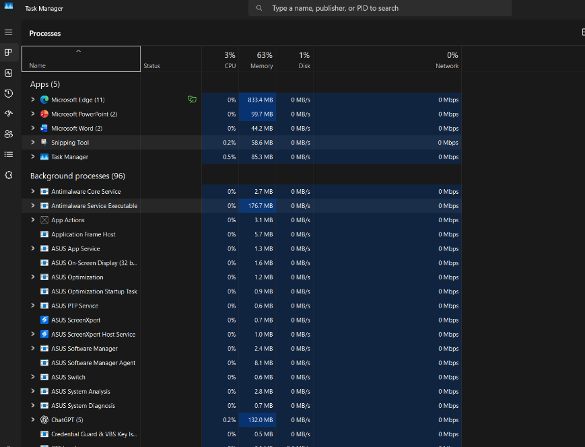
Figure 1: screenshot of task management

Application/Program Management:
Application management enables users to install, execute, update, monitor, and remove software applications within the Windows environment. The operating system provides the memory, processor time, storage access, and permissions required for applications to function correctly. It also helps prevent conflicts between programs, manages background services, and supports overall system stability [6].
Windows includes management tools such as Settings, Control Panel, Task Manager, and Apps & Features that allow users to manage installed applications, configure default programs, control startup applications, and monitor software performance. These tools help users remove unnecessary software, identify applications that slow down the system, and maintain an efficient computing environment [5].
Effective application management improves productivity, supports software compatibility, and ensures that applications operate securely within the operating system. It also helps reduce performance issues by controlling unnecessary background applications and ensuring that software is updated, configured, and managed appropriately [6].

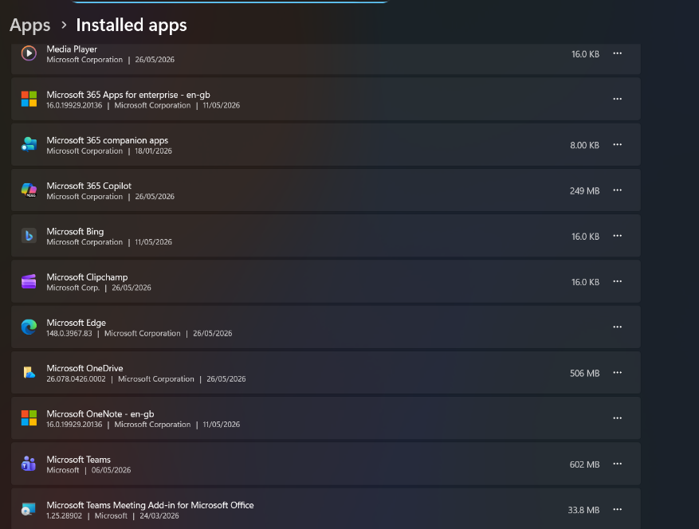
Figure 2: Screenshot of application management

File/Directory Management:
File and directory management enables users to organise, store, retrieve, and manage information stored on computer systems. Operating systems provide structured file systems that allow data to be stored efficiently and accessed when required. This includes creating folders, naming files clearly, arranging data into directories, and controlling how information is saved and retrieved. Effective file and directory management improves organisation, enhances security, and enables users to locate information quickly and efficiently [2].
Windows uses the NTFS file system, which provides advanced features such as file permissions, encryption, compression, and disk quotas. Users can create, copy, move, rename, and delete files and folders through File Explorer or command-line tools such as dir, copy, move, and del [9]. These tools allow both graphical and command-line methods of managing stored data, which is useful for everyday users as well as system administrators.
Effective file and directory management supports data protection, system organisation, and efficient storage use. It helps prevent files from becoming misplaced, reduces duplication, and allows access permissions to be applied so that sensitive data is protected from unauthorised users. This function is particularly important in multi-user systems where different users may require different levels of access to files and folders.

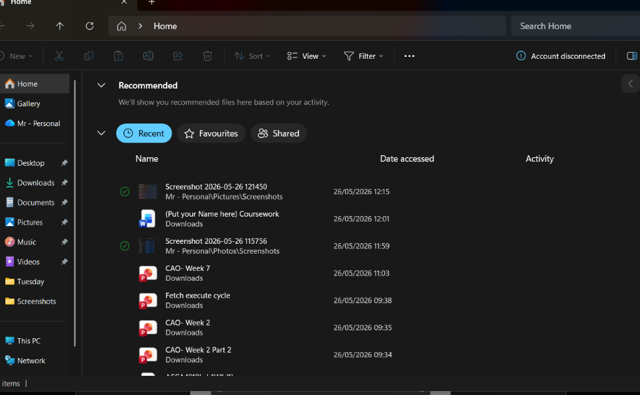
Figure 3: Screenshot of file management

Device Management:
Device management enables Windows to communicate with hardware such as printers, keyboards, storage devices, network adapters, and monitors through device drivers [3]. Device Manager allows users to view hardware, update drivers, troubleshoot problems, and disable malfunctioning devices, while Plug and Play automatically detects and configures compatible hardware. Effective device management supports hardware compatibility, system stability, and reliable performance [3].
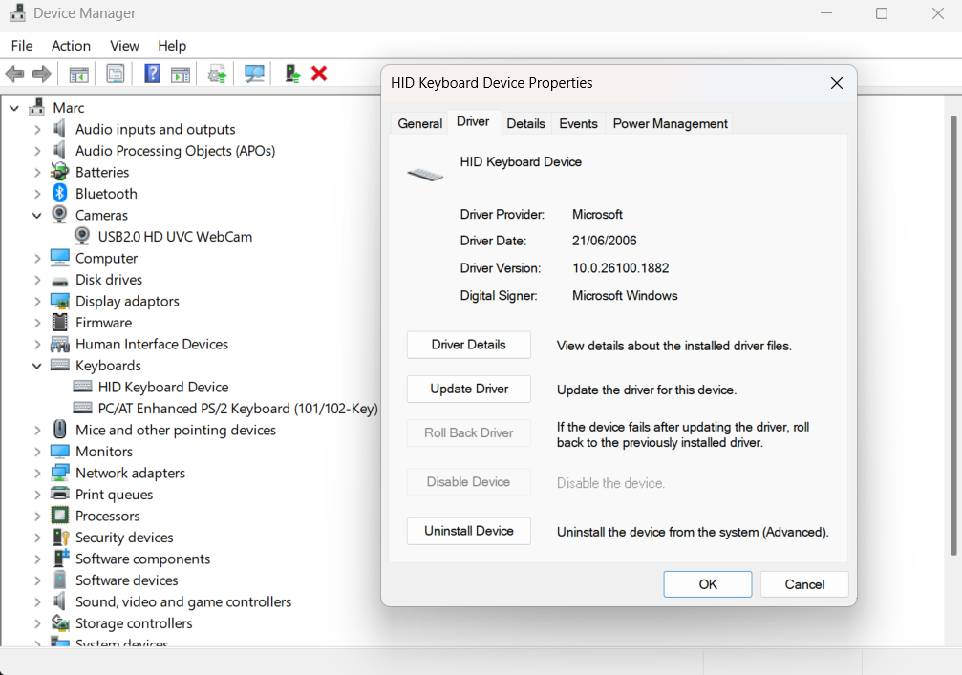
Figure 4: screenshot of device management

Security Management:
Security management protects computer systems, user accounts, applications, and data from unauthorised access and cyber threats. Windows provides features such as Microsoft Defender Antivirus, Windows Firewall, BitLocker encryption, and User Account Control (UAC) to reduce malware, unauthorised access, and other security risks [9]. These features can be monitored and configured through the Windows Security application.
Effective security management helps maintain the confidentiality, integrity, and availability of information. It reduces exposure to cyberattacks and provides a safer environment for users, applications, and stored data [9].

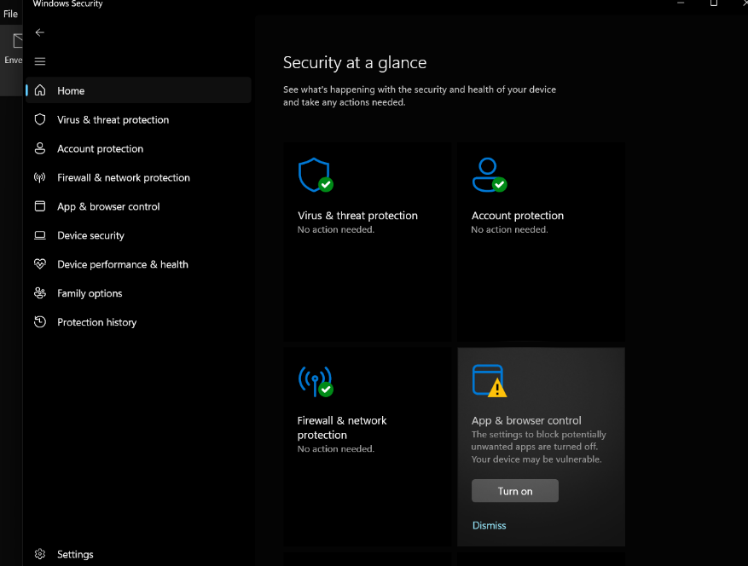
Figure 5: Screenshot of security management

Use of Windows OS CLI commands
The Windows Command Line Interface (CLI) provides a text-based environment for managing operating system functions. Commands can be used for file management, network troubleshooting, process monitoring, and system administration tasks. Command Prompt and PowerShell improve efficiency by enabling users to perform tasks quickly through command execution [4].

Example 1: dir
The dir command displays the contents of the current directory. The output shows files and folders, their sizes, and modification dates, allowing users to view and manage stored information efficiently within the Windows file system.
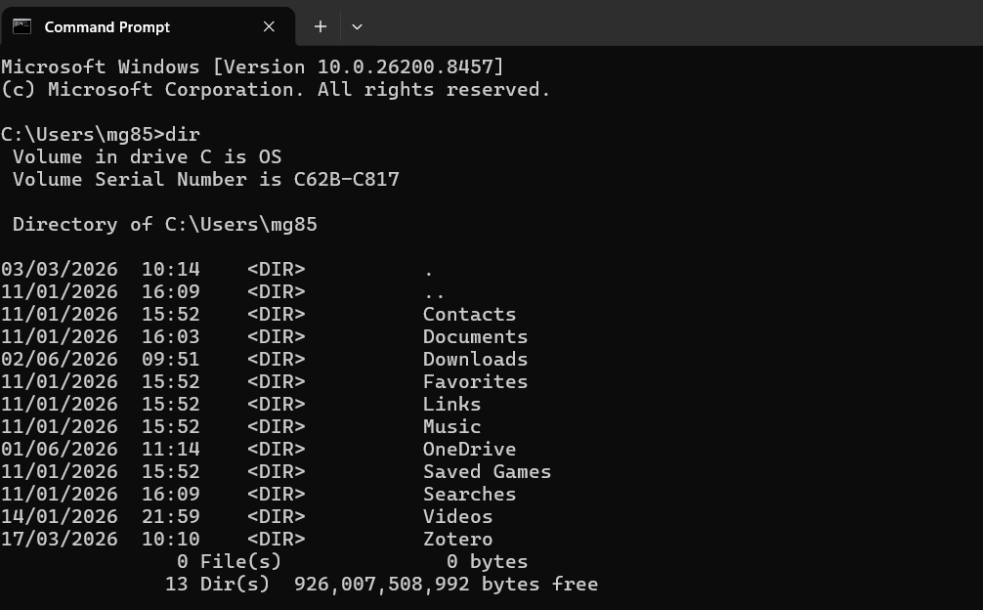
Figure 6: Dir

Example 2: cd
The cd command changes the current working directory. The output shows navigation between folders and demonstrates how users can move through the file system structure from the command line.
The cd command changes the current working directory. The output shows navigation between folders and demonstrates how users can move through the file system structure from the command
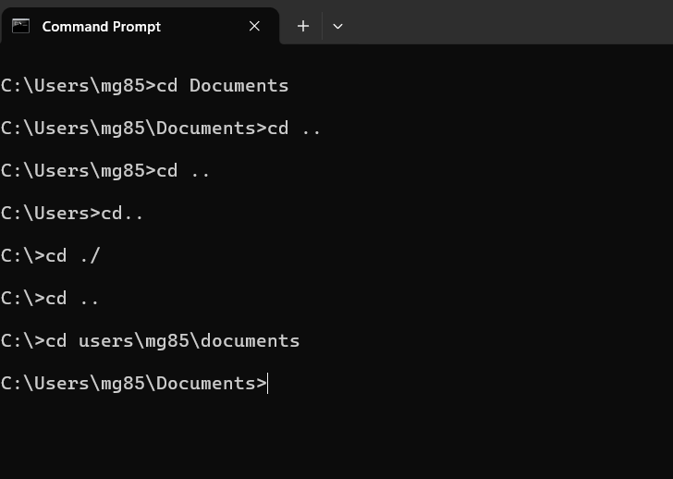
Figure 7: cd

Example 3: mkdir
The mkdir command creates a new directory or folder. The output confirms that new folders have been created successfully and are displayed when the directory contents are listed.
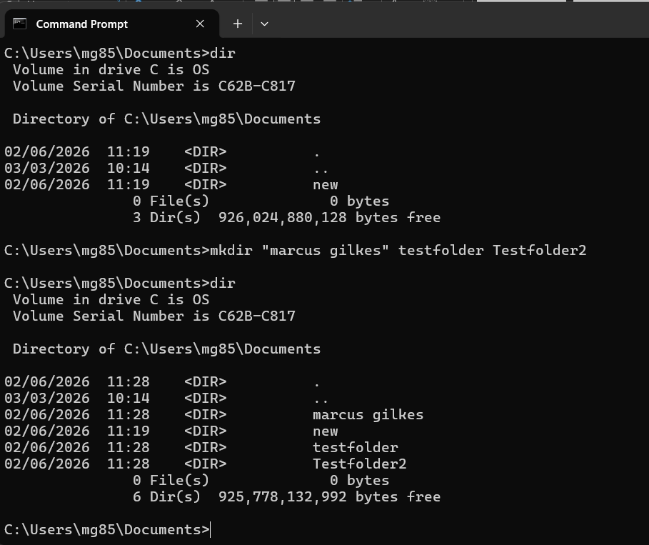
Figure 8: mkdir

Example 4: rmdir
The rmdir command removes an existing empty directory. The output shows that the selected folders have been deleted successfully from the current working directory.
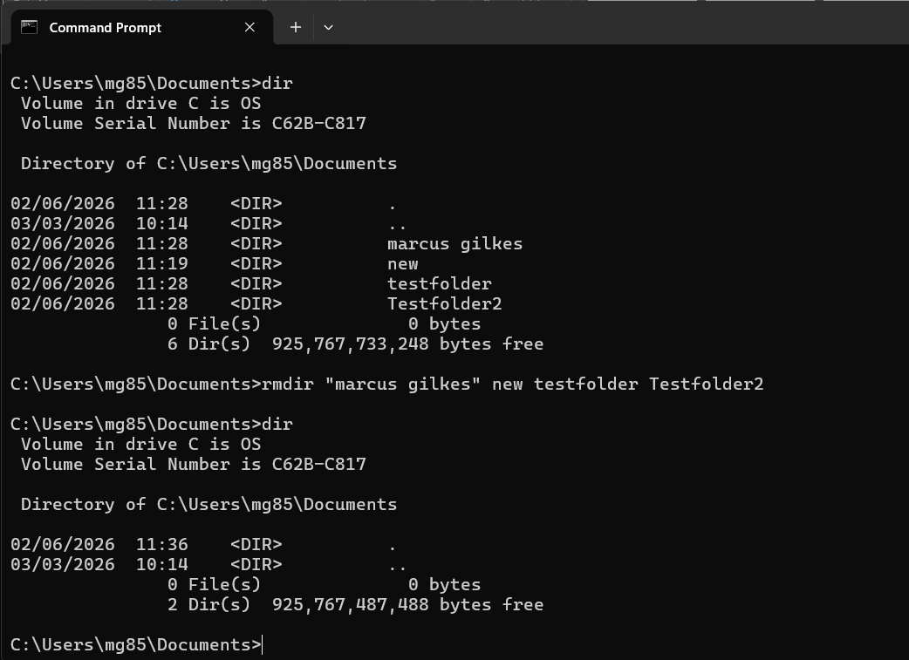
Figure 9: Rmdir

Example 5: rename
The rename command changes the name of a file or folder. The output demonstrates that the folder name has been updated while the contents remain unchanged.
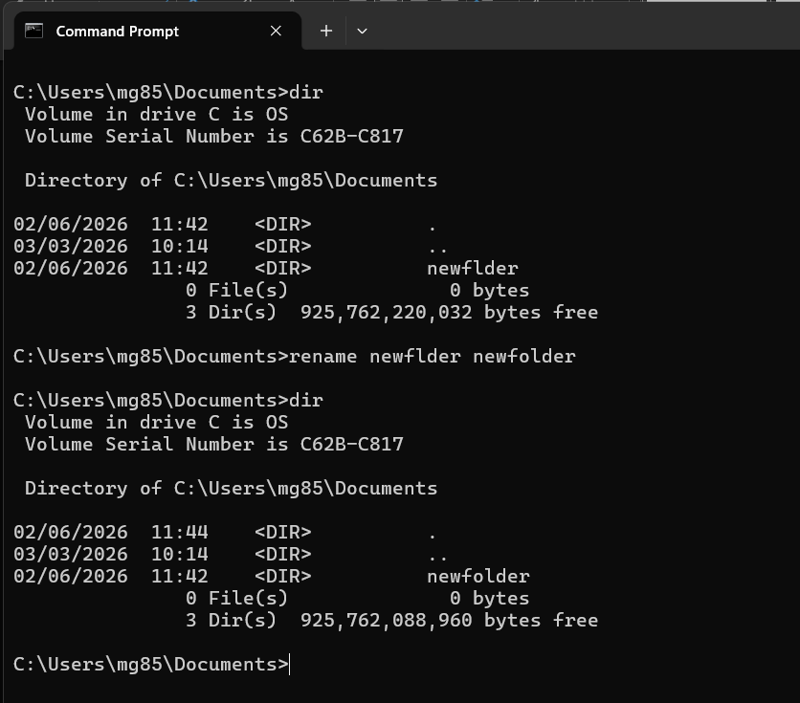
Figure 10: rename folder

Example 6: ipconfig
The ipconfig command displays network configuration information, including IP address, subnet mask, and default gateway. This information is useful when troubleshooting network connectivity problems.
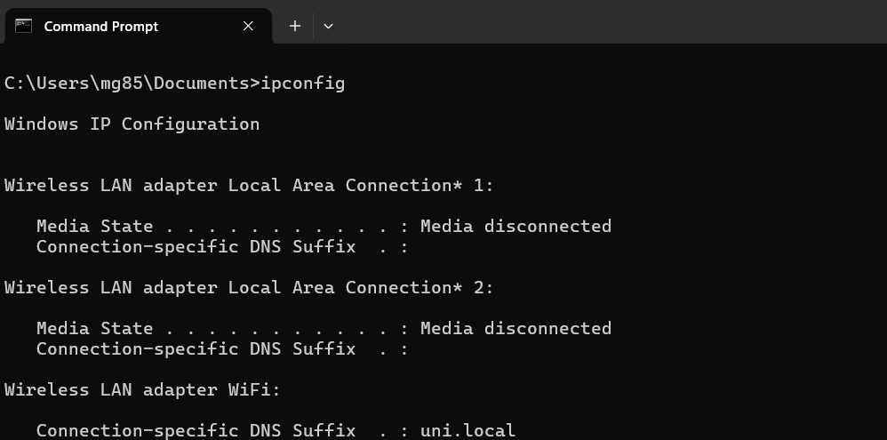
Figure 11: Ipconfig

Example 7: netstat
The netstat command displays active network connections and listening ports. The output helps administrators monitor network activity and identify communication between the computer and remote systems.
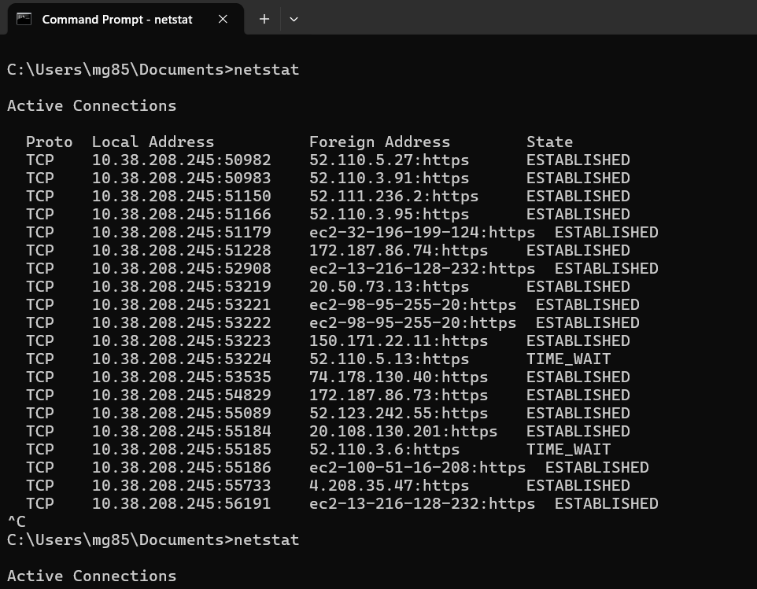
Figure 12: Netstat

Example 8: systeminfo
The systeminfo command displays detailed information about the computer, including operating system version, processor details, memory capacity, and system configuration settings.
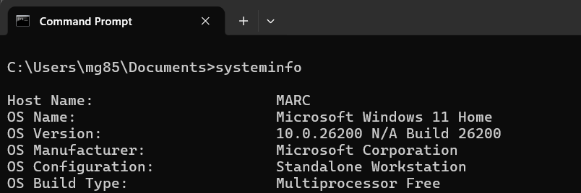
Figure 13: Systeminfo

Example 9: tasklist
The tasklist command displays all running processes on the system. The output includes process names, process identifiers (PIDs), and memory usage information for each running task.

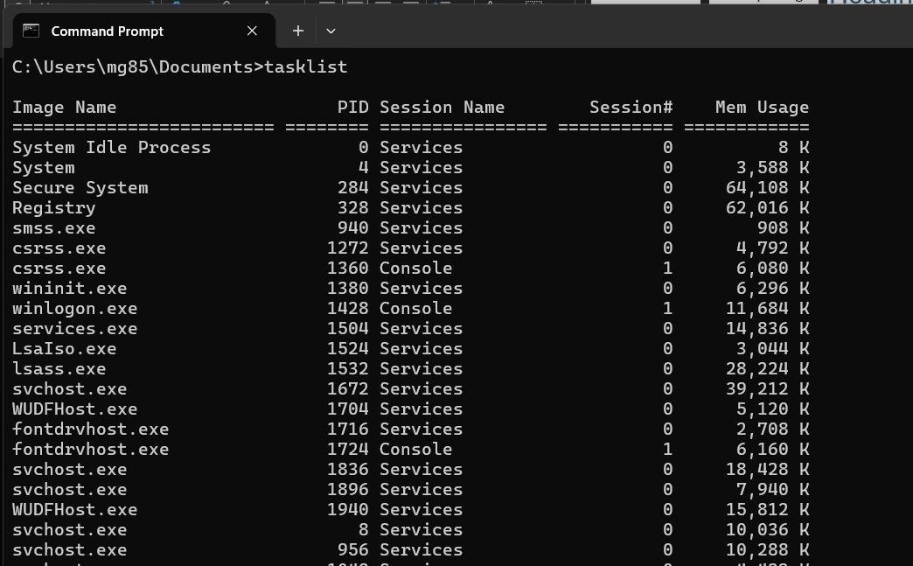
Figure 14: Tasklist

Example 10: ping
The ping command tests communication between network devices. The output displays response times and packet statistics, helping users verify network connectivity and diagnose communication issues.

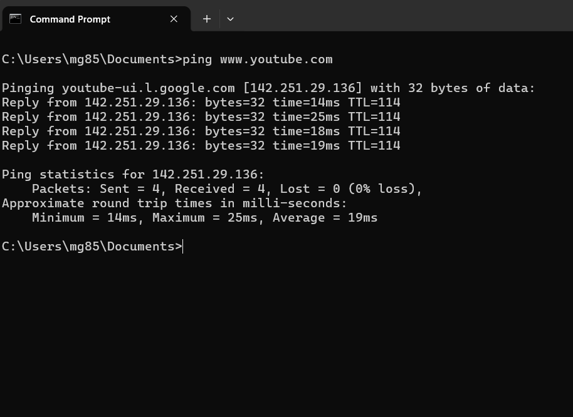
Figure 15: Ping

Use of Linux OS CLI commands
The Linux Command Line Interface provides direct access to operating system functions and administrative tools. Linux commands enable users to manage files, processes, users, and network settings efficiently. The command-line environment is widely used by system administrators for troubleshooting and automation tasks [6].

Example 1: pwd
The pwd command displays the current working directory. The output shows the complete path of the directory where the user is currently operating.
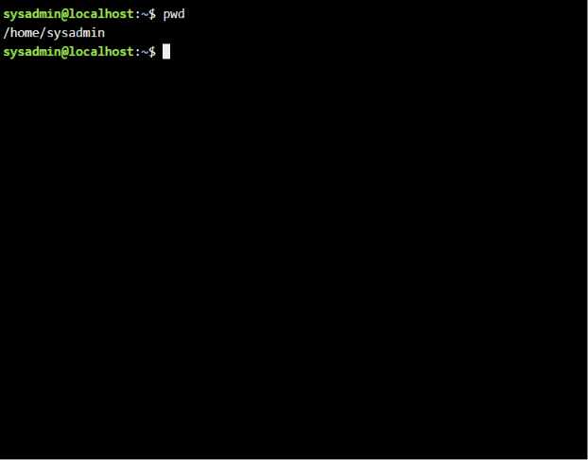
Figure 16: Pwd (present working directroy)

Example 2: su
The su command allows a user to switch to another user account. The output shows successful authentication and access to the specified account.

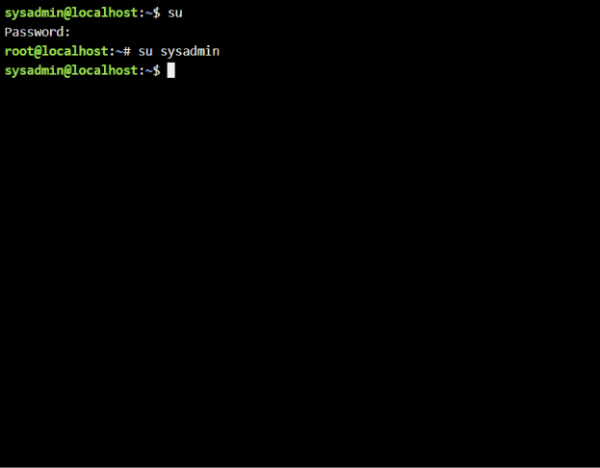
Figure 17: SU switch user

Example 3: ls
The ls command lists files and directories stored within the current location. The output displays file names, folders, and additional information when options are used.

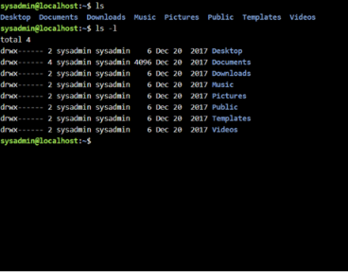
Figure 18: ls

Example 4: cd
The cd command changes the current directory location. The output confirms navigation to the Desktop folder and demonstrates movement through the Linux file system.

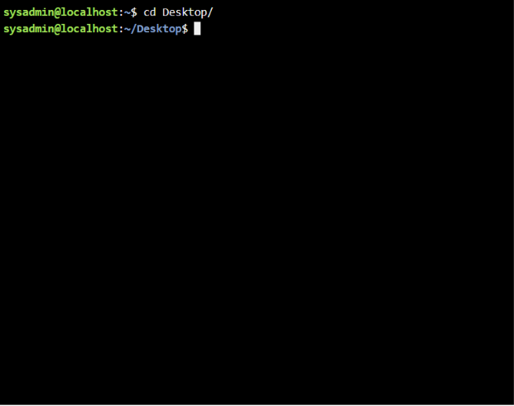
Figure 19: Description

Example 5: mkdir
The mkdir command creates a new directory. The output confirms that the folder named "new" has been created successfully within the current location.
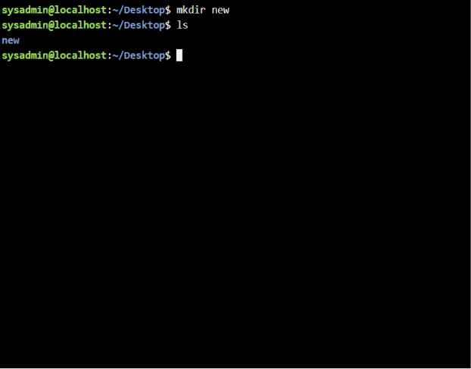
Figure 20: mkdir

Example 6: rmdir
The rmdir command removes an empty directory. The output demonstrates that the folder has been deleted successfully from the file system.
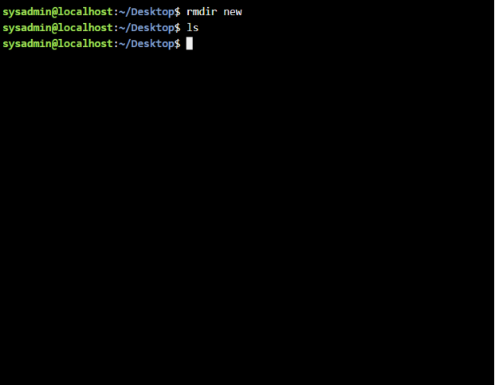
Figure 21: rmdir

Example 7: touch
The touch command creates a new empty file. The output confirms the creation of the file and displays it when the directory contents are listed.
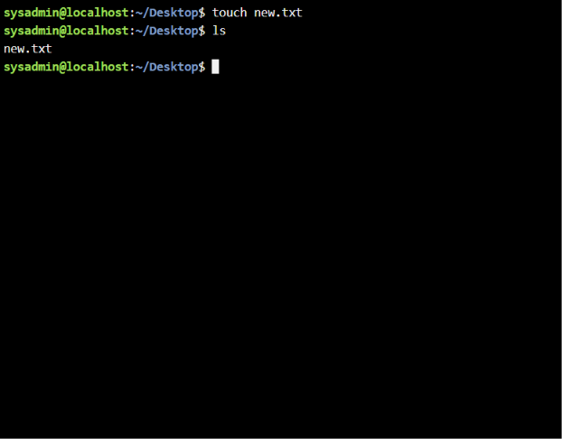
Figure 22: Touch

Example 8: echo and cat
The echo command writes text to a file, while cat displays the file contents. The output demonstrates basic file creation and content viewing operations.
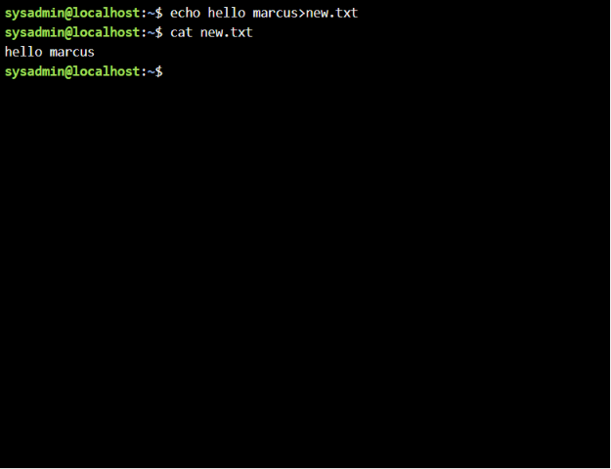
Figure 23: echo and cat.

Example 9: ifconfig
The ifconfig command displays network interface configuration details. The output shows IP addresses, network masks, and interface status information.
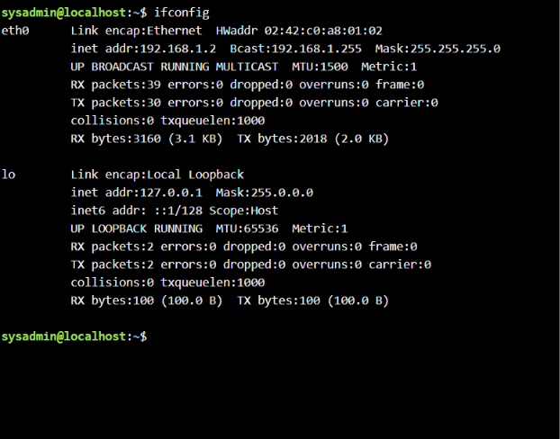
Figure 24: ifconfig

Example 10: who am I and date
The whoami command displays the currently logged-in user, while date displays the current system date and time. These commands provide useful system information.

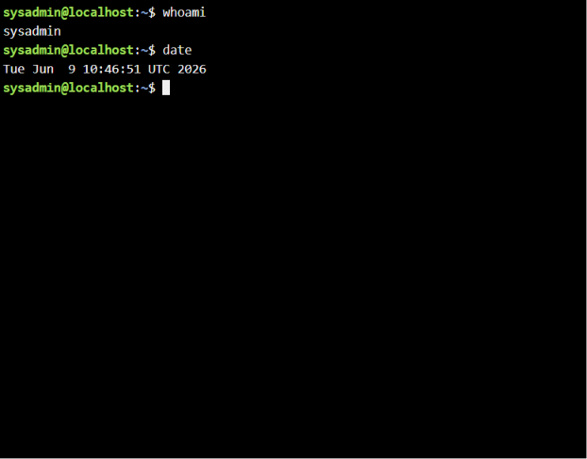
Figure 25: Who am I and date.

Use of Windows OS scripts
Batch scripting enables users to automate repetitive tasks within Windows environments. Batch files contain a sequence of commands that execute automatically when run. They can be used for calculations, file management, user interaction, and administrative tasks, helping improve efficiency and reduce manual effort [5].

Example 1:
This Batch script demonstrates the use of variables, user input, conditional statements, and basic decision-making. The script requests the user's age and stores the value in a variable using the set /p command. An IF statement then evaluates the age entered by the user. If the age is 18 or above, the script displays a message indicating that the user is eligible to drink alcohol. If the age is below 18, an alternative message is displayed. The output demonstrates how the script processes user input and makes decisions based on predefined conditions. This type of script can be adapted for many administrative tasks where user input needs to be validated before actions are performed. The example highlights how Batch scripting can automate routine tasks while reducing the need for manual decision-making.

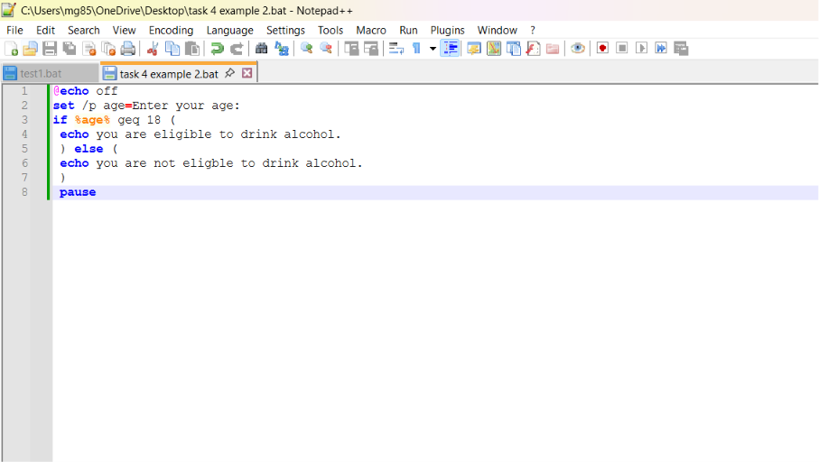
Figure 26: Script of adding
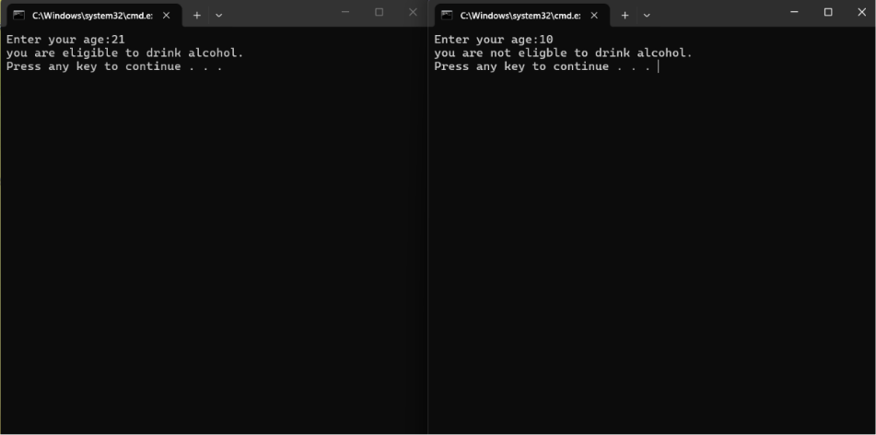
Figure 27: Output of script

Example 2:
The Student Grade Calculator is a Windows Batch script that determines whether a student has passed or failed. It uses variables to store the student's name and mark, while set /p collects user input. The set /a command performs arithmetic, and an IF...ELSE statement checks whether the mark is 40 or above. The choice command and goto START create a loop, allowing multiple students' grades to be calculated without restarting the program.

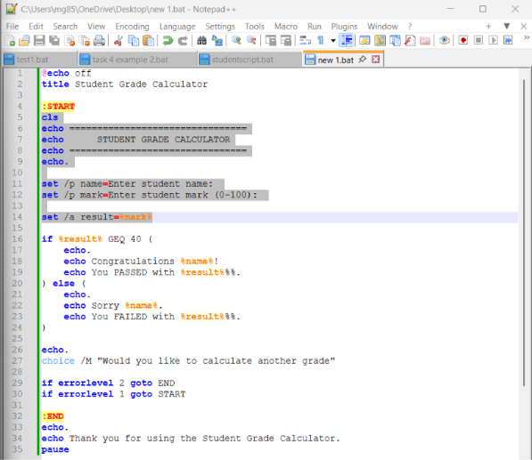
Figure 28: script input
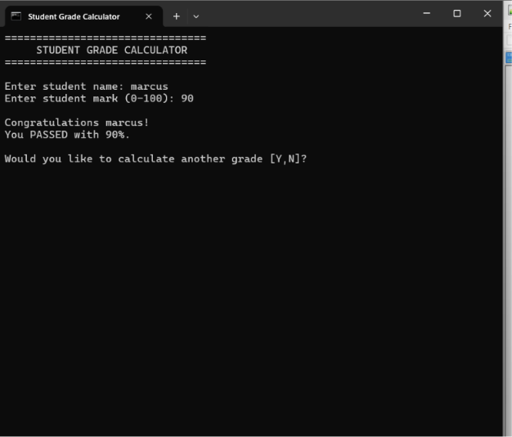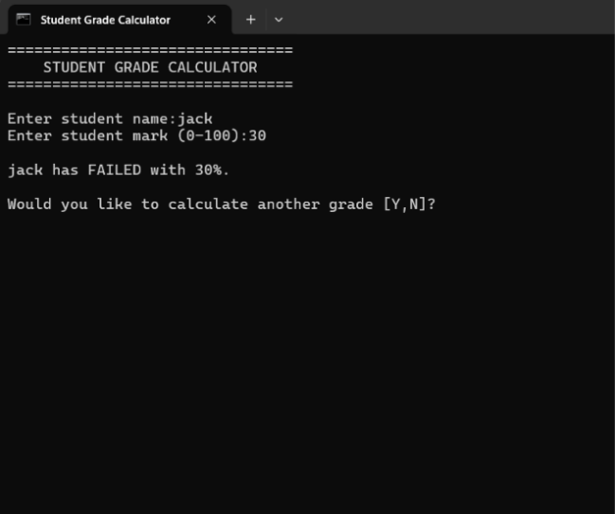
Figure 29: script output

Use of Linux OS scripts
Bash scripting is a powerful automation tool used in Linux operating systems. Bash scripts allow administrators to automate repetitive tasks, process user input, perform calculations, and manage files efficiently. Bash scripting improves productivity and is widely used for system administration, monitoring, and automation tasks [6].

Example 1:
This Bash script demonstrates the use of variables, user input, and arithmetic operations. The script requests two numerical values from the user and stores them in variables using the read command. The values are then added together using Bash arithmetic syntax and stored in a third variable. Finally, the script displays the result using the echo command. The output confirms that the user input has been processed correctly and that the calculation has been completed successfully. This example demonstrates how Bash scripts can automate mathematical operations and reduce the need for manual calculations. The use of variables allows the script to be reused with different values each time it is executed. Such scripts are commonly used in administration and data-processing tasks.
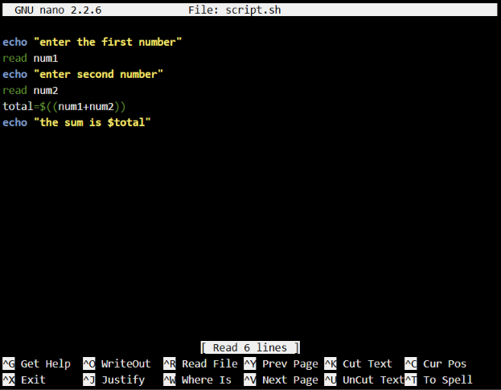
Figure 30: script
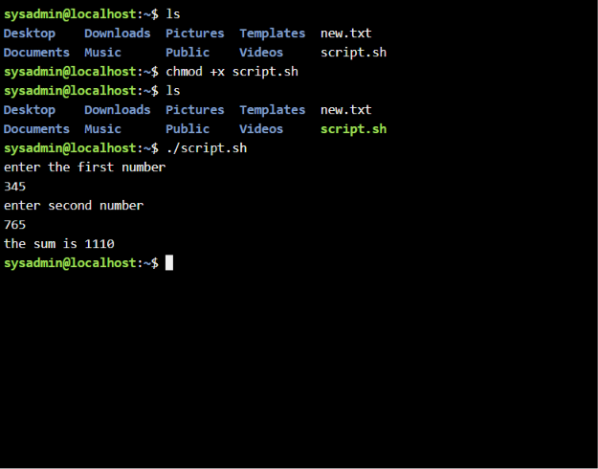
Figure 31:

Example 2:
This Bash script demonstrates the use of loops within Linux scripting. The script requests a numerical value from the user and stores it in a variable. A for loop then executes repeatedly according to the number entered by the user. During each iteration, the script displays a value on the screen. The output shows the loop counting through the specified range and confirms that the script executed successfully. Loops are important because they allow repetitive tasks to be automated without requiring the user to enter the same command multiple times. This functionality is commonly used for file processing, system monitoring, and administrative automation. The example demonstrates how Bash scripting can improve efficiency and reduce manual effort.
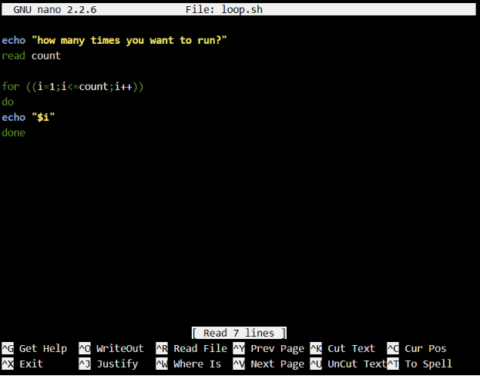
Figure 32: script loop input
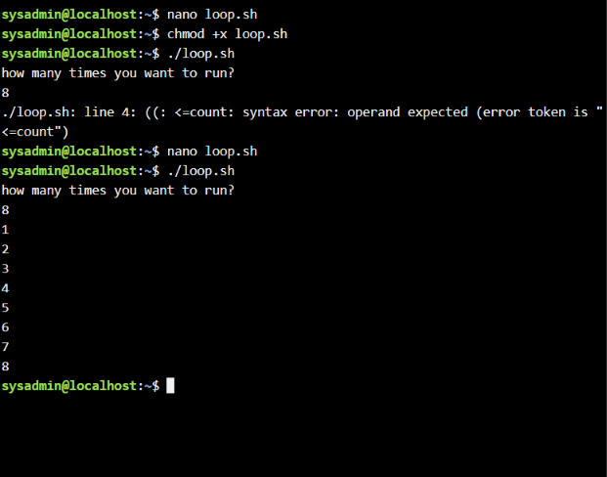
Figure 33: loop output

Conclusion
This report examined the key functions of operating systems and demonstrated how Windows and Linux provide tools for managing processes, applications, files, devices, security, users, and network resources. It showed that operating systems play an essential role in coordinating hardware and software while providing users with practical tools for system management. The command-line examples demonstrated how both Windows and Linux can be used to complete file management, navigation, networking, and system information tasks efficiently. The scripting examples also showed how Batch and Bash scripts can automate repetitive activities, process user input, and reduce manual effort.
Overall, the practical use of commands and scripts helped develop a greater understanding of operating system management, troubleshooting, and automation techniques. These skills are valuable for system administration because they support efficient problem-solving, improve productivity, and provide a foundation for future careers within the computing industry.

References
[1] A. Silberschatz, P. B. Galvin and G. Gagne, Operating System Concepts, 10th ed. Hoboken, NJ, USA: John Wiley & Sons, 2018.
[2] W. Stallings, Operating Systems: Internals and Design Principles, 9th ed. Harlow, England: Pearson Education Ltd., 2018.
[3] Microsoft Corporation, “Windows Documentation,” Microsoft Learn. [Online]. Available: https://learn.microsoft.com/en-us/windows/. [Accessed: 14-Jul-2026].
[4] Microsoft Corporation, “Windows Commands,” Microsoft Learn. [Online]. Available: https://learn.microsoft.com/en-us/windows-server/administration/windows-commands/. [Accessed: 14-Jul-2026].
[5] Microsoft Corporation, “PowerShell Documentation,” Microsoft Learn. [Online]. Available: https://learn.microsoft.com/en-us/powershell/. [Accessed: 14-Jul-2026].
[6] The Linux Foundation, Introduction to Linux, Linux Foundation Training. [Online]. Available: https://training.linuxfoundation.org/. [Accessed: 14-Jul-2026].
[7] Red Hat, “Red Hat Enterprise Linux System Administrator's Guide,” Red Hat Documentation. [Online]. Available: https://access.redhat.com/documentation/. [Accessed: 14-Jul-2026].
[8] Canonical Ltd., “Ubuntu Server Guide,” Ubuntu Documentation. [Online]. Available: https://ubuntu.com/server/docs. [Accessed: 14-Jul-2026].
[9] National Cyber Security Centre, “Cyber Security Principles,” NCSC. [Online]. Available: https://www.ncsc.gov.uk/. [Accessed: 14-Jul-2026].
[10] IBM Corporation, “Linux Commands Reference,” IBM Documentation. [Online]. Available: https://www.ibm.com/docs/. [Accessed: 14-Jul-2026].

Online Course Name: Linux Unhatched (Cisco Networking Academy).

Appendices
Online Course name:

Figure 34: online course Linus Unhatched (Cisco Networking Academy).

