Human resource management

Table of Contents
Introduction 3
Part A 3
The current state of the labor market in the UK 3
Shortage of workers 4
Part B 5
The emerging changes in Human Resourcing Strategies in the post-Covid, post-Brexit 5
External environment. 5
Post-Brexit environment impact on HRM 6
Engagement strategies 7
Conclusion 9
References 10

Introduction
HR management is over an important part of any company. It is one of the strategic approaches for effective and efficient management in an organization and it helps the business to gain a competitive advantage. This management is designed to maximize employee performance in the service of an employer's necessary strategic objectives. The main purpose of HR management is to ensure the company is able to achieve success through the employees and the people of the company. Human resource management is a very important management and it plays an important role in a company it usually focuses on the human capital of the organization and has the basic policies of the implementation and procedures. There are basic designs that meet the needs of HR and it turns the basic administrative functions into business value. The HR management is highly responsible for hiring the procedures and managing the people more effectively with the workforce productivity. The main aim of human resource management is that they give great strategies and policies and also help in gaining the competition. It is very necessary to have proper control over the employees and their training and selection procedure is also a great responsibility for the human resource or HR management(Yong et al.2019).

Part A

The current state of the labor market in the UK
In UK market, The employment rate is 1.0% age and it is lower than before the pandemic of the Covid-19. There are many timely estimates of the payroll employees for September 2022 and it showed that up to 68,000 on the revised August figures to record 28.8 million(Saeed et al.2019). The UK is facing the worst problem in the labor market. This market is facing many big challenges for many years. And many research shows that labor has a shortage of holding the ability of the business to service existing customers and grow. In 2021 the UK labor market has affected more after the pandemic and the unemployment rate has been decreased over the year after the pandemic. The Labor rate in July was increased by 0.1 but in the latest 4 months period, the number of people who were unemployed for up to 6 months increased and the increase was all age groups. The youngsters also face problems in employment so it is the worst condition for the UK because youngsters are the future of the country and they have to be responsible and contribute to the economy but in the labor market they are facing many problems and all ages groups are also facing the major problems The HR professionals also believe that in the UK job market there is the labor shortage and up to 43% of the state the company is losing between the 12 to 15% in the revenue due to the shortage of the skilled workers and 24% of the business claiming the loss between the 15 to 16%(Bratton et al.2018). It is very important to have these killed laborers because without skill levels it is not possible to have effective company and HR management responsible for selecting the company employees. For employment, skills are very necessary so the HR managers are trying to have great training to give the skills and technology.
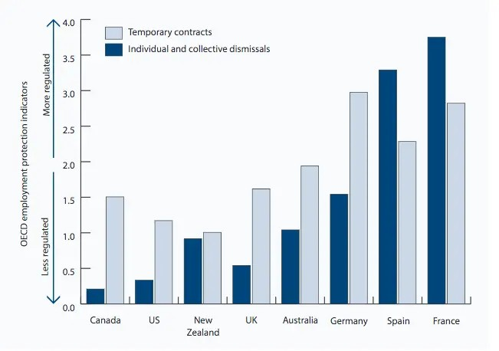
. Figure name:- (The current state of the labor market in the UK)
Source name:- (Yong et al.2019).

Shortage of workers
The demand for workers has been growing up with time but the supply is being limited. On the demand side, the economy has reopened independent make and it lost a grip which was the stronger competition for the staff. The labor market has decreased after the pandemic and it wastes many problems due to which there are various types of problem occurred and it is very necessary to have a proper understanding and the HR management goals. There are major problems occurring in the current state of the labor market in the UK after the pandemic. Many policies have been made by the HR management and they are trying to sort out the problem of unemployment there is a very limited selection of employees and workers because selecting an important skilled worker is a very difficult thing and it is very necessary for a company. There are various types of methodologies that are used to increase employment in the country. The growth in the employee's pay was up to 6% and the growth in the regular pay was at 7% in 2022(Boon et al.2018). In real terms, the total pay fell by three percent and the regular pay fell by The unemployment was at the very lowest in 1971 but with employment, the growth was inactivity horizon and the low employment was due to the people who are leaving the labor force entirely rather than the more entering the work. 94% of HR professionals believe that there are major problems occurring with the shortage of labor(Yong et al.2019). The labor market is remaining incredibly tight and the candidates are very much facing hard times to come. Employers are pulling out so that they can stop to attract and crucially retaining the staff but with the high inflation eroding the packets of pay and the recession forecast for the end of 2022 the labor market has not reached to peak. There are many skill shortages and poor candidate availability in the sectors of England and the job vacancies are also growing but at the lowest rate. In 2022 unemployment increased by 0.10% and unemployment is 4%. The labor market is facing the problem and the rate is increased up to 6% as per the comparison of the 19 71 to 2022(Stone et al.2020). It is very important to have a proper methodology of having a condition of skill labor methodology and the labor market should be increased and all the employers and workers or the candidate should get the chance to prove themselves and the other managements also making the strategy to select the appropriate candidate which is necessary for the organization and the job rate should also be more.

Part B

The emerging changes in Human Resourcing Strategies in the post-Covid, post-Brexit

External environment.
There were many changes done in the post-COVID. The attire management decided to provide the employees with the option the work from home in the hybrid setting which has become a growing trend and is likely to continue. According to the data of LinkedIn, remote jobs which were about 30% of all the available positions received more than 60% of all the applications. There were many challenges come but remote working, technological advancements, and the competitive level markets have made many difficult situations for the manager to develop and maintain the human capital of the organization. There were many issues of employee retention and talent acquisition and employees were also increasing the challenges for human resource management. The important strategies which were made after the post covered were to have a proper SS in the HR capacity and forecasting the HR requirements with the development of the talent strategies with the review and the evaluation. It was very necessary to have a proper methodology for making the strategy more strong so that the employee who was working during the covid times were not able to enhance their skills then more training was made for the employees so that proper skill can be maintained. Many business objectives were made for example measuring the performance of human resources at regular intervals. Maintaining the proper atmosphere of performance and innovation was very difficult in the covid era. The role of each employee was clearly explained as per the expectations of the organization but it was not necessary that that employee was having a great strategy to their mind. There were many emerging trends for example the data infrastructure storage and the various applications. Artificial intelligence and many technologies were made. Human resource management also tries to hire employees and develop ways that can support the organization in its long-term goals(Saeed et al.2019).
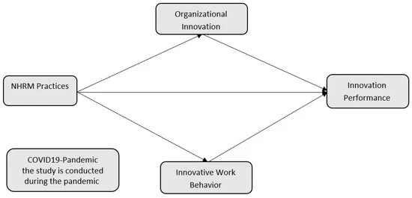
. figure name:- Emerging challenges in HRM Strategies
Source name:- (Saeed et al.2019).

Post-Brexit environment impact on HRM
There was a big impact after Brexit that the free movement of people within the EU to the UK ended on the first of January 2021 and it made changes with the recruitment from the outside of the United Kingdom. The immigration system was also introduced in which the EU and the non-EU citizens were equal in the terms of work in the UK. This was also beneficial for the HRM because many skilled and different candidates were coming from different places due to which they were getting different ideas for the business and they were also having the opportunities to have a great strategy and policies. Many strategies were made for example the cross-culture communication concept was enhanced because there were many people who are coming from the outside and their communication language was different so a proper improvement of the communication was held and if the staff is not confident then the HR management is giving them proper training. Brexit also change the whole game of human resource management because engaging and retaining the talent of the uncertainty was also difficult. After the untidy referendum, Britain's decision to end with the European Union was filled with much uncertainty that how Brexit will change human resource management. The human resource was not ready for the impact of Brexit and the HR directors were very much serious they gathered a team with this scenario planning and the teams were having the right tool to attract and retaining talent from the difficult post-Brexit situations. The important teams were already decreased from the EU countries and skills appears to be low to supply. There were many problems occurring for example(Bratton et al.2018).
- The war can be started in the UK for the talent.
- The HR was needed to get more creative and attractive for retaining the talent.
- There was great pressure on the human resource to cope with the legislative competition and engagement with the task.
- The word force management was also important.

There were many predictions done with that talent was in the less supply and many most recruiters were reporting that they need to increment to bumper the regular payment and other profit to retain the employees. Britain's exit from the EU has had a significant impact on the organization's future planning of HR management and the market strength is that the UK was appealing for the talent and the free movement was started for the attractive talent because in the UK labor market many support was needed for the selection of the unskilled and trained worker between the countries and the chain of good employees from the other countries. The UK also faces a problem and experience of declining in the number of people to coming to work. The HR management was very much focused on the development of the migration rules after Brexit. And it was possible that the current workers in the United Kingdom will not cover the worldwide UK immigration rules and the UK having the important post system. . The UK exit from the EU was having a great impact on global organizations and without the freedom of the labor impact from the EU global firms also have the feeling that the talent which is available in the UK was smaller than May achieved elsewhere. The market which was impacted was in the US and the organization was looking for a branch out of Europe. Unlikely the changes to the holiday pay limitations were short and have the limitations or there was also annual leave carry overdose on the term sick leave. There was also a decline of the major beneficiary of EU employment and it was possible were at some point that the Brexit negotiations were having the workers from the EU may find the benefits or free health care had been removed for them and they need to pay the social security There was also collective consultations major rights and the project budgets(Boon et al.2018).

Engagement strategies
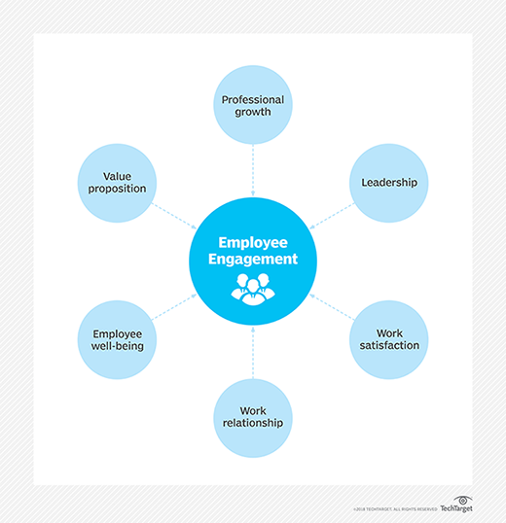
The development of a strong employee engagement strategy was the major strategy of human resource management and this was impacted by Brexit this was needed to reinsurance that the human resource system and Methodology is on the very high of things. The support of communication is important and it can help the important firm is to ensure that the l employees are aware of all business leadership and the HR is also aware and was ready to deal with the post Brexit situations and the matter was concerned. Engaging and retaining talent is the most important thing and it will give more talent in the company HR can have more programs to reassure the major talent with the solutions of the Brexit scenario. There were many plans to create for example challenging the fuel on the organization and having the best talent making for the HR in some organizations the HR will also need to look for more techniques and have the development of the internal talent and it was also necessary to include the use of the talent tools to optimize the skills and power the engagement level(Boon et al.2019).
Figure name:- ( Employee engagement strategy)
Source name:- (Boon et al.2019).

Conclusion
Human resource management place an important role in the labor market and they have important rules everywhere so it is very necessary to make these strategies there are strategies and strong strategies the communication because it gives the goals to the company to have a more effective goal and the goal should be clear to each and every employee and having this killed workers is the responsibility for the HR management because sometimes it needs that the employment is not mean that selecting those employees who are just capable and already have skills but it is also necessary to give them training and enhance their skills during the job due to which more people can get employment because due to many reasons people are not able to enhance their skills before the job so sometimes it is necessary to make a strategy for those employees and candidates. Human resource management also faces many problems and they were having long-term goals but due to the changes they are not able to decide what is right so it is very necessary to have major important goals for the company and making the changes is very necessary because not necessary that the strategy that has made will be worked because there are important strategies with the show that there are many plans which are made with the importance and it is very necessary to have the important goals so that it could be performed well and there are also some important methodologies are very necessary for the human resource management and yes market strategy.

References
Boon, C., Den Hartog, D.N. and Lepak, D.P., 2019. A systematic review of human resource management systems and their measurement. Journal of Management, 45(6), pp.2498-2537.
Boon, C., Eckardt, R., Lepak, D.P. and Boselie, P., 2018. Integrating strategic human capital and strategic human resource management. The International Journal of Human Resource Management, 29(1), pp.34-67.
Bratton, J., Gold, J., Bratton, A. and Steele, L., 2021. Human resource management. Bloomsbury Publishing.
Carnevale, J.B. and Hatak, I., 2020. Employee adjustment and well-being in the era of COVID-19: Implications for human resource management. Journal of business research, 116, pp.183-187.
Chams, N. and García-Blandón, J., 2019. On the importance of sustainable human resource management for the adoption of sustainable development goals. Resources, Conservation and Recycling, 141, pp.109-122.
Macke, J. and Genari, D., 2019. Systematic literature review on sustainable human resource management. Journal of cleaner production, 208, pp.806-815.
Saeed, B.B., Afsar, B., Hafeez, S., Khan, I., Tahir, M. and Afridi, M.A., 2019. Promoting employee pro-environmental behavior through green human resource management practices. Corporate Social Responsibility and Environmental Management, 26(2), pp.424-438.
Stewart, G.L. and Brown, K.G., 2019. Human resource management. John Wiley & Sons.
Stone, R.J., Cox, A., and Gavin, M., 2020. Human resource management. John Wiley & Sons.
Yong, J.Y., Yusliza, M.Y., Ramayah, T. and Fawehinmi, O., 2019. Nexus between green intellectual capital and green human resource management. Journal of cleaner production, 215, pp.364-374.

