BMDS7004
Data Analytics

Statistics Practical and Dissertation Analysis Plan

Sue Hamer - 2112925
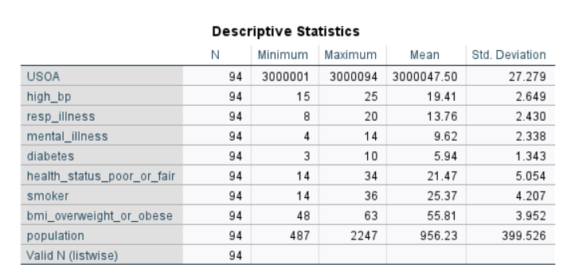
Part 1

SPSS output file 1:
Data Set 1
The descriptive table provides valuable insights into the distribution disease incidence in Wales, using six years of data obtained from the Welsh Health survey. The descriptive stats table presents key summary measures such as mean and standard deviation, allowing us to understand the central tendency and variability of the prevalence for each disease in 94 output areas in Wales using the upper, super output area (USOA) codes.
If we were to look at “high_bp”, the percentage of adults who reported being treated for high blood pressure ranged between 15 to 25 percent. This gave a mean value across all groups as 19.41 and a standard deviation (SD) of 2.649, which is the measure the value lies from the mean or the centre. Higher SD values signify that more data points are further away from the mean. In other words, extreme values occur more frequently.
If plotted on a graph as a bell shape, most values would cluster around a central region and peak in the middle and taper off as they go further away from the centre.

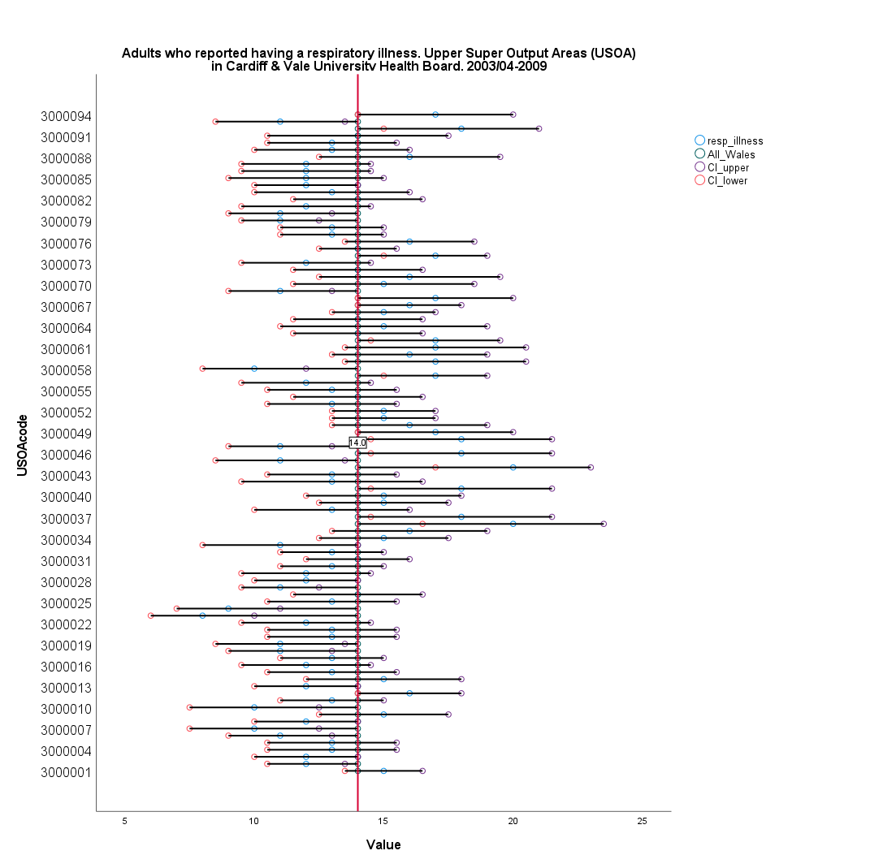
All Wales line
95% confidence interval. All Wales mean = 14

Age-standardised proportions (ASPs) account for different age structures in populations.

Data label of age standardised percentage

SPSS Output file 2:
Data Set 2
The graph shows the differences on different groups for respiratory illness. The confidence intervals are derived from the sample size and in this case they have been classed as a 95% confidence level. If a small sample size is selected the margin of error is likely to be huge which means the confidence level would be low.
When reviewing the upper confidence interval, this has been established as 18.62 (13.76 + 2.430 + 2.430 = 18.62), with the lower confidence interval established at 8.9 (13.76 -2.430 -2.430 = 8.9).
As shown on the forest plot, those not touching the red line are statistically different in that all those circled blue to the left of the line is less than all Wales value of 14, and those circled green to the right of the line are higher than all Wales value. This would mean that it is not a significant result if either side of the red line and not overlapping the confidence level, which would be difficult to compare so would be an area of concern to be looked into in more depth. It is suggested that data is analysed from the other six health boards in Wales to explore patterns or correlations in population health and social determinants.

Part 2

Effectiveness evaluation of Powys Teaching Health Boards Integrated Health & Social Care Community System.

1.0 Introduction
As summarised by NHS England (nd), “Integrated care systems (ICSs) are partnerships of organisations that come together to plan and deliver joined up health and care services, and to improve the lives of people who live and work in their area”.
For the Welsh Government, a common electronic health and social care record has been reported key to its ambition of an integrated and person-centred health and social care service. In A Healthier Wales (2018), the Welsh Government dedicated their efforts into accelerating the roll-out of this tool across local authorities and health boards.
Integrating health and social care has been an ambition of national policy for over thirty years, and with the introduction of the Health and Care Bill in 2022, has started to gather pace. There are various interactions between how health and care systems work together, such as when a patient is discharged from hospital into social care, but it's often hard for health and care professionals to share information about patients and people accessing services. Access to the right information at the right time is essential to transfer people smoothly between care settings and to ensure continuity of care. (A Healthier Wales, 2018)
In 2015 The Welsh Community Care Information System (WCCIS) was developed to enable health and social care staff to deliver more efficient and effective services using a single system and a shared electronic record. It was intended for use across a wide range of adult and children’s services, and health, moving away from several multiple systems or paper records management. The Welsh Government had intended that all 22 local authorities and seven health boards would implement WCCIS by the end of 2018.
Five years on from implementation, the Welsh Audit (2020) reported that key aspects of the expected functionality had been significantly delayed with only 13 local authorities and two health boards using the system (52%). This included a lack of developments to the primary contractual arrangement. It was estimated that the remaining updates would be delivered on a phased basis through to the end of 2021, but has this been achieved? Areas where work was still required in the report included development of the Welsh-language requirements, mobile functionality, and interfaces with other NHS Wales systems. The National Programme Team has also needed to address concerns about system performance. This evaluation is intended to address the effectiveness of the health & social care system, find out what users feel about the system's usefulness in supporting the delivery of care, what aspects are missing and any common frustrations and challenges. The current problems are depicted in Diagram 1.
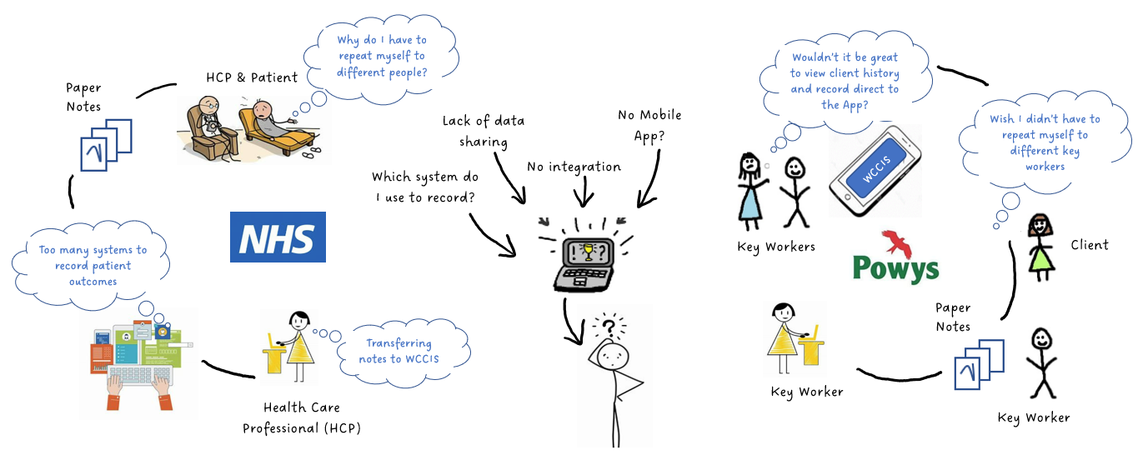

Diagram 1
Rich Picture of the problem

When fully implemented across Wales, the intention is to overcome obstacles posed when organisations use different IT systems by securely storing important information covering a range of activities such as community nursing, health and social care visits, mental health, learning disabilities, substance misuse, complex care needs or social care therapy.
2.1 Problem
In 2014, Welsh Government realised that when a patient or client received treatment or care in Wales, information was either written down or held on a computer which were used to support individual care. However, when care was delivered in the home or community, it was often provided by different people from different organisations and the patient’s records are a vital tool for communication between them.
Health care professionals were working on different electronic and paper systems to record information about the people in their care, which made it difficult for the information to be shared to support continuity of care. The Welsh Community Care Information System (WCCIS) was developed as a 12-year programme, sponsored, and funded by Welsh Government and delivered in partnership with Digital Health and Care Wales to integrate information into a single national system to ensure transparency, on a need-to-know basis, and for information to be shared safely and securely between health and social care services.
However, from conversations with colleagues at Powys Teaching Health Board (PTHB), and the detail reported in the Welsh Audit (2020), key aspects of the expected functionality have been significantly delayed and not implemented, and it seems the product has not delivered as intended. Also implementing and rolling out the system over the life cycle of the programme has proved more costly than expected and the number of local authorities and health boards live with the system is disappointing when £30million has been invested (Welsh Audit, 2020). Some might ask if that has this been value for money?
The primary goal of the integrated system was to ensure frontline staff had access to information ‘on the go’ and record following a visit/consultation using devices that could be used in the community, such as smart phones and tablets. This would allow them to access up to date information, and what treatment or service plans were in place. There would be the ability to share or transfer across regional and cross organisational borders if the individual was referred to new services or re-located. Most importantly the individual wouldn’t have to repeat their details time and again to different professionals, leading to better consistency of care.
2.2 Research
The National Institute for Health and Care Research (2018) carried out a literature review of 267 studies to understand how new models may affect patients, providers and systems which included a qualitative review of attitudes, barriers, and enablers of integration. The evidence was that integrated care models can increase patient satisfaction, quality of care and improve access to services. If there is evidence on the benefits, then there is merit in ensuring these systems support professionals and patients as intended.
2.3 Aim
As stated in The Institute of Healthcare Improvement (IHI) and cited by Provost and Murray (2011, page 4) as the model for improvement into three sections; “What are we trying to accomplish?” ”How will we know that a change is an improvement”? and “What change can be made that will result in improvement?”. The aim of this study will be: “To identify the perceptions of health & social care staff using the integrated system and understand what has not been delivered that would support better adoption and usability”. This can only be answered by collecting data and user feedback, otherwise known as quantitative and / or qualitative data.
2.4 Objective
The objective of the study will be to assess how staff feel about the community system and the underlining problems. Are these down to the supplier, users, functionality, or legacy products, and are the views of health board staff different to local authority staff? What needs to happen to support greater adoption and acceptance? To answer the three fundamental questions within the model for improvement, a system evaluation will be required to assess whether the system is meeting the objectives it was designed to deliver on, such as:
- Creating a single system
- Integration with other NHS Wales systems for national reporting
- Once for Wales Approach
- Mobile app for remote working
- Shared electronic record
As described by Lilford et al. (2010), the Donabedian model has been applied as a quality improvement framework for health care since 1966, or otherwise referred to as a logic model to demonstrate how a project will achieve the desired outcomes. As observed by Lilford et al. (2010), implementing a service intervention to support a policy goal cannot be derived solely with the patient in mind, and that interventions and processes should be assessed against the desired outcome to assess quality.
The model describes structure, process, and outcome measures as having close relationships, each vital evaluating the quality of health care. Structural measures are described as characteristics of the space where care occurs, including architecture and availability of equipment/information; process measures include delivery of care to patients and the workflows encompassed therein; and outcome measures describe the effects of health care on populations.
While there are other quality of care frameworks, including the World Health Organization (WHO) recommended quality of care framework, the Donabedian Model continues to be a dominant framework for assessing the quality of health care, which will be the framework used to review the effectiveness and useability of WCCIS. Diagram 2 provides a modified Donabedian diagram showing the interventions and immediate steps which are assumed as lending towards the required desired change from reviewing internal reports and initial discussions with colleagues.
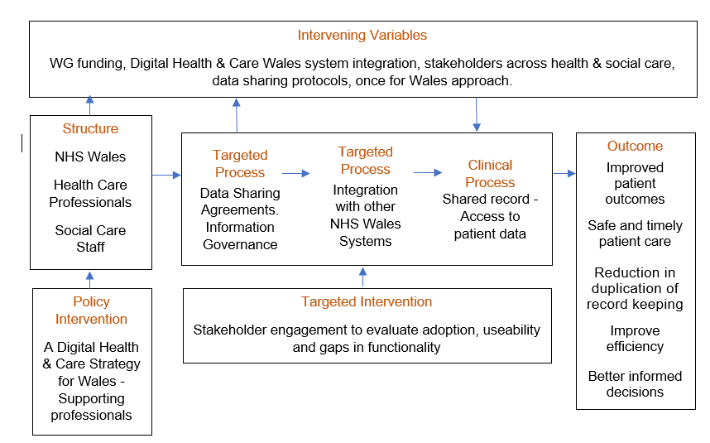

Diagram 2
Modified Donabedian diagram to support service transformation.

Policy Intervention
The policy intervention driving the change is from the Digital Health & Care Strategy for Wales, supporting professionals having improved access to information to do their jobs more effectively with improvements in quality, safety, and efficiency via digital tools. Having a ‘Once for Wales’ approach aims to implement common external standards for achieving interoperability between systems and access to structured, electronic records in all care settings to join up and co-ordinate care for service users, patients, and carers.
Structure
As noted in the findings from Welsh Audit (2020) report, the system was developed to support the delivery of a digital tool to help health and social care professionals work together, introducing a paperless tool to share patient information securely across PTHB, the region and across the whole of Wales.

Intervening Variables
Engagement with system users and stakeholders will be a key factor in evaluating the success of this integrated system which has been in place for 8 years to identify the perceptions of health & social care staff using the digital tool, to discover what has not been delivered that would support better adoption and useability. Future funding will also need to be considered given that £30million has already been invested.
Targeted Interventions and Processes
The targeted intervention looks to bring together feedback from users and data from the system, where the processes are what needs to happen to improve the “as is” as illustrated on diagram 1 as reported in the 2020 Audit.

Outcome
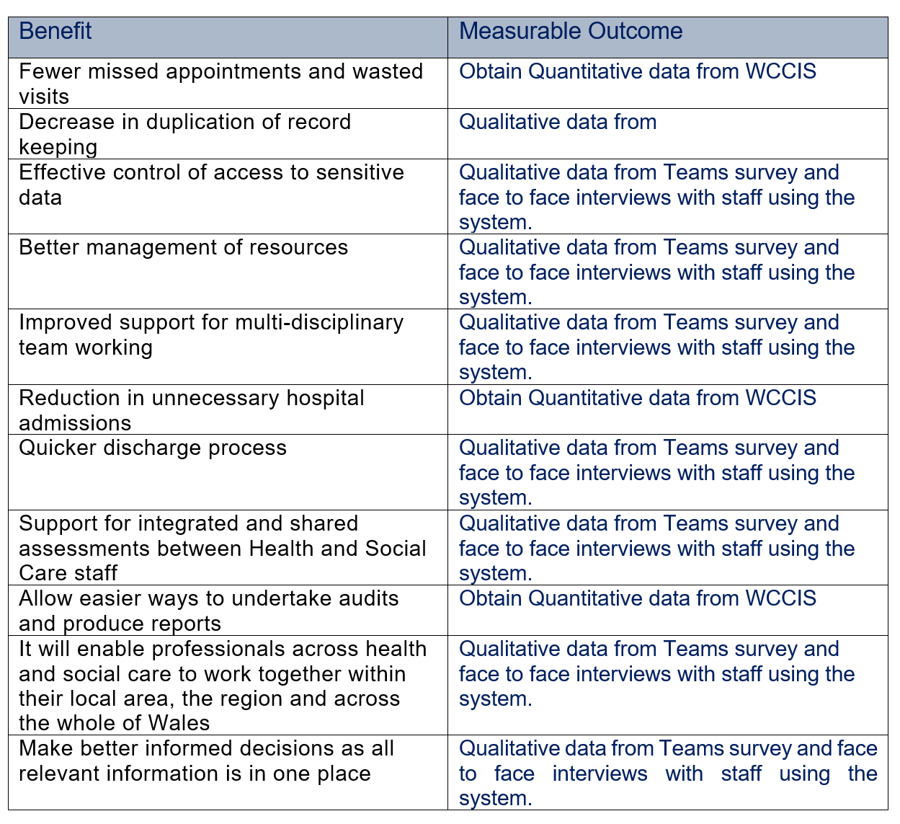
The outcome would bring about many benefits as evidenced in table 1, which were taken from Digital Health and Care Wales (nd). These would support improved patient outcomes, safe and timely patient care, reduction in the number of electronic and paper systems used to record information and improved efficiency.

Table 1
Recorded benefits at project initiation.

An important factor of the evaluation will be to identify the stakeholders who use the system, to help understand the intervention or lack of, and fix any problems. Having access to data is more likely to improve adoption and make it a success. (Health Foundation, 2015). The stakeholders have been identified in table 2 which have been shared by the health boards project team.
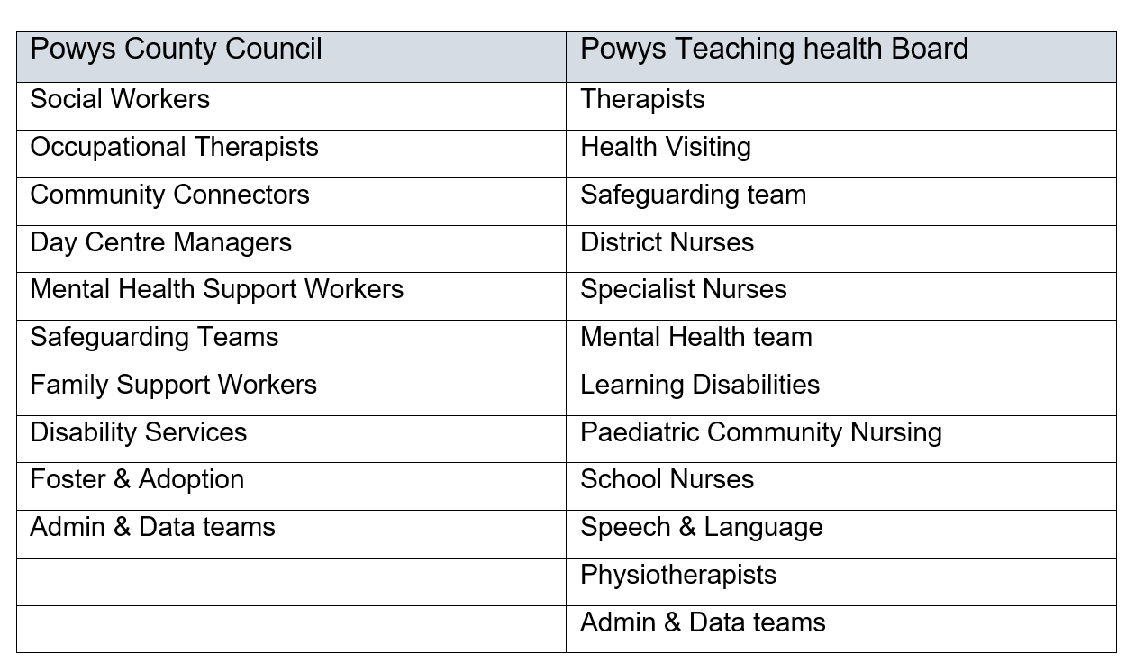

Table 2
Users of the system across health & social care

3.0 Data collection
Evaluation is an essential part of quality improvement and when done well, it can help solve problems, inform decision making and build knowledge (Shadish, Cook and Leviton, 1991). Evaluations don’t just evidence if an intervention worked, they determine why they might not have been successful, allowing people to learn lessons and share with others. As noted by Menon, Karl and Wignaraja (2009), an evaluation should form a structured assessment of an ongoing or completed task, programme, policy, or intervention that will establish the effectiveness of the change and whether it is achieving its objectives.

As noted in the guide to evaluation published by the Health Foundation (2015), when undertaking improvement work, evaluations can be a resource for learning and sharing knowledge about what others have found to work, and what they have found to be difficult or unsuccessful. Over the last 20 years, mixed method research has grown increasingly popular and as explained by Punch (2016, p. 8) has developed in three waves:
- Wave 1 – the historical dominance of quantitative methods
- Wave 2 – the emergence, acceptance, and growth of qualitative methods
- Wave 3 – the increasing tendency to combine quantitative and qualitative methods and data using mixed-method research.

In 2011 The National Institutes of Health (NIH) released recommendations for scientists using this approach as it combines the strengths of qualitative and quantitative research, and in 2013 the Mixed Methods International Research Association (MMIRA) was launched to promote the development of an international and interdisciplinary mixed methods research. A number of academics have published standards or criteria for appraising, conducting, and/ or reporting mixed-methods research, for example, Bryman, Becker, & Sempik, (2008) and Romm and Ngulube (2015).
Klassen et al. (2012) reported several reasons for using mixed methods in health science research. It helps researchers seek the view of a problem(s) from multiple views which improves and deepens the meaning of a singular perspective. Research might also want to target information from a particular setting, for example a community hospital and include information about individuals working at different levels or in different departments. Plano Clark (2010) described other reasons for using mixed method research which included merging quantitative and qualitative data to develop a more complete understanding of the problem which would provide; a 360-degree understanding to compare, validate and triangulate results or to examine processes/experiences along with outcomes. As reported by Creswell et al. (2003), the motive of combining both would be to validate quantitative statistical findings with qualitative data results.

Determining the right analysis methods are important factors in ensuring the right data is obtained for an evaluation and which method to act on first. As described by Sandelowski (2014) and Punch (2016, p. 6), researches should be more focused on which method and design collections make sense for responding to important research questions. As described by Romm & Ngulube (2015), quantitative methods are used when researchers are concerned in providing numerical measures and applying statistical tests to the material being considered and Qualitative methods focus less on numerical findings and more on in-depth investigation and analysis of certain features of topics being investigated. Qualitative research questions are usually flexible, non-directional, and more adaptive (Creswell, 2013) and aim to “discover,” “explain,” or “explore.”
Diagram 3 is a useful tool and strategy for developing proposals, created by Punch (2016, p. 19).
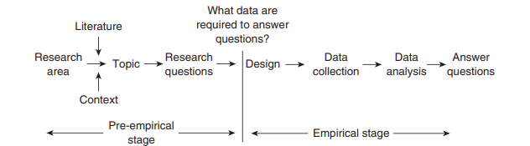

Diagram 3
Simplified model of research (Punch, 2016)

The simplified model of research looks to:
- Frame the research in terms of research questions
- Determine what data is necessary to answer those questions
- Design research to collect and analyse the data
- Using the data and results of the data analysis to answer the questions
For this research, the type of research questions that would provide insight into the current system and support the research area are shown in table 3.

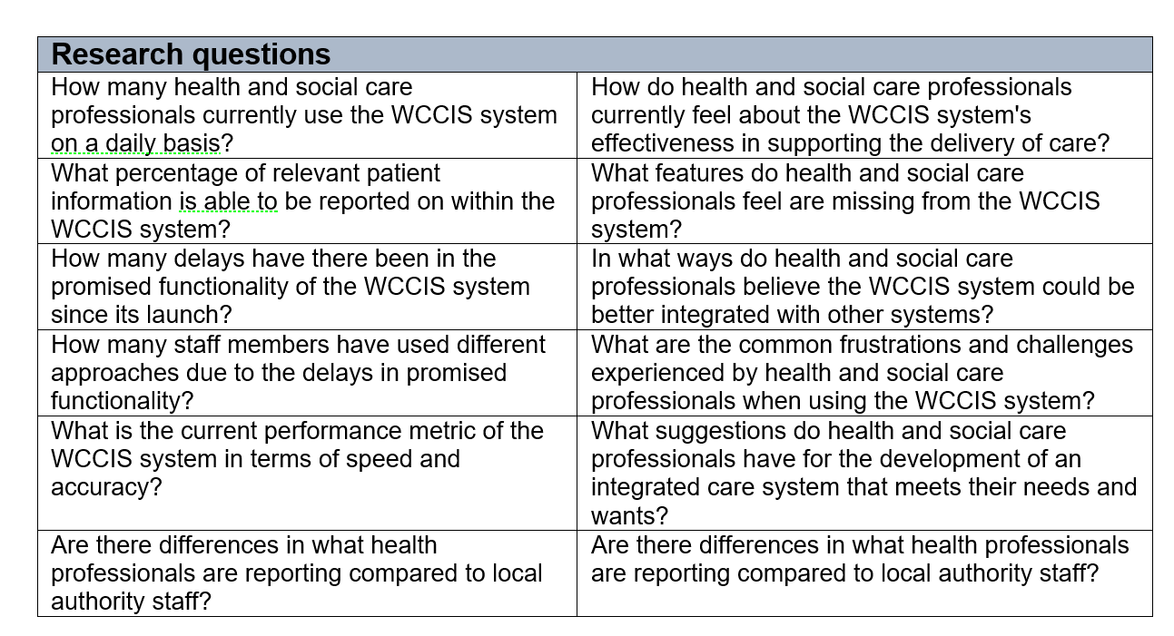

Table 3
Research Questions

3.1 Appropriateness of Mixed Method
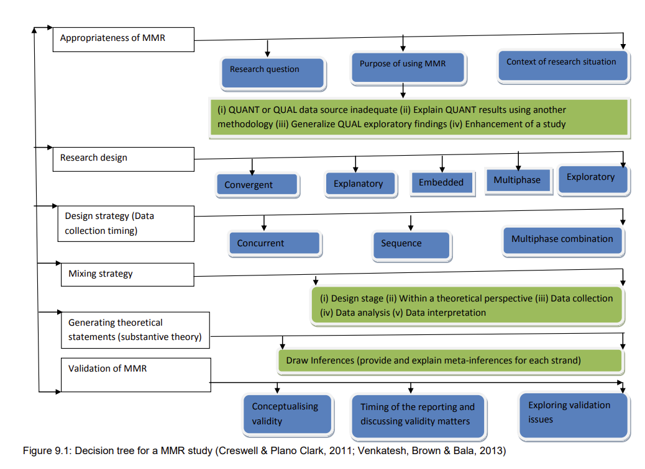
This leads to an analysis that the methods of data required would include both quantitative and qualitative data so that a triangulation of evidence for recommendations of improvement can be presented to management with a view to making the adoption and usability a greater success. Cresswell & Plano Clark (2011) designed a decision tree to aid researches when carrying out a mixed method study which is shown in diagram 4 which will support the decision and sequence for this evaluation proposal.

Diagram 4
Decision Tree for a mixed method study (Cresswell & Plano Clark, 2011)

3.2 Research Design
Cresswell and Plano Clark (2018 p. 65) describe three core mixed method designs as illustrated in diagram 5 which are also shown in the research design section of the decision tree (Diagram *)
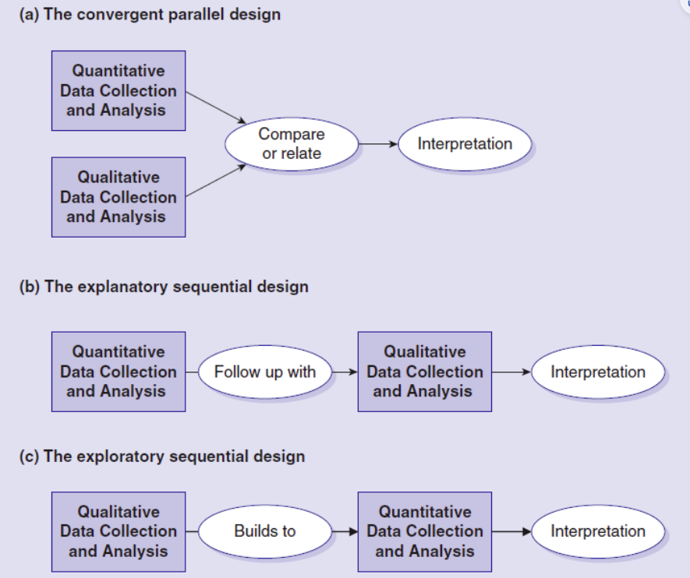

Diagram 5
Mixed method designs (Cresswell & Plano Clark, 2018)

Given that the researcher has access to quantitative data for analysing the responses of those using the system and has the ability to return to participants for a second round of qualitative data collection due to their work in the organisation and links with the project team, it seems sensible to use the explanatory sequential design.
The mixed method sequential explanatory design (Cresswell and Plano Clark, 2018 p. 77) consists of two phases; quantitative followed by qualitative. In this design the research will look to gather and examine quantitative data, and then the qualitative data will be collected and scrutinised as phase two to help explain or elaborate on the quantitative results obtained in phase one. Quantitative data provides a universal understanding of the research problem where the qualitative data refines and explains the statistical results exploring participants views in greater detail, which will be the approach taken for this evaluation.
3.3 Design Strategy methods
Quantitative Data

Data metrics will be obtained and analysed from the health and care system with support from the project team which will provide a good insight into data on usage and performance over the past 8 years and comparisons between staff working in the field of health versus those in social care. A survey will also be shared with a sample of users as there are currently over 2000 system users, using the framework of the system useability scale to gain insight into the quality of a user’s experience (ue) using a 10-item attitude Likert scale. The approach taken to sampling will be a stratified random approach to divide users into subgroups called “strata” based on which department they work in, then a sample, i.e., 50 will be selected randomly from that group.
Qualitative Data

The second part will explore participants views in more depth utilising methods recommended for obtaining qualitative data and looking for themes, for example interviews, questionnaires. Qualitative data is the most important step in the qualitative research process (Leech and Onwuegbuzie, 2007) because it assists researchers make sense of their data. Data will be obtained to find out how people feel about the system; what functionality do they believe is currently missing, common frustrations and suggestions on how it can be improved as a future design. This will be achieved by interviewing a sample of users from each department across both organisation and gaining insight into their experiences with the system known as narrative methodology (storytelling), along with creating an open-ended survey on Teams. Again the stratified random approach will be followed to mirror phase 1 but less participants selected.
As suggested by Creswell and Plano Clark (2018, p. 190), if using an explanatory sequel design for data collection, it is recommended that individuals selected for the qualitative follow up phase be a sub-set of individuals who participated in the quantitative data collection. The reason being that the explanatory design aims to explain the initial quantitative results and supports consistency.
3.4 Analysis
Quantitative Data
Descriptive statistics will be used to summarise data from the health and care system taken from the period it went live in March 2015 to March 2023. The data will be illustrated on a time series graph to show measurements over a given time period utilsiing tools such as excel or SPSS to plot charts to understand and quantify patters of variation in data. In parallel a usability evaluation will be shared with a sample of users to ascertain the quality of the user’s experience across health and social care.
The System Useability Scale (SUS) was developed by John Brooke in 1996 as a simple but valid tool for measuring usability, using a 10-item attitude Likert scale which provides a benchmark score for differentiating between a usable and unusable system as evidenced in table 4. The measurements of usability have three different aspects:
- effectiveness (can users successfully achieve their objectives)
- efficiency (how much effort and resource are expended in achieving those objectives)
- satisfaction (was the experience satisfactory)
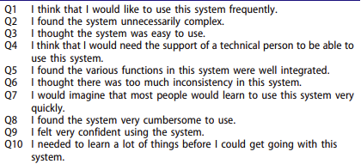

Table 4
Standard version of the system useability scale (SUS)
The response scale for each question is a 5-point Likert agreement scale as shown in table 5:
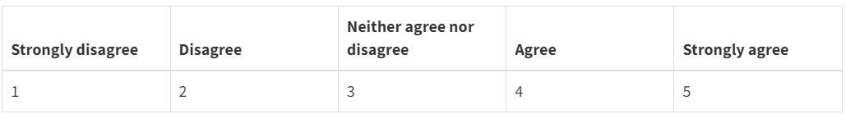

Table 5
5-point Likert agreement scale

The SUS score estimates an individual’s view regarding the usability of a system based on a score from 0-100. For positive-oriented questions, “one” gets subtracted from the original score. For negative-oriented questions, “five” gets subtracted from the original score. This gives a consistent scale for all responses of 0-4. The scores then get added up and multiplied by 2.5 to get the final score. For example, if the sum of a user’s responses to the ten questions is 20, you would multiply that sum by 2.5 to get a SUS score of 50.
This unit score works very well for making relative comparisons, but as discussed in Bangor, Kortum and Miller (2008), there is often need to explain what a single SUS score itself really means. For example, is 65 good or bad? To address this, Bangor, Kortum and Miller (2008, 2009) presented an adjective-anchored rating scale based on six responses from worst imaginable moving to best imaginable, that correlated highly with the SUS scores. See diagram 6.
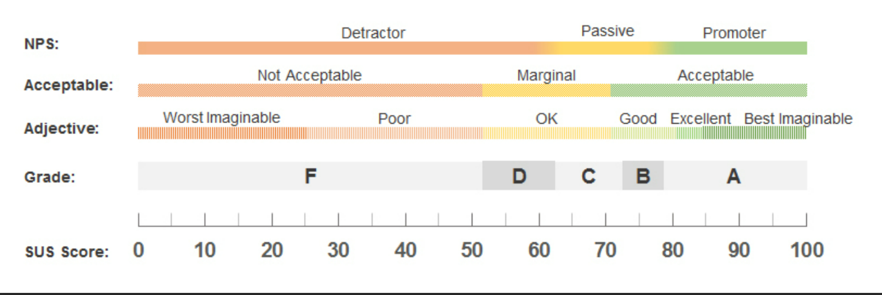

Diagram 6
Adjective-anchored rating scale

The SUS scale will be used to ascertain how well received the Welsh community care information system has been adopted by staff at PTHB and Powys County Council and what themes emerge from the results. Without this in place, it will be unknown if the system has been well received and is achieving the desired goals of being used as a single system and a shared electronic record of care for staff to use across health and social care.

Statistical significance

As described by Tenny and Abdelgawad (2022), a p-value is the probability under a specified statistical model that a numerical summary of the data (e.g., the sample mean difference concerning two related groups would be equal to or more extreme than its observed value. In this case comparing results from health care users versus results from social care staff using the following formula and symbols to determine if the data provides a statistically significant result or not:
- Null hypothesis (H₀ = no difference assumes no difference between groups
- Alternative hypothesis (H₁) = states a difference between the study groups
- Significance level = calculating the test statistic using the study data which then creates the p-value (0.05 = 5%).
A study will be statistically significant if the p-value is less than the pre-specified alpha. Stated succinctly:
- A p-value less than alpha is a statistically significant result
- A p-value greater than or equal to alpha is not a statistically significant result.
Tenny and Abdelgawad (2022) noted a few concerns when creating a study in that the alpha, or confidence level, should be specified before any intervention or collection of data. It is easy for a researcher to "see what the data shows" then pick an alpha to give a statistically significant result. Such approaches compromise the data and results as the researcher is more likely to be lax on confidence level selection to obtain a result that looks statistically significant.
A second important issue raised by Tenny and Abdelgawad (2022 is selecting the correct statistical analysis method. With there being numerous methods for obtaining a p-value, the method chosen depends on the type of data, the number of data points, and the question being asked. It is therefore important to consider these questions during the study design so the statistical analysis can be correctly identified before the research begins.
Operational significance
As described by Punch (2016, p. 101), there needs to be a justification, importance or intended outcomes of a study of why is it worth doing. Marshall and Rossmann (2015) classed these into three areas.

- Knowledge / literature in the area or theoretical contribution
This method will be used to analyse any reports or literature on what is happening in NHS England/Europe/USA related to integrated care systems and doing a comparison of WCCIS. Are others experiencing the same challenges? What might they have that has improved the user experience and supported the professional and patient more positively than what PTHB have in place.

- Policy consideration
Given that the health and social care system was developed to enable health and social care staff to deliver more efficient and effective services using a single system and a shared electronic record, whilst supporting plans of A Healthier Wales (2018). With a vast amount of money invested (£30m) from Welsh Government, it seems logic that the system would benefit from an evaluation to allow for data, themes, and feedback to be analysed with the aim of improving the functionality, adoption, and usability.

- Practitioner consideration
Surely considering the view of the patient and practitioner is paramount here given the outcomes listed in the Donabedian model (diagram 1). These have been considered as:

- Improved patient outcomes
- Safe and timely patient care
- Reduction in duplication of record keeping
- Improved efficiency
- Better informed decisions

Qualitative Data
The data used will take the form of three methods.
- Thematic Analysis
- Content Analysis
- Grounded Theory

Thematic Analysis
Thematic analysis will be used to closely examine the data to identify common themes; topics, ideas and patterns of meaning that come up repeatedly, which will be placed into response categorise. There are various approaches to conducting thematic analysis, but the most common form was created by Braun and Clarke (2006) which follows a six-step process: familiarization, coding, generating themes, reviewing themes, defining and naming themes, and writing up.
Grounded Theory
Introduced by Glaser and Strauss in the 1960s, Grounded Theory will be used to develop a theory of how an integrated care system could be designed to meet the needs and wants of the Powys health and social care workforce, utilising feedback received from the users. The data will then be analysed to identify patterns and relationships. This will be supported from the outcome of the thematic analysis and working in collaboration with the project team.
Content analysis
Content analysis is a research method used to identify patterns in recorded communication obtained from the data received. This method will be used to analyse any reports or literature on what is happening in NHS England/Europe/USA related to integrated care systems and doing a comparison of WCCIS against two or three relative systems that were developed for the same purpose to identify similarities and gaps.
Data Saturation

Saturation is the most common guiding principle for assessing the adequacy of the volume of samples required in qualitative research (Sandelowski, 2014) and Guest, Bunce and Johnson (2006, p. 60) refer to it as having become ‘the gold standard by which sample sizes are determined in health science research. It refers to the point in the research process when no new information is discovered in data analysis, and this redundancy signals to researchers that data collection may cease. But how do researchers know when they have reached that point?

Gerrish and Lathlean (2015, p. 192) notes the difficulties in deciding when saturation has occurred and happens at different stages in each project which can’t be predicted from the offset. Its about acknowledging the objective and having enough data to satisfy the research questions so that the necessary conclusions can be formed.
Data Transferability

Quantitative research considers the possibility of duplication; if the same methods are used with the same sample, then surely the results should be the same? Providing a consistent approach to data collection supports the reliability for collecting data. Researchers must obtain consistent results throughout the research process, no matter the type of method used for data collection (Nicolas, 2023) However, reliability is more important than merely providing consistent results or scores throughout the process. It’s also important because of two other reasons as described by Nicolas (2023):
- Observed score (outcome of a person’s survey) = true score (based on knowledge) + error which could be contributed by a system error or random error i.e., environmental factors.
- Validity – the conclusions made from a test are justified and accurate. And have measured what it’s supposed to measure.
The way the researcher will ensure transferability is achieved, will be to use a consistent tool for measuring data i.e., SUS scale, and using the same set of questions if the survey were to be repeated.
4.0 Ethical Considerations
Debates concerning ethics in research have been apparent for a long time but have become more extreme in the twentieth century. All social research involves consent, access and associated ethical issues, since it is based on data from people and about people (Punch, 2016). As noted by Creswell & Plano Clark (2018, p. 177), researchers require permission to collect data from individuals and sites. This permission often needs to be gained from multiple persons and levels in an organisation, for example those who are in charge of sites to individuals providing the data.

Obtaining permission to access sites and individuals means having a recruitment strategy in place and being sensitive to the ways of involving and recruiting people to a project (Creswell & Plano Clark (2018, p. 179). Successfully recruiting participants can be a challenging aspect of research, and incentives can help recruit individuals and sites, for example, what will each person gain from having taken part in the study? Do they have the capacity to invest time, energy, or money? As Miles and Huberman (1994, p. 291) wrote; study participants like that they get listened to; they may get awareness or self-learning; they may improve their personal practice; a programme they are involved with may be strengthened; or they may get support in taking effective action on some recurring problem. These will all resonate with this evaluation research.
As advised by Creswell & Plano Clark (2018), a recruitment strategy will be required to ensure the study is managed in terms of time and commitment and interviews will be managed around their availability, so it doesn’t impact on any clinical time. As noted by Punch (2016, p. 23), there are important ethical questions to be considered and the questions central to them as shown in table 6 are:

Ethical Issues | Questions to consider | Response to the study
Informed Consent | Do the people I wish to study have full information about the research including why and how they have been chosen to participate? | They will be notified before they are asked to participate along with the commitment required.
Confidentiality & Anonymity | How will the information be safeguarded and the identity of people? | Names will be replaced by numbers to protect personal identifiable information (PII) when interviewing and surveys will remain anonymous. Just the organisation (PTHB or local authority) and department will be visible.
Ownership of data & conclusion | After collection and analysis, who owns the data and the conclusions? How will the results be reported and disseminated? | This will need to be discussed with the Research & Development department of PTHB.
Use and misuse of results | What obligations do researchers have to ensure findings are used appropriately and not misused? | Adhering to the ethics form and information governance, information will only be used for the purpose of the evaluation and shared with the project team and not used for anything else.
Honesty & trust | What is the relationship between the researcher and people involved in the study? | Variation between known colleagues to users who are unfamiliar.
Reciprocity | What do participants gain from the research? | Providing insights that could enhance the current system which would improve patient outcomes, reduce duplication, and better inform decisions.
Intervention & advocacy | What does the researcher do if they see harmful, illegal, wrongful behaviour during the research? | This will need to be discussed with the Research & Development department of PTHB so appropriate and ethical action can be taken.
Harm & risk | What might this research do to hurt the people involved | Evidence that the system is not performing or meeting its initial objective when over £30m has been spent to date to implement and develop.
Conflict of interest | Does the researcher have a reference, or be perceived to preference, their own interests or obligations over their duties and responsibilities as a researcher. | Fairness will be honoured by obtaining a random response from users which will ensure that certain people have not been selected.

Table 6
Ethical considerations (Punch, 2016)

A draft ethical approval form for this research proposal has been included in Appendix A to ensure the research results in a benefit to the organisation and minimises the risk of harm to anyone involved in the study. A form has also been submitted to the health boards R&D department for consideration and approval.

The Imperial College London (nd) defines research governance as a broad range of regulations, principles and standards of good practice that exist to achieve and continuously improve research quality across all aspects of healthcare in the UK and worldwide to ensure the integrity of research is upheld. It is needed to:
- Safeguard participants in research
- Protect researchers/investigators (by providing a clear framework to work within)
- Enhance ethical and scientific quality
- Minimise risk
- Monitor practice and performance
- Promote good practice and ensure lessons are learned

Without due diligence, the risk of not adhering to ethics and information governance could result in research misconduct, (The Imperial College London, nd), which could cause harm to the organisation and people and damage the credibility of the research.
Given that this research will be looking at the use of questionnaires, interviews and computer generated files, then no research activity should be undertaken until full ethical approval has been obtained.

References

- Audit Wales (2022). The Welsh Community Care Information System update. Available at: www.wao.gov.uk/publication/welsh-community-care-information-system-update. (Accessed: 25 April 2023).
- Bangor, A., Kortum, P. & Miller, J.A. (2008). The System Usability Scale (SUS): An empirical evaluation. International Journal of Human-Computer Interaction, 24(6),574-594.
- Bangor, A., Kortum, P. & Miller, J.A. (2009). Determining What Individual SUS Scores Mean: Adding an Adjective Rating Scale. Journal of Usability Studies, 4(3), 114-123
- Braun, V. and Clarke, V. (nd). University of Auckland: Thematic Analysis. Available at: https://www.thematicanalysis.net. (Accessed: 12 May 2023).
- Brooke, J. (1996). Sus-a quick and dirty usability scale. In P. W. Jordan, B. Thomas, B. A. Weerdmeester, & A. L. McClelland, (Eds.), Usability Evaluation in Industry (pp. 189–194). London: Taylor and Francis.
- Bryman, A., Becker, S., & Sempik, J. (2008). Quality criteria for quantitative, qualitative and mixed methods research: A view from social policy. International Journal of Social Research Methodology: Theory & Practice, 11(4), 261–276. https://doi.org/10.1080/13645570701401644
- Creswell, J. W., and Plano Clark, V. L. (2018). Designing and Conducting Mixed Methods Research (3rd ed). London: Sage
- Creswell, J.W. and Plano Clark, V.L. (2011). Designing and conducting mixed methods research (2nd ed). Thousand Oaks, CA: Sage.
- Creswell, J.W., Fetters, M.D. and Ivankova, N.V. (2004). Designing a mixed methods study in primary care. Annals of Family Medicine, 2(1):7-12
- Creswell, J.W., Plano Clark, V.L., Gutmann, M.L. and Hanson, W.E. (2003). Advanced mixed methods research designs. In Tashakkorim A. & Teddlie, C. (eds.). Handbook of mixed methods in the social and behavioral research, pp. 209-240. Thousand Oaks: Sage
- Digital Health and Care Wales. (nd). Digital Community Care Record. Available at: www.dhcw.nhs.wales/systems-and-services/in-the-community/digital-community-care-record/. (Accessed 2 May 2023)
Field Methods, 18(1), pp. 59–82. Available at: https://doi.org/10.1177/1525822x05279903.
- Gerrish, K. and Lathlean, J. (2015). The Research Process in Nursing. (7th ed). Chichester: John Wiley & Sons.
- Glaser, B. G., and A. L. Strauss. 1967. The discovery of grounded theory: Strategies for qualitative research. New York, NY: Aldine de Gruyter.
- Guest, G., Bunce, A. and Johnson, L. (2006) “How Many Interviews Are Enough?,”
- Health and Care Act (2022 (c 31). Available at: www.legislation.gov.uk/ukpga/2022/31/contents/enacted. (Accessed: 25 April 2023).
- Imperial College London (nd). Research Governance and Integrity: What is Research Governance? Available at: www.imperial.ac.uk/research-and-innovation/research-office/research-governance-and-integrity/what-is-research-governance/. (Accessed 15 May 2023).
- Imperial College London (nd). Research Governance and Integrity: Research Misconduct. Available at www.imperial.ac.uk/research-and-innovation/about-imperial-research/research-integrity/misconduct/. (Accessed 15 May 2023).
- Institute for Healthcare Improvement (nd) Science of improvement: Setting Aims. Available at: www.ihi.org/resources/Pages/HowtoImprove/ScienceofImprovementSettingAims.aspx. (Accessed: 1 May 2023).
- Klassen, A. C., Creswell, J., Plano Clark, V. L., Smith, K. C., & Meissner, H. I. (2012). Best practices in mixed methods for quality of life research. Quality of life research : an international journal of quality of life aspects of treatment, care and rehabilitation, 21(3), 377–380. https://doi.org/10.1007/s11136-012-0122-x
- Leech, N.L. and Onwuegbuzie, A.J. (2007) “An array of qualitative data analysis tools: A call for data analysis triangulation.,” School Psychology Quarterly, 22(4), pp. 557–584. Available at: https://doi.org/10.1037/1045-3830.22.4.557.
- Lilford, R. J, Chilton, P. J, Hemming, K. Girling A.J, Taylor, C. A, Barach, P. (2010) Evaluating policy and service interventions: framework to guide selection and interpretation of study end points. BMJ 2010; 341 doi: https://doi.org/10.1136/bmj.c4413
- Marshall, C., and Rossman, G.B. (2015) Designing Qualitative Research, 6th edn. Thousand Oaks, CA: Sage.
- Menon, S., Karl, J., Wignaraja, J. (2009). Handbook on planning, monitoring, and evaluating for development results. Available at: Handbook on Planning Monitoring and Evaluating for Development Result (undp.org). (Accessed 26 April 2023)
- Miles, M. B., and Huberman, A. M. (1994). Qualitative Data Analysis: An Expanded Sourcebook. (2nd ed). California: Sage.
- Mixed Methods International Research Association (2013). Available at: https://mmira.wildapricot.org. (Accessed: 8 May 2023)
- National Institute for Health and Care Research. (2018). Ways of integrating care that better coordinate services may benefit patients. Available at https://doi.org/10.3310/signal-000693
- National Institutes of Health. (2011). NIH released best practices for combining qualitative and quantitative research. Available at: www.nih.gov/news-events/news-releases/nih-releases-best-practices-combining-qualitative-quantitative-research#:~:text=The%20National%20Institutes%20of%20Health%20today%20released%20recommendations,the%20strengths%20of%20quantitative%20research%20and%20qualitative%20research. (Accessed 8 May 2023).
- NHS England (nd). What are integrated care systems? Available at: www.england.nhs.uk/integratedcare/what-is-integrated-care/. (Accessed: 25 April 2023).
- Nicolas, A. (2023). Research Prospect: Transferability in Qualitative Research. available at: www.researchprospect.com/transferability-in-qualitative-research/. (Accessed: 12 May 2023)
- Plano Clark, V.L. (2010). The adoption and practice of mixed methods: U.S trends in federally funded health related research. Qualitative Inquiry, 6(6), 428-440
- Provost, L.P., and Murray, S.K. (2011). The Health Care Data Guide: Learning from Data for Improvement. San Francisco: John Wiley & Sons.
- Punch, K., F. (2016). Developing Effective Research Proposals. (3rd ed). London: Sage.
- Romm, N. and Ngulube, P. (2015). Mixed methods research, in Mathipa, ER & Gumbo, MT. (eds). Addressing research challenges: making headway for developing researchers. Mosala-MASEDI Publishers & Booksellers cc: Noordywk, pp. 157-175
- Sandelowski, M. (2014) “Unmixing Mixed-Methods Research,” Research in Nursing & Health, 37(1), pp. 3–8. Available at: https://doi.org/10.1002/nur.21570.
- Shadish, W.R., Cook, T.D. and Leviton, L.C. (1991) Foundations of Program Evaluation: Theories of Practice. SAGE.
- Tenny, S., & Abdelgawad, I. (2022). Statistical Significance. Available at https://www.ncbi.nlm.nih.gov/books/NBK459346/. (Accessed 12 May 2023).
- The Health Foundation (2015) Evaluation: what to consider. Commonly asked questions about how to approach evaluation of quality improvement in health care. Available at: www.health.org.uk/publications/evaluation-what-to-consider. (Accessed: 25 April 2023).
- Welsh Government A Healthier Wales (2018) Our Plan for Health and Social Care. www.gov.wales/sites/default/files/publications/2021-09/a-healthier-wales-our-plan-for-health-and-social-care.pdf. (Accessed: 25 April 2023).
- World Health Organization. (‎2006)‎. Quality of care: a process for making strategic choices in health systems. World Health Organization. Available at: https://apps.who.int/iris/handle/10665/43470. (Accessed 1 May 2023).

Appendices

Appendix 1 – Application for Ethical Approval


