

Strategic Management and Sustainability
LCBB6015

MODULE LEADER: Mr. Nadeem Mirza

STUDENT NAME: ANDREEA ALINA BALAN
STUDENT ID: 2213951

Executive Summary
This report involves critical analysis of Nissan motor manufacturing UK (NMUK) strategic position in the fast-changing UK automotive industry. Electrification, environmental control, and technology are the factors that are greatly changing the industry. The strategic management models that are used to analyse both the external and internal strengths of Nissan include the PESTLE, Porters Five Forces, Value Chain, RBV, VRIO, and SWOT. The analysis has revealed that Nissan is competitively strong based on large-scale production facility at Sunderland, experience in electric cars, and strategic partnership with Renault Nissan Mitsubishi. However, increasing global competition and global supply chain vulnerability, as well as excessive cost of EV conversion, are also the challenges that the company is facing. The report recommends that it should hasten EV manufacturing to remain competitive and lead in the industry, enhance battery manufacturing and use sustainable manufacturing methods.

Table of Contents
Executive Summary 2
1. Introduction 4
2.1 PESTLE Analysis 5
2.2 Porter Five Forces Analysis 6
3. Internal Environment Analysis 7
3.1 Value Chain Analysis 7
3.2 Resource-Based View (RBV) 8
4.3 VRIO Analysis 8
5. SWOT Analysis 9
6. Strategy Formulation 10
Strategy 1 – Expansion of Electric Vehicle Production 10
Strategy 2 – Battery Manufacturing and Supply Chain Integration 10
Strategy 3 – Sustainable Manufacturing Strategy 11
7. Conclusion and Recommendations 11
8. References 12

List of Figures
Figure 1: NMUK 4
Figure 2: PESTLE Analysis 5
Figure 3: Porter Five Forces Analysis 6

List of Tables
Table 1: VRIO Analysis 8
Table 2: SWOT Analysis 9

1. Introduction
Strategic management plays a vital role in ensuring organisations react positively to the dynamic external environment, retain competitive advantage and long-term organisational performance (Alharbi, 2024). The strategy planning can help a company in coping with change in technology, change in regulation as well as consumer preference particularly in the highly competitive field such as the automotive industry. Nissan motor manufacture United Kingdom (NMUK) in Sunderland was established in 1986, and the largest automaker in the United Kingdom with a rough workforce of 6,000 people (NEAA, 2024).
The plant manufactures such large models as Nissan Qashqai, Juke, and fully electric Leaf. The plant, which is situated in Sunderland, can produce 600,000 vehicles on an annual basis that depicts its strategic importance to the automotive industry in the UK.
Sustainability policies and technology have initiated a colossal revolution in the sector through electrification. Nissan in response has only started spending money on the production of the second-generation Leaf EV, and the strategies on 3,000 cars of the Leaf EV have already been manufactured in Sunderland, and this portrays that the company is interested in the electric mobility and sustainable production.
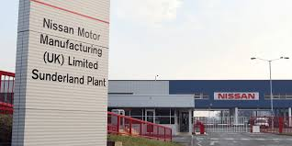
Figure 1: NMUK
Source: (Electrive, 2021)

2. External Environment Analysis

2.1 PESTLE Analysis
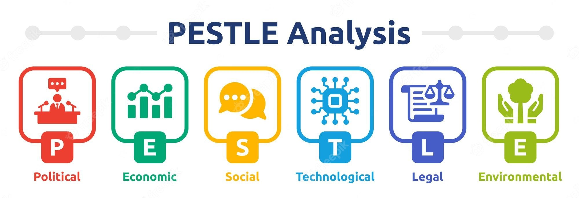
Figure 2: PESTLE Analysis
Source: (Mukherjee, 2023)
- Political Factors: Government policy has a significant effect on the UK automotive market. The UK had introduced Zero-Emission Vehicle (ZEV) directive, 80 percent of all new vehicle sales will be zero-emission in 2030 and 100 percent in 2035 (GOV.UK, 2024). To achieve this transition and as a component of this transition the government has spent over 2 billion pounds in EV infrastructure and manufacturing, and businesses are investing electric mobility. Nissan has responded by investing heavily in its Sunderland factory. However, these rules also make compliance costly and adapt the technology more quickly to the new rules.
- Economic Factors: Economically, the automotive industry has a great impact because it adds about 25 billion pounds to the UK economy and has about 183,000 employees in manufacturing (Blackie-Kelly, 2025). This contribution has seen the industry affected by inflation, rise in the costs of energy, and disruption of supply chains despite all this. During the process of investing in EV transformation, the UK car manufacturing sector reduced to approximately 905,000 vehicles in 2024, which shows the financial strain the sector has to deal with (ACEA, 2025).
- Social Factors: The increasing green awareness of the consumers has put a strain on sustainable movement. The low-emission vehicles receive an increased role in the list of factors among the consumers; thus, manufacturers are being forced to develop EVs and greener production processes at an expedited pace.
- Technological Factors: The sector is evolving because EV batteries, digital production, and autonomous tech are being introduced to improve the industry. Nissan EV36 Zero programme was a mix of EV manufacturing, battery manufacturing, and renewable energy infrastructure which was based at Sunderland (Nissan News, 2025a).
- Legal Factors: The stringent pollution standards and the phase out of petrol and diesel automobiles by 2035 require them to electrify the vehicle portfolios in a short period of time.
- Environmental Factors: Car manufacturers are forced to include carbon-neutral production and sustainable supply chain by climate policies and global decarbonisation goals.

2.2 Porter Five Forces Analysis
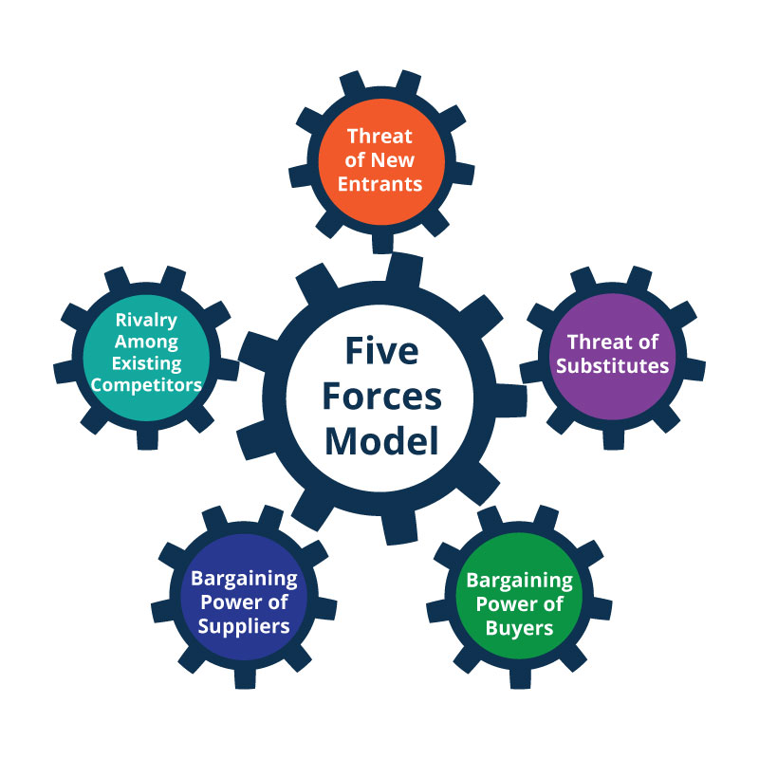
Figure 3: Porter Five Forces Analysis
Source: (Planium, 2021)
Competitive Rivalry – High
The competitor in the automotive industry is highly intense since it has international car manufacturers like Tesla, Volkswagen, BMW, Toyota and Jaguar Land Rover (Hong, 2024). These firms compete on EV innovation, price and brand name. With the UK vehicle production reaching about 905,000 vehicles in 2024, manufacturers are very competitive to remain in the market and technologically at the leading edge in the highly expanding EV market (Jolly, 2025).
Threat of New Entrants – Low
The barriers to entry in the auto industry are so high. Establishing the manufacturing facilities is costing in billions of pounds, engineering quality and compliance with strict regulatory criteria. All these barriers significantly decrease the type of new entries in a market but disruptive companies like Tesla show that technology can at times displace well-established manufacturers.
Bargaining Power of Suppliers – Moderate
Automotive manufacturers have specialised suppliers of semiconductors, lithium-ion batteries, and advanced electronics. The recent shortages in semiconductors evidenced lack in global supply chain (Trovão, 2023). To reduce the dependency, similar producing firms like Nissan are also investing in local battery production and supply chain resiliency.
Bargaining Power of Buyers – Moderate
Consumers have numerous options in the market as to what to purchase. However, the brand recognition, technological advancement and product differentiation reduce the overall bargaining power amongst the buyers.
Threat of Substitutes – Moderate
The alternative ways of transportation include public transport, ride-hailing, and mobility-as-a-service, although a car is something that many consumers cannot do without.

3. Internal Environment Analysis

3.1 Value Chain Analysis
The Nissan values chain identifies the operational effectiveness and technological innovation as that which contributed to its competitive advantage. The company predominantly aims at mass production within the Sunderland plant that is the largest car making plant in the UK with an office amounting to approximate 6,000 making approximately 284,000 cars annually (Rane, 2025). The plant manufactures some of the best model like Nissan Qashqai, Juke and Leaf and can manufacture as many as 600,000 in a year. Efficiencies in operations are high due to the degree of automation, robotics, and digital systems of production that enhance productivity and reduce operation costs.
The support activities also improve the value creation in Nissan. Its high-level investments in research and development, sourcing networks and technological innovation make it possible to continue to progress in car design and production efficiency. These integrated value chain activities enable Nissan to be in a stronger position of delivering high quality motor vehicle at reduced expenses.

3.2 Resource-Based View (RBV)
Resource-Based View emphasises on how distinctive organisational resources help firms to achieve a sustainable competitive advantage. There are strategic assets that lead Nissan in its competitiveness in the global car market. Firstly, the organization possesses excellent electric automobile technology that has been developed using both research and innovation thus has made Nissan a pioneer in the supply of mass market electric cars, particularly through the Nissan Leaf, one of the best vehicle models in the world to be sold (Cabigiosu, 2022).
Second, Nissan has a boast of good world brand image, which has been attained over several decades because of the reliability of its products and technological advancements. Third, Renault-Nissan-Mitsubishi Alliance has immense strategic advantages in the aspect of combined research, worldwide production and economies of scale (Warner, 2024). All these have contributed to the potential innovation of Nissan, its efficiency and competitiveness in the global marketplace.

4.3 VRIO Analysis
Table 1: VRIO Analysis
Resource | Value | Rarity | Imitability | Organisation
EV manufacturing capability | High | Moderate | Difficult | Strong
Global alliance network | High | Rare | Difficult | Strong
Brand reputation | High | Moderate | Moderate | Strong

The VRIO model has indicated that not all the resources of Nissan possess sustenance of competitive advantage. Its potential to produce an electric car is also quite nice as it allows the company to shift towards electrification in a strategic way, when other companies slowly enter the use of similar technologies (Nissan, 2022). A set of resources known as Renault-Nissan-Mitsubishi Alliance is hard to duplicate and that can be described as scarcity of sharing technologies, economies of scale, and worldwide product production. In addition, Nissan also enjoys a favourable brand that enhances the positioning and consumer trust. As these resources have the organisation systems, they can assist Nissan to utilise its resources well and remain top in most of the dynamic car industry.

5. SWOT Analysis
Table 2: SWOT Analysis
Strengths | Weaknesses
Largest UK car manufacturing plant with capacity of 600,000 vehicles annually | Production below capacity with ~284,000 vehicles produced in 2024
Early EV pioneer with over 282,000 Nissan Leaf units produced in Sunderland | High investment costs associated with EV transition
Strong global alliance with Renault–Nissan–Mitsubishi supporting innovation and economies of scale | Dependence on global supply chains and semiconductor availability
Opportunities | Threats
Rapid growth of EV market supported by UK ZEV mandate and £2 billion EV investment | Intense competition from Tesla, Volkswagen and other EV manufacturers
Government incentives and rising demand for sustainable mobility | Supply chain disruptions and rising raw material costs

The SWOT analysis reveals that Nissan possesses viable strategic strength, especially its giant size factory at Sunderland and pioneering efforts in electric cars. By producing over 282,000 Nissan Leaf EVs, Nissan can place itself in the market and technologically (Nissan Global, 2026). However, the EV transition will be expensive, and it will create a burden and operational risks on the finance. Serious governmental policies, such as the Zero-Emission vehicle policy and national electric vehicle investment programmes are also favourable as chances that have led to the uptake of electric mobility. However, Tesla and Volkswagen are also raising technological competition among the manufacturers in a very competitive industry. The disruptive variability of raw material prices and issues with the global supply chain have also become operational risks that Nissan must efficiently manage so that it can effectively create less competitiveness in the long-term.

6. Strategy Formulation

Strategy 1 – Expansion of Electric Vehicle Production
The manufacturing of electric vehicles (EV) at the Sunderland plant is one of the strategic interests of Nissan UK. The company has already strongly invested in the EV36Zero scheme which aims at transforming Sunderland into a full electric vehicle factory (Tees Valley Lithium, 2025). There will also be the introduction of three new models of electric vehicles that will be produced in the UK, which will strengthen Nissan in the rapidly expanding market of electric cars. This proposal will be in line with the UK government mandate that by 2030 and 2035, all new cars sold are electric by 80% and 100% respectively. The evolution of EV production would introduce additional consumers who need sustainable mobility to Nissan and stay viable to compete with the crucial EV manufacturers Tesla and Volkswagen. Furthermore, a dedicated manufacture of EVs will also offer Nissan the means to use its existing manufacturing base and technological expertise acquired during the successful manufacturing operations of over 282,000 Nissan Leaf vehicles in its plant in Sunderland.

Strategy 2 – Battery Manufacturing and Supply Chain Integration
Nissan spends on establishment of battery manufacturing ecosystem at Sunderland to support the growth of EVs. Construction of a battery gigafactory will supply approximately 300,000 electric vehicle batteries annually, making the supply chain of the whole Nissan more resilient (Nissan News, 2025b). This strategy will reduce its dependence on external supply and the threats associated with global semiconductor and battery shortage that has already disrupted automotive manufacturing globally. Additionally, the localised battery production will add value in cost-efficiency and better technological relationship in Renault-Nissan-Mitsubishi Alliance which helps in innovation and economies of scale.

Strategy 3 – Sustainable Manufacturing Strategy
Long term competitive advantage at Nissan is being spelt out by sustainable manufacturing practices. Nissan can also compensate the global climate commitment and the demands of the stakeholders in the form of a carbon-neutral production process, use of renewable energy, and a circular system of the supply chain (Hao et al., 2024). The functions enhance the image of corporations, reduce environmental liability and the ability of the firm to compete in a dynamically evolving industry of sustainability.

7. Conclusion and Recommendations
The discussion shows that the radical change in the UK auto industry is taking place because of the electrification, sustainability programs, and technological development. Nissan UK has great strategic competencies of its big Sunderland manufacturing facility and its early adaptation and implementation of the electric vehicle technology that has positioned in it well in the evolving electric vehicle market.
However, the growing competition, the weakness of the supply chain and its higher cost of transition require appealing strategies. To become a competitive company in the long term, Nissan should speed up the development of electric vehicles manufacturing, expand its battery production base to increase the system resilience of supply chains, and develop sustainable manufacturing and the cyclic supply chain to become a carbon-neutral mobility industry leader.

8. References
ACEA (2025). Economic and Market Report: Global and EU auto industry – Full year 2024. [online] ACEA - European Automobile Manufacturers’ Association.
Available at: https://www.acea.auto/publication/economic-and-market-report-global-and-eu-auto-industry-full-year-2024/.
Alharbi, I.B. (2024). Strategic management: A comprehensive review paper. International Journal of Professional Business Review: Int. J. Prof.Bus. Rev., [online] 9(3), p.8. doi: https://dialnet.unirioja.es/descarga/articulo/9399293.pdf.
Blackie-Kelly, C. (2025). UK automotive sector gains £2.5 Billion boost for advanced manufacturing and EV innovation.[online] Automotivemanufacturingsolutions.com.
Available at: https://www.automotivemanufacturingsolutions.com/strategy/uk-auto-sector-set-to-receive-25-billion-boost-from-government/645445.
Cabigiosu, A. (2022). Sustainable development and incumbents’ open innovation strategies for a greener competence‐destroying technology: The case of electric vehicles. Business Strategy and the Environment, 31(5). doi: https://doi.org/10.1002/bse.3023.
GOV.UK (2024). Pathway for zero emission vehicle transition by 2035 becomes law. [online] GOV.UK. Available at: https://www.gov.uk/government/news/pathway-for-zero-emission-vehicle-transition-by-2035-becomes-law.
Hao, X., Wang, H., Zheng, Y., Lin, Y., Han, S., Zhong, R. and Li, J. (2024). Toward Carbon Neutral Road Transport: Development Strategies and New R&D Organizational Paradigms. Automotive innovation. doi:https://doi.org/10.1007/s42154-023-00246-z.
Hong, J. (2024). Competitive Strategies and Market Positions of Global Automotive Giants: Toyota, Tesla, and BMW. Modern Management Science & Engineering, [online] 6(2), pp. p53–p53. doi: https://doi.org/10.22158/mmse.v6n2p53.
Jolly, J. (2025). UK car production falls to lowest level since 1954. [online] the Guardian. Available at: https://www.theguardian.com/business/2025/jan/30/uk-car-production-falls-to-lowest-level-since-1954.
Mukherjee, A. (2023). PESTLE Analysis. [online] Medium. Available at: https://medium.com/@anirbanmukherjee1311/pestle-analysis-c6b822164d4.
NEAA (2024). Nissan Motor Manufacturing (UK) Ltd - North East Automotive Alliance (NEAA). [online] North East Automotive Alliance (NEAA). Available at: https://northeastautomotivealliance.com/directory/nissan-motor-manufacturing-uk-ltd/.
Nissan (2022). Sustainability Report 2022 | Sustainability | Nissan Motor Corporation Global Website. [online] www.nissan-global.com. Available at: https://www.nissan-global.com/EN/SUSTAINABILITY/LIBRARY/SR/2022/.
Nissan Global (2026). The All-New LEAF: A truly global EV | Stories | Nissan Motor Corporation Global Website. [online] Nissan-global.com. Available at: https://www.nissan-global.com/EN/STORIES/RELEASES/the-all-new-leaf-a-truly-global-ev/ [Accessed 13 Mar. 2026].
Nissan News (2025a). Next generation Nissan LEAF brings EV36Zero vision to life at Sunderland Plant. [online] Official Great Britain Newsroom. Available at: https://uk.nissannews.com/en-GB/releases/next-generation-nissan-leaf-brings-ev36zero-vision-to-life-at-sunderland-plant.
Nissan News (2025b). SK On and Nissan Announce Battery Supply Agreement to Support Future EV Production in America. [online] Official U.S. Newsroom. Available at: https://usa.nissannews.com/en-US/releases/sk-on-and-nissan-announce-battery-supply-agreement-to-support-future-ev-production-in-america.
Planium (2021). Porter’s Five Forces Analysis: Assessing The Competitive Environment. [online] Planium Pro. Available at: https://www.planiumpro.com/blog/porters-five-forces-analysis-assessing-the-competitive-environment/.
Rane, A. (2025). The UK’s biggest car factory with 6,000 employees given major lifeline after £3.8bn loss. [online] Express.co.uk. Available at: https://www.express.co.uk/life-style/cars/2147465/uks-biggest-car-factory-6000 [Accessed 13 Mar. 2026].
Tees Valley Lithium (2025). Tees Valley Lithium. [online] Teesvalleylithium.co.uk. Available at: https://www.teesvalleylithium.co.uk/news-and-updates/ev36zero-the-future-of-nissan.
Trovão, J.P. (2023). Exploring Current Automotive Industry Trends [Automotive Electronics] | IEEE Journals & Magazine | IEEE Xplore. [online] ieeexplore.ieee.org.
Available at: https://ieeexplore.ieee.org/abstract/document/10375860/.
Warner, J. (2024). Renault-Nissan-Mitsubishi alliance: what you need to know. [online] IG.
Available at:https://www.ig.com/en/trading-strategies/renault-nissan-mitsubishi-alliance--what-you-need-to-know-230810.

