Rhys Whatty (1900045)

Book store Database design
ACCB4012 Information Engineering

Contents
Introduction 2
Database Design 3
Access Database 5
Initial Design 5
Forms and Reports 5
Querying and SQL 7
User Guide 9
Navigation 9
Main Menu 9
Table Forms 9
Adding and Deleting Records 9
Adding 9
Deleting 9
Editing a record 10
Conclusion 11

Introduction

This report covers the design and development of a database system for use in a bookstore that allows for the store to keep track of its books available, details on its customers and suppliers, and record all transactions made between the shop and clients.
The report displays the planning that went into creating the system, how many tables would be needed and what information that they will store, then proceeds to cover the database itself in access, detailing all the tables, forms that were used on the visual functionality, use of SQL in the creation of the database and reports generated from the entered data.
Also included in the report is a user guide which covers the functionality of the database, how to navigate around it and how to manipulate the tables in the database by being able to add, edit and delete records from them.

Database Design

Before constructing a database in access, a plan of what data would be stored on what tables, and how these tables would be linked up was created in Visio.

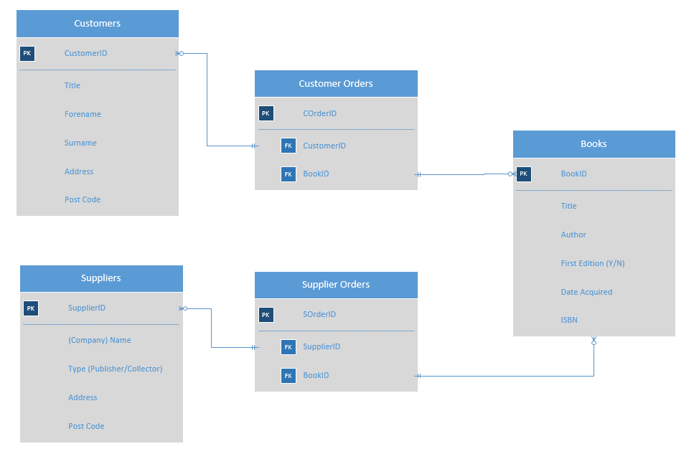

As displayed in the diagram above, the data has split up according to third normal form and displayed across a total of 5 tables. The central table is the table containing the information on the books that the bookstore has available. This information includes a Book ID value, to be used as a Primary Key and for use as a foreign key in tables that involve orders being placed. The table also stores the ISBN of the book; however, this is not used as the Primary Key because it is possible for 2 identical books to have the same ISBN number. Other information that is stored is the title of the book, the author, whether it is a First Edition and the date that it was acquired by the bookstore.
The two other main tables in the database are ones for the Customers and one for the suppliers. The customer table stores details on the customers, including a title, full name and address and postcode, along with a Customer ID for use as a Primary Key. The supplier table stores information on the Suppliers that provide books to the bookstore. This table includes the company name of the supplier, whether they are a publishing company or another book dealer, and the company’s address.
The 2 remaining tables store the information of transactions made with Suppliers providing books to the store in the Supplier Orders table, which contains and Order ID, the Supplier ID and a Book ID, and transactions made with Customers ordering or obtaining books from the store in the Customer Orders table, which contains another Order ID, the Customer ID and the Book ID.
As mentioned above, the table has been designed according to third normal form. This means that instead of storing everything on one table, the database makes use of Primary and Foreign keys to split the data up into various tables to eliminate repetition, reduce confusion of similar data appearing multiple times in the database and greatly reduce the chance of errors in the database due to not having to edit data in multiple locations should an edit need to be made.

Access Database

Initial Design

As seen on the section covering the design of the database, the database contains 5 tables linked by relationships. The Books table features a Book_No field to act as a primary key with a character limit of 5, which would allow for a capacity of 100,000 individual ID’s to be stored. The table also has an ISBN with a character limit of 17, which is the number of characters in a standard ISBN including hyphens (XXX-X-XXX-XXXXX-X). Another entry is an option to say if the book is a first edition, which has a 1-character limit to only allow for a Y/N response. The table also contains fields without exact character limits for the Title, Author and the date it was acquired.
The Customers table features a Customer_ID for a primary field, that has a character limit of 4, an option for a Title with a character limit of 5, as the longest option for this field is Other, and also a postcode with a character limit of 8, as that’s the longest possible Postcode (AA00 0AA). The table also contains fields for Forename, Surname and Address.
The Suppliers table is similar to the Customers table in which is has a Supplier_ID as a primary field and an option for a Postcode, with the same character limits as above, and also contains fields for Company name, whether they are a publisher or book dealer, and an address. The final 2 tables, for transactions between the shop and customers or suppliers, only contain an Order_ID, with a character limit of 4, a Book ID and Customer or Supplier ID as foreign keys to their respective tables.

Forms and Reports

The database contains 6 forms to navigate between. The first main form is a Main Menu that allows the user to navigate between all the 5 tables in the database and view 2 premade reports.
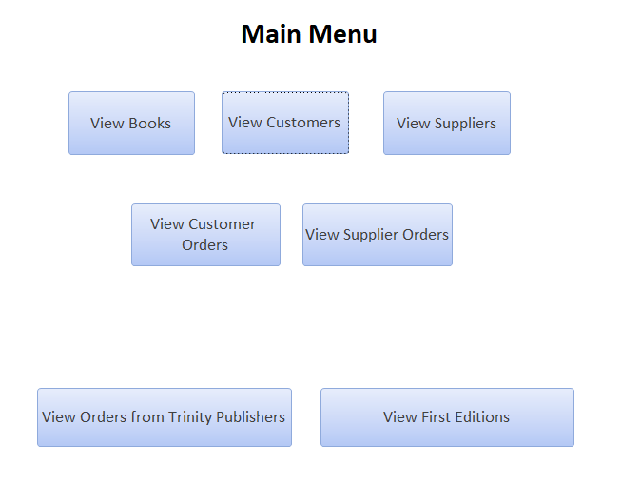

Each of the 5 buttons at the top half of the main menu will each lead to a form containing its respective table. All 5 of these tables are identical except for which table of information is being displayed.
As well as the table of information, the form included 4 buttons to navigate the records in the table, being the ability to go to the first record in the table, the last record in the table, and going to the next and previous record on the table. There are also 2 more buttons that allow user to add and delete records to the tables, and then one final button that closes the form and returns the user to the Main Menu.
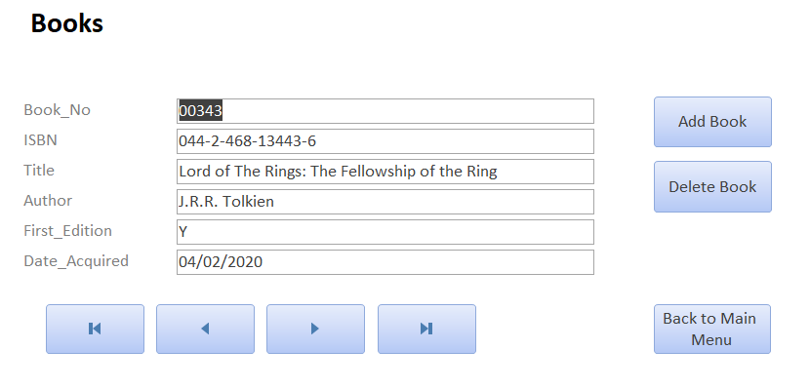
The forms that have been generated can also be accessed from the main menu and display all examples in the table of a certain criteria. The two that have been created are for displaying all orders from Supplier ID 0001 (pictured below) and displaying all of the books that are first editions.

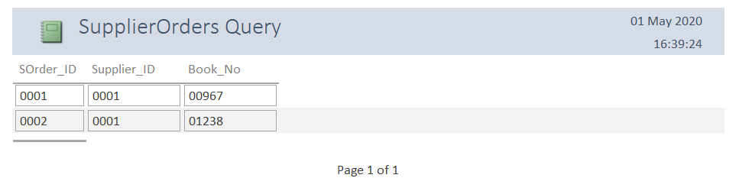

Querying and SQL

Several SQL queries were created in the process of building the database. SQL can be used to do certain tasks through writing a string of code and triggering it. SQL was used in the creation of the database for creating the tables by use of the CREATE command, which allowed for the table to be named, insert fields, place a character limit on the fields and set a field to be a primary or foreign key. Executing the code that generated the Supplier Orders and Customer Orders tables mean that the foreign keys are successfully assigned on generation of the table.
Here is a Relationship diagram of the tables linked together in Access after generating them.
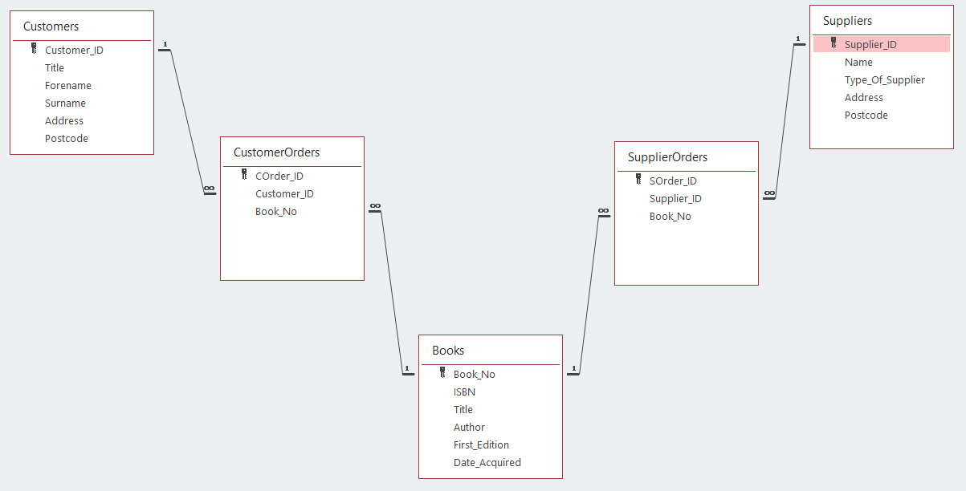

SQL was also used to add an entry to each of the tables once they were generated using the INSERT command. This command allows the user to insert values into the records into a field of a table. This command was used to enter one record into of the 5 tables. Below is an example of the entry into the Books table.

User Guide

Navigation

Upon bootup, the main menu form will be displayed, which can allow users to view any of the tables that store information, and view 2 pre-made forms of information inputted into the tables.

Main Menu
On the main screen, the first five buttons, which are marked ‘View Books’, ‘View Customers’, ‘View Suppliers’, ‘View Customer Orders’ and ‘View Supplier Orders’. These the button. Each of these pages contain a button labelled ‘Back to Main Menu’ that allows the user to close the current form and return to the main menu.

Table Forms
Within each of these pages, below the table display, are 4 buttons with arrows on them. These buttons are used to navigate the database table you are currently viewing. From left to right, the buttons will display the first record on the list, the previous record to the current displayed record, the next record to the current display record and the final record on the list. Attempting to move outside of the bounds of the table will issue a warning to the user. After the final record there will be a blank entry, which can be used to enter a new record, and this blank entry can be more easily accessed by pressing the Add button, covered in the next section of the guide.
There are 2 more buttons on the main menu which are labelled ‘View Orders from Trinity Publishers’ and ‘View First Editions’, which allows the user to view a report based on the descriptions of the buttons.

Adding and Deleting Records

Adding
When viewing a form featuring a table, it is possible to add a new record to the table by clicking the Add button on the right side of the page. The button will say what will be added to the table, so for example adding a record to the Book table means that the button will read ‘Add Book’.
When the Add button is pressed, all the boxes on the table will show up blank, allowing new values to be put into the table. The first box, labelled as an ID, is the Primary Key of each table, and as a result, there cannot be any duplicate values in this field, meaning an error will flag up if a duplicate value is entered.

Deleting
To delete a record from the database, first locate the record to deleted by navigating to the correct page and then using the navigation buttons to search the table for the record. Once the record has been found, click the Delete button on the right side of the page, below the Add button, to remove the record from the database.

Editing a record
If the user wishes to edit a record on the database, first the record must be located on the correct table. Once the record has been located, simply edit the text in the box of the field you wish to edit, and the table will automatically update immediately.

Conclusion

The project functions to an effective level, and while there are a couple of things that could be added or changed in future, it works well to the brief that was required of the database. The database is very user friendly with all the pages clearly titled and all the buttons either having clear and concise descriptions of they do or are well indicated based on their location on the form as to their functionality. The process of adding, editing and deleting records from the tables is a simple method which is easily outlined on how to do and is also easy to execute.
However, as previously mentioned, there are a few changes and additions that can be made to the project to improve its efficiency for the bookstore in the future. For the forms displaying the tables of Customer and Supplier Orders, the addition of name-based fields as well as the Primary key ID would allow for ease of viewing the data and not having to remember which ID belongs to which Customer, Supplier or Book. The brief mentions the newsletter that the store releases quarterly with a list of all new available since the previous newsletter, and while this was factored into the database by having a date acquired tab on the Books table, a means of separating all the book acquired in the last 3 months automatically would greatly increase company efficiency.
A possibility that could be implemented in future could be a quantity count field added to the Books table, where instead of listing the same copies of a singular book multiple times, enter the book once and have the quantity value list how many the store has. This however would raise a major issue as this would mean that each copy of that book would not have a unique Primary key, so changes would have to be made to how the database works if that was a thing to be implemented.

