Project Management
Assessment 1
Essay

Student Name: Veronica Nita
Student ID: 2123371
Module Code: LCBB5005
Lecturer: Faizu Edu
Table of Contents
Introduction 3
Review of core elements and evaluation of the project plan 4
Conclusion 12
References 13

Introduction
To initiate any particular project, the first task is to plan for the project and evaluate each element of the project so that the project can be accomplished effectively at the end of the day (Campbell, 2014). This project-based essay will assess the concept of a new project considered by Google. From the case study, it is found that Google is on the way to launching a new project, and under this project, it has decided to establish its new headquarters which would be at King’s Cross in London. The timeframe of the £1 billion project is confined to the ensuing year and the project would include prime office space, accommodation, retail stores, training centers, and so on. This will be fully owned by the USA which will be the first building outside the USA. Besides, it will be the campus with the potential to house 7,000 Google employees. Considering the entire case study, this essay will focus on reviewing the core components of the project including budget, time, quality stakeholders, and risk factors. besides, the entire project plan will be evaluated considering the review.

Review of core elements and evaluation of the project plan
Review of core elements
A project consists of some particular components and their significance is realized when the project is going to be implemented (Campbell, 2014). From the brief scenario of Google’s case study, a clear observation has been presented, where the budget, costs, and some other relevant issues have been mentioned and discussed. Now, core elements are going to be reviewed before being utilized and implemented.
Project’s budget: It is a significant element of a project in which the total project’s expenses need to be completed over a specific period. In this case, the planner of the project needs to estimate the probable costs and the actual costs of the project (Hanioğlu, 2022). That is why it is considered a critical element of a project that needs to be initiated during the initial planning procedure. By presenting an effective budget, a project planner can determine the revenue needed to obtain the ultimate target of the project. If the planner, like Google’s headquarters project in London, intends to ensure success, it is quite crucial to consider some crucial and critical issues efficiently. Such as:
- Budget baseline: It is the baseline in a project’s budget that is regarded as the estimate of the entire project’s expenses that usually begins at the initial phase of the project (Lennon, 2021). For instance, Google’s headquarters project in London decided to invest £1 billion; based on this investment, it also expects that it would get a return from it. As Google’s budget is projected by £100 million, but only obtains by £85 million, the company can then sustain only a £15 million cut. If it is equivalent, then there will be break-even. Otherwise, Google can expect from its project budget that it will obtain a positive return from its investment.
- Analysis of cost variance: It is the divergence between actual and projected expenses in the budget. It is also crucial for project planners to find out the difference between these two issues so that proper or immediate actions can be undertaken in this field. For example-
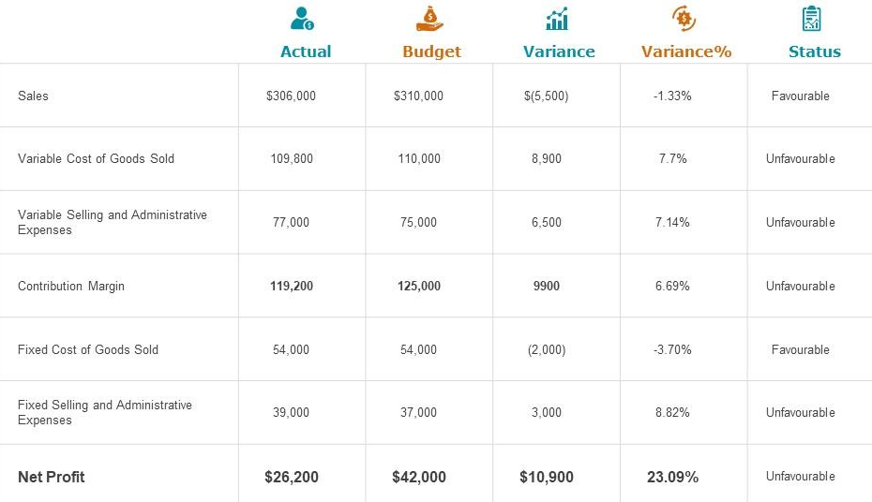
Figure 1: Variance analysis in a project
Source: (Hanioğlu, 2022)
- Cost forecast: Like the previous one, this section is considered by project planners for identifying the probable cost of the project because this can help realize whether the project should be undertaken or not. In the case study, different issues are related to the expenses (Hanioğlu, 2022). For example, expenses of the project include prime office space, accommodation across stores, events, a training center, cafes, gyms, multi-use games, a pool, a landscaped terrace, a running track, and so on. That means land, buildings, materials, equipment, machines, skills, staff, etc. need to be forecasted.
Project time: It is also an essential ingredient of a project because the project planner needs to complete the project within the deadline. The project’s timeline also follows the costs and relevant issues of the project that need to be accomplished within the deadline. To review the timeline or schedule, the first task is to emphasize the content that will be put in the schedule based on the entire project management plan (Maylor & Turner, 2022). In the case study, it is found that Google intends to launch its project in the next year and for this, the start date of the project needs to be specified correctly. The project planner keeps monitoring the entire project regarding its timeline from its starting date. That is why it is essential to set the start date correctly. Then, the sequence of tasks needs to be logical and consistent. Likewise, the first step of Google’s headquarters in London, UK is the contractual milestone and under this milestone, project commencement will be initiated at a particular date. Following this date, other relative steps need to be executed sequentially. For example-
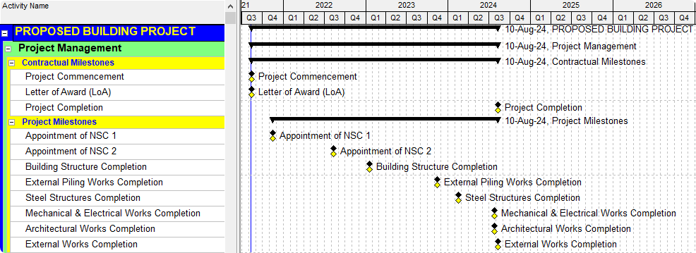
Figure 2: Schedule of a project
Source: (Maylor & Turner, 2022)
Quality: It is such sort of element in the project that can help identify the major causes of critical issues and complexities of a project so that detailed guidance can be obtained in terms of tracking the project efficiently. In addition, this can support inspecting a specific structure, defined goals or roles, as well as procedure designed so that a product’s completeness and adherence to the quality standards can be ensured. That is why it is essential to set criteria and goals or objectives initially as well as assess the effect and value of the review (Ingason, 2020). It is the quality management of a project that is considered as a procedure of estimating the overall quality of all functions and adopting appropriate actions until the team can obtain its expected quality in the project and for this, the cost of a project is usually controlled. In this project quality management, three different aspects or issues can help review the quality of the project, like Google’s headquarters in London, UK. Such as:
- Quality plan: This plan is like other planning activities that include inputs, methods skills, and outputs. The first issue is inputs that include quality strategies, scope statements, production introductions, standards and rules, and the output of another program (Ingason, 2020). From the aspect of the case study of Google’s headquarters, quality strategies need to be implemented that can support accelerating and conducting the project efficiently. Then, it must prepare a document that can aid in defining the boundaries and limitations of the entire quality of the project. Product introductions are also essential, as these can provide a clear and deep insight into the project. In this field, it is essential to clearly define and introduce the product efficiently so that proper standards and rules can be ensured or specified (Dupont, 2019). Such as, Google decided to set up a new building as a headquarters for the first time in the UK. In this case, its project planner needs to specify the core product that also needs to be introduced effectively. Moreover, to implement quality planning efficiently, the output of other functions also needs to be assessed, especially those that are relevant to the project. In this quality planning, appropriate methods and skills need to be specified, as these issues will execute the entire quality plan, and for this, the project planner needs to analyze the benefits, basic level standards, flow charts, and test designs.
- Quality assurance: Like planning, this quality assurance phase will have three distinct issues. Likewise, in inputs, quality management plans, control test outcomes, and operations need to be defined and specified (Ingason, 2020). Then, methods and skills, quality inspections, etc. following the charts and test designs can also help represent this field. The outcome of this quality assurance of the project will be quality improvements.
- Quality control: In this phase, work results are quite essential because this can aid in tracking and controlling the entire quality of the project. In the case of methods and skills, proper inspections can support controlling the quality through the accomplishment of control sheets, pilot charts, sample statistics, flow charts, and trend analyses. In this case, ultimate outputs will include quality improvement, acceptable decisions for the project, like Google’s headquarters, inspection sheet after completion, and then debugging.
Stakeholders
Stakeholders in the project have an interest in completing a specified project and can impact the project, especially in managing the project. Without these stakeholders, a project cannot be completed (Willert, 2019). That is why their participation is quite a beggar description and this can support bringing several benefits to the project. Besides, stakeholders can indulge in adopting appropriate decisions for the business regarding the decision-making procedure and the effect of the organization’s actions. Considering the case study of Google and its project, different stakeholders need to play their distinct roles and responsibilities. Now, those roles and responsibilities. Such as:
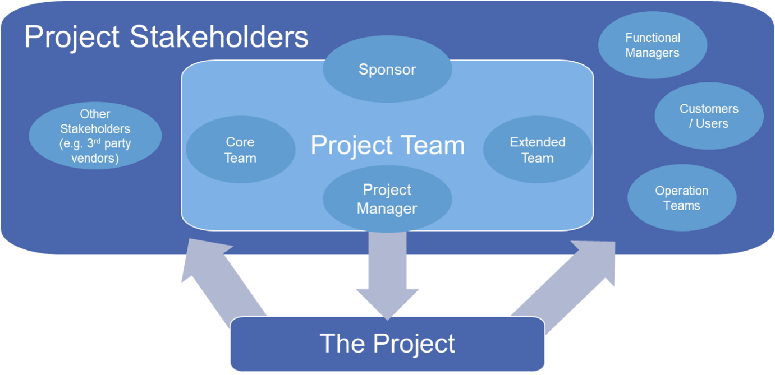
Figure 3: Project stakeholders
Source: (Dupont, 2019)
Internal stakeholders
These stakeholders are found in the business, like employers, employees, managers, supervisors of the project’s team, etc. Google is going to launch a new building or headquarters in London, UK and for this, project teams need to be formed who keep executing each phase of the project and monitoring or tracking the project till the completion of the project (Ponnappa, 2014). They have distinct onuses that need to be conducted appropriately because their efficiency in conducting responsibilities can aid in obtaining the ultimate objective of the project. So, their roles are going to be assessed in this case:
Project manager: A project manager needs to focus on planning and developing the idea or concept of the project in such a way that can help start the project as an idea. Then, it is also required to create and lead the team appropriately. The project manager also indulges in monitoring the progress of the project considering the fixed deadlines of the project (Dupont, 2019). In this case, he or she also needs to come ahead in terms of resolving divergent issues. Sometimes, project managers in the business, like Google can be found in managing money or money-related issues and ensuring other stakeholders’ satisfaction. Finally, their ultimate role is to evaluate the project and its performance.
Sponsor: From the investigation, it is found that a project usually has three major responsibilities. To begin with vision and people, the sponsor usually needs to align the project with business objectives, strategies, techniques, and so on (Fusaro, 2023). In addition, they are to emphasize the existing governance of the project which they need to ensure that the project is launched and executed appropriately (Lang, 2020). Finally, their ultimate responsibility is based on ensuring value and benefits. In this case, they need to manage risks and divergent changes, while ensuring the quality of the project.
Other teams: Core teams in a project usually work under the supervision of a project manager who is determined to move toward the solution of objectives. Then, they are to complete tasks in relevant fields of expertise. In the case of Google’s headquarters project, this core team will also indulge in delivering project responsibilities within deadlines and communicating with the project lead on roadblocks (Willert, 2019). On the other hand, the extended team will work as an internal team that will concentrate on delivering the project for which it is not viable to recruit members perpetually. For instance, the project manager of Google’s headquarters project can delve into the case of an extended team, as it is a form of outsourcing that includes proximity, communication, and other cooperation.
External stakeholders
This kind of stakeholder has an interest in ensuring either the success or failure of a specific project plan without being involved directly in the project. They have also some specific and significant effects on the overall business performance (Fusaro, 2023). Likewise, functional managers can indulge in assisting the project and evaluate the entire effectiveness and quality of the project and deliverable issues.
Risk factors
These lies in the project can endanger the project’s result, especially whether the project planner will obtain success or not depending on the level of risks. Different external factors including any issues or events can threaten the project’s completion. More or less, three major risk factors for each project’s objectives are usually found (Kendrick, 2015). First of all, cost-related risks insist on reworking an error or emerge from an underestimation of the time of completion, poor site management, and so on. Then, quality-related issues include fluctuation in material prices, poor supervision, lack of consultant experience, and so on. Finally, time-related risks include inadequate project management, late funding, rework due to error, late delivery of material, and shortage of skilled laborers.
Considering the required project, some potential risks are presented below:
Budget | Strategic value | Complexity | Failure effect | Ability to deliver
The projected cost may be less than the actual cost of the project which may accelerate the burden of additional costs (Kendrick, 2015) and for this, the project may not bring positive results. | The importance to the company, as this can often be estimated by the management level involvement. | The simplest measure of complexity is the number of operation operational areas required to deliver the project. | The cost to the organization, if the project fails preferably in monetary terms. | The question is whether the business can work with partners or expand the available resources to complete the project within the set timeframe (John et al., 2019).

How to evaluate the project plan
To evaluate any sort of project, three different phases are usually considered; based on these phases, the project planners are to evaluate the entire project significantly.
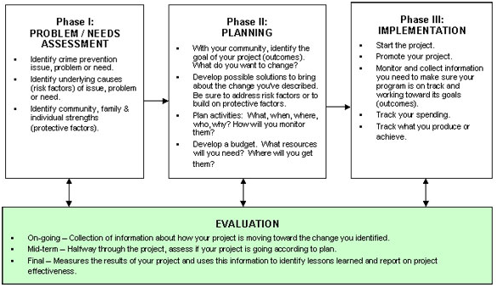
Figure 4: Project evaluation processes
Source: (John et al., 2019)

Conclusion
The entire report is based on reviewing the core elements of a project and that is why this review has considered the case study and scenario of Google’s headquarters operation in London, UK. In this case, project planning, quality, time, cost, budget, and risk factors have been assessed. In terms of reviewing some particular issues have been emphasized.
Recommendations
- The project planner in Google should prepare an effective budget and schedule at the initial level,
- The company should urge or insist on forming different teams as well as encourage other stakeholders to be involved efficiently,
- The project planner should consider the risk and estimate an appropriate risk assessment; considering this, project teams should be instructed to deliver effective performance.

References
Campbell, G.M. (2014) Project Management. Indianapolis, IN: Alpha, a member of Penguin Group (USA) Inc.
Dupont, D. (2019) A qualitative case study on how to use Project Benefit Managers to ensure benefit realization [Preprint]. doi:10.4135/9781526467690.
Fusaro, F. (2023) 8 project team roles for successful Digitalization projects, MoreThanDigital. Available at: https://morethandigital.info/en/8-project-team-roles-for-successful-digitalization-projects/ (Accessed: 01 December 2023).
Gurley, D. (2023) Program manager vs. project manager: What is the difference? (2023 guide), MarketWatch. Available at: https://www.marketwatch.com/guides/business/program-manager-vs-project-manager/ (Accessed: 01 December 2023).
Hanioğlu, M.N. (2022) ‘Project Cost Budget’, A Cost-Based Approach to Project Management, pp. 120–138. doi:10.1201/9781003172710-8.
Ingason, H.T. (2020) ‘Operation of quality management systems’, Quality Management, pp. 133–161. doi:10.4324/9781003003137-8.
John, D., Suzanne, S. and Jonathan, R. (2019) ‘4 project risks’, International Project Finance [Preprint]. doi:10.1093/law/9780198832850.003.0005.
Kendrick, T. (2015) Identifying and managing project risk: Essential tools for failure-proofing your project. New York: American Management Association.
Lang, I. (2020) The importance of sponsorship in delivering better project outcomes, International Airport Review. Available at: https://www.internationalairportreview.com/article/117471/project-sponsorship-model-airport-benefits/ (Accessed: 01 December 2023).
Lennon, C. (2021) ‘Project Budgetary Management’, The Silver Bullets of Project Management, pp. 72–74. doi:10.4324/9781003188964-8.
Maylor, H. and Turner, N. (2022) Project Management. Harlow, England: Pearson.
Ponnappa, G. (2014) ‘Project Stakeholder Management’, Project Management Journal, 45(2). doi:10.1002/pmj.21400.
Roeder, T. (2013) Managing project stakeholders [Preprint]. doi:10.1002/9781118654491.
Willert, S. (2019) Standard Design Review Process for engineering projects, Powerful extensions for engineering tools. Available at: https://www.sodiuswillert.com/en/blog/standard-review-process-engineering-project (Accessed: 01 December 2023).

