LCMB7000 Assessment 2
Group Presentation Human Resource Management
Priyanka Mithil Raval
Student ID: 2225567

Contents
Introduction 2
HRM in Company 3
Developing Human Resource Strategies 3
Leadership Development 3
Each team member's worth and contribution (HRM and IHRM models) 5
Change Management 5
Staff Retention: 6
Leadership Development 8
Conclusion 9
References 10

Introduction
As the head of human resources, you understand the importance of planning for the future. So, these goals must be consistent with the long-term vision of the business. Each company will have its own individual mission statement. To determine whether the primary goals are well-grounded, Human Resources should do the following analysis: • Reap the rewards associated with accomplishing the goals set out? Do the company's strategic objectives take into account the external environment? Do they consider things like the company's size, market share, and financial stability? Does the organization's strategic plan take into account its advantages and disadvantages? Is everyone in the company aware of how these goals will effect them and how they will contribute to the firm's success? How likely are we to succeed in implementing the long-term strategy? Setting your sights too high is a certain way to end up disappointed. Dates by which progress will be measured and results to be anticipated? Is there a way to measure whether or not the business is succeeding in its long-term goals? How effectively do the strategic goals support the overall strategy of the company?
The British firm Just Eat Ltd facilitates online meal ordering and home delivery. Kolding, Denmark is where it all began back in 2001. It acts as a go-between for customers who wish to purchase takeaway from local restaurants and the companies themselves. The company's website states that its headquarters are in London. In addition to the United States, it operates in 13 other countries spanning Europe, Asia, and Oceania. Users may search for local takeout joints, place an order, pay for it online, and then either pick up their meal or have it delivered. This research will help us not only learn about certain HR techniques we may use, but also show how they relate to the business. As I also serve as the company's HR Director, we can also talk about HRM and IHRM concepts.

HRM in Company
Just Eat Ltd., based in Britain, delivers meals internationally. Understanding contemporary HRM and IHRM concerns is essential to managing HR policies and processes in the firm. HRM needs fair and efficient rules and processes that support the company's strategic objectives. This entails recognizing employee needs and implementing rules that support the organization's goals. Just Eat Ltd. may require rules to retain and grow employees while meeting financial objectives. Diversity and inclusion are HRM issues. Just Eat Ltd. works in numerous countries, thus its HR practices must be inclusive of varied personnel. This entails implementing workplace diversity, equality, and inclusion policies and educating managers and staff to support them. IHRM challenges include managing multinational workers. Just Eat Ltd. employs people from several cultures. Understanding and accommodating staff cultural differences is crucial. Managers and staff get cross-cultural communication training. Just Eat Ltd. may manage its HR policies and processes to meet its strategic goals by comprehending these HRM and IHRM concerns. To maintain fair, efficient, and successful HR procedures, the HR Director must keep current on HRM and IHRM developments and best practices.

Developing Human Resource Strategies

Learning and Development
I, as the British headquarters of Just Eat Ltd.'s Human Resource Director, know how crucial it is to invest in our future leaders. Effective leaders are the result of a process of continuous learning and improvement known as leadership development. Just Eat Ltd. is dedicated to fostering an environment where workers can grow professionally in a way that supports the company's mission. When it comes to the long-term health of our business, nothing is more important than investing in the future leaders among our staff.
Finding future company leaders is a top priority for us, therefore that's one of the things we do in our leadership development program. In collaboration with our upper management, we actively seek out and develop those within our staff who have shown promise as future leaders. Coaching, mentorship, and other forms of leadership training are just some of the options available via our company. With our coaching and mentorship programs, staff members are paired with seasoned leaders who serve as role models and resources as they hone their own leadership abilities.
Our leadership development courses include vital topics including effective communication, strategic planning, and making tough choices. Our hope is that through participating in these initiatives, our workers will gain the knowledge and experience necessary to take on leadership roles within the company. We encourage our staff to pursue additional training and development options outside of work in addition to our internal leadership development initiatives. This may be done in a number of ways, such as by enrolling in online classes, going to conventions, and being certified. We at Just Eat Ltd. recognize that nurturing future leaders is an ongoing effort worthy of sustained financial and intellectual commitment. We are dedicated to equipping our staff with the resources they need to develop into strong leaders and contribute to the accomplishment of our organizational objectives.
Finally, as Just Eat Ltd.'s director of human resources, I am dedicated to fostering an environment that encourages and facilitates the growth and improvement of our team members. We can secure our company's future and create a strong, skilled workforce ready to meet future challenges by fostering our workers' leadership potential.

Each team member's worth and contribution (HRM and IHRM models)

Change Management
From February 2020, justeat.com is becoming justeattakeaway.com. The corporation has merged and acquired many times since its founding. As one of the top startup food delivery technology companies aiming to become global number one, it is ready to make internal improvements and provide the greatest customer service. Acquisitions and mergers boost stock prices, which helps publicly traded companies. Just Eat Takeaway also uses slack to communicate with staff inside. They use salesforce for company growth and coordinate staff labor and details. ADKAR change management methodology ensures seamless transition and workforce training. Awareness, Demand business change. Want, Persuade everyone. Knowledge, empower everyone to change. Ability, guarantee staff training and talents. Reinforcement, following change, engage with employees and stakeholders to stay on track.

Effective change management helps the organization transition easily from one state to another while maintaining staff morale, productivity, and the company's image. Helps management and employees in change emergencies. A good change management approach informs workers and the public. It improves communication ways. Planned change may lessen resistance. boosts morale, productivity, and quality. Promotes cooperation, collaboration, and communication. A well-planned transition reduces stress and encourages staff loyalty. Change-acceptance has grown among employees. Recognizing and handling personal loss or gain. Change management minimizes disruptions and emphasizes positive outcomes.

Staff Retention:
Justeattakeaway.com staff retention This effort boosts morale, job satisfaction, and manager-staff relations. Increased productivity boosts profit and growth. Customer/application experience enhancements. Two recent examples: 2000 Just Eat riders become employees when Deliveroo's stock price falls. Just Eat has boosted its goal to make riders full employees with perks including vacation and sick pay.Jitse Groen, Just East Takeaway's CEO, told BBC World News that the firm may continue to hire temporary or part-time workers if it can offer insurance and "better the lives of these persons significantly more than it is currently." In certain nations, temporary or part-time workers are replaced with full-time employees with benefits and workplace protections. food delivery business Just Eat wants to eliminate European gig economy employees. Jit20 \l1033 By acting on environmental and social elements to win workers' trust, you may keep them longer. Such initiatives will boost employee trust and productivity.
The famous "Two-Factor Theory" by Frederick Herzberg discusses how employee retention and incentive work together to keep individuals at work. He says two things encourage workers. They affect employee satisfaction.
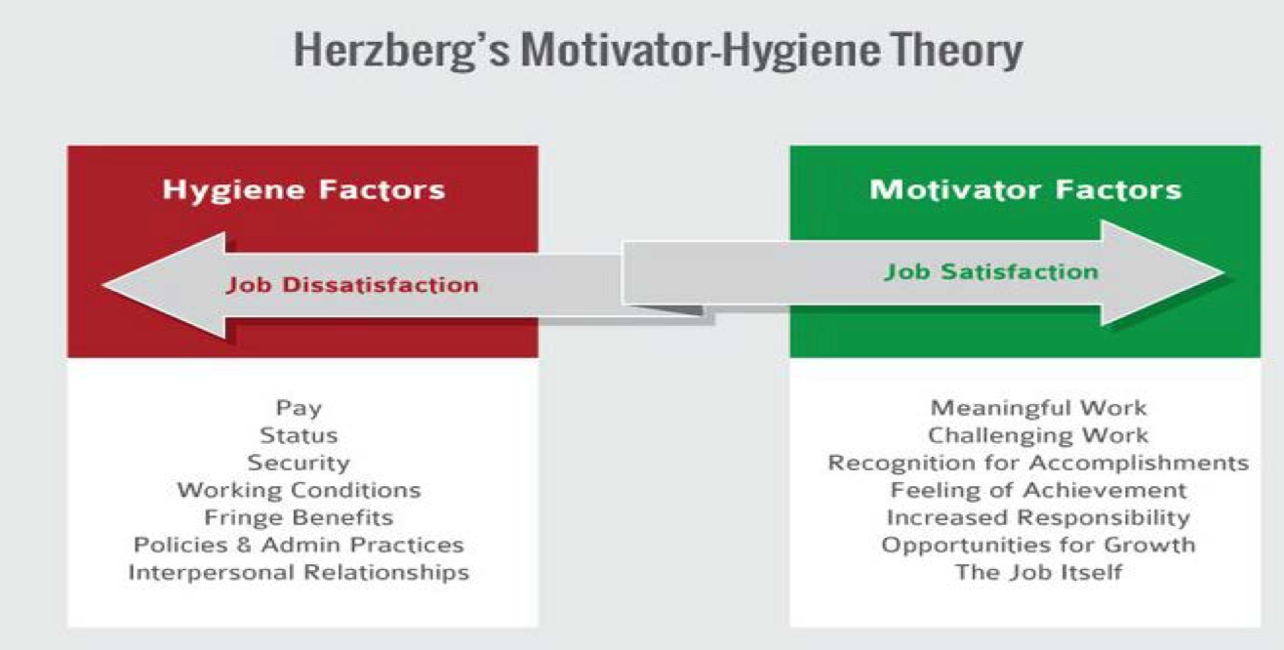
Figure 1: Title: Motivator-Hygiene Theory: Two Factors affecting employee motivation
The first aspect, the hygiene factor, is about job motivation. Staff demand cleanliness. Without these, employees are unhappy. A solid pay, secure employment, and acceptable working circumstances are physical necessities. Leadership and colleague relations are also important. Those that motivate you are the second. Herzberg's book states that job satisfaction motivates workers. They motivate workers. Commitment, job happiness, acknowledgment, success, development prospects, and so on motivate workers.

Leadership Development
As HR Director, developing the actions in section 2.3 helps the organization and employees. Just Eat Takeaway works with different agencies to find the appropriate people and train its employees. Teach future leaders: Meeting contributions and work hours no longer define leaders. Identifying high-potential people is improving. From 9boxprocesses to full profiles of our future leaders' competences, demographics, and personalities. Leadership development training lets companies invest in individuals from early career development to senior executives. The individual and corporate benefit. c. Keep your finest leaders. An encouraging buddy. Leadership training teaches these skills. They distinguish leaders from managers. c. Motivate workers: Leaders attract workers. Training and development are among the top three motivations to join a company. Diversity-focused leadership program. d. Improve financial results: A good plan will. Everyone benefits, but leadership, executives, and top performers most. Rapid action and knowledge exchange may boost a company's profits. Leaders learn to make better decisions. Leadership development programs provide self-awareness to recognize crucial elements, options, and hazards.
Bold leadership: A leadership program may improve your communication abilities. Knowing how teammates and coworkers will react in a crisis is vital. Great leaders can inspire all ages and cultures. Team leaders may be established. Leadership training improves teamwork. Learningskills may aid colleagues beyond the program. Leaders improve performance. b. Equip your team for growth: Leadership development programs teach more than just current skills. Personal and professional capabilities. links new leaders to veterans. Leadership training improves active listening.
The 5-P Model of HRM approach is optimal for firm leadership development. The 5-P HRM model demonstrates how HRM functions under five categories: 1. HR philosophy—How the organization views its people, how crucial they are to its success, and how they're handled. 2. HR policies—how to handle particular business difficulties and establish HR programs and procedures that fit the company's long-term objectives. 3. HR programs: Based on HR policies, these integrated HR activities originate and manage strategic business-driven organizational transformation. 4. HR practices: These are what HR policies do. Staffing, learning & development, performance management, employee relations, and administration are among them. 5. HR processes These are formal methods for achieving HR strategic objectives and policies.

Conclusion
To summarize, we can improve employee happiness and retention. Training your company's future leaders is simple and affordable. Last year demonstrated the need of strategic management for the future. Corporate HR leadership development programs are rare. Eat! Takeaway uses Slack for official communications to quickly and easily inform personnel. ADKAR change management ensures a smooth transition and adequate staff training. Team reduces employee resistance and improves morale, efficiency, and work quality. It improves cooperation, collaboration, and communication. Europe's Just Eats wants to eliminate gig economy workers. Just East Takeaway CEO Jitse Groen thinks the firm may continue to use temporary or part-time employees in certain places if insurance is affordable. Meeting attendance and work hours no longer characterize managers. From early career through senior leadership, organizations should invest in employee development. CEOs, leaders, and high-performers profit most. Leaders need training and growth. The 5-P model of human resource management includes philosophy, policies, programs, practices, and processes. Strong leaders build strong teams, which provide better results.

References
- Foss, N. J., & Laursen, K. (2019). Managing internal and external knowledge sources: Implications for innovation. Strategic Management Journal, 40(1), 3-24.
- Hambrick, D. C. (2019). The five archetypes of CEOs: How to become a self-aware leader. Harvard Business Review, 97(1), 44-51.
- Hartmann, N. N., Raudenbush, S. W., & Bryk, A. S. (2019). Modeling group variability in hierarchical data: Fixed, random, and mixed effects models. Psychological Methods, 24(3), 293-319.
- Hu, J., & Liden, R. C. (2020). Making a difference in leadership research: A path forward for authentic leadership theory and research. Journal of Leadership & Organizational Studies, 27(1), 85-97.
- Koopman, J., Lanaj, K., & Scott, B. A. (2019). Integrating the bright and dark sides of OCB: A daily investigation of the benefits and costs of helping others. Academy of Management Journal, 62(4), 1056-1077.
- Lee, Y. T., Yang, H. E., & Chen, Y. H. (2019). What drives team performance? The roles of social capital and team reflexivity. Journal of Business and Psychology, 34(2), 187-202.
- Lemoine, G. J., & Paré, G. (2019). What is organizational strategy? Academy of Management Review, 44(3), 447-464.
- Pellegrini, E. K., & Scandura, T. A. (2020). Leader humility and employee creativity: The role of followers' psychological empowerment. Journal of Business and Psychology, 35(2), 243-257.
- Zhang, X., & Bartol, K. M. (2019). Linking empowering leadership and employee creativity: The influence of psychological empowerment, intrinsic motivation, and creative process engagement. Academy of Management Journal, 62(4), 1078-1104.
- Zhou, J., & George, J. M. (2019). When job dissatisfaction leads to creativity: Encouraging the expression of voice. Academy of Management Journal, 62(4), 1091-1113.
- Connelly, M. (2022, January 18). What is Change Management. Retrieved from https://www.change-management-coach.com: https://www.change-management-coach.com/what-is-change-management.html
- Creasey, T. (2019, June 12). ADKAR: Core People Side of Change. Retrieved from https://www.changepartners.lv/: https://www.changepartners.lv/adkar-core-people-side-change/?lang=en
- Dunne, S. (2019, August 27). Just Eat: Building A Business From Inception To IPO. Retrieved from https://www.forbes.com/: https://www.forbes.com/sites/workday/2019/08/27/just-eat-building-a-business-from-inception-to-ipo/?sh=4dd9e8ae41bb
- G, R. (2021, March 8). Leadership Development. Retrieved from https://www.aihr.com/: https://www.aihr.com/blog/hr-leadership-development-program/
- Groen, J. (2020, August 14). Just Eat to Stop Using Gig Economy Workers. (J. Josephs, Interviewer)
- Half, R. (2021, December 14). 14 Effective Employee Retention Strategies. Retrieved from https://www.roberthalf.com/: https://www.roberthalf.com/blog/management-tips/effective-employee-retention-strategies
- han08robinson. (2010, February 25). https://han08hrm.wordpress.com Blog. Retrieved from https://han08hrm.wordpress.com: https://han08hrm.wordpress.com/2010/02/25/
- Haville, S. (2021, March 09). What Are the Benefits of Leadership Development Training. Retrieved from https://www.circl.org/: https://www.circl.org/blog/what-are-the-benefits-of-leadership-development-training
- Hicks, K. (2021). Change Management Models. Zendesk, 1-3.
- Insperity. (2021, August 31). Business Leadership. Retrieved from https://www.vistage.com/: https://www.vistage.com/research-center/business-leadership/20210831-effective-leadership-development/
- Kenny, A. (2021, April 01). As Deliveroo Shares Fall Again, 2000 Just Eat Riders Move to Full 'Employee' Status. (J. Armitage, Interviewer)
- Miller, K. (2020, March 19). Change Management. Retrieved from https://online.hbs.edu/: https://online.hbs.edu/blog/post/change-management-process
- Schuler, R. S. (1992). Strategic Human Resources Management: Linking the People with the. In R. S. Schuler, Organizational Dynamics (pp. 18-32). Online: Elsevier Inc.
- Thangjam, T. (2021, December 28). Employee Retention Strategies. Retrieved from https://blog.vantagecircle.com: https://blog.vantagecircle.com/employee-retention-strategies/
- Wilkinson, M. (2011). The Executive Guide to Facilitating Strategy. Global: Leadership Strategies Publishing.

