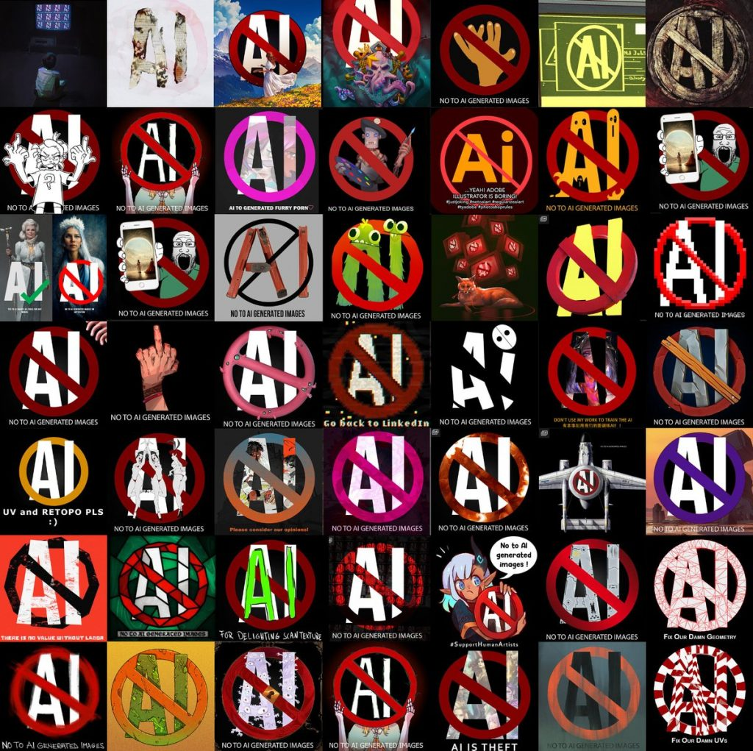
Introduction
AI art has become a fast-growing presence in today’s media industry, with both good and bad implications to several creative industries. Taking into consideration the implications that this might have in the industry and how this will affect the future of jobs, from artist in games, movies and television. Is there a respectable balance where AI can be implemented into workflow and therefore increase productivity or is this the end of individual artists in this industry and is there even a need to hire artists anymore? Does this break the ethical boundaries for artist and creators?
The Definition of AI Art or artificial intelligence art is a series of images complied together by an AI to create a new image. For AI art to work the generator must take existing images to input into the programme using an algorithm, doing this generates an output in the form of a new image as the AI cannot create an image with no reference material. These AI programmes usually work under rules from the user via text to mimic human creativity. AI does not have the ability to be able to be creative, yet. Still relying on software engineers to programme the AI art generators to be able to mathematically associate patterns in images using text prompts from the user themselves. “AI Art refers to any artwork created with the assistance of artificial intelligence. It can be a work created autonomously by AI systems or a work that is a collaboration between a human and an AI system. Artists can use software to automate some part of their process with code – rather than working entirely by hand. Algorithms can be used to create everything from abstract works of digital art where lines are drawn according to a set of rules”. [10]
AI ART AND THE RISE OF MACHINES
2023
ACCA4027
Rory Evans (2218702)
Main Causes
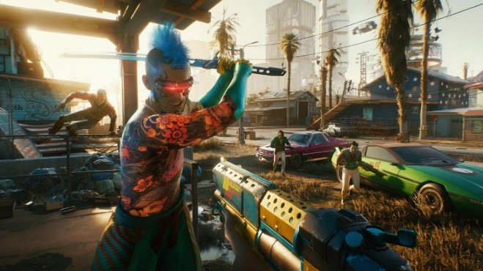
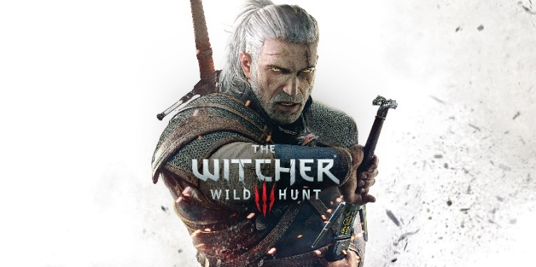
AI art has existed since the 1950’s- 1960’s. In it’s earliest of stages it was used to create simple shapes and patterns using algorithms. Today AI has reached a more advanced and technically superior stage compared to its earliest predecessor. With AI art becoming more mainstream in today’s age, anyone with access to theses programmes free or paid can access AI generation programmes. Some examples that are commonly raised are that individuals are claiming the AI art as their own, receiving backlash from communities across different platforms. More innocent examples of AI art have been individuals making creative images combining their favourite characters in other familiar worlds.

Figure 1 left, Geralt of Riva from Witcher 3: Wild Hunt [6] Figure 2 right, Gang member from Cyberpunk 2077) [7]

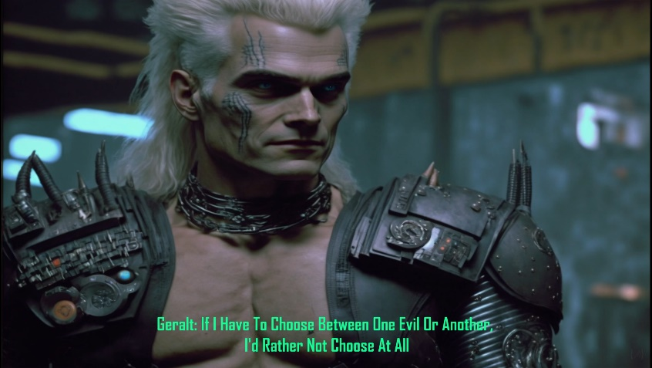

(Figure 3 – Shows an image generated by Midjourney [8] with a combination of text prompts such as “Geralt of Riva” and “Cyberpunk” to create the image above)

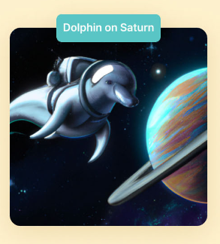
With the ease of access to these platforms, is the future looking bleak for artists and creators being phased out by AI? One of the biggest worries is that artists and creators will no longer be commissioned to work on projects such as video games, movies, television and multimedia projects.
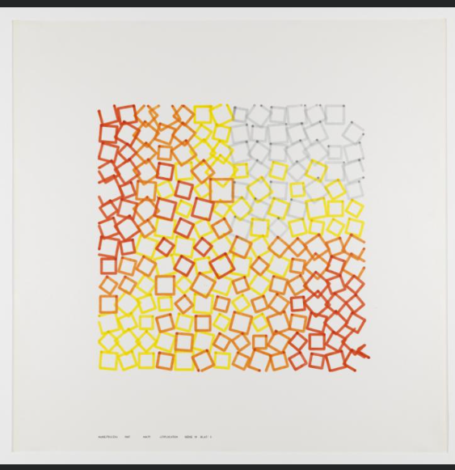
(Figure 4 - Untitled (1967), by Frieder Nake) [4] (Figure 5 – Dall-E 2 AI generator) [3]
Art director of Teslagrad and Teslagrad 2, Ole Ivar Rudi quotes the following – “On one level, I totally see the appeal and think it's super fascinating... [but] the data sets are largely built from unethically sourced material, including the work of illustrators who certainly don't want their work being used as input in this way, and this worries me a lot”. Others such as concept artist Karla Ortiz can see AI art uses in the industry, "I would say it would be great for finding references, creating mood boards, heck, it may even be good for assisting art restoration!". However, adding that AI art has its negative implications as well. Stating that AI is exploiting by its use of using copyright images from other artists. [9]

The effects and consequences of AI Art
One of the biggest issues to have surfaced in the rise of AI art is copyright. Copyright poses a big threat to creators of all occupations in the industry. Because these AI art programmes have to use images that have been data mined by programmes to take from creators that have posted online. These images are taken without permission of the artist, with no form of recognition or compensation to the artist. Without these images the AI is unable to create new art. Ethically this becomes a more challenging subject matter, essentially when these programmes are technically stealing from artist and creators. There are examples of these platforms accepting payments from people to use these AI generators to create their own images, with none of the proceeds or recognition going to the original artist.
There follows an uncertain aspect of copyright as there is a grey area to using these programmes - “Copyright is a huge issue when it comes to AI-generated art. To make it clear right off the bat, in the US, there are no copyright protections for works created by a machine; copyrightable works require human authorship.” [1]

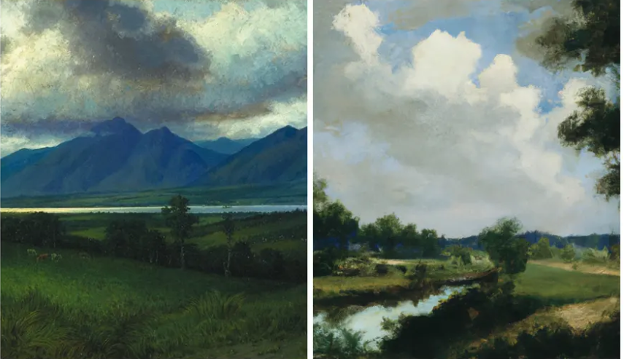
That isn't stopping people from trying to copyright AI-generated art. However, the new images themselves sometimes can form something original and not resembling the original art piece itself.
(Figure 6 Left) Homer Watson, Down in the Laurentides (1882). (Figure 7 Right) An image generated using Dall-E [3] with the prompt “Landscape oil painting Constable Claude Corot”. Composite: Homer Watson/ National Gallery of Canada; Image generated by Jo Lawson-Tancred and Philip Booth. [2]
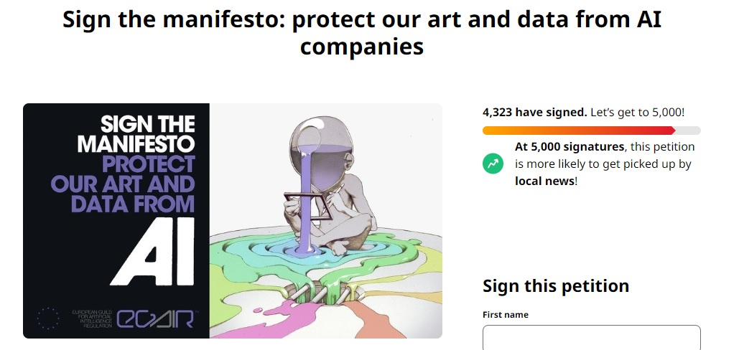
Potential solutions to help address the subject
Throughout the rise of AI art, the subject of has become a fast-talking topic among the creative community prompting for a ban against AI art. Several petitions have made their presence on www.change.org [5] with thousands signing the petition for the outright ban or regulations for the rights for artist against AI art.
(Figure 8 above – Petition signed by over 4,000 people in response to AI Art)
Whilst the biggest push back has been the complete ban of AI art and that legally, not much can be done about AI art being created using copyright material.
Is there a middle ground where AI art can co-exist alongside artist trying to make a living and continue to produce original art? Looking at a balanced potential solution to this issue, if there was a regulated system in which artist themselves could sign up to websites to be able to grant permission for there art likeness to be used as input images for the generator and also receive some form of commission. Karla Ortiz also suggest that having a domain that can ethically use the content of artist with the permission of the individual themselves and making sure the artist is compensated for the fair use of their art. [9]
Summary
The subject itself is still an uncertain one at present, with various aspects to consider for the future. To summarise the topic, looking at the definition of AI art and what AI art fundamentally means in today’s era. This helps us understand why it can be a topical conversation with the future of art itself is in the balance. Looking into the foundations of the causes and why AI is such a prominent figure in media today, this helps understand its consequences to the future of art. What does it mean for the individual artist? How will it affect the dynamic of the industry? Are there any possible solutions that can be implemented to still preserve human creativity and the media of art?

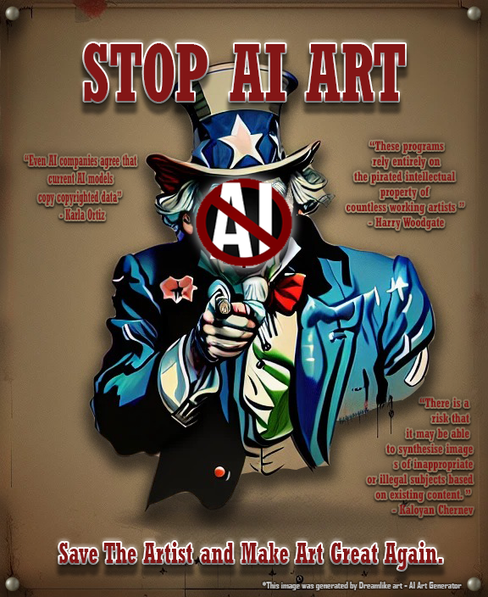
Poster for Part 2 of Assignment CW1

Assignment References
[1] S. Tolcheva, “The Dark Side of AI Art: 4 potential issues with the growing trend,” MUO, 12-Jan-2023. [Online]. Available: https://www.makeuseof.com/dark-side-of-ai-art-potential-issues/#:~:text=2.-,Copyright,to%20copyright%20AI-generated%20art.
[2] Jo Lawson-Tancred, “Is this by Rothko or a robot? we ask the experts to tell the difference between human and ai art,” The Guardian, 14-Jan-2023. [Online]. Available: https://www.theguardian.com/artanddesign/2023/jan/14/art-experts-try-to-spot-ai-works-dall-e-stable-diffusion.
[3] OpenAI, “Dall·E 2,” OpenAI, 14-Apr-2022. [Online]. Available: https://openai.com/dall-e-2/.
[4] F. Nake, “'matrix multiplications', Frieder Nake, 1967,” Tate, 01-Jan-1967. [Online]. Available: https://www.tate.org.uk/art/artworks/nake-matrix-multiplications-128667.
[5] “The world's platform for Change,” Change.org. [Online]. Available: https://www.change.org/.
[6] “The Witcher 3: Wild Hunt .” CD Projekt Red, 19-May-2015.
[7] “Cyberpunk 2077.” CD Projekt Red , 10-Dec-2020.
[8] “About,” Midjourney. [Online]. Available: https://www.midjourney.com/home/?callbackUrl=%2Fapp%2F.
[9] K. Gray, “How do game developers and artists feel about the rise of AI art?,” Nintendo Life, 02-Jan-2023. [Online]. Available: https://www.nintendolife.com/features/how-do-game-developers-and-artists-feel-about-the-rise-of-ai-art.
[10] Admin, “Make stunning &amp; strange artificial intelligence (AI) art [Beginners guide],” Surrealism Today, 04-Dec-2022. [Online]. Available: https://surrealismtoday.com/beginners-guide-artificial-intelligence-art/#:~:text=AI%20Art%20refers%20to%20any,than%20working%20entirely%20by%20hand.
Poster References
[1] “Ai Art Generator, AI Art Maker,” dreamlike.art. [Online]. Available: https://dreamlike.art/.
[2] Karla Ortiz cited in K. Gray, “How do game developers and artists feel about the rise of AI art?,” Nintendo Life, 02-Jan-2023. [Online]. Available: https://www.nintendolife.com/features/how-do-game-developers-and-artists-feel-about-the-rise-of-ai-art.
[3] “'it's the opposite of art': Why illustrators are furious about ai,” The Guardian, 23-Jan-2023. [Online]. Available: https://www.theguardian.com/artanddesign/2023/jan/23/its-the-opposite-of-art-why-illustrators-are-furious-about-ai.

Bibliography
S. Tolcheva, “The Dark Side of AI Art: 4 potential issues with the growing trend,” MUO, 12-Jan-2023. [Online]. Available: https://www.makeuseof.com/dark-side-of-ai-art-potential-issues/#:~:text=2.-,Copyright,to%20copyright%20AI-generated%20art.
Jo Lawson-Tancred, “Is this by Rothko or a robot? we ask the experts to tell the difference between human and ai art,” The Guardian, 14-Jan-2023. [Online]. Available: https://www.theguardian.com/artanddesign/2023/jan/14/art-experts-try-to-spot-ai-works-dall-e-stable-diffusion.
OpenAI, “Dall·E 2,” OpenAI, 14-Apr-2022. [Online]. Available: https://openai.com/dall-e-2/.
F. Nake, “'matrix multiplications', Frieder Nake, 1967,” Tate, 01-Jan-1967. [Online]. Available: https://www.tate.org.uk/art/artworks/nake-matrix-multiplications-128667.
“The world's platform for Change,” Change.org. [Online]. Available: https://www.change.org/.
“About,” Midjourney. [Online]. Available: https://www.midjourney.com/home/?callbackUrl=%2Fapp%2F.
K. Gray, “How do game developers and artists feel about the rise of AI art?,” Nintendo Life, 02-Jan-2023. [Online]. Available: https://www.nintendolife.com/features/how-do-game-developers-and-artists-feel-about-the-rise-of-ai-art
Admin, “Make stunning &amp; strange artificial intelligence (AI) art [Beginners guide],” Surrealism Today, 04-Dec-2022. [Online]. Available: https://surrealismtoday.com/beginners-guide-artificial-intelligence-art/#:~:text=AI%20Art%20refers%20to%20any,than%20working%20entirely%20by%20hand.
https://redideostudio.com/fine-art/art-artificial-intelligence-the-pros-cons/#:~:text=Overall%2C%20there%20are%20both%20pros,often%20present%20in%20traditional%20art.
https://www.forbes.com/sites/robsalkowitz/2022/09/16/ai-is-coming-for-commercial-art-jobs-can-it-be-stopped/?sh=412fd98b54b0
https://www.youtube.com/watch?v=W4Mcuh38wyM
https://www.youtube.com/watch?v=gv9cdTh8cUo
https://www.youtube.com/watch?v=5Viy3Cu3DLk

