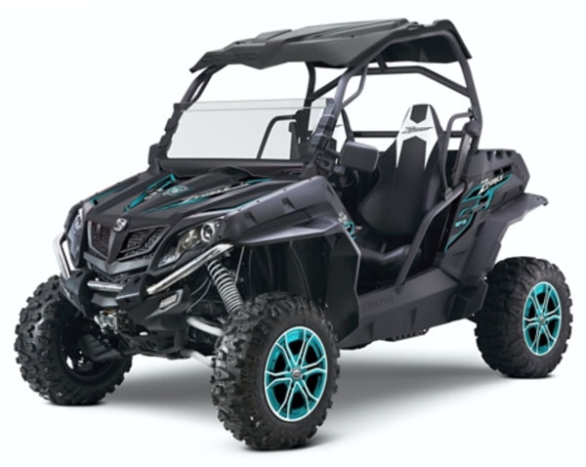

Series Hybrid Vehicle
  - Part A
Gwyddian Thomas | Level 6 BSC Motorsport Engineering | 05/12/2017
Contents
Abstract 1
Introduction 1
Vehicle Specifications 2
Quadzilla Z8 4x4 2
Assumptions 3
Equations 3
Spreadsheet 4
Duty cycle analysis 5
Summary of findings 6
Referances 6

Abstract
Duty cycles and drive cycles are an effective method of calculating the typical work done of a vehicle under various loads. “A range of cycle characteristics have been used to estimate the hybrid potential for vehicle duty cycles including characteristic acceleration, aerodynamic velocity, kinetic intensity, stop time, etc. These parameters give an indication of overall hybrid potential benefits” (Z and M, 2012) These methodologies have been vital to the development of new hybrid systems.
With the prominence of hybrid vehicles on modern roads. The motorsport and recreational industries will soon follow suit. With the development of battery technologies, it is now economical option to utilize a series hybrid system for a recreational off-road vehicle. Adapting validation methods that would usually be used to develop road vehicles it is possible to calculate the potential gains of implementing a series hybrid system to a recreational off-road vehicle.

Introduction
For the purposes of this paper the aims are to develop a duty cycle for a recreational off-road vehicle for a company from entertainment sector. The company would like to establish an effective duty cycle for use in corporate events. to accomplish the goals of this task, a spreadsheet must be developed to create a theoretical duty cycle containing the various loads and resistances one would expect from an off-road buggy during normal operation. A suitable track will be developed also during this investigation to establish whether the chosen vehicle is capable given a particular set of parameters such whether the power and torque figures produced by the vehicle are sufficient. Data collected from the spreadsheet will then be collated and analyzed to produce an effective Duty cycle.

Vehicle Specifications

Quadzilla Z8 4x4
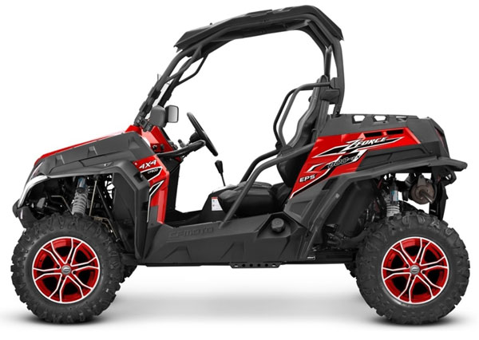
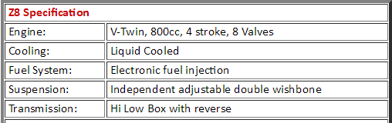
Wet Weight (Kg) = 516.47
Frontal Area = 2.76m²
Wheel Diameter = 14 inches
Power = 62.2hp or 46.38 Kw
Torque = 72 Nm
(Whateverwheels.co.uk, 2017)

Assumptions
Due to the limited amount of information available for this vehicle a few assumptions must be made:
The frontal area may only be calculated as an estimate as the only commercially available information only stated the length, height and width of the vehicle in question. This does not portray an accurate representation of the vehicle. This is due to the skeletal design of the vehicle and the lack of windscreen. It may be assumed that the Frontal area value is an overestimate.
Weight and number of passengers. To account for a possible worst-case scenario in terms of total vehicle weight I have accounted for two adult males their weight was taken from the national average as it would be impossible to account for the weight of each individual without weighing prior to completing a cycle I believe that the national average will serve as a satisfactory baseline.
Assuming the estimate values for the coefficient of rolling resistance of each terrain is constant across the track this of course is not possible and accounts for wet and dry conditions will also need to be considered to achieve a higher level of accuracy.

Equations
Rolling resistance = Mg x coefficient of rolling resistance
Aerodynamic Drag = ½ Area x Cd x Density of air x velocity²
Coefficient of drag = 2 x mg ÷ density of air x velocity² x frontal area
Gradient = Mg Sin θ
Acceleration = (Vcurrent – Vprevious) ÷ distance
Total resistance = Aerodynamic resistance + Gradient resistance + rolling resistance
Power = Mass x Acceleration = V x total resistance
(Engineeringtoolbox.com. 2017).
(Lecture handouts 2017)

Spreadsheet
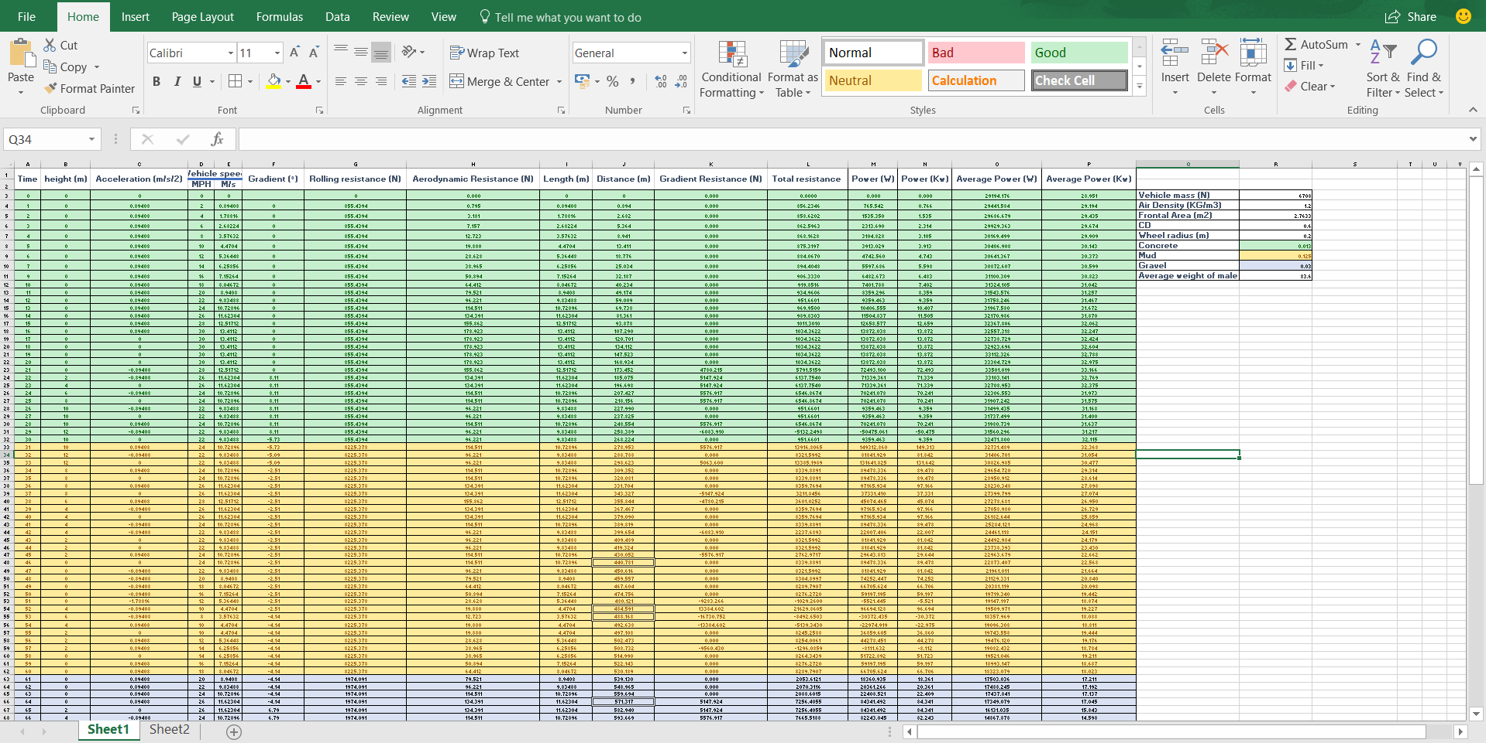
Taking points at every second of the 120 second drive cycle to attain a high level of accuracy without overpowering the spreadsheet with data that may not be required. The track was written with a variance of inclines and declines at two-meter intervals. From this point known values from vehicle data may be introduced with equations to develop the spread sheet over the 120 second period. Once the data is collated within the spreadsheet graphs may be derived to give a clearer understanding of the processes, losses and operations occurring during the cycle.

Duty cycle analysis

Summary of findings
From the results derived from the excel spreadsheet, graphs produced and known values of the vehicle in question, it is clear that the vehicle chosen for this report is perfectly suitable for the application. The course designed is a conservative example of an off roading course I am confident that this vehicle is capable of completing a much higher It can be seen from the graphs above that during stages of deceleration that power is being consumed to a negative value. During these periods it would be possible to recover energy during these periods taking into account for the frictional losses that may occur with increased braking forces being applied during the operation of a kinetic energy recovery system.

References
Whateverwheels.co.uk. (2017). QUADZILLA Z8 EX EFI 4x4 Buggy 2017 :: £9099.00 :: Quads / ATV / Buggies :: ROAD LEGAL BUGGIES :: WHATEVERWHEELS LTD - Number 1 Dealer Lexmoto, AJS, Rieju, Sym, Neco, Keeway - Quality Motorcycle & Scooter Sales - 50cc & 125cc. [online] Available at: https://www.whateverwheels.co.uk/m24b0s460p8867/QUADZILLA-Z8-EX-EFI-4x4-Buggy-2017
Z, S. and M, A. (2012). Vehicle Duty Cycle Characteristics for Hybrid Potential Evaluation. SAE International, 3(1).
Engineeringtoolbox.com. (2017). Engineering ToolBox. [online] Available at: https://www.engineeringtoolbox.com

