

Managing Enterprise in the 21st Century

Business Plan
THE DAILY GRINDILY GRIND
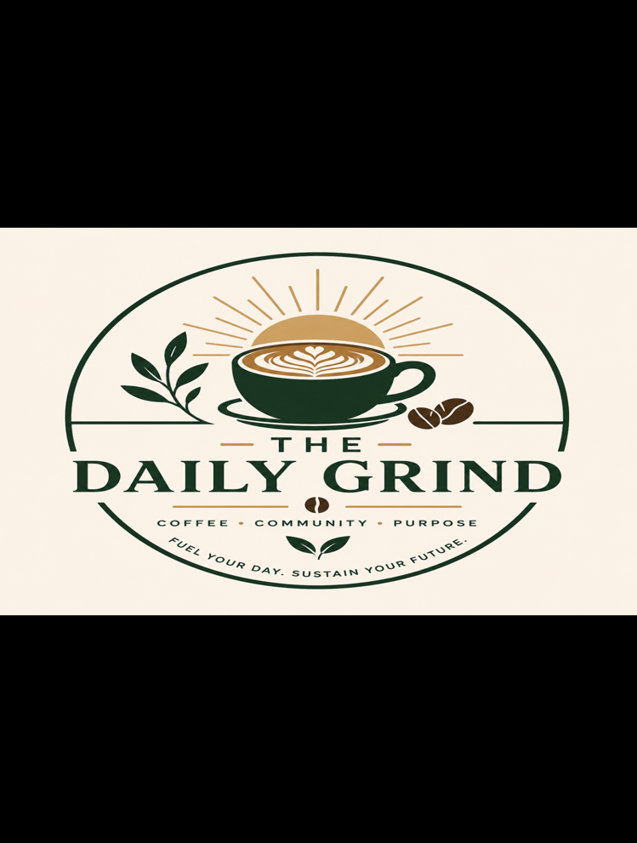

Submission Date:Monday 27th July 2026
Lecturer:Dr Charles oham
Student name:Nikolas Cruz
Student id:2512830

Table of Contents
Group Information 2
Executive Summary 4
Business Concept 5
Business Description 5
Product Description 5
Business Objectives (SMART Objectives) 5
Short-Term Objectives (less than a year) 5
Long-Term Objectives (less than a year) 5
Market Analysis and Marketing Plan 6
Market Analysis (Competitors, Customers, Target Groups) 6
PESTEL Analysis 6
SWOT Analysis 6
Marketing Mix (4Ps) 6
Management Team 6
Management Team and Their Background 7
Organisational Chart 7
Key Milestones 7
Financial Plan (One Year) 7
Sources of Finance 7
Cash Flow Forecast 7
Sales Forecast 7
Cost of Production Forecast 7
Break Even Analysis 7
Operations and Management Plan 7
Production of Good and Service 7
Technology Plan 7
Human Resource Plan 7
Expansion Plan 8
Reference List 8
Appendices: 9

Executive Summary
The Daily Grind is an independent coffee shop in Croydon offering quality coffee, fresh food, and a welcoming environment for students, commuters, office workers, and local residents. The business focuses on sustainability, ethically sourced products, and excellent customer service. Operating as a Private Limited Company (LTD), it aims to become a leading independent café before expanding across South London.

Business Concept

THE DAILY GRIND is a modern, independent coffee shop that combines premium coffee, fresh food, and exceptional customer service with a strong commitment to sustainability and community engagement. The business aims to create more than just a café by offering a welcoming space where customers can relax, socialise, study, or work in a comfortable environment.
Located in Croydon, THE DAILY GRIND will target commuters, student, office workers, and local residents who value high-quality products and a personalised customer experience. Unlike many large coffee chains, the business will focus on ethically sourced ingredients, environmentally friendly practices, and building strong relationship with the local community. Through quality products, innovative marketing, and sustainable business practices, THE DAILY GRIND aims to establish itself as a trusted local brand with potential to expand across south London in the future.

Business Description

The Daily Grind is an independent coffee shop that will provide high-quality coffee, freshly prepared food, and a welcoming environment where customers can relax, study, work, or socialise. The café will be located in Croydon, attracting students, commuters, office workers, and local residents.

The business will operate as Private Limited company (Ltd), providing limited liability while supporting future growth. The daily grind aims to stand out by offering excellent customer service, premium products, and a strong commitment to sustainability. The café will use ethically sourced coffee beans, Eco-friendly packaging, and offer discounts to customers who bring reusable cups. These initiatives will help me build a positive reputation and encourage customer loyalty. (Burns,2022).

Product Description
The Daily Grind will offer a range of high-quality food and beverages made using fresh, responsibly sourced ingredients. The menu will include speciality coffees such as expresso, cappuccino, latte, flat white, mocha, and iced coffees, alongside a selection of teas, hot chocolate, and seasonal drinks.
The food menu will feature freshly baked pastries, sandwiches, toasties, wraps, cakes, and healthy breakfast options. Vegetarian, vegan, and gluten-free choices will also be available to ensure the café meets wide range of customer needs.
In addition to its products, The daily Grind will provide free Wi-fi, comfortable seating and charging points, and a customer loyalty programme to encourage repeat visits. By combining quality products with excellent customer service and a welcoming atmosphere, the café aims to create a memorable experience that keeps customers coming back(Kotler et al., 2022).

Business Objectives (SMART Objectives)
The Daily Grind aims to become a recognised independent coffee shop in Croydon by providing high-quality products, excellent customer service, and sustainable business practices. To achieve this, the business has set the following SMART objectives:

Short-Term Objectives (less than a year)
- The Daily Grind within six months after securing funding.
- Achieve a customer satisfaction rating of 90% or above through feedback and online reviews.
- Build a social media following of at least 2,000 followers across Instagram and TikTok within the first year.
- Reach monthly sales of £25,000 by the end of the first year.
- Introduce a loyalty programme and attract 500 repeat customers within 12 months.

Long-Term Objectives (More than a year)
- Become one of Croydon’s highest-rated independent coffee shops within three years.
- Open second café in South London within five years.
- Increase annual revenue by 15% each year after the first year.
- Continue reducing environmental impact by expanding sustainable. Practices and maintaining partnerships with local charities .

Market Analysis and Marketing Plan

Market Analysis (Competitors, Customers, Target Groups)

Market Analysis

Competitors
The Daily Grind will compete with well-known coffee chains such as Starbucks, Costa Coffee, and Caffe Nero, as well as independent cafes in Croydon. These businesses have a strong brand recognition and loyal customers. However, The Daily Grind will differentiate itself by providing a more personalised customer experience, ethically sourced coffee, eco-friendly packaging, and a strong commitment to sustainability (Statista, 2024).
Customers
The business will serve customers who are looking for high-quality coffee, fresh food, and a comfortable place to relax, work, or study. Customers will valuer friendly customer service, a welcoming atmosphere, and responsibly sourced products.
Target Group
The primary target market will be adults aged 18-45, including students, commuters, office workers, remote workers, and local residents in Croydon. These groups are more likely to purchase coffee regularly and appreciate cafes that offer free Wi-Fi, loyalty rewards, and sustainable business practices(Kotler et al., 2022).

PESTEL Analysis

Political: The Daily Grind must comply with UK employment law, food hygiene regulations, and health and safety legislation to operate legally.
Economic: Rising inflation and higher costs for coffee beans, ingredients, and energy could increase operating costs and affect profits.
Social: Customers are increasingly choosing independent cafes that offer quality products, excellent customer service, and sustainable practices.
Technological: Online ordering, contactless payments, social media marketing, and a loyalty app will help improve customer experience and increase sales.
Environmental: Using recyclable packaging, ethically sourced coffee beans, and reducing food waste will help minimise the café’s environmental impact.
Legal: The business must comply with food safety standards, GDPR, licensing requirements, and employment legislations (burns, 2022).

SWOT Analysis
Strengths | High-quality coffee and fresh food  Friendly customer service  Sustainable business practices

Opportunities

Growing demand for independent cafes

Expansion across South London

Partnerships with local business

Weakness

New business with limited brand awareness

High start-up costs

Strong competition from established brands

Threats

Rising supplier and energy costs

Economic uncertainty

Competition from Starbucks, Costa and caffe Nero

Marketing Mix (4Ps)

Product
The Daily Grind will offer premium coffee, fresh food, seasonal drinks, and a welcoming café experience with free WIFI and a loyalty programme.
Price
Products will be completely priced to offer value while reflecting the quality of the ingredients and customer experience.
Place
The café will be located in Croydon, making it easily accessible to students, commuters, office workers, and local residents.
Promotion
The Daily Grind will promote its brand through Instagram, TikTok, Facebook, student discounts, loyalty rewards, and partnerships with local businesses and community events(Kotler et al., 2022).

Management Team

Managing director- Nikolas Cruz
- Founder of The Daily Grind
- Responsible for business strategy finance, and expansion
- Hospitality experience in five-star hotel and barista experience, providing strong knowledge of customer service, coffee quality, and daily operations.
- Currently studying a BA in leadership and Management, developing skills in strategic planning, leadership, and business management.

Management Team and Their Background

Management: Managed by experienced café supervisors and managers with backgrounds in hospitality, customer service, and café operations. They oversee staff, customer satisfaction, stock control, and daily operations.

Organisational Chart

Managing Director
│
Operations Manager
│
────────────────────────
│ │ │
Baristas Kitchen Marketing &
Staff Social Media
│
Customer Service Staff

Key Milestones
- Month 1- secure funding and location
- Month 2- hire and train staff
- Month 3- grand opening.
- Month 6 – reach regular customers base
- Month 12 – increase sales and review expansion.

Financial Plan (One Year)

Sources of Finance
- Owner’s investment - £20,000
- Bank loan - £30,000
- Total £50,000

Cash Flow Forecast
Cash Inflows | £
Sales revenue | 180,000
Owner's investment | 20,000
Bank loan | 30,000
Total cash in | 230,000
Cash Outflows | £
Rent | 24,000
Staff wages | 72,000
Stock | 36,000
Utilities & marketing | 18,000
Total cash out | 150,000
Net cash flow | 80,000

Sales Forecast
Forecast | Amount
Average daily sales | £500
Monthly sales | £15,000
Annual sales | £180,000

Cost of Production Forecast
Item | Cost (£)
Coffee beans & milk | 18,000
Food ingredients | 12,000
Packaging | 6,000
Total | 36,000

Break Even Analysis
Item | Amount (£)
Fixed costs | 126,000
Annual sales | 180,000
Estimated profit | 54,000

The Daily Grind is expected to break even during its first year as projected sales exceed fixed costs.

Operations and Management Plan

Production of Good and Service
The Daily Grind will prepare fresh food and premium coffee daily using high-quality ingredients. Orders will be prepared by trained staff following food hygiene standards to ensure consistent quality and excellent customer service.

Technology Plan
The café will use modern POS(point of sale) system, contactless payment terminals, online ordering, free WIFI, and social media platforms to improve efficiency and customer experience.

Human Resource Plan
The Daily Grind will employ experienced baristas and customers service staff. Employees will receive training in food hygiene, customer service, health and safety, and coffee preparation to maintain high service standards.

Expansion Plan
After establishing a successful café in Croydon, The daily Grind aims to open a second location in south London within five years while growing its customer base.

Reference List

British Coffee Association (2025) Coffee facts and statics. Available at: https://britishcoffeeassociation.org (Accessed: 22 july 2026).
Companies House (2025) Register a company. Available at https://www.gov.uk/government/organisations/companies-house (Accessed: 22 july 2026).
Burns, P.(2022)New Venture Creation: A Framework for Entrepreneurial start-ups.3rd edn.London:Red Globe Press.
Kotler, P Armstrong, G. and opresnik, M.O.(2022)Principles of Marketing. 19th Global edn. Harlow: Pearson.
Statista (2024) Coffee shop market statistics in the UK. Available at: https://www.statista.com
(Accessed:22 July 2026).

Appendices:

