HTML & CSS Web Development
Christine Woods 1704446
School of Applied Computing, Business information Technology, Computing and Information Systems, Web Development and Software Engineering
Kemi Ademoye
Submission Date = 22.12.17

Declaration by Christine Woods

I declare that this assignment is all my own work and that I have acknowledged all materials used from the published or unpublished works of other people. All references have been duly cited.

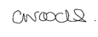

Contents
 | Page Number
1. Introduction | 1
2. Requirements | 2
3. Implementation | 3
4. Validation | 4
5. Evaluation | 5-8
5.1 Headings | 6
5.2 Information Structure | 6
5.3 Image and media content | 6
5.4 Scalable text content | 6
5.5 Colours of the website | 7
5.6 Forms | 7
5.7 Navigation | 7
6. Evaluation | 9
7. Recommendations for future improvement | 9
8. Appendix | 10-19
9. References | 20

Introduction
This report demonstrates the understanding of developing a webpage by outlining the specifications that have been included when building the website. It is an over view of the design and content of the web pages. The report also highlights the implemented features as laid out in the task description.
The report has two main tasks
- Design and hand-code a website using web standards
- Write a specification report with 7 sections.
- Title Page
- Contents Table
- Introduction
- Requirements section
- Implementation section
- Evaluation section
- References

Requirements
The website chosen for this assignment will be a source of information for topics involving Medicines Management in Abertawe Bro Morgannwg Health Board. It will provide a resource for Patients, GPs surgeries, Pharmacy, Parents, Members of the public, Care Homes and Nurses.
There are many resources available using many different websites which are vast and varied. The purpose of this website will be to provide up to date information from one main site allowing the user a better and more efficient outcome when looking for information.
The website will target the main topics in Medicines Management such as Medicines Waste, Inappropriate prescribing of antibiotics, Childhood conditions, Conditions of the elderly in Care Homes, Patients on hospital wards as well as other relevant areas.
Discussions have taken place with members of the above groups and the findings were that they could not find required information easily and could not be sure which information was most relevant and up to date.
The Medicines Management teams across Abertawe Bro Morgannwg health board are constantly trying to reduce cost as well as risk of illness and have countless requests to provide information for people to share and utilise. Being able to provide one main site should help with this.
Using Visio 16 a Site Map was produced to show the flow of the information required for the website, each group will require a different set of targeted information as seen in Appendix 1. The website will provide pages for each group where they will find the relevant links to posters and leaflets that can be viewed or downloaded.
The Wireframe grid map drawing shows the design of the web page. Please see Appendix 2. Each group has a click on feature, which will guide the user to the specific page required. This will target the audience eliminating the user having to trawl through information that is not specific to their need.

Implementation
Please see appendix 3 for screen shots of the completed website.
Included are the following screen shots
- Home page x 2 (top and bottom)
- About us page
- Contact us page
- Linked pages to
  - Care Homes Resources
  - GP Surgery Resources
  - Nursing Resources
  - Public Resources
  - Pharmacy Resources
  - Children Resources

Validation
The main HTML and main CSS webpages were both validated using the on line W3 validators. [1]
The HTML validator showed there were seven errors. Please see Appendix 4.
The errors shown included
- Illegal characters in the path element – (use of spaces)
- Extra div elements not required (<p>)
- Duplicate ID’s
- Error when using child elements of div.

The CSS validator showed one error. Please see Appendix 5.
The error shown was
- Value Error: padding, is an incorrect operator: 20px,20px,20px,20px

Evaluation

Headings

There are many things to consider when designing a website. Headings need to be descriptive, detailing the content of the webpage. Headings should not be lengthy but should be clear so that the user can discover the content of the webpage easily. [2] Having the heading in a bold font will make sure that it stands out drawing the user’s attention to the main topics of the page. The headings used in the website all conform with the above regulations.
As discussed in [3] the user’s visual perception of a webpage is built around how the web page is structured. The paper references to the complexity of a webpage and what effect this has on the user.

Information structure
The structure of the website requires a theme to visually maintain the users understanding of the site. As shown in the HTML & CSS book [4] tags can be used in any number of visual ways to enhance the design. The headings may be in bold and sub headings may be in the same font for example. Colours may be used to distinguish topics of the same interest. The relationship of the content requires a visual theme. The Medicines Management website has been designed to allow the user to see exactly which part of the website is suited to them by using headings of a larger font and images that shows the content. The images have all been aligned together and each page is of the same layout. The information has been structured throughout the webpage to be easy to follow and informative. The presentation has been streamlined on all pages so that navigation and information searches are easy.

Images and media content
As per the guidelines on the WCAG 2.0 website [5] the web content needs to meet certain requirements
- Perceivability – is it easy to see?
- Operational – is it easy to use?
- Understanding – is it easy to understand?
- Robust- will it break?

Informative images have been used throughout the website allowing the user to easily see which area of the information is relevant to them. There is a short description using the “alt “feature.
There are functional images that show the user where to click for relevant links.
Decorative images have been used for the design of the website. These images have been linked to the area that the web page covers (Abertawe Bro Morgannwg University Health Board). The images used for this website were taken from a free imaging website [6].
The information leaflets and web pages used for the links on the web pages are all freely shared on the internet and do not breach any copyright regulations [7] [8].

Scalable text content
Scalable text allows the user to change the size of the text depending on their own needs and preference [5].
For example, someone with good sight may wish to view smaller text, whereas someone who has challenged sight may wish to make the text bigger or may wish to see it in a different colour.
The complexity of a site will have an outcome on the user’s ability to access information [3] especially for the visually impaired. The website must try to get a balance of usability features along with accessibility features to maintain a design that works for all.
The Medicines Management Resource website has chosen a large text to define the headings and then smaller text for the heading description.

Colours of the Website
Medicines Management Resource webpage has been designed using a black back ground for the header section and white background for the main section. This will allow the user to decipher between the two.
As discussed in [4] section 11 Color -
“When picking foreground and background colors, it is important to ensure that there is enough contrast for the text to be legible”
The colour has remained consistent throughout the website on all pages that will guide the user to know where they are on each webpage. [9]
The text colours for the header are in white, which is easy to see against the black background. The main picture text is in white so that is shows up against the picture of Swansea Bay.
Command links “Click here” have been highlighted in blue across the website allowing the user to easily see where they need to go to find information.

Forms
Forms are used on a page web to allow the user to input data. For usability reasons these forms should not have a time constraint on them to allow users with disabilities the required time to input the data [5]
The Medicines Management Resource page has a user form on the contacts page giving the user the additional benefit of requesting be spoke information.
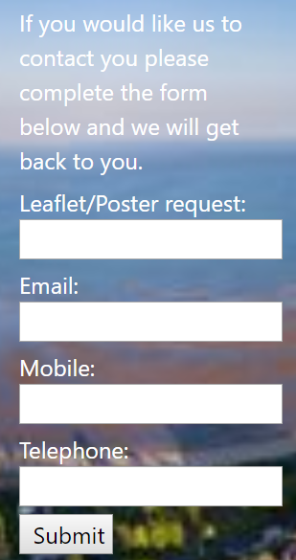
This form is easily readable, with clear instruction of the information required. There is no time limit for input.
There is a large area for the user to input the information allowing for people with limited dexterity.
Using the power point shared on Moodle it was decided to use the Text input boxes allowing the user to free text their details into the web page which would then be sent via the submit button to the chosen URL. [10]

Navigation
Users need to be able to find the content they require whilst keeping track of where they are on the website.
The Medicines Management Resource page has placed three main features on each page
- Home
- About us
- Contact us

These navigational links ensure that the user can find their way to the home screen from any other page. They can also use the contact page to ask for further information at any point.
At the bottom of each page, a link to the top of the page has been inserted so that the user can navigate to the top of the screen easily.
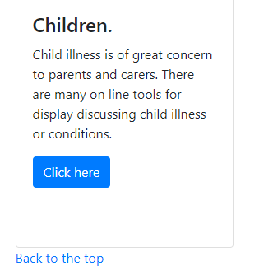
Each topic has a link to the relevant website/information area that is highlighted in blue to show the user where to go.
It was decided to use both a link and descriptive text to ensure that the user navigates correctly.
Whilst researching links using [4] is says on page 78 that
“Where possible, your link text should explain where visitors will be taken if they click on it (rather than just saying “click here”).”
However, it was felt that in this instance the “Click here” option has been streamlined on the linked pages and lets the user know exactly where they need to go to access the links. The descriptive text above “Click here” link clearly defines the accompanying information.

Evaluation
The content of Medicines Management Resources website complies with the WCAG 2.0 [5] accessibility regulations.
The site is easy to manage, informative and has a streamlined design across all the web pages.
The site has great functionality allowing the user to find the required elements easily.
The information is up to date and relevant. The links are easy to use and take the user to the desired page within two clicks of the mouse. The images used are free to be copied and shared [6].

Recommendations for future improvements.
In the future, the web page may require a better graphical content, such as video footage making it more technically and ascetically pleasing for the user. It may need to have many more links for each sub heading giving the user a better choice of material.

Appendix
Appendix 1. Site Map
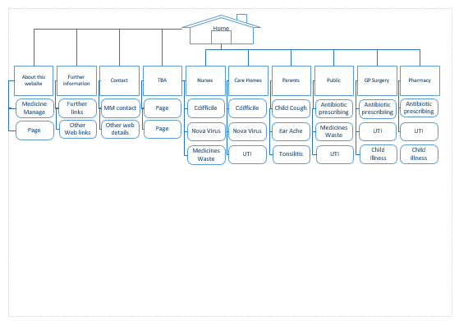

Appendix 2. Grid Layout
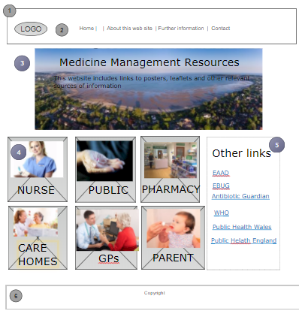
Key
1 Logo
2 Navigational Buttons
3 Picture (jumbo Tron)
4 Content (links)
5 Other links
6 Footer (information)

Appendix 3. Screenshots of webpage
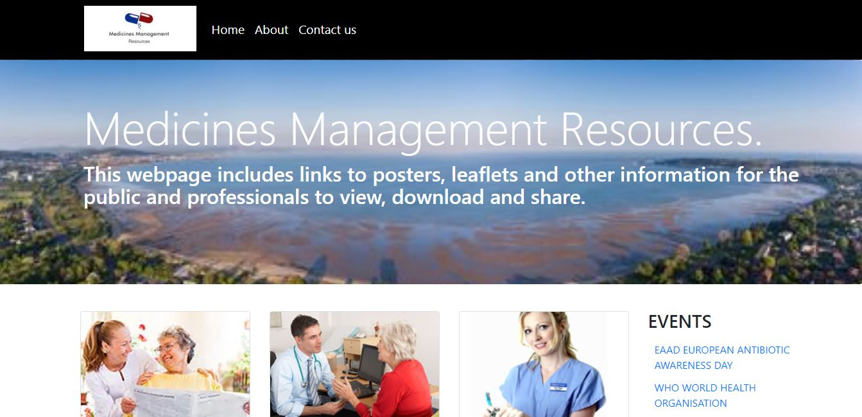
Home Page (top).
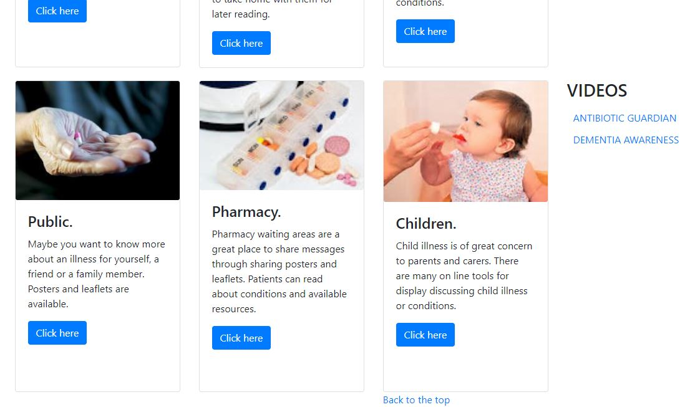

Home Page (bottom).
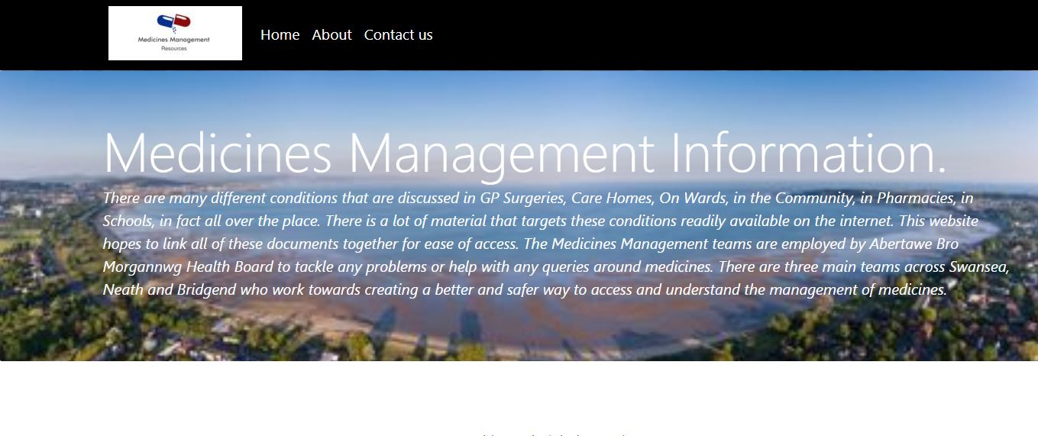
About page.
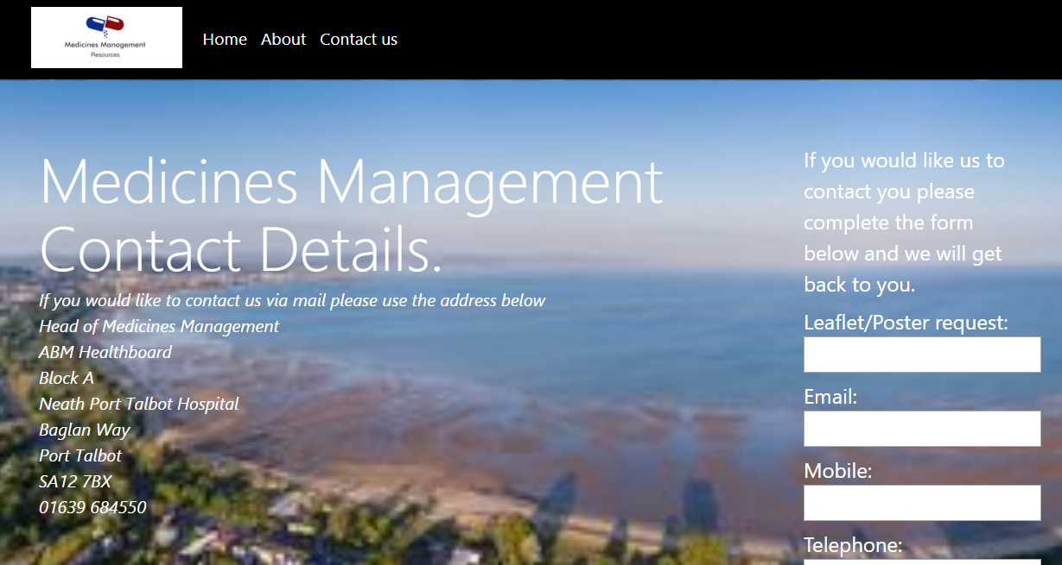
Contact us page.
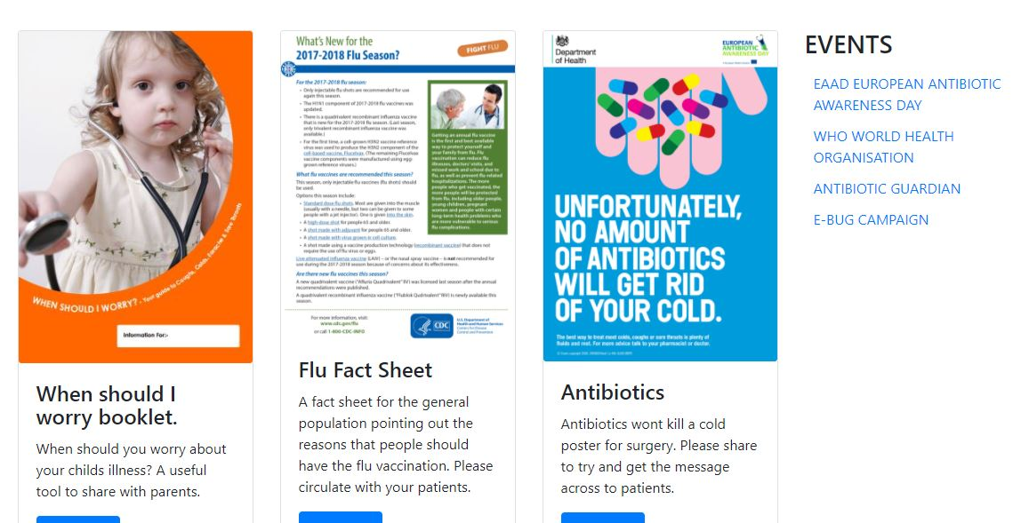
GP Surgery linked page.

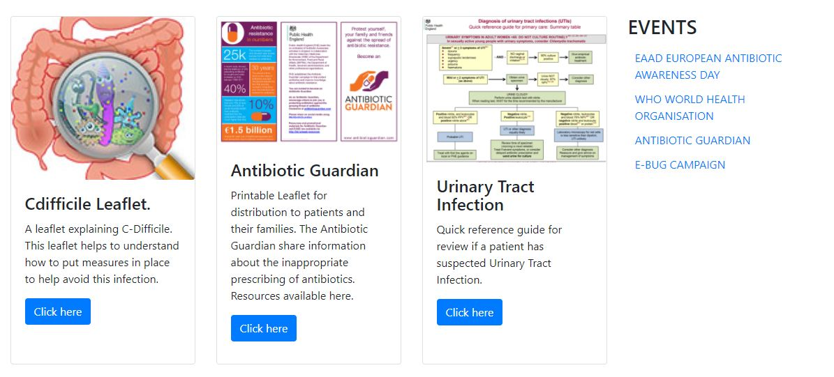
Care Home linked page.
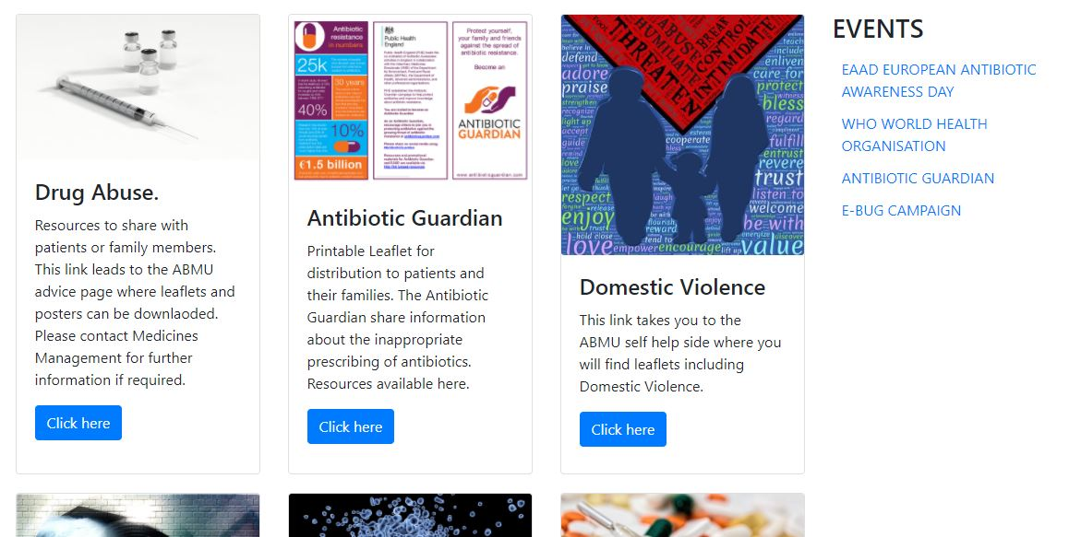
Nurses linked page.

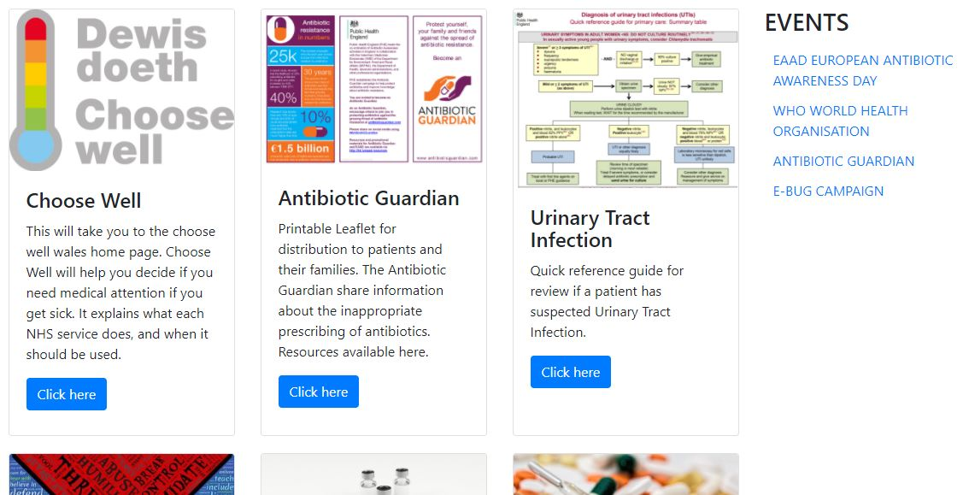
Pharmacy linked page.
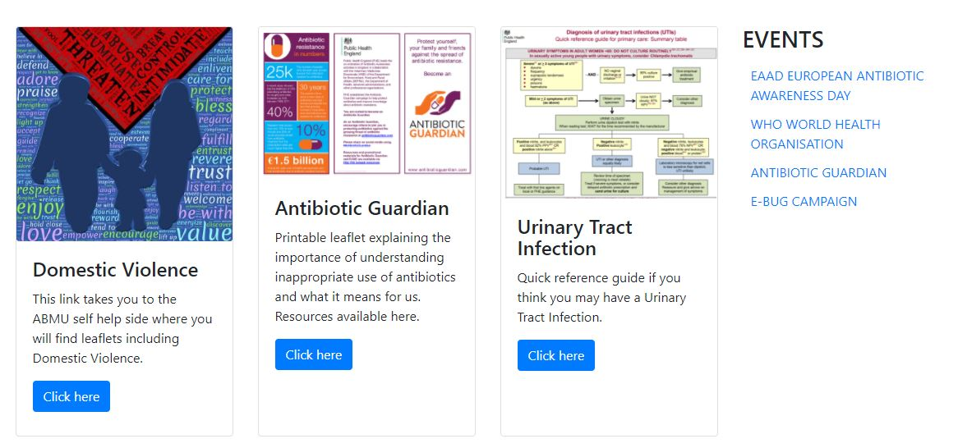
Public linked page.

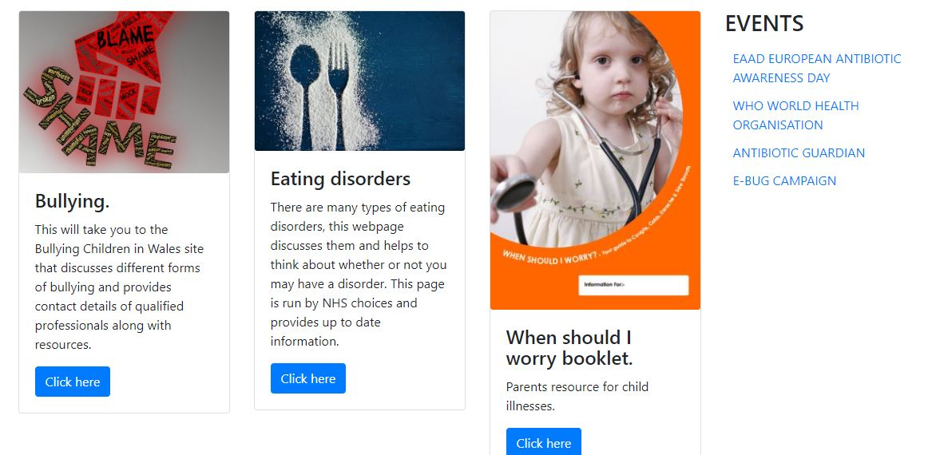
Children’s linked page.

Appendix 4. Validation of HTML
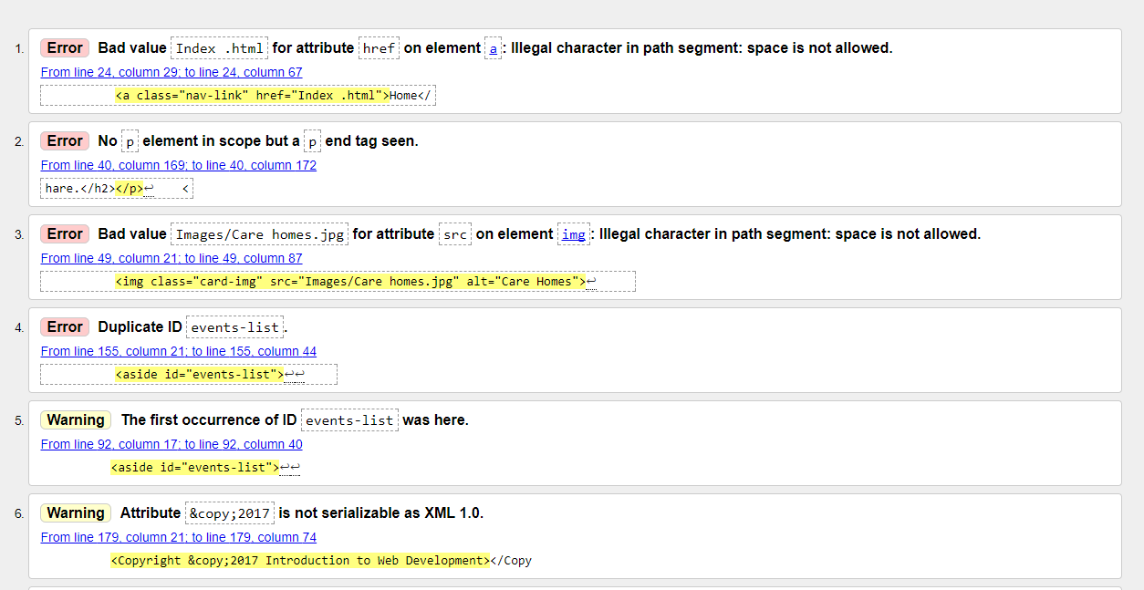
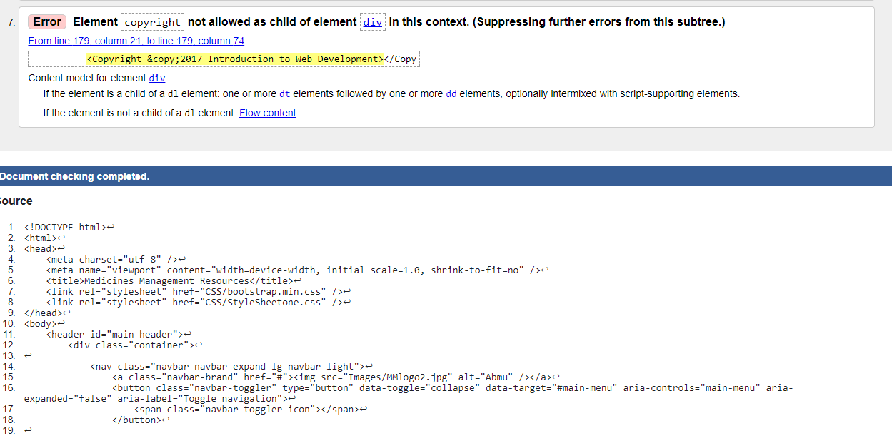
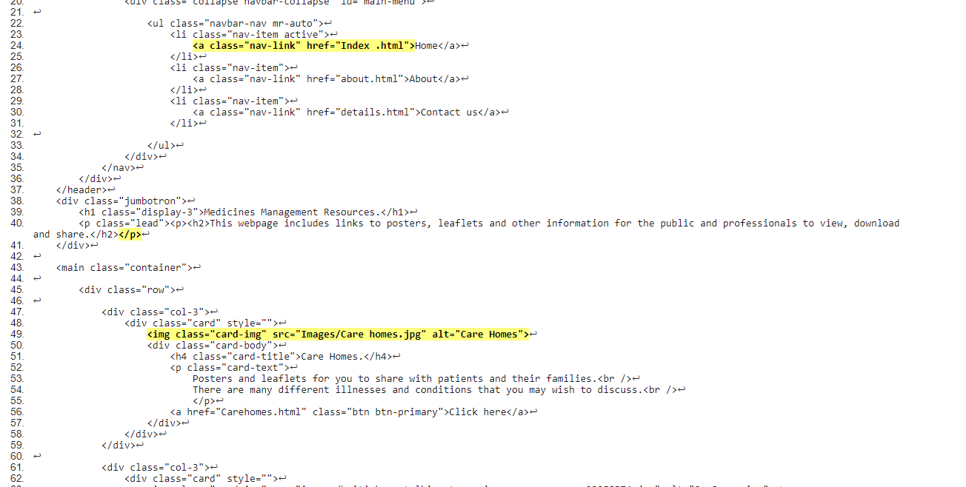
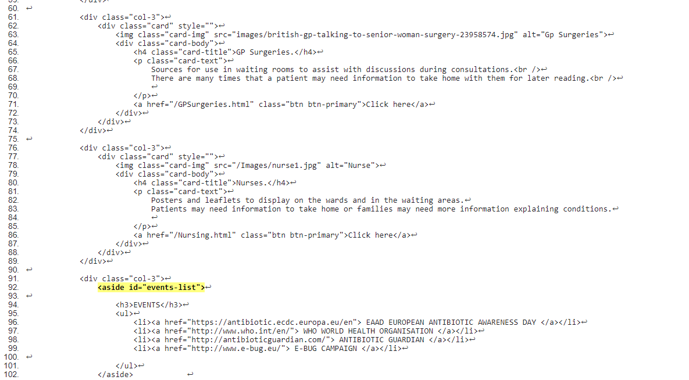
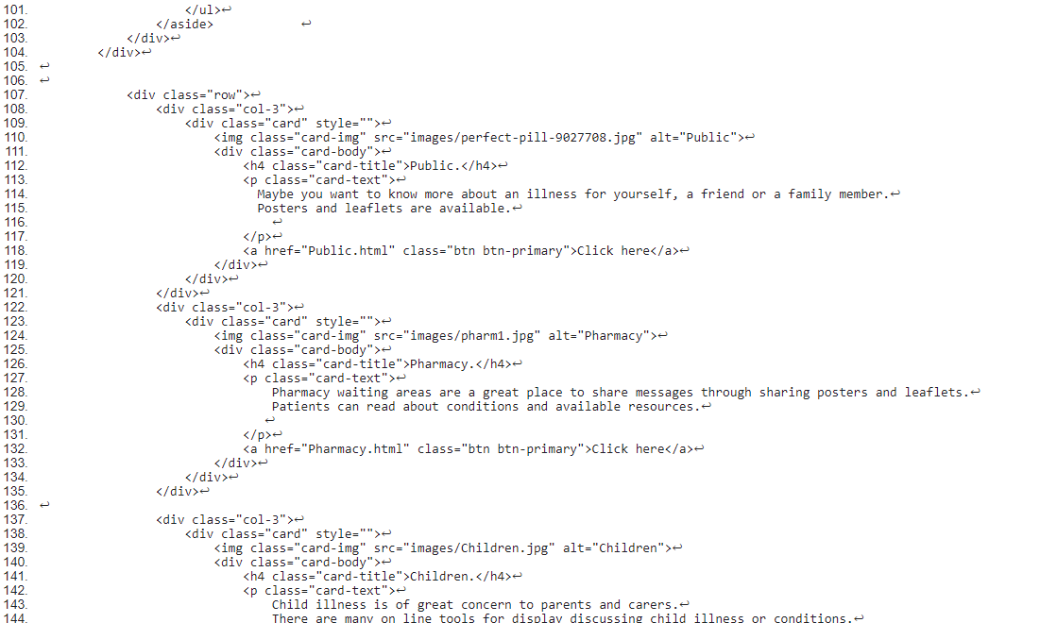
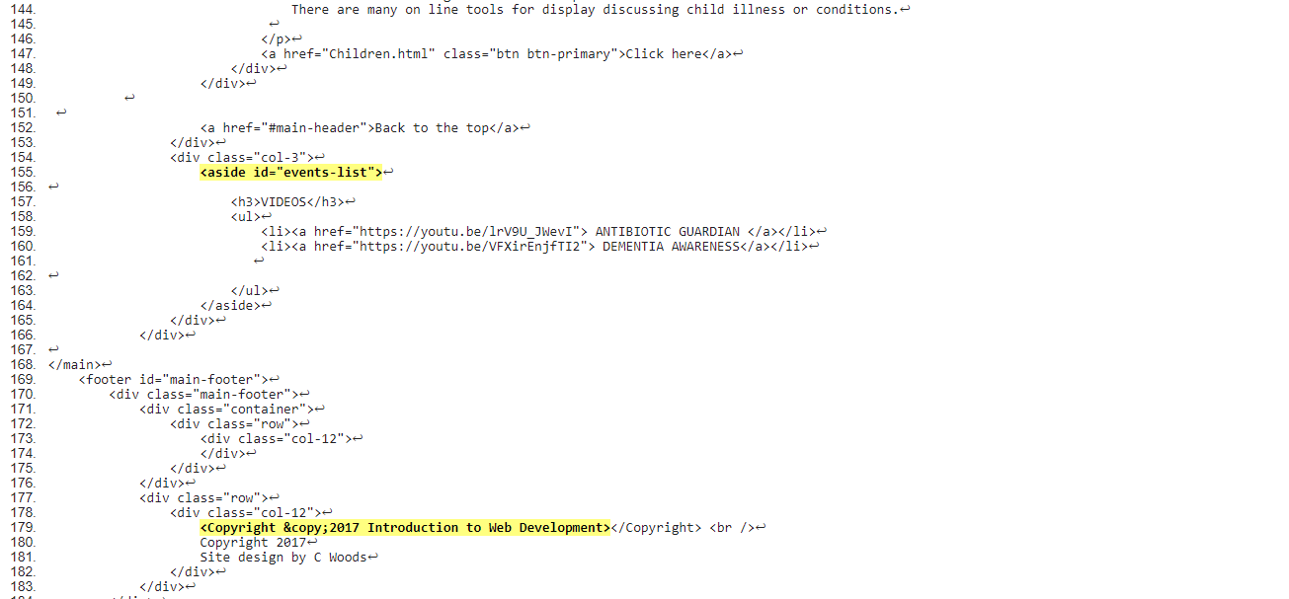
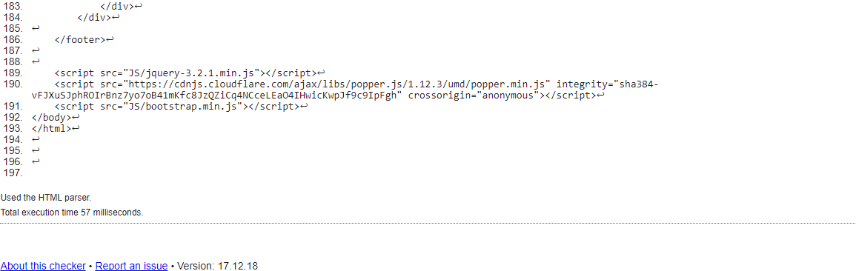

Appendix 5. Validation of CSS

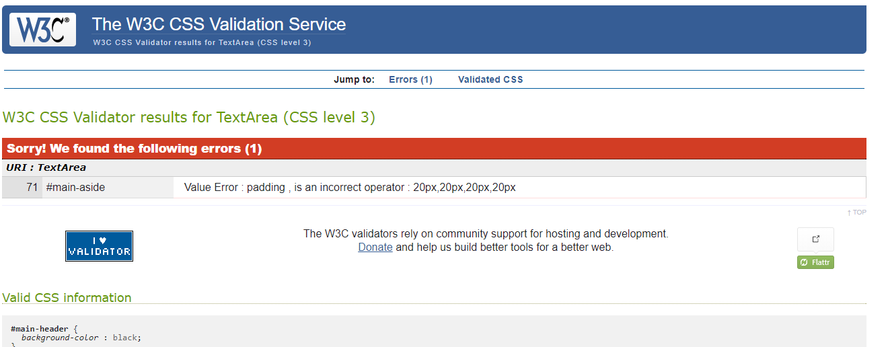
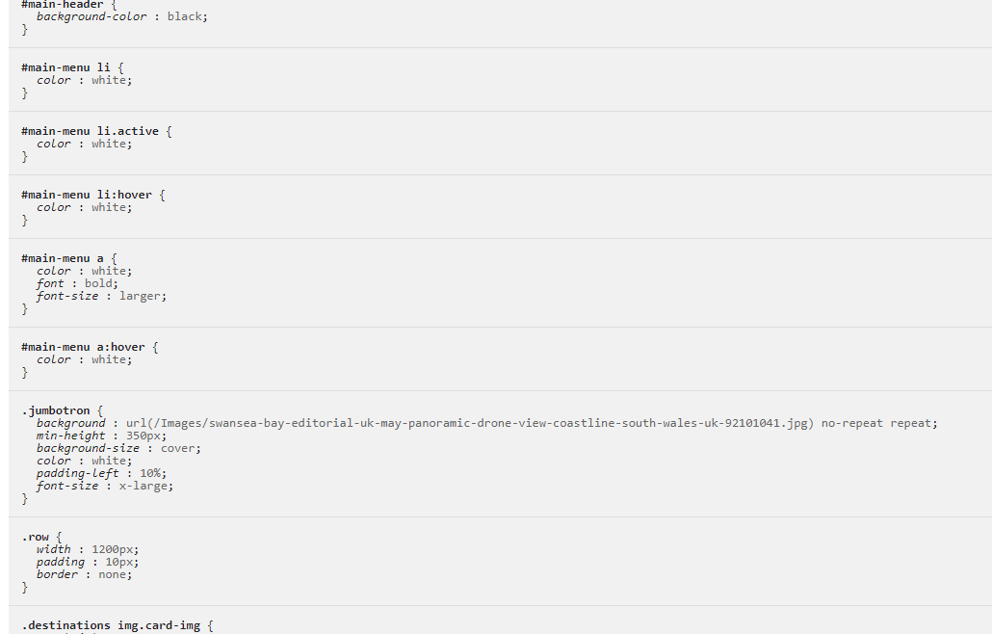
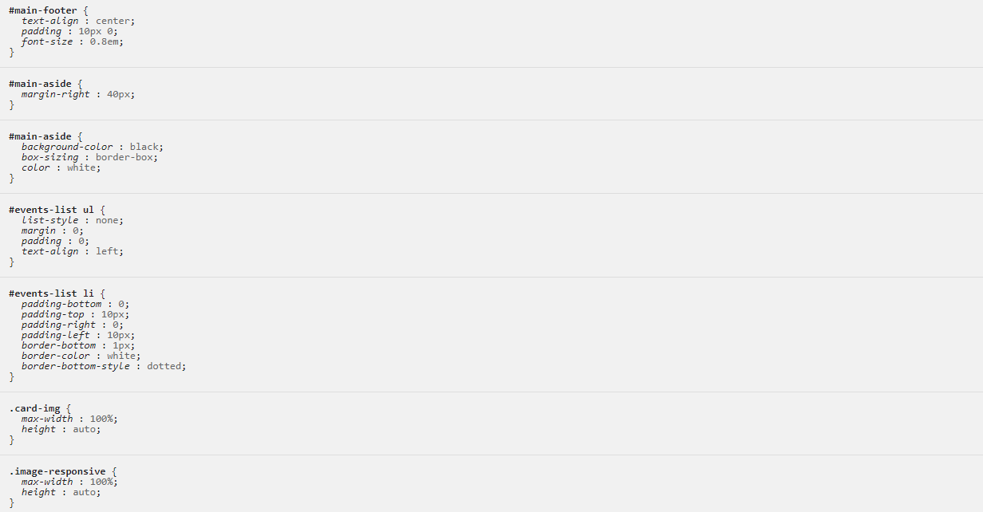
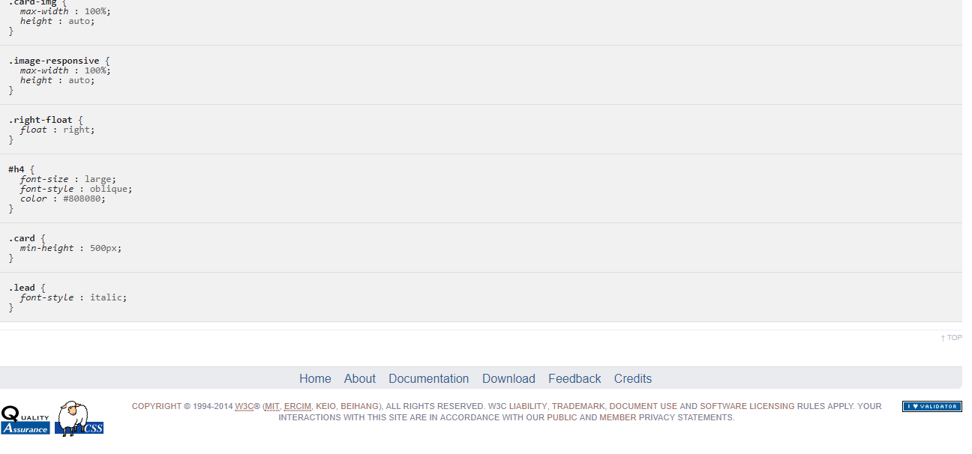

Referencing

[1] | W3C, “W3C CSS Validator results for TextArea (CSS level 3),” [Online]. Available: https://jigsaw.w3.org/css-validator/validator. [Accessed 18th December 2017].
[2] | T. R. C. U. o. W.-M. Ben Caldwell, “Web content accesibility guidelines (WCAG 2.0),” 11 December 2008. [Online]. Available: https://www.w3.org/TR/WCAG20/. [Accessed 15 December 2017].
[3] | S. H. e. al., “Analysing the visual complexity of web pages using document structure,” Behaviour & Information Technology, vol. 32, pp. 491-503, 2013.
[4] | J. Duckett, HTML & CSS, Indiana: John Wiley & Sons, 2014.
[5] | T. R. C. U. o. W.-M. Ben Caldwell, “Web Content Accessibility Guidelines (WCAG) 2.0,” [Online]. Available: https://www.w3.org/TR/WCAG20/#seizure. [Accessed 17th December 2017].
[6] | P. W. Site, “Beautiful Free Images,” [Online]. Available: https://pixabay.com/en/service/faq/. [Accessed 12th December 2017].
[7] | P. H. England, “Antibiotic awareness posters and leaflets,” 23 September 2016. [Online]. Available: https://www.gov.uk/government/publications/european-antibiotic-awareness-day-and-antibiotic-guardian-posters-and-leaflets. [Accessed 30th November 2017].
[8] | Nice, “National Institute for Health and Care Excellence,” [Online]. Available: https://www.nice.org.uk/guidance. [Accessed 30th November 2017].
[9] | Paletton, “The colour scheme designer,” [Online]. Available: http://paletton.com/#uid=1000u0kllllaFw0g0qFqFg0w0aF. [Accessed 16 November 2017].
[10] | K. Ademoye, “HTML Forms and More CSS,” Swansea, 2017.

