Marketing Fundamental

Discover Romania
(BLOG)

By: LILIANA HARTAN (1811830)
ANDREI DAVID (1814707)
VERONICA ANDRIESAN (1811269)
SERGIU MECHERES (1814709)
ZUZANNA TUSK (1708231)

Contents
Introduction 2
Places (by Zuzanna Tusk) 3
Culture (by Liliana Hirtan) 5
Activities (by Adrei David) 7
Food and drinks (by Veronica Andrisan) 9
Prices (by Sergiu Mecheres) 11
References 13

Introduction

Romania is a middle-sized Central European country, both in terms of surface area and population, located at roughly equal distances between the western and eastern extremities of the continent. The favorable consequences of this geographical position are obvious: moderate temperatures, sufficient rainfall, fertile soils, rich vegetation, including forestry. Geographically, Romania is not a Balkan country because it is to the north of the Balkan Peninsula.
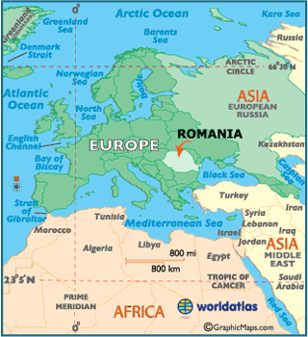
Source: www.worldatlas.com

Romania is highlighted by three landmarks: it is a Carpathian country, it is a Danubian country and it is a Pontic country. Romania is a Carpathian country because 2/3 of the Carpathian chain length is taking place on the territory of Romania. The Carpathians are the backbone of Romania's relief.

Places (by Zuzanna Tusk)

Being a country with all forms of relief, Romania has many touristic places to visit. For example, in the south-east of the country, there is The Black Sea with its wonderful beaches. There are many tourist resorts from which you can choose, but the most visited by young people is, by far, the Costinesti Beach, where many students come to party up until the morning and watch unforgettable sunrises (Booth, 2014). The clubs are very different and you can definitely find something suitable just for you, with the kind of music you listen to usually. Besides this, the most popular beach is Mamaia, but the prices there are a little bit higher.
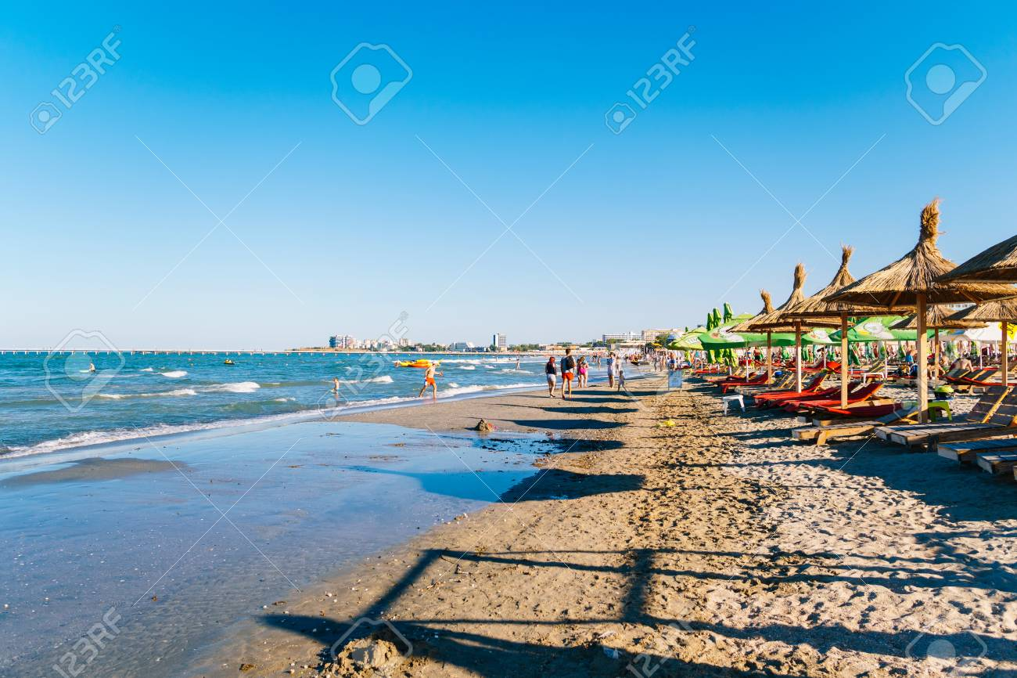
Source: 2017 - www.123rf.com
Another wonderful destination is Techiegheol Lake, where older people come for its wonderful mud and sulfuruos water treatments. In the south of the country is situated the Danube, which borders Romania and Bulgaria. Besides this, the Danube at its discharge into the Black Sea, through three arms and it forms a wonderful landscape with many species of birds and wonderful water lilies (Stanley, 2017).
Crossing to the center of the country we can visit the Carpathian Mountains. They are so funnily placed that it can give you the impression that someone wanted to divide the country (Discover Romania). In this part of the country we can find a lot of old monasteris which were built by Stefan cel Mare to commemorate those who were killed in the wars between Romanians and Turkish.One of them is the Putna monastery where the ruler is buried.
Another interesting thing that you can do while you stay in Romania is to cross the longest road that crosses the Carpathian Mountains, Transfagarasan.
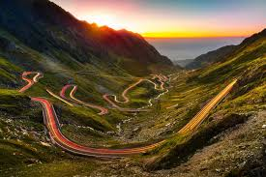
Source: www.viator.com
There are a lot of things you can do while visiting Romania because this country has all the types of relief so you can enjoy the diversity it offers.

Culture (by Liliana Hirtan)

Romania is a mixture of cultures, landscapes and flavours. The vibrant colors of the traditional costumes, the lush green forests of centuries, the noise of the medieval towns with cobbled streets and the perfectly preserved wildlife in the Danube Delta, are just some of the wonders that give charm to this country.
Each city has a story waiting to be said, each building hides ancient secrets and carries traces of battles preserved in history books, every tradition that has passed through time and together they make up that "beautiful country with remarkable people" which Prince Charles was talking about.
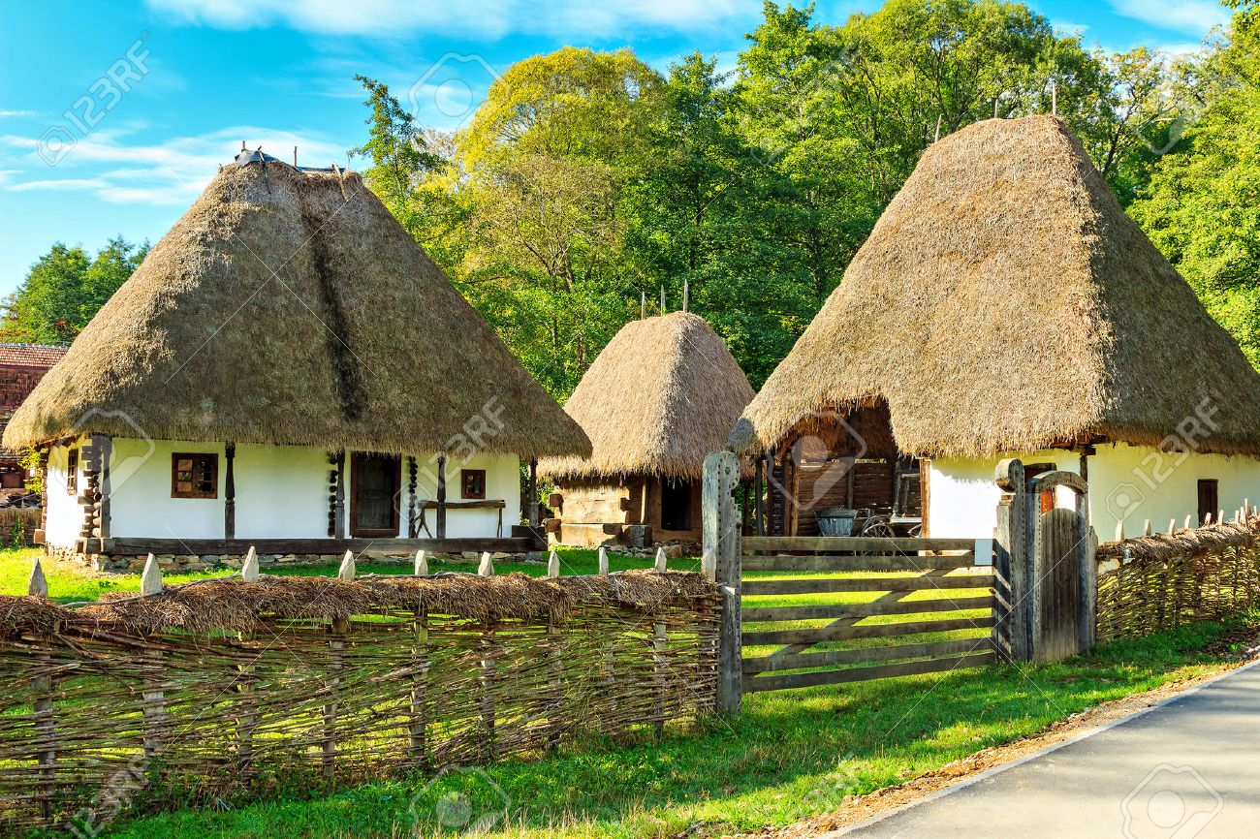
Source: www.123rf.com
Romania boasts with many traditions and customs that can’t be met in other parts of the world, with impressive tourist attractions, excellent food and great accommodation. Romanians find a special occasion at different times of the year – in religious days (Easter, Christmas), in the agricultural calendar, there is always a special occasion for which they have a tradition or a habit that is repeated from generation to generation.
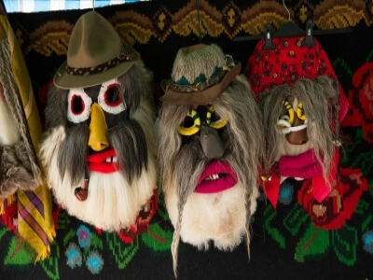
Source: https://romaniatravelplanner.com
One of these traditions is old folk dances. Foreign tourists are always fascinated by the old folk Romanian dances, such as the ”calusarii” or "hora", combining elegant movements with satirical lyrics and rhythmic music. ”Călusarii” is a ritual of the dance of initiation, while the ”hora” can be danced by all the inhabitants of a village, especially on Sundays.
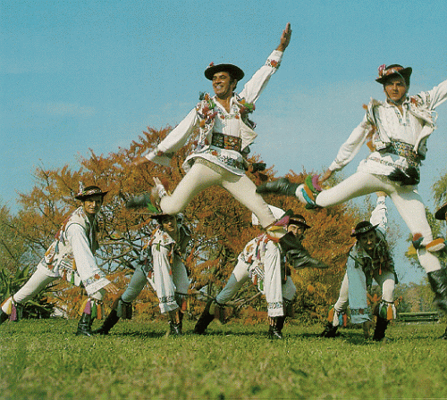
Source: 2011 - https://welcome2romania.wordpress.com

When it comes to the people, Romanian people can be easily described as being joyful and friendly, trying to make everything feel like a holiday. They are very talkative and even though many of the old people don’t know any other language besides Romanian, they always find a way to communicate with foreign people. Every Romanian will offer you something to drink and even something to eat as soon as you enter they home, and they will even invite to one of their traditional parties if they like you enough.

Activities (by Adrei David)

There are a lot of activities from which you can choose depending on the destination you visit. For example, if you go for a holiday in the mountains, the main activity in the cold season (and not only) is skiing. You can ski on almost any season, and in any conditions because there are portions where avalanches never pass. Besides that, Romanian mountains have which will lead you to so many beautiful views of the mountains. You can also climb, and if needed, there is always a specialist in our team who can guide you. Hicking is a the best thing that can be done in the summer, on warmer days, when the paths are not sloppy.
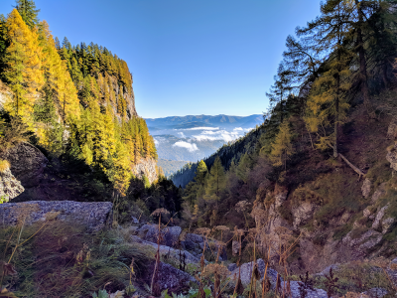
Source: https://hikingbeast.com

Besides these activities, you have the oportunity to watch some wild animals, like bears, wolves and boars. Depending on the region you’re visiting, you can always go around the cities, visit some churches, castels and find more about the history behind them. A lot of mountain villages offer the opportunity to ride the carriage around the place, and if you choose to go to the Danubian villages you’ll have the opportunity to go fishing, riding the boat and even take some photography courses if you want to capture some moments.
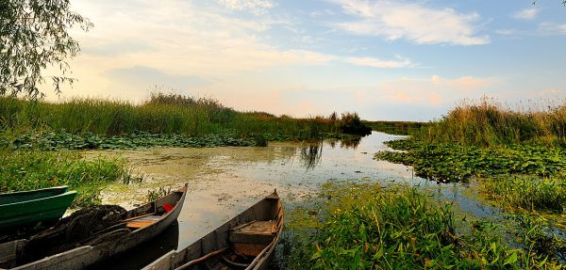
Source: 2013 - www.agromonitor.ro
In summer season, the Romanian seaside is full of opportunities, from clubbing to just laying in the sun, waiting for a nice tan. In June we even have a festival on the beach, named Neversea, where singers all over the world are invited every year.
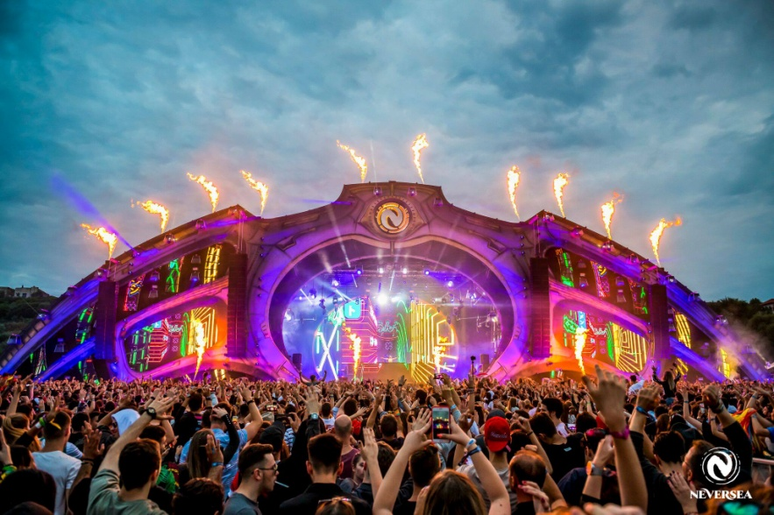
Source: https://axis-structures.com

Food and drinks (by Veronica Andrisan)

The traditional Romanian cuisine has a variety of delicious culinary delights that you can hardly resist. We can be proud of four products recognized at European level, like Topoloveni Magnus, Sibiu Salami, Ibanesti Cheeses and Plescoi Sausages.
The Romanian cuisine has been formed and developed in the same time with the Romanian people, both from loans from the gourmet cultures of the different peoples with whom it has been involved in history, as well as from the capitalization of its own agricultural crops and animal breeding. Thus, we can today enjoy a wide range of products offered by the fields of the country: from cereals, vegetables, fruits, to meat and milk products, each having unique flavors and tastes given by the local traditions of the areas where prepare, as well as the methods and techniques of realization and preservation.
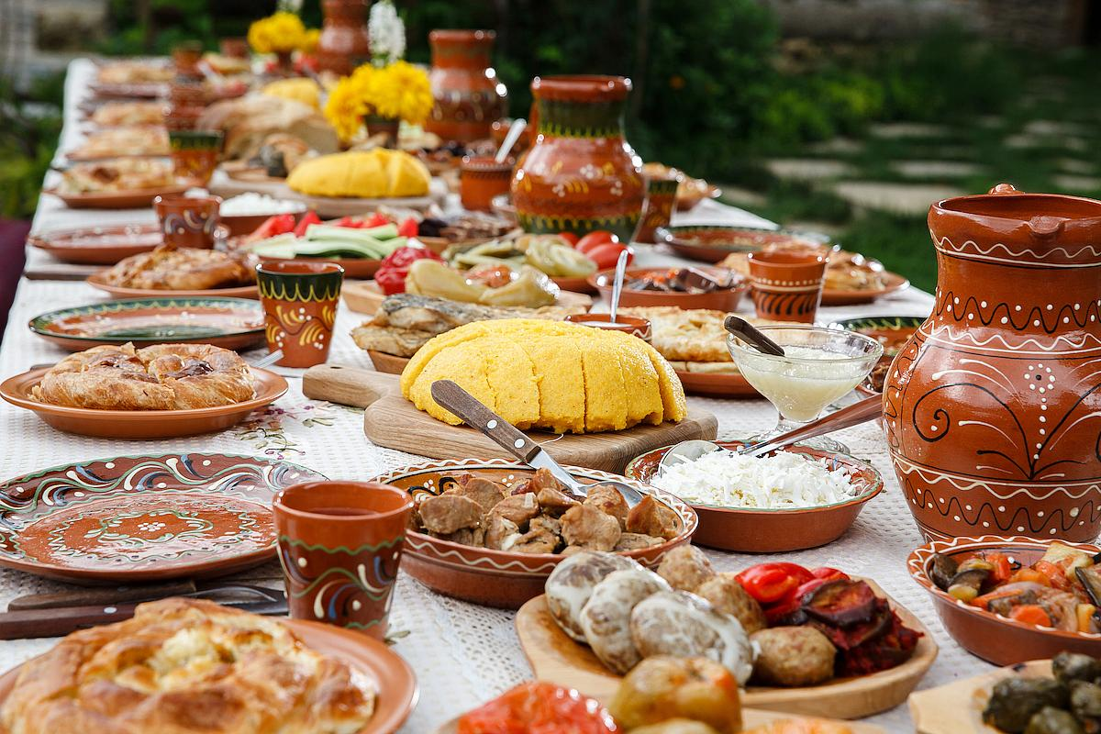
Source: 2014 - www.descopera.ro
We are proud of some of the world's most delicious dishes prepared with much love and skill by our housewives, such as:
- soups for which there are numerous recipes, from vegetable soups, fish soups, meat soups, belly soup, potato soup
- meat in cabbage leaves with polenta, a tasty and appreciated meal by all the tourists who visit us
- small barbecue with mustard, an indispensable dish on Romanian tables
- Stuffed peppers, a blend that perfectly combines sweet peppery flavor with a mixture of meat and spices, cooked in the oven and served with a homemade sour cream
- ”Tochitura”, a high calorie food specially prepared around winter pork feasts, a dish which contains pork, cheese and fried eggs.
- ”Zacusca”, a delicious and savory dish made from baked vegetables (eggplant, peppers, carrots, onions) that can be preserved in jars for a long time – we usually serve it in the morning, for breakfast
- boiled cabbage, a traditional dish that can be prepared from both sweet cabbage and cabbage, seasoned with various spices and served together with warm polenta and hot pepper
- ”Pilaj”, a dish made of boiled rice with vegetables or meat.
- ”Piftie”, a cold dish that serves as an appetizer and can be obtained from bones and pork or turkey
- ”Drob”, another cold dish served as aperitif and specially prepared for Easter;
- ”Pastrama”, a culinary goodie which can be prepared from a wide assortment of meat (beef, pork, sheep) and served whenever you want;
- ”Ostropel”, a cooked dish of tomatoes and meat
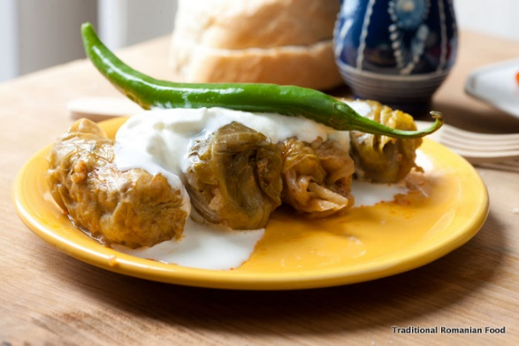
Source: 2018 https://class-hotel.ro
Our traditional cuisine has specific desserts: cake with cocoa filling and walnuts, cheese pies, apples or pumpkin pies, donuts, pancakes, milk rice and many cake recipes, passed on from generation to generation. The housewives are also very competent in the preparation of many types of jam and fruit compote, and the gentlemen are unbeatable in making our specific drinks.
When it comes to the food, we also have some options for vegetarians and vegans as we try to be friendly with every quest.
Now, moving on to the drinks, just as we pride ourselves with our traditional dishes, in the same way Romanian traditional drinks are remarkable and worthy of praise. Developed through advanced methods throughout generations, they are now part of what sets us apart as a country. Whether it is ”tuica”, ”rachiu”, ”palinca” or ”slibovita”, regardless of the region they come from, the common element of all these is the exceptional quality and exclusive use of natural ingredients.

Prices (by Sergiu Mecheres)

Accommodation at the hotel is one of the safest ways to get shelter when you start your expedition to Romania. A good advice to remember is to look for a hotel chain that is represented in several cities in Romania. If you want something cheaper, you can always use AirBnb, or look for some other places to stay. When going to the mountains, for example, you can always choose to stay in a tent, which will cost you nothing. Going to the seaside, you can choose the tent as well, but you have to pay a small amount of money, something around 10 euros per night, to install your tent somewhere. However, be careful to look for a place like this with at least one month before going to the seaside in full season (June-August), because that’s the period of time when almost everything is fully booked.
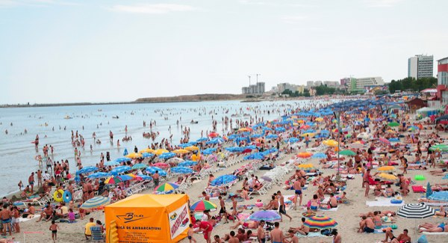
Source: 2008 – http://www.nubricks.com
Depending on the comfort and luxury you want in a room, the prices for a hotel room may vary between 20 euros per night and maybe more than 150 euros per night. Besides that, another element that can change the price is the season in which you choose to visit a certain place. For example, if you go to the seaside between June and August, the accommodation is going to be more expansive than in the spring or autumn. For this seasons (spring and autumn) there are some promotional packages which give you the opportunity to rent a place for a cheaper price (for example, you can rent a room which usually costs 50 euros per night, just at the price of 30 euros per night, or even 20).
When it comes to the lifestyle, it is pretty cheap in Romania. You can find drinks and food at low prices in every city you choose to visit, and even the clubbing has low prices.

References

Booth, Tom 2014, A Black Sea beyond the all-inclusive eyesores, The Telegraph, 18 August, accessed 18 August 2019
Discover Romania, The Carpathian Mountains, accesed 20 August 2019, www.rolandia.eu/en/blog/discover-romania/the-carpathian-mountains
Stanley, Courtney 2017, The 12 Most Beautiful Spots In Romania, Culture Trip, 9 February, accessed 20 August 2019
https://www.worldatlas.com/img/areamap/4d0da08ecdfa17439515182c059168b9.gif
https://www.123rf.com/photo_82300922_mamaia-romania-july-14-2017-people-having-fun-in-water-and-relaxing-in-mamaia-beach-resort-at-the-bl.html
https://www.viator.com/tours/Bucharest/Bucharest-Private-Day-Trip-to-Transfagarasan-The-Road-in-the-Sky/d22134-10193P31
https://www.123rf.com/photo_32770508_the-old-peasant-houses-astra-village-museum-sibiu-transylvania-romania-europe.html
https://romaniatravelplanner.com/winter-activities-in-romania/
https://welcome2romania.wordpress.com/2011/11/25/calusarii-intre-traditie-si-magie-calusarii-the-mystical-dancers-www-welcome2romania-wordpress-com/
https://hikingbeast.com/romania/
http://www.agromonitor.ro/intalnire-de-constientizare-cu-pescarii-din-delta-dunarii/ July 2013, Dragos Serban
https://axis-structures.com/en/project/neversea-festival-2/
https://www.descopera.ro/cultura/13632728-care-sunt-de-fapt-mancarurile-traditionale-ale-romanilor Nobember 2014, Mihaela Stanescu
https://class-hotel.ro/erm_menu_item/sarmale/ February 2018
http://www.nubricks.com/archives/1200/new-on-the-market-in-romanias-black-sea-beach-coast/ November 2008

