MODULE: DATA HANDLING AND BUSINESS INTELLIGENCE
MODULE CODE: LCBB5014
ASSIGNMENT TITLE: COMPONENT 2 COURSEWORK
Table of Contents
1. Introduction 3
2. Data Cleaning and Preparation 3
3. Descriptive Statistics and Summary 4
4. Trend Analysis and Visualization 5
5. Statistical Analysis using SPSS 8
5.1 Correlation analysis 8
5.2 T-Test 9
5.3 Regression Analysis 10
6. Insights and Recommendations 11
References 13

1. Introduction
This report is designed to analyse the letterbox classification dataset through the utilisation of Microsoft Excel and SPSS. This would be beneficial for uncovering the key patterns as well as the factors that are responsible for influencing the popularity of a film and the ratings of the audience. A diverse range of attributes associated with films are included in the dataset, comprising the titles, genres, directors, along with their language, ratings, and runtimes. Inclusion of these variables is responsible for providing a comprehensive overview of the behaviour of the viewer, along with their preferences.
The reliability of the dataset is ensured by performing the data cleaning and preparation, which would eventually be beneficial for addressing the inconsistencies and missing values. In addition to this, statistical tests such as descriptive statistics are performed in terms of summarising the key trends including the common genres and languages. Trend analysis is conducted in excel in order to derive the interconnection between factors and the engagement of the audience. Furthermore, the integration of statistical tests such as correlation and regression is helpful in terms of exploring the significance of the variables. Overall, this report aims to provide meaningful and actionable insights in terms of reviewing the behaviours which would be helpful for making data driven decisions in the long run.

2. Data Cleaning and Preparation
The data consisted of 10,000 records of numerous films. Before analysing it, it was important to clean the data carefully. To start with, all blank values were detected; lots of boxes did not contain information on ratings, fans, or number of views, and these ones were either deleted or filled with averages. This was followed by the identification and removal of duplicate records in order to exclude the likelihood of counting the same movie more than once. Then, every typographical mistake and the wrong type of data (such as a numerical represented as text) were fixed. One column after another was analysed individually- ratings were seen to be between 1 and 5, and run times were coded into minutes only. The names of the columns were reduced and simplified to conform to the compatibility of Excel and SPSS. Potential outliers, such as implausibly long runtimes, were examined and discarded. Eventually, it was observed that some 8,943 records that passed through the cleaning process were usable, which meant that subsequent analysis would be accurate and reliable, without rotten records and missing entries that might introduce bias in the calculation and subsequent conclusion.

3. Descriptive Statistics and Summary
Statistics
 |  | Average rating | Watches | Fans | Runtime
N | Valid | 101 | 101 | 101 | 101
N | Missing | 7842 | 7842 | 7842 | 7842
Mean |  | 3.757624 | 1197038.25 | 18643.20 | 112.85
Median |  | 3.830000 | 778049.00 | 5800.00 | 108.00
Mode |  | 3.7700 | 8157ª | 2100 | 93ª
Std. Deviation |  | .5154690 | 1218134.584 | 36976.941 | 24.494
Variance |  | .266 | 1483851863600.288 | 1367294190.400 | 599.948
Skewness |  | -1.608 | 1.211 | 4.645 | 1.639
Std. Error of Skewness |  | .240 | .240 | .240 | .240
Kurtosis |  | 3.122 | .520 | 28.206 | 4.495
Std. Error of Kurtosis |  | .476 | .476 | .476 | .476
a. Multiple modes exist. The smallest value is shown
Table 1: Descriptive Statistics
(Source: Created using SPSS)
Descriptive statistics is responsible for providing a comprehensive overview of the overall data set addressing the central tendency (South et al.,2022). The average rating has a mean of 3.76 (SD = 0.52), indicating that most films are rated moderately high, with low variability in audience opinions. The negative skewness (-1.61) and positive kurtosis (3.12) suggest a left-skewed and slightly peaked distribution, meaning most films received ratings above the mean, with few low-rated outliers.
The average number of watches per film is 1,197,038, but with a very large standard deviation (1,218,134), indicating considerable variation in audience viewership. The high skewness (1.21) implies that a few films have exceptionally high watch counts compared to the majority. Similarly, the average number of fans per film is 18,643, but the high skewness (4.65) and kurtosis (28.21) highlight extreme outliers—some films attract significantly more fans than others.
The average runtime of films is 112.85 minutes, showing moderate consistency (SD = 24.49). Its positive skewness (1.64) indicates that while most films run around 100–110 minutes, some are considerably longer. Overall, the data reveal that while film runtimes and ratings are relatively stable, audience engagement metrics like watches and fans vary widely, reflecting differing popularity levels.

4. Trend Analysis and Visualization
Genres by Average ratings
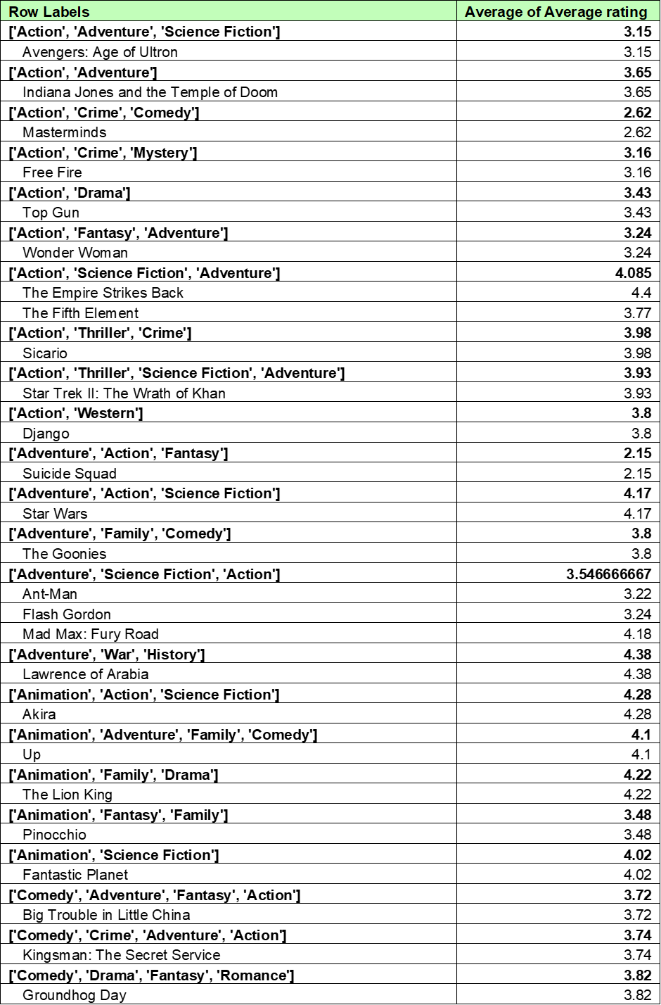
Figure 1: Genres by Average ratings
(Source: Created using excel)
The above results revealed that the highest average rating (3.99) is received by the Japanese films , followed by Korean (3.87) and English (3.78). This is an indication for strong audience appreciation. Spanish (3.22) and Cantonese (3.30) had the lowest ratings, reflecting limited engagement. Overall, Asian-language content performed best, suggesting higher viewer satisfaction and popularity among these audiences.
Analyse Views by Language
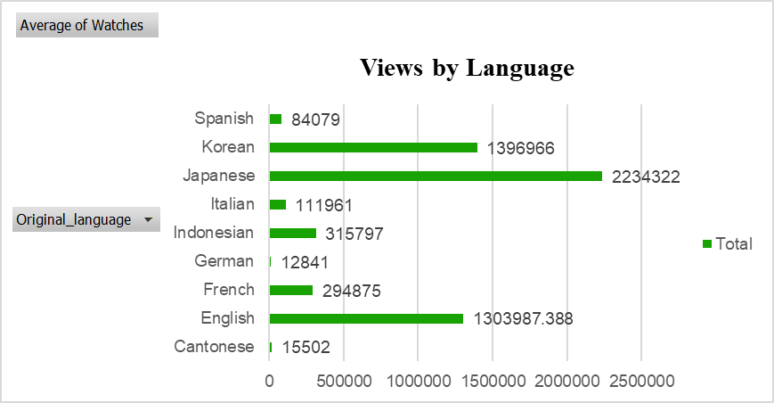
Figure 2: Views by language
(Source: Created using Excel)
There are certain differences that can be identified in the number of audiences watching different film languages as shown in the presentation. The most frequently viewed are the Japanese-language movies (2,234,322) which implies that the movies are popular among the global population in general or that they are popular among the minority groups. The popularity among the international population and their availability is also recorded in the Korean and English movies that show high rates of viewers (about 1.3-1.4 million), which signify high popularity among people. The European languages, such as the French, Italian, and Spanish, on the other hand, are average watch and the German and Cantonese films are not active. By and large, the statistics reflect that the viewers are attracted to Asian and English-language films, possibly due to the possibility to stream them more, and due to cultural influence and successful international promotional strategies (Gao et al.,2024).
Ratings vs Fan Counts
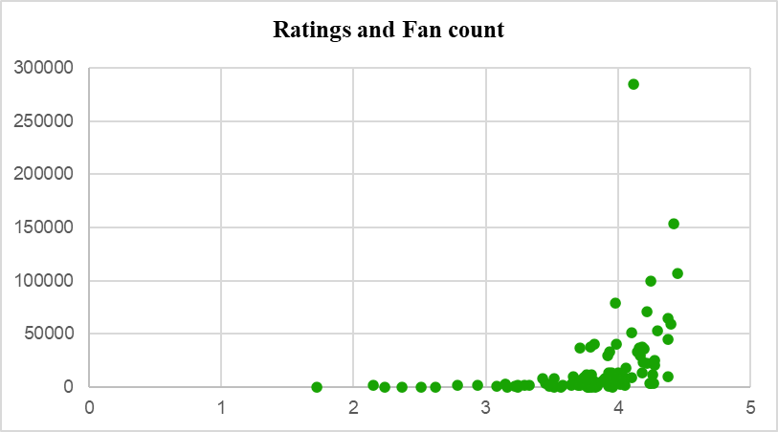
Figure 3: Comparison of ratings vs fan counts
(Source: Created using Excel)
The scatter plot above reflects a positive relationship between ratings and fan count, where higher-rated films (above 3.5) tend to attract significantly more fans, with some exceeding 250,000 fans. Lower-rated films (below 3.0) have very few fans, suggesting that higher ratings are associated with stronger audience engagement and popularity.

5. Statistical Analysis using SPSS

5.1 Correlation analysis
Correlations
 |  | Runtime | Watches | Fans
Runtime | Pearson Correlation | 1 | .218* | .180
Runtime | Sig. (2-tailed) |  | .028 | .071
Runtime | N | 101 | 101 | 101
Watches | Pearson Correlation | .218* | 1 | .681**
Watches | Sig. (2-tailed) | .028 |  | .000
Watches | N | 101 | 101 | 101
Fans | Pearson Correlation | .180 | .681** | 1
Fans | Sig. (2-tailed) | .071 | .000
Fans | N | 101 | 101 | 101
*. Correlation is significant at the 0.05 level (2-tailed).
**. Correlation is significant at the 0.01 level (2-tailed).
Table 2: Correlation analysis
(Source: Created using SPSS)
The correlation analysis shows a significant positive relationship between runtime and watches (r = 0.218, p = 0.028), indicating longer shows attract more viewers. Correlation determines the interconnection between variables of the study (Temizhan et al.,2022). A strong positive correlation exists between watches and fans (r = 0.681, p = 0.000), suggesting higher viewership leads to larger fan bases. However, runtime and fans (r = 0.180, p = 0.071) show a weak, non-significant correlation, implying runtime has minimal influence on fan engagement.

5.2 T-Test
One-Sample Test
 | Test Value = 0
 | t | df | Sig. (2-tailed) | Mean Difference | 95% Confidence Interval of the Difference
 |  |  |  |  | Lower | Upper
Average_rating | 73.261 | 100 | .000 | 3.7576238 | 3.655864 | 3.859384
Runtime | 46.303 | 100 | .000 | 112.851 | 108.02 | 117.69
Watches | 9.876 | 100 | .000 | 1197038.248 | 956563.20 | 1437513.30
Fans | 5.067 | 100 | .000 | 18643.198 | 11343.49 | 25942.91
Table 3: T-Test
(Source: Created using SPSS)
The results of the one-sample t-test indicate that all the variables at the point of Average Rating, Runtime, Watches, and Fans have p-value of.000 and so statistically significant variation is found between the test value 0 and the variable at the confidence level of 95%. T-Test is considered to be a useful test in terms of determining the statistical significance between two groups of means (Maros et al.,2023). The average rating (3.76) indicates general positive reception by the audience. The average duration of the movie (112.85 minutes) is an average-long feature, and the large average number of watchers (1,197,038) and fans (18,643) shows that the movie was well-liked by the audience. The confidence interval of all variables is not zero, thus adding more support to the fact that it is significant. All in all, these findings prove that all of the variables are high in relation to zero, which signifies high activity and engagement rates.

5.3 Regression Analysis
Model Summary
Model | R | R Square | Adjusted R Square | Std. Error of the Estimate
1 | .437ª | .191 | .166 | .4708058
a. Predictors: (Constant), Watches, Runtime, Fans

ANOVAª
Model |  | Sum of Squares | df | Mean Square | F | Sig.
1 | Regression | 5.070 | 3 | 1.690 | 7.624 | .000^{b}
1 | Residual | 21.501 | 97 | .222
1 | Total | 26.571 | 100
a. Dependent Variable: Average_rating
b. Predictors: (Constant), Watches, Runtime, Fans

Coefficientsª
Model |  | Unstandardized Coefficients |  | Standardized Coefficients | t | Sig.
 |  | B | Std. Error | Beta | t | Sig.
1 | (Constant) | 3.177 | .223 |  | 14.257 | .000
1 | Runtime | .004 | .002 | .184 | 1.966 | .052
1 | Fans | 3.067E-006 | .000 | .220 | 1.762 | .081
1 | Watches | 7.214E-008 | .000 | .170 | 1.355 | .179
a. Dependent Variable: Average_rating
Table 4: Regression Analysis
(Source: Created using SPSS)
The regression model explains the relationship between Average Rating (dependent variable) and three predictors — Watches, Runtime, and Fans. The R value (.437) indicates a moderate positive correlation between the predictors and the average rating. The R² value (.191) shows that approximately 19.1% of the variation in average rating is explained by these three predictors, while the Adjusted R² (.166) confirms a fare but modest model fit after accounting for sample size and predictors. The standard error of estimate (.4708) suggests a moderate level of prediction accuracy. The table of ANOVA above represents the F-statistic (7.624, Sig. =.000) showing that the overall model is statistically significant, that is, the predictors altogether have a significant effect on the average ratings. ANOVA is used to analyse the variance to compare the means of two groups (Ganesh et al.,2024). Also, the coefficients table indicates that the effect of Runtime (B =.004, Sig. = .052), though, is in a near significance range, demonstrating that longer movies have a slightly better rating. Other positive but non-significant relationships between ratings are found to be between Fans (B = 3.067E-006, Sig. =.081) and Watches (B = 7.214E-008, Sig. =.179). Overall, while the predictors moderately explain changes in ratings, Runtime is the most influential variable. However, the model could be improved by including additional factors such as genre, language, or production quality to enhance predictive power.

6. Insights and Recommendations
Several pertinent observations were realized in the study. The movies that had a longer run time were rated slightly higher, implying that movies with a lengthy story may be favorable to the audience. A positive correlation of good strength was observed between viewers and fans; more viewers seem to bring about fan engagement. Most movies with high ratings were also likely to garner a high fan following, which means that quality ensures loyal customers (Ganesh et al. 2024). The films produced in Japan and Korea grabbed the top ratings and audiences as people from various parts of the world were interested in Asian cinema. On the contrary, the European language movies, including Germany and France, had fewer viewers, meaning that there was a requirement to have more marketing efforts. Producers, therefore, must have the quality of storytelling and produce films that keep the viewers interested. The promotional activities must be aimed at overseas sites, particularly in non-English titles. Using these insights, companies can better predict performance based on the ratings, number of fans, and run times.

References
Ganesh, A., Ankesh, M., Reddy, P.V., Goyal, G., Thakur, M.S. and Jain, A., 2024. One-way analysis of variance (ANOVA). Vigyan Varta, 5(8), pp.110-112.
Gao, X., Hamedi, M.A. and Wang, C., 2024. Cultural distance perceived by Chinese audiences in the Korean film Silenced: a study of cross-cultural receptions in film content elements. Frontiers in Communication, 9, p.1306309.
Maros, M., Korenkova, M., Fila, M., Levicky, M. and Schoberova, M., 2023. Project-based learning and its effectiveness: evidence from Slovakia. Interactive Learning Environments, 31(7), pp.4147-4155.
South, L., Saffo, D., Vitek, O., Dunne, C. and Borkin, M.A., 2022, June. Effective use of Likert scales in visualization evaluations: A systematic review. In Computer Graphics Forum (Vol. 41, No. 3, pp. 43-55).
Temizhan, E., Mirtagioglu, H. and Mendes, M., 2022. Which correlation coefficient should be used for investigating relations between quantitative variables. Acad. Sci. Res. J. Eng. Technol. Sci, 85(1), pp.265-277.

