Assignment 2

Lecturer: Allan Nantel

Module: Material Science and building services (ACBA4006)

Student: Adam Hassan (1802740)

Submitted: 6th April 2020

TASK A
- Calculation

- Room Index
RI=(LxW/Hm(L=W)
60 x 24/7(60+24) = 2.45

- Utilisation Factor = 0.46

- Number of lamps required
E x A/F x UF x LLF
E = 200 A = 60 x 24 F = 18000 UF = 0.46 LLF = 0.75
= 1440

200 x 1440/18000 x 0.46 x 0.75 = 46.37
So, 48 Lamps

4) Suitable Layout Value for ‘S’
1.5 x 7 = 10.5

- Suitable Layout
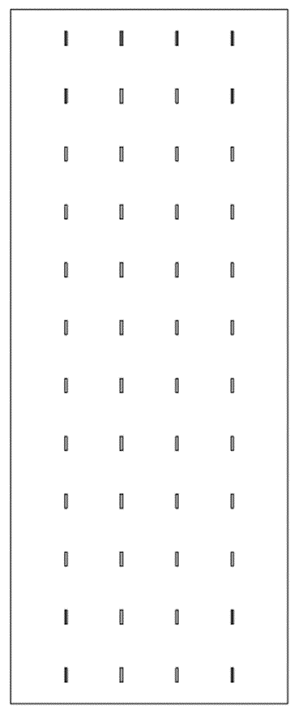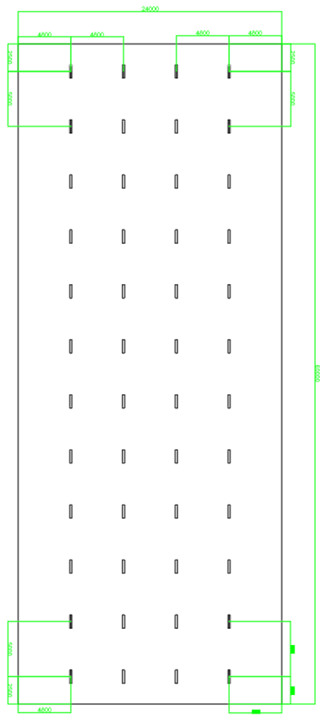
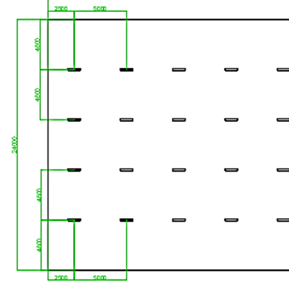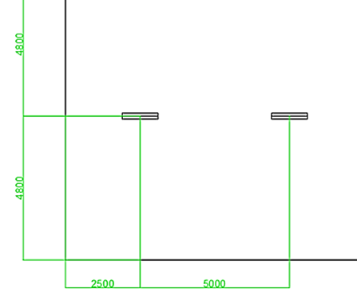
The layout drawn is 60m x 24m with 48 lamps. The best fit layout from the centre of each lamps is as shown in the drawing, going across the 24m length the spacing is 4.8m. Across the 60m length the spacing of ‘S’ is 5m which makes half ‘S’ 2.5m which gives the lamps even spacing throughout.

TASK B

- Calculation

Brick Wall Window
Area = 16m² A = 4m²
SRI = 50 dB SRI = 10 dB

50 = 10(log₁₀(1/T₁)) 10 = 10(log10(1/T₂))
50/10 = log₁₀(1/T₁) 10/10 = log10(1/T₂)
5 = log₁₀(1/T₁) 1 = log10(1/T₂)
1/T₁ = 10⁵ 1/T₂ = 10¹
T₁ = 10⁻⁵ T₂ = 10⁻¹

T₀ = (T₁ x A₁) + (T₂ x A₂) / A₁ + A₂
T₀ = (10⁻⁵ x 16) + (10⁻¹ x 4) / 16 + 4 = 0.020008

Overall SRI
10 (log₁₀ (1/0.020008)
=16.99

- Discussion

Introduction
When we have sound energy from a source hit a room boundary, the sound wave can either be reflected, absorbed or transmitted. The amount of energy that is reflected, absorbed and transmitted is different for each frequency (Chiu et al, 2015). A higher frequency, which has a short wavelength, can be absorbed by a thinner material whereas a lower frequency, which has a longer wavelength will not be absorbed (Stocker, 2013; Siemens, 2019).

Reflection
As sound strikes a surface, the incident sound wave will equal the reflected sound wave. Reflected sound contributes to the sound field in the room. An echo is a reflected sound wave that arrives 0.1s or more from the original sound source, also a minimum distance of 17m is needed to hear an echo (Bhavikatti, 2012).
To reduce echoes in construction, like auditoriums or theatres, you can lower the ceiling, which reduces the sound wave path distance or install reflectors (Bruel & Kjaer, 1988). Plane reflectors should be wide enough to reflect sound to the full width of the audience. They are usually suspended above a stage to reflect sound into the audience as the reflected sound must not be delayed. Curved reflectors are used to either concentrate the sound in a specific area or to disperse it (Cox and D'antonio, 2009).

Absorption
When a sound wave strikes a surface, the absorbed sound is converted into heat. Harder surfaces tend to reflect sound waves whereas softer surfaces absorb them. The absorption coefficient of a material is a ratio of how efficient a material is at absorbing sound energy. Each material has its own absorption coefficient and is measured by:
α = Absorbed acoustic energy
Incident acoustic energy

α = coefficient
If α = 1 all sound is absorbed
If α = 0 no sound is absorbed

Table 1: Absorption curve
(Source: Siemens, 2019)

When sound frequency is below 50hz, the material does not absorb well, whereas all sound between 50hz-100hz is absorbed (Siemens, 2019).

Transmission
Some sound coming from a source will travel through the material of a wall for example, becoming mechanical vibration and then becoming airborne sound again.

Partition Wall construction & Insulation
There are different methods of insulating sound in partition walls, but one method of insulating sound is to use gypsum plasterboard in a cavity partition wall using viscoelastic glue to stick the plasterboard layers together. Testing on this method shows that this improves sound insulation by a noticeable difference compared to without (Davy et al, 2015). The cavity gap between the walls allows sound to disperse before reaching the second partition leaf, although a common method is to have insulation such as fibreglass between the gypsum boards for an increased sound insulation but also thermal insulation. The use of gypsum plasterboard as a material is useful because of its low density but high sound insulation properties (Losso, and Viveiros, 2005). Another method of sound insulation is DFM (dense fibre matting) boards between the partition wall with sound breaker bars and soundproof panels as shown in the diagram (fig.1).
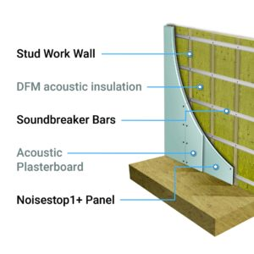
Fig.1 Diagram of stud wall
(Source: Noise stop systems, 2019)

References

Bhavikatti, S.S., (2012). Acoustics of buildings, Building construction, Vikas Publishing House Pvt Ltd, pp.293-309.

Bruel and Kjaer (1988). Behaviour of sound in a room, Measurements in building acoustics, pp.3-4.
Available online at https://www.bksv.com/media/doc/br0178.pdf
[Accessed online 04 April 2020]

Chiu S., Noble D. and Valmont E. (2015). Acoustics in architectural fabric structures: The case of ETFE pillows, Fabric Structures in Architecture, Woodhead Publishing Series in Textiles, pp. 241-256.

Cox, T.J. and D'antonio, P., (2009). Geometric reflectors and diffusers, Acoustic absorbers and diffusers: theory, design and application, Crc Press, pp.331-373.

Davy J.L., Phillips T.J. and Pearse J.R. (2015). The damping of gypsum plaster board wooden stud cavity walls, Applied Acoustics, 88, pp.52-56.

Losso, M. and Viveiros, E.,( 2005). Sound insulation of gypsum board in practice, In INTER-NOISE and NOISE-CON Congress and Conference Proceedings, Institute of Noise Control Engineering, pp.1196-1206.

Noise stop systems (2019). How to Soundproof a Stud Wall, Noise stop systems.
Available online at https://www.noisestopsystems.co.uk/how-to-soundproof-a-stud-wall/
[Accessed 05 April 2020]

Siemens (2019). Sound absorption, Siemens.
Available online at https://community.sw.siemens.com/s/article/sound-absorption
[Accessed online 03 April 2020]

Stocker, M., (2013). What is this thing called sound, Hear where we are: Sound, ecology, and sense of place, Springer Science & Business Media, pp.67-103.

