DS 1 Template

My Screenshots/Photos

Screenshot 1: Map app
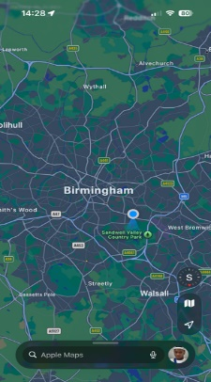
This shows that I use map apps to find my way around

Screenshot 2: Google
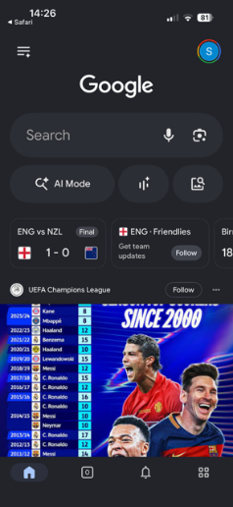
This shows that I use Google to navigate the internet and search for information.

Screenshot 3 : Moodle
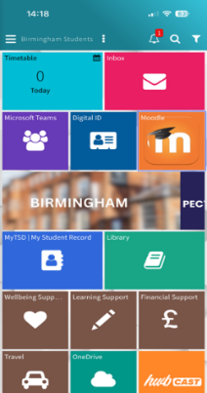
This shows that I use Moodle to access and complete my assignments

Screenshot 4: Gmail
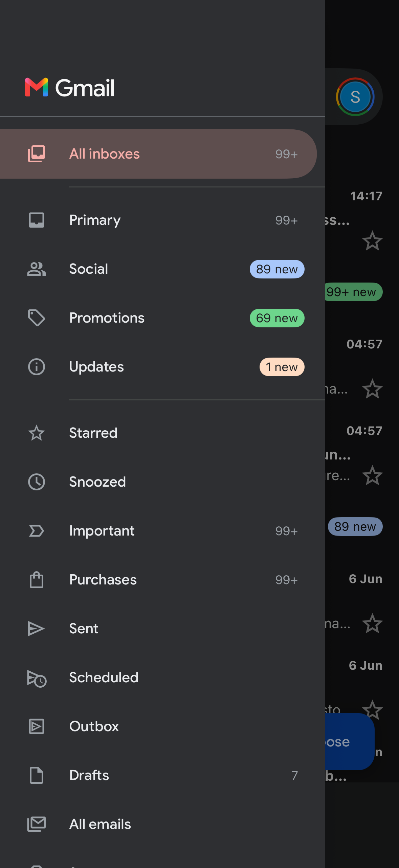
This shows that I use Gmail to send and receive emails.

Screenshot 5: WhatsApp
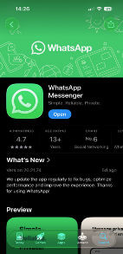
This shows that I use WhatsApp to communicate with friends and family through texting and calling.

Screenshot 6: Duolingo

This shows that I use Duolingo to learn a new language.

My Short Reflection
- I use digital tools to communicate with friends and family.
- I use digital tools to do my research online.
- I feel confident using digital tools because it helps keep files and document in order.
- Digital skills are important for me because it helps me learn new skills
- Digital skills are important for me because it keeps me connect with the whole world
- I hope this module will help me improve my digital skills and learn new skill that will help me with my future career.

