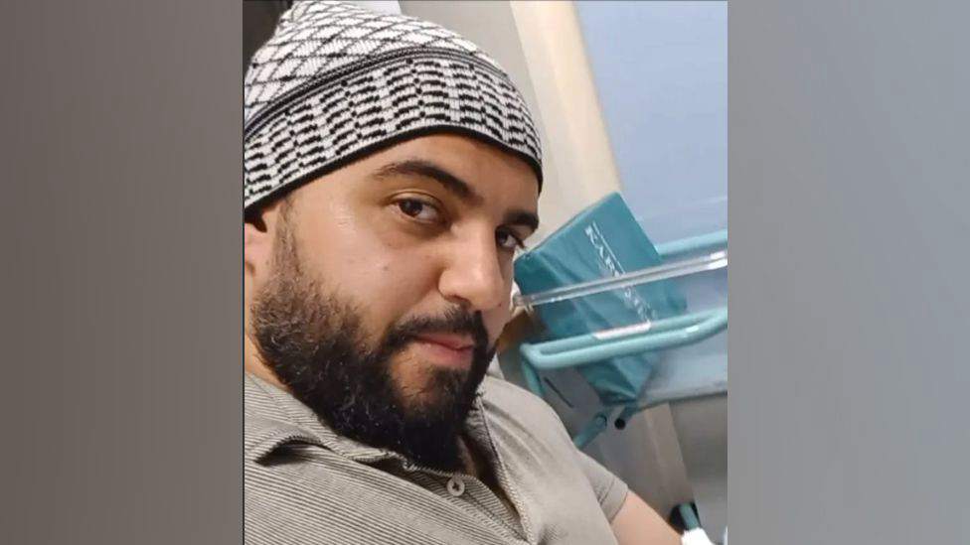

Jihad al-Shamie and the Manchester Synagogue attack

Case report

By Ashley Diaz
BMLC6007

Jihad Al-Shamie Upbringing:
The Manchester Synagogue attacker was Jihad Al-Shamie which translates as “struggle of the Syrian” Al-Shamie, a 35-year-old British Citizen from Syrian descent who was granted British citizenship in 2006 at the age of 16. Jihad Al-Shamie lived in Prestwich, Manchester which is a predominantly Orthodox Jewish community and two miles roughly from the Synagogue. Many of his neighbours reported to BBC that he was a weightlifting enthusiast who rarely spoke to his neighbours. "He was just a straightforward, ordinary lad, nothing would stand out to make you think he was." In the report many of the neighbors made comments about his clothing he would wear, saying that they would see him in western clothing and then the next in a traditional full gown. Jihad childhood was in Manchester in the 1990s his father Faraj al-Shamie was a trauma surgeon who would work for NGOs who worked in conflict zones worldwide, covering nations like Iraq, Afghanistan and South Sudan. Shamine himself was a tutor, who specialized in language and coding yet records indicted during the attack showed him as jobless and financially struggling which lead to apply for debt management. It has also been revealed that Shamie had been involved in criminal offences before some including rape allegations and had reports of further petty crimes. However Shamie was never on the anti-terrorism units or security services. Investigators pulled areas of research to understand who, or what prompted him towards violence. The investigation involved reviewing data, examining his internet history, and family connections. Based on the findings it appeared that Shamie was fixated on the plight of Muslims areas and grew more interested in recent years in Gaza. While Shamie wasn't active in online presence there was on photo display a firearm as its main image, alongside a white flower, and a scripture verse and references the bombing of Manbij in Syria in 2016. (BBC News, 2017)

The Manchester synagogue attack unfold:
The attack took place on Yom Kippur - the holiest day in the Jewish Calendar the attack also took place in an area of north Manchester in a very large Jewish community. On the day of the incident a member from the public called the police at 9:31 BST to say they had witnessed a car being driven towards members of the public near Heaton park and that also a man had been stabbed. At 9:37 the force declared “Plato” which is an emergency protocol followed by emergency services to large-scale including terrorist attacks. And at 9:38 shots were fired by GMP officers. Video of the incident was captured and shared on social media which showed police officers pointing their weapons at someone lying on the ground and then seen to get up before there was the sound of a gunshot and then fell back to the ground. Witnesses claimed that police gave him multiple warnings and did not listen so they opened fire. Shamie killed two people and left three other people seriously injured after he drove his car at pedestrians outside a synagogue and then began stabbing people. (BBC News, 2017)

Police Report:
The police report response to the Manchester attack was led by Greater Manchester Police, with the support from the counter Terriorism Policing. The response was immediate operational response and emergency services were alerted at 9:31am. Armed response units were deployed to the scene which are used in the UK for high-risk incidents involving weapons. When officers arrived at the scene they quickly assessed they encountered the suspect, who was armed with a knife and already caused multiple casualties. The police force made the decision to use lethal force on the suspect and shots were fired and pronounced dead at the scene. This reflects on the UK policies, where firearms are used when absolutely needed to protect lives of other individuals, under the Human rights law. The use of force in this case aligns with the legal framework governing police firearms in the UK. According to official statements, the suspect never possessed a firearm, and any shots that were fired were by police officers. After the incident was referred to the independent office for police conduct. This is a standard procedure in all cases involving police use of lethal force. In the report it was revealed that one victim may have been struck by police gunfire highlighting the complexity of armed interventions. In the investigation the case was quickly classified as terrorism-related. Counter Terrorism policing took the lead.

Court’s finding:
The legal outcome of the Manchester synagogue attack was fundamentally constrained by the death of the perpetrator at the scene, preventing any formal criminal trial from taking place. In the absence of judicial proceedings, accountability shifts to independent oversight bodies, most notably the Independent Office for Police Conduct (IOPC). The IOPC is tasked with assessing whether police actions—particularly the use of lethal force—were lawful, necessary, and proportionate. Early findings suggest that officers acted in accordance with the principle of “absolute necessity” under Article 2 of the European Convention on Human Rights, which permits the use of force where it is strictly required to protect life (IOPC, 2025). However, the reported possibility that a civilian may have been unintentionally harmed by police gunfire raises important concerns regarding operational risk and proportionality in high-pressure situations.

Criminal Justice Perspective:
From a criminal justice perspective, the absence of a trial limits opportunities for due process, evidential scrutiny, and public transparency. This creates what some scholars describe as a “justice gap,” where victims and communities are denied formal legal closure (Loader and Walker, 2007). The classification of the incident as a religiously motivated terrorist attack also highlights the intersection of crime with race, religion, and social divisions. Hate crime literature emphasises that such attacks are not only acts of individual violence but also symbolic offences that target entire communities, reinforcing fear and marginalisation (Perry, 2001). In this context, the targeting of a place of worship underscores the broader social harm beyond immediate physical casualties.

Critical Analysis

While the police response to the Manchester synagogue attack was widely characterised as rapid and effective, a critical analysis reveals deeper tensions within the criminal justice system concerning proportionality, accountability, and structural bias. The use of lethal force, although justified under the principle of “absolute necessity,” raises ongoing concerns about the risks associated with armed policing in densely populated civilian environments. The potential for unintended harm, as indicated in early oversight findings, highlights the inherent difficulty of balancing immediate threat neutralisation with the duty to preserve life (IOPC, 2025).
Moreover, the absence of a trial significantly limits opportunities for procedural justice. Without judicial scrutiny, key questions regarding motive, intent, and possible systemic failings remain partially unresolved. This reinforces what Loader and Walker (2007) describe as a legitimacy deficit, where public confidence in the justice system may be undermined by a lack of transparency and formal accountability mechanisms.
From a race and religion perspective, the case also invites scrutiny of how terrorism is constructed and applied within criminal justice discourse. Pantazis and Pemberton (2009) argue that counter-terrorism practices can produce “suspect communities,” disproportionately affecting minority groups through heightened surveillance and securitisation. Although the attack itself targeted a religious minority, broader responses may still reproduce unequal power dynamics, particularly if policy measures are implemented in ways that stigmatise certain ethnic or religious populations.
Additionally, the gendered nature of the offence—consistent with patterns of male-perpetrated violence—suggests that insufficient attention is given to masculinity as a risk factor within counter-terrorism frameworks (Messerschmidt, 2018). This reflects a broader limitation in policy approaches that prioritise ideological explanations while overlooking social and cultural dimensions of offending.
In conclusion, a critical perspective demonstrates that while operational effectiveness is essential, it must be evaluated alongside issues of fairness, inclusivity, and long-term societal impact.

Recommendations:
Recommendations should therefore focus on both preventative and responsive measures. First, intelligence-sharing between agencies must be strengthened to improve early identification of potential threats. Second, community-based counter-radicalisation programmes should be expanded to address underlying drivers of extremist behaviour. Third, continued independent oversight of police use of force is essential to maintain public trust and legitimacy. Finally, targeted support for affected communities—particularly those defined by religion or ethnicity—is crucial in mitigating long-term social harm and reinforcing confidence in the criminal justice system.

Analysis: Race, Gender and Religion
The Manchester synagogue attack illustrates the complex intersection of race, religion, and gender within contemporary criminal justice debates. As a religiously targeted act, the incident can be understood within the framework of hate crime, where violence is directed not only at individuals but at the symbolic identity of a wider community. Jewish communities, historically and contemporarily, have been disproportionately targeted by antisemitic violence, reflecting broader patterns of racialised and religious hostility (Perry, 2001). In this context, the attack reinforces the argument that religion often operates as a racialised marker, blurring distinctions between race and faith in the construction of “the other” (Meer, 2013).
From a gendered perspective, although the perpetrator was male—consistent with broader patterns in violent offending—the role of masculinity is significant. Research suggests that extremist violence is often linked to constructions of hegemonic masculinity, where violence becomes a means of asserting power, control, or ideological dominance (Messerschmidt, 2018). This aligns with wider criminological findings that men are disproportionately responsible for acts of serious violence, particularly those framed within ideological or political motivations.
Additionally, the police and media framing of the incident may reflect differential narratives depending on the perceived racial or religious identity of the offender. Scholars argue that acts of violence committed by individuals associated with minority or Muslim backgrounds are more likely to be labelled as “terrorism,” whereas similar acts by others may be framed differently (Pantazis and Pemberton, 2009). This raises critical questions about bias, representation, and the potential for selective criminalisation within the justice system.
Overall, the attack highlights how race, religion, and gender are not isolated factors but intersect to shape both the nature of offending and the societal response. Understanding these intersections is essential for developing more equitable and effective criminal justice policies.

Theoretical Framework: Criminal Justice Perspectives:
Several criminological theories provide insight into the causes and responses to the Manchester attack. Strain theory, particularly as developed by Merton (1938), suggests that individuals may resort to deviant behaviour when they experience disconnection between societal goals and their ability to achieve them. In the context of extremist violence, this strain may be ideological rather than economic, where individuals perceive injustice or marginalisation and respond through radical action.
Social learning theory (Akers, 1973) is also relevant, as it emphasises the role of learned behaviour through interaction and exposure to deviant norms. Radicalisation processes often involve the consumption of extremist content and reinforcement within like-minded networks, where violence is normalised and justified. This aligns with evidence that ideological offenders may be influenced by online propaganda or transnational extremist narratives.
Labelling theory (Becker, 1963) offers a critical perspective on how individuals and groups are defined as deviant by societal reactions. In the context of terrorism, certain communities may experience heightened surveillance and suspicion, which can reinforce social exclusion and potentially contribute to cycles of marginalisation. This is particularly relevant in discussions of race and religion, where counter-terrorism measures may disproportionately impact minority groups (Pantazis and Pemberton, 2009).
Finally, routine activity theory (Cohen and Felson, 1979) helps explain the situational dynamics of the attack. The targeting of a synagogue during a significant religious observance reflects the convergence of a motivated offender, a suitable target, and the absence of capable guardianship at a specific moment in time.
Together, these theories provide a multi-dimensional understanding of the incident, highlighting the interplay between individual motivation, social context, and systemic criminal justice responses.
Conclusion:
In conclusion, while the police response was operationally effective in neutralising the threat, the overall criminal justice outcome remains incomplete without judicial examination. The lack of a court process limits institutional accountability and restricts the development of legal precedent in similar cases. Furthermore, it raises questions about whether earlier interventions—particularly in relation to prior contact with authorities—could have prevented escalation (HM Government, 2018).

References

Akers, R. (1973) Deviant Behavior: A Social Learning Approach.
BBC News (2017) Manchester Arena attack: What we know so far. Available at: https://www.bbc.co.uk/news/uk-england-manchester-40008389 (Accessed: 1 May 2026).

Becker, H. (1963) Outsiders: Studies in the Sociology of Deviance.

Cohen, L. and Felson, M. (1979) ‘Social Change and Crime Rate Trends’, American Sociological Review.

Meer, N. (2013) Racialization and Religion.

Merton, R. (1938) ‘Social Structure and Anomie’, American Sociological Review.

Messerschmidt, J. (2018) Hegemonic Masculinity and Crime.

Pantazis, C. and Pemberton, S. (2009) ‘From the “Old” to the “New” Suspect Community’, British Journal of Criminology.

Perry, B. (2001) In the Name of Hate.

