

BA Business Management

ENTREPRENEURSHIP TASK 2 REPORT

LCBB5001

Student: Daniel Catrina 2123271
Lecturer: David Jenkins

Table of Contents

Introduction 1
PESTEL Analysis of WearX 1
Political 2
Economic 2
Social 3
Technological 3
Ecological 3
Legal 4
4Ps Analysis of WearX 4
Product 5
Price 5
Place 5
Promotion 5
Conclusion 6
References 7

Introduction
Numerous different models and theories can assist a company in analysing a variety of elements. Analysis of the market, analysis of the internal environment, analysis of the external environment, and a great number of other types of studies are necessary for a company to be in a secure position (Cadle et al., 2010). An external environment study and a marketing analysis are both things that a growing firm like WearX certainly has to accomplish to stay on top of its game. Because this is a brand-new venture, these models will be of great assistance to the organisation in determining who their rivals are and what they are up against. The organisation will be better able to comprehend the demand in the market thanks to marketing analysis, which will also help them sell the product more efficiently. The PESTEL and 4Ps models of marketing are both utilised when working with WearX.

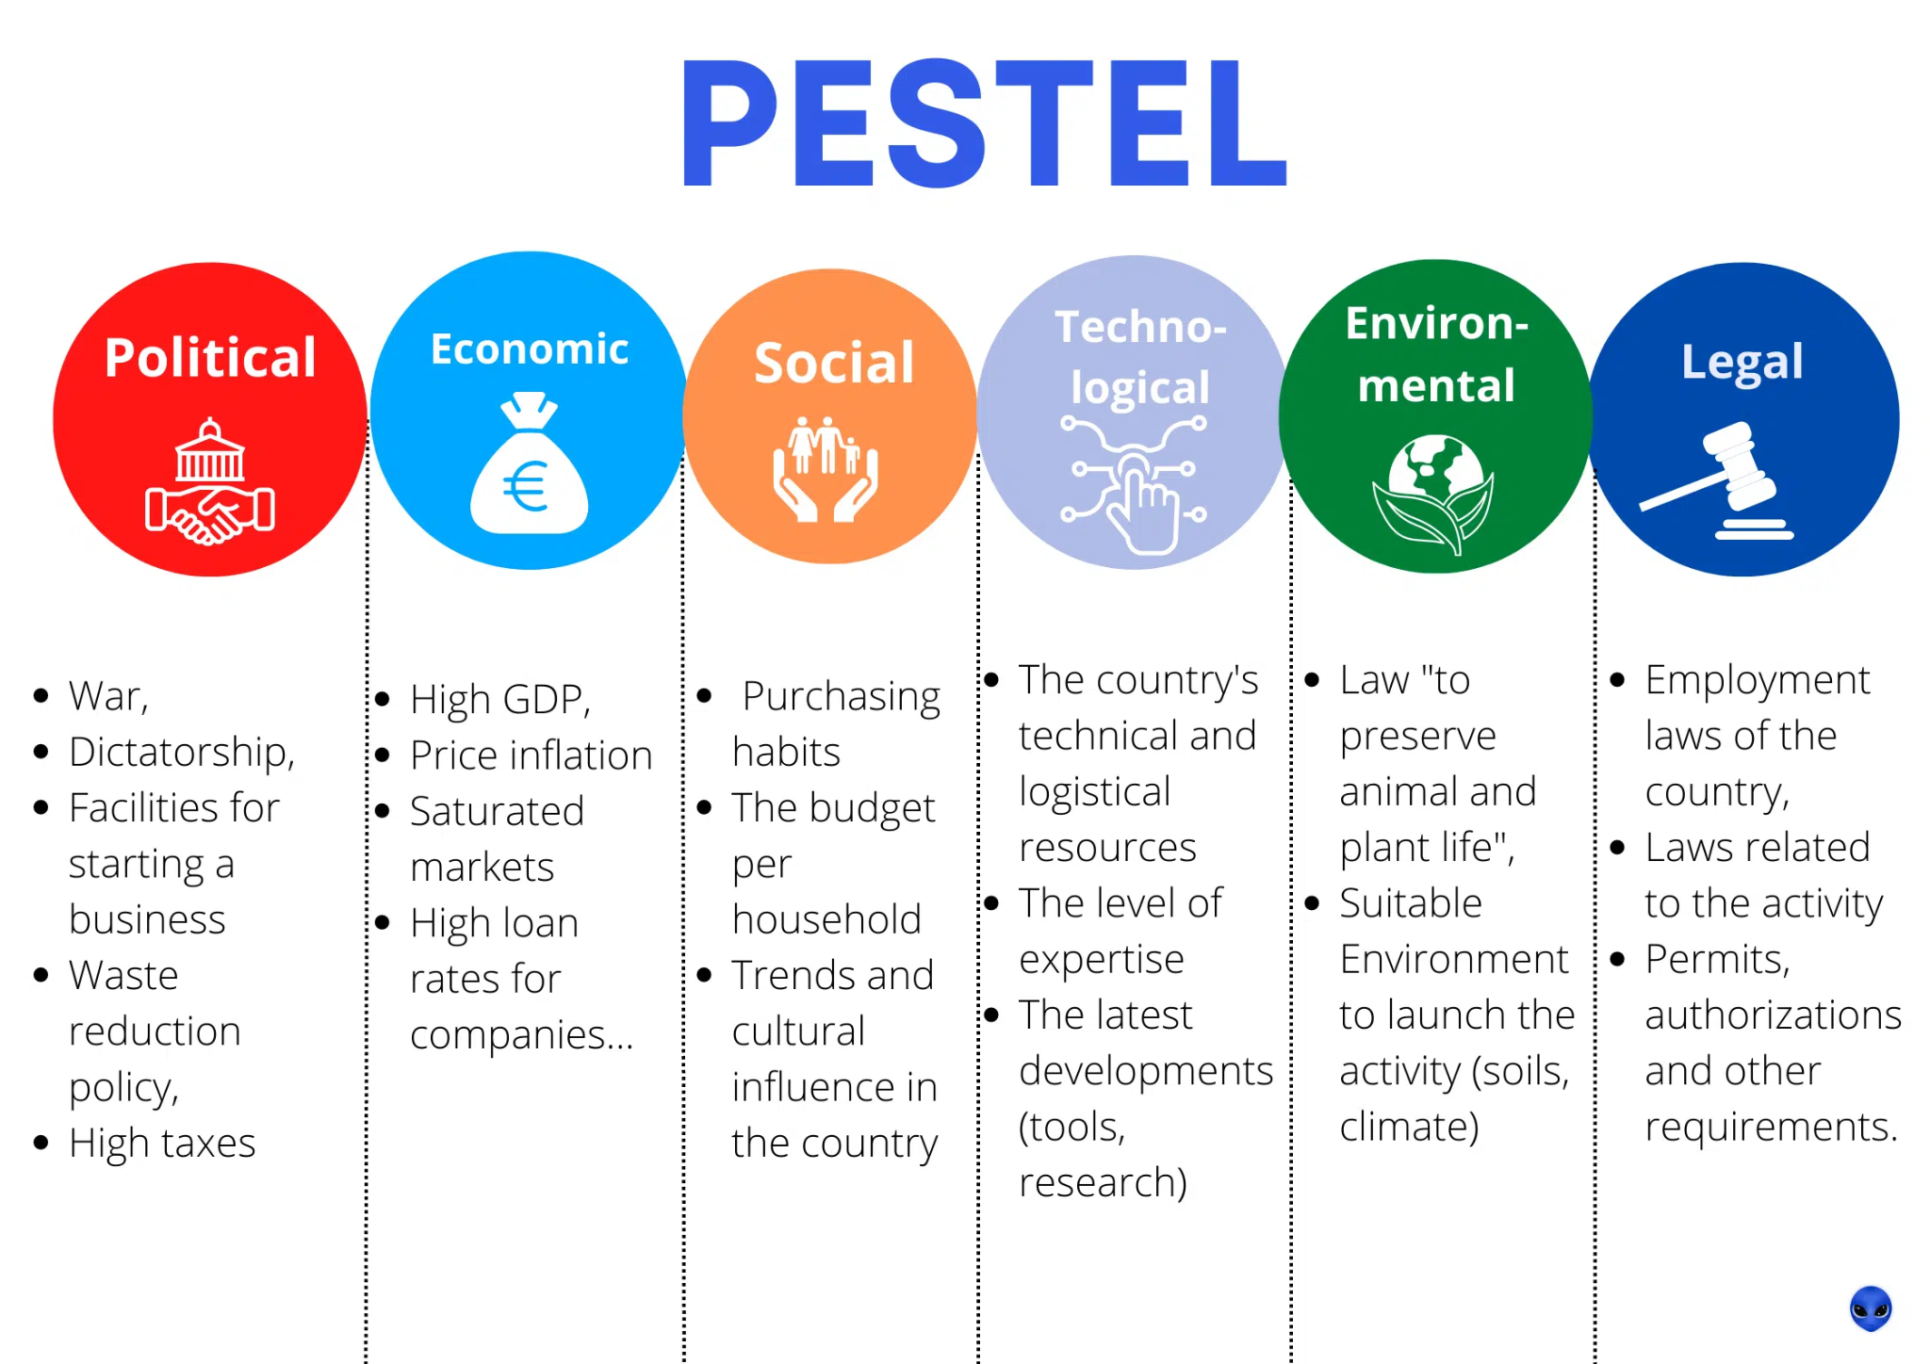
PESTEL Analysis of WearX
Figure 1: PESTEL Analysis (Source: Blog Waalaxy, 2022)

PESTEL analysis is a model that is utilised by businesses to research the external environment of the business (Yüksel, 2012). PESTEL is an abbreviation for the six different environments that exist outside of the firm; these six environments are listed below. In this part of the research, we will conduct an in-depth investigation of the six different external environments that are relevant to the WearX clothing brand.

Political
The policies, leadership, and change within the government, as well as the policies governing international trade, are examples of political forces that are present in the external environment (Pan et al.,2019). WearX is a trendy apparel boutique in the United Kingdom that has a hip-hop-inspired motif. When it comes to clothing, the corporation is not required to comply with any particular laws because there are none. Nevertheless, there are a few statutes that must be followed by the organisation, such as the Modern Slavery Act of 2015, the Employment Rights Act of 1996, and the National Minimum Wage Act of 1998 (Clarke et al., 2017). The United Kingdom's laws have been updated as a result of Brexit, which may result in a fluctuation in the cost of materials. Because of the position taken by the government of the United Kingdom about environmentally friendly products, the corporation is required to keep up a sustainable commercial operation.

Economic
The current and predicted rates of economic growth; inflation and interest rate levels; job growth and unemployment rates are examples of the economic components that make up the external environment (Giesen et al., 2010). The state of the economy in the United Kingdom has a significant bearing on WearX's operations. Since the United Kingdom is the third largest apparel and footwear market in the world, the company finds it relatively simple to import goods into the country. However, the population of people between the ages of 16 and 24 has the largest unemployment rate, which may render the firm obsolete because its target demographic is unable to afford expensive clothing. On top of that, there has been an increase in the rate of inflation throughout the country over time, which has resulted in individuals having less money they can spend. Therefore, although the market is relatively large, it does not appear that the company will benefit from the current economic climate.

Social
Aspects such as demographics (age, gender, ethnicity, and family size), as well as the attitudes and opinions of consumers, are included in the social environment (Santos et al., 2016). Because every firm operates inside a society, the many aspects of that society have a significant bearing on the company. WearX is not an exception to this rule. The business is active in a society that is located in the United Kingdom. Teenagers in the United Kingdom are following the trend of the rest of the population becoming increasingly concerned about the environment. Therefore, the targeted audience will respond positively to the sustainable policy that WearX has adopted. People in the United Kingdom have a wide range of preferences when it comes to the kinds of clothing they wear because the population there is so diverse. Hip-hop culture has a strong following among adolescents in the United Kingdom, particularly those in their early teen years. This is an omen of good things to come for the organisation.

Technological
Businesses, and businesses in particular in the United Kingdom, are subject to a significant amount of influence from technological elements. People in the United Kingdom have a high level of familiarity with many forms of technology (Cherunilam, 2021). Everyone, regardless of age, utilises technology in every aspect of their lives. The majority of teen and young adult consumers conduct their purchasing online. If WearX builds a website or an app that will allow customers to do online shopping, the company will see a significant increase in revenue as a result of this development. Because consumers spend a significant amount of time on social media, marketing your business online will be an excellent move to do. Therefore, the technology part of WearX appears to be a strength.

Ecological
The factors of the environment are just as important as any other aspects that come from the outside environment. It has been shown that the United Kingdom is making increasing efforts to improve its relationship with the natural world. WearX maintains a sustainable policy for all of its products, which helps the company maintain its place of prominence in the present market. It would be beneficial for the company to launch some Green Initiatives, which would make it more appealing to the younger generation (Gast et al., 2017). The increasing awareness of the company's economic impact will ensure that it remains relevant for a significant amount of time.

Legal
Legal considerations include health and safety requirements, requirements for equal opportunity, and advertising rules. There is no need to repeat the fact that the Employment Rights Act of 1996 and the National Minimum Wage Act of 1998 both abided by WearX because it has already been stated. In addition to this, the country has consumer legislation that was passed in 2015 (Giliker, 2017). For the business to continue operating legally in the market, it must comply with the consumer rights act.

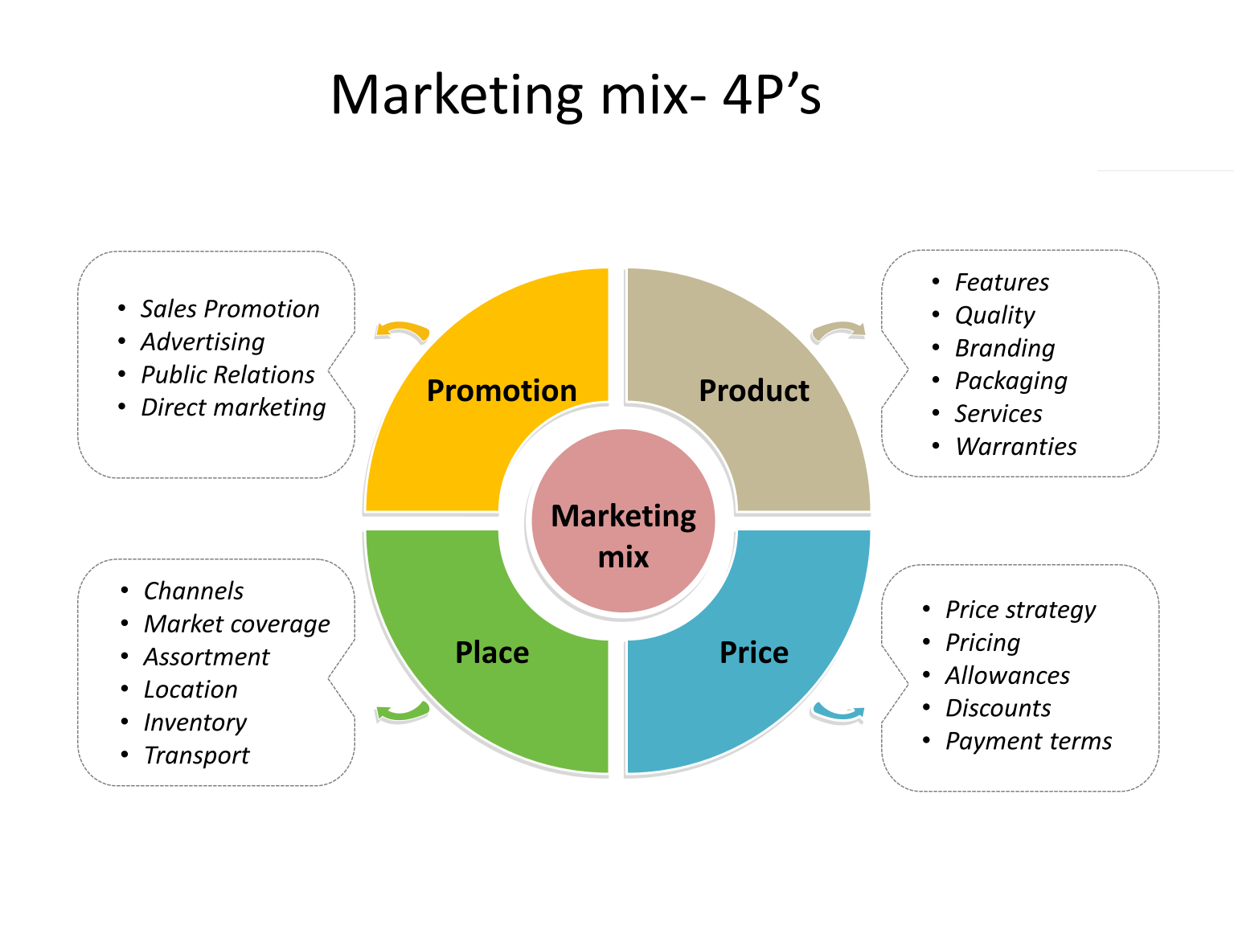
4Ps Analysis of WearX
Figure 2: Marketing Mix (Source: The Intactone, 2019)
The marketing mix is another name for the analysis of the four Ps. The product, the location of the business, the level of advertising, and the selling price are the four primary aspects of makeup marketing (Išoraitė, 2016). The marketing mix of 4Ps analysis refers to the process of analysing these four aspects of marketing. The 4Ps analysis of WearX will be presented in the next section.

Product
A consumer good might be a material or intangible item as long as it satisfies the requirements set out by the target market. Products not only satisfy the demand in the market, but in many instances, they also create demand in the market (Thabit and Raewf, 2018). The majority of what WearX produces is clothing. Products by Nike, apparel associated with hip-hop culture in general, and other innovative forms of contemporary dress are the company's primary focus. The brand offers a diverse range of styles, including urban fashion, despite the fact that the aesthetic is hip-hop. Because of this, there are now many different options available to the target market.

Price
The amount of money that the consumer is willing to spend on a product is referred to as the price of the item (Londhe, 2014). If WearX wants to be in a strong position in the market, it needs to set a price that will be cheaper than the prices set by the majority of the other companies in the market. However, the corporation must avoid setting the price too low or it will not be able to achieve its profit margin requirements. The organisation can provide a variety of price points for the goods, which are determined by both the product's quality and the clientele. It is unacceptable to charge excessively for fashionable items aimed at teenagers because they do not have the financial means to do so. People who buy at luxury retailers will be able to shop at this store because it has the potential to sell high-end limited-edition products at premium prices.

Place
The point of distribution for the store is known as the "Place." A location may exist in the real world, online, or in both. WearX has decided to proceed with both options. It indicates that the corporation will have stores, both online and off, in the future. The clients will appreciate the added ease that this provides. People will not experience any difficulties when shopping if the company locates its store in a high-traffic and easily accessible region. Online shopping allows shoppers to circumvent the need to physically visit a business.

Promotion
Promotion means making the company and the products known to the target market. There are many ways to promote the product and the company. WearX has relied mainly on internet marketing, specifically social media marketing. Other than that, WearX will do website and email marketing as well.

Conclusion
Throughout its existence, a business requires a significant amount of study and analysis. By conducting these assessments, the company can better understand where it is in the market and what steps are necessary to move closer to the top. There is a great deal of dangers surrounding the company. The organisation can identify those threats and develop plans to combat them with the assistance of analyses. Therefore, it is vital to be familiar with a variety of models and theories of analysis and to employ the one that is most appropriate for the company.

References
- Cadle, J., Paul, D. and Turner, P., 2010. Business analysis techniques. British Informatics Society Limited.
- Cherunilam, F., 2021. Business environment. Himalaya Publishing House Pvt. Ltd.
- Clarke, M.A., Hooley, R.J., Munday, R.J., Sealy, L.S., Turner, P.G. and Tettenborn, A.M., 2017. Commercial law: Text, cases, and materials. Oxford University Press.
- Elodie (2022). PESTEL analysis = Definition and Examples in USA [2022]. [online] WAALAXY. Available at: https://blog.waalaxy.com/en/pestel-analysis/.
- Gast, J., Gundolf, K. and Cesinger, B., 2017. Doing business in a green way: A systematic review of the ecological sustainability entrepreneurship literature and future research directions. Journal of cleaner production, 147, pp.44-56.
- Giesen, E., Riddleberger, E., Christner, R. and Bell, R., 2010. When and how to innovate your business model. Strategy & leadership, 38(4), pp.17-26.
- Giliker, P., 2017. The Consumer Rights Act 2015–a bastion of European consumer rights? Legal Studies, 37(1), pp.78-102.
- Išoraitė, M., 2016. Marketing mixes theoretical aspects. International Journal of Research-Granthaalayah, 4(6), pp.25-37.
- Londhe, B.R., 2014. Marketing mix for next generation marketing. Procedia Economics and Finance, 11, pp.335-340.
- Pan, W., Chen, L. and Zhan, W., 2019. PESTEL analysis of construction productivity enhancement strategies: A case study of three economies. Journal of Management in Engineering, 35(1), p.05018013.
- Santos, F.J., Roomi, M.A. and Liñán, F., 2016. About gender differences and the social environment in the development of entrepreneurial intentions. Journal of Small Business Management, 54(1), pp.49-66.
- Thabit, T. and Raewf, M., 2018. The evaluation of marketing mix elements: A case study. International Journal of Social Sciences & Educational Studies, 4(4).
- theintactone (2019). Marketing Mix. [online] theintactone. Available at: https://theintactone.com/2019/09/14/mm-u3-topic-1-marketing-mix/.
- Yüksel, I., 2012. Developing a multi-criteria decision-making model for PESTEL analysis. International Journal of Business and Management, 7(24), p.52.
‌

