Managing People
Lecturer: Dr. Olusoyi Ashaye
Mihail Roussev
Student number:2115133
Table of Contents
Introduction 3
PART 1: 4
(a) Explaining the significance of these actions for successful UK-based HR professionals. 4
(b) Demonstrate to what extent this map might be applicable to HR professionals operating on a worldwide scale irrespective of areas and sizes of firms. 6
PART 2: 9
(a) Justifying the skills gap that exists in the UK government despite the country's high unemployment rate. 9
(b) Recognizing and analyzing trends in the long-term labour market that could help fill the UK's healthcare industry's skill gaps. 10
Conclusion 12
References 13

Introduction
Those working in human resources can use the CIPD Profession Map as a reference. It's a web-based resource that aids in personal growth, professional improvement, and career preparation and advancement. Organizations of any size, in any industry, can benefit from the professional map because it applies to all aspects of human resources and learning and development (Jackson, D., 2012). This is feasible because the system is based on individuals' abilities as professionals rather than on factors like hierarchy, culture, or function. The 1st part describes that the map details the skills and actions required of HR and L&D experts to meet our standards of professionalism. In the next section, the skill gaps in the public sector and the UK's healthcare industry's skill gaps are described further.

PART 1:

(a) Explaining the significance of these actions for successful UK-based HR professionals.
The Chartered Institute of Personnel and Development (CIPD) Profession Map is a dynamic set of criteria designed to enable all who operate in people management to continually evolve and enhance the environment of work. Everyone who works in human resources (HR) should adhere to a similar set of guidelines and principles, and that is the goal of the Profession Map, which seeks to assist develop a unified professional status throughout the sector (Ulrich, Younger, Brockbank, and Ulrich, 2013). The CIPD has a code of conduct that can be split into subsections such as stewardship, spokesperson of the Professional, professional skills and conduct, and ethical standards and accountability." Among the ways that the CIPD measures professionalism is through this code (Jones, and Saundry, 2012).
A useful strategy for human resource professionals is to take what is known as an "outside-in" method. This involves identifying industry trends by observing the practices of rivals or other companies and determining how such practices might be used inside. It is essential to not only be capable of providing superior service to our consumers but also to keep the objectives of the business in mind at all times. In order for human resources to maximize their results, they need to take into account not just the abilities of individuals but also those of the organization. Instead of focusing solely on individual operations including hiring and compensation schemes, HR should work toward the achievement of comprehensive and long-term alternatives (Ulrich, Younger, Brockbank, and Ulrich, 2013). Previous Human resource policies should be refined and reworked so that they may be applied in the present in a way that is both more productive and efficient. Because we need to be capable of overseeing not just the day-to-day daily functions in addition to the lengthy strategic practices, human resources management (HR) combines both core functions and a strategic purpose.
Strong Professionals in human resources consider and act using an outside-in perspective. They have an in-depth knowledge of external market trends and are capable of putting that information into the choices and actions taken within the company. They discover the client segments that make up their organization's valuable customers, as well as the aspirations of those consumers, and then match the behaviours of their organization with those expectations. This allows them to focus on and engage those consumers. They also contribute to the co-creation of their organizations' strategy reactions to the circumstances of their businesses and the requirements of their clients by contributing to formulating and making decisions regarding strategic and organizational matters. Effective human resource professionals are considered to be "credible advocates" due to the fact that they create their own individuals with their business skills. Credibility is earned when human resource professionals deliver on their commitments, cultivate personal connections based on trust, and demonstrate their ability to be depended upon. It makes it easier for HR workers to maintain healthy close relationships (Jones, and Saundry, 2012). This means communicating in a manner that is both transparent and consistent while maintaining one's authenticity.

(b) Demonstrate to what extent this map might be applicable to HR professionals operating on a worldwide scale irrespective of areas and sizes of firms.
The "professional standards" established by the CIPD are used as a basis for entrance certifications in the field of human resources (HR), and they have served as a foundation that is recognizable to tens of millions of people who are just starting out in their careers. HR professionals, in their capacity as activists, have such a point of view also regarding HR processes, but also concerning the requirements of the business (Jackson, 2012). HR professionals that take on an activist role get the ability to positively affect the actions of many others with the help of messages that are crystal clear, persistent, and impactful.
HR professionals who already have credibility but who don't become involved in activism are respected, but they don't have much of an impact. In order to be taken seriously as activists, HR managers must possess a strong sense of self-awareness and a dedication to further developing their field. Helping to establish and enhance an organization's purpose is one of the primary responsibilities of an appropriate HR professional (Price, 2014). This helps the HR professional to combine the skills of its employees to form a powerful and effective organization. Professionals working in HR should have the ability to assess and invest in the development of organizational capabilities. Such capacities are not dependent on the actions or results of any particular management or system. However, the function of human resource professionals is shifting so rapidly that the institution has concluded that instead of simply updating the current standards, a fundamental re-visioning is required to prepare the HR professional for the difficulties that lie ahead. The overall CIPD Map is figured out below:
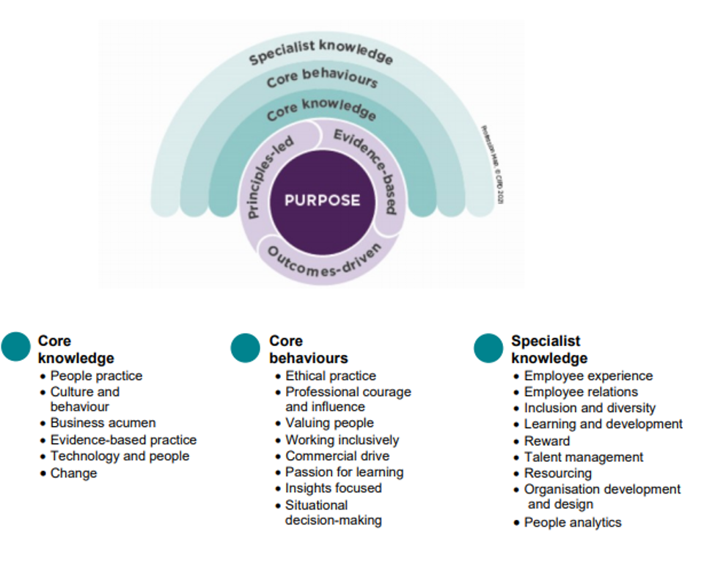
Figure 1: The CIPD Map (Ulrich, Younger, Brockbank, and Ulrich, 2013)
The map, in its most basic form, reveals what the greatest accomplished professionals in human resources understand and do at each phase of their careers, and this information is demonstrated to be an efficient approach for many people. As professionals progress through the ranks, they take on increasingly strategic responsibilities, which in turn motivate them to give their all in order to have a positive influence on both themselves and their employers. To ensure they have a firm grasp on the features or difficulties that characterize their job, experts should look into the specifications of each tier within the designated categories (Price, 2014). The map is currently being used by a diverse variety of organizations and HR personnel to evaluate and grow their HR capabilities at the person, team, sector, and organization levels respectively. Because it is customizable, the map enables human resources professionals to zero in on the topics that are particularly essential to them. The CIPD, on the other hand, recommends beginning with the centre of the map since here is where we'll truly begin to notice a movement in performance and achievement (Ulrich, Younger, Brockbank, and Ulrich, 2013). Observations, strategic planning, and remedies, as well as guiding HR, are indeed the two professional regions that make up the core. According to the CIPD, one of the most important aspects of great human resources is the fact absence of this component or professional framework, Human resources would always communicate at the technologist level (Su, Dai, Ullah, and Andlib, 2022). The heart of the HR Professional Map is where the competencies are defined that perhaps the CIPD considers the basis for excellent HR practice as well as the most important aspects of such activity.

PART 2:

Justifying the skills gap that exists in the UK government despite the country's high unemployment rate.
At the height of the Covid-19 outbreak in the United Kingdom in the month of March 2020, in-person operations in the retail, hospitality, and entertainment companies were temporarily shut down to prevent the transmission of the virus and save lives. As of the most recent monthly numbers available, the labour market in the UK has never been healthier, with far more job openings than unemployed persons (McGuinness, and Ortiz, 2016). After the initial COVID shutdown ended in the year 2020, economic output has been given permission to continue, mostly as a result of the nearly fourfold increase in employment openings to roughly 1.3 million. During March 2020, as the Covid-19 outbreak expanded throughout the United Kingdom, in-person operations in the retail, hotel, and entertainment industries were permanently shut down to prevent the infection from spreading and save lives (Ulrich, Younger, Brockbank, and Ulrich, 2013). When compared to the peak of the economic crisis in 2008, the increase in the jobless rate was minimal.
Having a record number of openings to fill might appear to be a positive idea in terms of keeping the unemployment rate low (Jackson, 2012). However, businesses in every industry are having a hard time filling open positions, which slows economic recovery. For example, between 50% and 70% of the population who were formerly employed in retail were directly impacted by this shift. Young individuals, lower-paid employees, and those on uncertain deals were especially hard hit. Professionals aged 55 and above had less disruption than their younger colleagues, although they were more certain to have been laid off, put on furlough, or had their wages reduced than the national average (Price, 2014). There may not be enough available workers to meet demand at times. In other cases, it's because not enough individuals want the job due to low pay or unpleasant working circumstances. Some industries, like food processing, agriculture, and hospitality, are presently protesting about skill shortages because they have trouble competing for skilled employees and must depend on the government to offer a resource of migrant labour due to a lack of alternatives.
Another reason why young adults were affected so severely in the initial phases of the Covid-19 situation is that they represent the age range most likely to find employment in fairly low, consumer occupations, and on unsecured and short contracts, which are among the first to engage in a global recession. It's also partly due to Brexit. Many European employees have arrived home, despite earlier claims that the number of migrants inside the UK declined by 1.3 million (Jackson, 2012). For this reason, it is not surprising that numerous of these professionals fled the UK during the height of the outbreak, seeking refuge closer to their families and in areas with reduced living costs.

Recognizing and analyzing trends in the long-term labour market that could help fill the UK's healthcare industry's skill gaps.
In the United Kingdom, almost half of businesses report having difficulty finding qualified workers. In recent years, shortages of medical professionals around the globe have been a major issue (Su, Dai, Ullah, and Andlib, 2022). There is a global scarcity of healthcare professionals across the board, from doctors and nurses to experts and consultants. However, this healthcare threat became more brazen throughout the CCOVID -19 outbreak, The public health sector took a severe hit during the epidemic as medical professionals left their positions for a variety of reasons. King's Fund estimates that there are 1.2 million people working in the healthcare sector full-time in the UK. The National Health Service (NHS) is the country's primary healthcare provider. The NHS is the country's largest employer by a wide margin, and the healthcare sector as a whole employs 10% of Brits (Price, 2014). The country's healthcare workforce is in crisis, notwithstanding its size relative to other European countries. The physician In comparison to other industrialized countries, where one doctor serves an average of 277 patients, the country's doctor-to-patient ratio currently stands at 1:365 (Figen, and Ebru, 2019). Across the board, the number of people working in healthcare, from doctors to midwives, is on the decline. The NHS has an estimated 100,000 unfilled positions throughout hospitals, psychiatric health facilities, and public health services, according to estimates by healthcare think tanks such as the Health Foundation, King's Fund, and Nuffield Trust. It would appear that the senior social care sector has another 120,000 open positions. Based on this split, it is estimated that there will be up to about 0.25 million job openings (Cappelli, 2015).
Each of the four UK hospital wards has a severe lack of nurses, and this is putting the patient at higher risk. Due to the absences of key personnel, skill sets get diluted as assistants fill in for expert groups. The scarcity of medical professionals can be remedied by a number of different strategies. The administration of the United Kingdom and other organizations involved in healthcare delivery should launch initiatives to inspire young people to pursue careers within the healthcare sector. Nursing students' ability to graduate is slowed by a lack of clinical practice. Some change careers altogether in response to this obstacle. Because of this, we need to expedite healthcare specialists so that it does not put off prospective students (Martin, and Learmonth, 2012). Medical and other healthcare academics and experts will have access to educational facilities as part of this initiative. The medical field needs to catch up with the times and start using cutting-edge tools. Healthcare services distribution can benefit from the use of cutting-edge technologies to address the scarcity of healthcare professionals. Many hours can be saved by switching to a digital health record administration system.
The administration of the United Kingdom also needs to reevaluate and cut the price of medical professional training. To achieve this goal, we can introduce fresh programs like debt cancellation for higher education. Professionals in the healthcare industry may benefit from financial rewards to pursue continuing education (Cappelli, 2015). New guidelines should indeed be implemented in order to boost the patient-to-nurse proportion and avoid healthcare personnel from developing burnout. This will also enhance the standard of health care. Meaningful legislation is also essential to alleviate the healthcare workforce deficit.

Conclusion
The CIPD Profession Map is a useful tool for anyone working in the field of human resources. It's an online hub for self-development, expert enhancement, and career planning and development. The professional map is useful for businesses of all sizes and across all sectors because it covers all elements of human resources and training & development. This is possible due to the system's emphasis on professional competence rather than external criteria like status, background, or job description. In the first section, we explain that this road map specifies the abilities and behaviours needed for HR and L&D specialists to satisfy professional standards. Further details about the public sector's and the UK healthcare industry's skill deficits are provided here.

References
Cappelli, P.H., 2015. Skill gaps, skill shortages, and skill mismatches: Evidence and arguments for the United States. ILR Review, 68(2), pp.251-290.
Figen, Y. and Ebru, D.R., 2019. Health care service quality: A comparison of public and private hospitals. African Journal of business management, 4(6), pp.962-971.
Jackson, D., 2012. An international profile of industry-relevant competencies and skill gaps in modern graduates. International Journal of Management Education, 8(3), pp.29-58.
Jones, C. and Saundry, R., 2012. The practice of discipline: evaluating the roles and relationship between managers and HR professionals. Human Resource Management Journal, 22(3), pp.252-266.
Martin, G.P. and Learmonth, M., 2012. A critical account of the rise and spread of ‘leadership’: the case of UK healthcare. Social science & medicine, 74(3), pp.281-288.
McGuinness, S. and Ortiz, L., 2016. Skill gaps in the workplace: measurement, determinants and impacts. Industrial Relations Journal, 47(3), pp.253-278.
Price, A., 2014. Human resource management in a business context.
Su, C.W., Dai, K., Ullah, S. and Andlib, Z., 2022. COVID-19 pandemic and unemployment dynamics in European economies. Economic Research-Ekonomska Istraživanja, 35(1), pp.1752-1764.
Ulrich, D., Younger, J., Brockbank, W. and Ulrich, M.D., 2013. The state of the HR profession. Human Resource Management, 52(3), pp.457-471.

