In the age of technology, the cybersecurity landscape has significantly evolved in the last decade, propelled by swift digital transformation, extensive usage of cloud computing and the prevalence of hybrid and remote work settings. Usually organizations have relied on perimeter based security models, also known as castle-and-moat strategy. In this approach, internal network seems secure while external treated as hostile. To stop unauthorized access from outside the network perimeter, security measures including firewalls, intrusion detection systems, and demilitarized zones are put in place. However, this strategy has become rapidly ineffective in the modern tech environment [1]. New systems like software as service, cloud infrastructure, and mobile computing has start to dissolved the clear boundaries that one defined organizational networks. Data of information what ever are no longer confined to on premises servers but is distributed over many cloud platforms and can be access from different different endpoints. As a result, the traditional any has effectively no more, making it significantly more difficult to enfore the patch of security using legacy approaches.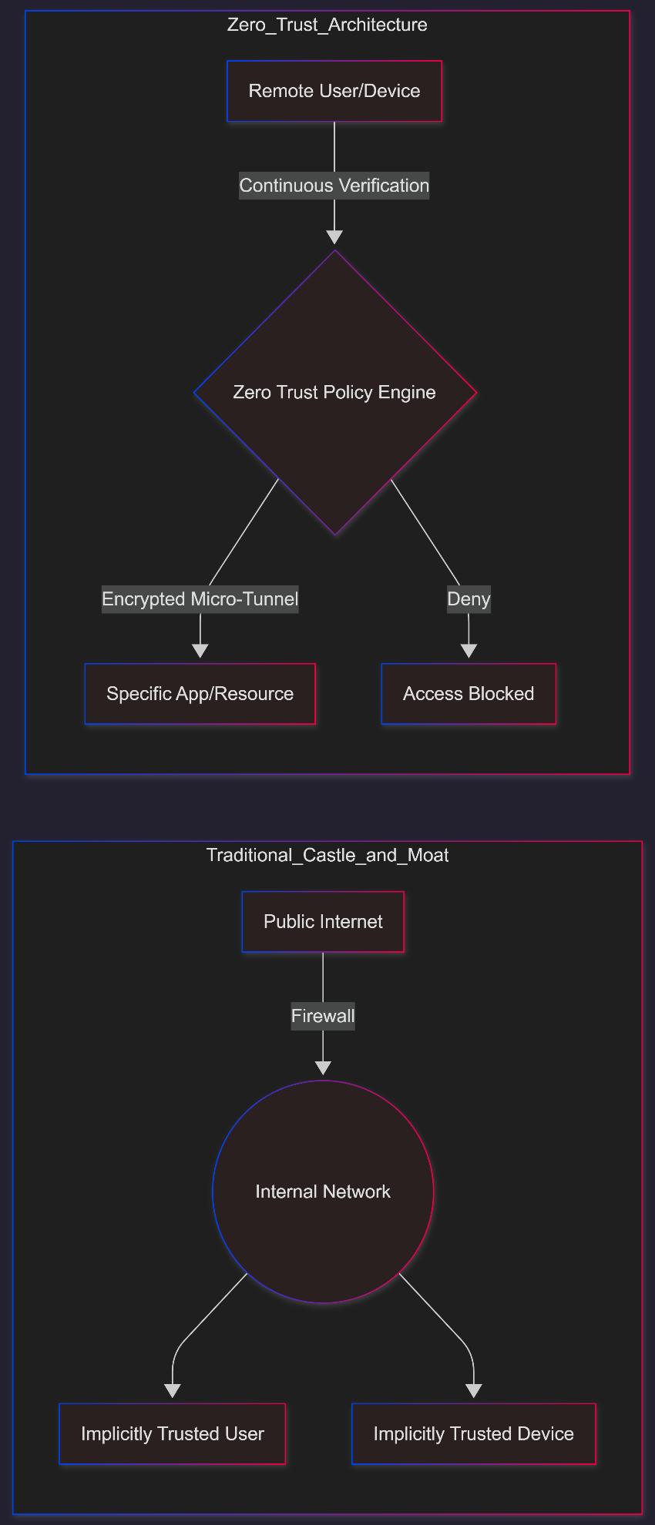
This changed has introduced new vulnerabilities and extend the attack surface for organizaitons. Now a days cyber threats like phishing attack, credential theft, ransomware and so many become more sophisticated and frequent . Threats makes doesn’t need to breach a hardened perimeter instead, they can exploit weak authentication mechanisms, or vulnerable endpoints to get the sensitive system access and once get inside its done they can take the control on their hands.
To response this challenges Zero Trust Architecture (ZTA) came into the picture. Unlike the traditional way, ZTA runs the principle of ‘never trust, always verify’ scheme means no user or device is automatically trusted, regardless of whatever they are inside of outside [2]. In this process every access request must meet the continuously authenticated, authorized, and validated basded on mulitpled fators, including user and dever indnetiy, posture and access including contextual info. Multi factor authentication and identify and access management together create a more dynamic and resilient security patch suited to today’s environments.
1.2 Research Problem
The contribution of small and medium enterprises(SMEs) in global economy is huge specifically in terms of employment, innovation, and economic growth they contribute a lot. Despite their importance these kind of enterprises are increasingly become the prime targets for attacker due to weaker security infrastructures. Most of SMEs operate below what is often described as the security poverty line where limited financial and human resources prevent them from implementing robust security measures [3].
Where as Zero Trust Architecture is widely recongnized as the most secure approach to advanced cyber security, its adoption within the SME sector remains limited. Typically ZTA frameworks are designed to handle the security of large enterprises in mind these frameworks oftern assume the availability of dedicated security teams, advanced infrastructure and substantial financial investement, conditions that are rearly met in SME environments.
Few key challenges hinder the ZTA adoption in SMEs. The most first that have to be faced is implementation complexity presents a lot of barrier. Deploying a ZTA model need the integration of many components such as identity management systems, endpoint security solutions, and network segmentation mechanisms. Here is the catch for SMEs with limited technical expertise managing such integration can be bit complex.
On the other hand, another issue is financial constraints to restrict further adoption cause many enterprise grade zero trust solutions runs on subscription based approach that become really expensive as the number of user grows. Because of the insufficient budget of SMEs find the less secure alternative.
Third there is a point that shortage of security expert within SMEs. Unlike most of large organizations that can easily haired specialized security teams, where SMEs often rely on small IT departments or even single operator to manage all the security operations. Which can introduce new vulnerabilities rather and optimizing existing problem.
Finally, there are risk of misconfiguration is particularly critical in zero trust implementations. That can lead to disrupt into business operations or create security gaps that attacker can easily exploit. This risks make SMEs rethink to adopt complex security measures.

1.3 Research Aim and Objectives
The aim of this report is to design and evaluate a scalable, cost effective ZTA framework tailored particularly to the needs and constraints of SMEs. So this finding seeks to bridge the gap between theoretical and practical implementation strategies which suitable for constrained enviroments.
So to reach this goal the study will pursues the following objectives.
- Analyze existing Zero Trust frameworks and standards enterprise implementations to assess their applicability to SMEs.
- Find-out and test the specific obstacle that hinder the adoption of zero trust principles within the SME sector
- Design a minimum viable zero trust framework that focused on simplicity, scalability, and cost effective at the same time with maintaining strong security principles.
- Observe and evaluate the framework based on key performance indicators like usability, ease of deployment, cost efficiency, and security effectiveness.

1.4 Significance of the Research
This study is significant because it will find out the technical gap between advanced cybersecurity theory and the realities of practical implementation faced by SMEs. While zero trust architecture has been studied and adopted by large organizaitons. There will be limited followings on how small organization can implement similar principles without having excessive costs or complexity.
As this studies amis to make zero trust more accessible to SMEs, enabling them to enhance security posture and reduce exposure to cyber threat. Additionally, the proposed framework can support SMEs in achinving compliance with standard and regulations, for example ISO 27001 and cyber essentials which are increasingly important for business credibility and regulatory requirements.
Overall this research contributes to the broader goal of strong security resilience across the SMEs. By providing practical solution it will empowers smaller enterprise to defend against rapidly growing threats and sustain their operation in an increasingly digital and interconnected world.

2 Literature Review
2.1 introduction to zero trust architecture
Now a days ZTA has emrged as one of the most advanced approach in digital cybersecurity, fundamentally challenging the traditional assumption that internal networks elements can be trusted by default. The concept was first introduced in 2010 by john kindervag a security analist at forrester research who argued that trust should never be implicit within any network circumstance instead every rwquest must be verified, authenticated and authorized regardless of its origin.
The core concept of ZTA is often known as ‘never trust, always verify’. This methods assumes that breaches are inevitable or may have already occurred, and therefore focuses on minimizing impact of such breaches. Instead relying on a single defensive perimeter.
The growing reliance on cloud services, mobile and electronic devices, including remote work which are accelerated the adoption of zero trust concept. As most of organization started move away from centralized infrastructure, they need more advanced, dynamic and identity centric security approach becomes evident. ZTA figure out these challenges by emphasizing continuous verification,least privilege access and real time monitoring, thereby enhancing overall security resilience.
2.2 key frameworks and models
One of the most comprehensive and widely recognized frameworks for ZTA is national institute of standards and technology (NIST) special publication 800-207[6]. This frameworks allow a detailed conceptual model for implementing ZTA key components such as the policy decision point and the policy enforcement point. Which is responsible for evaluating request of access based on the predefined security protocols and enforce the decisions by granting of denying access to the systems.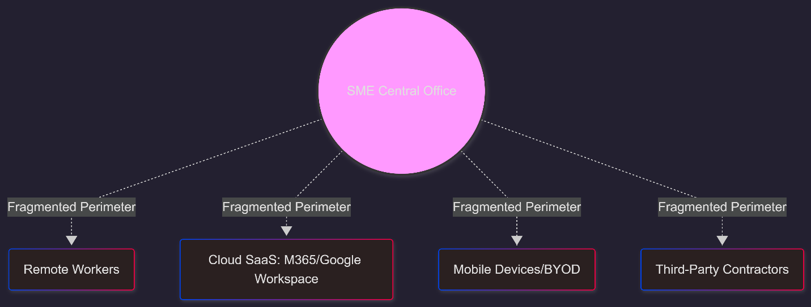
NIST SP 800-207 also allow the continuous diagnostics and monitoring which enable company’s to assess their secyity posture of users and devices in real time which includes evaluating such factors like device health, behavior of users, and others info before granting access. But the matter of fact that it is largely conceptual and does not provide more detailed implementation guidance, particularly for smaller enterprise with limited resources.
Lets focus on another model which represents a practical ZTA implementation at scale as known Google’s BeyondCorp. Which is the advanced alternative of traditional virtual private network know as (VPN). BeyonCorp access decisions are based on identity, security status of devices, and contextual factors rather network location. This model has proven high efficiency in large scale enterprise environments, demonstrating the feasibility o full ZTA based infrastructure.
Microsoft has developed its own ZTA which also work at large scale. Despite their strength these frameworks share a common limitations. Which is they are mainly designed for big organizations with substanstial financial and technical resources. The complexity and the managing cost with implementing these model can be quite impossible for SMEs that make the sense as well.
2.3 Core components of Zero Trust
The literature frequently identifies serveral core components that are important for implementing ZTA. These components form the base of any effective ZTA framework with idnetiy and access management, multi-factor authentication, device security, network segmentation, and continuous monitoring.
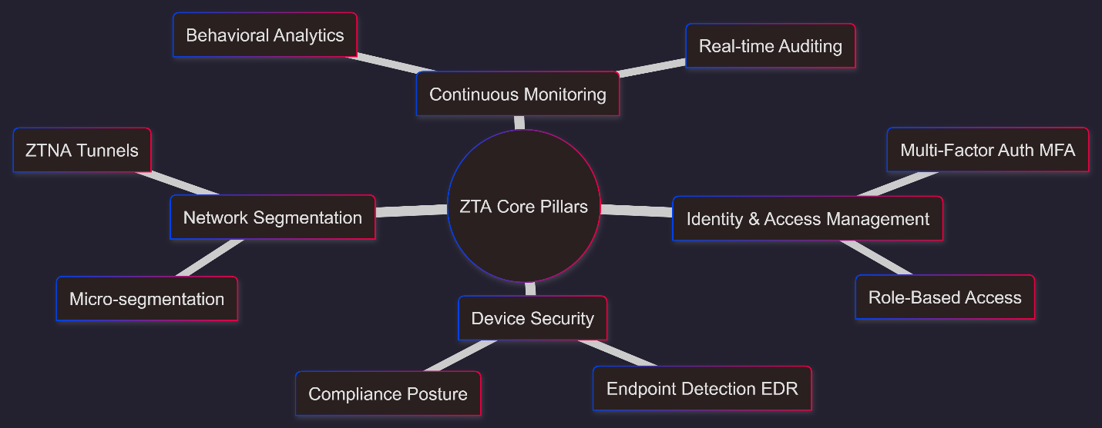
The most critical element of ZTA is identity and access management which ensure that only authorized user and devices can access particular resources also enable organizations to define and enhance access policies base on user roles, responsibilities, and attributes. In a ZTA identity becomes the main security perimeter, replacing traditional network based controls. Another component is multi-factor Authentication (MFA) add strengthens access control by requiring users to provide multiple form of verification before access the request. This is significantly reduced the risk of being unauthorized [4].
Device security is another important component, as it ensure that only trusted devise can connect to the resources. This may involve checking device config, patch levels, and security status before accepting request. In many case organizations implement mobile device management or endpoint detection and response solutions to maintain device intergrity.
Network segmentation, particularly micro-segmentations, plays a vital role in limiting lateral movement within a a network. By separate the network into smallaer , isolated segments, osgranizaitons can prevent attackers form moving freely across systems after getting initial access. This methods siginificantly reduces the protential impact of breach.
Finally, continuous monitoring and analytics enable organizations to detect and response to suspicious behavior in real time. Behaviroal analytics and machine learing techniques are often used to figure out anomalies and potential threates, allwong for proactive security measures.
2.4 Zero Trust in SME Context
Where the benefits of zero trust framework are nicely documented, its adoption within SME sector remains relatively limited. Existing study find out few more difficulties that SMEs face when attempting to implement ZTA framework, many of which stem from resource constraints and organizational limitations. One of the main difficulties is the insufficient financial resources. Many ZTA solutions are designed as enterprise grade products with pricing models that scale based on the number of user or devices. For SMEs with limited budget is become quickly unsustainable. As a result, SMEs most of time prioritize basic security measures over more advanced security frameworks like ZTA.
Shortage of experites is another challenge. Implementing ZTA required very deep level of understanding of varous technologies. So SMEs typically lack dedicated cyber security teams, making it challenging to desing, deploy and maintain this security systems.
Despite these difficulties, some research suggest that SMEs can benefit significantly from adopting simplified ZTA methods [5] By focusing on high impact, low cost controls such as Multi-factor authentication to secure remote access, and basic network segmentation. SMEs can achinbe substantial improvements in their security patch without incurring excessive costs.
2.5 Research gaps and opportunities
A research of the existing literature reveals few gaps that this study aims to address. First while there is extensive documentation on ZTA, there are lacks of physical implementation process tailored specifically for SMEs. The most common framework provide high level concepts but do not offer step by step instructions for resource constrained environment.
Second, there are limited study on cost effective alternative to enterprise grade ZTA solutions. Where big company’s can invest in comprehensive security platforms, SMEs require affordable and scalable options that align with their budget constraints. This creates an opportunities to explore the use of open source tolls and low cost cloud services in implementing ZTA core concepts.
Third, the literature doesn o adequately address the usability and operational difficulties are related with ZTA implementation in SMEs. Factor like ease of deployment, user experience, and maintenance requisite are often critical for SMEs but are frequently overlooked in academic research.
Finally, there is a need for empirical evaluation of simplified zero trust frameworks in real world or simulated environments. Most researches focus on theoretical models or large scale enterprise implementation, leaving a gap in evidence based research for smaller organizations.
2.6 Summary
In summary, the the literature demonstrates that ZTA represents a significant advancement in cybersecurity, offering a robust framework for protecting modern, distributed IT env. Key models such as NIST SP 800-207, Google beyondcrop, and microsoft’s ZTA framework valuabe insights intot eh desing and Implementation of ZTA.
However, these frameworks are often complex, resource intensive and tailored to large enterprises, limiting their application to SMEs. The core components of zero trust to large enterprise, limiting their applicability to SMEs. The core componets of zero trust such as multi factor authentication, device security, and network paritition are necessary but it can be difficult to implement in limited environment.
The identity gaps in the literature highlight the need for a simple, cost effective methods to ZTA that addresses the qnique challenges face by SMEs. This research seeks to fill this gap by developing and evaluating a minimum viable zero trust framework that is both practival and scalable for small and medium sized enterprises.
3 research desing and methodology
This research will adopts a Design Science Research(DSR) methodology to address the identified problem of limited accessibility to ZTA for small and medium enterprises. Design Science Research is particularly fits for this research because it focuses on the creation and evaluation of practical solutions which referred to artifacts to solve real world problems in t his context, the primary artifacts is the proposed minimum viable zero trust (MVZT) framework.
This DSR methods will follows a structured and interative system that sonsiting of serval key stages: problem identifications, definition of objectives, design and development, demonstration, evaluation, and communication. The problem identification phase focuses on understanding the limitation faced by SMEs, including the financial constraints, lack of expertise, and the reliance on legacy systems. Based on the challenges, the objectives of the soluton are defined, emphasizing cost, scalability, and ease of implementation.
3.1: Research Design
The deployment phase involves constructing the MVZT framework using a modular architecture that combines identity, connectivity, and device validation [6]. The demonstrate phase simulates the deployment of this framework within a control lab environment that colons a typical SMEs structure. Finally the evaluation phase assesses the effectiveness of the effectiveness fo the framework using predefined performance metrics such as security resilience, cost efficiency and usability.
The selction of DSR is justified because traditional study methods, such as purely qualitative or quantative methods, would not sufficiently address the practival nature of this problem. Instead DSR enables the research to bridge the gap between theoretical and real world implementation by producing a tangible and testable solution.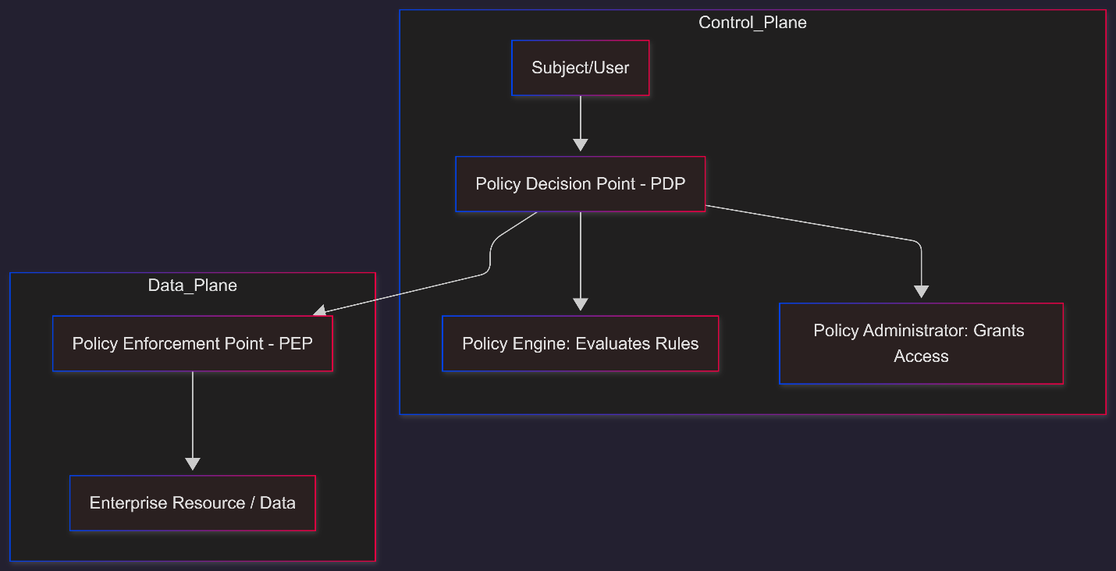
3.2 Research approach
This is a mixed methods approach research which combining both qualitative and quantative elements to provide a comprehensive analysis of the proposed framework. The qualitative components will focus on the critical evaluation of existing ZTA models and identification of obstacle to adopt within SMEs. This includes reviewing academic literature, industry reports, and documents related framework such as NIST SP 800-207 and enterprise implementations.
The quantitative elements are applied during the evaluation phase, where measureable indicators are used to assess the performance of the MVZT framework. Metrics like deployment time, cost savings, and resistance to simulated attacks are assess to determine the efficiency of the proposed solution.
The mixed methods approach is fits here because it allows the study to benift form both in depth understanding and validation. While qualitative analysis provides context and justification for the framework desing, quantitative evaluation make sure that the solution delivers measureable improvements in security and efficiency.
3.3 Research strategy
The strategy is bsed on infrastructure and simulation approach, which involves build a prototype fo the MVZT frame work and the testing it within a particular system. This strategy is suitable for research, where real world experiments may be constrained by ethical legal and operational considerations.
According to strategy the MVZT framework is implemented following these three tier architecture:
- Identity Layer: this layer will measure the user authentication and authorization by cloud based Identity Providers.
- Connectivity Layer: this layer will provide secure, identity aware access to applications using the ZTA technology.
- Device Security Layer: this layer will ensure the compliant and secure devices can only access the resources.
This approach will go through testing common cyberattack and will be observe how the framework responds to the threats so this study can evaluate its effectiveness and mitigating real risks.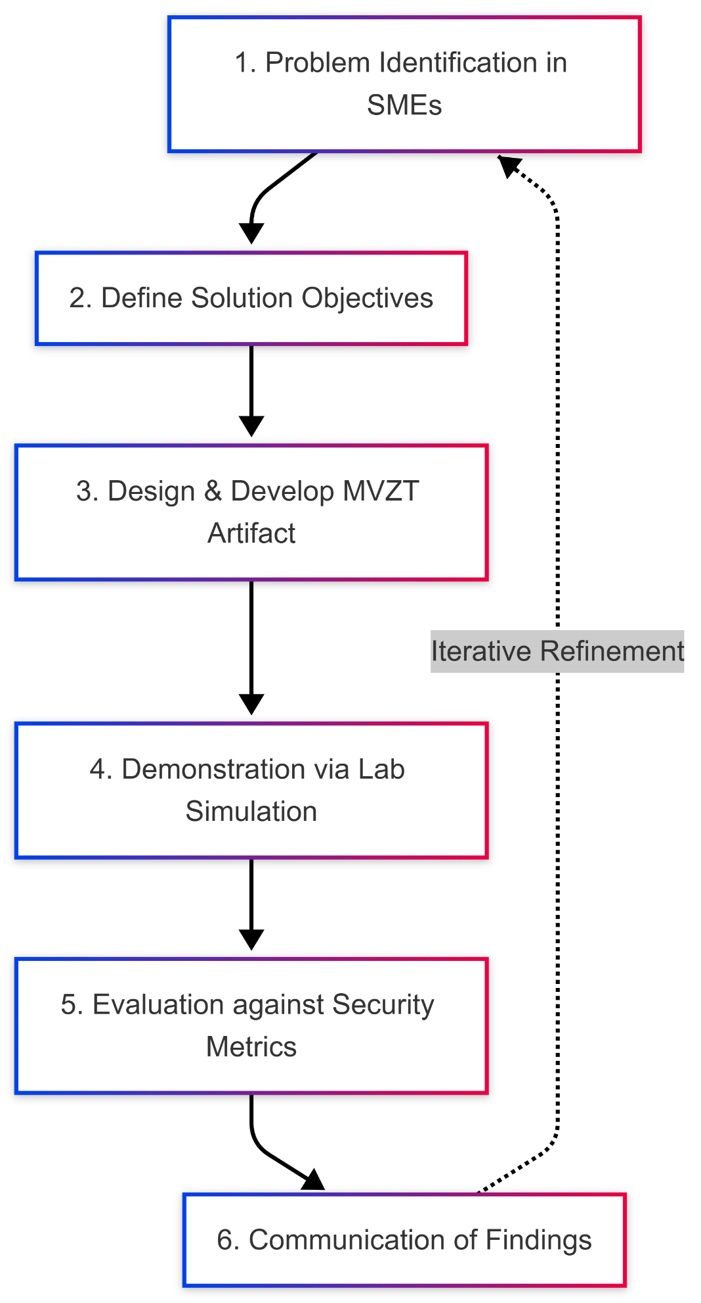
3.4 data collection methods
This research relies mainly on secondary data sources which is includes journals, industry white papers, and official documentation related to ZTA framework and SMEs. These sources provide the theoretical base for the research and infothe design of the MVZT framework. No primary data involving human pariticipants is colleted in this study.
3.5 data analysis techniques
Data analysis methods is include both process qualitative imterpertation and quantitative measurement. Qualitative process is use for interpret findings from literature review and to assess the baseline of the proposed framework with ZTA principles. Which will describe how well the MVZT framework incorporates key concepts like least privilege access, micro segmentation, and always verification.
Quantitative phase focus on assess the workflow of the framework using predefined metrics such as:
- Time to Deployment
- Security Effectiveness
- Cost Efficiency
- Usability
The results are analyzed to determine whether the propsed framework meets its requisite and objectives for viable solution for SMEs.
3.6 Ethical considerations
This research adheres to standard ethical guidelines in cybersecurity and academic research. Since the research does not involve human participants of personal data so the risk of ethical violation is minimal. All the simulation are within an isolated environment to preven the unintended impacts on real systems.
Moreover, this research avoids the use of malicious techniques that cloud harm external environment. The focus keeps on defensive security and the evaluation of protective mecahnisms. Any of elements are used to conduct this research are selected based on their legitimacy and compliance with ethical standards.
3.7 Limitations of Methodology
As like every system despite strengths, has also limitation. The chosen methodology has certain limitations, the use of the simulated environment may not fulfill the coplesxitya nd varialbity fo real world SMEs infrastructure. Factors like user behavior, culture and technical issues may influence the effective ness fo the framework practice. There are few others limitations as well such as time and resources limitations. Which may restric the scope of testing and evaluation.
Finally, the reliance on secondary data may lack the depth of contextual insights into SME specific difficulits. However, this limitation is mitigated by the practical focus of the simulation and the use of widely recognized tools and framework.
4 Expected outcomes
At the stage of proposal research does not yet provide empirical results anyway based on the theoretical foundation and design approach, several anticipated outcomes can be projected.
4.1 anticipated Result
The main expected outcome of this research is the successful development of minimum viable zero trust framework which is both practiacal and cost effective for SMEs. This framework anticipated to demonstrate that its possible to implement main principles of zero trust for example identity based access control, least privilege and keep verifying without requiring enterprise level financial investments or highly specialize expertise.
It is expected that the MVZT framework will reduce the attact surface with SMEs including prevent unauthorized access even in cases where user credentials have been compromised.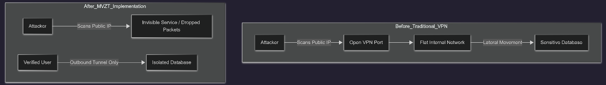 In comparison to traditional virtual private network(VPN) based architectures, the proposed framework is expected to provide enhanced security and flexibility.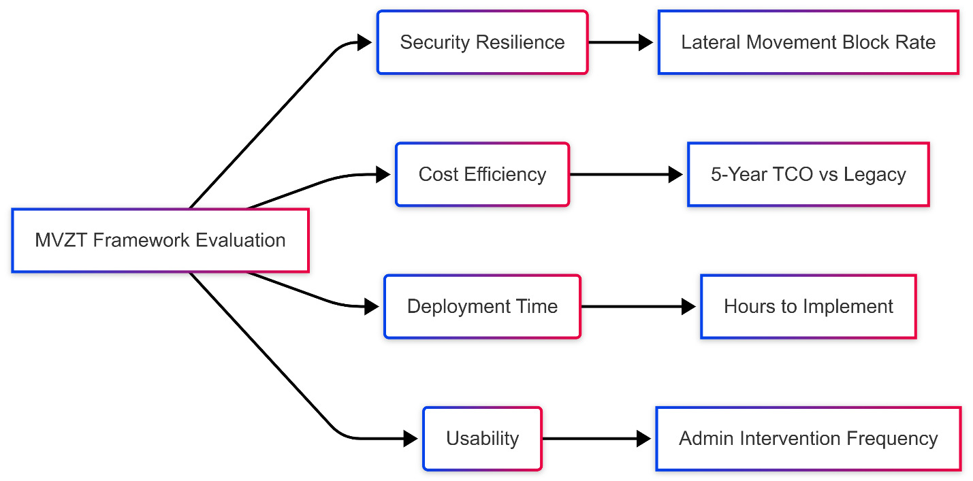
Additionally, the framework is expected to demonstrate reduced deployment complexity and faster implementation times by levering cloud based and low cost tools.
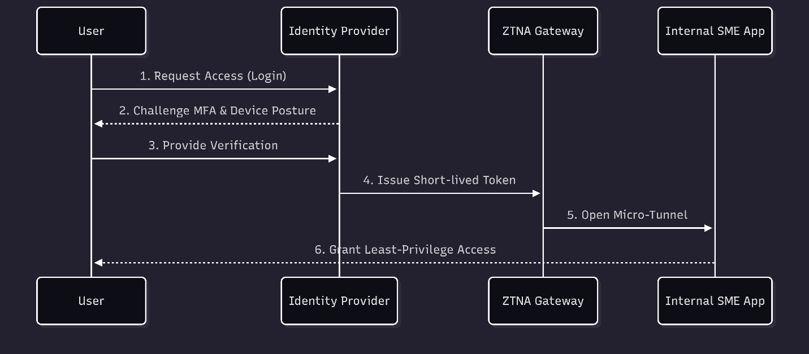
4.2 Implications and limitations
This research makes significant practical and theoretical contributions by introducing simple and scalable zero trust model(MVZT) particularly for limited resources, offering low cost strategy that enhance posture of security. However these findoing are limited by the evaluaion’s use of simulated environment which may not capture real world user behavior or legacy system integration, alongside constrains related to time, resources and potential remaining financial barriers for very small enterprises.

5 Timeline
This research takes 10 weeks to complete, where is the clearly defined phases and milestones to ensure to structured progress and timely completion.

week 1-2 – Introduction and proposal
Week 3 – Research Process, Aim and Objectives
Week 4 – Literature Review
Week 5-8 Methodology & Analysis
Week 9- 10 Report writing

6. Overall presentation of the proposal
The overall presentation of this research proposal is designed to ensure the larity, coherence, and academic rigor. This research follows a logical progression, starting with an intro that build the context and research problem, followed by a comprehensive literature review that figure out core concepts and gaps in existing knowledge. Then the methodology which provides a detailed explanation of the design and approach, ensuring transparency and reproducibility and the rest of other sections are state about outcomes and timeless which are pretty straight-forward.
So each sections are clearly organized with proper headings. Which allow to easy navigation and readability. Usages academic language and formal tone that meets the standards expected in higher education.
Overall, the proposal effectively integrates theory with practical approach which are well justified and feasible research plan. This balanced approach strengthens the quality of the work and ensure that it meets the required academic assessment criteria.

7. References
[1] S. Mushtaq, M. Mohsin, and M. M. Mushtaq, “A systematic literature review on the implementation and challenges of zero trust architecture across domains,” Sensors, vol. 25, no. 19, 2025.
[2] Z. S. M. A. Bashi and S. Senan, “A comprehensive review of zero trust network architecture (ZTNA),” International Journal of Pervasive Computing and Communications, vol. 11, no. 1, 2023.
[3] W. Yeoh, M. Liu, M. Shore, and F. Jiang, “An analysis of zero-trust architecture and its cost-effectiveness for organizational security,” Computers & Security, vol. 118, Art. no. 102724, 2022.
[4] A. Soni et al., “A comprehensive review and comparative analysis of zero trust architecture,” Simulation Modelling Practice and Theory, 2025.
[5] M. L. Gambo and A. Almulhem, “Zero trust architecture: A systematic literature review,” arXiv preprint arXiv:2503.11659, 2025.
[6] S. Rose, O. Borchert, S. Mitchell, and S. Connelly, “Zero Trust Architecture,” National Institute of Standards and Technology, NIST Special Publication 800-207, Aug. 2020.

