1 Introduction
The rapid development of multimedia collection equipment, such as cloud storage and the Internet, makes people acquire various multimedia data more accessible. Image, video, audio, and other multimedia data have become the main media for obtaining and disseminating information. The explosive growth of big multimedia data (text, audio, image, video, 3D animation, etc.) in cloud storage has brought unprecedented opportunities. In the face of massive multimedia data, it has always been a hot issue in the research field to retrieve the required content from the rapid mass data. Deep learning is a new field in machine learning research. Its goal is to establish and simulate a neural network that simulates the human brain for analysis and learning. This neural network can imitate the mechanism of the human brain to interpret different types of data such as images, sounds, and texts. At present, many scholars have applied deep learning to EEG emotion recognition. Zheng, et al. [1] use Deep Belief Network (DBNS) to perform two-class emotion recognition on EEG signals, and the recognition accuracy can reach 86.08%. Li, et al. [2] combine Convolution Neural Network (CNN), and Recurrent Neural Network (RNN) networks, the correct recognition rate of EEG is up to 74.12%; Yang, et al. [3] proposed a special neural network with sub-nodes to extract differential entropy from EEG signals, and the highest accuracy rate reached 93.26%; Bengio, et al. [4] proposed and evaluated a set of deep belief network models, and verified that these models have greatly improved the classification accuracy. This article will use the seismic signal classification experiment and the Beijing PM2.5 prediction experiment to demonstrate the time-series signal classification and prediction of deep learning. Finally, we show how to process text in deep learning by building a model to identify airline tweets Positive or Negative.

2 Basic Introduction to Network
At present, the two mainstream structures in the field of deep learning applications are CNN and RNN. One of the characteristics of CNN is that the state of the network only depends on the input, but it is not suitable for all problems. For example, for data with time attributes, the effect of only relying on the input at the current moment is not very ideal. Therefore, some researchers have begun to use sequence models in the research of emotion recognition. For example, Alhagry, et al. [5] use Long Short-Term Memory (LSTM) to perform emotion recognition on EEG signals and has achieved good results. However, traditional sequence models are all evolved based on RNN. Such as LSTM [6], Gate-Variants of Gated Recurrent Unit (GRU) [7], etc. Therefore, the sequence model has a big problem: its training efficiency is lower than that of CNN. Because of the structural characteristics of RNN, the state learning at each moment is dependent on the state at the previous moment, so it cannot achieve parallel operations, resulting in a significant reduction in computational efficiency. The two main network structures used in this article are CNN and LSTM.
Convolutional Neural Networks (CNN) is typical deep neural networks. The working principle is to perform operations such as multi-layer convolution and pooling on data and gradually extract features from shallow to abstract. At the same time, its unique network structure can effectively reduce the number of parameters, reduce the complexity of the model, and facilitate the training and application of the model. Convolutional neural networks can effectively extract hidden features of high-dimensional data, but Recurrent Neural Networks (RNN) can learn historical information. Research shows that recurrent networks are more suitable for processing time series. As a variant of RNN, Long Short-Term Memory (LSTM) network makes up for the problem of gradient disappearance and gradient explosion caused by ordinary recurrent networks, making it difficult to train the network and better adapts to the processing of time-series information. LSTM has successful applications in speech recognition and text recognition [8].

3 Display of experimental results
3.1 Seismic signal classification experiment
An elastic wave is propagating in the earth's medium from an earthquake source. When an earthquake occurs, the medium in the source area ruptures and moves rapidly, and this disturbance constitutes a wave source. Due to the continuity of the earth's medium, this kind of wave propagates to the inside of the earth and everywhere on the surface, forming an elastic wave in the continuum medium. Seismic waves refer to elastic waves radiated from the seismic source to the outside world [9]. There are backbone interfaces, Moho and Gutenberg surface with sudden changes in seismic wave velocity inside the earth, which divide the earth's interior into three layers: crust, mantle, and core. Earthquakes are divided into three types according to their propagation modes: longitudinal waves, transverse waves and surface waves. Longitudinal waves are propulsion waves with a 5.5 to 7 kilometres propagation speed per second in the crust. They first reach the epicentre. They are also called P waves. They cause the ground to vibrate up and down and are less destructive. Longitudinal waves are propulsion waves with a 5.5 to 7 kilometres propagation speed per second in the crust. They first reach the epicentre. They are also called P waves. They cause the ground to vibrate up and down and are less destructive. The Transverse wave is a shear wave: the propagation speed in the crust is 3.2-4.0 km/s, and the second one reaches the epicentre, also known as the S wave, which causes the ground to shake back and forth and left and right, which is more destructive. Surface waves, also known as L waves, are mixed waves that are excited after longitudinal waves and transverse waves meet on the earth's surface. Its large wavelength and strong amplitude can only propagate along the ground's surface, which is the main factor causing severe damage to buildings. This experiment will try to distinguish whether the seismic wave is a longitudinal wave or a transverse wave by using the CNN network to build a network model. As shown in Figure 1.
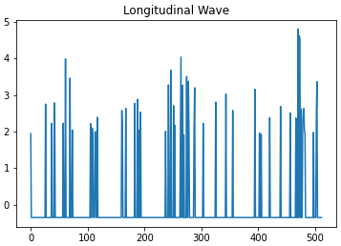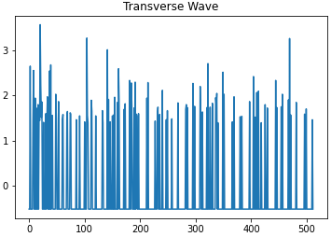
Fig.1. Seismic wave
A total of 461 data are used for training this time, of which 322 are used to train the model, and the remaining data are used to test the quality of the model. Before training, it is necessary to deal with the missing values ​​in the signal. If it is replaced with 0, it is improper. Finally, we choose to use the mode to replace the missing values ​​in the signal. At the same time, before training, the signal needs to be normalized. The maximum and minimum values ​​in the signal are selected for unified scaling, and the range of all signal values ​​is guaranteed to be between 0 and 1. Finally, the model is built. Considering that there are too few trainable sample sets, over-fitting is prone to occur during the training process. I added Dropout Dense between each layer to suppress the occurrence of over-fitting. The network model architecture shown in Figure 2.
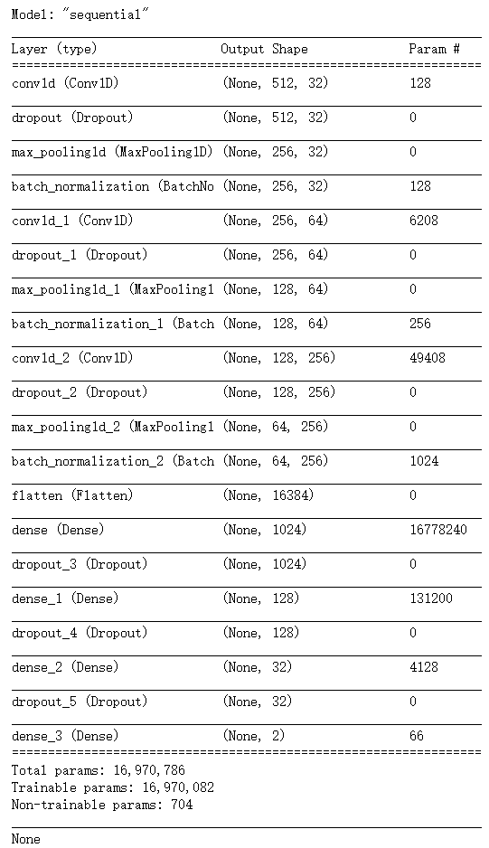
Fig. 2. The architecture of the model
After 150 steps, the accuracy on the training set is as high as 99.06%, and the accuracy on the test set is 96.06%. Overall, the result is excellent. The training situation is shown in Figure 3. We can observe that on the verification set, whether it is accurate or lose value, the fluctuation is relatively large. Because of Dropout, there is no over-fitting phenomenon.
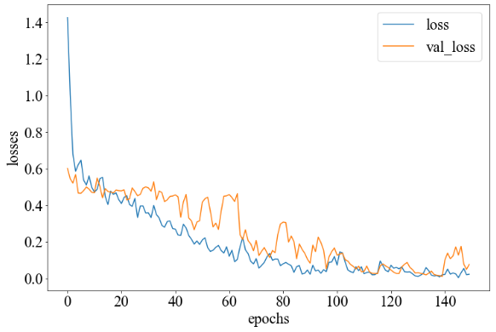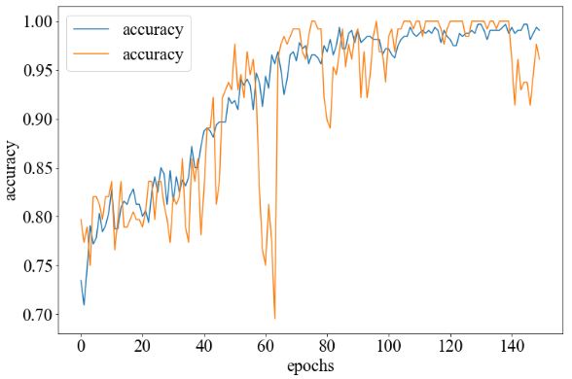
Fig. 3. Losses and accuracy on training
To further understand the performance of the model on the verification dataset, draw the corresponding confusion matrix, as shown in Figure 4. It can be observed that the recognition accuracy of longitudinal waves is as high as 100%. At the same time, it is very easy to misjudge transverse waves as longitudinal waves.
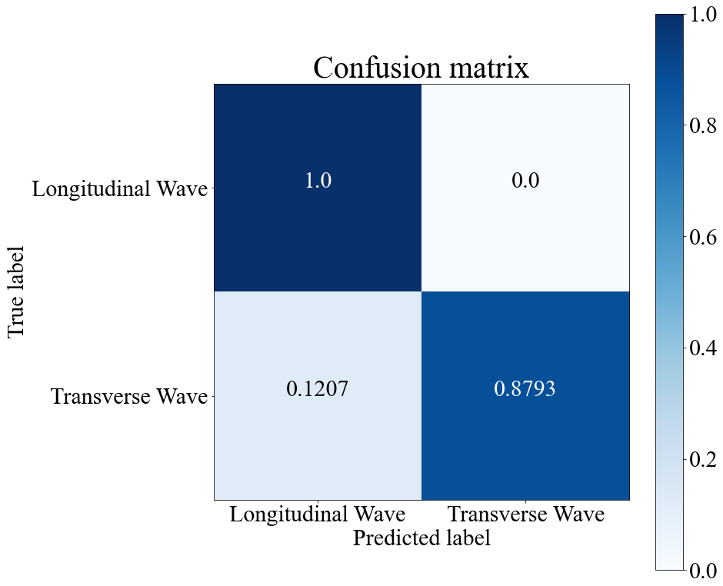
Fig. 4. Confusion matrix on verification dataset

3.2 Forecast on Beijing PM2.5 value
Particulate matter (PM), atmospheric particulate matter, particulates refer to solid particles or liquid droplets suspended in the air [10]. The particles are small and even difficult to identify with the naked eye but still have dimensions difference. In environmental science, excessive particle dispersion and suspension caused by human activities are among the main indicators of air pollution. Still, it may cause discomfort to the organism or affect the ecological and energy cycle. The range covers a wide range of scales, ranging from water mist, dust, pollen, Crumbs, allergens, and haze. Human-made emissions, pesticides, fertilizers, and wastes such as livestock manure meet wind and dust until the precursors undergo a series of highly complex chemical changes and photochemical reactions in the atmosphere to form sulphates, nitrates and ammonium salt. Particles with a diameter less than or equal to 2.5 microns are called PM2.5, such as indoor second-hand smoke [11]. There are three main forms of PM2.5 sources: (1) The first form of existence is primary particles, including the burning of oil, coal and other fuels, road dust, farmland farming, and so on. (2) The second form of existence is secondary particles, mainly produced by chemical reactions such as SO2 and other harmful substances. (3) The third form of existence is solid primary condensable particles, composed of semi-volatile organic compounds (particulate matter formed at a specific ambient temperature). PM2.5 is a kind of atmospheric particulate matter that is harmful to human health and the atmospheric environment [12]. Although its diameter is relatively small, it has strong activity and is easy to contain toxic and harmful substances. It is precise because of the small diameter of PM2.5 that it will cause fine particles to enter the human alveoli from the respiratory tract and have a more direct impact on the ventilation function of the lungs, leaving the body in a state of hypoxia. Therefore, long-term exposure to fine particles will cause cardiovascular and respiratory diseases and lung cancer. And when the concentration of PM2.5 in the air is higher than a specific value, as the concentration of PM2.5 in the atmosphere continues to increase, the overall risk of human death will increase. PM2.5 can also directly or indirectly affect climate change by affecting the land, air radiation budget, or cloud and rain formation.
From the above analysis, we can know that PM2.5 is related to meteorological indicators such as Dew point temperature, temperature, atmospheric pressure, weather conditions, etc. It means that these meteorological indicators could be used to predict the situation of PM2.5. So that citizens can be reminded that day situation of whether it is suitable to go out and exercise. Considering the significant correlation between each value, the RNN network model can fully link the various indicators. At the same time, to avoid gradient disappearance, LSTM is selected to build the network model. The dataset used in this experiment derives from the hourly weather conditions and pollution levels in Beijing during a certain period. At the same time, some indicators were selected to be input into the final model for training. Build a 4-layer LSTM architecture, and its basic network architecture shown in Figure 4.
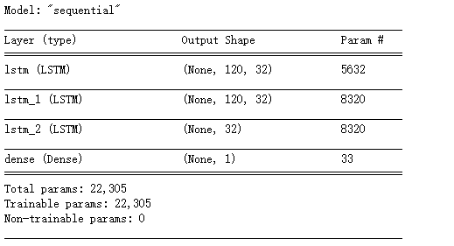
Fig. 4. The architecture of the model
After 200 steps of training, the training set loss value drops to 28.9433, and the verification set loss value drops to 32.6964. The training steps are shown in Figure 5.
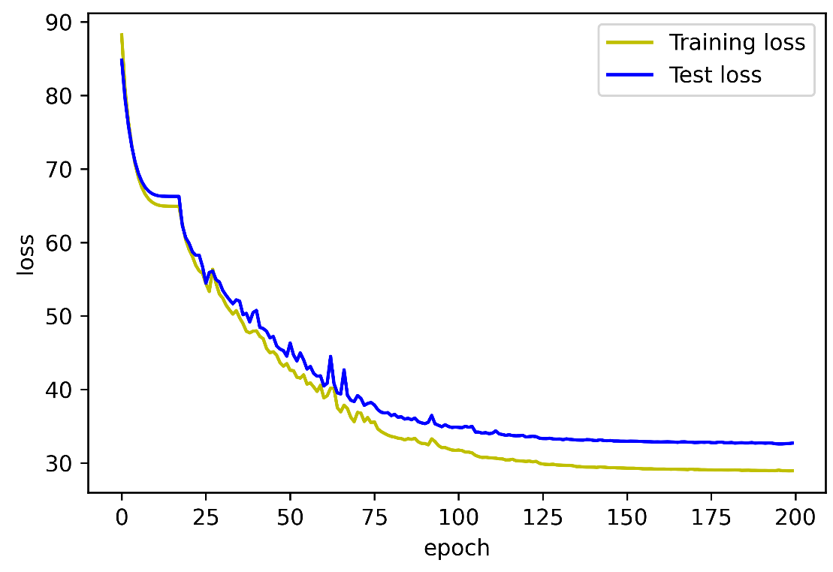
Fig.5. Training process
By observing the training loss value, it can observe that the training process is stable. To have an obvious overfitting phenomenon, to further analyze the training situation, draw a scatter plot corresponding to the true value and the predicted value, as shown in Figure 6.
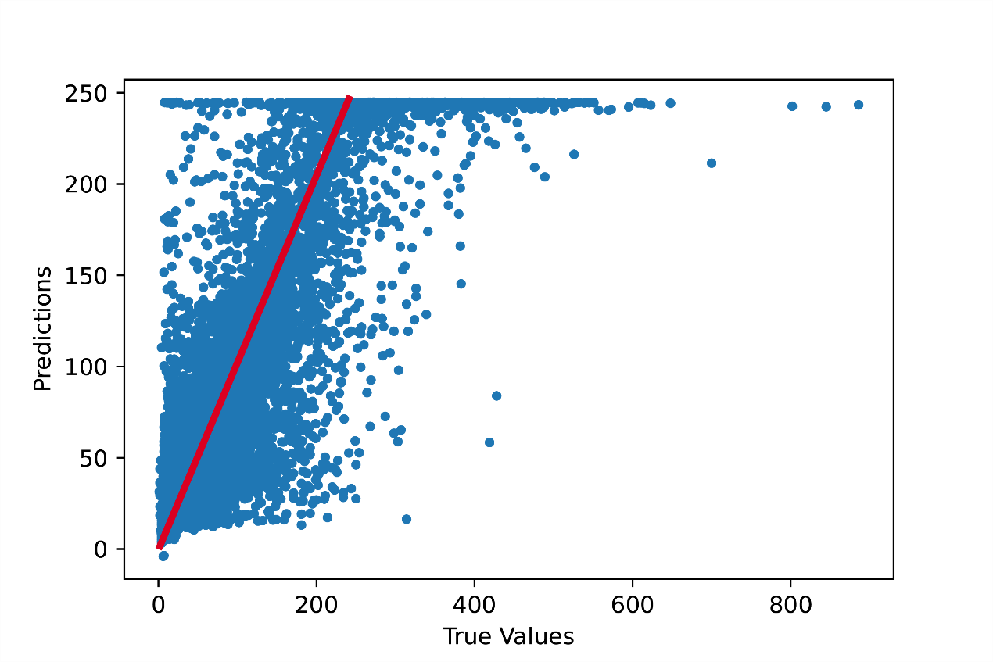Fig.6. scatter plot of the true value and the predicted value

We can observe that the overall trend is a function of $y=x$ in Fig.6, and the prediction situation is good. Still, when the value of PM2.5 exceeds 250, the prediction situation is not very ideal, but these are special cases. From the overall situation, the model can predict the value of PM2.5 well based on the weather signal of the day.
3.3 Airline tweets forecast
Information transmission on the Internet is the carrier of user emotional expression. Take Twitter as an example because Twitter is a comprehensive multifunctional platform that integrates news and entertainment, social interaction, and information publishing. It has attracted many people and is a mainstream information media that has emerged in recent years, with a large number of users and massive text information. Assist the government in monitoring public opinion by studying users' emotional tendencies towards news events, avoiding violent publishing incitement, racial discrimination, and other speeches, avoiding social divisions, and guiding social opinion. Merchants analyze and research review information, understand user preferences, improve their products on time, and provide personalized recommendation services. This experiment is to analyze customers' evaluations of airlines. Due to the huge amount of data generated by huge users, the cost of manually analyzing the data is very high. Therefore, the technology of automatically extracting the emotion contained in the user's comments has emerged. Emotion classification is an important branch field of emotion analysis technology, which divides the data set into a certain category according to the characteristics of the defined emotion category. The binary or ternary classification of emotions is more general and cannot accurately locate the user's true feelings. Compared with this, the multi-class classification solves this problem well and can better reflect the richness of human emotions. Parrott divides human social psychology into five categories: Happiness, Sadness, Anger, Fear and Surprise by studying the expression of human psychological emotions [13].
In this experiment, user's reviews of airlines will analyze how deep learning processes text data. The data set categories can divide into three categories: Neutral, Positive and Negative.However, there are 9178 data for Negative tweets and only 2,363 data for Positive tweets. There is a serious data imbalance. At the same time, the Neutral class and the other two classes are not very easy to distinguish. To reduce the difficulty of training, we need to balance the dataset. 2363 dataset and Positive data are extracted from the negative data to form a new data set to achieve two classifications.
The machine cannot understand words for machines, so the most important step is to convert words to numbers. Before mapping words to numbers, all uppercase letters need to be converted to lowercase letters. By counting all the comments, 4395 words are used in total, and these data are mapped into numbers in the form of a dictionary. Of course, the number of comment words for each person is different. For this reason, it is necessary to add an Embedding layer to the network model to map the text into a dense vector to facilitate network training—the network structure shown in Figure 7. After 200 steps, the training accuracy and training loss shown in Figure 8.
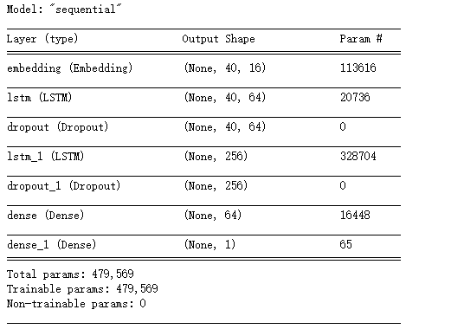
Fig. 7. The architecture of the model

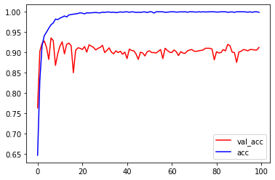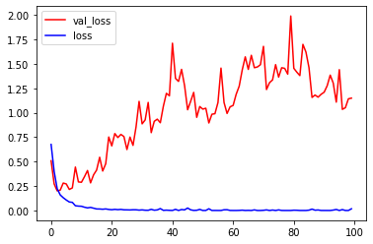
Fig. 8. Accuracy and losses in training
We can observe from Fig. 8 that although a Dropout layer is added between the LSTMs to suppress the over-fitting of the model, the over-fitting phenomenon still occurs during the training process. If you want to suppress over-fitting further, the accuracy and generalization ability of the network model can be improved through the corpus.
This experiment simply analyzes the comments to determine whether the comments are positive or negative, and can form a simple corpus by extracting words. However, if deep learning is applied to the field of translation, then the corresponding corpus is needed to support it. A corpus is an electronic text database with a certain capacity built by using random sampling methods to collect naturally occurring continuous languages ​​and using text or speech fragments in accordance with certain language rules. The corpus can reflect the rules and true appearance of language in actual use, and reveal the most typical language features, so it is widely used in language and translation research. Translators also need to use a corpus to provide a collection of possible translation units or equivalent chapters, and need to contact real bilingual corpus to improve the quality of translation. Studies have shown that when translating, checking related translation issues with reference to the bilingual parallel corpus can help translators improve their expressive skills and reduce errors [14]. Because the parallel corpus can be used to quickly and easily find the translation method of a specific expression, and it can provide multiple translation options or references so that the translation of terms and phrases is more accurate and authentic, which is better than the examples of bilingual dictionaries. Therefore, in terms of translation, the accuracy of translation can be improved by referring to the corpus [15].

4 summary
In the first experiment, by building a CNN network, the classification of shear and longitudinal waves can be achieved, but considering that the data contains less information, the model complexity is higher. Although higher accuracy is obtained on the test dataset, It is not so good at the verification dataset. The information volume of the original signal can be increased by adding the first-order derivation of the time sequence signal and the frequency domain signal. In experiment 2, overall, the prediction results are relatively ideal. If you need to improve the performance of the model further, we can train the model by adding more relevant parameters. In Experiment 3, the corpus was not used for model training, resulting in higher accuracy on the training dataset, but the results were not very satisfactory on the validation dataset. It is possible to improve it by adding a corpus. As I know, for some words, they usually appear in negative comments. At the same time, for some words, they are positive in themselves, but through a specific combination, they are negative. On the one hand, if you consider those situations, it can reduce the difficulty of training; on the other hand, it can also greatly improve the accuracy of the model.

References
- Zheng W L, Lu B L. Investigating critical frequency bands and channels for EEG-based emotion recognition with deep neural networks[J]. IEEE Transactions on Autonomous Mental Development, 2015, 7(3): 162-175.
- Li X, Song D, Zhang P, et al. Emotion recognition from multi-channel EEG data through convolutional recurrent neural network[C]//2016 IEEE international conference on bioinformatics and biomedicine (BIBM). IEEE, 2016: 352-359.
- Yang Y, Wu Q M J, Zheng W L, et al. EEG-based emotion recognition using hierarchical network with subnetwork nodes[J]. IEEE Transactions on Cognitive and Developmental Systems, 2017, 10(2): 408-419.
- Bengio Y. Learning deep architectures for AI[M]. Now Publishers Inc, 2009.
- Alhagry S, Fahmy A A, El-Khoribi R A. Emotion recognition based on EEG using LSTM recurrent neural network[J]. Emotion, 2017, 8(10): 355-358.
- Huang Z, Xu W, Yu K. Bidirectional LSTM-CRF models for sequence tagging[J]. arXiv preprint arXiv:1508.01991, 2015.
- Chung J, Gulcehre C, Cho K H, et al. Empirical evaluation of gated recurrent neural networks on sequence modeling[J]. arXiv preprint arXiv:1412.3555, 2014.
- Graves A, Jaitly N, Mohamed A. Hybrid speech recognition with deep bidirectional LSTM[C]//2013 IEEE workshop on automatic speech recognition and understanding. IEEE, 2013: 273-278.
- Ben-Menahem A, Singh S J. Seismic waves and sources[M]. Springer Science & Business Media, 2012.
- Dominici F, Greenstone M, Sunstein C R. Particulate matter matters[J]. Science, 2014, 344(6181): 257-259.
- Kim K H, Kabir E, Kabir S. A review on the human health impact of airborne particulate matter[J]. Environment international, 2015, 74: 136-143.
- Feng S, Gao D, Liao F, et al. The health effects of ambient PM2. 5 and potential mechanisms[J]. Ecotoxicology and environmental safety, 2016, 128: 67-74.
- Al-Shawaf L, Conroy-Beam D, Asao K, et al. Human emotions: An evolutionary psychological perspective[J]. Emotion Review, 2016, 8(2): 173-186.
- Pustejovsky J, Stubbs A. Natural Language Annotation for Machine Learning: A guide to corpus-building for applications[M]. " O'Reilly Media, Inc.", 2012.
- Baker M. Corpus-based translation studies: The challenges that lie ahead[J]. Benjamins Translation Library, 1996, 18: 175-186.

Appendants
Experiment 1
#%%

import pandas as pd
import numpy as np
import tensorflow as tf
import matplotlib.pyplot as plt

#%%

data_1 = pd.read_table('C://Users//Administrator//Desktop//英国作业//人工智能//peoject//Earthquakes//Earthquakes_TEST',",",header=None)
data_2 = pd.read_table('C://Users//Administrator//Desktop//英国作业//人工智能//peoject//Earthquakes//Earthquakes_TEST',",",header=None) #read the dataset

#%%

data_1.shape #chech the shape of data

#%%

data_2.shape

#%%

data_1 = data_1.to_numpy()
data_2 = data_2.to_numpy()

#%%

test_label = data_1[:,0]
data = data_1[:,1:]

#%%

path_pictutre = r'C:\Users\Administrator\Desktop\英国作业\人工智能\图片'

#%%

import os

#%%

plt.plot(data[0,:])
plt.title("Transverse Wave")
plt.savefig(os.path.join(path_pictutre,"Transverse Wave"))

#%%

plt.plot(data[1,:])
plt.title("Longitudinal Wave")
plt.savefig(os.path.join(path_pictutre,"Longitudinal Wave"))

#%%

def tranform(data):
label = data[:,0].astype(np.int64)
label = tf.keras.utils.to_categorical(label,2)
data_real = data[:,1:]
ds_train=np.reshape(data_real,(data_real.shape[0],data_real.shape[1],1))
return tf.data.Dataset.from_tensor_slices(ds_train),tf.data.Dataset.from_tensor_slices(label)

#%%

ds_train_data,ds_train_label = tranform(data_1)
ds_test_data,ds_test_label=tranform(data_2)

#%%

ds_train=tf.data.Dataset.zip((ds_train_data,ds_train_label))

#%%

ds_test=tf.data.Dataset.zip((ds_test_data,ds_test_label))

#%%

ds_train

#%%

BATCH=16
ds_train=ds_train.shuffle(322).repeat().batch(BATCH)
ds_test=ds_test.shuffle(139).repeat().batch(BATCH)

#%%

ds_train

#%%

ds_test

#%%

model=tf.keras.Sequential()
model.add(tf.keras.layers.Conv1D(32,3,padding='same',activation='relu', input_shape=(512,1)))
model.add(tf.keras.layers.Dropout(0.5))
model.add(tf.keras.layers.MaxPool1D())
model.add(tf.keras.layers.BatchNormalization())
model.add(tf.keras.layers.Conv1D(64,3,padding='same',activation='relu'))
model.add(tf.keras.layers.Dropout(0.5))
model.add(tf.keras.layers.MaxPool1D())
model.add(tf.keras.layers.BatchNormalization())
model.add(tf.keras.layers.Conv1D(256,3,padding='same',activation='relu'))
model.add(tf.keras.layers.Dropout(0.5))
model.add(tf.keras.layers.MaxPool1D())
model.add(tf.keras.layers.BatchNormalization())
model.add(tf.keras.layers.Flatten())
model.add(tf.keras.layers.Dense(1024,activation='relu'))
model.add(tf.keras.layers.Dropout(0.5))
model.add(tf.keras.layers.Dense(128,activation='relu'))
model.add(tf.keras.layers.Dropout(0.5))
model.add(tf.keras.layers.Dense(32,activation='relu'))
model.add(tf.keras.layers.Dropout(0.5))
model.add(tf.keras.layers.Dense(2,activation='softmax'))
print(model.summary())

#%%

model.compile(optimizer='adam',
loss='categorical_crossentropy',
metrics=['accuracy'])

#%%

history=model.fit(ds_train,epochs=150,steps_per_epoch=322//16,
validation_data=ds_test,validation_steps=139//16)

#%%

np.save(r"C:\Users\Administrator\Desktop\英国作业\人工智能\peoject\historyOfEarthquakes",history.history)

#%%

plt.rcParams['font.family'] = 'Times New Roman'
plt.rcParams['font.size'] = 23

#%%

fig = plt.figure(figsize=(12,8))
ax = fig.subplots()
ax.plot(history.history['accuracy'],label='accuracy')
ax.plot(history.history['val_accuracy'],label='accuracy')
ax.set_xlabel("epochs")
ax.set_ylabel("accuracy")
ax.legend()

#%%

import os
path = r'C:\Users\Administrator\Desktop\英国作业\人工智能\peoject\图片汇总'
fig.savefig(os.path.join(path,'分类预测情况'))

#%%

fig = plt.figure(figsize=(12,8))
ax = fig.subplots()
ax.plot(history.history['loss'],label='loss')
ax.plot(history.history['val_loss'],label='val_loss')
ax.set_xlabel("epochs")
ax.set_ylabel("losses")
ax.legend()

#%%

fig.savefig(os.path.join(path,'earthquakes损失值情况'))

#%%

pre_data = data_2[:,1:]

#%%

pre_data.shape

#%%

pre_data = np.reshape(pre_data,(322,512,1))

#%%

pre_value = model.predict(pre_data)

#%%

pre_value_label = np.argmax(pre_value,axis=1)

#%%

pre_value_label

#%%

def plot_confusion_matrix(y_true, y_pred, title = "Confusion matrix",
cmap = plt.cm.Blues, save_flg = False):
import matplotlib.pyplot as plt
from sklearn.metrics import confusion_matrix
import os,glob,random, csv,itertools
import numpy as np
classes = ['label_1','label_2']#参数i的取值范围根据你自己数据集的划分类别来修改，我这儿为7代表数据集共有7类
labels = range(2)#数据集的标签类别，跟上面I对应
cm = confusion_matrix(y_true, y_pred, labels=labels)
cm.dtype='float'
for i in range(cm.shape[0]):
cm[i,:]=cm[i,:]/(cm[i,:].sum())
cm=np.around(cm,decimals=4)
plt.figure(figsize=(14, 12))
plt.imshow(cm, interpolation='nearest', cmap=cmap)
plt.title(title, fontsize=40)
plt.colorbar()
tick_marks = np.arange(len(classes))
plt.xticks(tick_marks, classes, fontsize=20)
plt.yticks(tick_marks, classes, fontsize=20)
print('Confusion matrix, without normalization')
thresh = cm.max() / 2.
for i, j in itertools.product(range(cm.shape[0]), range(cm.shape[1])):
plt.text(j, i, cm[i, j],
horizontalalignment="center",
color="white" if cm[i, j] > thresh else "black")
plt.ylabel('True label', fontsize=30)
plt.xlabel('Predicted label', fontsize=30)

if save_flg:
plt.savefig("./confusion_matrix_earthquakes.png")
plt.show()

#%%

plot_confusion_matrix(data_2[:,0],pre_value_label,save_flg=True)

#%%

Experiment 2

#%%

from tensorflow import keras
from tensorflow.keras import layers

#%%

import pandas as pd
import numpy as np
import matplotlib.pyplot as plt
%matplotlib inline

#%%

data = pd.read_csv(r'C:\Users\Administrator\Desktop\英国作业\人工智能\peoject\北京空气_2010.1.1-2014.12.31.csv')

#%%

data.info()

#%%

data[data['pm2.5'].isna()]

#%%

data = data.iloc[24:].copy()

#%%

data.fillna(method='ffill', inplace=True)

#%%

data.info()

#%%

data.drop('No', axis=1, inplace=True)

#%%

import datetime

#%%

data['time'] = data.apply(lambda x: datetime.datetime(year=x['year'],
month=x['month'],
day=x['day'],
hour=x['hour']),
axis=1)

#%%

data.set_index('time', inplace=True)

#%%

data.drop(columns=['year', 'month', 'day', 'hour'], inplace=True)

#%%

data.head()

#%%

data.columns = ['pm2.5', 'dew', 'temp', 'press', 'cbwd', 'iws', 'snow', 'rain']

#%%

data.cbwd.unique()

#%%

data = data.join(pd.get_dummies(data.cbwd))

#%%

del data['cbwd']

#%%

data.info()

#%%

data['pm2.5'][-1000:].plot()

#%%

data['temp'][-1000:].plot()

#%%

data.head(3)

#%%

sequence_length = 5*24
delay = 24

#%%

data_ = []
for i in range(len(data) - sequence_length - delay):
data_.append(data.iloc[i: i + sequence_length + delay])

#%%

data_ = np.array([df.values for df in data_])

#%%

data_.shape

#%%

np.random.shuffle(data_)

#%%

x = data_[:, :-delay, :]
y = data_[:, -1, 0]

#%%

split_boundary = int(data_.shape[0] * 0.8)

#%%

train_x = x[: split_boundary]
test_x = x[split_boundary:]

train_y = y[: split_boundary]
test_y = y[split_boundary:]

#%%

train_x.shape, test_x.shape, train_y.shape, test_y.shape

#%%

mean = train_x.mean(axis=0)
std = train_x.std(axis=0)

#%%

mean.shape

#%%

train_x = (train_x - mean)/std

#%%

test_x = (test_x - mean)/std

#%%

batch_size = 128

#%%

model = keras.Sequential()
model.add(layers.LSTM(32, input_shape=(train_x.shape[1:]), return_sequences=True))
model.add(layers.LSTM(32, return_sequences=True))
model.add(layers.LSTM(32))
model.add(layers.Dense(1))

#%%

model.summary()

#%%

model.compile(optimizer=keras.optimizers.Adam(), loss='mae')

#%%

learning_rate_reduction = keras.callbacks.ReduceLROnPlateau(monitor='val_loss', patience=3, factor=0.5, min_lr=0.00001)

#%%

history = model.fit(train_x, train_y,
batch_size = 128,
epochs= 200,
validation_data=(test_x, test_y),
callbacks=[learning_rate_reduction])

#%%

plt.plot(history.epoch, history.history.get('loss'), 'y', label='Training loss')
plt.plot(history.epoch, history.history.get('val_loss'), 'b', label='Test loss')
plt.legend()

#%%

test_predictions = model.predict(test_x).flatten()

#%%

f = plt.figure(dpi= 600)
plt.scatter(test_y, test_predictions, s=10)
plt.xlabel('True Values')
plt.ylabel('Predictions')
f.savefig("回归预测图.eps", dpi=600, format='eps')
# plt.show()

Experiment 3
#%%

import tensorflow as tf
from tensorflow import keras
from tensorflow.keras import layers
import numpy as np
import pandas as pd
import matplotlib as plt

#%%

data = pd.read_csv(r'C:\Users\Administrator\Desktop\英国作业\人工智能\peoject\Tweets.csv')

#%%

data.head()

#%%

data = data[['airline_sentiment', 'text']]

#%%

data.airline_sentiment.unique()

#%%

data.airline_sentiment.value_counts()

#%%

data_p = data[data.airline_sentiment == 'positive']

#%%

data_n = data[data.airline_sentiment == 'negative']

#%%

data_n = data_n.iloc[:len(data_p)]

#%%

len(data_n), len(data_p)

#%%

data = pd.concat([data_n, data_p])

#%%

data = data.sample(len(data))

#%%

data['review'] = (data.airline_sentiment == 'positive').astype('int')

#%%

del data['airline_sentiment']

#%% md

tf.keras.layers.Embedding 把文本向量化

#%%

import re

#%%

token = re.compile('[A-Za-z]+|[!?,.()]')

#%%

def reg_text(text):
new_text = token.findall(text)
new_text = [word.lower() for word in new_text]
return new_text

#%%

data['text'] = data.text.apply(reg_text)

#%%

word_set = set()
for text in data.text:
for word in text:
word_set.add(word)

#%%

max_word = len(word_set) + 1
max_word

#%%

word_list = list(word_set)

#%%

word_list.index('spending')

#%%

word_index = dict((word, word_list.index(word) + 1) for word in word_list)

#%%

word_index

#%%

data_ok = data.text.apply(lambda x: [word_index.get(word, 0) for word in x])

#%%

len(data_ok.iloc[2])

#%%

maxlen = max(len(x) for x in data_ok)

#%%

maxlen

#%%

data_ok = keras.preprocessing.sequence.pad_sequences(data_ok.values, maxlen=maxlen)

#%%

data_ok.shape

#%%

data.review.values

#%%

import matplotlib.pyplot as plt
%matplotlib inline

#%%

def train_model():
model = keras.Sequential()
model.add(layers.Embedding(max_word, 16, input_length=maxlen))
model.add(layers.LSTM(64,
dropout=0.2,
recurrent_dropout=0.5, return_sequences=True))
model.add(layers.Dropout(0.5))
model.add(layers.LSTM(256,
dropout=0.2,
recurrent_dropout=0.5))
model.add(layers.Dropout(0.5))
model.add(layers.Dense(64, activation='relu'))
model.add(layers.Dense(1, activation='sigmoid'))
model.compile(optimizer=keras.optimizers.RMSprop(),
loss='binary_crossentropy',
metrics=['acc'])
return model

#%%

model = train_model()

#%%

model.summary()

#%%

history = model.fit(data_ok, data.review.values, epochs=100, batch_size=128, validation_split=0.2)

#%%

plt.plot(history.epoch, history.history.get('val_acc'), c='r', label='val_acc')
plt.plot(history.epoch, history.history.get('acc'), c='b', label='acc')
plt.legend()

#%%

plt.plot(history.epoch, history.history.get('val_loss'), c='r', label='val_loss')
plt.plot(history.epoch, history.history.get('loss'), c='b', label='loss')
plt.legend()

