
MODOU
PENE
1810381

SOFTWARE
DEVELOPMENT

ASSESSMENT 2
SECTION II

LECTURE NAME
JOY BOTU

SUMMARY
ARRAYS……………………………………………………………………1
TYPE ARRAYS……………………………………………………………2
LIST………………………………………………………………………2.1
ARRAYLIST………………………………………………………………2.2
FUCTION……………………………………………………………………3
DEFFERENT BETWEEN REFERENCE & VALUE……………………….4

PART B
TEST SOFTWARE……………………………………………………………5
EXERCISE 1……………………………………………………………………6
EXERCISE 2……………………………………………………………………7
EXERCISE 3……………………………………………………………………8

1.ARRAY

An array is a sequence of elements, all of the same type, which can be either a reference type or a value type. This sequence is identified by a name, which is the name of the array. To declare ed access the elements of an array, in C # we use the indexing operator [] (square brackets). A.D
example writing
int [] vector;
identifies an array of integers, but does not yet contain any elements, nor dice how many elements the array it can contain, that is what its length is. To initialize an array we can use several Modi. The first consists in declaring and simultaneously assigning the elements of the vector, writing the elements of the array enclosed in curly brackets and separated by a comma:
int [] vector = {1,2,3,4,5};
It is possible to initialize the size of an array using the keyword new. For example if we want an array to be prepared to contain 10 interiors, but we still don't know what the ten will be values ​​that we will have to store in the array, we can write
int [] vector = new int [10];
The elements of a vector are numbered starting from zero, so the previous array will have 10 elements numbered from 0 to 9, which therefore we can access individually by writing the index of the item to be accessed
inside the square brackets [], for example to store the value in the first box of the array 100, and in the second 101, just write:
Vector [0] = 100;
Vector [1] = 101;
Arrays in C # are instances of the System.Array class. So actually an array variable, such as the vector variable of the example, is an instance of a reference type. If we assigned another variable a matrix,
int carrier2 = vector;
what we assign is actually just the reference to the array. So if we create the following two arrays, then ad example we change the first element of one of the two arrays, the variation will also be reflected on the first element of the other array, because in fact the two elements coincide.
2.TYPES ARRAYS
List and ArrayList are collections of data or objects, called Collection, which offer greater flexibility than arrays because they do not have a fixed size and, moreover, they can contain elements of different types. C # has two different types of class-based lists:
- List, for elements of the same type
List<int> Mylist = new Mylist<int> {1,2,3,4};

- ArrayList, for elements of different types
Int[] number = {2,3,4,2,1};
ArrayList Mylist = new ArrayList(n);

2.1 LIST
The typed lists “List<>” can contain any number of elements as long as they are of the same type. First include the Generic namespace “using System.Collection.Generic”. If the values to be inserted inside it are known they can be indicated as shown in the previous example. Later, a new element can be added to the list, at any time, with the .Add () method.

2.2 ARRAYLIST
ArrayLists can contain a series of elements that can vary both in number and type of data. Include the System.Collections namespace. The ArrayList class has many properties and methods for manipulating list elements. To insert a new element, even of a different type from those in the list, use the Add () method.

3.FUNCTION
Leafing through the first pages of almost all the texts dedicated to the OOP (Object Oriented Programming), a typical sentence that we read is that everything is an object. Quoting a definition more serious and precise given by one of the fathers of the same paradigm, Grady Booch, we can say that an object it is something that has its own state, its identity, and its behavior. From the point of view of So, as a software developer, an object is something that maintains internal data, which supplies data methods to manipulate them, and that resides in its own reserved memory area, living with other objects, of the same type or other type. In the Object Oriented paradigm, in general, the type of an object is its class, that is, each object belongs to a certain class. For example, a dog named Argo, who has his own identity, a behavior, and a state (for example weight, height, date of birth), is an element of a class, the Dog class. The concept of class is therefore synonymous with type. Each class defines the common characteristics of each object that belongs to you. For example, all elements of the Dog class, have four legs, bark, they walk. But each object will then have characteristics that distinguish it from any other. Every element of a class, that is each object, is said to be instance of that class, and the creation itself of an object is also called, therefore, instantiation of the object. Going back to software development, when we program in an object-oriented way, not we have to do nothing other than think about the concepts of the domain we are facing, and then derive them objects and functionalities they must have, and provide the means of communication between different objects
of the class itself or of different classes. Furthermore, every object in the common world is not an atomic entity, that is, every object is formed by others
objects, the classic mouse, for example, consists of a ball, two or more keys, perhaps a wheel, all objects that aggregate provide the full functionality of the mouse.
Example:
Public static int Age18()
{
Return 18;
}

TYPE OF FUNCTION
When we perform a function, we must determine the type. If the function does not render any data, then void must be indicated in the type. If the function renders a data, then it is necessary to indicate the type of the expected data.
For example:
A function that determines the maximum between two integers and then has to re-enter an integer value, so its type is Integer. A function that trades two and does not shrink any value then the type is void

Public static int MaxNumber(int a,int b){
If(a>b){
Return x;
}else{
Return y;
}

Public static void SwapNumber(ref int a, ref int b;){
Int c=a;
a=b;
b=c;
}

A one that works in C#. can return either types (such as int, float, bool, double, or string) or reference (int[] object).

C # object-oriented
C # is a totally object-oriented language, that is when we program in C # we have to think in terms of classes and objects, so much so that even for the simplest of programs, such as the hello world seen a few chapters ago, you need to create a class, which will be instantiated by the CLR to run the program, invoking the Main method which will be exposed by the created object.

The classes
In an object-oriented language, creating new types of data means creating new classes. To do this C #provides the keyword class. According to the definition, or at least one of the many definitions, a class is a data structure that can
contain data members (constants and fields), function members (methods, properties, events, indexers, operators, instance constructors, destructors and static constructors) and nested types.
In C # the methods must necessarily be members of a class, so there are no global functions. In the following examples, even where they are not explicitly invoked with the notation object.method (), it is understood that the methods belong to a class, and therefore the invocation with the notation method (), ie without the object name, assumes that they are invoked inside of the object itself that exposes them, that is, it acts on the object itself.To make explicit the action on the members of the object itself, the keyword this, like we will see later. A particular type of methods are the properties of a class. Properties are methods, which allow read and / or write access to the attributes of a class.
In fact the behavior of the properties is obtainable by writing ad hoc methods, as they will be used to making java or C ++ programmers, ie the classic Set or Get. However, properties allow you to access a field intuitively, for example with an assignment, as would be done with a public field, but with the difference that the properties do not denote data storage locations, such as fields, and simultaneously allow for make checks on the value you want to assign or read. Furthermore the properties retain the code consistent and compact, since reading and writing are implemented in adjacent blocks. As an example, we will add a Direction property to the Vehicle class to set the direction of
motion, assuming that it is expressed in degrees, and therefore variable from 0 to 359.
public int Direction
{
get
{
return direction;
}
set
{
if (direction <0)
direction + = 360;
direction value = 360%;
}
}
We called the property Direction (taking advantage of the fact that C # is case-sensitive) which invokes
immediately the fact that it deals with access to the private management field. The reading of the field yes
gets through the get block, which must return a value of the type declared by the property. The writing of the
field happens instead in the set block, to which a parameter is always passed implicitly, of
value name.
We underline the fact that the two get and set branches do not necessarily have to be simultaneously
present, for example, it is easy to implement a read-only property by providing only the get branch:
public string Name
{
get
{

return name;
}
}
Similarly, even if it happens less frequently, a write-only property can be implemented
with the set branch only, for example:
public string Name
{
set
{
name = value;
}
}

Passing parameters
In case the method has arguments in its signature, it is necessary to specify the correct number
and the correct type of the arguments themselves, when calling the method, also the variables passed
as arguments to a method must necessarily be initialized. For example, suppose we of
have a method that sums two integers, and returns the value of that sum:
public int Sum (int a, int b)
{
return a + b;
}
the method thus defined must be invoked passing as parameters two variables of type int, or of a type
however convertible, implicitly or explicitly, in int:
int sum = Sum (1,2);
The arguments can generally be passed by reference and by value. In the above example i
arguments are passed by value, because what is actually passed to the method is a copy of the value
of the arguments, while the original variables will not undergo any modification, in fact if in the body of the method
we modify the values ​​of the topic variables, and we print them at the exit from the method itself, we will see that i
values ​​are still those prior to the call. The following method calculates the square of an integer,
assigning it initially to the topic variable:
public int Square (int a)
{
a = a * a; // I assign to a the value of its square
return a;
}
Invoking this method, passing as an argument a variable n:
int n = 3;
int q = Square (n);
Console.WriteLine ("n = {0}, q = {1}", n, q);
The value of n printed at the exit of the method, still remains the one assumed before the call of the method itself. In the passage by reference instead the value of the variable is modified by the method, as what it is passed to the method is precisely a reference to the value, and therefore for complex data types it is more efficient mode of passing parameters.

REFERENCE
The Reference types are always allocated by the Managed Heap and the new operators return the memory address of the object, that is the address refers to the bits of the object. Since memory is allocated by the Managed Heap, a garbage collection takes place with relative performance decrease.

VALUE
Value types instead are usually allocated in the thread's stack (but could also be encapsulated in an object of type Reference) and the variable representing the object does not contain a pointer to it, but directly the value of the object itself. Value types are not under the control of the garbage collector.
PART B
TEST SOFTWARE

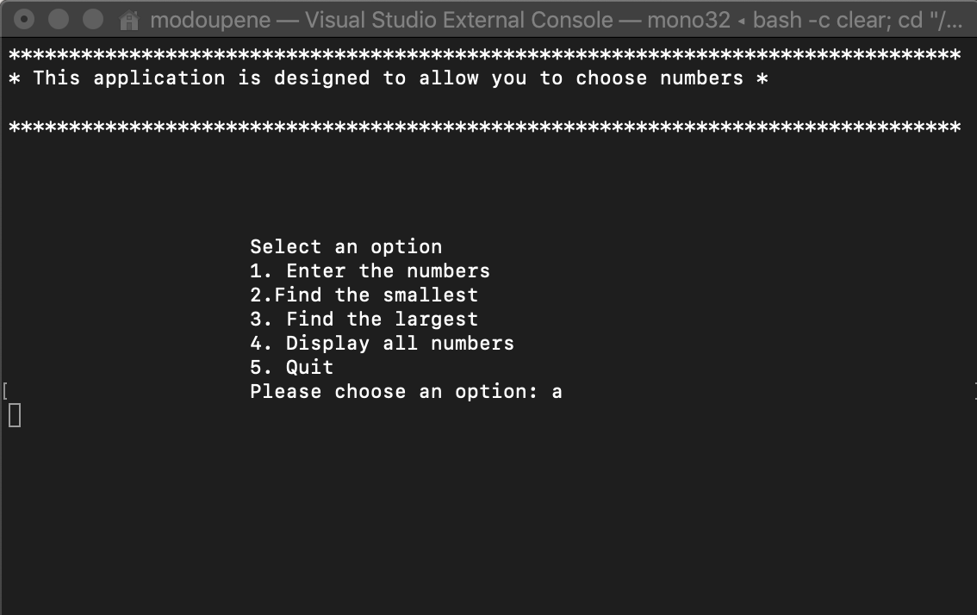

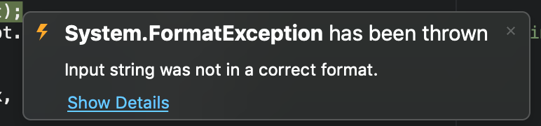
FIRST TEST
We found various types of bugs in the software that were developed. The first bug we found is that when the user inserts a String instead of the integer then it is a problem because the system is assigned only integer variables that it accepts in choosing an option.
On visual studio comes on video an error message that says only integers you can put

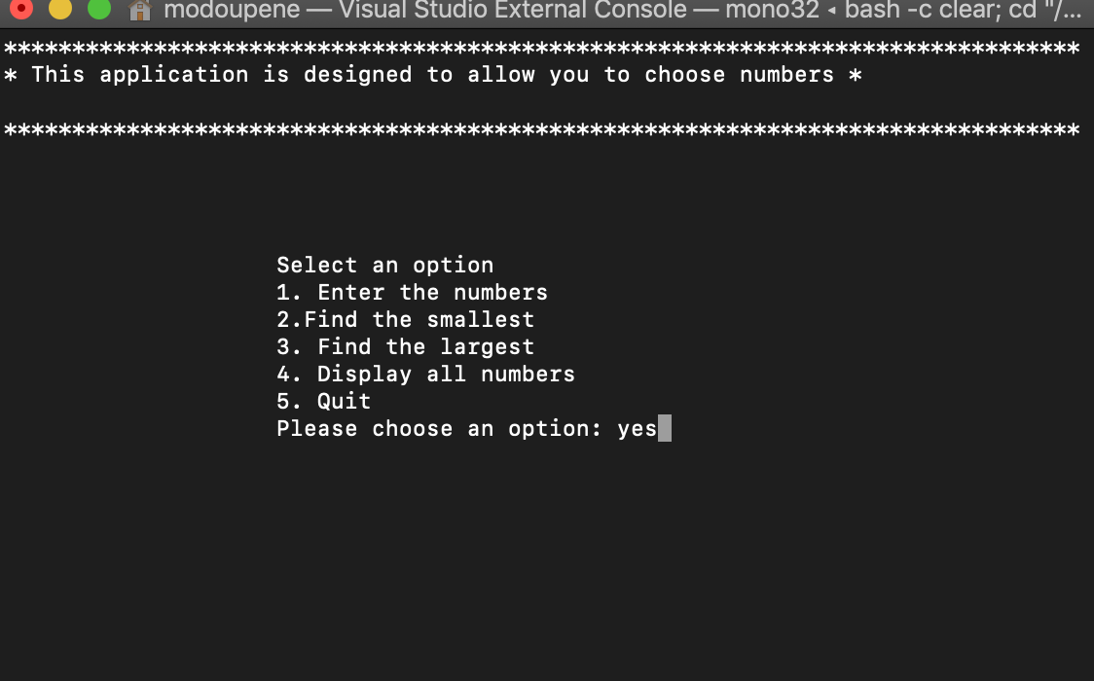

SECOND TEST
When the user inserts in the first phase "YES" is accepted and the program closes, trying others like "yes, YES ,y" is not recognized and returns to the main menu. These cases happen because in the system they have insert only one condition "YES" and nothing else
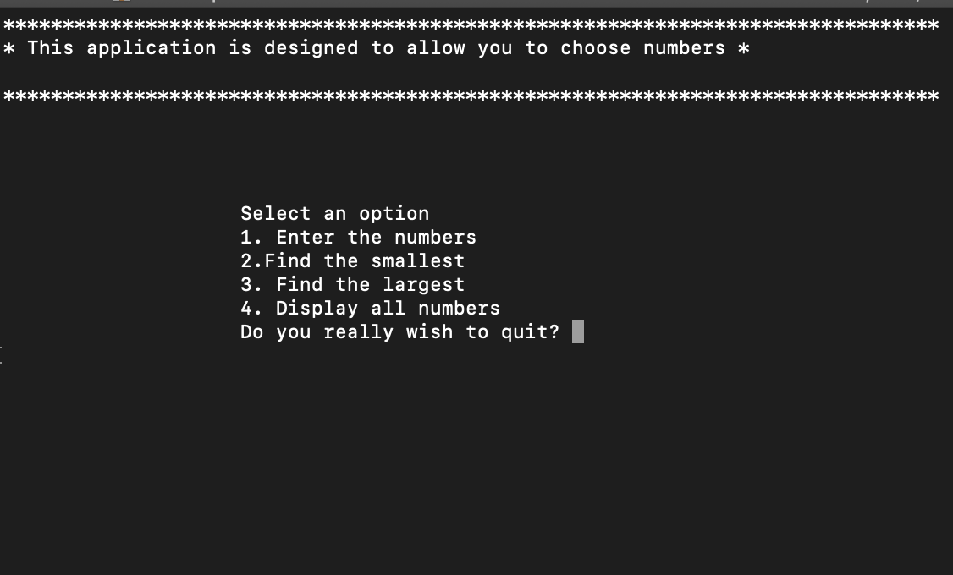
ThIRD TEST
The user was trying to see all the numbers that contain the vector, but we understand that it shows us if we want to exit the program and that means that option 5 has been activated in option 4 so not all numbers are displayed

EXERCISE 1
using System;
using System.Collections;

namespace Exercice_1
{
class MainClass
{
public static void Main(string[] args)
{
int number=0;
int count = 0;
Console.WriteLine("How many value you wish to enter");
number=int.Parse(Console.ReadLine());
count++;
int[] vector = new int[number];
for (int index = 0; index < vector.Length; index++)
{
Console.WriteLine("Insert value");
vector[index] = int.Parse(Console.ReadLine());
count++;
}
Console.WriteLine("");
for (int i = 0; i < vector.Length; i++)
{
Console.Write(" {0} ,", vector[i]);
}
Console.WriteLine("\nBecomes\n");
if (count % 2 == 0)
{
for (int i = 0; i < vector.Length - 1; i += 2)
{
Console.Write(" {0} , ", i == count - 2 ? vector[i] : vector[i] * vector[i + 1]);
}
}
else
{
for (int i = 0; i < vector.Length - 1; i += 2)
{
Console.Write(" {0} , ", vector[i] * vector[i + 1]);
}
}
}
}
}
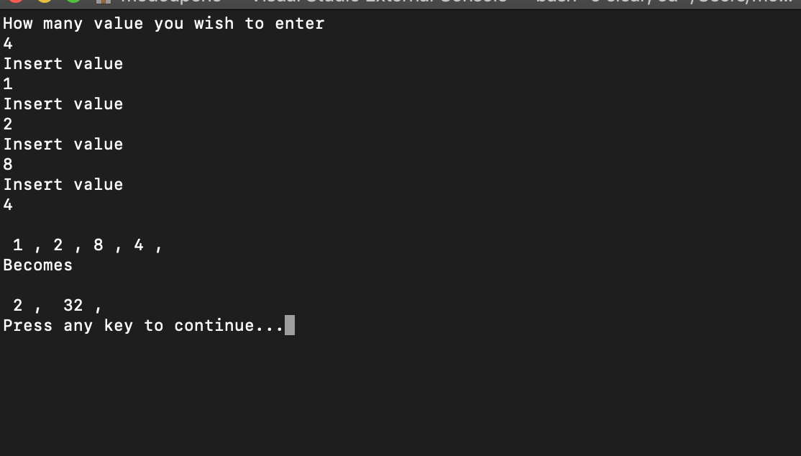

EXERCISE 2
using System;

namespace exe2
{
class MainClass
{
public static void Main(string[] args)
{
int i;
int player_one;
int player_two;
int som_player_one = 0;
int som_player_two = 0;

for (i = 0; i < 10; i++)
{
Console.WriteLine("Goals player One: ");
player_one = int.Parse(Console.ReadLine());
Console.WriteLine("Goals player two: ");
player_two = int.Parse(Console.ReadLine());

if (player_one > player_two)
{
Console.WriteLine("Player one Wins");
som_player_one += 2;
som_player_two += 0;
}
else
{
if (player_two > player_one)
{
Console.WriteLine("Player two Wins");
som_player_two += 2;
som_player_one += 0;
}

}
if (player_one == player_two)
{
Console.WriteLine("It's a draw");
som_player_one += 1;
som_player_two += 1;
}

}
Console.WriteLine("Player One Points: " + som_player_one + "\n" + "Player two Points: " + som_player_two);
if (som_player_one > som_player_two)
{
Console.WriteLine("Player One is the Champion with " + som_player_one + " points");

}
else
if (som_player_two > som_player_one)
{
Console.WriteLine("Player two is the Champion with " + som_player_two + " points");
}
if (som_player_one == som_player_two)
{
Console.WriteLine("It's a draw " + som_player_one + " for each player");
}
}
}
}
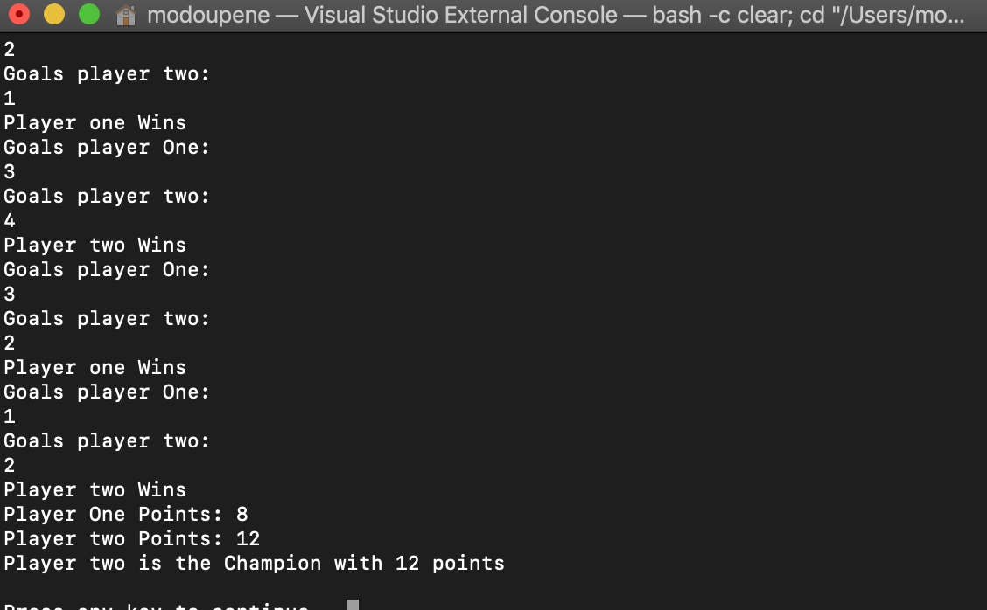
EXERCISE 3

using System;
using System.Collections;

namespace Assignment_2019
{
class MainClass
{
public static void Main(string[] args)
{
int choose;
ArrayList a = new ArrayList();

const int MAXNUMBERS = 2;
int[] theNumbers = new int[MAXNUMBERS];
bool respond;
string ans;
do
{
respond = true;
Console.WriteLine("-*-*-*-*-*-*-*-*-*-*-*-*-*-*-*-*-*-*-*-*-*-*-*-*-*-*-*-*-*");
Console.WriteLine("Select an option");
Console.WriteLine("1.Enter the number");
Console.WriteLine("2.Find the smallest");
Console.WriteLine("3.Find the largest");
Console.WriteLine("4.Display all numbers");
Console.WriteLine("5.Quit");
Console.WriteLine("-*-*-*-*-*-*-*-*-*-*-*-*-*-*-*-*-*-*-*-*-*-*-*-*-*-*-*-*-*-*");

choose = Convert.ToInt32(Console.ReadLine());

switch (choose)
{
case 1:
for (int index = 0; index < MAXNUMBERS; index++)
{
Console.WriteLine("Insert Your number");
theNumbers[index] = int.Parse(Console.ReadLine());
}
a.Add(theNumbers);
break;

case 2:
int smallest = theNumbers[0];
for (int index = 0; index < MAXNUMBERS-1; index++)
{
if (theNumbers[index] == 0)
{
Console.WriteLine("Your Vector is empty\n Insert value case 1");
respond = true;
}
else
{
if (theNumbers[index + 1] < smallest)
{
smallest = theNumbers[index + 1];

}

index++;
Console.WriteLine("The smallest value is");
Console.WriteLine(smallest);
}
}

break;

case 3:
int largest = theNumbers[0];

for (int index = 0; index < MAXNUMBERS - 1; index++)
{
if (theNumbers[index] == 0)
{
Console.WriteLine("Your Vector is empty\n You need to insert a value case 1");
respond = true;
}
else
{
if (theNumbers[index + 1] > largest)
{
largest = theNumbers[index + 1];

}
index++;
Console.WriteLine("The largest value is");
Console.WriteLine(largest);
}
}

break;
case 4:
Console.WriteLine("All numbers are\n");
foreach (var item in theNumbers)
{
if (item == 0)
{
Console.Write("Empty your vector");
respond = true;
}
else
{
Console.WriteLine(item.ToString());
}
}

break;

case 5:
Console.WriteLine("Do you really wish to quit");
ans = Console.ReadLine();
if (ans=="yes" || ans=="YES" || ans=="y" || ans=="Y")
{
respond = false;
Console.WriteLine("$$$$$$$$$$$-END PROGRAM-$$$$$$$$$$$$");
}
else
{
respond = true;
}
break;

default:
Console.WriteLine("Errorr");
break;

}

} while (respond);

}
}
}



