Object Biography of a Samian ware sherd.
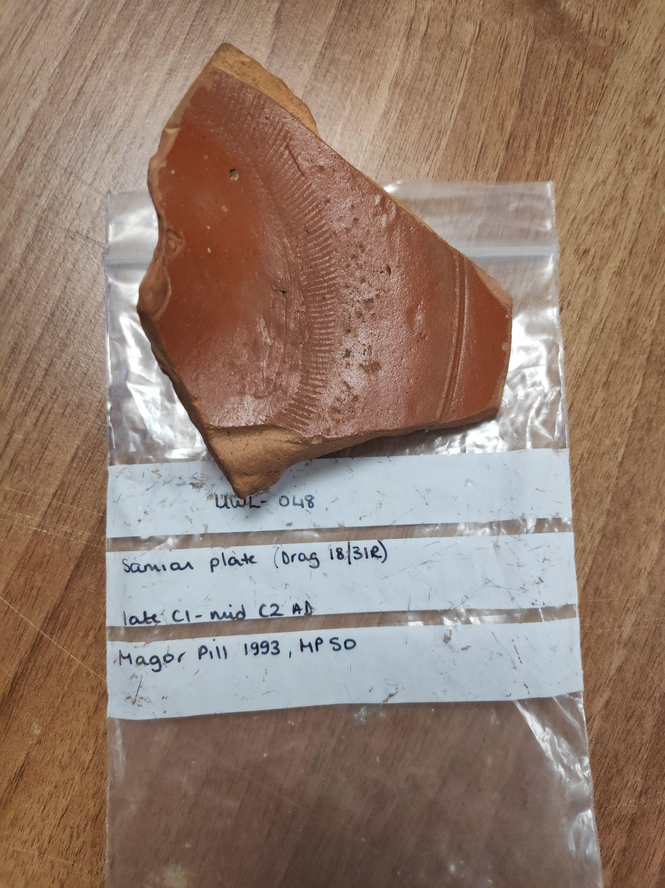
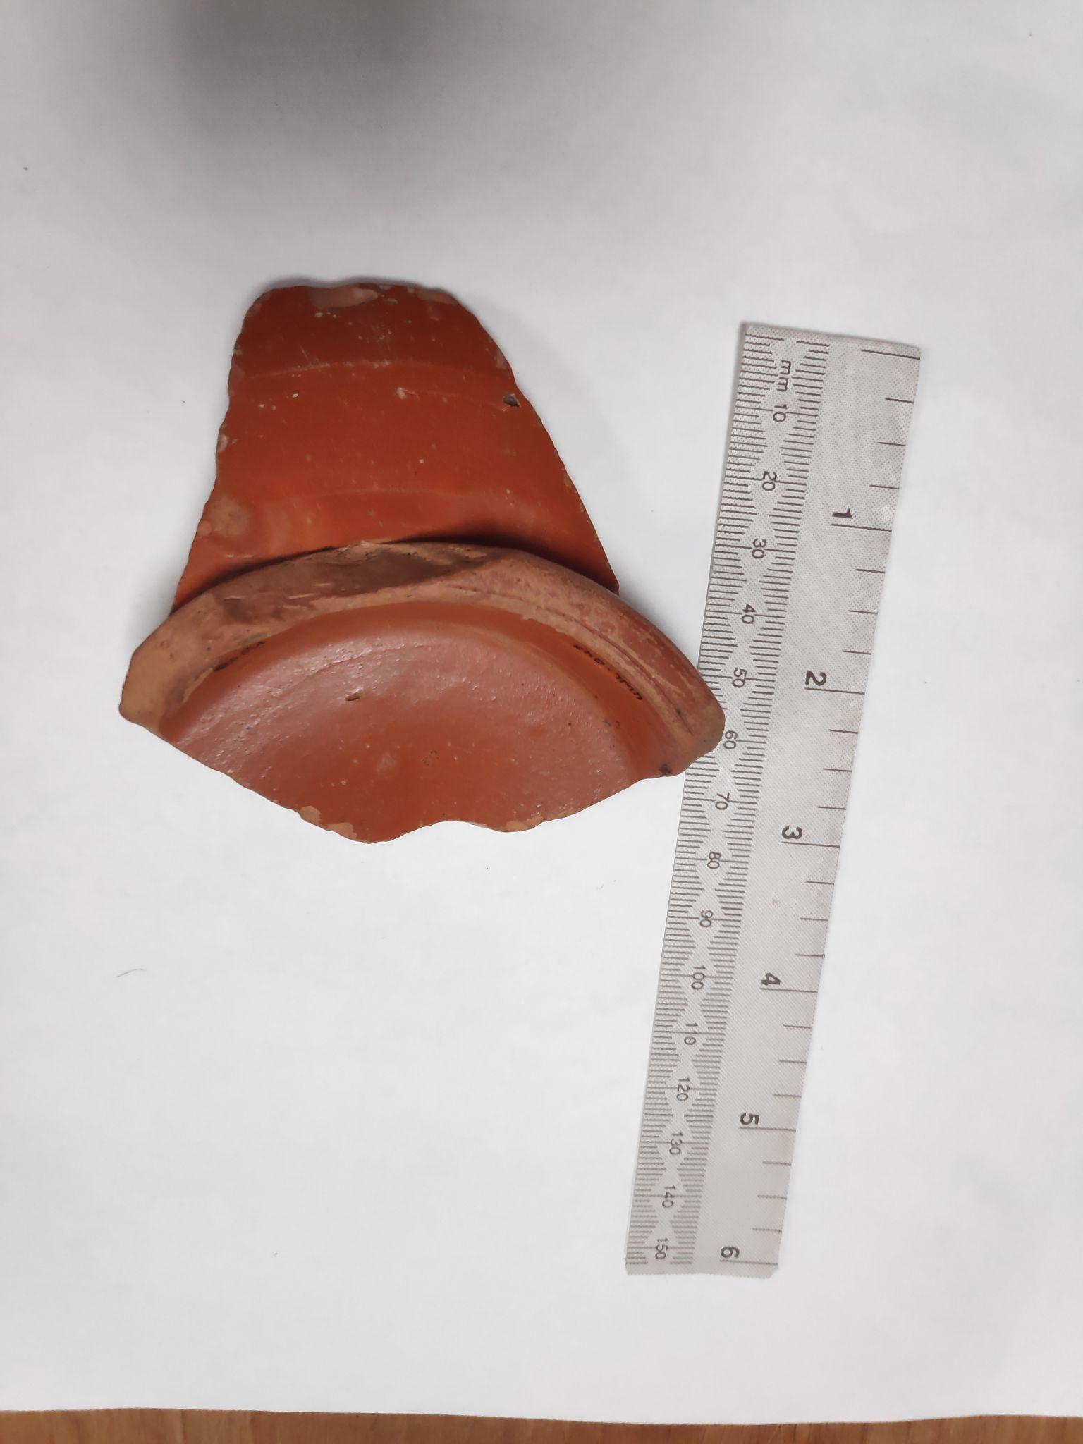
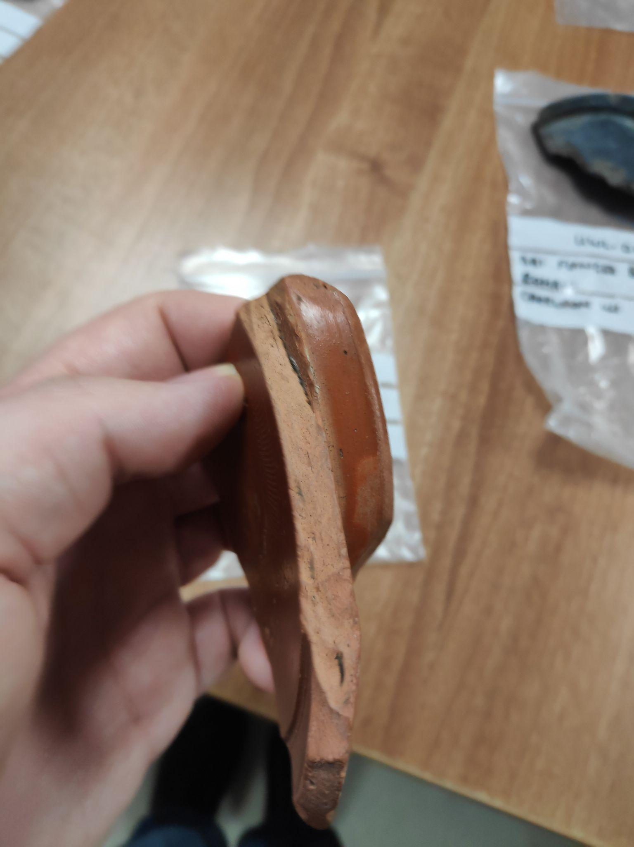
Under the care of the archaeology department at the Lampeter campus of University of Wales Trinity Saint David are a number of artefacts. One particular artefact is a Samian sherd of the form Dragendorff (Drag.) 18/31R (seen above). Typical of Samian ware, this piece is red with a glossy red slip, with a consistent lighter shade of red being exhibited throughout the inside of the material. Drag. 18/31R were shallow bowls (Tyers, 2014) and were typically larger than their Drag. 18/31 counterparts (Willis, 2005a). The ‘bowl shape’ can be easily imagined by looking at the base of the sherd, whereby the rim of the base can be seen. The bowl would have been approximately sixteen centimetre in diameter, however the exact dimensions of the bowl that this sherd would have been part of are not entirely apparent due to both the rim and the base shown in this sherd being deteriorated. Furthermore, the thickness of the bowl itself is approximately one centimetre, likewise the rim of the base is also approximately one centimetre.
Samian Plate at University of Wales Trinity Saint David, Lampeter (Morgan, 2024)
Base of sherd (Morgan, 2024)
Inside of Samian ware (Morgan, 2024)
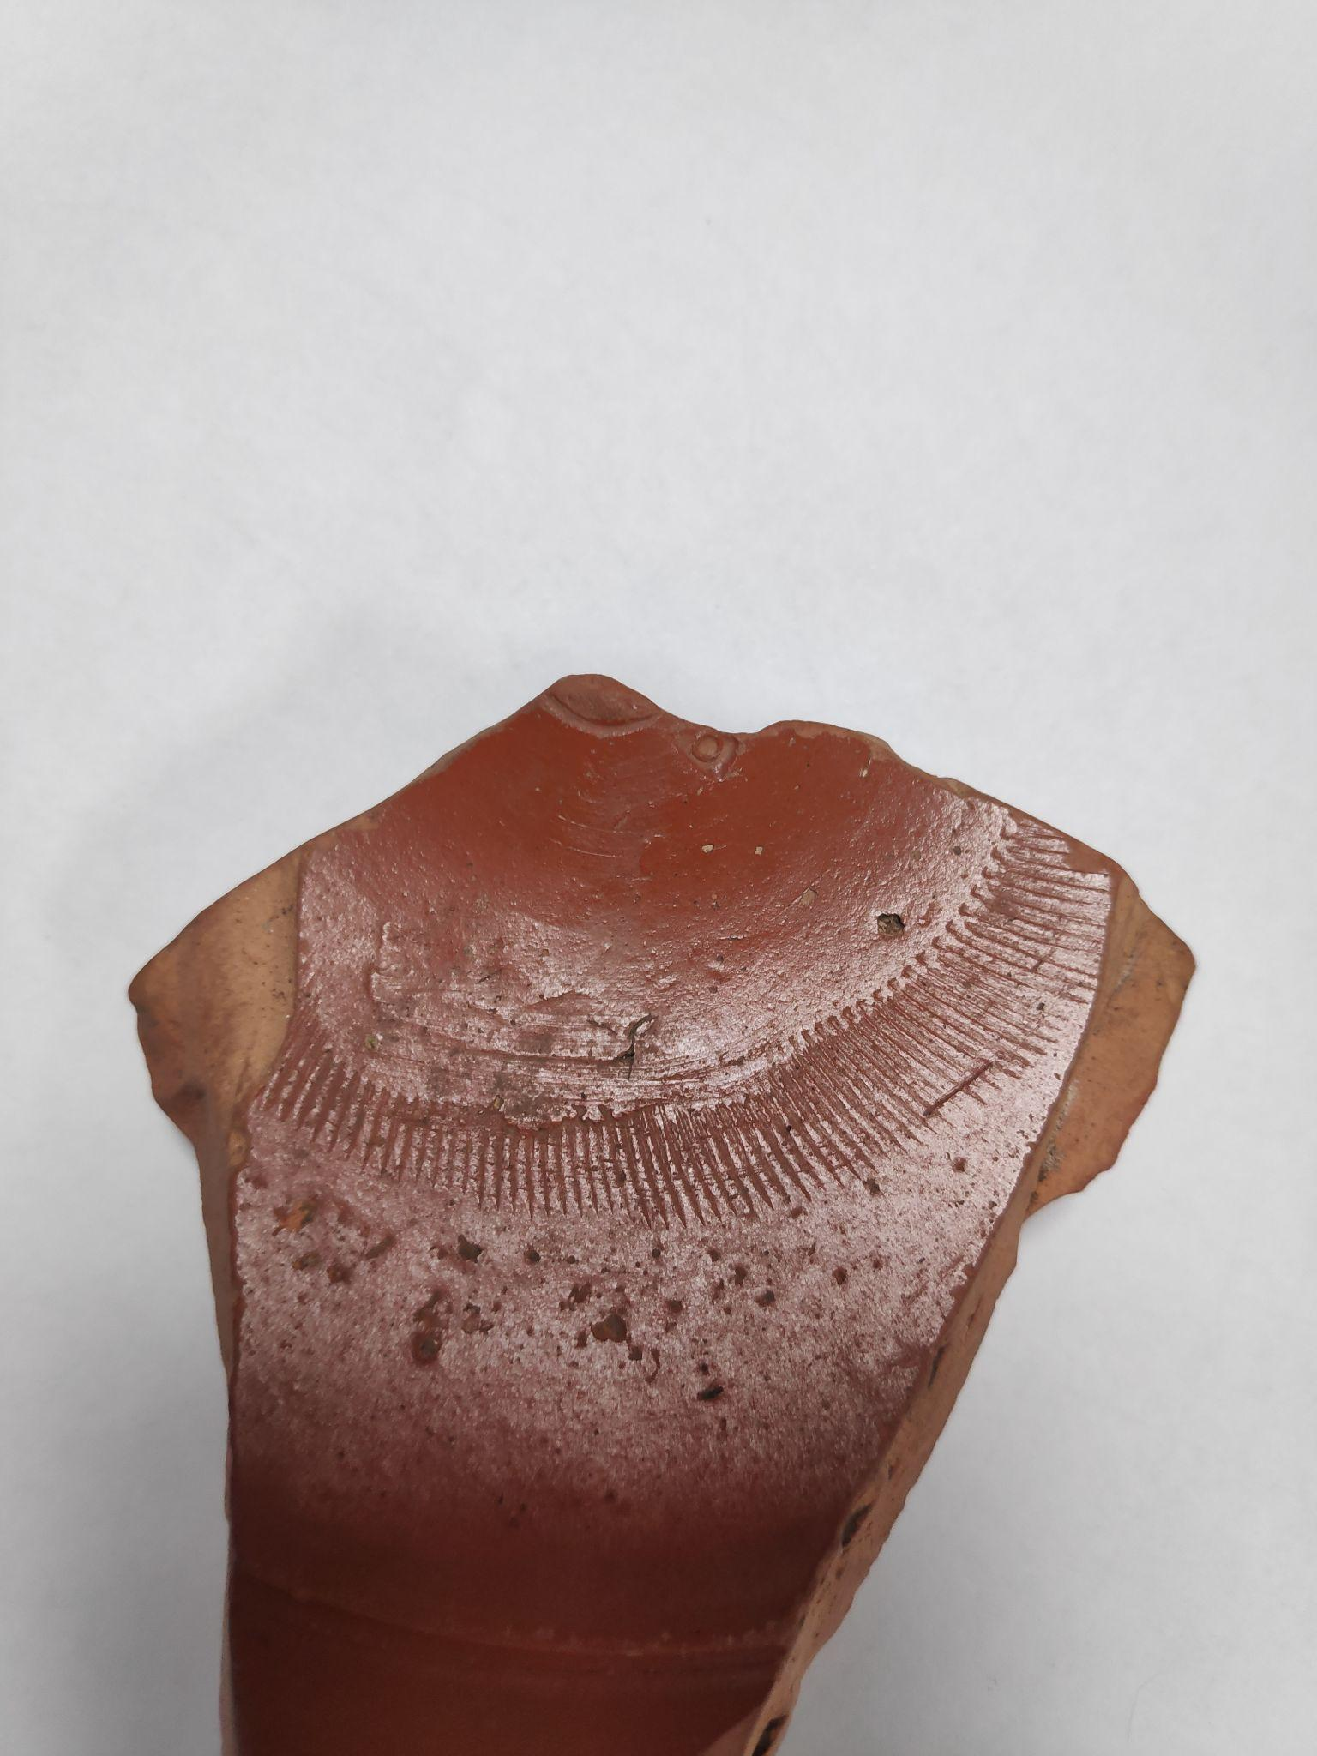
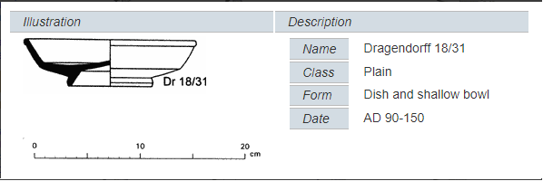
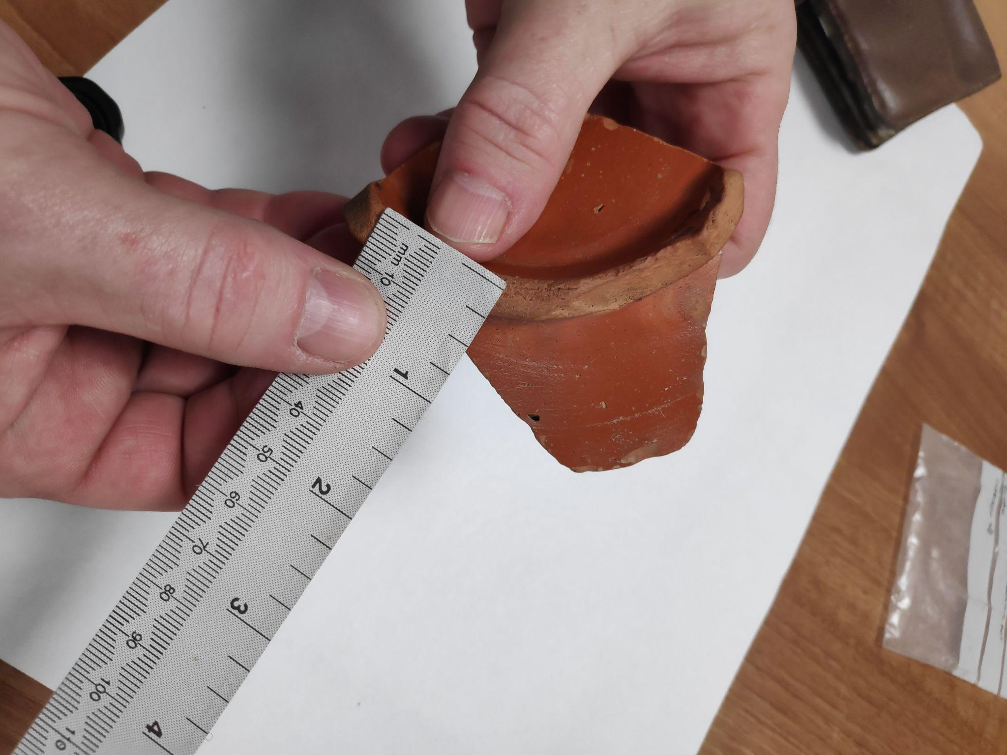
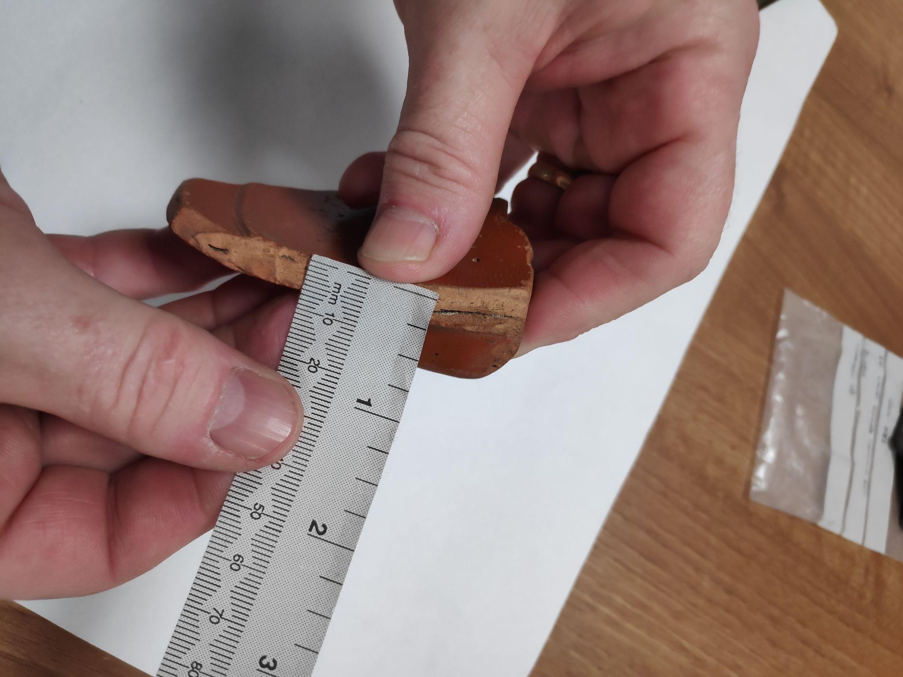
One of the more notable features of this sherd is its decoration and design. Samian ware can be either plain or decorated, with decorations typically consisting of embellished designs such as leaves, animals or abstractions (Roman Alcaster Museum, 2020). This sherd in has a particular design to it, one of a uniform abstract design of markings, which would have gone in a ring shape all the way around the inside of the bowl. This design was achieved through the use of a roulette, or put differently through the technique of rouletting. This involves using a roulette, a cylindrical texture tool to deboss the design into the surface of the bowl (Sunken Studio, 2022). This is also what the R in the Dragendorff 18/31R form name indicates, that it is a rouletted variant of Dragendorff 18/31 (Jareno et al., 2021, p. 4). Other ways of design in samian ware was achieved through debossing the design by hand or more typically through the use of a mould (Roman Alcaster Museum, 2020).
Decorations on sherd (Morgan, 2024)
Illustration and Description of Dragendorff 18/31, a smaller and less decorated variant of Dragendorff 18/31R. (Tyers, 2014)
Thickness of base (Morgan, 2024)
Thickness of bowl (Morgan, 2024)
This sherd was excavated at the site of Magor Pill in the Severn Estuary in Wales. This is a multiperiod site, whereby a large collection of both Romano-British and prehistoric finds has been found (Allen, 1998, p. 45). The material evidence gathered from this site shows that there was a flourishing later Roman settlement there, with evidence showcasing that occupation had existed there since Iron Age (ibid). Archaeological work had taken place at this site throughout the 1990s (ibid), and this particular sherd was excavated in 1993 according to the label that it is stored with. This piece would have been given to the university sometime after this for educational purposes.
Samian wares are widely distributed across the area that the Roman empire consumed and beyond, and due to its relatively high frequency they have been the focus of much study within archaeology and there has been much knowledge garnered on their typology and chronology (Willis, 2005b). It is quite apparent that Samian ware was considered different from usual wares of the same period and place for a number of reasons. Firstly, it is seen that Samian wares are repaired more often than other wares:

The fact that samian was more often repaired than other pottery types has been seen as an indicator that these vessels were particularly valued, and were repaired either because of their relatively high cost to replace or because broken samian might, in some localities, be difficult to physically replace.
(Willis, 2005c)

Another tendency that showcases the value of samian ware is that of graffiti. Evidence shows that there is a lower frequency of coarsewares that contain graffiti compared to samian ware, suggesting that the value of samian wares were greater and that there was a concern to mark ownership, showcasing its worth as a possession (Evans, 1987; Willis, 2005d).
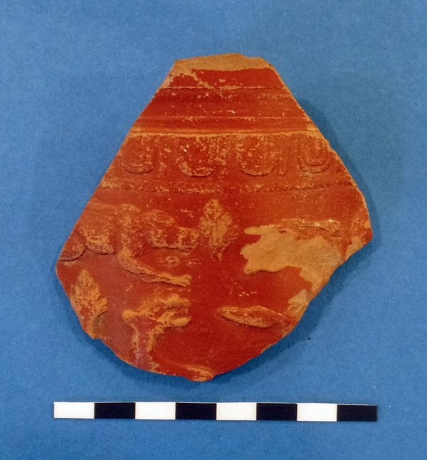
A more obvious sign of value is seen in the production of samian ware. Despite the scale of production of these wares, it is likely to have been a comparatively pricey commodity (Willis, 2005d). There is evidence of the cost of these wares, with there being a Drag. 37 samian ware having a graffito pricing it at 20 asses, to approximate equivalent of one day’s pay for a soldier, and another plate having a graffito pricing it at 12 asses (Darling, 1998, p. 169, cited in Willis, 2005d). Furthermore, there exists a correlation between the status of a site and the proportion of samian ware, with the higher status and more affluent areas containing more samian wares than what was typical (Willis, 2005d).
Sherd showcasing mythology (McNamee, 2023)
The manufacturing of samian pottery was also one that was evidently a skilled craft, with a strong knowledge of the procurement and the manipulation of raw materials. This includes the collection of fuel, water, potting clay and temper from a wide range of different deposits. Evidence also seems to indicate that potters preferred specific raw material sources, which can be seen in the occurrence of certain distinctive compositions (Borgers, 2015, p.68). Samian ware, like the one discussed in this essay, were often also decorated, as discussed before, which showcases another level of craftsmanship that went into the manufacturing of these wares. Not only were scenes of nature and abstraction decorated on these wares, but notably typical classical scenes from Roman mythology were not uncommon on these wares (McNamee, 2023). This is evidence that these wares had a cultural implication, and that its widespread distribution of these wares showcases evidence of a strong cultural identity that was strengthened through material culture such as these samian wares.
If samian ware was evidently of value to the people of its time, then this proposes the question of what was the function of samian ware? Samian pottery appears in many forms, in what we would define today as bowls, dishes, cups, etc. (Willis, 2005e). It is generally intuitively recognisable what each of these forms were used for, and mirror modern western uses for these items. Kiln site graffiti shows that these specific forms were designed for certain uses, establishing a relationship between producers and consumers (Willis, 2005e). At a general level, samian ware existed as prized tableware, with an intention to be used somewhat regularly for table functions in which they were socially visible as prizes (ibid). Due to the nature of them being prized, use in communal events was common. This is especially applicable to an artefact such as the Drag. 18/31R that is being examined in this object biography due to its size and the shift towards larger samian wares in later Roman periods (Hawthorne, 1997, p. 32).
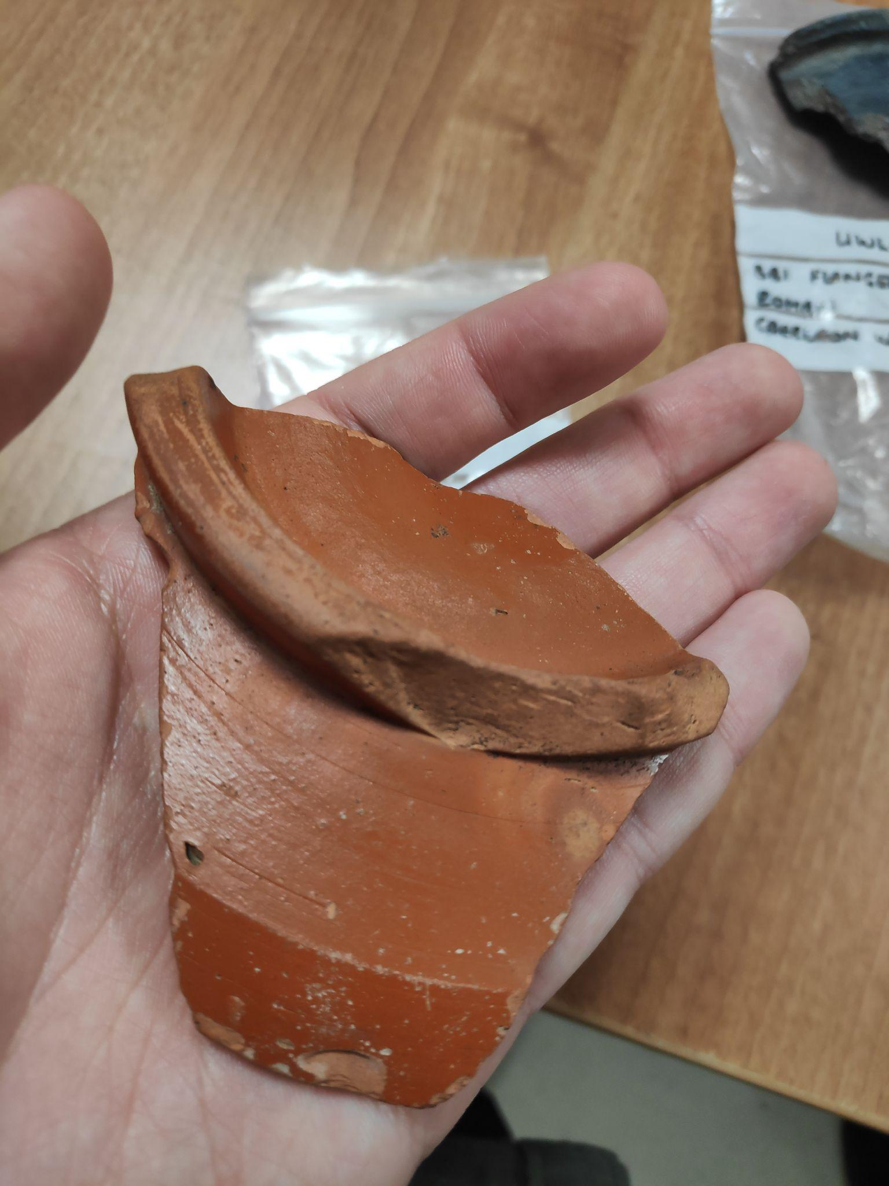
However, function is not linear nor is it permanent. Discussing this object through the concept of its’ chaines operatoire, it is important to describe and understand some of the main cultural transformations that this sherd of samian pottery has undergone (Sellet, 1993, p. 106). One such transformation is its use as an archaeological tool. Its wide distribution, together with the fact that many of the vessels are stamped with the name of the potter or factory that produced them, they are the most closely datable form of Roman pottery. This means that these wares are of crucial importance in dating sites by association, and the way in which they were made into distinct forms allows them to be susceptible to typological treatment (Wild, 2014). Forms changed over time, with only a proportion of samian form types being current in any one period (Willis, 2005e). This makes samian ware an extremely valuable tool in dating archaeological sites.
The object in the hand of a student (Morgan, 2024)
At the time of this essay being written, this object now exists as a form of education. As previously stated, it is now in the hands of University of Wales Trinity Saint David, where it is utilised as an artefact to teach students of archaeology as practical engagement. It has been utilised by a student to write this object biography, and to teach and engage in the idea of an object biography and to teach concepts such as chaine operatoire. This current state and current location are where it is most likely to stay, to teach into the future.
In conclusion, this sherd of pottery that belongs to the archaeology department of University of Wales Trinity Saint David is kept at the Lampeter department under the care of the archaeology department. It is a sherd from a samian ware bowl, of the type Dragendorff 18/31R. Its value has shifted from being that of a prized possession to that of abundance within the archaeological world. The function of the object has also changed over time, from having a functional use as simultaneously tableware and as a prized possession, to being an archaeological find, to being an object to be used to educate prospective archaeologists.

Bibliography

Allen, J. R. L. (1998) ‘Magor Pill Multiperiod Site: The Romano-British Pottery, and Status as a Port’, Archaeology in the Severn Estuary, 9, pp. 45-60.

Borgers, B. (2015) ‘Roman pottery production and the site of Vervoz, Belgium, between the mid-first century AD and the end of the second century AD.’, in Willis, S. (ed.) Journal of Roman Pottery Studies Volume 16, pp. 54-72. Oxford: Oxbow Books. Available at: http://www.jstor.org/stable/j.ctt19893qb.8 (Accessed on 27th of January 2024)

Evans, J. (1987) ‘Graffiti and the Evidence of Literacy and Pottery use in Roman Britain’, Archaeological Journal, 144(3), pp. 191-204. DOI: 10.1080/00665983.1987.11021199

Hawthorne, J. W. J. (1997) ‘Post Processual Economics: The Role of African Red Slip Ware Vessel Volume in Mediterranean’, in Meadows, K., Lemke, C., and Heron, J. (eds.) TRAC 96: Proceedings of the Sixth Annual Theoretical Roman Archaeology Conference, Sheffield 1996, pp. 29 - 37. Oxford: Oxbow Books.

Jareno, S. J. N., van Helden, D. P., Mirkes, E. and Tyukin, I. (2021) Learning from scarce information: using synthetic data to classify Roman fine ware pottery. Available at: https://www.researchgate.net/publication/353052409_Learning_from_scarce_information_using_synthetic_data_to_classify_Roman_fine_ware_pottery (Accessed on 26th of January 2024)

McNamee, L. (2023) From Lagore Crannog, Co. Meath. Available at: https://www.museum.ie/en-IE/Collections-Research/Collection/Documentation-Discoveries/Artefact/Roman-Samian-Ware/62d96a49-bcd6-48b3-947c-fbf231c5feae (Accessed on 27th of January 2024)

Morgan, M. (2024) Collection of Photographs of Samian Ware Drag. 18/31R. Unpublished.

Roman Alcaster Museum (2020) Roman Pottery Samian Ware. Available at: https://romanalcester.org/alcester-roman-museum-artefacts/roman-pottery-samian-ware/ (Accessed on 24th of January 2024)

Sellet, F. (1993) ‘Chaine Operatoire; The Concept and its Applications’, Lithic Technology, 18(1/2), pp. 106-112. Available at: https://www.jstor.org/stable/23272868 (Accessed on 27th of January 2024)

Sunken Studio (2022) Texture tools: Roulettes. Available at: https://www.sunkenstudio.co.uk/blog/2022/1/18/texture-tools-roulettes (Accessed on 26th of January 2024)

Tyers, P. A. (2014) TERRA SIGILLATA GALLERY - TYPOLOGY. Available at: https://potsherd.net/atlas/types/sigillata/gallery (Accessed on 24th of January 2024)

Willis, S. (2005a) ‘9.8 Interpreting samian forms in graves’ in ‘Samian Pottery, a Resource for the Study of Roman Britain and Beyond: the results of the English Heritage funded Samian Project. An e-monograph’ Internet Archaeology, 17. Available at: https://intarch.ac.uk/journal/issue17/1/9.8.html

Wild, F. (2014) ‘The history and importance of illustrating samian’ in Biddulph E. (ed.) Illustrating Samian Ware [no place]: Study Group for Roman Pottery.

Willis, S. (2005b) ‘1.1 Samian: definition, archaeological value and international significance’ in ‘Samian Pottery, a Resource for the Study of Roman Britain and Beyond: the results of the English Heritage funded Samian Project. An e-monograph’ Internet Archaeology, 17. Available at: https://intarch.ac.uk/journal/issue17/1/1.1.html

Willis, S. (2005c) ‘11.1 The repair of samian vessels’ in ‘Samian Pottery, a Resource for the Study of Roman Britain and Beyond: the results of the English Heritage funded Samian Project. An e-monograph’ Internet Archaeology, 17. Available at: https://intarch.ac.uk/journal/issue17/1/11.1_2.html

Willis, S, (2005d) ‘1.3 The status of samian ware in the Roman era’ in ‘Samian Pottery, a Resource for the Study of Roman Britain and Beyond: the results of the English Heritage funded Samian Project. An e-monograph’ Internet Archaeology, 17. Available at: https://intarch.ac.uk/journal/issue17/1/1.3.html

Willis, S, (2005e) ‘8.1 Introduction: samian forms and functional use’ in ‘Samian Pottery, a Resource for the Study of Roman Britain and Beyond: the results of the English Heritage funded Samian Project. An e-monograph’ Internet Archaeology, 17. Available at: https://intarch.ac.uk/journal/issue17/1/8.1.html

