Skills required for effective dynamic risk assessment
‘Risk management is a dynamic, ongoing process of evaluating the potential for risk and determining the best methods to address those risks” ~ Van Der Smissen 1990
After doing some research into the domino theory first realized by Heinrich and then later adapted by Meyer I feel as though I have gained a practical understanding of the skills required to perform an effective dynamic risk assessment.
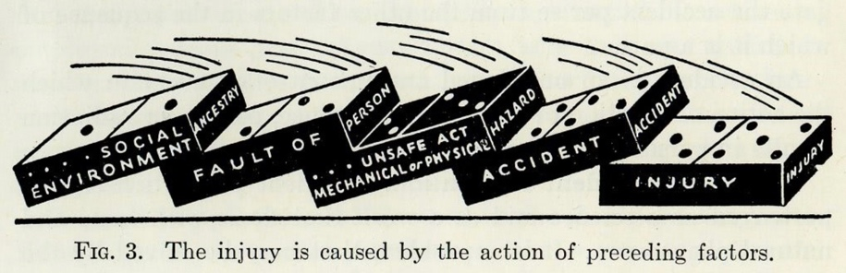
The first stage of the theory recognizes the environment in which the activity is taking place such as weather, conditions, food and rest, ideally as specialists in outdoor adventure we want to understand and in some regards have a certain amount of control over each stage or if you like “domino” and so the first step to make effective decisions would be to have an understanding of the environment in which you are operating.
Stage two comprises of defects of the person like lack of skill, knowledge etc... In this situation knowing the people or kind of people you are operating with either fellow outdoor leaders or clients would be essential to complete an effective dynamic risk assessment, knowing and understanding other’s strengths and weakness will allow you to make informed decisions that better impact the group.
Stage three refers to unsafe behaviors or conditions but by good knowledge, understanding and experience being applied to stage one and two we mitigate the potential for harm caused by stage three and in doing so hope to decrease the likelihood of reaching stage four and five, accident and injury.
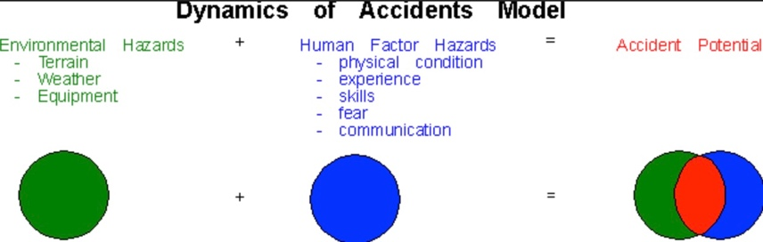

Having a well-developed understanding of both subjective and objective factors is essential to effective dynamic risk assessment, ensuring adequate preparation to properly mitigate the objective factors and hopefully limit the need for dynamic risk assessment and making effective decisions backed up by knowledge and experience will help to mitigate the subjective factors there by limiting the accident potential where the two overlap.
Site specific risk assessment
Date created: 20/02/26
Site name: Long strand Beach
Site Location: Castlefreke, Clonakilty, Co. Cork, P85 YD77, Ireland. /// sugared.fascination.mourns
Site type: Beach/Coastal area
Environmental conditions: Water, Sand, Dunes, Variable temperature, Variable tides, Variable wave conditions,
Accessibility: Parking at either of the beach accessible from a main road.
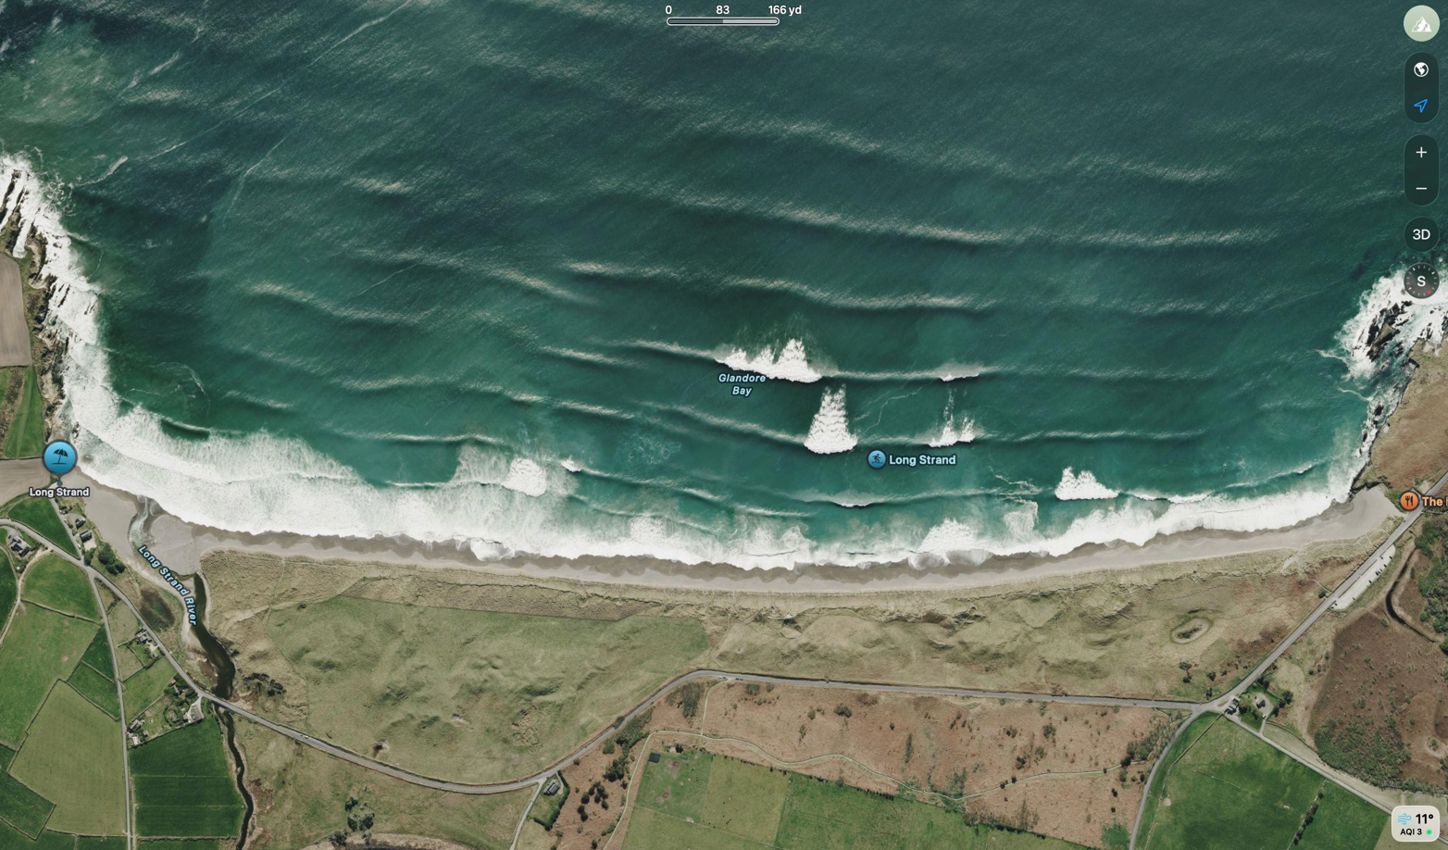
Lifeboat station: RNLI Union Hall Lifeboat Station
Lifeguarded: Yes
HAZARD | SEVERITY | LIKLIHOOD OF INJURY | CONTROL MEASURE | RISK AFTER CONTROL
 | 5/10 | 7/10  This beach has a steep drop which means the tides change rapidly especially on Spring tides. | Knowledge of local tides, see tide chart below | 2/10
 | 8/10 | 8/10  Beach goers may find themselves quickly out of their depth due to the steep decline. | See the beach at low tide and assess individual ability to cope with hazard | 4/10
 | 8/10 | 5/10  The water is cold year around and if staying in the water for longer periods a wetsuit is always recommended. Average summer temp: 14-19C. Average winter temp: 9-11C. | Wear a wetsuit. Monitor your body temperature. Always have dry clothes to change into after being in the water. | 2/10
 | 2/10 | 2/10  There is an outcrop of sharp rocks either side of the beach but in between it is mostly sand. | Stay away from sharp rocks. Don’t leave children unsupervised. | 1/10
 | 8/10 | 8/10  Long strand is known for its powerful rip currents and swimmers entering the water should be wary. | Be aware of the location of rip currents. Stay within your depth and aware of your surroundings. | 3/10
 | 8/10 | 6/10  Long strand is hit with big swells year-round and is known as a consistent beach break for surfing. Level: Intermediate-Advanced. | Don’t enter the water during big swells. Check the swell forecast. Always let some-one know if you are entering the water. Wear a buoyancy aid if necessary.

ALWAYS FOLLOW LIFEGUARD INSTRUCTION AND INFORM SOMEONE OF YOUR LOCATION.
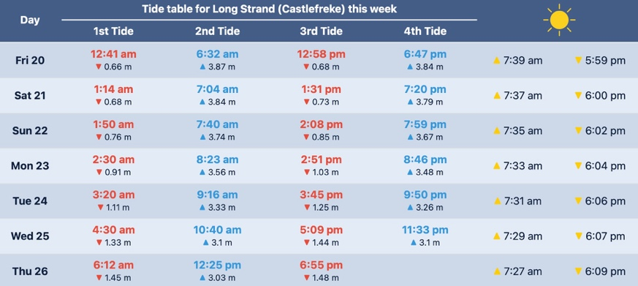
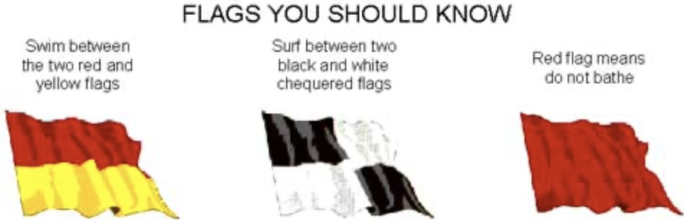

Risk and Benefit assessment (river swimming)

“Adventure sports involve a kind of interaction with the natural world that is not found in other sporting activities, and that the experience of such an interaction is valuable enough to justify the acceptance of the risks that accompany such activities” ~ Philosophy, Risk and Adventure Sports, edited by Mike McNamee, Routledge 2007

Hazard | Fast moving water | Rocks | Cold temperatures | Pollution | Riverbanks | Obstructions
Risk | Drowning | Injury | Cold Water Shock | Illness | Entrapment | Entrapment
Inclusion | Wast moving water was included as it is an essential element of river swimming and has the benefits of being fun, good for mental health and physical wellbeing and gaining experience in a variety of different water conditions. | Rocks are unavoidable aspect of river swimming. The opportunity to assess the river environment and avoid rocks there by gaining experience was a benefit. | The opportunity to learn about the different equipment used to mitigate the chance of cold-water shock was a valuable experience for everyone. | Pollution is an unavoidable factor when swimming in U.K rivers. (no benefit) | Learning to assess safe entry and exit points in a monitored environment allowed everyone the chance to gain experience in dynamic risk assessment so they would be better prepared for any future experiences/circumstance. | Some tree roots and similar obstruction were allowed in the river swim to gain experience navigating in the water.
Exclusion | Complex river features such as large hydraulics and fast rapids were excluding due to the overall ability level of the group in which the level of risk would have become unacceptable. |  |  |  | Areas of the river where there were no easily assessable entry/exit points were avoided, as was swimming in the river outside of its recommended water level due to the potential for serious harm/injury. | Major obstructions were avoided due to them causing an unacceptable level of risk.

Overall RISK VS BENEFIT
The risk involved for river swimming is rated moderate-severe. Control measures put in place helped to mitigate the level of risk to acceptable for each member of the group, the risks presents overall were balanced by the benefits of gaining valuable experience in the river environment that will help to mitigate future risks in a similar environment posed to any member of the group by attaining risk management and hazard identification skills.



RISK | SEVERITY BEFORE CONTROL | CONTROL MEASURE | SEVERITY AFTER CONTROL
Drowning | 8/10 | Buoyancy aids, wetsuits. Clear communication, pre identified exit points, throw lines and hazard identification. | 3/10
Injury | 6/10 | Clear instruction on how to avoid any hazards. PPE e.g. helmets. Instruction on proper technique and a warmup before entering the water. | 4/10
Cold water shock | 5/10 | Wear wetsuit and acclimatize beforehand. | 1/10
Illness | 5/10 | Choose a river that is known for safe paddle activities, seek local knowledge and wear earplugs. Be mindful not to swallow any water. | 2/10
Entrapment | 6/10 | Identify clear entry and exit points, have someone on standby at the designated exit point prepared to throw a line. Keep feet on the surface of the river and identify and obstruction that require avoidance before entering the water. | 4/10

RISK BENEFIT

Reflection on learning from this module in relation to your continued professional development within your chosen field of study.

Risk management wasn’t a topic I was initially excited to study but throughout the past weeks I have realized that there is more to risk assessments than long exhausting documents and this study has allowed me better to evaluate not only my decision-making process but also the reasons behind it.

Our understanding of risk is developed early on in our childhood, and some would argue that exposure to risk is essential to “character building, resilience and self-reliability”. ~ No Fear, Growing up in a risk adverse society, Tim Gill, Calouste Gulbenkian Foundation 2007. And for me it was no different, my up bringing no doubt has influenced my risk perception and tolerance, my study of risk management has tempered those influences into experience and understanding that I will carry into my career going forward.

Upon reflection this module also really made me think about the benefits of adventure sports, I have always partaken in these sports because I enjoy them and the associated lifestyle, so I didn’t have cause to consider the why’s.
There is the obvious benefits as regards to mental health, immersion in nature and fitness but I really wanted to understand the philosophy behind why we are drawn to the outdoors in search of adventure.
Extreme sports are a typical example of practical realization some might even say they express clearly and graphically the characteristics of current postmodern experience ~ (derived from adventure and philosophy)

Is it possible that adventure sports bring us closer to the ontology of human existence, that something about them, the experience, the thrill, the closeness with nature speaks to something inside us that is an integral part of the very core of our being? I can’t claim to have the answer to that but I do know that my search for the reason behind why we do what we do has given me a deeper understanding of adventure and also the people who choose to partake in it, which I hope will help me to become a better leader in the outdoors in which ever field I choose to pursue.

On a purely practical note the experience I gained in the form of dynamic risk assessments as well as legalities, regulations and national governing bodies will prove invaluable to my development as a lifeguard, fitness instructor and future employee of the outdoor industry and to my understanding of the adventure sector as a whole, I now feel confident in my ability to assess and manage risk and I will continue to work on my competency and currency in order to make myself as well rounded, successful and employable as possible.

References
Philosophy, Risk and Adventure Sports edited by Mike McNamee, Routledge 2007
No Fear, Growing up in a risk averse society, Tim Gill, Calouste Gulbenkian Foundation, 2007
Risk Management in Outdoor and Adventure Programs, Aram Attarian, 2012

I abhor the use of AI and do not use it in any of my assignments.

