BA International Hotel Management

Food & Beverage Operations

Module Code: BMIH4002
Student Name: Persima Barreto
Student ID: 2243324
Assignment 2 Menu Engineering (Practical Task)

Table of Contents
1. Brief Writing 3
2. Menu 5
References 7

1. Brief Writing
In the Swindon of the UK, one will find a restaurant called "Sabor de México", a hotel chain of Hotel Trinity, that serves up a menu that expertly combines traditional Mexican cuisine with innovative dishes. This restaurant idea is not only about eating; it's about showcasing the rich cultural fabric of Mexico via its cuisine. It caters to a clientele that varies from gastronomic explorers to those who want comfort in classic Mexican foods.
Locals and visitors alike who are looking for authentic Mexican cuisine are the intended customers. Sustainable eating is a priority for the restaurant, which hopes to attract foodies, explorers of other cultures, and eco-warriors. The "Sabor de México" menu, which draws off the work of Youssef and Spence (2021), aims to expose guests to a greater range of Mexican dining options while still paying homage to the country's culinary traditions and encouraging them to try new takes on old favourites.
The menu was designed to reduce food waste in an ethical and environmentally responsible way, using cues from Filimonau et al. (2021). The "Sabor de México" restaurant chain understands the need of minimising food waste, thus they've included food waste management measures into their business model.
Beginning with "Entradas" like "Sopa de Tortilla" and "Tostadas de Ceviche," two Mexican food mainstays, diners may peruse the menu. The variety of textures and flavours in these appetisers bode well for the rest of the dinner. In the next section, "Platos Principales," you'll find dishes like "Chile en Nogada" and "Carnes Asada" that demonstrate the range and sophistication of Mexican cuisine. The inclusion of these foods is in keeping with Rodriguez's (2022) assessment of the worldwide attraction with Mexican food, and it ensures that visitors will get as much cultural appreciation as they do for the food.
Vegan choices and nut-free meals are clearly labelled on the "Sabor de México" menu in response to consumers' growing interest in animal welfare and other ethical concerns. This consideration of food allergies and intolerances echoes Lawrence's (2019) discussion on the moral implications of our food choices and their impact on the environment.
Wines like "Valle de Guadalupe Cabernet Sauvignon" celebrate Mexican viticulture by showcasing local harvests and pairing well with hearty dishes. The carefully selected drinks complement the local flavour of the meal.
Finally, the restaurant's bright and colourful decor and welcoming atmosphere reflect the festivity of Mexican traditions, making "Sabor de México" a culinary destination that offers more than just a meal, promising an unforgettable cultural encounter, where each bite is a celebration of Mexico's gastronomic heritage.

2. Menu
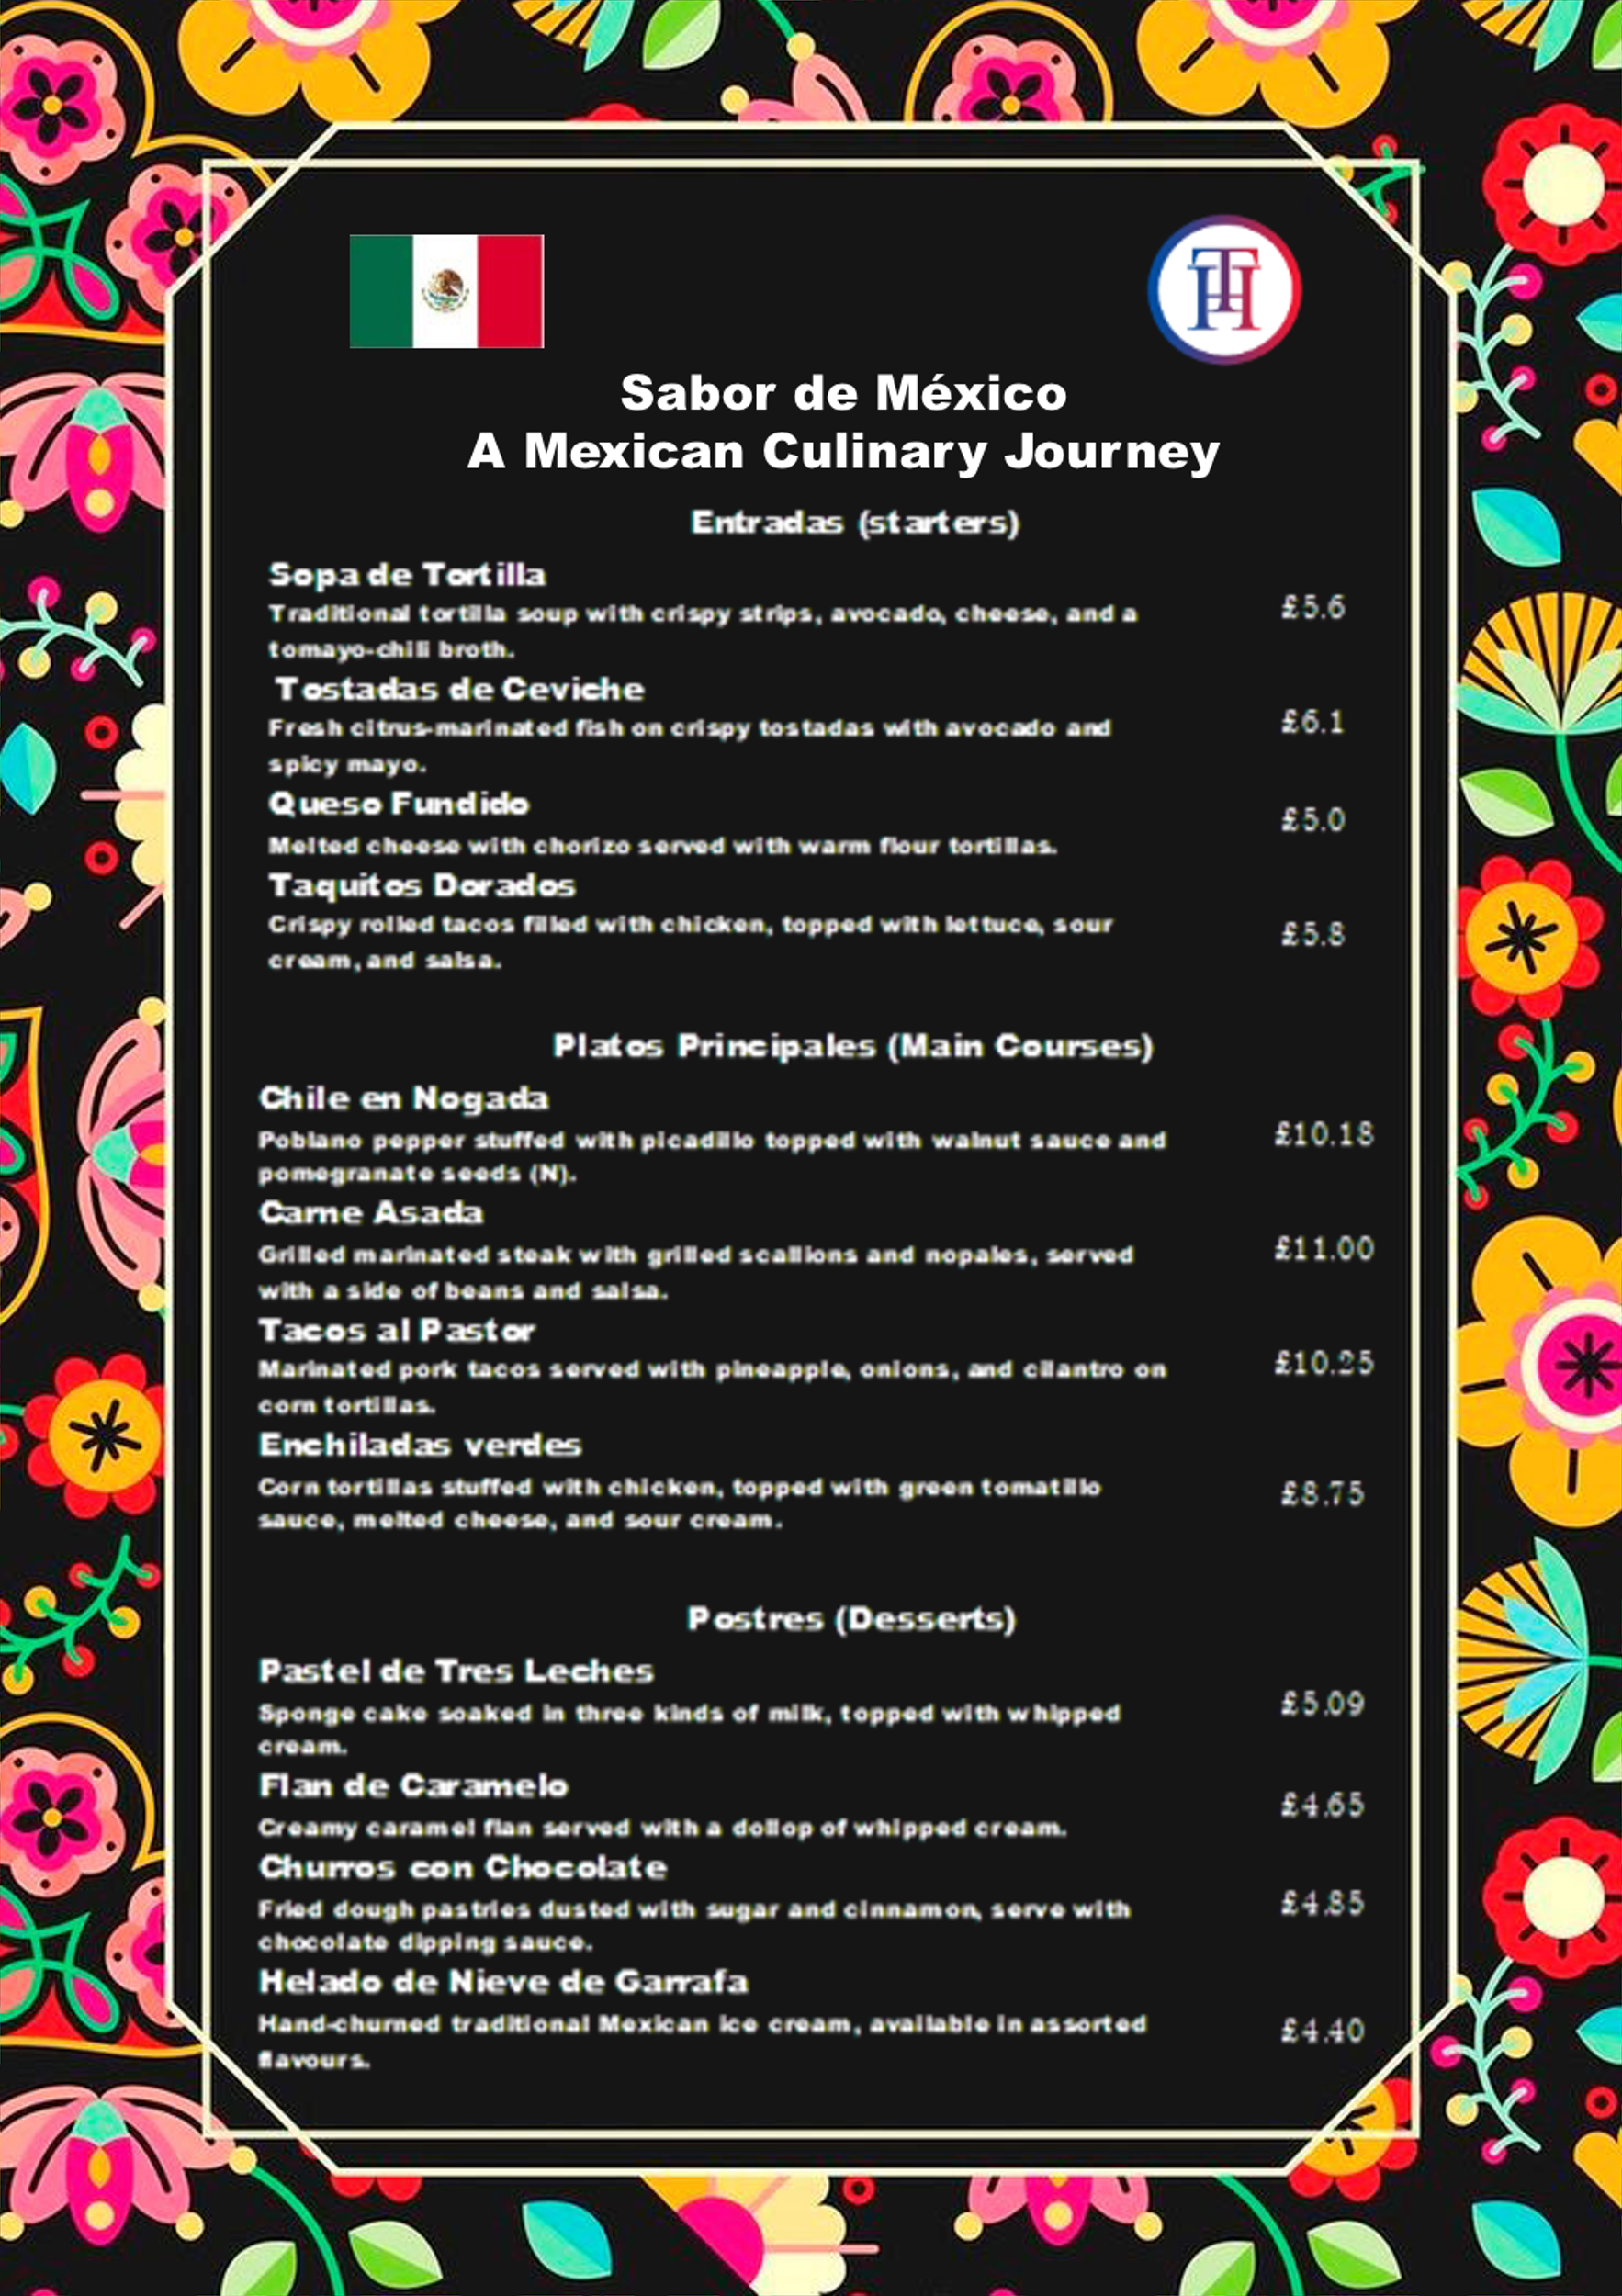
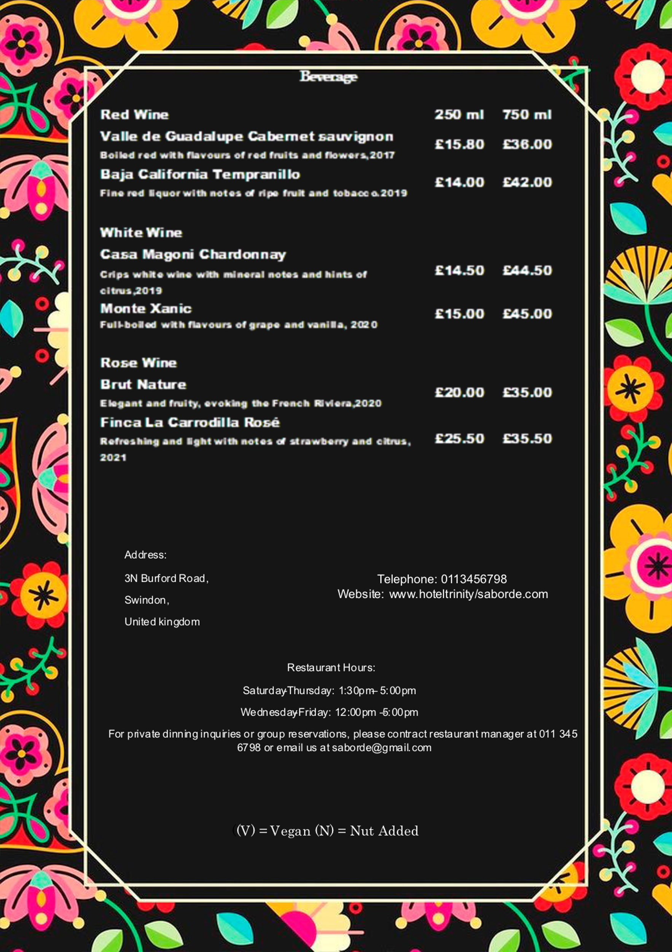

References
Fausto-Castro, L. et al. (2020) ‘Selection of food waste with low moisture and high protein content from Mexican restaurants as a supplement to swine feed’, Journal of Cleaner Production, 256.
Filimonau, V., Nghiem, V. N. and Wang, L. E. (2021) ‘Food waste management in ethnic food restaurants’, International Journal of Hospitality Management, 92.Lawrence, H. (2019) The Ethics of Eating: A Comparative Study of Sustainable. Austin, TX and London, UK. The Rice Examiner.
Rodriguez, E. T. (2022) In a country obsessed with Mexican food and culture, why do Mexican people not receive the same reverence?
Youssef, J. and Spence, C. (2021) ‘Introducing diners to the range of experiences in creative Mexican cuisine, including the consumption of insects’, International Journal of Gastronomy and Food Science, 25.

