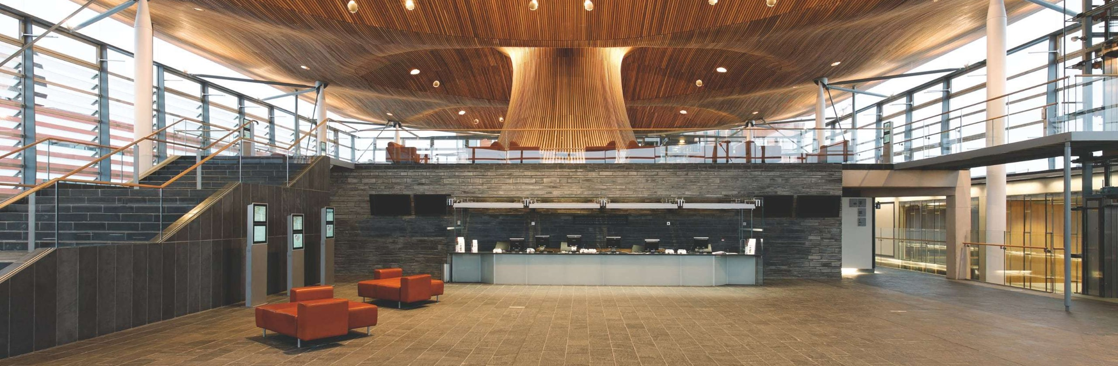  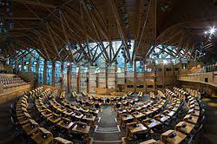  ALTERNATIVES TO TRADITIONAL Procurement  Dr. Deborah Hughes | UWTSD  Abigail Johnson (2114475)  Project Management

TABLE OF CONTENTS

The Senedd…………………………………………………………………………………………………………. 2

Holyrood……………………………………………………………………………………………………………… 6

Reasons for Holyrood’s Down Fall………………………………………………………………………… 7

Recommendations for Holyrood……………………………………………………….………………… 7

Bibliography………………………………………………………………………………………………………… 8

THE SENEDD

The construction industry has a reputation for poor quality service delivery, late and over budget projects. Often the UK construction industry chooses lower cost of procurement at the expense of quality which needs to stop.

This will be an investigation into the procurement route, tendering process, and contractual arrangements of two parliament buildings, the Welsh parliament building called the Senedd and the Scottish parliament building called Holyrood. Also based on the outcome of both projects a discussion if had there been a different approach taken in both projects if better results would have ben produced.

The Senedd shown in figure 1, is in Cardiff the capital of Wales it is considered an iconic landmark that was designed by Lord Richard Rogers and Ivan Harbour to have a 100-year lifetime. The Senedd a 5000 (m2) area building was officially opened in 2006 on St. David’s Day (1st March). The design of the building leaned heavily towards sustainability by minimizing the consumption of waste of energy and water and the design also leans to using indigenous materials such as the Welsh slate used in construction. (Senedd Cymru Welsh Parliament, 2001)

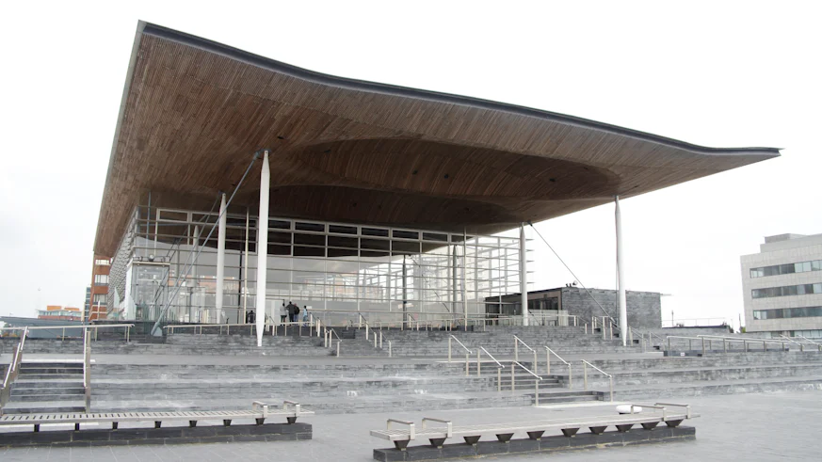
Figure 1 shows an image of the Welsh parliament building known as the Senedd. (senedd.wales, 2022.)

Competitive tendering was used to attain architects to do the initial drawings and plans for the Senedd, in the form of an international design competition held under the Royal institute for British Architects (RIBA) with a twelve million budget. After a shortlist of six architects was perused, it was decided that Richard Rogers Partnership now known as RSHP had won the tender and their design was submitted to the secretary of state. (SENEDD WALES, 2020) However the use of competitive tendering to decide on the contractor when retendering was being done had a very disappointing response from the market because only two companies responded: Taylor Woodrow and David McLean, also David Mclean did not meet one of the requirements that was given by the assembly government so Taylor Woodrow automictically won the contract, David Mclean served as substitute in the event that Taylor refused to agree to a fixed price contract. (Audit Committee, 2008)

The reason for the retender was because the project was halted in 2001 because the initial project cost was between £12 million and £17 million however as the project progressed the estimated prices increased, by the time the project as halted the end cost was estimated to be between £37 million and £47 million. When the new contractor Taylor Woodrow took over the new cost moved to £66 million however, in the end the project’s full cost was £70 million.

The purpose of tendering is to find the best goods/services for your money but when using competitive it then gives everyone a chance to bid in this case it was an international competition which allowed organizations not only from Wales or the UK to partake, however RSHP is a British company. It also gives you a better value for your money and improves efficiency, because companies are competing to get the contract so they will put forward their best designs, work, and price to get it.

The decision taken to halt the project was a very smart one, this allowed for retendering and change in procurement route along with other changes because there was a lot of disagreements between Richard Rogers Partnership and the Welsh Assembly. Cost certainty was a very important factor so when the assembly realised this was not going according to plan, and cost certainty became non-existent it was halted.

When the project was halted in 2001 not only was the tendering changed but the procurement route was also changed. The project restarted using a design and build procurement route, this decision was made to increase cost certainty and to ensure the project is on time. As mentioned above the project encountered problems as it relates to cost, so a different route was taken (design and build) to negate the issue. Design and build was chosen because it can fast track a project seeing that the project was already halted for roughly a year and the design phase took some time it was a vary smart decision. Design and build mesh well with the tendering process being a competitive one and this route transfers some risk from the client to the contractor. By using this route, the contractors must make an early commitment to a maximum price which in this case was needed. Design and build allow for there to be great communication between client, designer, and contractor this makes construction phase easier if any changes need to be made it can be done quite smoothly. Quality is also kept at a good standard due to the interactions between parties they will all have a say in materials and any other factors that help improve quality. It should also be noted that once all parties establish good communication it is easy to work out any problems and issues that arise. After the restart of the project changes where easily made as well as problems easily delt with without any long and tedious process. When it was noted that cost has become a problem all efforts were made to rectify and keep wit in the time frame the project was expected to end.

The project used a lump sum contact or fixed price contract (GC works 1) which is a contract primarily used for government projects but can also be used for private sector projects, therefore this particular contract was chosen for this government project. However, it should be noted that this form of contract is not very collaborative at all, though this was in fact that contract in play it was never really resorted to. A lot of time and money was wasted to get the contract that was not used. This only works once all parties and organisations involved agree to be collaborative and a level of trust must be given to each party involved. This also worked well because from the restart in 2002 it was decided on that it will be a collaborative project had it been any later it might have been too late and would not have worked as well as it did. Working collaboratively saved time because when issues arose parties did not resort to the contract and follow as the guidelines stipulate for certain problems that had a simple discussion between each other and found a way to fix or get around the problem. As mentioned before trust plays a very important role in this, track record and creditability as well. If a contractor is known for getting the project done on time, within the price range and of the quality needed more trust will be given and working collaboratively with them will be easier on the client’s side. It takes persuasion to get the clients on board but once they are shown the benefits of leading the project in a collaborative way, they will most likely be on board. However, this cannot be done with just anyone, different persons have different drives it is up to all parties, especially the client of main contractor to figure out what that is for each person and find a common ground that will work. Once the completion of the project on time and within the price range and to the quality expected is everyone’s primary goal thought there might be others everything should go smooth.

This project did not start of well in 1998 the best decision made throughout the entire project was to halt it and start again from scratch. Changing to a fixed coast design and build route is the reason the project was on time and within price range. What added to the procurement route used and tendering was the fact that the contract was entirely ignored, and they made the choice of being collaborative by giving each other a level of trust in both themselves and their capabilities this trust. The reputations of the companies and people involved in the project can either increase or decrease the level of trust that will be given as well as previous projects and their outcome base on their input. Had there be no trust being collaborative would not have been possible and turned out as well, when using trust in this aspect we are trusting that no party will partake in any foul play, withholding important information or being greedy. The goal of each party is to see to the completing of the project both on time and within the cot and at a good quality. This project is a very good example of combating all risks associated with construction: time, cost and quality and show us that taking a break and restarting may be a better option that continuing had they continued instead of stopping in 2001 the project would have been over budget and the deadline for the project would not have been met. The fact that the estimates were done long ago prices for materials and services went up so by the time they were bought and used this will add to the cost of construction, so testing cost against open market and using the contractors established supply chain help to add cost certainty. Though this project had a rocky start it managed to win numerous awards such as: 2007 Civic Trust Award, 2007 Chicago Athenaeum International award, 2006 RIBA National Award, 2006 RIBA Stirling Prize Building of the Year shortlist which are awards given to buildings to recognize the great architecture, planning and design put into the winning project. Apart from this project start this was a well-executed project and the awards show such along with it being on time and within cost and good quality the procurement route and tendering choice were well made and worked for this project and the only recommendation to be made is that the procurement routes and tendering styles should have been adapted from the start instead of having to halt and restart the project.

HOLYROOD

The Scottish Parliament building known as ‘Holyrood’ it is the second building we will be investigating more specifically procurement and tendering, and contractual agreements involved in its construction.

Holyrood is found in Scotland’s capital of Edinburgh, the project started in 1998 and was completed in 2004 however its due date was July 2001, an image of Holyrood is shown in figure 2. This project is known for being very late and over budget, the original cost estimate was between £40 to £50 million the end cost of the project was £414 million which is 10 times over budget by its completion. (Macnab, 2019)

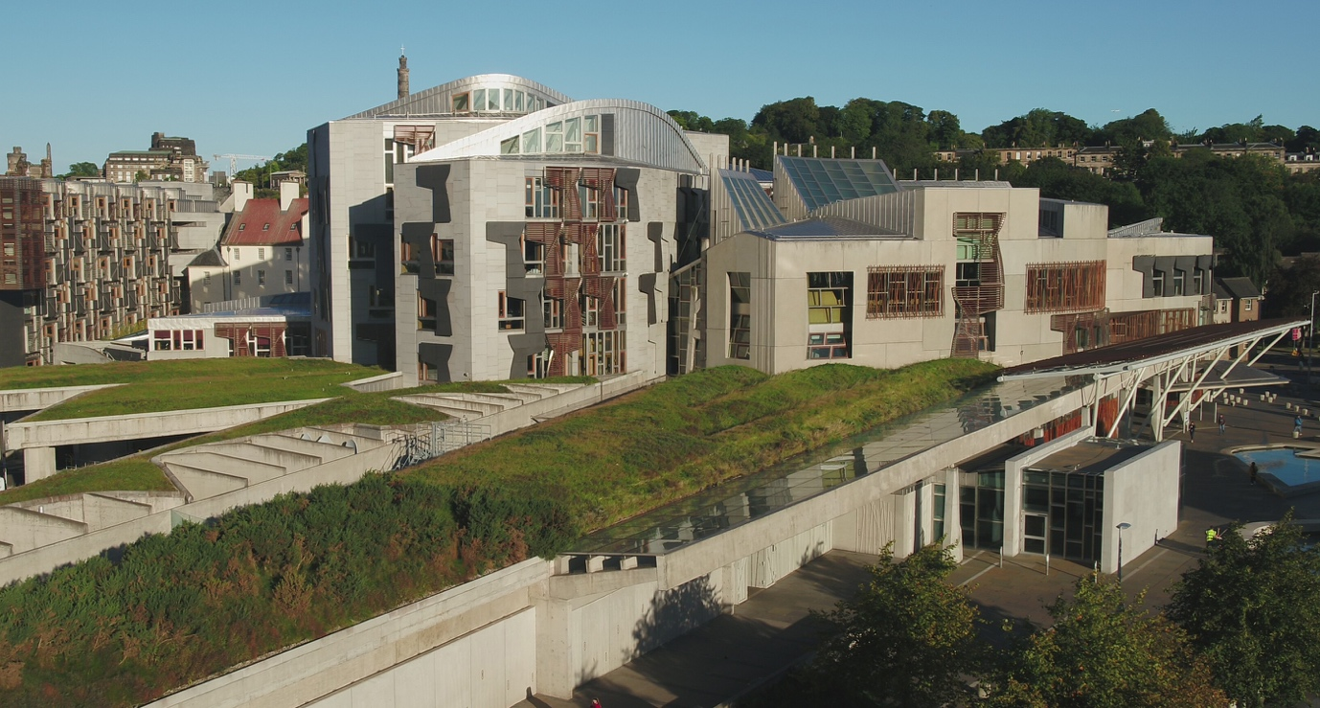
Figure 2 showing an image of the Scottish Parliament building known as ‘Holyrood’ (Scottish Parliament, 2019)

Holyrood used construction management as the procurement route, this decision to use this route had a lot to do with the project’s outcome. By using construction management almost all the risk lies with the client, it is known as a route that allows the project to be fast tracked because the design, tendering and construction phase can overlap unlike in traditional route most of the design must be completed first before work is put out to tender. Using this route will also allow for there to be changes made late in the project which did happen in the case of Holyrood where there needed to be and expansion to accommodate additional staff this happened late in the project and impacted the cost severely. This route is very complex as not one main contractor is hired by the client and he does all the work, but the work is split up into chunks (trade packages) and different tenders are put out for subcontractors to tender in Holyrood there was around 60 trade packages to tender to, leaving the client in control of the overall project. (Rt Hon Lord Fraser of Carmyllie QC, 2004) The complexity of this route requires good communication between everyone and if they are not communicating and collaborating everything will go south which it did. Though there are sub-contractors there is no main contractor it should be noted that the construction manager is more of an advisor and does not operate as a main contractor. This route is not the best suited route if cost certainty or a fixed price is needed because this route does not give that, this route was still relatively new and there was no source of proper guidance available yet when it came to using this route, they basically went in blind.
For this method to work for Holyrood there was no proper strategy planning going into the project into the method that where planning on using. After having the plans changed to accommodate more staff the architect of the building Enric Miralles died 4 years into the project who was found through an international design competition he is a Spanish architect. The cost of Holyrood went up gradually when the cost got up to £109 million Members of the Scottish Parliament (MSP) voted for it to continue this project was almost squashed. (Rt Hon Lord Fraser of Carmyllie QC, 2004)

REASONS HOLYROOD’S DOWN FALL

The procurement method used construction management should not have been used in the first place because this does no give cost certainty. Had there been proper investigation put into choosing the appropriate route for this project this should not have been chosen. This route also has no main contractor but many sub-contractors who the client directly deals with this can cause chaos depending on how many different sub-contractors are tendered for and this will have to be done throughout the construction phase rather than the client getting one main contractor and he controls everything and then bring the relevant information to the client. Thanks to this route you are allowed to make changes during the project there were over 10,000 changes all these changes of course will add to cost, one of which was a 47% increase in size of the building. (Audit Scotland, 2004) Also, because you can begin construction before the design is finished the cost given initially will not be accurate.

The design of the building was the original design was not as complex as the result, and the tight deadlines did not make completing them any better actually made them worse; they left no room time running over. This was also true for the initial cost estimate it left no room for slippage which will carry up the cost. Design issues were changed whilst the project was in its construction phase thus adding again to cost. These design changes include increasing the size of the building.

RECOMMENDATIONS FOR HOLYROOD

In hindsight the main problem for this project was the chosen procurement route, along with the complexity of the design and tight timetable. These along with more are the causes for this projects overly expensive, and late project. Design and build procurement route would have been a better fit for this project giving it the speed needed to construct and flexibility and giving some of the risk to the contractor instead of the client taking all the risks along with still giving cost certainty. As well as with all parties working collaboratively and communicating well with each other. This project should have been halted like the Senedd was and change the tendering and procurement route and start again this would have positively changed the outcome of the project.

BIBLIOGRAPHY

- Audit Committee (2008). The Senedd Committee Report.
- Audit Scotland (2004). Management of the Holyrood Building Project.
- Macnab, S. (2019). Scottish Parliament at 20: £414m, endless recrimination, and finally, an iconic building. [online] www.scotsman.com. Available at: https://www.scotsman.com/news/scottish-news/scottish-parliament-20-ps414m-endless-recrimination-and-finally-iconic-building-1418185.
- RSHP (2007). Senedd Cymru, Welsh Parliament – Civic – Projects – RSHP. [online] rshp.com. Available at: https://rshp.com/projects/civic/senedd-cymru-welsh-parliament/.
- Rt Hon Lord Fraser of Carmyllie QC (2004). The Holyrood Inquiry.
- Scottish Parliament (2019). Home. [online] www.parliament.scot. Available at: https://www.parliament.scot/.
- Senedd Cymru Welsh Parliament (2001). The Senedd - A Landmark Building. [online] senedd.wales. Available at: https://senedd.wales/visit/our-estate/the-senedd-a-landmark-building/.
- SENEDD WALES (2020). Senedd Building History 1998-2001 - Design Stage. [online] senedd.wales. Available at: https://senedd.wales/visit/our-estate/senedd-at-15/senedd-building-history-1998-2001-design-stage/.
- Senedd Wales (2022). Senedd. [online] senedd.wales. Available at: https://senedd.wales/visit/our-estate/senedd/.

