

Mixed Mode Parallelism – Programmatic Elicitation of Optimal Combinations of Parallelism Method(s)

by
William Baker

Supervisor: Tim Bashford
Second Marker: Gordon Dickers

Project submitted as part of the requirements for the award of BSc (Hons) Software Engineering

May 2020

DECLARATION

I, William Henry Baker that I am the sole author of this project; that all references cited have been consulted; that I have conducted all work of which this is a record, and that the finished work lies within the prescribed word limits.

This work has not previously been accepted as part of any other degree submission.

Signed: William Baker

Date: 19/05/2020

FORM OF CONSENT

I, William Henry Baker hereby consent that my project, submitted in candidature for the B.Sc. (Hons) Software Engineering degree, if successful, may be made available for inter-library loan or photocopying (subject to the law of copyright), and that the title and abstract may be made available to outside organisations.

Signed: William Baker

Abstract

Parallelisation is an incredibly useful but underused programming method; it can bring massive performance gains to software. Modern computers often have more than a single a core, and generally have a GPU (Graphics Processing Unit), which are almost always underutilised in modern software. This means the graphics card and many cores of the CPU (Central Processing Unit) sit idly by while a single core on the CPU runs the whole application, leaving a large amount of the potential performance of the computer wasted. This paper takes a look into what can be done about this waste, and how developers can efficiently parallelise their code and make the most of the processing capabilities of the computer. The findings show that when utilised correctly, parallelisation can improve the performance of particular algorithms ten-fold. The results also go against parallelisation, showing that when not utilised under the right circumstances, it can have an equal effect in the opposite direction, decreasing the performance of the algorithm significantly. A balance needs to be found between the right parallel methods, which algorithms should utilise them, and at what point do they become useful and increase performance.

Contents
Abstract 4
1. Introduction 6
2. Research and Review of Literature 8
2.2. Methods of Parallelism 8
2.2.1. GPGPU (General Purpose Graphics Processing Unit) 9
2.2.2. Multithreading 10
2.2.3. Cluster Processing 11
2.3. Programming Languages 12
2.4. Code Analysis 13
2.4. Conclusion 14
3. Research and Development Methodology 15
3.1. Research Methodology 15
3.1.1. Research Philosophy 16
3.1.2. Research Approach 16
3.1.3. Research Strategy 16
3.1.4. Time Horizon 17
3.1.5. Data Collection Methods / Analysis 17
3.2. Development Methodology 17
3.2.1. Agile Development Methodology 17
3.2.2. Software and Language Choices 18
3.2.3. Hardware 18
3.3. Conclusion 19
4. Design and Implementation 19
4.1. Requirements 19
4.2. Design 20
4.2.1. Chosen Parallel Methods 20
4.2.2. Programming Language 20
4.2.3. Algorithm Tests 21
4.2.4. Code Analysis 22
4.3. Implementation 23
4.3.1. Matrix Multiplication 23
4.3.2. Linear Search 27
4.3.3. Code Analysis 29
4.4. Conclusion 30
5. Evaluation 30
6. Conclusions and Recommendations 32
6.1. Suggestions for Further Work 33
7. Reflection 34
References 36
Appendices 37
Appendix A 37
Appendix B 39

Introduction

Modern computers are increasing their CPU (Central Processing Unit) core counts and graphics capabilities on a humungous scale. Despite the new power capabilities of modern hardware and their vast parallel capabilities, much of modern software is still incredibly linear and is mostly incapable of taking advantages of these new performance increases. More development needs to be put into the creation of parallel software. This aim of this project is to develop a program that can automatically detect and apply an optimal combination of parallel methods to a given program. One of the main objectives of the project is for the software to be able to automatically analyse a given section of code and decide on an appropriate parallel computing method to apply. From there, the next main objective is for it to be actually able to apply that method, without any user or developer input. Initially, some research and development must be carried out to decide which parallel methods are suitable for which algorithm, and how they can be applied. Too much processing power on modern computers goes unutilised; this project aims to take a look how that can be reduced by taking a deep looking into an optimal combination of parallel methods – methods that can be used in conjunction with each other, within the same application to provide the optimal run time. The use of automated parallelisation could help parallelise much of the existing software on the market but to do so, the implementation needs to be stable, and not introduce bugs.
There are a number of different options and factors that could potentially increase the performance of the application, a number of design choices will depend on the result of the research, such as the programming language to use and the structure of the application. There are a large number of known algorithms that are often labelled as "embarrassingly parallel", meaning that they are so easily parallelised, and run so well under parallelisation that it is embarrassing for them not to be. It is common for developers to not even parallelise these algorithms, despite the performance increase that could be achieved. This is often down to the fact it can be time-consuming to parallelise an algorithm, and can often introduce bugs into the code, meaning developers often just leave them running linearly.
The following chapter will take a look into the research of parallel methods that will have to be carried out, including which are useful for different algorithms and how they can be implemented. It will also cover the differences in programming languages, their performance, and their ease of use. It will also cover code analysis; how a given piece of code can be analysed to decide on an effective and appropriate parallel computing method for that algorithm, to increase the performance. Lastly, the method of applying the parallel method with be discussed, how it can be done and what the best options are, whether it be at pre-compile or run-time. A brief overview of how parallel methods could be automatically applied to a given piece of code will also be included.
The next chapter will take a delve into the research and development methodologies chosen for the project, and more importantly, why they were chosen to be used within the project. It will look into the advantages these methods provide to the project, and on the other end, any disadvantages it provides to the project, and how they will be worked around. The development methodology will also cover any choices made for the development of the project, such as software choices, hardware requirements, and any tools required to carry out the development.
From there, the report will have a chapter containing details about the design and implementation of the project. This includes the design choices of the application, how the program was structured, and why certain choices were made to be used in the development of the application. The implementation section will cover how these design choices were used in the actual implementation of the application, which tools and techniques were used, and any problems that were encountered. The chapter will also contain the main results of each test carried out, and some brief information on exactly what those results mean.
The last chapters will contain evaluation, conclusions, and recommendations. The evaluation chapter will discuss the results of the implementation and development in a large amount of detail, including the affects the results of testing parallel methods has on the project. The conclusions of the project will be discussed, and how the objectives were met, and what could be done differently in the future.

Research and Review of Literature

This section will cover the research carried out at the beginning of the project. This research was used guided any future design and implementation choices. It will cover a number of methods of parallelism used in computing, such as GPGPU (General Purpose Graphics Processing Unit), multithreading, and Cluster processing, looking into the advantages and disadvantages of each. It will also cover common programming languages which are often used to carry out these methods of parallelism, covering which is faster, easier to use, and any more general advantages and disadvantages. Lastly, it will take a look into code analysis methods and how they can be used to achieve the task of automatically selecting a parallel method for a given piece of software or algorithm, as well as a look into how these methods can be applied to a given piece of code using code transformation.

2.2. Methods of Parallelism

Parallelism is a way of processing more than one command at a time of the CPU. This is useful as it helps speed up the computation time. Traditionally, applications are computed in a non-parallel, linear way. In the traditional way, a piece of software is broken up into a series of instructions that are computed one by one by the CPU. In parallel computing, a parallel piece of software is broken up into multiple parts that can be solved concurrently; this means the instructions are computed much faster as more than one instruction is computed at once. One of the biggest differences between conventional, sequential programming and parallel programming is the requirement of understanding the underlying architecture of the computer. Without knowing exactly what the hardware is doing with your code, it can be hard to get efficient results. The term “parallel processing” means processing computational tasks in a concurrent, parallel way, or in simple terms, computing two tasks at the same time. [1]

2.2.1. GPGPU (General Purpose Graphics Processing Unit)

GPGPU, also known as GPU Compute is essentially running 'general-purpose' code on the GPU (Graphics Processing Unit), instead of graphics processing. When utilised properly, a GPU can perform much more than their intended graphics capabilities. This method can vastly increase processing speeds as often the GPU is not being used or fully utilised by any applications. Generally, the GPU is used for specialised calculations, such as rendering. In GPGPU, it is used for entirely non-specialised calculations that are typically conducted by the CPU. Using the GPU for these general-purpose uses can bring massive performance increases, even up to two or three times the increase in comparison to the same software using a single-threaded CPU.

These days, it is common for the GPU to be used for tasks that were traditionally run on the CPU. Some examples of this are physics calculations, encryption and description, and artificial intelligence. GPUs are also used widely for cryptocurrency mining due to their superior performance; the GPU vastly outperforms the CPU due to the power of clustered computing cores. A GPU is essentially a highly parallel processor with incredible arithmetic and memory bandwidth; it can outpace the CPU in many calculations. The GPU is much better when it comes to massive, repetitive calculations, the same computing cores that allow multiple pixels to be rendered can be used to process vast amounts of data at the same time. GPUs cannot handle the control flow or movement of data as well as a CPU, meaning it is only particularly useful for SIMD (Single Instruction Multiple Data) instructions. Although the cores within a GPU are not as complex as a CPU, a good GPU will have thousands of these cores versus a CPU that might have four or eight. The GPU is essentially made for highly parallel mathematical tasks and can be utilised for much for than just graphics processing. There are two main GPGPU libraries, CUDA, and OpenCL. Although both achieve the same outcome and work in very similar ways, there are some key differences. [2] GPGPU has many uses in the modern world, being used in many different areas such as physics, chemistry, biology, computer vision, and econometrics. Essentially any science or area using complex mathematical equations is most likely using GPGPU to compute. A modern GPU in a person’s computer can process more FLOPS (Floating Point Operations Per Second) than a supercomputer the size of a whole room in the 80s. [3]

CUDA is a library created by NVIDIA to allow developers to run general-purpose code on their GPUs. CUDA is one of the most highly used CUDA does not work on any GPUs other than those made by NVIDIA. CUDA has been used in industry for a massive variety of applications such as medical imaging, computational fluid dynamics, and environmental science. CUDA is often utilised by teams developing artificial intelligence due to its superior performance. [4]

OpenCL is another library used for running code on GPUs. OpenCL was created by the Khronos group. Unlike CUDA, OpenCL can be used on all GPUs; it is made to be open source and usable on most hardware, even NVIDIA GPUs. Like CUDA, there are many benefits of using OpenCL for general processing. In AMD's training guide for OpenCL, they even state "A primary benefit of OpenCL is substantial acceleration in parallel processing". This backs up the idea that OpenCL and GPGPU, in general, can be incredibly useful tools. [5]

D-Wave Systems carried out some research into the performance differences between CUDA and OpenCL. They found that CUDA outperformed OpenCL in almost every scenario. They stated, "CUDA seems to be a better choice for applications where achieving as high a performance as possible is important.". This could make the choice between the two interfaces obvious, but there are some disadvantages of CUDA, mainly that it will not run on NVIDIA GPUs, meaning half of the market is not covered. They do however agree with this point, stating that "Otherwise the choice between CUDA and OpenCL can be made by considering factors such as prior familiarity with either system, or available development tools for the target GPU hardware.", the consumer market share of non-NVIDIA GPUs is relatively large, meaning by solely focussing on CUDA leaves out a large number of GPUs. On the other hand, OpenCL supports almost every device, meaning all devices could be supported using a single interface, but then the maximum performance is not achieved. The optimal outcome would be to use CUDA on systems that it can be used and use OpenCL everywhere else, getting the maximum performance out of every device. [6]

2.2.2. Multithreading
Standard software and application Multithreading is a way of separating a process or application into multiple execution threads. Each execution thread runs entirely independently; this makes some applications run much faster. The keyword is some, not all applications will benefit from multithreading, in some applications, multithreading can cause more issues than benefits, and that is why part of the project was to research which common algorithms can benefit the most from multithreading. Part of the issue with multithreading is the sharing of data. If more than one thread is accessing a piece of data, it can cause concurrency issues, either overwriting one threads data or not using the most recent data for the next calculation. Extreme care needs to be taken when multithreading, to avoid concurrency issues and ensure that threads run efficiently. These issues are a bit reason why many developers do not even consider multiple threads for many applications. Many programs can run just fine without it, so why bother? [7]

When multiple threads are attempting to access the same data and process it, an issue arises known as a race condition. As stated previously, the outcome of the race condition depends on the order of execution by the threads. An excellent example of this can be explained using a multithreaded counter. If one thread tries to increase the count, while another tries to decrease it, what will the outcome be? It entirely depends on which thread happens to be executed first; the counter could either come out higher or lower than expected. [8] Several techniques can be used when multithreading to avoid concurrency issues, such as read-write privileges, semaphores, and mutual exclusion. [9]
Another issue that can occur with multithreading is parallel slow down; this is where the parallelisation of an algorithm causes the application to slow down, rather than speed up. This is often caused when the threads spend more time communicating with each other than processing information.
Modern CPUs are often using more than a single core, some desktop computers even having eight or sixteen cores as seen in AMD's latest Ryzen processors. Since most applications only use a single thread, many cores go unutilised, meaning both the software and processor are not running at their potential maximum performance. AMD has really pushed the core count of modern processors over the last three years, having their lowest performing desktop CPU shipping with six cores, at a cheaper price than the competition.

2.2.3. Cluster Processing
Cluster processing is the use of multiple computers in processing a single application, similarly to multithreading but instead of multiple cores on the CPU, multiple computers themselves are being utilised. Frank Sommers defines a cluster as "A type of parallel or distributed computer system, which consists of a collection of interconnected stand-alone computers working together as a single integrated computing resource" [10]. To sum this up, clusters are a collection of computers being used as if it were a single computer. Clustered computers can take advantage of multithreading and GPGPU since they are all fully-fledged computers, containing CPUs and generally some sort of GPU. Because of this, it can be used to create an optimal combination of parallel methods, by using all three, multiple computers connected using both GPGPU and Multithreading. The only trouble with cluster processing for mainstream applications is the fact that oftentimes people may only have a single computer in their home, or they would have to set up some sort of link between the computers to get it working, compared to multithreading and GPGPU that will simply work, provided there is a GPU and/or multi-core CPU available. Home computers can be used to create high performing parallel computing networks, this is often known as a “Beowulf cluster”, where generally almost identical, ‘commodity-grade’ computers are locally networked, installing libraries and application that allow the processing to be shared between them.

2.3. Programming Languages
There are a number of programming languages that can be used for parallel computing. The main two that are commonly used are C++ and Java. Although they have their differences, they both support multithreading, GPGPU and are fully capable, widely used programming languages.
C++ is an object-orientated, general-purpose programming language, based on the C language. C++ has all the features of C, with some added extra to make object-orientated programming much more straightforward.

Java is also an object-orientated, general-purpose programming language. It has all the major features of C++ but lacks the low-level memory manipulation that's provided to C/C++. For most applications, low-level memory manipulation is not needed. Instead, Java is what is known as a garbage-collected language. Garbage collection is an automated method of deleting unused data from the system memory, Java continually keeps track of precisely what is and is not in use, and deletes anything that's no longer needed, making the implementation much more manageable. Java can be considered to be 'slower' than C++, but the performance difference on modern computers is so marginal that's it's almost unnoticeable, especially for general-purpose desktop applications.
Multithreading can be done in both languages, but it can be much easier to implement in Java using its executor service and thread pools. Thread pools are essentially a store of threads that are executed concurrently by the CPU; in C++ the developer would have to program the thread management manually.
One of the big perks of using C++ is the native access to both OpenCL and CUDA for GPGPU. Other languages like Java, use an in-between interface to communicate between the two, which decreases performance. It also means that there is a separate set of documentation for the interfaces compared to the original, even though the syntax is incredibly similar. The native implementations of OpenCL and CUDA are backed up by masses of information and tutorials that aren't seen with the Java binding and libraries.
Java has a number of libraries for GPGPU, there are more than two just for OpenCL, but the most popular are JOCL (Java Open CL) and JavaCL. In general, it is thought that JavaCL is easier to use, providing more setup that JOCL, but JOCL has better performance due to its implementation, and how it interfaces with OpenCL. Dominquez states "JavaCL has been the easiest library to work with. It has three times less code lines and the library and documentation is more friendly than the others." [11] Both Libraries can be used to achieve the same outcome, the differences between them are marginal, and the choice will come down to personal preference.
Java also has a very popular set of binding for CUDA, known as JCuda. These bindings work in the same way for CUDA that JavaCL and JOCL do for OpenCL, providing a direct interface to the original code. JCuda can be used to carry out almost every task that is available within native CUDA code, there is, of course, a performance drop off but it is so marginal that it would almost be unnoticeable.

2.4. Code Analysis
Code Analysis is the idea of analysing code, searching for a given outcome. Development teams generally use it for automatically debugging code, helping code releases reach coding and compliance standards easily and effectively. Code Analysis helps save time doing detailed code reviews, eliminating several bugs before it even gets to that stage. In this project, the idea is to use code analysis to search a given piece of code and find certain algorithms that can be parallelised. Since code analysis is made for this exact thing, searching for patterns in code. Most code analysis frameworks allow developers to develop their own search patterns, meaning patterns could potentially be created for common "embarrassingly parallel problems", making it easy to find them in code. There are two main types of code analysis, static and dynamic. Both types of code analysis can achieve the same outcome; the big difference is where they find them. Manual code analysis is often referred to as "code reviews" in teams, where a developer peer reviews a section of source code checking for error and areas of improvement. Within this project, the idea is to automate the code analysis when searching for algorithms that could be parallelised.
What code analysis can actually find within the code is determined by the implementation. It may be used to find syntax issues, help enforce coding standards, or identify anomalies and defects in the code. What's interesting about code analysis in this project is its ability to find a pattern within the code. Every common "embarrassingly parallel" algorithm, and almost every algorithm for that matter has traits that can help it be identified. For example, within matrix multiplication, it is known that it will likely use a two-dimensional array, and the multiplications will be in a set order. It should be possible to detect a number of algorithms that can be effectively parallelised and inform the user.
Static Code Analysis is carried out on the source code before any execution is carried out. Manual code reviews are a type of static code analysis since they are carried out before the code is executed, the developer looking through the actual source code of the program manually to find any issues. Automated static analysis is often used as the first layer of analysis, helping remove any noticeable and significant issues within the code. Automated static analysis is also incredibly fast; it can take seconds to automatically analyse a piece of source code, whereas it could take hours for a developer to do it. Automated analysis also does not have the issue of human error, meaning it should not miss anything that it has been programmed to find.
Dynamic Code Analysis is carried out when the application is executing. The most significant disadvantage of dynamic code analysis is that the results are not always generalised for future executions of the code. The input or environment in which the application was run could easily change, meaning so could the outcome. With static analysis, nothing changes, meaning the test will return the same every time.

2.4. Conclusion
This chapter provided a relatively brief overview of that methods and technologies required for the project. It has discussed the advantages and disadvantages of each. OpenCL and CUDA essentially create the same result, but CUDA is limited to NVIDIA GPUs. Java and C++ can be used to carry out every type of parallel method, C++ has better performance, but Java is easier to implement. There are a number of parallel methods that can be used, each improving performance in a completely different way. Multithreading and GPGPU can theoretically be run on most computers, whereas cluster processing requires some setup on the user end, potentially making it non-user-friendly. Static code analysis and dynamic code analysis can both effectively achieve the same result, static code analysis analysing the code before it is executed, versus dynamic code analysis analysing during the execution. Manually analysis code, or code reviews, are also a method of static code analysis and could prove an excellent starter method for this project, seeing where an application could be improved through parallelisation.

Research and Development Methodology

This section will cover the research and development methodologies used during the project. It will cover each section of the research onion, discussing the chosen method for each layer and why that layer was chosen.

Research Methodology
The research methodology used for the project was experimental; this is because the aim of the project was to apply an optimal combination of parallel methods to a piece of software. Experimental research is pretty self-explanatory – carrying out experiments as part of the research. This was the most suitable methodology for the project since the idea was to figure out which parallel methods were most suitable and how they could be selected and applied in an automated process. It could be said that parts of the projects used exploratory research since a number of the methods used in the development were already known, such as the algorithms used, and the methods applied.
Experimental research provides the researcher with a high level of control; every variable can be controlled and adjusted by the researcher, for example, if one method of analysing code is not working in the expected way, it can be changed easily – which is the whole idea of it being experimental.
One of the main advantages of using experimental research is the outcome that it provides – Since there is such a high level of control, it can be used to produce specific and relevant results with a high level of constancy. Changing methods during the experimental development helps push towards the hypothesised outcome, in this case, that could be changing the combination of methods, or how they are applied, eventually developing a piece of software than can correctly analyse and apply the parallel methods. This also means that the conclusion tends to be specific to the research, there are many different ways to reach the end result, and through experimentation, the result which perfectly meets the criteria can be found. If the criteria are even slightly different, then it is likely the outcome will be too.
Possibly the most significant disadvantage of the experimental research methodology is that it could be subjective to human error if there is an error in the algorithm, or the performance tests for the project it could produce unrealistic, and inaccurate results. [12]

Research Philosophy
The research philosophy for this project was positivism. Within positivism, data is only considered trustworthy if it was gained through observation or measurement. The data must be factual and verifiable by others if they were to reproduce the experiment. This philosophy works incredibly well for the project since all variables should be verifiable on a multitude of computer systems. Using this research philosophy is advantageous since the results of the project must be factual, and verifiable by others to be considered correct if a combination of parallel methods works for one machine, they should work on another that is similar or identical, by recreating the experiment/test.

Research Approach
The research of this project took a deductive approach. This is because there is essentially a hypothesis for the project. The hypothesis being that software performance should be able to be improved via the use of an optimal combination of parallel methods, this hypothesis is essentially tested on a wide range of software through the use of code analysis and automated application of these parallel methods.

Research Strategy
As previously discussed, the project requires an experiment research methodology; the strategy is exactly the same – experimental. The idea behind the project is to apply a combination of parallel methods, this is going to have to take an experimental strategy since the outcomes are not known, experiments will have to be carried out in order to check for the correct/optimal combination, and how they can be applied to the project. Almost every stage of the project will be experimental, from the choice of algorithms, choice of parallel methods, and also how they will be automatically detected and applied.

Time Horizon
A cross-sectional time horizon was chosen for this project. Cross-sectional studies generally last a lot less long than longitudinal studies. Since this project was only designed to be carried out over a few months, this was the obvious choice. The data being looked at within this project is only recent data, no data will be looked at from a long time ago, this is because computer systems and hardware are changing so fast that specific algorithms may run just as fast on a modern CPU as they did on a GPU five or ten years ago, making a lot of old data irrelevant in today's world.

Data Collection Methods / Analysis
The research carried out in the project will mainly be from quantitative data sources, meaning that it is backed up by hard data/ statistics. This is backed up in the previous section about the research philosophy. The data collected will mainly be run times of algorithms when using specific parallel methods; this can be stored in tables and charts to compare the results. The majority of the data will be collected by the researcher, making it primary data simply because the performance difference of parallel methods needs to be tested on a number of algorithms, and this data is not readily available.

Development Methodology

A development methodology had to be chosen for the project, a methodology that was flexible enough to cover a large number of changes in a short amount of time needed to be selected. This subsection will cover which methodology was chosen and why it is such a perfect fit for the project.

Agile Development Methodology
The Agile development methodology was chosen as the most suitable development methodology for the project. In the agile methodology, limited upfront planning is carried out and instead, a number of iterations of the software are created, with each iteration being slightly different to the last. One of the main reasons this methodology was chosen is because the project has a number of components that need to be worked out and tested during development, such as structure code analysis since there are a large number of ways of doing it. For almost every section of the project, there are a lot of options, each with very little documentation. This means that it is likely that the project will change a large number of times before it is actually completed, and the agile methodology accommodates significantly for that. [13]
The agile development methodology is incredibly advantageous to this project due to the flexibility it brings. Being able to make a lot of changes and adjustments through each iteration brings flexibility that cannot be achieved get with other methodologies. The code analysis framework is an excellent example of this within the project, there are so many different options available, and it is unlikely to be able to choose which one is best until development has started, being able to change the framework through each iteration could allow it to support many more common algorithms.
Agile development has one major downside, which is the uncertainty that it brings due to the lack of planning. This lack of planning makes it incredibly easy for tasks to go over their deadline, and each iteration of development can have substantial delays due to the planning between the completed iteration and the next.

Software and Language Choices
The primary software choice for this project is IntelliJ, a Java IDE (Integrated Development Environment) developed by Jet Brains. Java is the language that will be used for this project due to its more straightforward syntax and the number of libraries and packages that are available for GPGPU, such as JCUDA, a library to support CUDA development within Java, and the JOCL library for programming with OpenCL. IntelliJ is widely known as the best Java IDE and makes development much easier.

Hardware

The hardware selected for this project is pretty basic, almost any computer with a reasonably modern CPU and GPU would work. However, a personal computer with a mid-range CPU and GPU would suit best, it should show a good performance increase on most algorithms, and should give a good example of hardware that is common with a large number of consumers, which will essentially be the target market. The software needs to able to show a performance increase in a wide range of computers, not just high end or server-level computer.

Conclusion

Within this chapter, the research and development methodologies were discussed. The chosen Agile development methodology fits the project perfectly due to that allowance of changes through each iteration. The main drawback of this methodology is that the project could potentially run overtime if a large number of changes are made through each iteration.

Design and Implementation

This section will cover the design and implementation of the project. On the design side, it will explain the project requirements, the design choices that were made for the development, such as the choice of methods and algorithms, and the system models that were created to aid the development. On the implementation side, it will cover some of the initial prototypes, some examples of parallel methods such as multithreading and GPGPU, and their effect on the performance of common algorithms. It will also cover the testing of the software and some problems and successes that were encountered during the development.

Requirements

There were a number of project requirements for this project. The first and possibly one of the hardest requirements is code analysis. This is where the proposed software should be able to scan an input source code and decide where it could benefit from the use of parallel methods. This is not something that can be done quickly and while static code analysis is well documented, having it applicable to a wide range of algorithms that can vary in implementation very slight is difficult.

Code transformation is another requirement of the project, the application having the ability to automatically apply parallel methods to an inputted application source code would save the developer a of development work, and reduce the risk of mistakes implementing the parallel method. Having a centralised implementation allows any bugs that arise the implementation of the parallel method to be fixed extremely easy, and fixed on any number of applications that have been optimised. For example, if a developer passes their code through the proposed parallelisation application, if a bug occurred on a specific piece of hardware or under specific circumstances, it would only have to be fixed in one place; on the parallelisation application. This would in turn, fix any software that has previously used the proposed application, simply passing the code back through would return a version with the latest fix.

Design
A number of design decisions had to be made during the development of the project, such as the programming language to use, the parallel methods to focus on, and also the algorithms that should be tested and supported by the software. The choices were inspired by prior research, much of which was discussed in the literature review section of this report.

Chosen Parallel Methods
There are three main parallel methods that were discussed in the literature review section of this report. However, only two were selected to be used within the project, multithreading and GPGPU. These two methods were selected due to the simple fact that most personal computers have a multi-core CPU and some sort of graphics card. Cluster processing was not selected because most people only have a single computer, or do not have the skills to connect multiple computers together to create a cluster. Cluster processing also creates a large amount of work for the user, having to connect multiple computers together to get the best performance out of an application is not very streamlined, although it could be included as an optional feature.
For GPGPU, OpenCL was chosen over CUDA due to that fact it can be used to execute code almost any graphics card, whereas CUDA can only be used with NVIDIA graphics cards. Although CUDA provides slightly higher performance over OpenCL, it would leave out a large amount of market share, leaving a number of users without the performance increases that GPGPU can bring.

Programming Language
Java was selected as the programming language to be used in this project. This is because it has a number of features to help with multithreading, such as its executor framework. Java is also a cross-platform language since it runs in the JVM (Java Virtual Machine), meaning it can be used on any operating system that has an implemented JVM. There is also a highly supported library available for running OpenCL, JOCL (Java Open CL). JOCL provides every method required to run OpenCL code in Java seamlessly. Although Java has a slight performance disadvantage when compared to C++, it is only minimal, and the ease of use with Java far outweigh the performance increase that is achieved through using C++. Using JOCL has a few more steps when compared to native OpenCL used with C++, but the implementation is actually much simpler due to the lack of memory management that would be needed with C++.

Algorithm Tests
A number of algorithms had to be selected to test the parallel methods; the algorithms selected come from a set known as "embarrassingly parallel problems", algorithms that can be so easily parallelised that it is embarrassing not to do it. The chosen algorithms were as follows:
Linear Search – A linear search can be easily parallelised by splitting the data set/array into a number of sections, then handling each section to a thread or core to be processed. Once the search result is found, the data can be returned, and the rest of the threads can be stopped.
Matrix Multiplication – Matrix multiplication is incredibly easy to parallelise, due to its simplistic nature of basic arithmetic on each row of the matrix. To parallelise a matrix multiplication algorithm, each row of the matrix can be handed off to a thread or core in the same way a section of the data set in a linear search can be handled.
Merge Sort – One of many sorting algorithms, merge sort is a divide and conquer algorithm, it breaks down an array splitting in half through each iteration, then eventually combing it back together creating a sorted array. Merge sort is a great choice to use a benchmark test as it is easily parallelisable, simply implemented, and lightweight algorithm. Merge sort only requires sequential access, meaning there will be no concurrency issues when implementing. Merge sort should perform much better in a parallel environment and should be easily implementable in both Multithreading and OpenCL/GPGPU. An image example of how merge sort is carried out can be seen in Figure 1. The visual representation can see how it splits the array through each stage. Merge sort may not benefit a lot from parallelism, but since it is a very commonly used algorithm, it is worth testing.
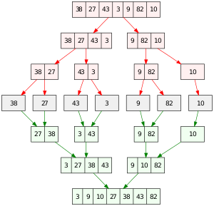
Figure 1 - The Merge Sort Algorithm

Code Analysis
As discussed in the review of literature, there are two types of code analysis, static and dynamic. Static analysis was chosen for this project, analysing the code before the execution was thought to be a more accurate method, as the exact expected inputs and outputs could differ slightly to each implementation of the algorithm. Static code analysis could allow the general structure of the algorithm to be analysed to detect precisely which algorithm it is.
A Java library called 'Spoon' was chosen to be used for the static code analysis. Spoon provides an excellent set of functions for both analysing and transforming code. Spoon could potentially be used to aid the actual implementation of the parallel methods, as well as the detection of the algorithms within the input source code.
The first stage of the code analyser is to simply inform the user of where the program could be parallelised, without actually carrying out the transformation of the code to implement the parallel method(s).

Implementation
During the implementation stage of the project, a number of parallel methods were tested on specified algorithms. One algorithm that was tested was Matrix Multiplication. This was chosen due to how easily it can be parallelised and how commonly used it is. Each algorithm test was used on the same hardware to keep the results consistent across the board. For these tests the following hardware was used:
CPU: AMD Ryzen 7 1700x – 16 Core / 18 Thread
GPU: AMD Vega 56

Matrix Multiplication
One of the chosen algorithms for the testing of parallel methods was matrix multiplication. As mentioned in the design section of this report, it was selected due to its simplicity and how well it can be parallelised, by simply splitting up the matrix into a number or rows to be calculated by each core or processor.
The programming of this method was relatively simple for the most part; it started with a single-threaded implementation to create a benchmark for the results, this is theoretically the slowest speed it should run on the computer. For the test, a 1000x1000 matrix was represented by a two-dimensional array, which was filled using a basic for loop, filling each row with the same number, the first row filled with 1, second with 2, till the array was full. A number of tests were taken on the single-threaded version to create an average; this was done to help rule out any anomaly results. The average speed for a 1000x1000 matrix came out as 1693311180 nanoseconds, equal to around 1.7 seconds.
Next, the same method was used, but instead of using a single thread, multiple threads were used. The matrix was split into rows, each section being computed by a different core. The threads were handled by Java Executor Service, which was created to help with dealing with multiple threads, it took a thread pool equal to the number of cores on the system [Appendix X] and would automatically assign a thread to each column that was passed to it. The results for this were quite interesting, although they did show a performance increase, it was not as much as expected when considering that it technically used 16x the compute performance. The average result came back as 1417321920 nanoseconds, or roughly 1.4 seconds, only a 0.2-second increase over a single core.
The next parallel method tested was GPGPU; this was done by using a set of OpenCL bindings known as JOCL (As mentioned in the design section). The implementation of this was far less straightforward than that of the CPU based programming used for the single and multithreaded algorithms. To get the matrix multiplication to run on the GPU, there were a number of steps, the first of which was creating some kernel code that would actually carry out the operation on the GPU [Appendix X]. GPGPU cannot process two-dimensional arrays since they are essentially a single array of pointers to other arrays, this was a problem because the previous two-dimensional matrix array could not be used. Instead, a one-dimensional array was created to hold the values, essentially joining each row into a single, large array. On the first few runs, the performance seemed to have increased over 100 times from the multithreaded test, this was unexpected, but it turned out that the run time was not accounting for the time spent transferring the matrix from the RAM (Random Access Memory) to the GPU memory. Therefore, the result did not give the true performance. After a quick fix, the result came in a bit more realistic; after ten tests, the average result was 672272180 nanoseconds, about 0.67 seconds. This result shows precisely how much better the GPU is at parallel calculations.

The chart in figure 2 shows a performance comparison of the different parallel methods on the execution time of the algorithms. Looking at the average run time for each parallel method, the visual representation shows the small decrease from single to multiple threads, and then a significant increase for the GPGPU. It is worth noting that GPUs, in general, are incredibly good at floating-point operations, and they are pretty much made for parallelism; this is why matrix multiplication is a great algorithm for testing the performance, the GPU used had around 12.6 Teraflops, meaning it can compute twelve trillion floating-point operations every second. In comparison, the CPU used while being a high-end desktop CPU can only compute around a maximum of 300 Gigaflops, a massive 42x difference.

Figure 2 - Matrix Multiplication 1000x1000

Another test was carried out, this time using a 2000x2000 matrix. The idea here was that with a bigger data set, there should be a bigger performance difference between the single thread and multithreaded run times.
The single thread came out to be an average of 76035955010 nanoseconds or 76 seconds, over a minute to complete the calculation.
As expected, there was a huge gap with to the multithreaded version, with a massive performance increase, the average run time coming in at 13431208000 nanoseconds or 13.4 seconds, over 5.5 times faster than using a single thread.
The GPGPU run time gained an even bigger lead here. It managed to calculate the matrix in a run time of just 768519420 nanoseconds, around 0.76 seconds. This means an increase of 100 times over using a single thread, completely the calculating almost instantly from a user's point of view. This just shows how good the GPU can be at certain highly parallel algorithms. A chart of the results can be seen below in Figure 3.

Figure 3 - Matrix Multiplication 2000x200

The final text for matrix multiplication was a 3000x3000 matrix. The results for this test can be seen in Figure 4, as you can see once again the GPGPU method took a massive lead completing at an average of 1.02 seconds, the single-threaded version took over 5 minutes to compute on average, a humungous performance difference to the single second compute the time of GPGPU. Multithreading completed the calculation in a respectable 51.4 seconds, still a long way behind GPGPU but a massive increase over a single thread. Although this was running on an eight-core, sixteen thread CPU, with a dual-core CPU seen in many modern laptops, the result would be much closer.

Figure 4 - Matrix Multiplication 3000x3000

Please see appendix A for the complete data that was recorded for each of the matrix multiplication tests. The averages for each test, and result for each of the ten tests on each parallel method can be seen there.

Linear Search

The next algorithm tested on the parallel methods was a linear search, as discussed, this was selected due to how commonly it is used in consumer software, where the project is mainly targeted. Implementing a linear search was incredibly easy, especially a single-threaded search. It simply involved looping over an array, checking if each index was equal to the search value. For the multithreaded implementation, the array was split by the number of processors available on the system, passing each section to a different thread. The threads would execute in parallel, each handled by a different processor. The main thread would check each thread continuously, seeing if it had found a value, if so, it would end the remaining threads and return the value. For the GPGPU implementation, OpenCL was used as before. A basic kernel code was written, the code for this can be seen below. It simply checked the input array index against the search value, storing the results in an output array. Within the output array, the element at index 0 would be the search value, and the element at index 1 would be the index that the search value was found at.

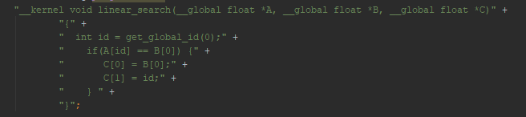

The first test was carried out on an array of floats with a length of 10000. The results for this can be seen in the charts below. Two charts were made because of the enormous performance difference between the parallel methods. The single-threaded version completed in 1.02 milliseconds, the multithreaded completed in 3.35 milliseconds, and surprisingly, the GPGPU version took a huge 424 milliseconds to complete, the reasoning behind this massive gap was thought to be the fact that the data had to be transferred to the GPU memory before being executed, meaning the run-time was more based on the transfer time more so than the actual search time.

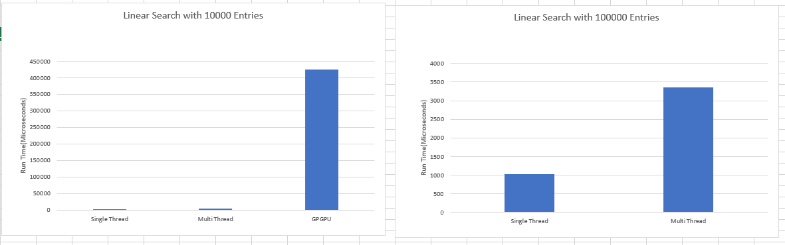

The next linear search test used 1000000 entries, a magnitude of 10 higher. The results for this were almost as expected, the single-threaded version still completed the fastest in 2.8 milliseconds, but the multithreaded version was close behind taking 3.5 milliseconds. Once again, the GPGPU version was far behind taking 440 milliseconds. While the GPGPU version was still far behind, the run time didn't increase much more than the previous test, even though the data set increased ten-fold. This further supports the idea that memory transfer time was the limiting factor. The results for this can be seen in the chart below.

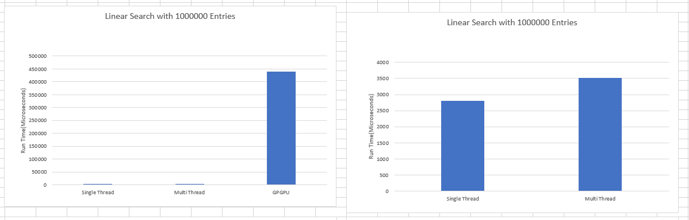

The final test used an array of 10000000 floats, another ten-fold increase. Multithreading actually took the lead in this test, with an average run time of 3.8 milliseconds, compared to 6.94 milliseconds it took on a single thread. What is interesting about this result is the fact that it only took the multithreaded version 0.3 milliseconds over the previous test, whereas the single-threaded code took over twice the run time. The OpenCL version once again trailed behind, taking 483 milliseconds to execute.
An interesting note of the GPGPU tests was that Windows Task Manager showed the GPU running at 100%, which shows that the algorithm was fully utilising the GPU. If it was only using 10%, then there’s potentially an issue as a parallel algorithm should use the GPU. An image of the GPU usage can be seen in Appendix C. Also visible in Appendix C is the previous tests, you can see each time the algorithm is executed the GPU usage spikes to 100%, then back down immediately after completion.
Please see Appendix B for the complete data that was recorded for each of the linear search tests. The averages for each test, and result for each of the ten tests on each parallel method can be seen there.

Code Analysis

A lot of research and work went into code analysis within the project; however, it proved incredibly difficult to get the results needed. Detecting basic code is simple enough with given code analysis frameworks such as Spoon, however, being able to detect specific algorithms when they have a number of different possible implementations is incredibly tricky, and possibly one of the hardest parts of this project.

The proposed Java library, Spoon, was incredibly useful, but the implementation that was required to get the desired result was not achieved. Basic code analysis and code transformations can be carried out easily using this library, such as detecting and changing the class name. Nevertheless, when it comes to the detection of specific algorithms, a large amount of knowledge of code analysis and the frameworks itself is required.

Conclusion
This chapter covered the design and implementation of the project, the chosen programming language, the algorithms to be tested under the parallel methods, and the general flow of the application. It showed some of the implantation and the issues that were encountered, such as the programming of code analysis. The algorithms were tried and tested, recording some results both for and against parallel implementation on those algorithms. Some of the key parts of the project were left unimplemented, such as the code analysis and automatic code transformation for the parallel methods. Regardless of that, some interesting information was found which will be evaluated in the coming chapter.

Evaluation

In this chapter, an evaluation of the project will be discussed. The results and outcome of the project will be discussed and how they compared to prior research and the original objectives of the project. The previous chapter showed how certain parts of the application were left unimplemented, the reasoning for that will be discussed, as will the results of the parallel algorithm tests.

The main conclusion of this paper is just how effective parallelism can be – under the right circumstances. Yes, multithreading and GPGPU CAN provide incredible performance increases, but it is debatable how much most consumer-grade software can actually benefit from them.
Overall, the results of the parallelism tests were as expected; multithreading does give a large performance increase unless the data sets are so small that more time is spent handing tasks out to threads rather than just computing. GPGPU can give a huge performance increase on a number of algorithms, but can't be used for everything. An excellent example of where GPGPU failed to increase speed was the linear search test where it took over 100 times longer than the single-threaded version on every test. Multithreading isn't always useful for common algorithms such as the linear search, which is used in a large number of desktop applications. This makes it hard to decide when parallelism should be used if a performance increase can only be gained when the data set is over x elements, using y cores, how is it determined if it should be utilised when the hardware varies so much on users' devices? Only with algorithms where there is an absolute sway, such as matrix multiplication on the GPU is it possible to be sure that it is a good idea.
Unfortunately, one of the main objectives of this project, the code analysis, was not met. Code analysis is incredibly difficult, especially to make an application that can analyse a slight difference in the implementation of algorithms. For example, there are many different methods that can be used to implement matrix multiplication, array searching, and array sorting.
Due to the lack of code analysis, the main aim of the project was not met, an optimal combination of parallel methods could not be applied to a given piece of code. This was caused by a knock-on effect of the lack of suitable code analysis. Without having the code analysis in place, there is no way to tell which algorithms are in the code, and which parallel methods could be used. There are a number of reasons that caused this, the major one being time constraints. Having more developers working on this project could help solve it, a similar application made by Intel (Intel Advisor XE) is worked on by a large number of developers, creating something of this scale is not always a one-person job, requiring much planning and multiple developers. However, it should still be possible to get a nice work prototype with research and development in the right areas.
Overall, the answers were as expected; parallelism can have an incredible effect on the run time of algorithms. Some interesting results were also found in just how much they can affect the performance, both as an advantage and as a hindrance. The linear search run time on GPGPU was somewhat unexpected, but it also made sense given the amount of data and the transfer times from system to GPU memory.
If the project was taken on once more, there are a number of things that could be done differently. The main one would be to focus more on the code analysis; being able to get this part right is crucial to the success of the project. Once the code analysis is done, the automatic application of parallel methods can proceed, and that could provide some really interesting results. From there, it would be possible to get the automatically parallelised code on a number of computer systems to test the performance result. The research and tests of parallel methods in this paper could serve as a guideline of the minimum amount of data each algorithm needs to use before parallelisation has a positive effect, more research into other algorithms could also be carried out.
This chapter of the paper has evaluated the results of the project, explaining what the recorded data meant, and how it can be used in the future. It also evaluated the issues that were encountered and why they were encountered. Once the code analysis section is cracked, this project could potentially produce some great performance increases in code through automatic parallelisation.

Conclusions and Recommendations
This chapter will discuss the outcomes and conclusions of the paper and recommend some areas for future research that could massively improve the outcome and development of the project. This paper researched the different types of parallel methods that can be used on a majority of modern computers and their effect on a number of common algorithms. It did this through testing the performance of a number of parallel methods on embarrassingly parallel problems, such as matrix multiplication.
Throughout this paper, it was shown that parallelism can increase the performance of common algorithms such as matrix multiplication, or even a linear search. The performance increase can be substantial, decreasing run-time ten-fold in certain circumstances. The GPU is often underutilised in a lot of software and sits idly not being used for its potential.
A major conclusion of this paper is just how much the size of data used within an algorithm can affect the usefulness of parallel methods. As mentioned, parallel methods can improve run-times massively, but they can also hinder them massively when not used under the right circumstances. The linear search test showed just how slow GPGPU could be for certain algorithms, taking over one hundred times longer to search an array when compared to the CPU. Care needs to be taken when implementing these parallel methods, ensuring the end-user will both have the required hardware to take advantage of these methods, and that the amount of data passed to each algorithm is at a level where the parallel method is actually useful.
Code analysis is a great tool; it can be used for a variety of things such as debugging code. Theoretically, static code analysis could be used to detect a variety of algorithms in the source code of an application, however detecting the exact type of algorithm is not easy, as discovered in this paper. Dynamic code analysis could also be used to achieve the same result at run time, both have their advantages and disadvantages but they only really serve a purpose from the developer's point of view, analysing the methods is only useful to either suggest a parallel method or to then further automatically apply the parallel methods. However, as previously stated, blindly applying parallel methods without checking that hardware on the system could slow down the run time significantly.
Since there was no working prototype or application featuring the code analysis feature mentioned in the paper, it could be an ideal area for future research. Further researching code analysis and how algorithms could be easily detected in a piece of code, and how parallel methods could be automatically applied could be a very useful tool for a large number of programmers, saving them the time and potential issues of implementing these parallel methods themselves. Automatically applying parallel methods could have a number of downsides. If a piece of software was shipped that had every algorithm parallelised, it could actually run slower for a majority of users. The research in this paper showed parallelism while being able to improve performance massively, can actually slow it down under the wrong circumstances. The main issue with parallelising code is the fact that every PC is different. With such a variance in the core counts and graphics capabilities among computers and laptops, how is it determined if the code should be parallelised or not? If it is parallelised, it might run twice as fast on the development machine but could run twice as slow on a user's machine. The only real option then is to run some checks in the code to detect the user's hardware and select the optimal parallel methods for that hardware, which is quite unrealistic, given the amount of hardware out there.

Suggestions for Further Work
It could be possible to look into a compile or run-time environment for applications that could detect the current hardware being used on the computer and select the appropriate parallel methods for that hardware; this would prevent the case where a user could be running multithreaded code on a single-core CPU or a GPGPU code on integrated graphics. Another area to research is the running of GPGPU on integrated graphics, testing if there is any performance increase over the CPU.
For the automatic application of parallel methods, it could be worth looking into the possibility of selecting/applying a parallel method at run time, on the user's computer. This way it would be possible to check the user's hardware and select the optimal combination of parallel methods for this device. Analysing the code an applying the methods in any other could potentially decrease performance like shown in the linear search tests.
Some algorithms implemented in an application may not work well with parallelism, like the tested linear search. However, it could be possible to detect these algorithms and replace them with an alternative that could achieve the same outcome AND be well parallelised, such as replacing the linear search with another search algorithm that could have a big performance increase when parallelised. This is especially true for many sort algorithms, such as merge sort, which could be replaced with a bitonic merge sort.
More research could be carried out into the code analysis of embarrassingly parallel problems, detecting where they exist in the code and if they meet the requirements of parallelism. This subset of algorithms that are 'embarrassingly parallel' would be a great starting point, since they generally can be easily parallelised and get a huge performance boost from being parallelised. By tackling these problems first, before starting any others would not only give an optimal performance increase for many applications but would also be one of the easiest and most useful applications. Many developers know that specific algorithms can be parallelised for big performance increases, but avoid doing so because of the extra work that comes along with it, as well as the potential concurrency issues.
If this project were developed into a real-world application, it would ideally have to support a number of different programming languages. Although most languages have a similar syntax, often the variables use different names and memory management is different. Take, for example, Bool vs Boolean; this would have to be accounted for in both the code analysis and automatic parallelisation stages. C and C++ generally require manual memory management, whereas other languages such as Java and C# are garbage collect, this would also have to be accounted for in the code.

Reflection

During the process of the project, a large amount of information was learnt in the various researched areas. The design and research process have proved to be equally important as the actual implementation of the project. Knowing the basic theory behind a project is totally different to the actual design of it. Without enough research and thought into the design, it is hard to get the implementation stage correct. The design stage should have been much more in depth, looking into exactly how the code analysis and code transformation could be carried out. Further design work in these areas would have greatly helped the implementation stage, by knowing exactly how the project needs to be implemented, not just having a general idea of what the implementation includes. A great example of this is the code analysis, knowing what it is, is totally different to actually applying that knowledge and programming a code analysis application.

Within the code analysis and transformation steps, further improvement could be included by having it include hardware checking. Having information on the speed and power of both the CPU and GPU could allow an optimal level of parallelism to be added. This of course would have to be done at run time on the users end.
GPGPU was found to be a very interesting area, the difference between programming the CPU and GPU is vast.

References

[1] | D. R. EMERSON, “Introduction to Parallel Computing Using,” Daresbury Laboratory, Cheshire, 2017.
[2] | M. H. D. L. S. G. John D. Owens, “GPU Computing,” Proceedings of the IEEE 8, vol. 96, no. 5, pp. 879-899, 2008.
[3] | T. A. R. M. D. BOGDAN OANCEA, “GPGPU COMPUTING,” Challenges of the Knowledge Society, vol. 2, pp. 2027-2035, 2014 .
[4] | J. S. Edward Kandrot, CUDA by Example: An Introduction to General-Purpose GPU Programming, Bostn: Addison-Wesley, 2011.
[5] | Advanced Micro Devices inc., Introduction to OpenCL Progamming, California: Advanced Micro Devices inc., 2010.
[6] | N. G. D. F. H. Kamran Karimi, “A Performance Comparison of CUDA and OpenCL,” D-Wave Systems Inc. , Burnaby, 2010.
[7] | G. O.-Č. Leonardo Jelenković, “EXPERIMENTS WITH MULTITHREADING IN PARALLEL COMPUTING,” University of Zagreb, Zagreb, 1997.
[8] | J. M. C.-K. S. Steve Carr, “Race Conditions: A Case Study,” Michigan Technological University, Houghton, 2002.
[9] | H. N. Kevin Jouper, “Performance analysis of multithreaded,” Blekinge Institute of Technology, Karlskrona, 2015.
[10] | F. Sommers, “Cluster Computing: High-Performance, High-Availability, and,” The University of Manitoba, Canada, Manitoba, 2006.
[11] | R. M. Dominguez, “Evaluating different Java bindings for,” University of Seoul, Seoul, 2012.
[12] | C. Igwenagu, Fundamentals of research methodology and data collection, Nigeria: LAP LAMBERT Academic Publishing, 2016.
[13] | V. B. Sridhar P. Nerur, “Theoretical reflections on agile development methodologies,” Communications of the ACM , vol. 50, no. 3, pp. 79-83, 2007.

Appendices

Appendix A

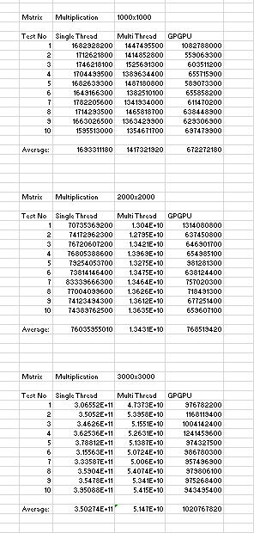

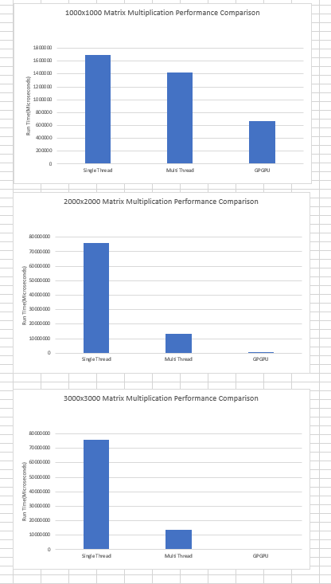

Appendix B

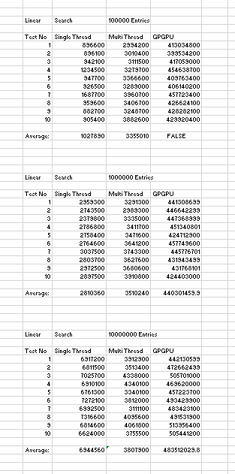

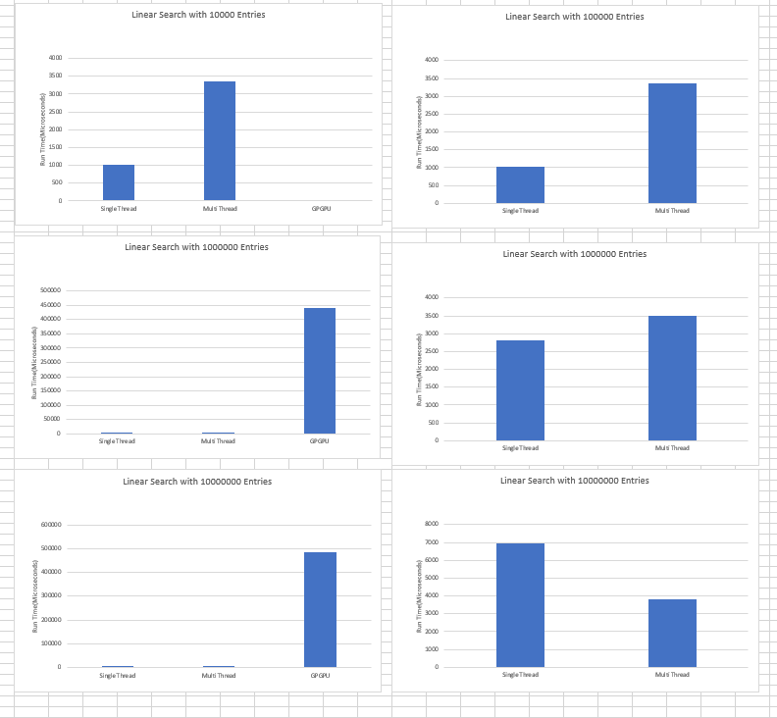

Appendix C


