

Student Name: Dharmikkumar Govindbhai Rabari

Student ID: 2510581

Module Name: Marketing Management

Module Code: LCMB7024

Lecturer’s Name: Dr.Laila Maazouz

Word Count: 2591

Term 1

Table of Contents
Element 1: Brand Extension Poster 4
1.1 Introduction to Apple Inc. 4
1.2 Proposed Brand Extension 4
1.3 Market Appeal & Trends 4
1.4 Sustainability Alignment 4
Element 2: STDP Analysis 5
2.1 Segmentation 5
2.2 Targeting 7
2.3 Differentiation 8
2.4 Positioning 9
Element 3: Marketing Mix (7Ps Recommended) 9
3.1 Product 9
3.2 Price 10
3.3 Place 10
3.4 Promotion 11
3.5 People 11
3.6 Process 11
3.7 Physical Evidence 12
Element 4: Reflection 13
4.1 Learning Experience 13
4.2 Skills Developed 13
4.3 Challenges Faced 14
4.4 Future Improvements 14
References 15

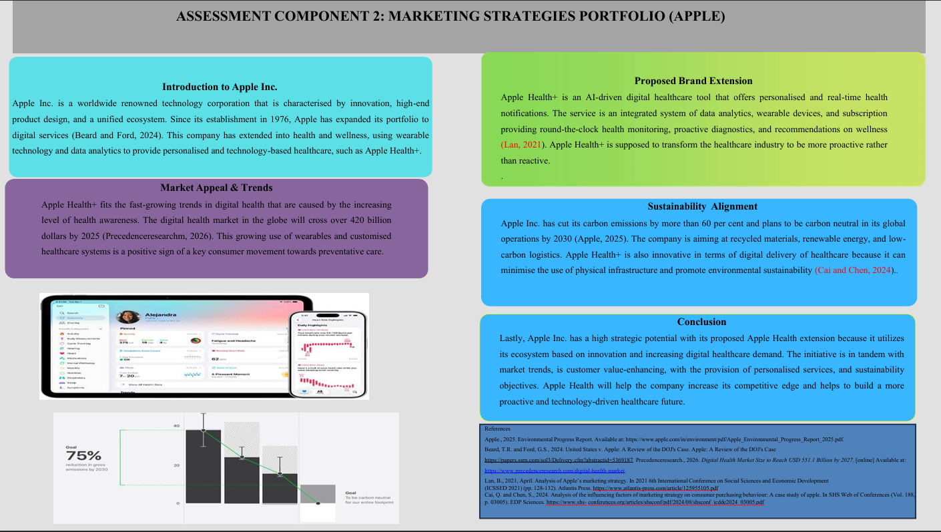

Element 1: Brand Extension Poster

1.1 Introduction to Apple Inc.
Apple Inc. is a worldwide renowned technology corporation that is characterised by innovation, high-end product design, and a unified ecosystem. Since its establishment in 1976, Apple has expanded its portfolio to digital services (Beard and Ford, 2024). This company has extended into health and wellness, using wearable technology and data analytics to provide personalised and technology-based healthcare, such as Apple Health+.

1.2 Proposed Brand Extension
Apple Health+ is an AI-driven digital healthcare tool that offers personalised and real-time health notifications. The service is an integrated system of data analytics, wearable devices, and subscription providing round-the-clock health monitoring, proactive diagnostics, and recommendations on wellness. Apple Health+ is supposed to transform the healthcare industry to be more proactive rather than reactive.

1.3 Market Appeal & Trends
Apple Health+ fits the fast-growing trends in digital health that are caused by the increasing level of health awareness. The digital health market in the globe will cross over 420 billion dollars by 2025 (Precedenceresearch.com, 2026). This growing use of wearables and customised healthcare systems is a positive sign of a key consumer movement towards preventative care.

1.4 Sustainability Alignment
Apple Inc. has cut its carbon emissions by more than 60 per cent and plans to be carbon neutral in its global operations by 2030 (Apple.com, 2025). The company is aiming at recycled materials, renewable energy, and low-carbon logistics. Apple Health+ is also innovative in terms of digital delivery of healthcare because it can minimise the use of physical infrastructure and promote environmental sustainability.

Element 2: STDP Analysis

2.1 Segmentation
Market segmentation is an important strategic tool which allows Apple Inc. to determine and categorize customers based on the shared characteristics by facilitating the effective positioning of its brand extension, Apple Health+. The segmentation strategy also incorporates geographic, demographic, psychographic, and behavioral variables. In terms of a geographic perspective, Apple initially targets customers in various developed markets including the United States, the United Kingdom, and the European Union, where the technological integration and purchasing power is high (Bryła and Abdusattarov, 2025). These regions describe a strong demand for premium health-tech resolutions. In the similar way, some emerging markets including India and urban regions of China show massive growth opportunities because of the increasing urbanization, rising disposable incomes, and expanding digital infrastructure that makes the company attractive for effective adoption of wearable health technologies. In the context of the demographic segmentation, the main focus is on the individuals aged between 25 and 50 years, who are mostly economically active as well as more inclined towards investing in personal health and technology.
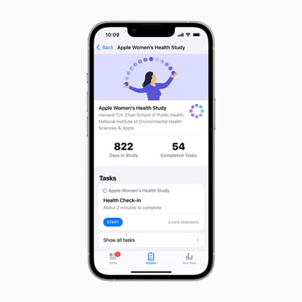
Figure 1: Health+
(Source: Apple, 2024)
This segment hugely consists of middle-to upper income earners including the professionals, entrepreneurs, and corporate employees, who have the financial capacity to afford Apple’s premium-priced products and subscription services (Start.io, 2024). Psychologically, the target customers exhibit a health-conscious lifestyle and describe a strong limitation towards fitness, wellness, and preventive healthcare. They are now technologically effective, value innovation and also prefer brands which symbolize status, quality, and exclusivity. On the other hand, behavioral segmentation mainly focuses on the loyal Apple users who are hugely embedded within the ecosystem of Apple. These customers exhibit a high brand loyalty, frequent product upgrades, and a willingness to take new technologies early. Along with that, their familiarity with the subscription-based services including Apple Fitness+ and iCloud that makes them more reliable to adopt Apple Health+ as the part of an adopted digital lifestyle.

2.2 Targeting
According to the segmentation analysis, Apple Inc. uses a differentiated targeting approach to its Apple Health + brand extension targeting the primary and secondary segments (Han, 2024). The key target market will include those urban professionals between 25 and 45 years of age with a high level of disposable income. This group is especially appealing because of the high purchasing power, high use of digital technologies and rising focus on health and wellness. The increasing tendency of the global population to preventive healthcare also increases the appeal of this segment, and people are looking to find proactive solutions to their health. The secondary target segment consists of the ageing population such as those at 50 years and more who are in need of constant health surveillance. This segment has a great potential of growth since the number of people with chronic diseases is on the increase as well as the awareness of health management solutions. Heart rate monitoring, fall detection, and AI-based health alerts can serve to meet these needs in Apple Health+ (Apple, 2024). The strategy for the choice of the target segments is their market appeal, which is characterized by high demand and readiness to invest in health technologies. The segments are also characterized by high growth potentials to the changing demographics and technological changes.
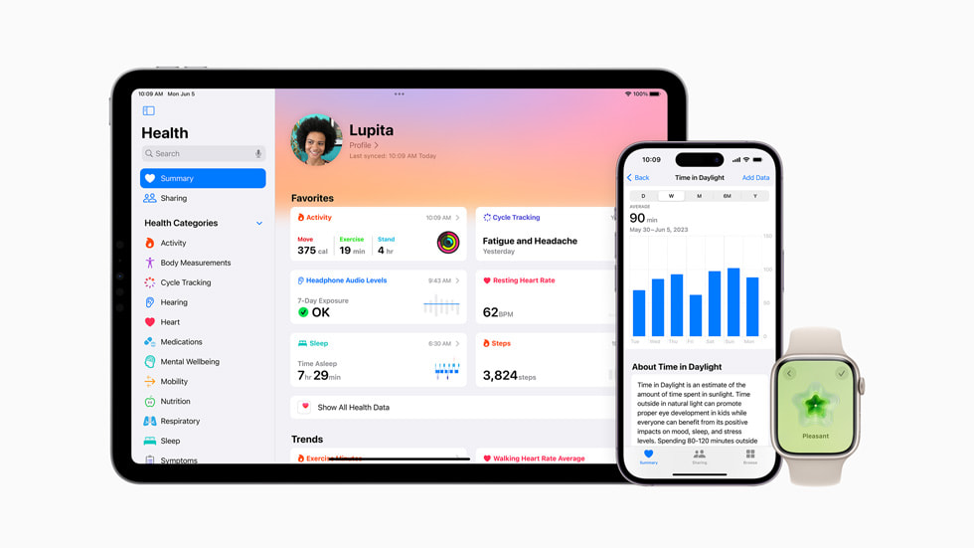
Figure 2: Health+
(Source: Apple, 2024)

2.3 Differentiation
Differentiation is critical to the positioning of Apple Health+ as it establishes a strong competitive advantage within the global digital health market. The global digital health market is projected to cross USD 937.3 billion by 2030 (Grand View Research, 2023). Other competitors such as Fitbit and Samsung Health are slightly different from Apple. Apple has over 2.2 billion active devices worldwide, and it has a tight ecosystem. A major differentiator is Apple's focus on data privacy and security that is becoming an important factor for over 70 per cent of consumers (Deloitte Insights, 2024). The end-to-end encryption and on-device processing further reinforce the trust of the user. Personalised insights are also provided by the Apple Health+ using AI-powered predictive analytics. The high quality of its brand is also a strength of Apple and it is always listed among the most valuable brands. It helps them to justify their premium pricing technique and maintain high customer loyalty rates. The integration of the ecosystem, privacy leadership, and brand strength enables Apple Health+ to achieve a competitive position.

2.4 Positioning
Positioning is the way Apple Health+ can be remembered by the targeted consumers when compared to other digital health solutions (Morley et al., 2025). Apple Health+ is a high-end, privacy-minded, and AI-based digital healthcare app that fits well into the daily routines of consumers. This is primarily focused on tracking activity and other basic measures of health as compared to other competitors, such as Fitbit and Samsung Health. Apple Health+ is a superior ecosystem system product that incorporates sophisticated analytics, real-time information, and customised health data. Apple Health+ aim to change the attitude of consumers to healthcare as reactive treatment to proactive and preventative healthcare management. A suitable positioning statement is:
“Apple Health+ provides a premium, secure, and intelligent health management experience, empowering users with real-time insights and seamless integration across their digital lifestyle.”

Element 3: Marketing Mix (7Ps Recommended)

3.1 Product
The Apple Health+ Services represent an extensive and comprehensive digital healthcare solution developed by Apple Inc. The product is a wearable device (Apple Watch) combined with an application that provides real-time health tracking (Secara and Hordiiuk, 2024). It is able to accurately track heart rate, activity, early risk and sleep patterns. Apple Health+ is a critical aspect that relies on artificial intelligence and predictive analytics, which display customised health information. The service is constantly renewed by software improvements, innovation and long-term consumer engagement. Apple Health+ will add to the ecosystem of Apple which enhances customer dependency and lifetime value. Integration with the current Apple devices provide lead to harmonization of the user experience and brand loyalty as well as positioning the service on top of already competing standalone products.

3.2 Price
Apple Health+ pricing is based on the high-end positioning of Apple Inc. and is based on the value-based subscriptions. It is anticipated that the service can be provided on a monthly or annual subscription basis. The customer can receive unlimited health tracking and individualised feedback. This strategy guarantees the recurring income and the improvement of customer lifetime value. Apple uses its high brand equity as one of the most valuable brands in the world to have premium prices, as its target customers have a high level of willingness to pay high prices in order to get quality, innovation, and privacy (Franky and Syah, 2023). By providing Apple Health+ as part of service packages such as Apple One (Apple.com, 2025). This might be another way of boosting perceived value and adoption. The high cost can enhance the differentiation strategy of Apple, and it is an indicator of exclusivity. The pricing strategy is competitive and sustainable as even the consumers are ready to pay higher prices than competitors.

3.3 Place
Apple Health+ distribution strategy can be aimed at making the product as widely reachable as possible and strengthening the ecosystem benefit of Apple Inc. The service is mostly provided on the digital platforms of Apple such as the App Store and the iOS ecosystem. This can allow easy access by users in over 175 markets across the world. This is a digital-first strategy, which makes it scalable globally with relatively low distribution costs as opposed to conventional healthcare services. Apple has its physical retail portfolio of more than 500 Apple Stores across the world, and it is also instrumental in customer experience (McCarthy, 2021). The store offers an experiential Apple Watch and a customised service to use Apple Health+. However, Apple has the option of enhancing its distribution by establishing strategic partnerships with healthcare providers, insurance firms, and corporate wellness programmes. These partnerships increase the scope of access beyond personal consumers and make Apple Health+ an organisational health solution.

3.4 Promotion
Apple Health+ promotional strategy capitalises on the international brand recognition of Apple Inc. Apple invests more than USD 1.95 billion per year in advertising and it allows conducting mass digital campaigns on YouTube, Instagram, and the company ecosystem (Kharpal, 2024). These are health and well-being; lifestyle change campaigns that are in line with the rising global wellness economy worth more than 5 trillion dollars. Apple has a very loyal customer base, and the retention rate of customers is over 90 per cent (Lee, 2025). This enables promoting the business within its own ecosystem through personalised notifications and recommended apps. The use of real-life cases of health impact stories in its communication by Apple reinforces emotional involvement and confidence. Apple uses the tactic of promotion that has provided a blend of dimension, trust, and individualisation. This guarantees Apple Health+ high visibility and adoption in the digital health market.

3.5 People
The element of the people is essential to providing a quality service experience to Apple Health+ since it incorporates not only employees but also other external stakeholders who help in creating value. Apple Inc. has 166000 employees worldwide, and they are highly trained to deliver a high-end customer experience (Diongson, 2026). The employees of the Apple Store can also contribute to educating users on the healthy features, especially by doing individual demonstrations of the Apple Health app. Moreover, Apple Health+ also enjoys the cooperation of healthcare professionals, fitness experts, and developers. Moreover, service quality is supported by the strong organisational culture of Apple as it emphasises innovation, customer-centricity, and privacy. Customer satisfaction rates remain above industry averages because of high employee engagement and skills (Amellia and Berlianto, 2023).

3.6 Process
Apple Health+ service delivery process is designed in the form of seamless integration that the Apple Inc. ecosystem is based on. Users can subscribe on the App Store and onboard on the Apple Health app that integrates the data on the Apple Watch and iPhone (Sadare et al., 2023). Constant analysis of human activities such as heart rate, and sleep patterns are processed by AI-based algorithms. It is also improved by the integration of secure iCloud which provides encrypted data and privacy that can be controlled by users. This is an automated system that is efficient to maintain accuracy, convenience and standardized user experience in all touchpoints.

3.7 Physical Evidence
Physical evidence is crucial towards enhancing the superior and credible image of Apple Health+. Apple Inc. provides a consistent branding experience by designing its products as minimalist, producing high-quality Apple Watch products and easy-to-use apps. Apple Stores reinforce this perception further as they provide a clean and modern retail experience where the user can feel the products. The health app can offer an attractive dashboard, well-defined data visualisation, and insights that are personalised. Green packaging and Apple's sustainability efforts also play a role in creating a positive brand perception.

Element 4: Reflection

4.1 Learning Experience
During the project, I had a positive learning experience when it comes to the creation of a brand extension strategy for Apple Health+. I learned how some of the marketing theories such as brand development, STDP, and marketing mix can be applied in business situations on the ground. The project assisted me in linking the theoretical material to real-life decision-making, particularly in the study of customer requirements and trends in the marketplace. Another important lesson I got is the importance of modern-day marketing as a field of innovation and digital transformation, especially in health-tech promotion. Additionally, Using Gibbs’ Reflective Cycle, I was able to reflect on my learning process by evaluating my experience, identifying strengths, and recognising areas for improvement. Marketing the poster and portfolio project enhanced my skills of communicating ideas in a professional manner. This experience has developed my understanding of the strategic marketing field.

4.2 Skills Developed
This project allowed me to acquire a number of academic and professional skills that have huge importance. My research expertise was enhanced and I have all sorts of academic resources to learn the market trends, consumer behaviour, and digital health innovation. This taught me to locate good and secure information and apply it to my practice (). I also improved my analytical competence through the implementation of STDP and marketing mix models to practical business care. This enabled me to think analytically and make a strategic decision using market information. My problem-solving capability was also enhanced as I was designing an appropriate brand extension of Apple. Additionally, my communication and presentation techniques were enhanced during poster creation and arrangement of ideas in an organised manner. I was taught how to state complicated material in a plain and systematic fashion. So, the skills will have a role to play in my future profession as a marketer and a manager (Han, 2024).

4.3 Challenges Faced
The central challenge was the fact that there was a need to pick an appropriate brand extension concept that resonates with the Apple brand image and market trends. The other obstacle was the practical use of theoretical concepts such as STDP and marketing mix because it was confusing to relate theory to the real-life context. Time management was also a challenging topic to handle as the assignment involved several aspects. It was also difficult to be articulate within the word limit. These difficulties allowed me to advance the knowledge base and abilities of solving problems.

4.4 Future Improvements
I would make my work better in the future by ensuring that I am able to work earlier and manage my time better. This would enable me to do more in-depth research and incorporate more and better academic resources. I would also work on developing my critical analysis through better correlation between theory and practice. I wish to improve my presentation skills by designing the poster, which will be more creative. Additionally, I would also consult with peers and tutors throughout the process to work on the improvement of my work at the stages. Further practice will allow me to become a more powerful marketing and analytical follower of a future project.

References
Amellia, A. and Berlianto, M., 2023. Factors That Affect Customer Satisfaction and Brand Loyalty for the Apple Brand in Indonesia. Manajemen Bisnis, [online] 13(02), pp.09-24. https://doi.org/10.22219/mb.v13i02.23040.
Apple., 2024. Healthcare. [online] Available at: https://www.apple.com/in/healthcare/
Apple., 2025. Apple One. [online] Available at: https://www.apple.com/in/apple-one/.
Apple.com., 2025. Environmental Progress Report. Available at: https://www.apple.com/in/environment/pdf/Apple_Environmental_Progress_Report_2025.pdf.
Beard, T.R. and Ford, G.S., 2024. United States v. Apple: A Review of the DOJ's Case. Apple: A Review of the DOJ's Case https://papers.ssrn.com/sol3/Delivery.cfm?abstractid=5369187
Bryła, P. and Abdusattarov, S., 2025. Apple’s Strategy Success Factors and Challenges in Europe: A Case Study of Apple’s Business Model and International Marketing. Annales Universitatis Mariae Curie-Skłodowska, sectio H–Oeconomia, 59(5), pp.7-30. DOI:10.17951/h.2025.59.5.7-30, https://journals.umcs.pl/h/article/download/19001/13386
Deloitte Insights., 2024. Earning trust as gen AI takes hold: 2024 Connected Consumer Survey. [online] Available at: https://www.deloitte.com/us/en/insights/industry/telecommunications/connectivity-mobile-trends-survey.html.
Diongson, D., 2026. How many employees does Apple have? A deeper look at the tech giant’s workforce. [online] Yahoo Finance. Available at: https://sg.finance.yahoo.com/news/many-employees-does-apple-deeper-150700096.html.
Franky, F. and Syah, T.Y.R., 2023. The Effect of Customer Experience, Customer Satisfaction, and Customer Loyalty on Brand Power and Willingness to Pay a Price Premium. Quantitative Economics and Management Studies, [online] 4(3), pp.437–452. doi:https://doi.org/10.35877/454RI.qems1639.
Grand View Research., 2023. Digital Health Market Size & Growth Report, 2021-2028. [online] www.grandviewresearch.com. Available at: https://www.grandviewresearch.com/industry-analysis/digital-health-market.
Han, Y., 2024. A Case Analysis of Market Segmentation and Product Differentiation. Highlights in Business, Economics and Management, 34, pp.52-57. https://pdfs.semanticscholar.org/4e74/d8d285667f8545bcc97c8c0af27f84361e7b.pdf
Joseph, R.J. and Pojednic, R.M., 2023. Performance Medicine: a novel and needed paradigm for proactive health care. Frontiers in Sports and Active Living, [online] 5, p.1156645. doi:https://doi.org/10.3389/fspor.2023.1156645.
Kharpal, A., 2024) Apple hit with more than $1.95 billion EU antitrust fine over music streaming. [online] CNBC. Available at: https://www.cnbc.com/2024/03/04/apple-hit-with-more-than-1point95-billion-eu-antitrust-fine-over-music-streaming.html.
Lee, R.A., 2025. Apple Customer Loyalty Statistics 2025: Top Insights • SQ Magazine. [online] SQ Magazine. Available at: https://sqmagazine.co.uk/apple-customer-loyalty-statistics/.
McCarthy, N., 2021. 20 Years On: The Global Apple Store Empire [Infographic]. [online] Forbes. Available at: https://www.forbes.com/sites/niallmccarthy/2021/05/14/20-years-on-the-global-apple-store-empire-infographic/.
Morley, J., Laitila, J., Ross, J.S., Schamroth, J., Zhang, J. and Floridi, L., 2025. An app a day will (probably not) keep the doctor away: an evidence audit of health and medical apps available on the apple app store. Minds and Machines, 35(1), p.11. https://papers.ssrn.com/sol3/Delivery.cfm?abstractid=4894882
Precedenceresearch.com., 2026. Digital Health Market Size to Reach USD 551.1 Billion by 2027. [online] Available at: https://www.precedenceresearch.com/digital-health-market.
Sadare, O., Melvin, T., Harvey, H., Vollebregt, E. and Gilbert, S., 2023. Can Apple and Google continue as health app gatekeepers as well as distributors and developers? npj Digital Medicine, [online] 6(1), pp.1–7. https://doi.org/10.1038/s41746-023-00754-6.
Secara, I.-A. and Hordiiuk, D., 2024. Personalized Health Monitoring Systems: Integrating Wearable and AI. Journal of Intelligent Learning Systems and Applications, [online] 16(2), pp.44–52. doi:https://doi.org/10.4236/jilsa.2024.162004.
Start.io., 2024. Apple Target Market Analysis – Apple Demographics, Marketing Strategy & Competitors. [online] Start.io. Available at: https://www.start.io/blog/apple-target-market-analysis-apple-demographics-marketing-strategy-competitors/

