Daniel Bridgewater (2218703)

Investigating the
Effect of Noise in
SSB-SC and DSB-SC
ACDA5019

Contents
Contents 1
Introduction 2
Background research 2
Literature Review 2
Transmitter and Receiver Architectures 3
Amplitude Modulation 3
Dual Sideband Suppressed Carrier 3
Single Sideband 4
Simulated Outputs and Results 5
Analysing the Results 12
Conclusion 12
Recommendations for future work 12
References 12

Equation 1: AM equation as shown in [1, p. 189] 3
Equation 2: Rewritten Equation 1 to follow modern conventions and include modulation index 3
Equation 3: DSB-SC equation, shown in [1, p. 190], where $ωm$ is the message frequency 3
Equation 4: SSB USB generation by adding a phase-shifted copy of a sideband 4

Figure 1: AM simulation 3
Figure 2: DSB-SC simulation 4
Figure 3: SSB simulation 4
Figure 4: AM with a modulation index of 0.3 (under-modulation) 5
Figure 5: AM with a modulation index of 1 (critical modulation) 5
Figure 6: AM with a modulation index of 2 (over-modulation) 5
Figure 7: AM Spectrum at critical modulation 6
Figure 8: DSB-SC SNR=-20 Spectrum Analysis 6
Figure 9: DSB-SC SNR=-20 Scope 6
Figure 10: DSB-SC SNR=-10 Spectrum Analysis 7
Figure 11: DSB-SC SNR=-10 Scope 7
Figure 12: DSB-SC SNR=0 Spectrum Analysis 7
Figure 13: DSB-SC SNR=0 Scope 8
Figure 14: DSB-SC SNR=10 Spectrum Analysis 8
Figure 15: DSB-SC SNR=10 Scope 8
Figure 16: SSB-SC SNR=-20 Spectrum Analysis 9
Figure 17: SSB-SC SNR=-20 Scope 9
Figure 18: SSB-SC SNR=-10 Spectrum Analysis 9
Figure 19: SSB-SC SNR=-10 Scope 10
Figure 20: SSB-SC SNR=0 Spectrum Analysis 10
Figure 21: SSB-SC SNR=0 Scope 10
Figure 22: SSB-SC SNR=10 Spectrum Analysis 11
Figure 23: SSB-SC SNR=10 Scope 11

Introduction
This report aims to analyse three different types of Amplitude Modulations (AM) and the effects of different modulation indexes and how noise affect the demodulated signal. The modulation types include plain AM (also known as Dual Sideband Transmitted Carrier, or DSB-TC [1, p. 192]), Dual Sideband Suppressed Carrier (DSB-SC), and Single Sideband (SSB). Research and review of the available literature will be conducted for each type of modulation, to acquire an understanding of the principles involved for each. This knowledge will then be used to implement simulations of each modulation in MATLAB Simulink software, which is designed to model and simulate signal processing systems.
First, to demonstrate the effects of under/over modulation, a basic AM modulator/demodulator will be implemented, with the modulator designed to be capable of changing its modulation index, which is a coefficient determining the extent of mixing the input message with the carrier signal. To compare the modulation index’s effect, different values will be tested while observing how the demodulated signal is affected.
Next, to investigate the effect of noise on DSB-SC and SSB, varying amounts of Additive White Gaussian Noise (AWGN) will be applied to the signals produced by both types of modulation with the modulation index set to 0.5, then observing the result using a scope and spectrum analyser. By comparing how accurately the distorted signal was demodulated under different levels of interference, this report will draw conclusions about the suitability of the modulation types.

Background research
Most literature involving SSB or DSB-SC written this century builds on the fundamentals and are not relevant to this report. For example, of 20,400 recent reports involving DSB-SC, approximately 14,600 (72%) are in the field of optics, typically discussing optical carrier suppression. The remaining 28% appear to be discussing particular implementations for various frequencies and applications. The only relevant sources of information the author could find were old and/or non-academic, such as archived amateur-radio magazines or websites. These will be discussed in the Literature Review.

Literature Review
There appears to be a lack of modern literature covering the fundamentals of amplitude modulation, as most reports assume the reader has perquisite knowledge on the topic so they may focus on more specialised topics. Therefore, the author must instead review relevant parts of older/informal resources.
The 1970 magazine entitled “Single Sideband for the Radio Amateur”, published by the ARRL [2], is mostly a collection of instructions for building SSB transceiver circuits using now-obsolete vacuum tubes, which were common at the time of writing. However, it starts with an introduction to SSB where it explains the principles in simple terms, comparing sidebands to hats [2, p. 10], a metaphor which is perfectly suited to the intelligence of this author. It goes on to explain the benefits and drawbacks of SSB, along with clearly explaining the reasons why those traits exist, but it does not contain mathematical definitions of the modulation.
For formal definitions of the modulations, the author referred to Chapter 8 of Bell Telephone Laboratories’ book entitled Telecommunications Transmission Engineering, written in 1977 [1]. This contains equations describing various types of modulations, including AM, DSB-SC, and SSB, intended for those who have a background in telecommunications.

Transmitter and Receiver Architectures

Amplitude Modulation
$$M\left(t\right)=a\left(t\right)\cos{ω_{c}t}$$
Equation 1: AM equation as shown in [1, p. 189]
AM is one of the simplest forms of modulation, since it’s just multiplying the message signal with the carrier. To demodulate the signal, a low-pass filter can extract the envelope, followed by a gain and high-pass filter to correct the DC offset. Equation 1 assumes critical modulation, where the signal is completely off when the message is 0. To vary the amount of modulation applied to the carrier, another term should be added, shown in Equation 2.
$$M\left(t\right)=A_{m}\sin{ω_{m} t}×\cos\left(ω_{c} t\right)$$
Equation 2: Rewritten Equation 1 to follow modern conventions and include modulation index
Following Equation 2, a simple AM modulator/demodulator was built in Simulink:
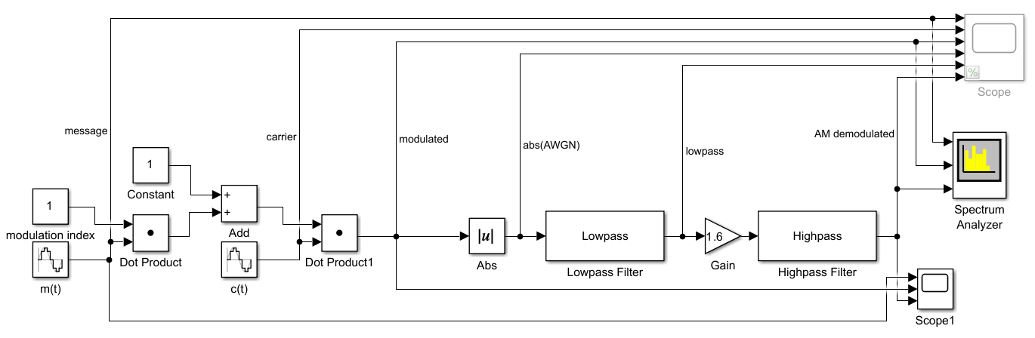
Figure 1: AM simulation

Dual Sideband Suppressed Carrier
$$M\left(t\right)=\frac{1}{2}\cos\left(ω_{c}-ω_{m}\right)+\frac{1}{2}cos⁡(ω_{c}+ω_{m}) t$$
Equation 3: DSB-SC equation, shown in [1, p. 190], where $ω_{m}$ is the message frequency
By modifying the Amplitude Modulation formula to create the sidebands explicitly, the carrier can be omitted from the output signal. This is more efficient as no power is spent sending the carrier, but increases complexity at the receiver, as the carrier must now be derived from the sidebands before demodulating.
Since this model and that of SSB, will be subjected to interference, an AWGN block has been inserted between the modulator and demodulator halves. Furthermore, for this implementation and that of SSB, the modulation index was set to 0.5.
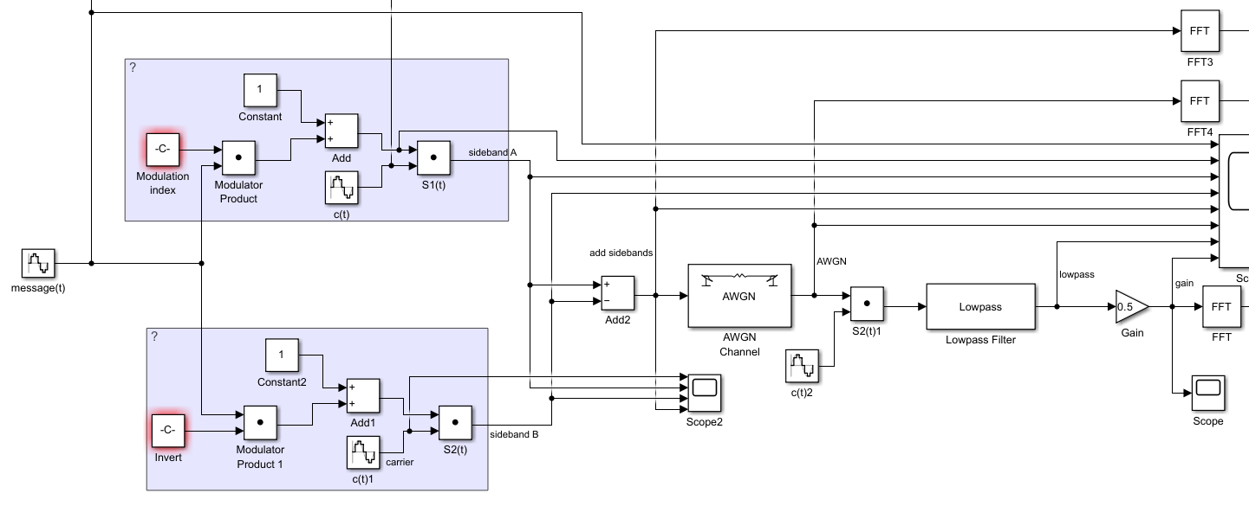
Figure 2: DSB-SC simulation

- For DSB-SC and SSB, use a fixed modulation index of 0.5 and introduce noise

Single Sideband Suppressed Carrier
$$M\left(t\right)=\frac{1}{2}\sin\left(ω_{c}+ω_{m}\right)+\frac{1}{2}cos⁡(ω_{c}+ω_{m}) t$$
Equation 4: SSB-SC USB generation by adding a phase-shifted copy of a sideband [1, p. 190]
Since both sidebands carry the same information, one can be removed to reduce power and bandwidth usage. By phase-shifting one sideband and adding to itself, the other sideband is cancelled out. In this case the Upper Sideband is selected. Again, the modulation index is 0.5.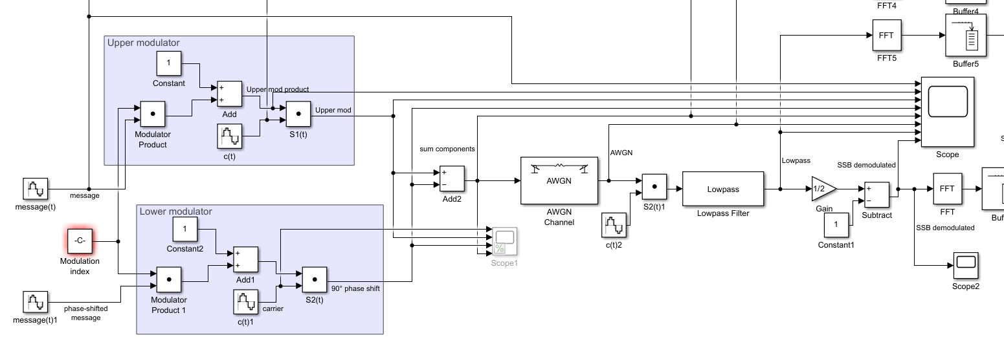
Figure 3: SSB simulation

Simulated Outputs and Results
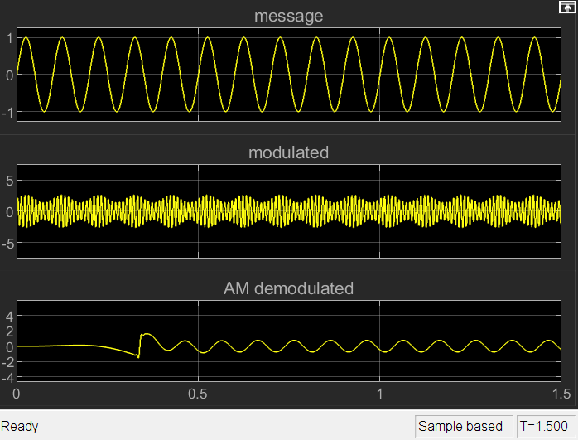
Figure 4: AM with a modulation index of 0.3 (under-modulation)
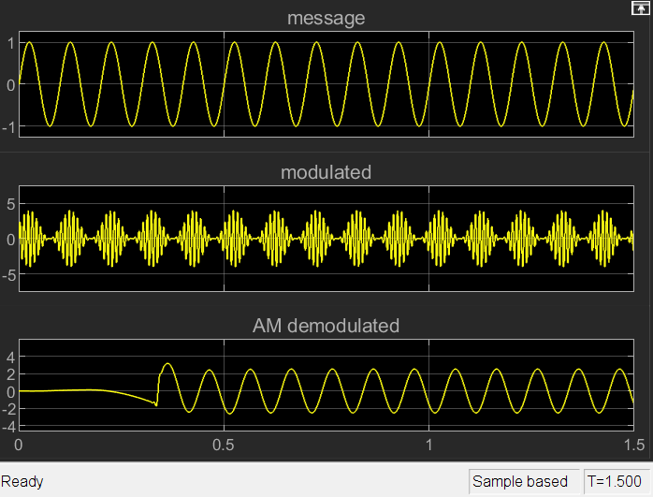
Figure 5: AM with a modulation index of 1 (critical modulation)
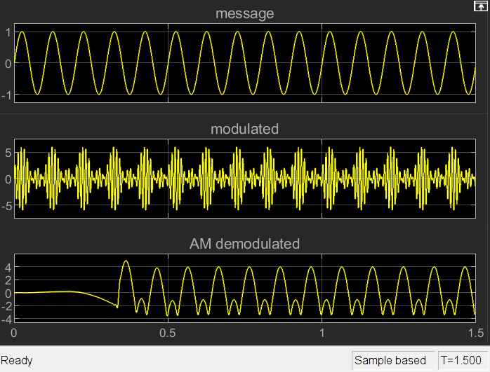
Figure 6: AM with a modulation index of 2 (over-modulation)
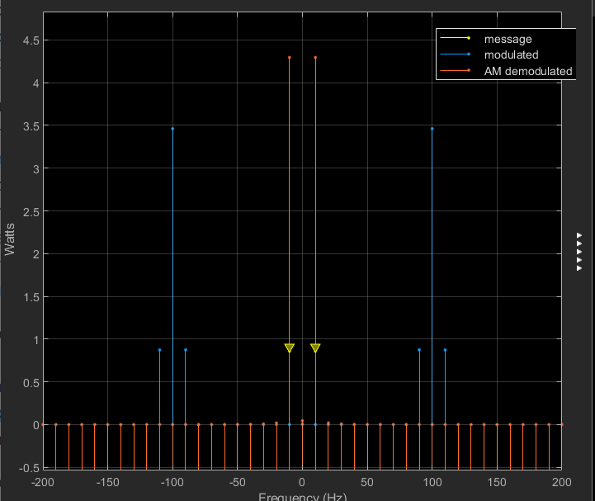
Figure 7: AM Spectrum at critical modulation
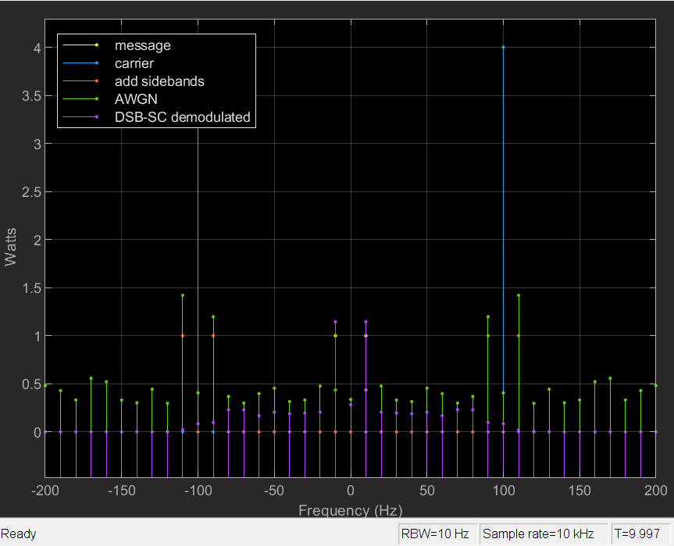
Figure 8: DSB-SC SNR=-20 Spectrum Analysis
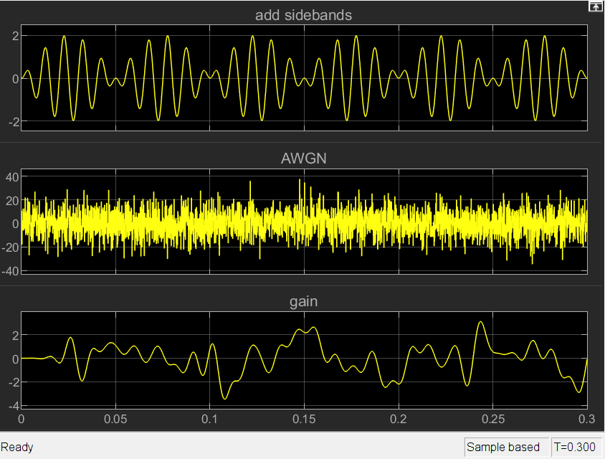
Figure 9: DSB-SC SNR=-20 Scope
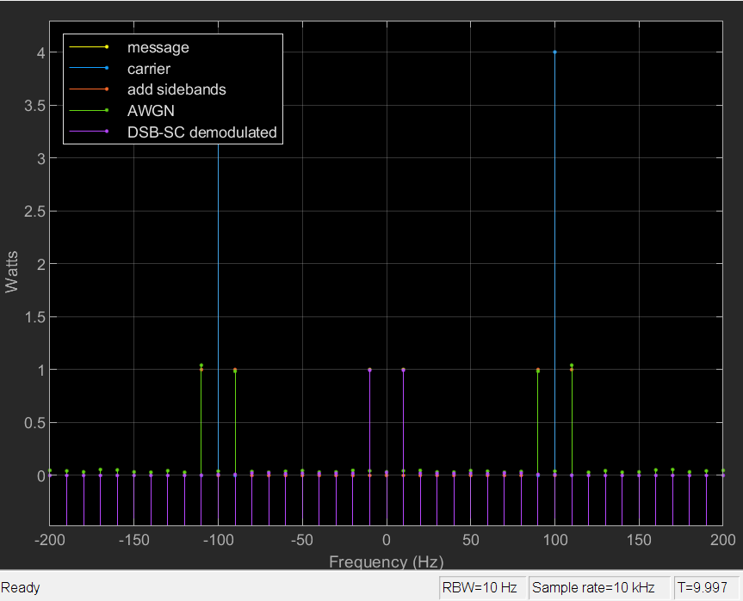
Figure 10: DSB-SC SNR=-10 Spectrum Analysis
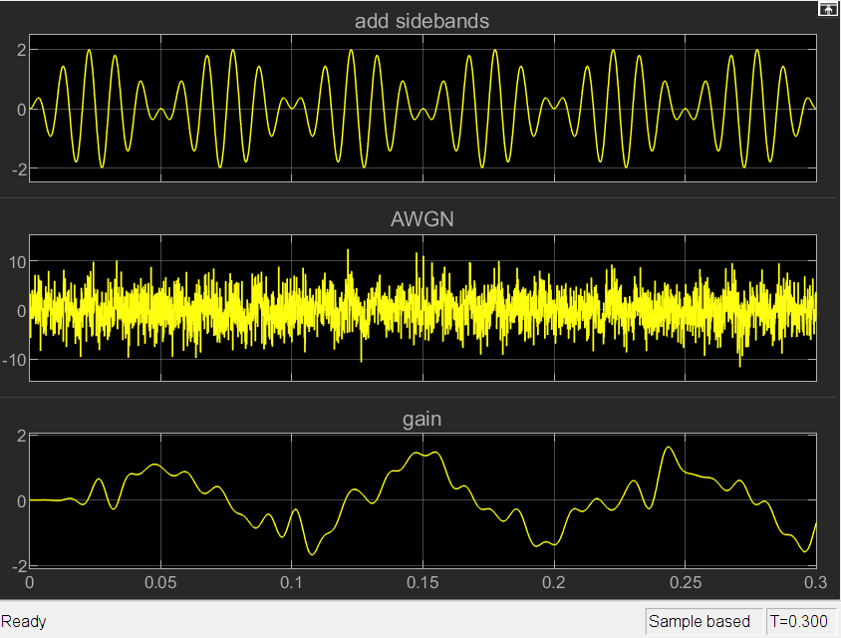
Figure 11: DSB-SC SNR=-10 Scope
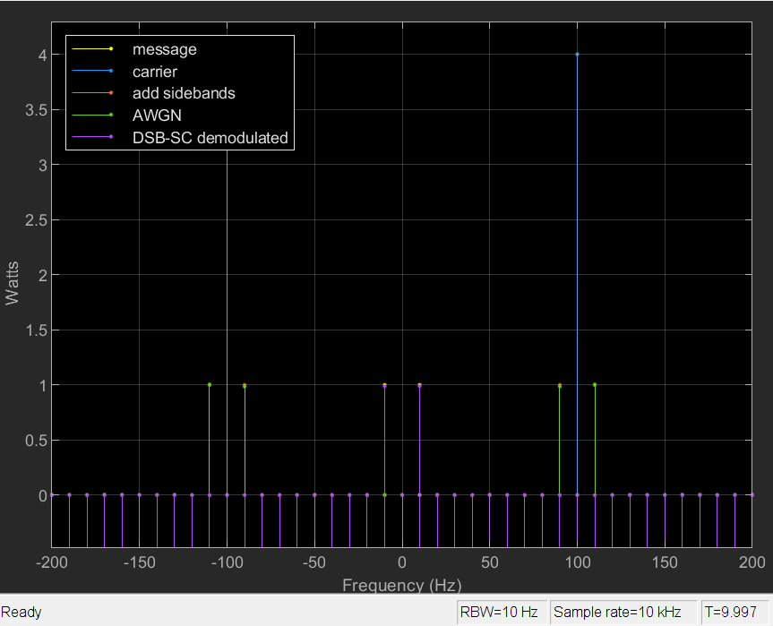
Figure 12: DSB-SC SNR=0 Spectrum Analysis
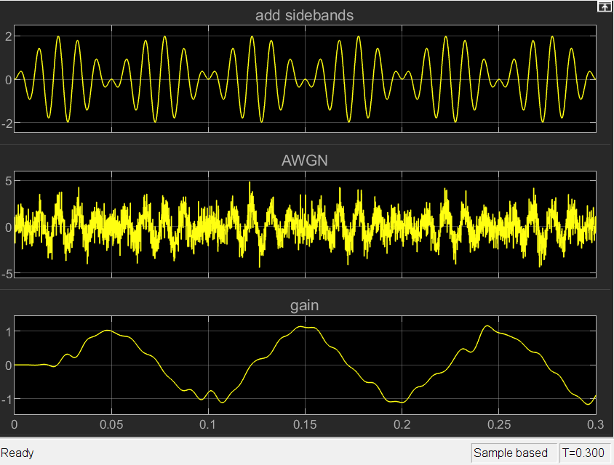
Figure 13: DSB-SC SNR=0 Scope
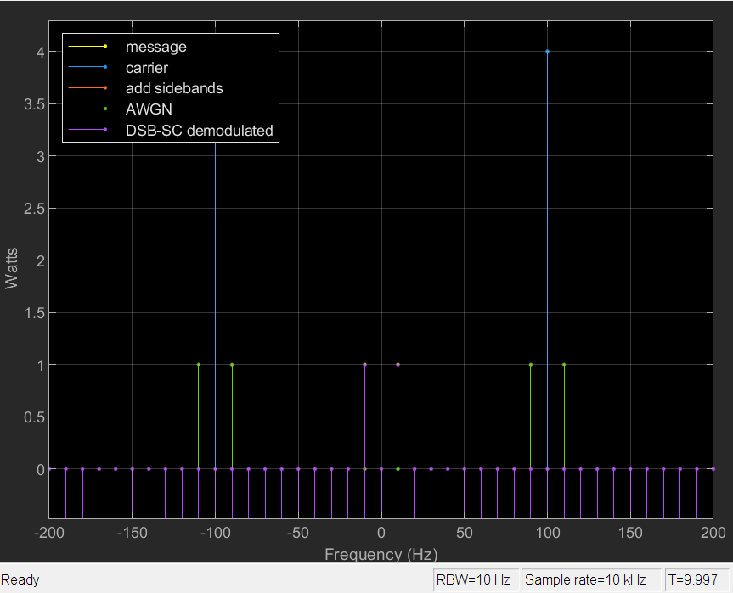
Figure 14: DSB-SC SNR=10 Spectrum Analysis
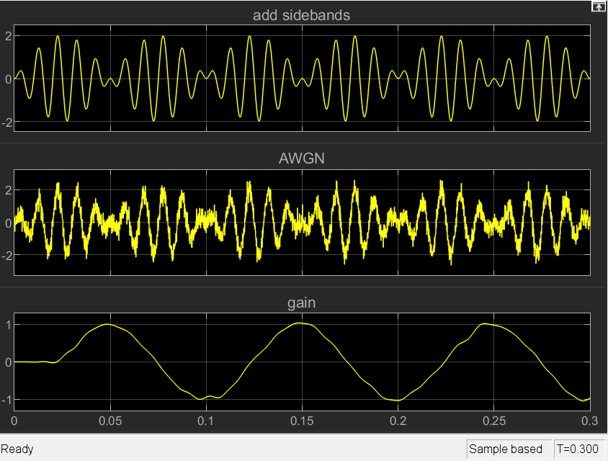
Figure 15: DSB-SC SNR=10 Scope
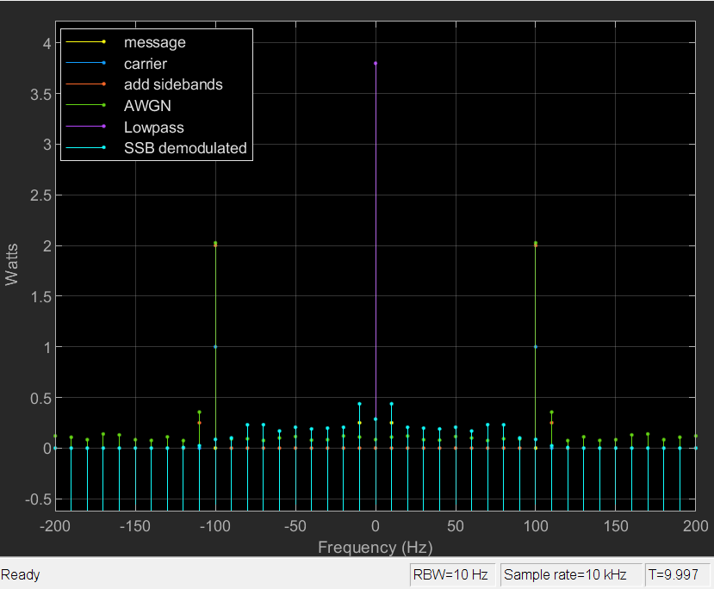
Figure 16: SSB-SC SNR=-20 Spectrum Analysis
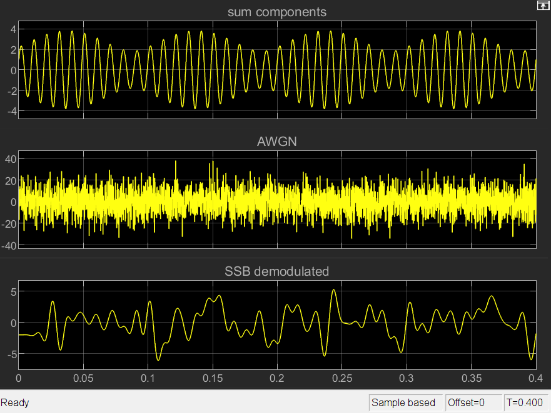
Figure 17: SSB-SC SNR=-20 Scope
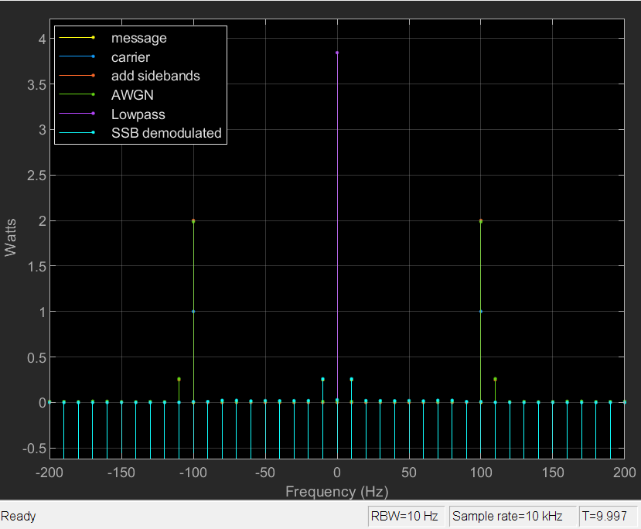
Figure 18: SSB-SC SNR=-10 Spectrum Analysis
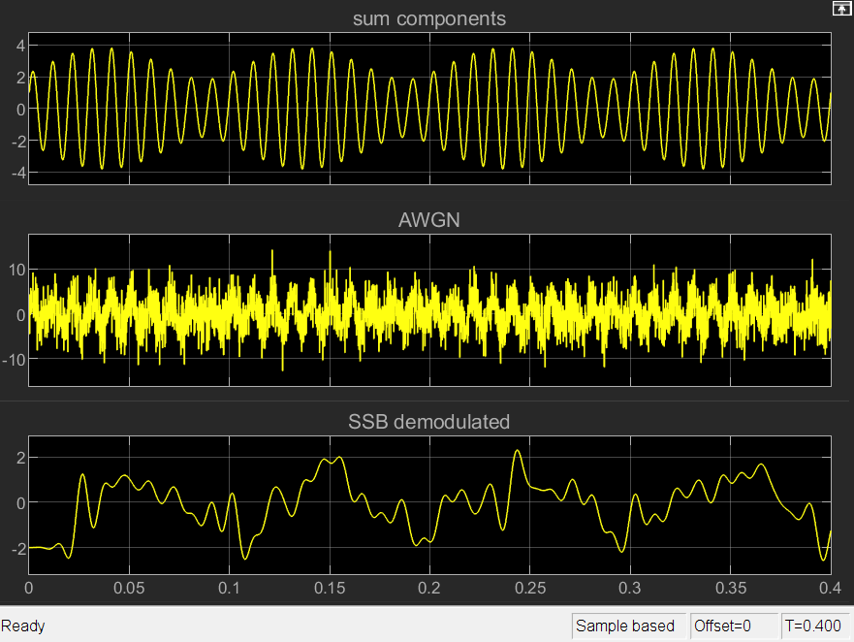
Figure 19: SSB-SC SNR=-10 Scope
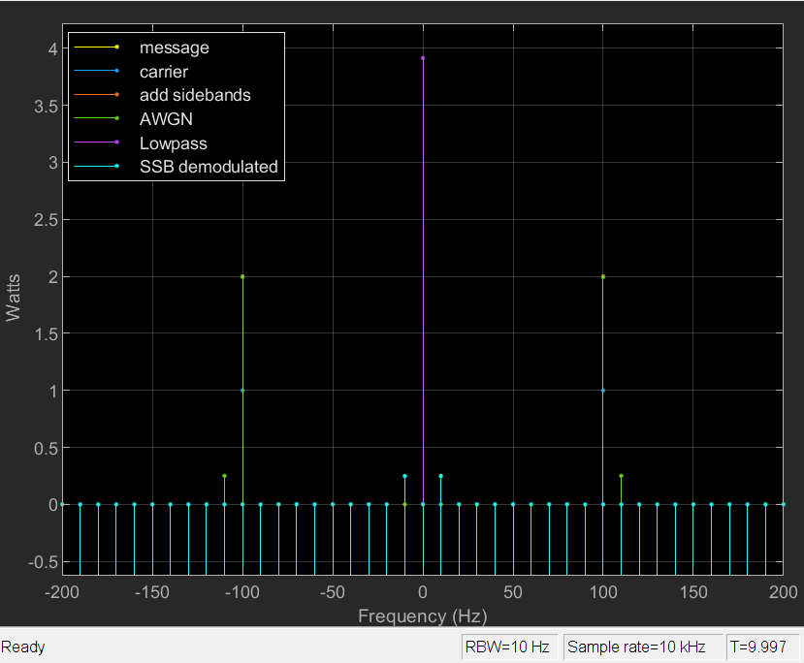
Figure 20: SSB-SC SNR=0 Spectrum Analysis
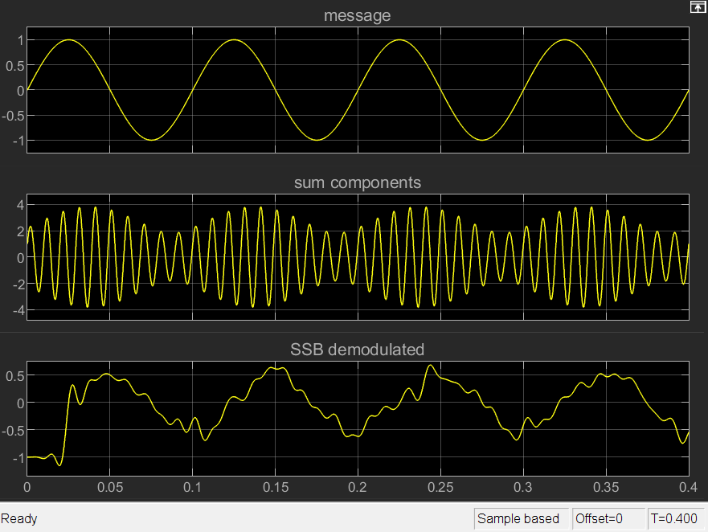
Figure 21: SSB-SC SNR=0 Scope
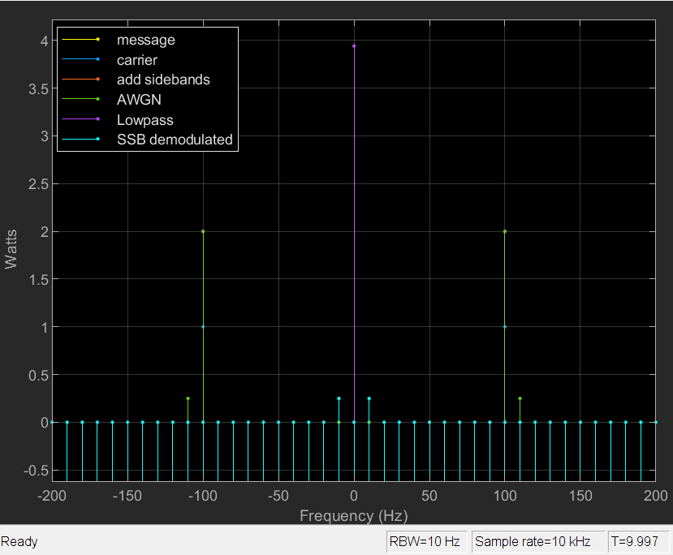
Figure 22: SSB-SC SNR=10 Spectrum Analysis
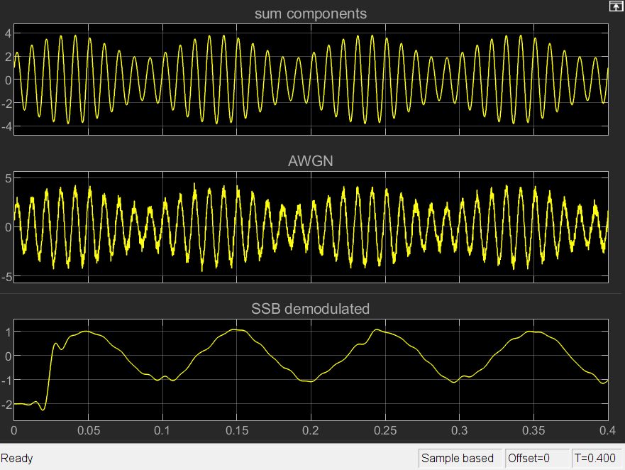
Figure 23: SSB-SC SNR=10 Scope

Analysing the Results
When the AM signal has a modulation index of 0.3, we can observe the nominal operation on the spectrum analyser tool, shown in Figure 7. The modulated signal, drawn in blue, has a carrier power of 3.5 watts, with sidebands at 0.9 watts, or 25.7%.
Adjusting the modulation index increases demodulated signal amplitude, which will increase signal to noise ratio, up until it becomes distorted from overmodulated. This is therefore an important variable to combat noise. To observe the effects of noise, DSB-SC and SSB-SC were deliberately distorted using an AWGN, set to -20, -﻿10, 0, and +10 to test a range of conditions. At -20, significant noise is introduced to the signal (Figure 8 and Figure 16) and renders the demodulated output unusable for both types (Figure 9 and Figure 17).
When the SNR is -10, the spectrum analysers show less noise and more stable demodulated outputs (Figure 10 and Figure 18) but the scopes reveal the signal is still noisy (Figure 11 and Figure 19). Figure 19 shows SSB-SC is producing a heavily distorted signal at -10 SNR while Figure 11 shows DSB-SC’s output is recognizable. This trend continues for higher SNRs; at 0 SNR, DSB-SC performs better than SSB-SC at 0 SNR, with DSB-SC producing a cleaner signal (Figure 13) than SSB-SC (Figure 21). This is due to DSB-SC transmitting 2 sidebands instead of 1, duplicating the information, allowing the receiver to combine them and reduce interference. SSB-SC only has 1 sideband so any distortion to the sideband cannot be removed.
As the SNR increases above 0, the quality of both DSB-SC and SSB-SC approach a perfect recreation of the original message signal. In Figure 15 and Figure 23, the reproduced signal has minimal distortion, although DSB-SC is still cleaner than SSB-SC.
DSB-SC, with a modulation index of 0.5, produces sidebands with 1.4 watts of transmitted power, shown in Figure 14. This is higher than the AM sidebands, meaning more of the power is going into useful communication. Of note, changing the modulation index for DSB-SC had no discernible effect other than scaling the signal amplitude. This is certainly not correct behaviour, so the modulated signal probably has a modulation index of 1 instead of 0.5.
The reason SSB-SC is often preferred over DSB-SC is efficiency; transmitting two sidebands with DSB-SC necessarily requires twice the power. However, Figure 22 shows SSB-SC likely is not being produced correctly in the simulations, as the carrier is not being suppressed and the sidebands are much weaker than expected. (See Figure 16, Figure 18, Figure 20, and Figure 22.) The expected outcome is for the SSB-SC sideband to be twice the power of one from DSB-SC. It’s also possible that reducing the modulation index to 0.5 is the reason for this phenomenon.

Conclusion
When designing a radio transmitter, great care must be taken to ensure the modulation index approaches but never exceeds 1, as higher modulation indexes improve the signal reception up until the signal distorts from over-modulation.
DSB-SC has been found to be more resilient than SSB-SC against noise, but the results are potentially invalid as the author has made at least 2 mistakes while creating the simulations. One mistake is in the DSB-SC simulation, where the modulation index seemingly cannot be changed, and there appears to be another in the SSB-SC simulation which wastes most of the power by allowing the carrier to be transmitted.
Because the findings in this report may not be accurate, future work should independently confirm the results. Therefore, the simulations must be recreated by someone with suitable expertise with radio frequency circuits, to avoid making the same implementation mistakes.

References

[1] | Bell Telephone Laboratories Inc., “Ch. 8 Modulation,” in Telecommunications Transmission Engineering, Volume 1, Second Edition, USA, Western Electric Company Inc., 1977, pp. 189-192.
[2] | The American Radio Relay League, “Single Sideband for the Radio Amateur,” 1970. [Online]. Available: https://www.worldradiohistory.com/BOOKSHELF-ARH/Amateur-and-SW/ARRL-Single-Sideband-for-the-Radio%20Amateur-1970-5th.pdf. [Accessed 03 06 2025].

https://www.worldradiohistory.com/BOOKSHELF-ARH/Amateur-and-SW/ARRL-Single-Sideband-for-the-Radio%20Amateur-1970-5th.pdf
https://collinsradio.org/archives/ssb_fundamentals/Fundamentals%20of%20Single%20Side%20Band-one-file.pdf

