

Student Name: Jowher Ahmed
Student ID: 2437456
Lecturer: Dr Laila Maazouz
Programme: Master of Business Administration
Module: Marketing Management
Module Code: LCMB7024
Word: 2455
Date of Submission: 17th December 2025

Table of Contents
Introduction 1
Element 1: EcoNivra: Segmentation, Targeting, Differentiation, and Positioning (STDP) Analysis for Cadbury 2
1.1: Introduction and Concept Rationale 2
1.2: Analysis of STDP 3
Element 2: EcoNivra: Marketing Mix (4Ps) Strategy 5
Element 3: Appendix 10
Element 4: Critical Reflection on Brand Concept and Strategy Development 11
Conclusion: 13
References 14

Contents of Table
Table 1: EcoNivra Segmentation 4

Contents of Figure
Figure 1: Cadbury 2
Figure 2: 4Ps Model 5
Figure 3: Environmentally friendly Packaging 7
Figure 4: Product Sample 9

Introduction
This portfolio is a case study of the brand development and strategic marketing planning by designing a new brand of premium functional beverage, EcoNivra, for Cadbury. It incorporates prominent marketing models such as STDP and the 4Ps to warrant strategic choices. The critical assessment of the strategy development and pitching process through the portfolio also shows a practical implementation of the marketing theory, market studies and strategic thinking to address the modern demand of consumers and sustainability.

Element 1: EcoNivra: Segmentation, Targeting, Differentiation, and Positioning (STDP) Analysis for Cadbury

1.1: Introduction and Concept Rationale
The selected company is Cadbury, an international brand, which is mostly known as a confectionery product and is currently owned by Mondelēz International (Mondelez International, 2022). The proposed new brand is EcoNivra, a collection of high-quality, clean-label, functional fruit and vegetable juices.
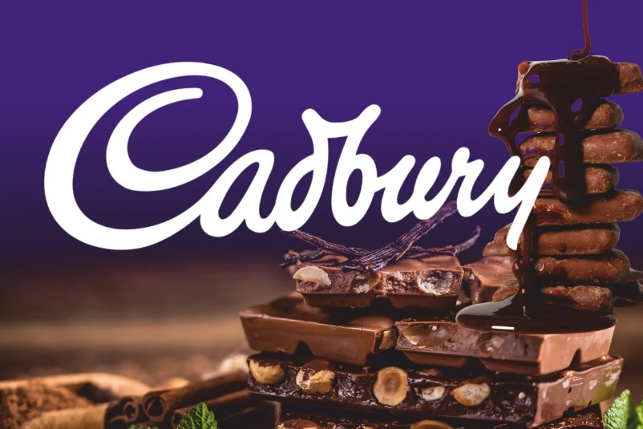
Figure 1: Cadbury
Source: theenterpriseworld
This expansion is strategically essential; the consumer behaviour is changing, and they are no longer spending on high-sugar deli drinks but on functional drinks with reduced sugar levels (Numerator, 2025). The company boasts of a strong brand name and loyalty as its main strength (Mondelez International, 2022). Using this trust, EcoNivra has embarked on a high-growth luxury juice market, which is estimated to hit the highs of 32.1 billion in the next three years due to the need to drink natural, organic, and other functional beverages (Dataintelo, 2024).
The brand captures the interest of the existing market by appealing to two significant megatrends directly:
- Functional Wellness: The consumers are looking at beverages with added value such as prebiotics, vitamins and adaptogens to boost immunity, gut health, and mental clarity (Einar Willumsen, 2025). The EcoNivra contains sugar and vitamin-enriched blends.
- Sustainability and Transparency: Customers are becoming more serious about making purchases that reflect their ethical beliefs, which require sourcing products that are transparent and environmentally friendly (Canable, 2025; Unseen UK, 2025). The parent company that owns EcoNivra is determined to be environmentally friendly, which explains why the company is based on ethical sourcing and eco-friendly packaging made of recyclable materials (Cadbury World, 2020).

1.2: Analysis of STDP
Segmentation and Targeting:
Segmentation
EcoNivra uses a multi-dimensional concept of market segmentation:
Segmentation Type | Key Market Segment | Description
Demographic | Affluent, high-income adults (25–45) | Individuals with the disposable income to afford premium products and a higher likelihood of adopting wellness trends.
Psychographic | Health Enthusiasts & Ethical Shoppers | Consumers who value natural ingredients, fitness, clean-label transparency, and actively seek products that minimize environmental impact (Synergy Food Group, n.d.).
Behavioural | Functional Benefit Seekers & Loyal Premium Buyers | Consumers who regularly purchase products for specific benefits (e.g., immunity boost, stress relief) and exhibit strong loyalty to trusted, high-quality brands (Grand View Research, 2025).
Geographic | Urban and Metropolitan Areas | Locations with higher population density and greater access to specialized distribution channels like health food stores and high-end supermarkets (Mordor Intelligence, 2025).
Table 1: EcoNivra Segmentation
Target Audience
The major target market is the "Conscious Well-Seeker". They are wealthy millennials (2840) that live in cities. They are time-starved, yet health-wealthy in their motives, desiring the convenient on-the-go drinks that will organically fit in their dynamic lifestyle (Numerator, 2025). Most importantly, they perceive their purchases as a statement of their value, i.e., the ethical sourcing and sustainability records of the product are as substantial as its low-sugar content and utility. They are very sensitive to online marketing and suggestions by influencers (Tring, n.d.).
Differentiation and Positioning:
Differentiation
EcoNivra is differentiated in three aspects:
- Efficacy, Functional: Numerous premium juices concentrate on cold-pressed freshness only, whereas EcoNivra is based on scientifically confirmed condition-specific blends (e.g., particular prebiotic/probiotic strains, doses of adaptogen-specific adaptogens).
- Ethical Foundation: EcoNivra will leverage the equity experience of Cadbury in sourcing (e.g., the Cocoa Life Program) with an auditable Ethical sourcing program of all fruits and vegetables, ensuring fair wages and transparent supply chains, which is a significant competitive advantage (Unseen UK, 2025).
- Brand Trust: It enjoys the immediate brand credibility with the Cadbury name as a ready entry point to the move towards indulgence to wellness, which lessens the riskiness that is usually linked to new and unfamiliar health brands.

Positioning
The positioning that EcoNivra wants is:
"The Premium Functional Juice that Delivers Health with a Conscience, from the Brand You Already Trust."
It is a Value-Based Positioning and Benefits-Based Positioning. It aims at establishing itself as the first option between Wellness and Responsibility. Competitively, it will position itself higher than mainstream refrigerated juices (such as Tropicana) and will directly compete with the high-end cold-pressed brands, as it will have better functional advantages and greater ethical transparency at a reasonable premium price (Kennesaw Juice, 2025). The brand story will be based on change: the Cadbury tradition of treating will be shifted to a tradition of well-being in the modern age.

Element 2: EcoNivra: Marketing Mix (4Ps) Strategy
To be able to support its premium, sustainable, and functional positioning, the Marketing Mix (4Ps) used in EcoNivra should be integrated. Utilising the capabilities of Cadbury will guarantee a successful market penetration, and differentiation in each of the Ps will focus on the Conscious Wellness Seeker and the rise of the functional drink market (Mordor Intelligence, 2025). The positioning strategy will be based on the internal strength (equity of Cadbury) and external trends (health and sustainability).
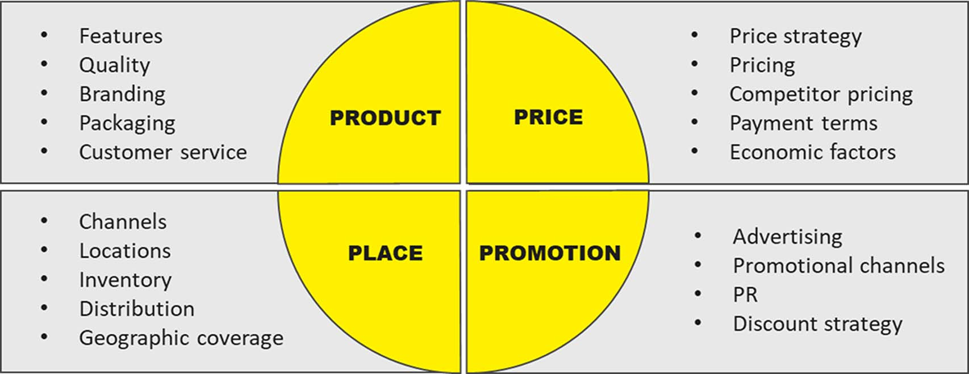
Figure 2: 4Ps Model
Source: vcmo
1. Product Strategy: Functional Wellness and Ethical Sourcing
The Product element should show that EcoNivra cherishes the main values of high quality, health, and ethical responsibility, which will make it take a higher price.
- Clean Label and Functional Benefits: EcoNivra will sell an assortment of fruit and vegetable juice combinations with low amounts of natural sugar and with no additional additives, preservatives, or artificial sweeteners (IMARC Group, 2025). It is concentrated on functional fortification, like the inclusion of prebiotics to promote gut health, the intake of a particular amount of B vitamins to energise the body, or adaptogens to deal with stress. This is consistent with the booming consumer market demand for beverages with proactive health effects (Einar Willumsen, 2025).
- Ethical Sourcing and Quality: The product will be prepared by using high-pressure processing (HPP) as much as possible to preserve most of the nutritional value and fresh taste, unlike other competitors who have been heat-pasteurized. More importantly, EcoNivra will follow a strong ethical sourcing ethos when sourcing ingredients, and it will use the expertise of the supply chain of Mondelēz International to control transparency and fair labour practices to support the moral foundation of the brand (Cadbury World, 2020).
- Environmentally friendly Packaging: Packaging will be a key point of distinction in order to attract the target market of the environmentally conscious segment. The bottles will be produced using 100% of Post-Consumer Recycled PET (rPET) or some other lightweight fibre-based material, with instructions on how to recycle clearly written on the bottle. This sustainability is critical, and buyers are basing their buying choices on environmental effects more often than ever before (Genedge, 2025).
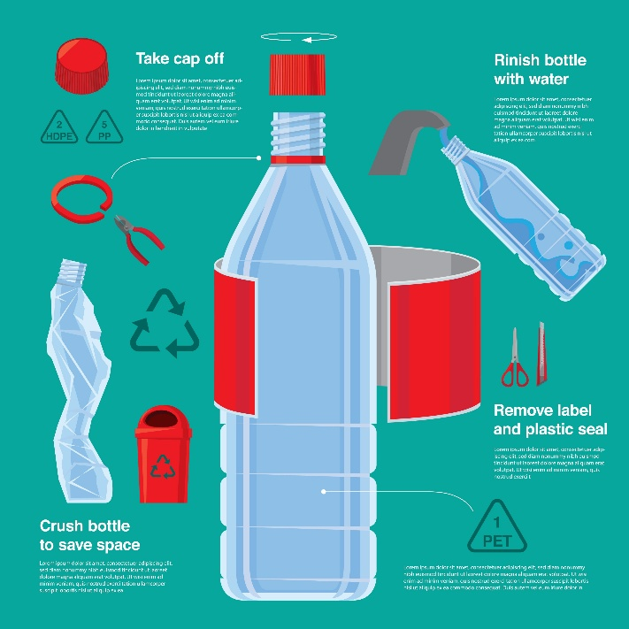
Figure 3: Environmentally friendly Packaging
2. Pricing Strategy: Value-based price and premium pricing
EcoNivra will focus on a Premium Pricing Strategy in order to correspond with its excellent quality ingredients, developed production technologies, and ethical position.
- Value-Based Pricing: The price will be higher than in the traditional mass-market juices but competitive within the high-end, clean-label, and functional category based on the perceived value to the Conscious Wellness Seeker. This value is based on the functional value, open sourcing and sustainable packaging, for which customers are ready to pay a premium (Kennesaw Juice, 2025).
- Skimming Element: This pricing component will be applied during the early launch phase in the select urban markets, where the skimming element will be required to aggressively take in early adopters (the influential, high-income segment) to build a strong brand image of exclusivity and quality before it may be rolled out to wider markets (IIDE, 2025).
- Pricing Segmentation: Pricing will be more flexible between the different packages (e.g., individual grab-and-go shots or multi-serve bottles) in order to reflect different consumption occasions, although the premium per-ounce price will remain the same.
3. Place Strategy: Selective and Omni-Channel Distribution
The Place strategy dwells on a selective distribution model in order to enhance exclusivity and make the product available in the places where the target customer purchases premium health goods.
- Selective Physical Distribution (Off-Trade): The first form of distribution will be focused on the high-end supermarkets, organic food stores, and speciality health boutiques in the major cities (Mordor Intelligence, 2025). This targeted strategy will provide the brand presence among the current high-quality rivals, as well as in the retailing stores, which will match the aesthetic and value offer of EcoNivra.
- On-Trade Channels: Placement will be done strategically in lifestyle cafes, high-end gyms, and corporate wellness areas so as to introduce trial and visibility to the active segment that is health conscious (Mordor Intelligence, 2025).
- E-commerce and Direct-to-Consumer (DTC): With the strong platform of supply chain and digitalisation, Mondelēz International will have an exclusive solution e-commerce portal which will provide subscription service and special offers. The channel offers more direct customer data and builds loyalty, as well as providing more control over the brand experience and inventory (The Strategy Story, 2023).
4. Promotion Strategy: Online, Educational, and Value-Based
The Promotion strategy will be based on the extensive use of digital channels to attract the target audience and focus on the main distinguishing features of the brand: health, sustainability, and ethics.
- Digital and Social Media Marketing: The campaigns will be graphic and will be implemented primarily on websites such as Instagram and TikTok, which will aim at educating the consumers about the functional ingredients (e.g., advantages of prebiotics), as well as ethical sourcing. The video material will demonstrate the transparency of the farm-to-bottle process, fostering a sense of trust (Wildnet Technologies, 2025).
- Influencer Collaboration: The partnerships will be made with wellness experts, fitness activists, and trusted real-life environmentally responsible influencers whose personal brand values perfectly fit the mission of EcoNivra and will offer real endorsement and tap into ready communities (Tastewise, 2024).
- Public Relations (PR): There will be a high PR emphasis on lifestyle and business media to emphasise the sustainability and the corporate social responsibility (CSR) as part of the brand and present EcoNivra as the leader in ethical beverage innovation, as opposed to a mere product (The Missing Ingredient, 2025).
- Experiential Marketing: Pop-up tastings and collaborations with wellness fests in urban areas will provide a chance to sample the product directly and form a memorable and interactive experience with the brand, which strengthens the high-end lifestyle association (Wildnet Technologies, 2025).
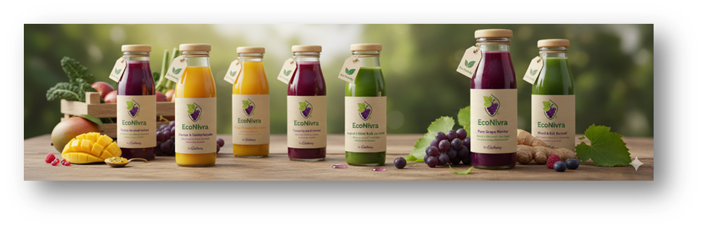
Figure 4: Product Sample

Element 3: Appendix
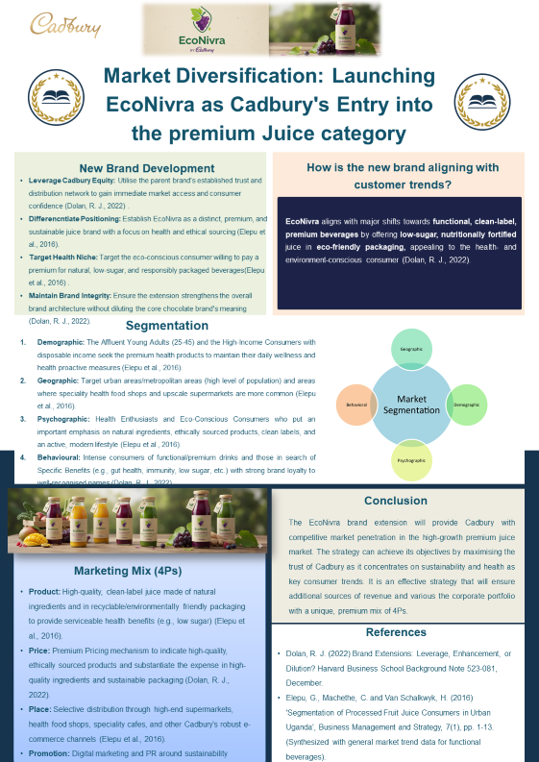

Element 4: Critical Reflection on Brand Concept and Strategy Development
The process of creating a new brand concept and overall marketing strategy was eminently educational and helped me realise the complicated integration needed between the foundational values of a brand and its performance. The difficulty was that, first, a conceptual market requirement, a demand for an environmentally friendly functional product, needed to be transformed into a concrete, value-orientated brand identity. This procedure was a hard discipline challenge and a measure of improving my strategic thinking and market analysis.
1. Reflecting on the Strategy Development
The greatest lesson that occurred during the strategy development process was that the cohesion between the Brand Strategy and the Marketing Mix (4Ps) was a must. The concept of brand was created in such a way that it was supported by the idea of sustainability and high quality, which immediately limited the Price and Place variables. My interpretation was quick to understand that the most minor incongruity in the distribution channel or pricing model would offset the very core brand promise. This involved the careful, fact-based decision-making, which necessitated a greater level of critical analysis and acquisition of information on primary and secondary research to justify assumptions, especially in relation to competitor pricing and consumer readiness to pay extra. The biggest dilemma in this case was the fact that the projected Return on Investment (ROI) must be realistic considering the cost base of a highly ethical and sustainable supply chain.
2. Costume Reflection on Pitch Preparation and Delivery
The development and presentation of the marketing strategy presentation was a specific learning curve, which was largely concentration and persuasion-related. The pivotal observation here was the change from technical narration to strategic narrative. A written strategy has to be effectively documented, but a pitch must be radically concise and emotional. I was required to reduce the months of intricate studies to a matter of 10 minutes and concentrate only on the distinct value proposal, market opportunity, and the estimated financial viability.
The important stakeholder communication skills were acquired by practice, as I learnt to expect difficult questions, especially on scalability and risk management. Altering my vocal modulation level, visual aids, and eye contact helped me to achieve a significantly better performance in delivery and establish trust and engagement. But I realised that my most important concentration was too much on the description of the problem at the expense of the fact that I was losing so much valuable time making a powerful, compelling appeal to action.
3. Future Enhancement and Critical consideration
The whole exercise taught me a lot of analytical skills – no longer theoretical application, but practical application in the market design. In order to improve my strategy in similar projects in the future, I will have to pay attention to two points:
- Improved Financial Modelling and Risk Analysis: As long as I developed projections, future courses of action should consider more advanced contingency planning and sensitivity analysis (e.g., what if prices of raw materials go up by 15 per cent?). This involves the incorporation of more financial modelling at the earlier stage of strategy to put the business model to the test.
- Iterative Customer Testing: I was very dependent on market research, but in the future, I would rely on quick small-scale testing through digital channels (A/B testing of messages, mock landing pages) during concept testing. This nimble methodology would be able to give real-time and quantitative feedback to the strategy before substantial resources are likely to be tied up.
A combination of more robust financial projections with an ongoing, data-based validation cycle can enable me to make sure that the future concept of the brand is not just strategically viable but also highly stress-resistant to the actual market forces.

Conclusion:
This portfolio demonstrates the process of developing a new premium brand with an established organisation that integrates market analysis, strategic planning, and critical reflection. It features the concept of EcoNivra to emphasise the effects of consumer behaviour trends, sustainability, and functional wellness on the current brand strategy. The STDP framework and marketing mix were employed to ensure strategic coherence, while the critical reflection highlighted the importance of financial realism, customer validation, and persuasive communication for the successful implementation of the brand.

References
Cadbury World. (2020) Human Rights Due Diligence and Modern Slavery Report 2020. Available at: https://www.cadburyworld.co.uk/media/xxmpnkmu/mdlz-hrdd-and-modern-slavery-report-2020.pdf [Accessed 1 December 2025].
Canable. (2025) 6 Key Trends Shaping the Beverage Industry in 2025. Available at: https://www.canable.co/blog-posts/6-key-trends-shaping-the-beverage-industry-in-2025 [Accessed 1 December 2025].
Dataintelo. (2024) Premium Juice Market Research Report 2033. Available at: https://dataintelo.com/report/premium-juice-market [Accessed 1 December 2025].
Einar Willumsen. (2025) Functional Beverage Trends in 2025: What You Need to Know. Available at: https://einarwillumsen.com/news/functional-beverage-trends-2025/ [Accessed 1 December 2025].
Grand View Research. (2025) Fruit And Vegetable Juice Market Size | Industry Report, 2033. Available at: https://www.grandviewresearch.com/industry-analysis/fruit-vegetable-juice-market [Accessed 1 December 2025].
Kennesaw Juice. (2025) Why Premium Juices Attract More Shoppers To Your Store. Available at: https://www.kennesawjuice.com/blog/why-premium-juices-attract-more-shoppers-to-your-store [Accessed 1 December 2025].
Mondelez International. (2022) 2022 ESG REPORT. Available at: https://downloads.ctfassets.net/qggsjlmpzfmx/2QNjwYM1vENKZhKiys6EwL/e54e7a6059a55215a606e53e87678af9/2022_MDLZ_Snacking_Made_Right_ESG_Report.pdf [Accessed 1 December 2025].
Mordor Intelligence. (2025) Juices Market Share, Size & Growth Outlook to 2030. Available at: https://www.mordorintelligence.com/industry-reports/global-juices-market [Accessed 1 December 2025].
Numerator. (2025) Beverage Behaviors: The Stories Shaping Drink Trends in 2025 and Beyond. Available at: https://www.numerator.com/resources/blog/beverage-trends/ [Accessed 1 December 2025].
Synergy Food Group. (n.d.) How to Market Your Juice Brand: Strategies for Success. Available at: https://www.synergyfoodgroup.com.au/how-to-market-your-contract-juice-manufacturing-business-strategies-for-success/ [Accessed 1 December 2025].
Tring. (n.d.) Fruit Juice Branding and Marketing Strategies. Available at: https://www.tring.co.in/brands/juice [Accessed 1 December 2025].
Unseen UK. (2025) 2025 chocolate scorecard: choose ethical chocolate this Easter. Available at: https://www.unseenuk.org/2025-chocolate-scorecard-choose-ethical-chocolate-this-easter/ [Accessed 1 December 2025].
Genedge. (2025) Eco-Friendly Beverage Packaging Solutions | Market Trends. Available at: https://genedge.org/resources-tools/eco-packaging-solutions-changing-beverage-packaging-market-for-good/ [Accessed 1 December 2025].
IIDE. (2025) Comprehensive Marketing Mix Of Cadbury - 4Ps Included. Available at: https://iide.co/case-studies/marketing-mix-of-cadbury/ [Accessed 1 December 2025].
IMARC Group. (2025) Functional Beverages Market Size, Share & Forecast 2033. Available at: https://www.imarcgroup.com/functional-beverages-market [Accessed 1 December 2025].
Mordor Intelligence. (2025) Functional Beverages Market Size, Share & Industry Report, 2030. Available at: https://www.mordorintelligence.com/industry-reports/functional-beverage-market [Accessed 1 December 2025].
Tastewise. (2024) 6 Beverage Marketing Strategies for 2025. Available at: https://tastewise.io/blog/beverage-marketing [Accessed 1 December 2025].
The Missing Ingredient. (2025) 2025 Digital Marketing Guide For Food and Beverage Brands. Available at: https://themissingingredient.com/2024-digital-marketing-guide-for-food-and-beverage-brands [Accessed 1 December 2025].
The Strategy Story. (2023) Cadbury SWOT Analysis. Available at: https://thestrategystory.com/blog/cadbury-swot-analysis/ [Accessed 1 December 2025].
Wildnet Technologies. (2025) 10 Effective Food and Beverage Marketing Strategies for 2025. Available at: https://www.wildnettechnologies.com/blogs/10-effective-food-and-beverage-marketing-strategies [Accessed 1 December 2025].

