A Post
Internship
Critical Review

Rachel Vetter 1807006
March 2020

BMSP6003 Internship and Volunteerism
Jessica Shore

1.0 Abstract

Seen by many as an essential part of University education. Internships offer students a unique insight into the work environment, offering real world experiences, team building, increased work ethics and building on their core principles. This report lays out the various concepts the students were required to undertake over the internship, as well as the interaction they were to required have with their lecturers and workplace provider. Several of the required items of paperwork needed before and after the internship process have been included in order to aid explanation.

2.0 Contents

1.0 Abstract ………………………………………………………………………………….. 2
2.0 Contents …………………………………………………………………………….……. 3
3.0 Introduction ……………………………………………………………………………… 4
4.0 Internships……………………………………………………………………………..…. 5
5.0 Analysis of internship …………………………………………………………….……… 7
5.1 The Application Process…………………………………………………….……. 7
5.2 The NUS Training Day Bristol…………………………………………………... 8
5.3 Pre-Internship Paperwork………………………………………………………… 8
5.4 SMART Objectives………………………………………………………………. 9
5.5 Gantt Chart……………………………………………………………………… 11
5.6 Skills Audits…………………………………………………………………….. 12
6.0 The Internship…………………………………………………………………………... 13
6.1 Communication………………………………………………………………….13
6.2 Resources……………………………………………………………………….. 14
6.3 Overall Experience….……………………………………………………………14
6.4 Post-Placement Paperwork and Skills Audit……………………………………. 15
7.0 Recommendations……………………………………………………………..………... 15
8.0 Conclusion ……………………………………………………………………………… 16
9.0 References ……………………………………………………………………………… 17
10.0 Appendix ……………………………………………………………………………… 20

3.0 Introduction
Internship and volunteerism are key subjects studied by level six students on the BA Business Management Degree. The programme’s process began in spring 2019 with discussions regarding what was expected, duration and resources for finding perspective (prospective?) businesses. Seen as an opportunity for students to gain experience by being part of the workforce, while also bringing together the academic and professional organisations (Sides & Mrvica, 2017). The onus was placed on students to organise their own placements, including producing up to date CVs, filling in online applications and engaging with various businesses. This report will break down the whole process from conception to completion. Evaluating what processes worked and looking at those that did not. It will also describe a number of theories regarding what internships are and their advantages and disadvantages to the student. A number of items have been included within the appendix in order to bring relevance to subjects discussed and the relationship to this internship.

4.0 Internships -
“The only source of knowledge is experience” (Einstein, 1995).
Research over a range of disciplines has highlighted a number of advantages of participation in an internship (Kelly, 2007). Internships within education require students to actively work often as a prerequisite to their current programme of study, this can often offer the student extra academic credit however, this is not always the case. The completion of Internships affords the student work-based experience and gaining knowledge along with a number of other benefits. However, it is important to note that in addition to the business or institution the student is employed within, the school will also reap benefits (Templeton, Bennett, & Updyke, 2012). These work placements or internships offer the practical integration and consolidation of the student’s actions and thoughts, through the incorporation of classroom learning within a real-world experience (Pitts, 1992). Through this the student builds a foundation of core principles and values which are essential for success when they enter the work place on completion of their degree (Ruhanen & Breakey, 2013). Moreover, participation with an internship can offer a student a wealth of significant practical business understanding and experience, that is impossible to obtain through class-based learning alone (Young , Wright, & Stein, 2006). Furthermore, this form of work-based learning offers the students the ability to refine their critical thinking, communication and interpersonal skills (Raymond, McNabb, & Freder, 1993). Clark 2003, states that those students who undertake internships become more engaged within the classroom environment, he continues that participation levels increase and students employ a better understanding of the relevance of the theoretical methods being taught (Clark, 2003). It is essential that any internship is appropriately monitored. Prior to commencement and throughout the placement, students must be made aware of who their coordinator or mentor is and remain in close contact throughout the experience. This can allow for changes to be made so that they can achieve the most effective learning experience while also offering an important level of support and guidance to the participant (Berklee, 2020).
Knouse and Fontenot (2008), state that internships can assist students in becoming more marketable once their course has ended. This is because it allows them to cultivate aptitudes, namely practical skills and experiences that potential employers expect from new graduates. They go on to state that during the internship process students are often subjected to a number of ethical aspects that they would not be exposed to within their learning environment (Knouse & Fontenot, 2008).
Solnet et al (2009) state that interns have the ability to offer an organisation unbiased opinions and skills. If an organisation is open to absorb and learn from the students than they could have the opportunity to transform some of these concepts into reality, or include students in some of its decision making processes (Solnet, Krali, Kay, & DeVeau, 2009).
The other beneficiary of the internship as mentioned above is that of the business school and faculty. These can be achieved through the assessment of students’ progress both during and after the completion of the internship, attained by using various academic activities, including the completion of key skills and assignments. These activities will allow lecturers to measure and assess if there are any improvements required to certain areas of the school’s programme and courses. This form of measured learning can be applied by the school when evaluating a student’s success at attaining learning objectives. It can also aid the implementation of target setting, put in place to improve individual a student’s personal achievement levels (AACSB International, 2012).
There are of course those theorists who believe that interns are just an unpaid assistant rather than a potential employee. Often taking place over short periods of time they neglect to offer any real education value. In truth many intern positions are created to carry out tasks which the organisation’s employees are unwilling to do themselves. (Karrera, 2017). Figiel believes that unpaid internships can lead to students seemingly paying for the privilege of gaining experience, through the combination of ever growing expenses for items such as travel and the loss of personal time along with elevated university fees paid (Figiel, 2013).

5.0 Analysis of internship
The following sections will break down the procedure taken at the beginning and during the internship process.
5.1 The Application Process
In May 2019 the application process commenced for level six internships. Lecturers offered a number of choices to students regarding the options available for obtaining positions. One of these options was the newly formed NUS for Good initiative. Launched in 2018 by the NUS predominantly as a mediator service, linking compatible students to progressive sustainable business. This service also offers the participants support and training they may require prior to commencing the placement (NUS , 2018).
The NUS for Good initiative was the chosen service used to apply for the 2019/2020 internship. However, due to the programme still being in early development, the site failed to offer extensive information and only offered the user a limited number of businesses to select from. In May 2019 two businesses were referred through the service, including The Business School at UWTSD Carmarthen. The description of the position was that of marketing a number of courses including the new Social Enterprise Management Certificate, with a purpose of signing up a minimum of 10 students.
By the end of May 2019, a meeting was organised with Jessica Shore the workplace supervisor for the Business school. The outline of the position and the expectations were presented. A number of essential dates were booked; however, the promotional ideas were left to be completed by the student involved.

5.2 The NUS Training Day Bristol
This event was organised by the NUS as an opportunity to introduce students and lecturers to the different universities involved as well as those facilitating the course (NUS , 2018). After welcomes had taken place the morning was taken up with a Lecture on Sustainability. The Business and Management degree students from UWTSD study all aspects of business through the prospective of sustainability and ethical thinking (UWTSD, 2019), So this part of the day was a little like preaching to the converted. During the afternoon students were advised on the importance of completing key skill audits before and after undertaking the internship as a guide to what personal goals they had achieved, along with a GANT chart to act as a guide for the most productive completion of the internship.
This event did not really offer the students any information or guidance that they could not obtain from lecturers. The other Universities taking part did not mingle or offer any advantage to the UWTSD students attending. The event would need to become more structured and informative to be useful to future students in forthcoming year.

5.3 Pre-Internship Paperwork

As part of the requisite for participation on the internship programme, several important documents must be completed. These include a Risk Assessment found in appendix 1, it is essential that all students and employers are aware of any potential risks that might arise during the duration of the internship. A completed risk assessment will also allow a business to control any potential health and safety issues, through establishing preventative measures if required. These assessments are required by law (HSE, 2019). The Health and Safety Questionnaire see Appendix 2, allows the employer and student to identify who is responsible for each aspect of health and safety within the business (HSE, 2018). The questionnaire also includes a role specific section, to aid identification of aspects that might affect the safe completion of the internship.
The final two pieces of paperwork required, are the Induction check list Appendix 3 and the Placement Provider Agreement Appendix 4. The induction check list acknowledges it is utilised to ensure the employer has conveyed all necessary information to the student before the commencement of the internship. The Placement Provider Agreement is a contract completed by the employer agreeing to adhere to all terms and conditions relating to the full term of the internship.
5.4 SMART Objectives

Setting specific relatable goals is a widely practiced trait used within businesses, organisations and education programmes over all sectors (Day & Tosey, 2011). By applying a conceptual framework as an instrument when establishing goals, students provide themselves with a reliable platform that allows future work to be both developed and assessed. Without these targets, any structured plan conceived by the student would lack justification, future strategies would be without relevance, actions made would have an absence of direction and the student would lack purpose (Mullins, 2016). Furthermore, it is essential that any goals set, are appropriately constructed in order for them to provide reliable benchmarks, allowing outcomes to be correctly observed and appraised (Bipp & Kleingeld, 2011). Therefore, the setting of goals must be formulated using a strong logical formation in order for it to be successful (Oracla, 2012).
The origins of the acronym SMART, have been widely debated, Lawlor (2012) states that SMART has emerged from several forms of literature from the 1950’s to the 1990’s organically moulding into the abbreviation used today (Lawlor, 2012). The acronym stands for five key criteria Specific, Measurable, Attainable, Realistic and Timely. By insuring that the work to be undertaken by the student within the internship is linked to these goals the job to be undertaken can be deemed appropriate to the business school’s programme (Williams, 2012). Figure 5 in the appendix shows the Smart objectives drawn up prior to commencement of the internship. When composing the objectives, links were added to the skills audit to pinpoint where developments within certain areas could be achieved.
Completion of the SMART goals concluded that the tasks set out by the UWTSD Business school were:
- Specific: Defined outline of what was expected including targets expected
- Measurable: the final number of students signing up would be tracked and documented
- Achievable: with the resources supplied the objective was attainable
- Realistic: The targets given were not too high and the placement had the full backing of the Carmarthen Business School.
- Timely: Time limits were in place for students wishing to enrol by September 2019, however, the objectives allowed for those wishing to enrol 2020,

The SMART goals were a useful tool in breaking down the description of tasks within the job specifications. It offered an awareness of the resources that would be needed to complete the tasks assigned, along with the essential connections required with relevant departments and the people within them.

5.5 Gantt Chart
A requirement of the internship programme was to design and produce a Gantt Chart. Simplified a Gantt Chart is a plan that lays out what jobs or actions are required over a specific period as well as whom is responsible for each task. Its design follows an X.Y axis in which all the jobs or tasks required over the whole project, are laid out on the vertical axis. The timings and expected duration of each task is signified within the horizontal axis (Nordqvist, 2019). The termed Gantt Chart came from creator Henry Gantt in 1910, seen by some as a tool used predominantly within project management, it is now widely used over the business industry. Use of this tool within an internship offers the student a clear visual image of the whole project, from its inception to completion including timelines and deadlines. It aids in time management, which is essential within any busy work environment, while offering reminders of time sensitive goals for students. Critically it can lead to efficient communication (Bajaj & Gogia, 2019). Naylor (2014) believes that it is all too easy to over complicate and produce a chart excessively complex, by adding numerous dependencies and tasks. Students should therefore produce a clear and simplistic progress strategy (Naybour, 2014).
The Gantt chart produced for the 2019 internship, see appendix 6. was completed once the internship had begun. At this point many of the appointments and dates had already been booked, so there was a limit to the forward planning required. Due to these factors the chart took on the guise of a diary, offering the user a guide to essential dates and events. Therefore, it was not used in association with its original purpose.

5.6 Skills Audit
Documentation of the desired skills deemed advantageous to students and their future employers has been identified within various academic and higher education papers (Crawford, Hellier, & Monk, 2011). Many skills are essential for an individual’s efficient and successful integration into the workplace. Productive and effective interaction skills are one of these essential skills that must be adopted by students within today’s cultural and diverse workplace (Bennett, Pitt, & Price, 2012). Students maybe required to interact with people from differing cultural background, from multiple generations and with differing personalities. An individual’s ability to integrate can also lead to improved Team working skills. The ability to work effectively with others as part of a team is one of the most strongly invested competences required within the corporate sector (Alda, et al., 2009). The expectations of the business industry around the world in relation to the high-level of essential employability skills delivered by students and graduates are growing. However, Jackson et al 2014 believes that it is possible to interpret the importance of these skills differently dependent on the position held within an industry or institution. This is in part due to their often-vague nature (Jackson, Sibson, & Riebe, 2014)
Two skills audits were compiled for the purpose of the internship. The Pre-Placement audit see appendix 9, was to be completed prior to the commencement of the placement. A delay in receiving the paperwork led to its completion halfway through the process. Every effort was made to ensure that it was completed without bias, from the prospective of having not yet started the internship, but this cannot be guaranteed. It is therefore not a true reflection of the student’s starting point
The Post-Placement Audit see appendix 8, was completed once the full internship had concluded. This is a true representation of the student’s current skill set from their perspective. However, it is essential to note that should the same audit be completed by the lecturer or employer involved it may initiate differing responses.
6.0 The Internship
The internship began in May 2019 and spanned over seven months. Unlike placements that required the student to attend work daily or one day a week, this placement worked around a number of essential events, open days and the student personal schedules. The desired outcome was the registration of a minimum of ten student on the new HE Social Enterprise Management Certificate. Included below is a breakdown of essential elements the internship.

6.1 Communication
Communication is a critical component essential for meeting the requirements of a diverse selection of participants throughout the entire internship process. Each person involved in the internship process is a stakeholder, who potentially could stand to gain or lose during the process if the correct communication skills are not performed (Hamilton & Pajari, 2018). It is therefore essential to implement an efficient interactive communication system that includes the intern, academic institutions, faculty supervisors and employers (Fulmer, 1993). In reality this cannot always be possible and certain challenges would exist when trying to meet the demands of such a varied stakeholder group (Devito, 2014).
During the majority of the Internship, Communication between students and University mentor was limited. Students were left to arrange and undertake many tasks on their own. This was partly due to internship coinciding with the summer holiday period, when lecturers were engaged in training, meetings or working from home. For future references the completion of a number debriefs during the internship would help to both encourage and motivate.

6.2 Resources
An individual is only as effective in a position as the resources they are given. If an organisation fails to pledge a satisfactory level of commitment to the internship and offers little or no resources or strategic planning then the success of the program could be in doubt (Crook, Combs, Ketchen, & Aguinis, 2013). Resources within this course would also include any supervision or mentoring provided and its value to the programme. Limitations to resource mentoring by the organisation or school can lead to the possibility of interns feeling less valued, which can have adverse effects on performance (Hardie, Almeida, & Ross, 2018).
At the beginning of the internship there were very few resources available for promotional use. The Enterprise course that was being promoted, initially had no material to give out to potential students only the information accessible online. It took the students a number of weeks and much begging to obtain the resources needed from across two campuses. It is therefore essential if an internal internship was made available in future years, that the business school builds a resource stockpile of useful and essential literature.
6.3 Overall Experience
The overall experience gained through undertaking the internship through UWTSD was mixed. The process allowed for the building of many new connections and often pushed the intern out of their comfort zone. A disadvantage felt in the pocket, was with the process of transportation and parking. The Swansea Air show was an amazing experience and many new connections were made, however, travel to and from Swansea and a staggering £10.00 to park the car at the event definitely left a bad taste in the mouth. Parking costs at other events and when working in certain shopping centres also added up to a substantial loss over the whole internship. Working on open days offered the student a chance to express their feeling for the courses, lecturers, teaching programme and the university as a whole, to all prospective students.
6.4 Post-Placement Paperwork and Skills Audit
The final piece of paperwork required once the internship has concluded is the completion of a post placement review, as seen in Appendix 7, this is completed by the placement provider. The review offers the employer a chance to inform the university about the positive aspects of the placements as well as any problems that occurred. They are also able to offer any recommendations that could improve the process in the future. As a student it is important to know how the employer felt your journey within the placement went, along with information regarding any issues. This can help students when setting new goals before entering the workplace.

7.0 Future recommendations
Following are a list of recommendations to be made to the UWTSD in regards to intern placements.
- Timely completion of SMART and Gantt Chart
Lecturers should set prework to all students including establishing SMART objectives and the production of Gantt Chart within the first week of placement
- Structured lesson concerning internship
Prior to applications being written, lecturers should communicate to students what is expected of them during and after the internship. It is also a good time to inform about future assignments linked to the programme.
- Regular Mentor Meetings
Students would benefit from informal meetings with their mentor, both to encourage and
- Debrief at end of Placement
On completion of placement a meeting should be held to discuss the outcome of the internship, including discussions relating to any issues
- Confidence Money Pot

A small amount of money should be available to cover expenses.

8.0 Conclusion
Placements in the form of internships offer students an invaluable workplace experience. Allowing them to improve and nurture their key skills, build confidence, communication skills and team building ready for entering the workplace after graduation. This will also put into context the various lessons studied over the course of the three years of study. The placement at UWTSD Carmarthen Business School, promoting the new Social Enterprise course, brought with it a number of positive and negative issues. With the guidance of Jessica Shore as the placement mentor and co-ordinator and Meg Baker the contact from NUS, a number of new connections and contacts were made. Unlike many other placements this one was spread across many months, which allowed the internee to utilise specific events and to fit them around their busy family life. The outcome of the internship was a record number of students signing up to the business courses in 2019 and for 2020.

9.0 References

References
AACSB International. (2012). AACSB International, Eligibility Procedures and Accreditation Standards for Business Accreditation. Tampa: AACSB International – The Association to Advance Collegiate Schools of Business . Retrieved from http://reforma.fen.uchile.cl/Papers/Accreditation%20Standards%20for%20Business%20Accreditation%20-%20AACSB.pdf
Alda, A., Bass, E. R., Chedd, G., Constantinou, C., O'Connell, C., & Schneider, H. (2009). Alda, Alan, Elizabeth Ruth Bass, Graham Chedd, Constantia Constantinou, ChrisRaising the bar employers views on college learning in the wake of the economic downturn. Hart Research Associates. Washington DC: Association of American Colleges and Universities.
Bajaj, G., & Gogia, P. (2019, December). How to Create a Gantt Chart Template. POwer Point Notes. INDEZINE. Retrieved from https://notes.indezine.com/2019/12/how-to-create-a-gantt-chart-template-in-powerpoint.html
Bennett, J., Pitt, M., & Price, S. (2012). Understanding the impact of Generational issues in the workplace. Facilities, 30(7/8), 278-288.
Berklee. (2020, January). What are the Expectations of Interns? Retrieved from Berklee College of Music: https://www.berklee.edu/experiential-learning/what-are-expectations-interns
Bipp, T., & Kleingeld, A. (2011). Bipp, T. and Kleingeld, A Goal-setting in practice: The effects of personality and perceptions of the goal-setting process on job satisfaction and goal commitment. Personel Review, 40(3), 306-323. doi:10.1108/00483481111118630.
Blaine Lawlor, K., & Hornyak, M. J. (2012). SMART GOALS: HOW THE APPLICATION OF SMART GOALS CAN CONTRIBUTE TO ACHIEVEMENT OF STUDENT LEARNING OUTCOMES. Developments in Business and Experiential Learning, 39, 267. Retrieved from https://absel-ojs-ttu.tdl.org/absel/index.php/absel/article/view/90
Clark, S. C. (2003). Enhancing the educational value of business internships. Journal of Management Education, 27(4), 472-484.
Crawford, L., Hellier, C., & Monk, E. A. (2011). Generic Skills in Audit Education. Accounting Education, 20(2), 115-131.
Crook, T. R., Combs, J. G., Ketchen, D. J., & Aguinis, H. (2013). Organizing around transaction costs: What have we learned and where do we go from here? The Academy of Management Perspectives, 27(1), 63-79.
Day, T., & Tosey, P. (2011). Beyond SMART? A new framework for goal-setting. The Curriculum Journal, 22(4), 515-534. doi:1080/09585176.2011.627213.
Devito, J. A. (2014). Human Communication: The Basic Course (Thirteenth Edition ed.). New York: Harper Collins.
Einstein, A. (1995). Ideas and Opinions (3rd ed.). Victoria , British Columbia : Crown Publications.
Figiel, J. (2013). Work experience without qualities? A documentary and critical account of an internship. Ephemera , 13(1), 33.
Fulmer, H. W. (1993). Public relations Internships: considerations for a successful Program. Journal of the Association for Communication Administration, 3, 67-73.
Hamilton, D., & Pajari, R. (2018, August 28). Effective Communication Among Stakeholders: A Key Component for Successful Internship Programs. Journal of Public Administration Education, 3(2), 203-215.
Hardie, G., Almeida, S., & Ross, P. J. (2018). Value of Industry Mentoring and Resource Commitment to the Success of an Undergraduate Internship Program: A Case Study from an Australian University. International Journal of Work-Integrated Learning, 19(2), 155-168.
HSE. (2018). Health and Safety Policy: overview. Retrieved from Health and Safety Executive : https://www.hse.gov.uk/simple-health-safety/policy/how-to-write-your-policy.htm
HSE. (2019). Risk: Controlling the Risks in the workplace . Retrieved from Health and Safety Executive : https://www.hse.gov.uk/risk/controlling-risks.htm
Jackson, D., Sibson, R., & Riebe, L. (2014, February 4). Undergraduate perceptions of the development of team-working skills. Education and Training. doi: https://doi.org/10.1108/ET-01-2013-0002
Jung, L. (2007). Writing SMART Objectives and Strategies That Fit the ROUTINE. Council for Exceptional Children , 39(4), 54-58. Retrieved from https://journals.sagepub.com/doi/pdf/10.1177/004005990703900406?casa_token=RZXxcR591XMAAAAA:V7ZPCO8dArsjqrKf7ro-my6APJ9PkwSM8PDqSUPYRkwM06PhLlNPG694N8nA_0S7PNCkkSK5ssau
Karrera, M. (2017, July 7). Advantages and Disadvantages of Internships. Career Addict. London, United Kingdom.
Kelly, K. S. (2007, April). Preparing Students for the Future: It's Time for PR Pros and Academics to go back to School on Internships. Public Relations Tactics, 10(22), 14.
Knouse, S. B., & Fontenot, G. (2008, December 23). Benefits of the Business College Internship: A Research Review. Journal of Employment Counselling, 45(2), 61-64.
Lawlor, B. K. (2012). Smart goals: How the application of smart goals can contribute to achievement of student learning outcomes. In Developments in Business Simulation and Experiential Learning. 39. Proceedings of the Annual ABSEL Conference. Retrieved from https://absel-ojs-ttu.tdl.org/absel/index.php/absel/article/viewFile/90/86
Mullins, L. J. (2016). Management and organisational behaviour (Eleventh ed.). Harlow: Pearson Education Limited.
Naybour, P. (2014, September 18). Using a Gannt Chart to Manage a Project Schedule. Retrieved from Association for Project Management: https://www.apm.org.uk
Nordqvist, J. (2019, May 30). Benefits of Using Gantt Charts in Project Management. Retrieved from Market Business News: https://marketbusinessnews.com/benefits-gantt-charts-project-management/203653/
NUS . (2018). Placements. Retrieved from Nus for Good: https://forgood.nus.org.uk/
Oracla. (2012). Goal-setting: A fresh perspective. An Oracle white paper. Red Wood Shores: ORACLE Taleo Cloud Service. Retrieved from www.oracle.com/us/media1/goal-setting-fresh-perspective-ee-1679275.pdf
Pitts, J. (1992). Organizing a Practicum and Internship Program in Counselor Education. Counselor Education and Supervision, 31, 31, 196-207.
Raymond, M. A., McNabb, D. E., & Freder, C. (1993). Preparing Graduates for the Workforce: The Role of Business Education. Journal of Education for Business, 68(4), 202-206.
Ruhanen, L., & Breakey, N. (2013, July). A tourism immersion internship: Student expectations, experiences and satisfaction. Journal of Hospitality, Leisure, Sport & Tourism Education, 13, 60-69.
Sides, C. H., & Mrvica, A. (2017). Internships- Theory and Practice. Abingdon, Oxon, UK: Routledge. Retrieved October 4, 2019, from file:///C:/Users/User/AppData/Local/Packages/Microsoft.MicrosoftEdge_8wekyb3d8bbwe/TempState/Downloads/9781315224305_googlepreview%20(1).pdf
Solnet, D., Krali, A., Kay, C., & DeVeau, L. (2009). A lodging internship competency model: Enhancing educational outcomes through work integrated learning. Journal of Hospitality & Tourism Education, 21(4), 16-24.
Templeton, W. K., Bennett, R. B., & Updyke, K. A. (2012). Internships and the Assessment of Student Learning. Business, Education and Accreditation, 4(2), 27-38.
UWTSD. (2019). Business and Management (BA). Retrieved March 8, 2020, from University of Wales Trinity Saint David: https://www.uwtsd.ac.uk/ba-business-and-management/
Williams, C. D. (2012). MGMT: What's Inside, A Student Tested, Faculty-Approved Approach to Learning Principles of Management. Chula Vista, California: South-Western College Publishing.
Young , R. F., Wright, F., & Stein, M. K. (2006). Putting it all together: Meaningful Outcomes of Workplace Experiences for Marketing Students. MMA Fall Educators’ Conference, (pp. 131-137). Nashville: MMA Global.

10.0 Appendix

Figure 1: Risk Assessment
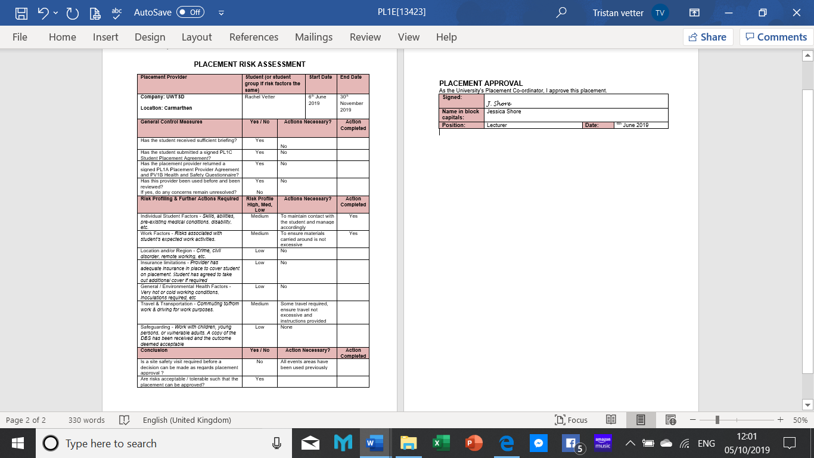

Figure 2 :Health and Safety Questionnaire
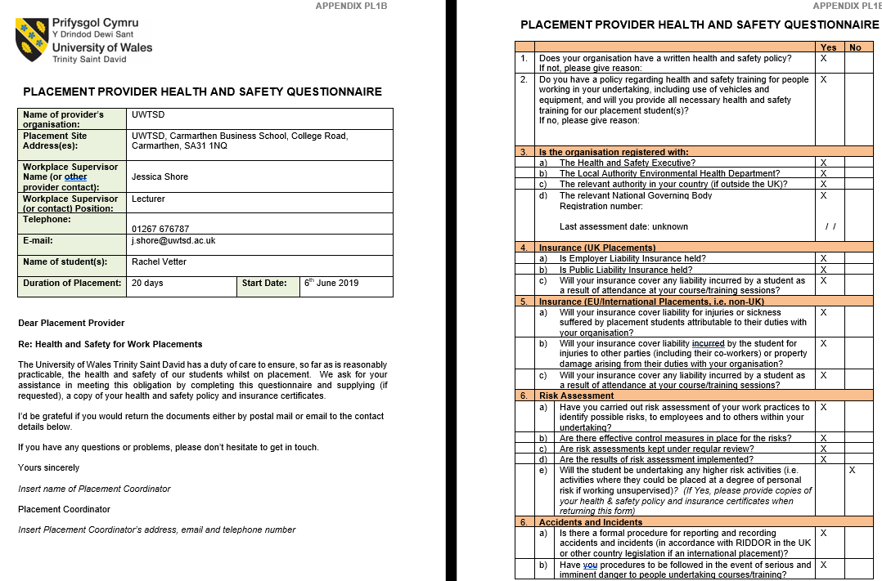
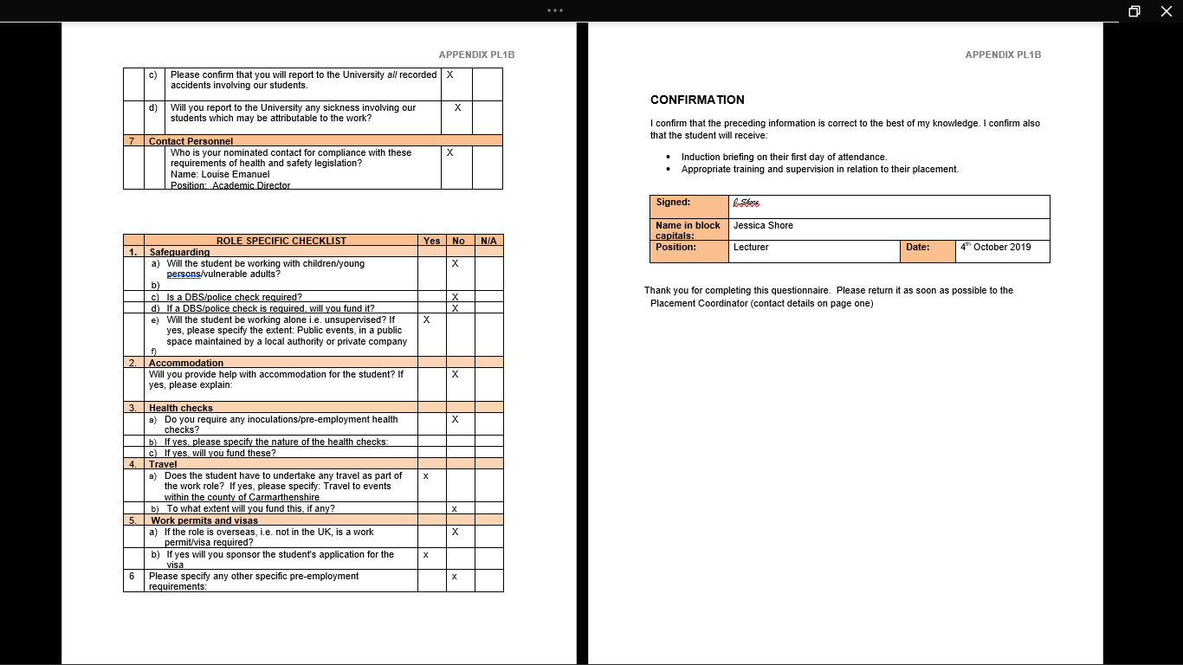

Figure 3 : Placement Provider Agreement
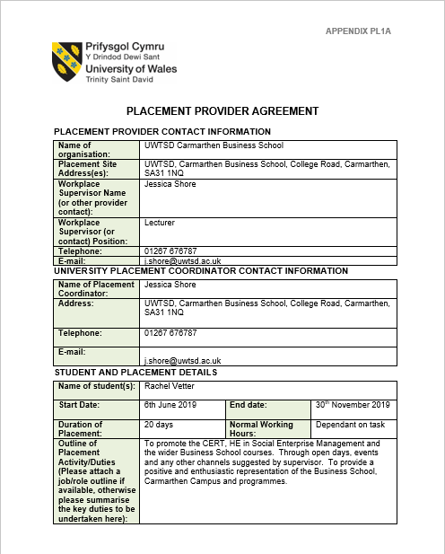

Figure 4 : Induction Check List

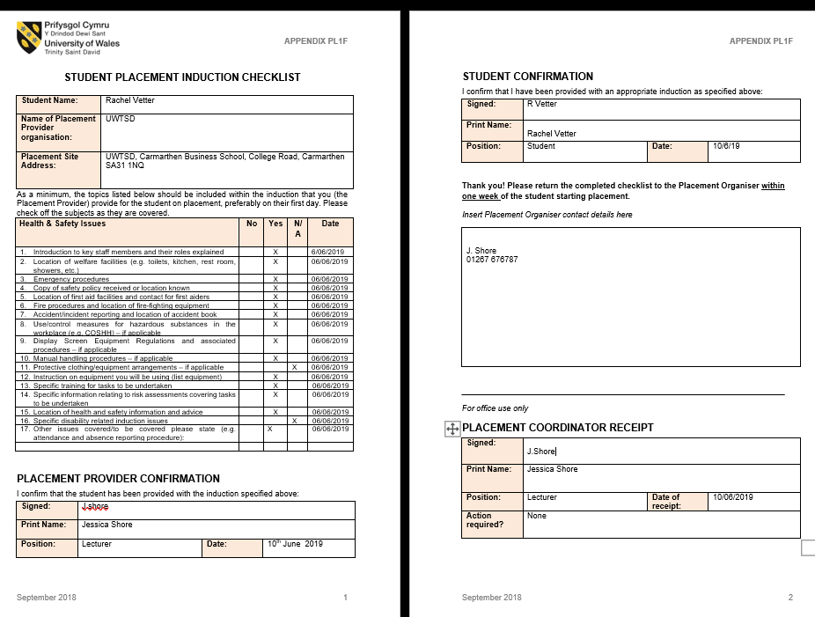

Figure 5 : Original SMART
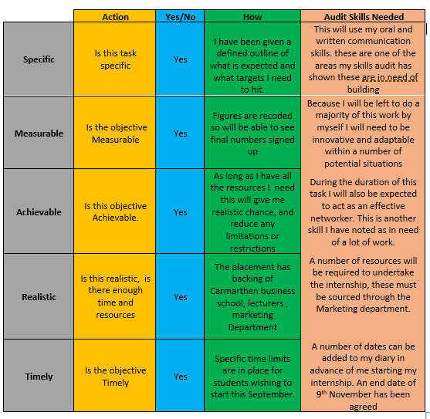

Figure 6 :Original Gant chart


Figure 7 : Post placement review
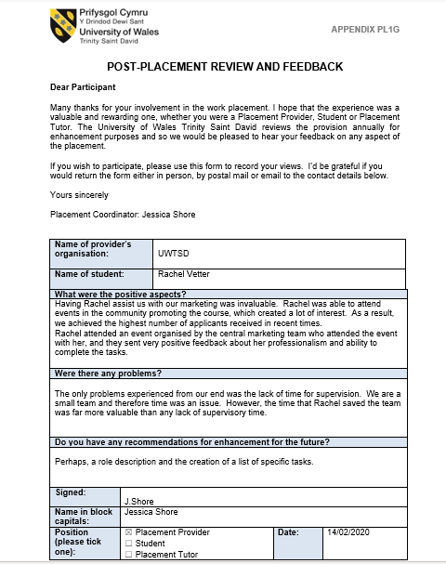

Figure 8 : Post - Placement skills Audit

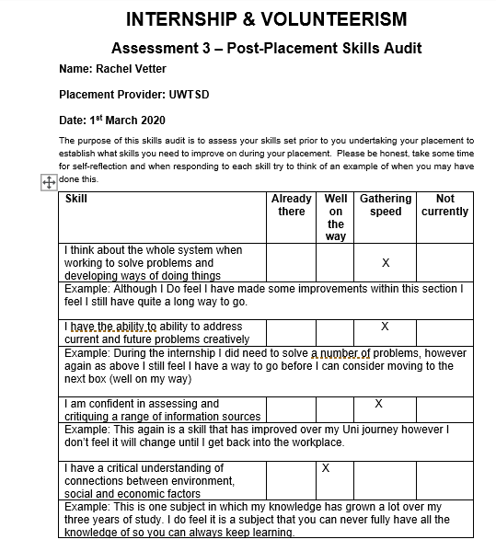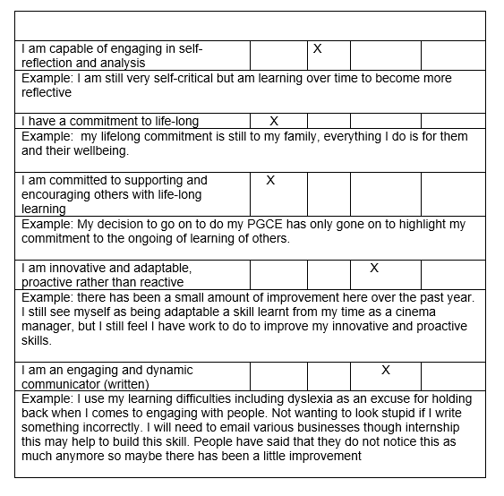

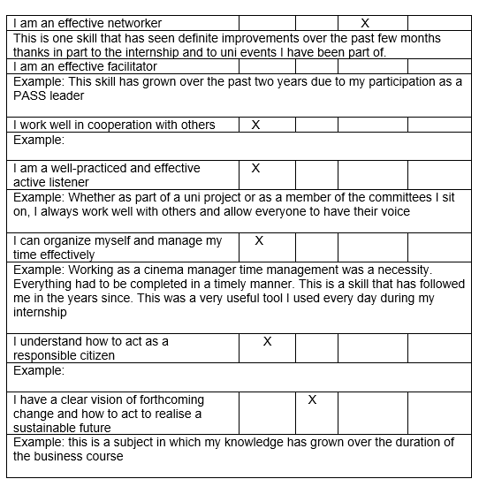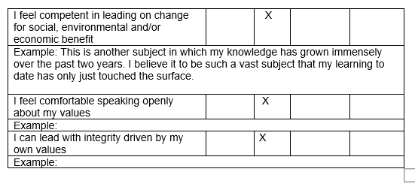

Figure 9 : Pre - Placement skills Audit


