Lab Report – Flame Tests

Author: Joseph S. Rula (2317963)
University of Wales Trinity Saint David
ACDB 4011
Instructor: Dr Ewa Kazimierska
Due: 14th March 2024

Lab Report – Flame Test
Contents
1.0 Introduction: 3
1.1 Hypotheses: 3
1.2 Variables: 3
1.3 Equations: 3
1.4 Materials and equipment: 4
1.5 PPE Used: 4
2.0 The Test: 5
2.1 Procedures: 5
2.2 Conclusions & Findings: 8
2.3 Relation to OME: 8
2.4 Limitations: 9
3.0 Conclusion: 9
Bibliography 9

1.0 Introduction:
This experiment qualitatively identifies metal ions by the colour change of flames due to the photon emission caused by changes to energy levels. Comparison to a colour reference table identifies which unmarked sample contains a specific ion(s).

1.1 Hypotheses:
- All eight unmarked samples can all be identified with usage of the flame test.
- Observations can be explained based on scientific evidence and understanding.

1.2 Variables:
Independent Variable – The specific ion.
Dependent Variable – Colour change of the flame.
Control Variables – Same Mole of HCl, Nichrome inoculating loop.

1.3 Equations:
ΔE = h x f
(Change in Energy between levels = Planck’s constant [6.63x10^-34 Js] x Frequency of light Hz)
C = f x λ
(Constant speed of light [3.0x10^8 ms^-1] = Frequency of light Hz [s^-1] x Wavelength), colour depends on the frequency of the light

1.4 Materials and equipment:
- Bunsen Burner
- Heat Resistant Mat or Tile
- Matches / Source of Ignition
- Nichrome Inoculating Loop
- 1M solutions of unknown metal salts
- De-Ionized Water
- Blue Cobalt Glass (To shield your eyes from potentially damaging EM radiation)

1.5 PPE Used:
- Nitrile Gloves
- Lab Coat
- Eye Goggles
- Hair Ties (If necessary)
- Moustache/Beard coverings (If necessary)

2.0 The Test:

2.1 Procedures:
- Connect Bunsen burner to gas nozzle, place on heat proof mat, ignite safety flame.
- Clean loop in HCl, and place into apex of the internal cone of the roaring flame ~1500°C, where all the gases from within the Bunsen burner are burning.
- Burn off all impurities, repeat if necessary, rinse in DI to remove remaining HCl before each test.
- Dip wire into unknown metal salt/mixture, place wire back into hottest part of the burner, holding Cobalt glass between eyes and possible UV exposure.
- Observe colour of flame through cobalt glass or normally if safe to do so. Record in table, repeat to affirm colour and with other samples.
- Clean up with HCl, and tidy away.

2.2 Results:
Sample | Perceived Colour | Assumed Identity | Wavelength Band (nm) | Assumed Wavelength
A | RED | STRONTIUM | 622 - 722 | 696nm
B | REDISH PINK | LITHIUM | 622 – 722 | 675nm
C | ORANGE | SODIUM | 597 – 622 | 610nm
D | LILAC | POTASSIUM | 390 - 455 | 400nm
E | GREENISH YELLOW | BARIUM | 492 – 577 | 577nm
F | RED/ORANGE/PINK | CALCIUM | 597 – 770 | 600nm
G | BLUISH GREEN | COPPER | 455 – 477 | 492nm
H | YELLOWY RED | SODIUM + POTASSIUM | 390 - 770 | 610nm+400nm
[1]
The photon that’s released will have the energy indicated by ΔE=h*f , f can be calculated by; c/λ=f , The assumed wavelength is the difficult aspect here, unlike an Atomic Absorption Spectroscopy Machine, which will give us specific wavelengths of light, the flame test can only be assumed to be within a band of colour. These assumptions, have a high degree of inaccuracy, and will affect the result calculated for the ΔE.
A; c/696=430736.2902Hz x 6.62607015x10^-34 = 2.854088875x10^-28J ΔE
B; c/675=444136.9748Hz x 6.62607015x10^-34 = 2.942882751x10^-28J ΔE
C; c/610=491463.0459Hz x 6.62607015x10^-34 = 3.256468618x10^-28J ΔE
D; c/400=749481.145Hz x 6.62607015x10^-34 = 4.966114643x10^-28J ΔE
E; c/577=519570.9844Hz x 6.62607015x10^-34 = 3.442713791x10^-28J ΔE
F; c/600=499654.0967Hz x 6.62607015x10^-34 = 3.310743095x10^-28J ΔE
G; c/492=609334.2642Hz x 6.62607015x10^-34 = 4.037491579x10^-28J ΔE
H; Combination of C & D 3.256468618x10^-28J & 4.966114643x10^-28J ΔE

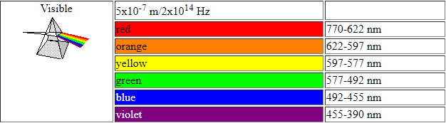 [1]
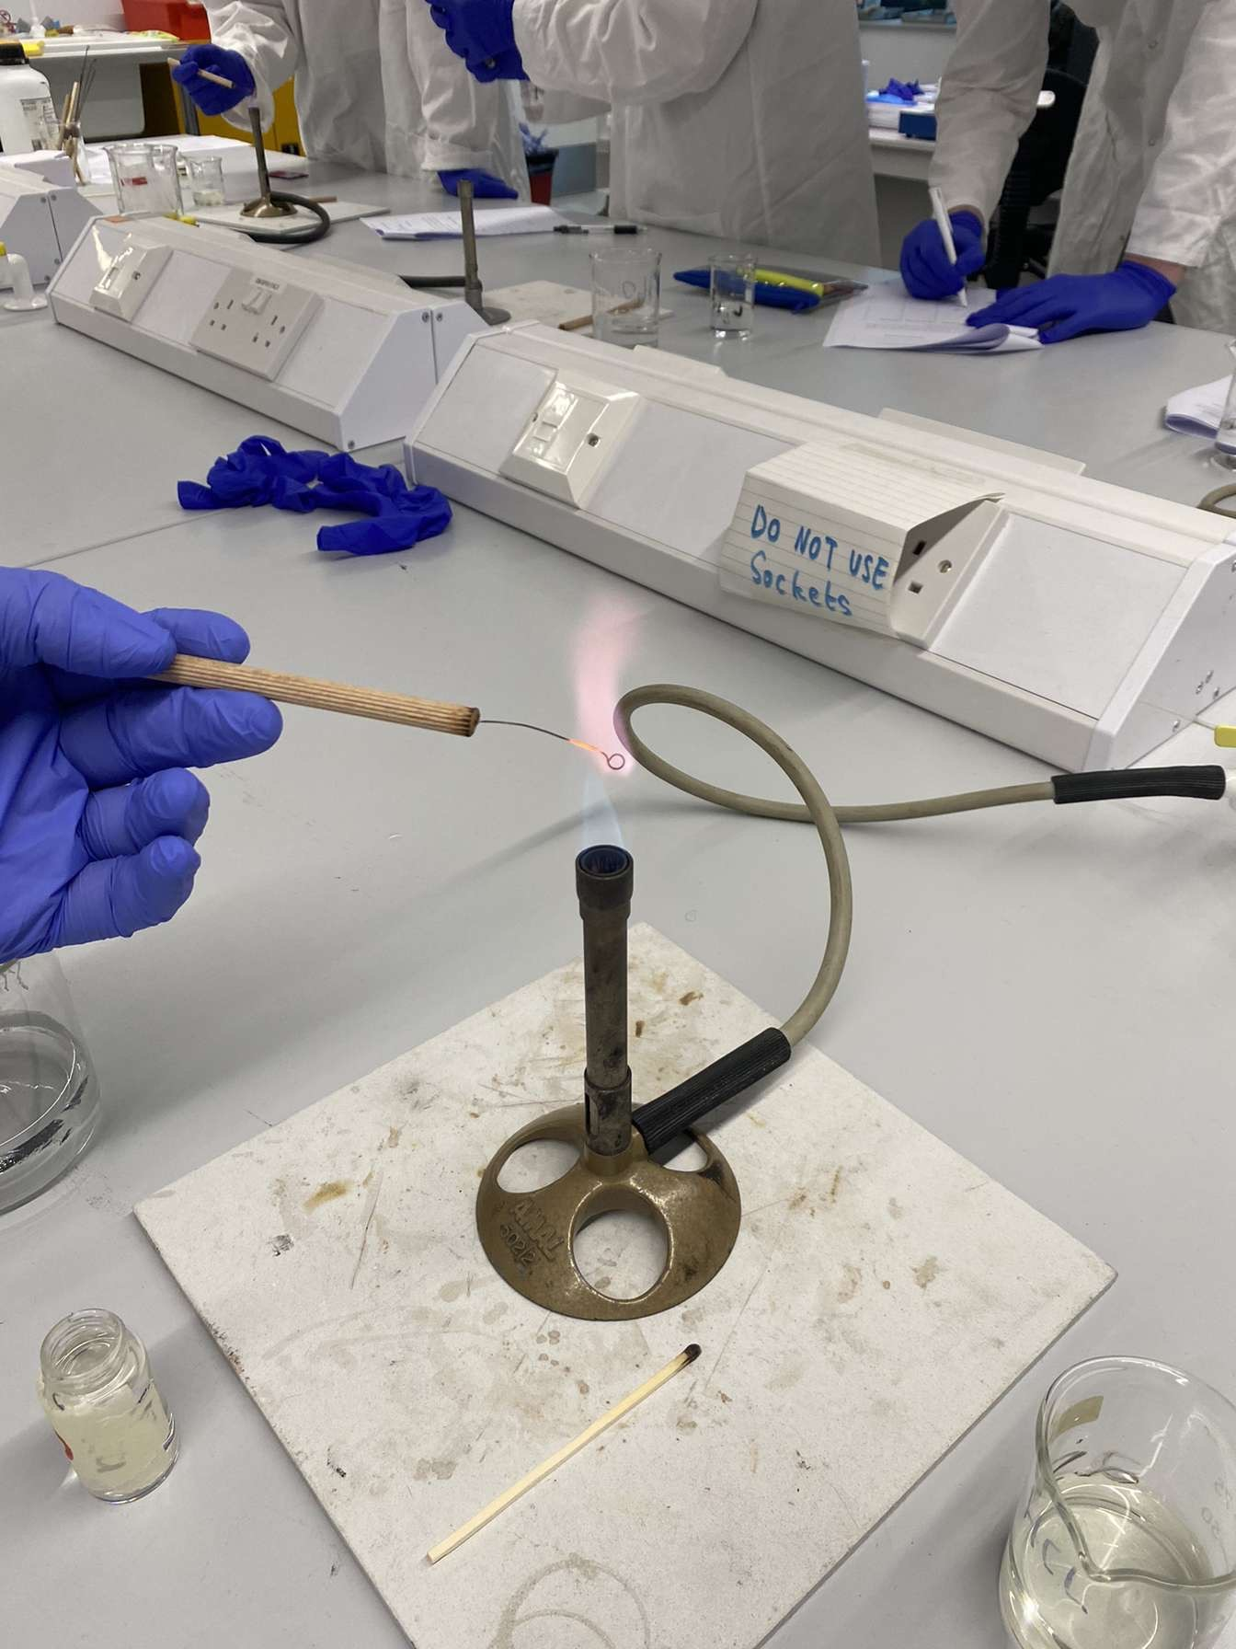
Figure 1 - Lilac Flame of Potassium, held at the apex of the blue flame within the Bunsen burner (the hottest region).
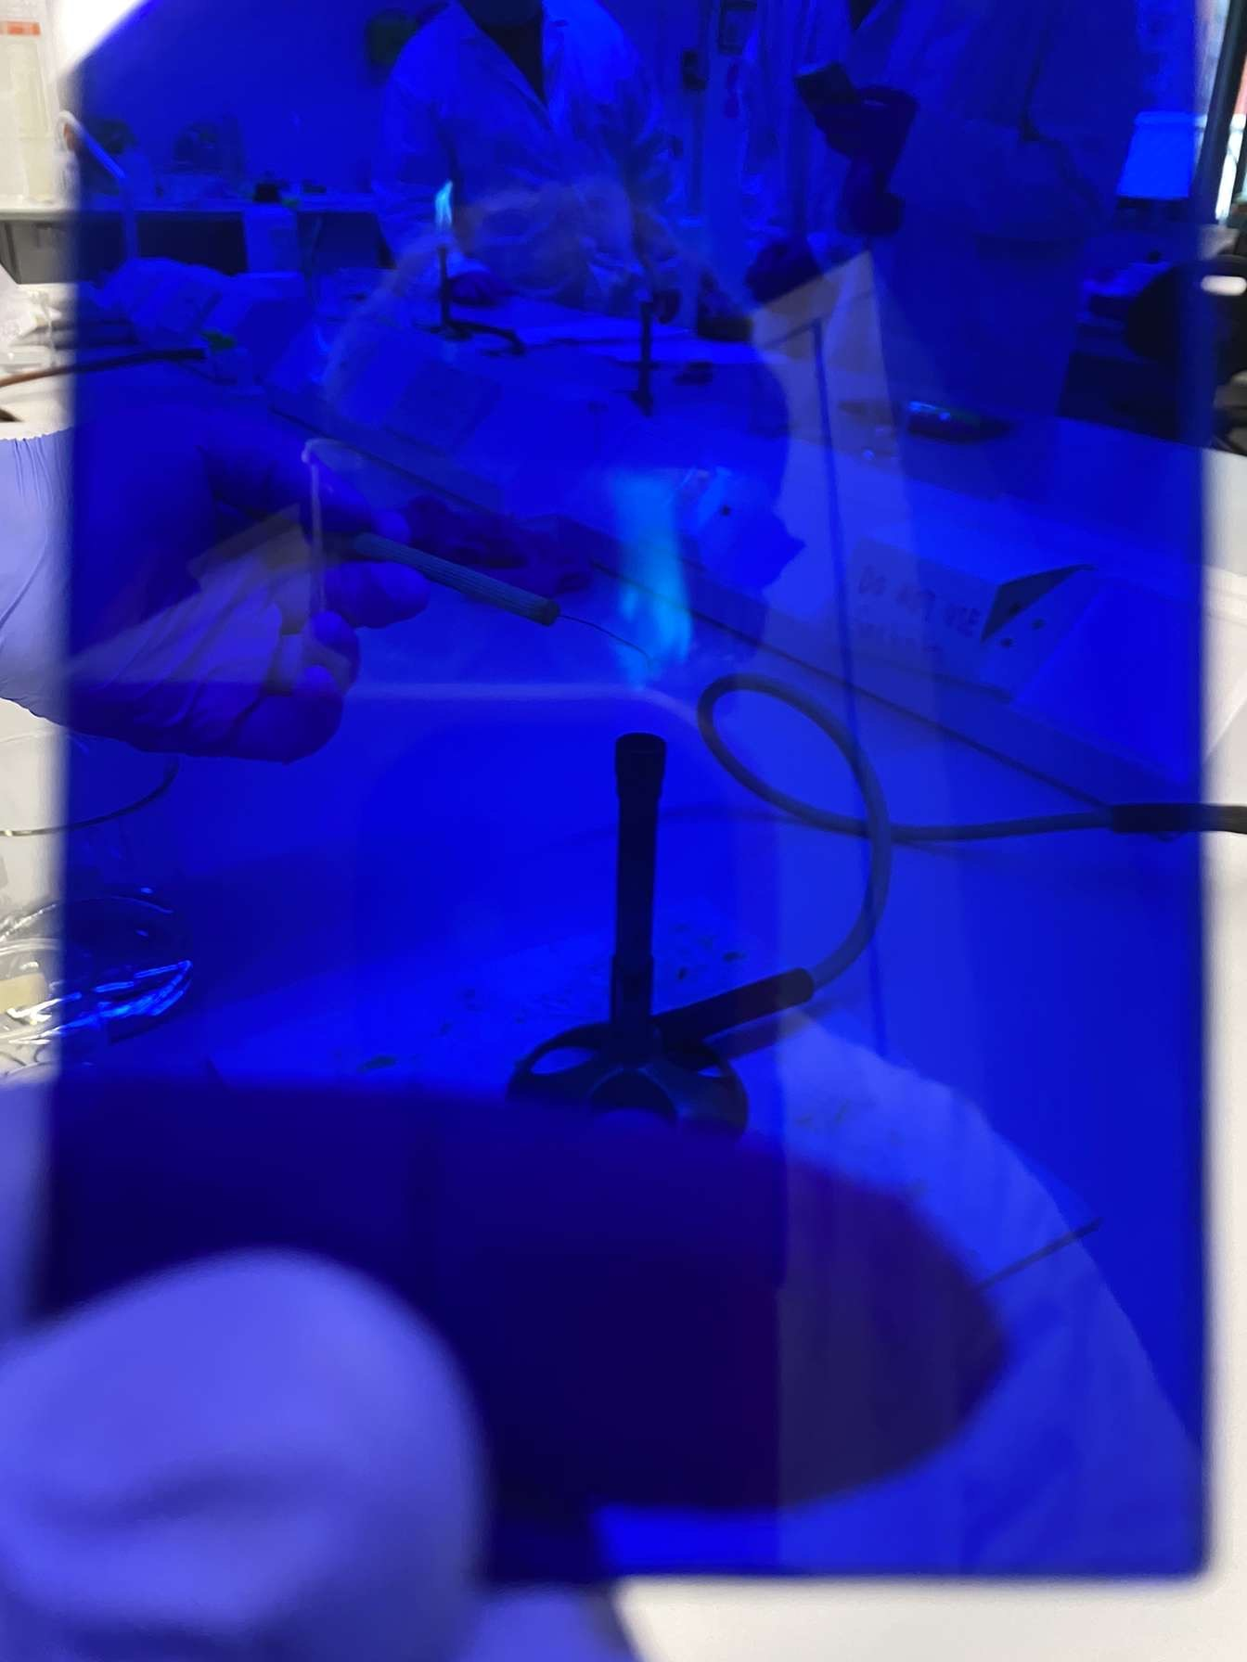
Figure 2 - Lilac Flame of Potassium seen through Cobalt Glass, note the change in colour that may make it hard to discern the true colour.

2.2 Conclusions & Findings:
The significance of these results is that they are wrong due to human error, the human eye cannot judge the wavelength of light it is seeing. So the best that can be done is by looking at a colour chart and assuming a wavelength. I allocated Sodium and Potassium wavelengths of 610nm and 400nm respectively, in reality Sodium has two wavelengths of 588.9950nm and 589.5924mm [2], and as a result of assigning a value instead of getting the exact value, possible with an Atomic Absorption Spectrometry machine, and the value I calculate to be ΔE is vastly different; and for potassium I assigned a wavelength similar to violet due to its lilac colour, this is somewhat correct, as Lilac is a colour created by the combination of both Violet and Red wavelengths. The reason there are two or more wavelengths is that more than one type of photon can be emitted, in the case of Potassium and other atoms, multiple photons can be emitted by a singular excited electron returning to its normal state. So long as the addition of their energy is the same as their resonance lines, for Potassium, two photons in the violet band could be emitted instead of a red photon. This combination of photons to form Lilac, is an example of a non-spectral colour. [3]

2.3 Relation to OME:
In relation to OME, Flame tests may not be used directly but instead their more advanced variant being the Atomic Absorption Spectrometry, as specific colour will be needed in OME, primarily in Flare and Tracer compounds. Flares needs to burn with specific IR intensities and temperatures to either attract heat seeking missiles, for IR Illumination mortars or ship countermeasures. The more advanced AAS gives specific readings for particular Wavelengths of light especially as IR is invisible to the human eye, if these are not within the tolerances the flares will fail to do their job, putting lives at risk. [4]

2.4 Limitations:
- Qualitative Results not quantitative.
- Difficult to observe low concentrations of ion.
- Difficult to observe a secondary or tertiary ion if present.
- Different Ions can give similar colour flames.
- Some Ions give flame colour similar to regular flame.

3.0 Conclusion:
The flame test is a core process for multiple parts of OME but mainly pyrotechnics. It can be used in areas such as warzones to identify metals for reasons such as contamination of water. The main hypotheses have been proven as each solution was identified and the reason for the colour of emission has been explained.

Bibliography

[1] | Wjec.co.uk, “The Electromagnetic Spectrum,” Wjec.co.uk, [Online]. Available: https://resource.download.wjec.co.uk/vtc/ngfl/science/109/spectra/The%20Electromagnetic%20Spectrum.htm. [Accessed 05 04 2024].
[2] | A. Kirkpatrick, “What is the wavelength of sodium light?,” PhysLink.com, [Online]. Available: https://www.physlink.com/Education/AskExperts/ae316.cfm. [Accessed 05 03 2024].
[3] | A. (https://chemistry.stackexchange.com/users/66245/achem), “Wavelengths of colors emitted by alkali metals during flame test,” Chemistry StackExchange, 12 10 2020. [Online]. Available: https://chemistry.stackexchange.com/questions/141382/wavelengths-of-colors-emitted-by-alkali-metals-during-flame-test. [Accessed 05 03 2024].
[4] | Chemring Group PLC, “Countermeasures-brochure,” Chemring Group PLC, Sept 2017. [Online]. Available: http://www.chemringsensors.com/~/media/Files/C/Chemring-V3/publications/countermeasures-brochure.pdf. [Accessed 11 03 2024].

