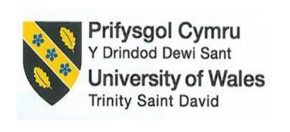

BMIH5007
Financial Management for the Hotel Industry
Business Report - Comparison of Two Hospitality Organisations

Student Name: Ion Popa
Student ID number: (2208502)
Module Mame: Financial Management for the Hotel Industry
Module Code: BMIH5007
Lecturer Name: Tristan Hawkins
Word Count: 2097

Executive Summary

This report presents a detailed comparative analysis of two prominent hospitality organizations: Corinthia Hotels and Ibis Hotels. The evaluation encompasses both financial and non-financial dimensions, offering a comprehensive overview of their performance and strategic positioning. Key areas of focus include revenue generation, market positioning, growth potential, and corporate social responsibility (CSR) initiatives.

Table of Contents
Introduction 5
Discussions 6
Comparative Revenue Analysis for both Businesses 6
Comparative Market Positioning of Corinthia Hotels and Ibis Hotels 7
Evaluating general Growth Potential for business 9
Financial Commitment to CSR by both Business 10
Recommendations 11
Conclusions 12
References 13

Introduction
The Corinthia Hotel Group and Ibis Hotels are popular brands in the global tourism and hospitality industries, each targeting distinct market segments. Corinthia Hotels focuses on the luxury market, catering to high-class customers willing to pay premium prices for personalized services and exceptional travel experiences at primary locations. Conversely, Ibis Hotels serves the middle-class market with budget-friendly plans that provide value for money and an overall positive experience for users.
This report investigates various aspects of these companies, including revenue generation principles, market position, and growth potential. Both financial and non-financial measurements are evaluated. The financial aspects highlight business revenue positions, while non-financial aspects cover market structure, growth initiatives, and CSR contributions by Corinthia and Ibis.

Discussions

Comparative Revenue analysis for both businesses
Corinthia Hotels and Ibis Hotels both operate dynamic hotel chains, each targeting different market segments. Corinthia focuses on the luxury market, while Ibis caters to budget-conscious travellers. Consequently, they employ distinct revenue generation strategies and growth factors.
Total Revenue
Corinthia Hotels: Corinthia Hotels is a private limited corporation. In 2022, it generated an annual revenue of approximately £238.207 million, a significant increase from £129.266 million in 2021 (corinthiagroup.com, 2023).
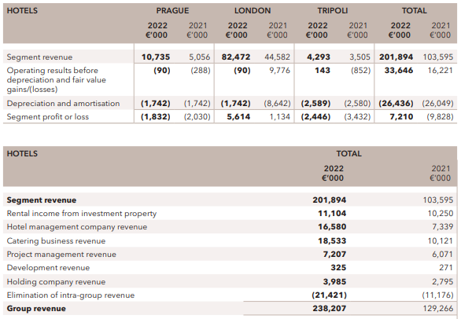
Ibis Hotels: As part of the Accor Hotels Group, Ibis Hotels, a public limited company, generated a combined revenue of £4224 billion (AccorHotels, 2023). While the exact share attributed to Ibis is not disclosed, its widespread presence indicates a strong market hold.
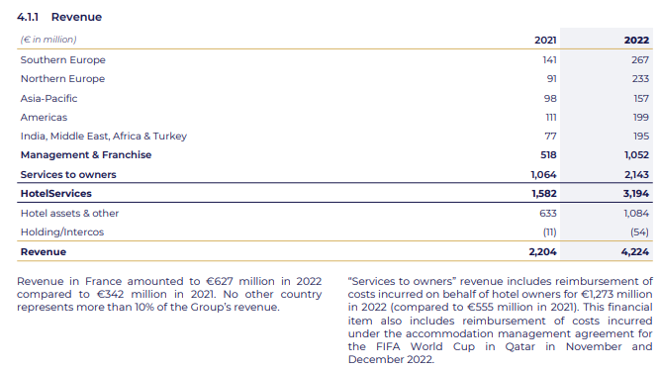
Revenue Sources
Corinthia Hotels: Primary revenue comes from room bookings, with secondary revenue streams from food and beverage services, skincare, event management, and other premium services. The focus on luxury experiences attracts high-class guests who spend on additional offers, generating diversified revenues. Key revenue-generating locations include Prague, London, and Tripoli. In the current year, revenue from London is approximately £82.472 million, accounting for about 40.80% of the total revenue.
Ibis Hotels: The primary revenue source is room bookings, targeting a budget-friendly model that appeals to young and middle-class travellers. The market's efficiency-driven operations result in lower costs. Current analysis shows hotel assets and relevant accounting elements valued at £633 million, with management and franchise-oriented performances generating £518 million in business revenue this year. Additionally, RevPAR increased by 23%, with significant growth in the Middle East, Asia Pacific, and Africa supporting progressive revenue generation (marketscreener.com, 2022).
Revenue Trends
Corinthia Hotels: The company has recorded steady growth in recent years, with an annual revenue of £62 million in 2022 (Corinthia Hotels, 2023). The main driver of this growth is the expansion into new markets such as Asia, offering personalized customer experiences. Corinthia operates 23 hotels across 16 countries and the United Kingdom, indicating a strong potential for further revenue growth (Corinthia, 2022).
Ibis Hotels: Ibis Hotels has been expanding its presence in the middle-class market, offering affordable plans and catering to the increasing demand for budget travel options. The brand currently owns 1,271 hotels, providing 158,423 rooms across 70 countries. This extensive network supports sustainable development and revenue growth (group.accor.com, 2022).
Driving Factors for Revenue Growth
Corinthia Hotels
Expansion of the company has entered into Vietnam and Chinese market base and revenue potential. Luxury Focus caters to high-class customers specialising in luxury experiences and premium services according to customer preferences. Brand Recognition means a strong brand reputation attraction of loyal clients and premium pricing.
Ibis Hotels
Global Network means extensive reach and access to various customer bases and channels. Cost-effectiveness is cost reduction and efficient operating capabilities, attracting budget-conscious customers. Market Expansion focuses on emerging markets requiring value for money and revenue potential.

Comparative Market Positioning of Corinthia Hotels and Ibis Hotels
According to the general identification the hospitality business in the UK is used to represent a competitive Market Positioning approach where plenty number of competitors with the same services mainly exist. Corinthia Hotel Group and Ibis Hotels are also identified as potential customers with strong brand value and market capitalisation support. A comparative analysis is given below for a clear understanding of their positions:
Market share: Corinthia is primarily part of InterContinental Hotels Group PLC, listed on the LSE. Its market capitalization is £12.928 billion, with a beta level of 0.93, indicating a stable market position (uk.finance.yahoo.com, 2023).
Ibis targets middle-class customers focused on budget-friendly options and aims to establish a presence in secondary cities. It has a significant footprint in Europe, Africa, and the Middle East. The parent company of Ibis holds 6.3% of the global market share, with Ibis contributing significantly (O'Neill, 2023).
Corinthia has fewer hotels but a strong position in the luxury segment.
Customer Demographics:
- Corinthia Hotels: Targets high-profile, luxury-oriented customers who seek quality and personalized services (Gabay, 2015).
- Ibis Hotels: Focuses on affordability, targeting young travellers and solo adventurers looking for budget-friendly and reliable accommodations (Franz, 2019).
Brand Perception: Corinthia assures its guests of sophisticated and unparalleled luxury services, blending iconic destinations with cultural experiences to enhance its perception (Solomon, 2016).
Ibis positions itself as a reliable, budget-friendly, and convenient travel option, focusing on practical and standard practices that appeal to its target customers.
Both brands face unique challenges. Corinthia's luxury focus can limit its accessibility and relevance to a broader audience. Ibis must avoid being typecast as purely budget-driven and ensure it balances affordability with value.
Competitive Landscape: Corinthia's main approach to the luxury market is filled with big players like Marriot International and Four Seasons Hotels and Resorts. Ibis face competition from budget clients like Travelodge and Premier Inn etc.
Future Outlook: In the daily changing territory of the hospitality industry, both organizations should focus on being adaptive to the changes. Fusion between personalized experiences and technology can give Corinthia the customer engagement needed to solidify its potion in the luxury market. Ibis should implement sustainable practices and meet the variable needs of the budget-conscious guest to be an option in the cos-sensitive market.

Evaluating general Growth Potential for business
The Global Hospitality industry is predicting substantial growth after the past pandemic. In this saturated market, the Corinthia and Ibis hotels compete constantly for leverage and growth in their respective market segments.
Corinthia Hotels
Corinthia Hotels focuses on the luxury market, offering exclusive experiences and personalized services at prime tourist destinations (Corinthia Hotels, 2023). Their growth strategy includes strategic partnerships, service acquisitions, and developing flagship assets in luxury markets. Notable examples are the acquisition of the Grand Hotel Excelsior in Rome and the construction of the Corinthia Hotel in Doha.
Several factors contribute to Corinthia's growth. The global market is projected to grow at a rate of 5.4% in 2023-2024 (Grand View Research, 2023). Increasing disposable incomes and the affluent growth of the middle class in established markets drive demand. Additionally, the company’s sustainability goals align with the rising preference for eco-friendly travel options.
However, Corinthia faces intense competition in the luxury segment from established players like Ritz-Carlton, necessitating constant innovation. Economic downturns, such as a recession or another global pandemic, could also impede stable growth.

Ibis Hotels
Ibis Hotels focuses on budget-conscious customers and young travellers seeking simple and reliable services over sophisticated and expensive ones. The company targets emerging markets, franchises, and secondary locations, aiming to provide value at competitive prices.
Several factors influence Ibis's growth. The industry is increasingly favouring budget-friendly options due to inflation and economic instability. Customers seek value and affordability. Rising travel costs, taxation, and other policies can also be advantageous for Ibis. Additionally, their focus on technological advancements and online marketing can attract more young customers.
However, Ibis faces significant competition from brands like Travelodge and Motel 6, necessitating continuous cost optimization and value proposition refinement (Statista, 2023). Fluctuations in occupancy rates and reliance on corporate travel can affect revenue stability (IBISWorld, 2023). Maintaining brand consistency across a large network of franchised properties requires robust quality control measures.
The Ansoff matrix can be applied to both businesses to determine growth strategies, whether through market development or product development initiatives. Both Corinthia and Ibis focus on AI-based technology to enhance hotel chain development and booking facilities, aiming to drive revenue growth and improve marketing initiatives.
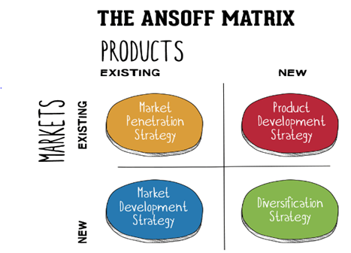
To enhance market penetration, Corinthia management is engaging in the development of 33 luxury suites, the restoration of the Grand Ballroom, and various dining and leisure venues. Additionally, the company is diversifying with the Rome project, converting a 7,500m² building into a luxury hotel featuring 60 guest rooms, including several suites (Corinthia, 2022).
Similarly, Ibis is focusing on market positioning and development. This includes the new Ibis Styles in Burton-On-Trent with 81 rooms and the renovation of the Premier Inn property in Coleraine, Northern Ireland, refurbishing its 49 rooms (businesstravelnewseurope.com, 2022). Ibis is also partnering with Phrasee to create high-performing content, enhancing service development and overall operational growth (Phrasee, 2023).

Financial Commitment to CSR by both business
Financial Commitment to CSR
A Comparative Analysis of Corinthia Hotels and Ibis Hotels
The uprising concern about environmental sustainability and prevention of exploitation has put tremendous pressure on the hospitality industry as many businesses have adopted policies in their operating procedures. Both Corinthia and Ibis Hotels acknowledge the CSR policies and tend to act according to the rules and regulations. But their approach to the matter differs from each other significantly and they both have variable sets of strategies.
Sustainability Practices
Corinthia has emphasized environmental goals through its “Planet Corinthia” program, which focuses on renewable energy alternatives, water conservation, and waste reduction (Corinthia Hotels, 2023). They aim for zero carbon footprints by 2040 and employ transparent reporting through annual sustainability reports, showcasing long-term financial commitments (Corinthia Hotels, 2023). This forward-thinking approach enhances customer loyalty, strengthens the brand image, and attracts an eco-friendly customer base (Gardetti, 2016).
Ibis Hotels has adopted a cost-driven approach with its “Planet 21” program, focusing on renewable energy, water conservation, and efficient operations. While this approach offers short-term financial benefits, it lacks the long-term brand advantages and leadership seen in Corinthia’s strategy. Consequently, Ibis may miss out on potential concerned customers or investors.
Community Engagement
Corinthia Hotels actively engages with local communities by supporting education, cultural events, and environmental initiatives (Corinthia Hotels, 2023). They also sponsor NGOs and charity funds, demonstrating their investment in community building and fostering relationships. This community engagement builds trust, enhances brand marketing, and expands market reach (Dhariwal et al., 2023).
Ibis Hotels also invests in community development, focusing mainly on education and skills development (AccorHotels, 2023). However, their approach is less specific and tailored to local expectations compared to Corinthia Hotels. This less customized approach may result in a smaller financial impact and missed opportunities, potentially allowing competitors to gain an advantage (Walker, 2021).

Ethical Business Practices

Corinthia Hotels has established a “Code of Conduct” that includes fair employment standards, transparent sourcing, and anti-corruption policies (Corinthia Hotels, 2023). They conduct regular audits and programs to ensure compliance, demonstrating a proactive approach to mitigating unethical practices. These ethical practices lead to higher employee retention, legal stability, and a strong brand reputation (Stangis and Smith, 2017).

Ibis Hotels also has an “Ethics and Compliance” program covering similar areas as Corinthia Hotels. However, their ethical standards information is not readily available, which can raise concerns about their commitment. This lack of transparency can damage stakeholder trust and potentially lead to financial losses.

Recommendations
Corinthia Hotels
Recommendation: The company should focus on providing luxury options with sustainable means. The company excel in personalized experiences but tapping into eco-friendly initiatives will solidify its brand image and attract more customers. Partnerships with technology companies specialising in the green economy will certainly aid the cause and brand image.
Justification: About 66% of luxury customers in the market are willing to pay for more sustainable products and services (McKinsey & Company, 2020). This trend is likely to increase and be more popular, in turn giving a great opportunity to give another aspect to the luxury experience.
Ibis Hotels
Recommendation: Develop community engagement strategies. Ibis is a budget-friendly alternative for ma y but it lacks the connection to the locals of its operations. Partnerships with local communities and brands will offer immersive cultural experiences for both the customer and generate a brand reputation.
Justification: community engagement leads to positive marketing and market expansion, and investment in the local communities caters to unique values for travellers who seek authentic ethnicity and experiences.

Conclusions
Corinthia and Ibis occupy distinct yet complementary corners of the hospitality market. Understanding their unique market positioning, customer demographics, and brand perceptions is crucial for both brands to thrive in the ever-changing landscape. By capitalizing on their strengths and addressing their respective challenges, Corinthia and Ibis can continue to cater to their target audiences and carve out successful paths in the competitive world of hospitality.

References
AccorHotels (2023). Planet 21. Retrieved from https://group.accor.com/en/commitment [Accessed 27 May 2024].
businesstravelnewseurope.com (2022). Ibis boosts presence in UK with new properties. [online] Available at: https://www.businesstravelnewseurope.com/Accommodation/Ibis-boosts-presence-in-UK-with-new-properties#:~:text=Accor's%20Ibis%20budget%20brand%20is,property%20in%20Coleraine%2C%20Northern%20Ireland. [Accessed 30 Apr. 2024].
Corinthia Hotels (2023). 2022 Annual Report. Available at: https://www.corinthiagroup.com/wp-content/uploads/2023/06/37547-CORINTHIA-ANNUAL-REPORT-2022_WEB-min.pdf [Accessed 26 Jan. 2024].
Corinthia Hotels (2023). Planet Corinthia. Retrieved from https://www.ghadiscovery.com/corinthia-hotels [Accessed 27 May 2024].
Corinthia (2022). About Corinthia | Corinthia Hotels International. [online] Available at: https://www.corinthia.com/en-gb/our-story/ [Accessed 27 Apr. 2024].
Corinthia (2022). New Openings. [online] Available at: https://www.corinthia.com/en-gb/new-openings/ [Accessed 30 Apr. 2024].
Dhariwal, E. et al. (2023). Event tourism and sustainable community development: Advances, effects, and implications. Palm Bay, FL: Apple Academic Press.
Franz, A. (2019). Customer understanding: Three ways to put the ‘customer’ in customer experience and at the heart of your business. [no place]: Independently published.
Gabay, J. (2015). Brand psychology: Consumer perceptions, corporate reputations. London: Kogan Page.
Gardetti, M.A. (2016). Sustainability in hospitality: How innovative hotels are transforming the industry. Sheffield: Greenleaf Publishing.
Grand View Research (2023, October 26). Luxury Travel Market Size & Growth - 2023-2028. Available at: https://www.marketresearch.com/Grand-View-Research-v4060/Travel-Leisure-c90/1.html [Accessed 27 May 2024].
group.accor.com (2022). Actualites. [online] Available at: https://group.accor.com/en/Actualites/2024/02/2023-full-year-results [Accessed 27 Apr. 2024].
IBISWorld (2023). Budget Hotels in the UK - Market Size, Industry Analysis, Trends and Forecasts (2024-2029). Retrieved from https://www.ibisworld.com [Accessed 27 May 2024].
Hotel Management (2023, January 9). News and events: Wyndham Hotels & Resorts (2023) Wyndham Franchise Opportunities. Available at: https://development.wyndhamhotels.com/news-and-events/ [Accessed 26 Jan. 2024].
marketscreener.com (2022). Accor sales rise 8 as Middle-East Africa and Asia-Pacific demand picks-up. [online] Available at: https://www.marketscreener.com/quote/stock/ACCthe OR-4602/news/Accor-s-Q1-sales-rise-8-as-Middle-East-Africa-and-Asia-Pacific-demand-picks-up-46534061/ [Accessed 29 Apr. 2024].
McKinsey & Company (2020). How we help clients. Available at: https://www.mckinsey.com/capabilities/sustainability/how-we-help-clients#:~:text=By%20actively%20engaging%20in%20the,sustainability%20objectives%20and%20regional%20nuances [Accessed 26 Jan. 2024].
O’Neill, S. and Skift (2023). Accor’s investor day: 7 top slides from the hotel group’s presentation. Available at: https://skift.com/2023/06/27/accors-investor-day-7-top-slides-from-the-hotel-groups-presentation/ [Accessed 26 Jan. 2024].
Phrasee (2023). Accor Partners With Phrasee to Create High-Performing Content. [online] Available at: https://phrasee.co/news/accor-partners-with-phrasee-to-create-high-performing-content/ [Accessed 30 Apr. 2024].
Solomon, M. (2016). The heart of hospitality: Great hotel and restaurant leaders share their secrets. New York: SelectBooks, Inc.
Stangis, D. and Smith, K.V. (2017). The Executive’s Guide to 21st Century Corporate Citizenship: How your company can win the battle for reputation and impact. Bingley: Emerald Publishing.
Statista (2023). UK REITs market cap 2023. [online] Available at: https://www.statista.com/statistics/1369569/market-cap-reits-uk/#:~:text=The%20market%20cap%20of%20real [Accessed 1 May 2024].
Statista (2023). Accor Group: Revenue 2022. Available at: https://www.statista.com/statistics/266261/revenue-of-the-accor-group/ [Accessed 26 Jan. 2024].
uk.finance.yahoo.com (2023). INTERCONTINENTAL HOTELS GROUP P (IHG.L) stock price, news, quote & history – Yahoo Finance. [online] Available at: https://uk.finance.yahoo.com/quote/IHG.L/ [Accessed 1 May 2024].
Walker, J. (2021). Introduction to Hospitality. Harlow: Pearson.

