

Module Name: Community Engagement
Title: Assessment 1 Community Engagement

Student Name: Pavel Bodushki
Student Number: 2023711
Lecturer: Karen Howells
University of Wales Trinity Saint David
Module Code: LCBB4002
Term 2 Group 3

Table of Contents
Introduction 3
Analysis 4
Event idea 4
Community engagement and importance of stakeholders’ participation 5
Stakeholder involvement 6
Social media communication 7
Conclusions and recommendations 9
References 10

Introduction
Homelessness is a major problem for UK and it continues to increase on a gradual scale. Quantifying it is a rather challenging task as many different factors need to be taken into account. There are several different types of homelessness, including rough sleeping (sleeping rough on the street), statutory homelessness (lacking a secure place to live) and hidden homelessness referring to people not entitled to help with housing or such who do not even approach their councils for help (Crisis, 2021a). There are many different reasons, which can lead to becoming homeless, including inability to pay mortgage, rent arrears, loss of accommodation, breakdown with partners, domestic violence and many more; thereby, making the issue even more complicated and difficult to be solved (Homeless Link, 2021). Many people are also homeless due to poverty, unemployment, mental or physical issues and other similar triggers (Crisis, 2021a). However, the increasing severity of the problem is concerning and imposes the risk of violence, drug abuse and many other potential problems which may arise from the climbing numbers of homeless people in UK.
Figure 1 – Reasons for homelessness UK
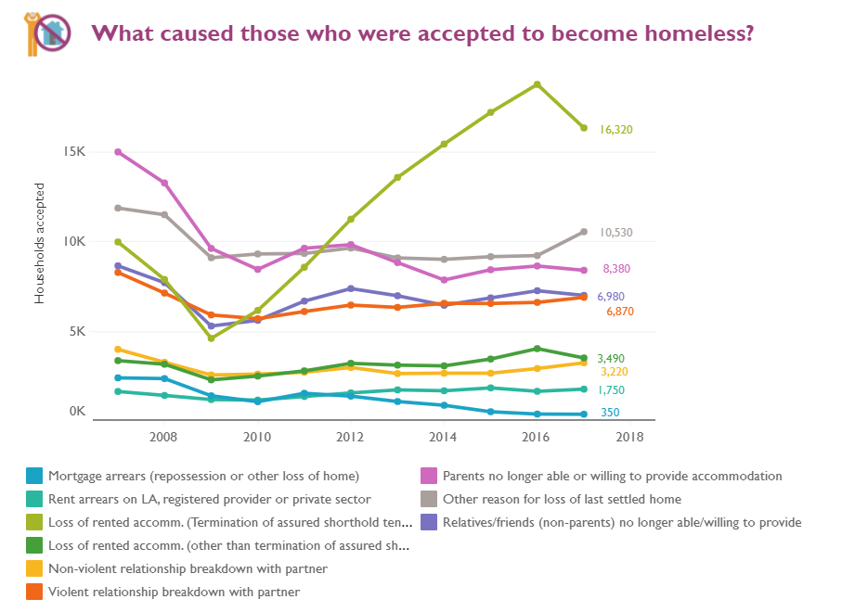
Source: Homeless Link (2021)
The current paper has the aim of planning and analysing an event organised by Crisis – one of the largest charity organisations which works directly with thousands of homeless people. The entity provides help to homeless people by assisting them in rebuilding their lives through direct support, funding, help to find employment or getting new skills, advice or various courses in 12 regions around UK (Crisis, 2021b). The analysis also reflects the best practices and principles of community engagement and stakeholders’ participation; thereby, focusing on using social media for higher effectiveness and success.

Analysis

Event idea
The idea of the proposed event is focused on the assumption that the majority of people do not realise the importance of homelessness in UK and its consequences to local community and people’s lives. When researching the activities of Crisis, it is revealed that it can be supported in three main ways – donation, volunteer work and campaigning (Crisis, 2021b). The proposed event is to organise a “You are not alone” day. The idea is to gather together local community, homeless people, businesses and institutions on one place – typically in a park outdoors. Local residents, who visit the event, will be encouraged to bring food, clothes, home items, such as towels, bed sheets, dishes and similar products, which can be donated to people in need. They can also meet with homeless people and hear their stories which will contribute to better understanding the causes and consequences of homelessness in UK and how it can be prevented.
Local businesses will have their own stands where homeless people can apply for jobs, understand what they need to improve their employability or receive additional assistance, such as courses for obtaining a new skill. The gathering will also be supported by the responsible municipality and government officials will also be invited. Everybody who is present on the event will also receive a booklet in which detailed information about homelessness will be included – current statistics, expected trends and forecasts, causes, consequences, NGOs which are engaged in solving the problem, ways to support this cause and other relevant data. Other NGOs will also be invited as co-organisers and they will be able to share their strategies, goals and activities and also attract supporters. In this way, every party involved will benefit from participation and the event will contribute to mitigating the impact of homelessness on community and people’s lives. This mixed approach would also contribute to providing solutions to different types of homelessness, better collaboration between different parties and addressing various needs of stakeholders depending on their aims.

Community engagement and importance of stakeholders’ participation
Campaigning is also an approach, which is supported by many scholars, who emphasise on its importance for the effectiveness and success of charity initiatives. Van Leeuwen and Wiepking (2012) suggest that campaigning is one of the most essential tools for NGOs; thereby, contributing to increasing awareness, better understanding of problems more active community engagement in various projects designed to provide alternative solutions to different challenges. However, the academics also emphasise on the need of using appropriate media and communication channels reflecting the needs and interests of participants and encouraging them to actively contribute to the success of the event. All this is also complying with the theoretical principles of community engagement continuum development, which is presented on the next figure.
Figure 2 – Community engagement continuum
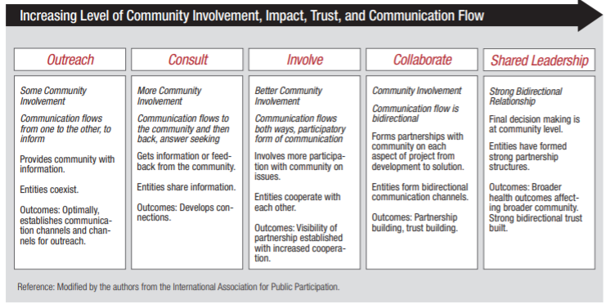
Source: NIH (2011)
As shown, community engagement is fully achieved through five main stages: outreach, consult, involve, collaborate and shared leadership (NIH, 2011). During the initial stage, communication has the main aim to provide information and increase the awareness and knowledge of the audience (NIH, 2011). The goal at this stage is to inform community about the event and its objectives and establish selected communication channels as sources of data when needed. At the stage of consulting, organisations aim at higher community engagement and provision of feedback which serves as an indicator for areas which can be improved (NIH, 2011). At this stage communication is two-ways and the goal is to establish connection and relationship between different stakeholders engaged in the project (NIH, 2011). At the stage of involving, communication is based on active sharing of information and discussion between parties and the main aim is greater collaboration between different parties (NIH, 2011). This also contributes to transparency and visibility of the event and the overall project. At the next stage focused on collaboration, communication flow is bi-directional and the main aim is building partnerships and trust between different stakeholder groups (NIH, 2011). The final stage – shared leadership, focuses on continuous and sustainable understanding of the problem and engagement of different parties on the basis of strong relationships, partnerships and structures (NIH, 2011).

Stakeholder involvement
Based on this knowledge, it can be assumed that community engagement practitioners should adopt a forward-looking approach to initially educate community members and then engage them in the specific project.
Following this process leads to a broad range of benefits obtained on the basis of higher stakeholders’ involvement. These include flexible and adjustable agenda and project focus, improved design and delivery, improved research and implementation of projects, higher ethics, better involvement and collaboration between different parties, enhanced understanding of the issue, easier attraction of partners and academics for further research and greater reception of the general public (NIH, 2011). It should be noted that the involvement and dedication of local community and other parties engage more in such projects if they are convinced that the benefits of their actions outweigh their costs (NIH, 2011). This suggests that it is crucial to properly communicate the aim of the event and project, as well as the importance of individual contribution of each party to solving the issue of homelessness. This can be achieved through the use of several different strategies, including social media as a main channel of communication.

Social media communication
Social media is one of the best approaches which is also innovative for engaging local communities. It has a high impact on residents and other parties and encourages them to contribute to the success of different campaigns. It is appropriate to be used in countries like UK where social media penetration represents the majority of population. According to Zivkovic (2021), approximately 48 million in UK have social media accounts, forming 67% of country’s population. 81.2% of those people use social media on their mobile devices which further increases the easiness of reach and convenience for all parties (Zivkovic, 2021). The most popular and used platforms in UK are Facebook, YouTube, Instagram and Twitter (Zivkovic, 2021).
Figure 3 – Social media platforms in UK
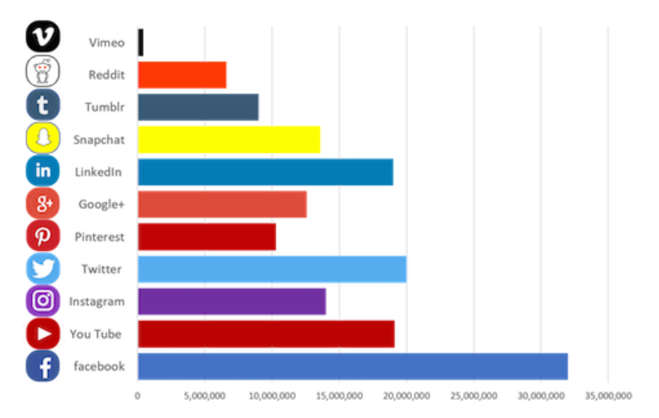
Source: Zivkovic (2021)
The users of social media platforms in UK are from diverse segments in terms of age, gender, race and other demographic characteristics, allowing for inclusion and multi-culturalism to be achieved through the use of this channel for communication.
The three platforms selected to be used for the proposed project are Facebook, Instagram and Twitter. This is based on their popularity, functions and potential contribution, as well as the fact that Crisis has profiles in all three of them and these can be used as an initial starting point of informative and persuasive campaigns.
On Facebook, Crisis has 88,219 followers who are engaged with its fan page on the platform. All events organised by the charity organisation have their own event pages where detailed data about the event, location, hosts, partners, venue, objectives and importance is provided. This leads to higher transparency and development of trust which is essential for the success of the campaign, as already explained previously. On the event page, the organisation can also share a file with division of item types where each participant can insert what they intend to bring. This will contribute to better organisation on the outdoors space, as well as better planning of storing facilities. Furthermore, if this information is available prior to the event, the charity organisation can also plan how these items can be allocated to homeless people directly which will increase effectiveness and will eliminate the need for large storing facilities. On this field on the event page, businesses participating in the event can also post available positions and the candidate profiles they are searching for. This will contribute to increased awareness of homeless people on what opportunities they might have if they attend the event which will also lead to higher engagement rate. On the page of the event, a discussion forum will also be created, so that different participants can share ideas and exchange information. This two-way communication is necessary to increase awareness, interest and engagement and is complying with the community engagement continuum presented previously. The page of Crisis can also publish different viral content regarding the severe importance of tackling with homelessness problem and why the contribution of each party is so essential. These posts can also be promoted, so that they reach a larger audience and gain popularity on the basis of the ‘snowball effect’.
On Twitter the organisation has 110.8K followers and also publishes content which is relevant to its events. The same type of posts can also be shared on Twitter with a tweet hashtag #YouAreNotAlone. The hashtag can also be used on Instagram for gaining a larger popularity. The hashtag will also be used for another strategy proposed to be included – digital storytelling. By definition, this is a tool for using digital technology to create and share autobiographical stories of ordinary people (Juppi, 2017). According to scholars, digital storytelling is one of the main mechanisms for engaging local communities in important charitable projects and increasing their potential success (Juppi, 2017). For the current project, Crisis entity can record the stories of different stakeholders (homeless people, local businesses, residents of the region, municipality representatives) and encourage them to share their personal stories, views and opinions on the matter. This can increase the interest and engagement of the rest and can motivate more supporters and partners to contribute to the campaign.

Conclusions and recommendations
The proposed idea for an outdoor event gathering together all parties who are affected by the problem of homelessness is considered to have a high potential for success in terms of addressing their various needs and contributing to solving the issue. In order to achieve that, Crisis charity organisation needs to plan on how each perspective of the problem and the specific event will be communicated to different stakeholders. It is recommended that the theoretical model of community engagement continuum is applied. In terms of communication channels and strategies, it is advised that social media are the main tool for reaching target audiences. The specific platforms, which are perceived as most appropriate for this purpose, include Facebook, Twitter and Instagram. The specific strategies used for content creation include viral content, informative and persuasive posts, the creation of #YouAreNotAlone hashtag, development of event page with various functionalities and the use of digital storytelling. These tools are believed to contribute to increasing community engagement of the project and leading to more sustainable dedication to solving homelessness issue in the future.

References
Crisis (2021a) About Homelessness, [online] Available: https://www.crisis.org.uk/ending-homelessness/about-homelessness/ [Accessed: 25 August 2021]
Crisis (2021b) How Can You Support Crisis? [online] Available: https://www.crisis.org.uk/ [Accessed: 25 August 2021]
Homeless Link (2021) Our Research, [online] Available: https://www.homeless.org.uk/facts/our-research [Accessed: 25 August 2021]
Juppy, P. (2017) Engagement and Empowerment: Digital Storytelling as a Participatory Media Practice, Nordicom-Information, Vol. 39(2), pp. 31-41.
Ministry of Housing, Communities and Local Government (2021) Statutory Homelessness January to March Q1 2021: England, [online] Available: https://assets.publishing.service.gov.uk/government/uploads/system/uploads/attachment_data/file/1004845/Statutory_homelessness_release_Jan-Mar_2021.pdf [Accessed: 29 August 2021]
NIH (2011) Principles of Community Engagement, [online] Available: https://synergy.dartmouth.edu/sites/default/files/docs/Principles_of_Community_Engagment_NIH_2ndEdition.pdf [Accessed: 30 August 2021]
The Big Issue (2021) Homelessness Facts and Statistics: The Numbers You Need to Know in 2021, [online] Available: https://www.bigissue.com/latest/britains-homelessness-shame-cold-hard-facts/ [Accessed: 30 August 2021]
Van Leeuwen, M. and Wiepking, P. (2012) National Campaigns for Charitable Causes: a Literature Review, Nonprofit and Voluntary Sector Quarterly, Vol. 42(2), pp. 219-240.
Zivkovic, J. (2021) 50+ Interesting Social Media Statistics UK, [online] Available: https://cybercrew.uk/blog/social-media-statistics-uk/ [Accessed: 23 August 2021]

