

Comprehending the role and extent of Digital Marketing within the Fashion Industry: The case of Raymond, a fashion brand in India

Student Name: Rupali Patidar

Student ID: 2246517
Supervisor: Prof Amare Desta

Programme: MBA-International Business

Module Code: LCMB7020

Assignment Title: Dissertation



Master’s Degrees by Examination and Dissertation
Declaration Form.

I, RUPALI PATIDAR declare that this dissertation has been composed by myself, that the work contained herein is entirely my own except where explicitly stated otherwise in the text, and that this work has not been submitted for any other degree or qualification, in whole or in part, except as specified.

Signature: Rupali Patidar

Date: 14th October 2024

ACKNOWLEDGEMENT
I extend my heartfelt gratitude to my supervisor Prof Amare Desta who helped me to complete the entire dissertation. Completing my dissertation would have been impossible without the help of my dissertation guide and advisor. He helped me undertake primary and secondary data analysis techniques and critically interpret the results. Besides, I also thank my university library which helped me to gather ample information from the rich data sources. A debt of gratitude was also owned by the participants, who enthusiastically included in the research and provided their valuable insight regarding the digital marketing approach of Raymond. Last but not least I would extend my gratitude to my parents and friends without their help I would not complete the work successfully.
ABSTRACT
The present research study is an endeavor to understand the current digital marketing strategies in the Indian fashion industry where special emphasis has been given to Raymond. The contemporary digital marketing strategy of Raymond has been analyzed along with its potential extent to gain critical insight into the research realm.
This research aimed at making a critical overview of Indican Fashion industry using Raymond’s digital marketing strategy as an example and provide recommendations to gain productive opportunities within the organization for its better visibility and traffic in the digital market.
The challenges of the Indian fashion brands regarding its digital marketing strategy have been analyzed here to generate effective insight into the modern digital marketing strategy of the company. Both primary quantitative and secondary qualitative data sets have been employed within the research to create stronger insight into the digital marketing strategy of Raymond. The primary and secondary analyses suggested the mobile-friendly website design and keyword-based SEO optimization process of Raymond provide a competitive edge to the company.
On the other hand, the creative personalised and social message-based content creation strategy of the company also enhances customer engagement which again provides effective benefits to the sales volume and revenue growth of the company. Raymond also focused on an influencer marketing approach to target each economic group within the target population. Providing personalized advertising content also promotes the strategic growth of the company.
This research study also recommended to utilize effective community engagement program with the company to create stronger customer engagement with the company. By applying this strategy Raymond can increase its brand reputation in digital platforms. Supporting sustainable initiatives and implying that the entire business process became a more helpful approach to sustain longer in the global fashion market with a competitive edge. It aligns with the goal of the company along with ensuring growth within Raymond.
Table of Contents
Chapter 1: Introduction 7
1.1. Introduction 7
1.2. Research Background 7
1.3. Rational 8
1.4. Problem Statement 9
1.5. Purpose of the Study 10
1.6. Research Aim and Objectives 10
1.7. Research Questions 11
1.8. Research Significance 11
1.9. Summary 11
1.10. Dissertation Structure 12
Chapter 2: Literature Review 13
2.1. Introduction 13
2.2. The Indian Fashion Industry 13
2.3. Digital Marketing in the Fashion Industry 15
2.4. Challenges in Digital Marketing for Traditional Brands 16
2.5. Effectiveness of Digital Marketing Strategies 19
2.6. Theoretical Overview 22
2.7. Literature Gap 23
2.8. Summary 24
Chapter 3: Methodology 25
3.1. Introduction 25
3.2. Research Philosophy 25
3.3. Research Approach 26
3.4. Research Design 26
3.5. Data Collection 27
3.5.1. Sample Size and Sampling technique 27
3.6. Data Analysis 28
3.7. Ethical Considerations 28
3.8. Summary 29
Chapter 4: Data Findings & Analysis 30
4.1. Introduction 30
4.2. Data Findings 30
4.3. Primary Data Analysis & Results 30
4.4. Secondary Data Analysis & Results 41
4.4.1. Social Media Marketing Strategy of Raymond 41
4.4.2. Personalized Data Analytics-Based Digital Marketing Solution Development of Raymond 43
4.4.3. Application of Search Engine Optimization Process of Raymond 45
4.4.4. Digital Content Marketing Strategy of Raymond 46
4.5. Discussion & Justification of Aim 48
4.6. Summary 50
Chapter 5: Conclusion 52
5.1. Critical Conclusion 52
5.2. Research Limitations 53
Chapter 6: Recommendations 54
6.1. Issues & Recommendations 54
6.2. Future Scope & Recommendations 55
References 56
Appendix……………………………………………………………………………………..66

Chapter 1: Introduction

1.1. Introduction
Rapid innovation in the technological realm transformed the entire business world, the fashion industry also impacted the strategic growth in the sales volume and profitability in the fashion industry (Islam et al. 2024). Besides this, Rathore (2021) stated that digital innovation in the technological realm changes the customer engagement process as well as revenue improvement in the fashion industry. Rapid involvement of digital technological initiatives in the fashion industry creates productive opportunities (Langley and Rieple, 2021). The transition from traditional marketing to digital marketing process creates effective changes in the fashion industry (Muniesa and Giménez, 2020).
The present study tries to find out the digital marketing process applied by the fashion brands like Raymond in India. Raymond is a renowned integrated fabric manufacturer in India and is also found as the biggest woolen fabric maker in India (Raymond, 2024). The application of modern digital marketing ability in the organization determines the growth of the company in the fashion industry. The application of digital marketing tools increases brand reach and sales increment in an individual (Islam et al. 2024).

1.2. Research Background
The process of digitization impacted all business aspects to create optimum growth within the global business operation. The use of digital marketing processes also rapidly indulges in the fashion industry to increase brand reach and brand awareness among global customers (Muniesa and Giménez, 2020). The digital marketing process also reduces the geographical boundaries for conducting international business (Muniesa and Giménez, 2020). The online global retail sales in the fashion industry will increase to $1.5 trillion in 2024 and forecasting data sets (Hamdani et al. 2022). It also suggested that more than 75% of global fashion brands will use AI-generated digital marketing content in the fashion business realm (Lorenzo-Romero et al. 2020). The process of customer engagement is also enhanced the use of digital tool that will increase the fashion industry’s business value.
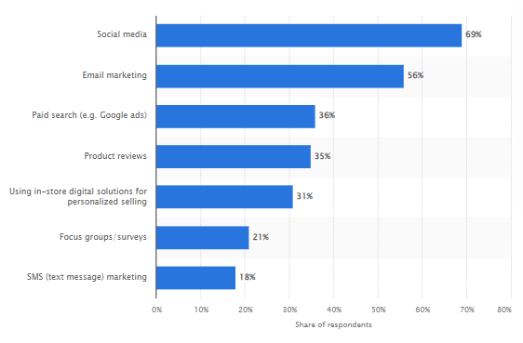
Figure 1: Digital tool used for increasing customer engagement
(Source: Statista, 2024)
The above graph denoted the importance of digital tools in the customer engagement process in the Indian fashion industry. Social media-based marketing (69%) and email marketing (56%) are the two major digital marketing approaches taken by the global fashion industry (Statista, 2024). Besides, paid search and SEO are some strategies developed by fashion marketers to create profitable opportunities in the organization. Raymond Company also engaged in the social media and email marketing approach (Dewi et al. 2022). Apart from that the influencer collaboration and omnichannel presence of the company create a stronger digital foothold for the company in the marketing realm (Islam et al. 2024). This study is to comprehend the role and extent of Digital Marketing study within the Raymond. It is a trustworthy fashion brand in India which creates its digital presence to attract tech-savvy young customers (Lorenzo-Romero et al. 2020). The digital marketing integration process also creates stronger brand awareness initiatives in the global fashion market.

1.3. Rational
This study evaluates to investigate the digital marketing strategy to show the business value of the Indian fashion brand. The research scholars will be benefited from this study by getting insights on digital marketing strategies of the evolving landscape of the fashion industry in India. Increasing digitization in the fashion industry creates productive opportunities for business owners (Alexandrova and Poddubnaya, 2023). Understanding the applicability of the modern digital tool in the fashion industry must create optimum opportunity in the sales volume and revenue generation process (Xue et al. 2023). Raymond Company transformed its previous marketing approach and turned it into a digital medium to extend its customer base within the target market (Islam et al. 2024). Addressing the fast-changing market demand is also mitigated by understanding specific strategies of Raymond in the Indian fashion market. Establishing new strategies in the digital marketing process helps to accelerate the entire fashion industry (Rathore, 2021).
As per Islam et al. (2024), creating optimum fashion marketing in a developing country like India is very challenging. Hence, understanding the challenges and their associated plans also establishes a stronger foothold for the newcomer organization in the fashion industry (Nobile et al. 2021). Both the strengths and weaknesses of the digital marketing process within the Raymond Company increase digital marketing awareness among the other fashion companies in the Indian fashion industry. The present research study must examine the conventional marketing management strategies in the fashion industry also changes the changing business dynamics in the Indian fashion industry (Tien et al. 2020). This study must inspire future researchers to carry out digital marketing application processes and decision-making abilities in the fashion industry.
This research study shed light on the specific fashion marketing policy and the role of modern digital technology in the Indian fashion market. The research on the role and relevance of digital marketing will become an inspiration for new fashion companies to create optimum opportunities in the Indian fashion industry (Gaudenzi et al. 2021). Besides, the discussion about digital marketing strategy creates unique strategies to increase customer engagement in the organizational set-up with the help of the digital marketing process. It provides optimum guidelines for using digital marketing strategies in the fashion industry (Alexandrova and Poddubnaya, 2023). The outcome draws the attention to create a digitally enabled marketing process rather than the traditional marketing process (Kang and Choi, 2024). The digital marketing scenario of Raymond acts as an example to generate digital demand in the fashion industry along with the optimum implication of the same.

1.4. Problem Statement
In the contemporary technology led business environment, a digital marketing strategy has been implemented in the fashion industry to create a digital drive in the marketing as well as overall business process in the fashion industry (Rathore, 2021). The major problem has been identified by the researcher in the present study is associated with the challenges and benefits associated with the current digital marketing process in the fashion industry. According to Putri et al. (2024), currently, the digital marketing sector grew by 539 billion in the current financial year which creates digital marketing growth in the Indian fashion market. This study addresses the process of brand awareness and customer engagement strategy of Raymond to identify the problem associated with the digital marketing process inclusion. This research also addresses the role and extent of the digital marketing process on understanding positive sales performance within the Indian fashion industry over Raymond. Possible growth of the digital marketing process in the Indian fashion market has been estimated by this research study to address current digital marketing issues in Raymond. The recommended strategies which have been provided in this study help to solve the problem in the Indian fashion industry.

1.5. Purpose of the Study
The purpose of this research is to understand the role of digital marketing strategy including brand value, customer engagement and business performance in the fashion brands of India. The digital marketing strategies of Indian fashion brands like Raymonds have been highlighted in the entire research for the in-depth analysis of both the pros and cons of the digital marketing process in the customer attraction process in the fashion industry. Understanding the digital marketing scenario in the Indian fashion industry is another important purpose of this study which provides future digital marketing strategy implications in the fashion industry. One of the other purposes of the present study is to understand the opportunity of the digital marketing process for newcomer start-up companies in the Indian fashion industry.

1.6. Research Aim and Objectives
The aim of this research is to explore the role and extent of digital technology in the Indian fashion industry by investigating the of Raymond and provide insights and recommendations for optimizing digital marketing efforts to enhance brand presence, customer engagement, and business performance.
The objectives of the present study are-
- To explore the role of the current digital marketing strategies implementation on Raymond in the Indian fashion industry.
- To evaluate the effectiveness of fashion industry’s digital marketing efforts in terms of brand awareness, customer engagement, and sales performance.
- To examine the main challenges and opportunities associated with digital marketing for the Indian fashion industry.
- To provide recommendations for enhancing fashion industry’s digital marketing strategies to better align with industry trends and consumer expectations.

1.7. Research Questions
The questions that have been answered in the present study are-
- What are the current digital marketing strategies employed by Raymond in the Indian fashion industry?
- What is the effectiveness of Raymond's digital marketing efforts in terms of brand awareness, customer engagement, and sales performance?
- What are the main challenges and opportunities associated with digital marketing for Raymond?
- What should be the recommendations for enhancing Raymond's digital marketing strategies to better align with industry trends and consumer expectations?

1.8. Research Significance
This researches comes up with an importance of the digital m marketing strategies in the fashion industry of India. This study focused on the customer engagement process with the help of digital marketing tools. The research provides optimum evidence on the digital marketing tool utilization process in the Indian fashion market which helps in further policy-making in the Indian fashion industry. Analyzing the challenges and benefits of the available digital marketing initiatives in Raymond creates optimum growth in the fashion industry. The result of this research study will apply to the global fashion market. Besides, the finally recommended strategies associated with the effective digital marketing process provide unique strategies to gain competitive advantages in the fashion industry (Langley and Rieple, 2021). Hence, the present study must create strategic competitive advantages for the Indian fashion market.

1.9. Summary
The first chapter of the present study focused on the specific aims and objectives of the research to unwrap the current digital marketing strategy in the fashion industry. Raymond is a renowned fashion textile manufacturing organization in India who are recently shifted to the digital marketing approach to attract tech-savvy customers in the company. The challenges and benefits of the digital marketing strategy implication process of Raymond have been discussed in the entire study to benefit future start-up companies within the Indian fashion industry. This research must open up a new podium for the optimum growth of the digital marketing process in the Indian fashion industry.

1.10. Dissertation Structure
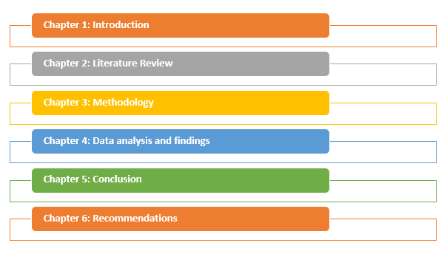
Figure 2: Dissertation Structure
(Source: The Researcher)

Chapter 2: Literature Review

2.1. Introduction
According to Atkar et al. (2021), as fashion firms compete for reach, consumer engagement and industry results, digital marketing is essential. Digital technology has fundamentally altered marketing, leaving fashion houses to adjust to shifting customer preferences and behaviours (Rathore, 2021). This transformation affects the Indian fashion industry that utilizes both digital and traditional methods. Research on fashion business digital marketing addresses how social media, e-commerce and influencer advertising impact brand exposure and customer involvement. These increase brand exposure, customer loyalty and sales, particularly for global and digital-first companies (Noris et al. 2021). Digital marketing dynamics vary by region and international brand methods might not work for established businesses in growing areas like India (Jadhav et al. 2023).
In a sector of Indian fashion where cultural heritage and traditional consumer behaviours are essential, internet marketing poses challenges and opportunities. In the case of trusted and high-quality brands, it is needed to blend digital tactics while keeping the brand identity and meeting the demands associated with an extensive client base (Sahai et al. 2019). This literature analysis reflects how internet marketing is altering Indian fashion. This particular review looks at present digital marketing practices, their efficacy and problems to understand how conventional fashion brands in India are adapting to the digital era and what lessons could be learnt for future marketing efforts.

2.2. The Indian Fashion Industry
The textile and garment business in India is one of the most ancient industries. Noris et al. (2021) further stated that the Indian textiles sector is distinct from industries in other countries due to its strong connection to agriculture for sourcing raw materials like cotton, as well as its deep-rooted cultural and traditional significance, as stated by the Indian Brand Equity Foundation (IBEF).
According to Panigrahi et al. (2020), the industry directly employs about 45 million people and indirectly employs up to 60 million people. Besides this, as per OGANJA (2020), the Indian Textile Industry makes up over 5 percent of India's gross domestic product (GDP) and contributes 14 percent to the total Index of Industrial Production (IIP). The textile industry is a significant contribution to India's export sector, accounting for around 13.5 percent of the overall export value, which amounts to 42.24 billion dollars (Atkar et al. 2021).
According to Shahi et al. (2021), the end of the 20th century saw the end of excessive promotion and exaggerated claims, resulting in a more realistic and sensible fashion industry that presents a more consistent and reliable image.
As per Madhav et al. (2018), during the 1950s, 1960s, and 1970s, the Indian fashion landscape was hardly devoid of colour. The experience was exhilarating, fashionable, and very elegant. The nation lacked designers, models, celebrities, and fashion design brands to showcase (OGANJA, 2020). The evaluation of a garment was based on its style and materials, rather than the identity of its creator.
According to Madhav et al. (2018), approaching an unknown tailor who could create a garment with impeccable fit, quality, and style for a few rupees was considered quite trendy and stylish. According to Roy et al. (2020), the affluent woman, who donned the garment, had a sense of pride for obtaining a favourable deal and for having her name associated with the final product.
Besides, Lista et al. (2021) mentioned that during the 1960s, women often wore fitted 'kurtas', 'churidars', and styled their hair in high coiffures as a fashionable trend. The period was characterised by a lively and exuberant atmosphere in the fields of arts, music, and movies. This was evident via the freedom from constraints and the embrace of innovative materials like plastic film and coated polyester fabric.
On the other hand, Jain (2022) opined that in the 1970s, there was a rise in the export of traditional materials both domestically and internationally. Therefore, foreign fashion made its way to India even before the emergence of MTV culture, showcasing vibrant colours, floral patterns, and bell-bottoms. As per Jain and Mishra (2020), the rise in popularity of synthetic materials and the influence of disco culture had a significant impact on the fashion industry. The inaugural of the fashion boutique 'Ravissant' took place in Mumbai during the early 1980s. Besides this, Khandual and Pradhan (2019) mentioned that during that period, clothing items were sold for a price that consisted of four digits. The 1980s was a period of heightened self-awareness, during which American fashion designers such as Calvin Klein gained significant popularity. In India, the shapes adopted a more masculine appearance, and the 'salwar kameez' was specifically tailored with the addition of shoulder pads (Majumdar and Sinha, 2018).
The emergence of designer boutiques in Mumbai led to the adoption of a beautiful fashion design culture by Indians, despite the high cost associated with it. According to Majumdar and Sinha, (2018), undoubtedly, a high-priced clothing was at the lowest level of fashion. However, Lista et al. (2021) stated that customers quickly assimilated into the realm of high fashion, where they believed that the term 'fine fashion design culture' implied a greater cost. The garments were offered at very low costs due to the designers' deliberate efforts to get attention by creating flashy costumes and aligning themselves with prominent shows, celebrities, and events. Besides this, according to Atkar et al. (2021), fashion shows transitioned into competitive occasions, with each one striving to surpass the others in terms of concept, guest list, and media attention. During that period, the fashion industry was considered the foremost professional art for any novice.
Apart from that Roy et al. (2020) mentioned that in the 1990s, the last decade of the century, there was a trend towards significant reduction in the popularity of ethnic clothing. Currently, the Indian ethnic wear industry is valued at Rs. 9000 crores (Thomas and Johny, 2018). This resulted in a fall and recession, as well as a strong emphasis on selling at any costs and maintaining a prominent public image. Majumdar and Sinha (2018) again stated that due to intense competition and a thorough understanding of the client's needs, the predictable outcome transpired. The price tags, previously at their height, started their descent. During that period, the decline was evident not only in the prices of clothing, but also in the fashion show industry (Lista et al. 2021). Additional models, choreographers, make-up artists, hairstylists, and designers descended into their respective professions.
According to Jain (2022), the enjoyment and festive atmosphere in the Indian fashion industry did not come to a stop with this, but rather persisted. with a certain threshold, the fashion industry attained a stable state. However, with the onset of the 21st century, the introduction of innovative designers, models, and thoughtful designs propelled the fashion frenzy to new heights (Thomas and Johny, 2018).

2.3. Digital Marketing in the Fashion Industry
According to Rathnayaka (2018), digital marketing in the fashion business involves using diverse digital platforms and technology to advertise and distribute fashion items and services. Therefore, marketing tactics play a crucial role in enabling fashion firms to effectively reach their intended audience and enhance their prominence in order to differentiate themselves from competitors. As per Rathore (2021), when fashion firms use social media methods, they can also take advantage of influencer marketing as an effective strategy to communicate with their target audience. This is a marketing tactic in which fashion firms form partnerships with social media influencers to endorse and advertise their items to their respective audience. Besides this, Alnaim and Albarq (2023) stated that companies use a wide range of strategies, including as email marketing, content marketing, fashion SEO, and PPC advertising, to expand their reach and establish deeper connections with clients. The primary objective is to enhance sales and foster brand loyalty.
In recent years, the fashion sector has seen a significant overhaul due to the emergence of digital marketing. In response to the increasing popularity of social media and online purchasing, fashion firms have had to modify their marketing tactics to cater to the demands of their clients in the digital era (Sahai et al. 2019). Brands may use social media platforms like Instagram and Facebook to exhibit their most recent collections and interact with their consumers in real-time. As a result, there has been a rise in brand recognition and a broader audience, resulting in more sales and profits. On the other hand, Behr (2018) mentioned that a significant advantage of internet marketing for fashion firms is the capacity to customise their marketing messaging. By using data, firms can customise their marketing messages to target individual clients, resulting in enhanced customer loyalty and higher repeat business.
Digital marketing offers a multitude of benefits for fashion firms (Noris et al. 2021). An important benefit is the capacity to access a worldwide audience. Due to the increase of e-commerce, fashion firms now have the ability to market their items to buyers worldwide. Digital marketing enables fashion firms to effectively target and reach certain client categories, resulting in more sales and profitability.
According to Guercini et al. (2018), one additional benefit of digital marketing is the capability to monitor and evaluate the efficiency of marketing activities. By using analytics solutions, fashion firms can monitor the effectiveness of their marketing efforts and use data-driven insights to enhance their marketing strategy. The outlook for digital marketing in the fashion business is promising. Besides this, Chaffey and Ellis-Chadwick (2019) stated that with the ongoing advancement of technology, fashion firms will be presented with an array of additional prospects to connect with their clients via novel and inventive means.
Hyper-personalization is a very important trend in digital marketing for the fashion sector (Noris et al. 2021). The practice of customising advertising photographs and material according to an individual's behaviour is gaining popularity. This may result in heightened consumer loyalty and a higher rate of repeat business. Short-form and shoppable films are becoming more popular in internet marketing for the fashion sector. Social media platforms provide a more efficient and convenient means for fashion firms to engage with their consumers and exhibit their items.

2.4. Challenges in Digital Marketing for Traditional Brands
Digital marketing is crucial to client engagement in a quickly changing corporate climate. Conventional businesses that have built their reputation and client base via traditional marketing face various challenges with digital marketing. The digital world opens many doors but requires businesses to reevaluate their marketing, audience communication and success metrics.
Adapting to Rapid Technological Changes
Traditional companies cannot keep up with digital marketing's rapid technical advancements. New platforms, tools and algorithms show up continuously in the digital world. According to Bala and Verma (2018), traditional companies accustomed to slower, more predictable marketing shifts struggle to adjust to this frenetic environment.
Social media platforms like TikTok and the rise of video content push marketers toward producing dynamic, engaging content for young viewers. As per Chaffey and Ellis-Chadwick, (2019), this particular change might be hard for brands that depended on print advertisements, TV advertising or in-store promotions. Additionally, it is tough to keep up with Facebook and Google's algorithm shifts that could affect a brand's reach and exposure.
Aligning Digital Marketing with Traditional Strategies
Tradition businesses have trouble incorporating digital marketing in their marketing mix. According to Veleva and Tsvetanova (2020), these firms established identities and client loyalty through conventional media including TV, print and radio. Transition to digital marketing calls for a planned approach to maintain brand message across platforms.
This integration difficulty is most manifest in resource allocation. Besides this, Katsikeas (2020) stated that conventional businesses have to handle digital and conventional marketing investments which might be divisive and difficult. A brand might face internal pushback when migrating cash from a TV campaign that worked to an untested digital approach (Dumitriu et al. 2019). The problem is proving digital marketing's value and coordinating digital and conventional initiatives to reinforce the brand message.
Brand Identity Management in the Digital Space
Traditional companies also struggle with digital brand consistency (Veleva and Tsvetanova, 2020). Digital customers expect businesses to be responsive, open, and honest. Peter and Dalla Vecchia (2021) stated that conventional businesses might struggle to fulfill this expectation if their brand identity was built on restrictive, one-way communication. Luxury brands, which have developed an image of exclusivity and grandeur might struggle to adjust their identity to the digital space in which engagement and connection are crucial. Bala and Verma (2018) further mentioned that brand identity should be adjusted to digital audience expectations without losing key principles. Digital marketing's interactivity and quick speed must balance the brand's legacy.
The Complex Digital Ecosystem
The digital marketing ecosystem is complex and huge consisting of several channels, platforms and technology. As per Veleva and Tsvetanova (2020), traditional companies cannot concentrate, particularly those with little digital know-how. These channels require different strategies and talents and selecting the wrong one might waste money and miss chances. On the other hand, Chaffey and Ellis-Chadwick (2019), stated that with all the development of digital media conventional businesses must operate across several platforms with different audiences and expectations. This might be daunting for brands used to fewer marketing channels. The idea is developing a cohesive digital strategy leveraging each platform and retaining brand consistency.
Building and Retaining Digital Expertise
Conventional companies need to find and keep digital experts to flourish in digital marketing. This normally involves recruiting or training digitally adept workers. Nevertheless, Dumitriu et al. (2019) stated that companies, which are not viewed as digitally aware or inventive might have a difficult time keeping and recruiting digital talent.
Conventional companies might face cultural hurdles when adding digital talent to their personnel (Chaffey and Ellis-Chadwick, 2019). Digital marketing is data-driven and dynamic unlike regular marketing for the brand. Digital change might be challenging because of opposition and conflicts.
Measuring Digital Marketing ROI
Traditional companies cannot measure Digital marketing ROI simply because Digital marketing delivers numerous data and indicators which could be difficult to decipher compared to traditional marketing channels which measure performance by frequency and reach (Katsikeas et al. 2020).
Traditional businesses might have trouble identifying which indicators are most relevant to company goals and which must be utilized to influence marketing strategies. As per Chaffey and Ellis-Chadwick (2019), digital marketing can measure consumer engagement and conversion rates precisely but these information might not correspond with the brand's conventional KPIs.
Handling Data Privacy and Security Concerns
With data-driven marketing also increasing, traditional businesses must also contend with data privacy and security. As per Chaffey and Ellis-Chadwick (2019), the digital world calls for gathering and utilizing client data for personalised marketing purposes but additionally, it creates hazards and legal constraints. Conventional firms, particularly new to digital marketing, might find it hard to comply with information protection regulations for example the CCPA or GDPR, causing penalties and brand damage (Veleva and Tsvetanova, 2020). Brands need to also invest in cybersecurity to stay away from data breaches and cyberattacks.
Competing against Digital-First Brands
Digital-first brands, developed around the digital world, challenge traditional companies. According to Rathore (2021), digital-native companies are more nimble, innovative and also in front of the curve in regards to digital trends and could thus compete for customers in client acquisition and retention.
An average retail business might find it tough to challenge an e-commerce brand specialized in electronic marketing, customer interaction and data analytics. Katsikeas et al. (2020) stated that traditional businesses must balance their legacy and client loyalty with the digital techniques that rivals are using successfully.

2.5. Effectiveness of Digital Marketing Strategies
Digital marketing has changed business-customer interaction and brought unprecedented growth, brand exposure and customer participation. Traditional marketing methods have given way to digital strategies, with social media and the internet presenting bigger reach, better targeting and much better ROI with increased accuracy and reach of targeting. Digital marketing tactics vary in efficacy across industry, target audience and implementation.
Precision Targeting and Audience Segmentation
Benefit from digital marketing is its ability to target customers precisely. As per Khan and Siddiqui (2023), digital marketing enables firms to segment their market by demographics, behaviour, preferences and geography versus conventional advertising, which uses broad communications to arrive at a wider audience. Besides this, Kumar (2021) mentioned that targeted marketing drives conversions by sending the right message at the right moment to the right buyers.
Google and Facebook Ads offer advanced targeting to display personalized information to individuals most likely to like their services or products. This increases engagement and conversions above and beyond some other tactics. Bakri (2020) mentioned that Precision targeting demands excellent data quality and appropriate use and interpretation in marketing activities. Bad data / targeting squanders resources / misses opportunities.
Enhanced Customer Engagement and Interaction
According to Chaffey and Ellis-Chadwick (2019), digital marketing approaches increase consumer contact and engagement. Social media, email and content marketing and advertising are two-way interactions between companies and customers. This strengthens customer ties and also reveals consumer preferences and behaviour. However, De Pelsmacker et al. (2018) stated that brands might respond to comments, hold surveys, and promote UGC with the goal of creating consumer community and loyalty that may increase brand advocacy and repeat business with customers on social media. Personalised, timely email marketing could capture leads and convert. On the other hand, as per Olson et al. (2021), digital marketing offers numerous interaction possibilities but also demands continual monitoring and response. These methods work best if the brand can reach consumers and fulfill their requirements in real-time. A lack of response could rapidly erode client trust and loyalty and erase digital engagement gains.
Measurable Results and Data-driven Decisions
Digital marketing measures results. According to Ijomah et al. (2024), unlike traditional marketing, digital marketing can analyse click-through rates, conversion rates, price per ROI and acquisition with high accuracy. These analytics enable marketers to assess their progress in real-time and also to enhance their plans using information.
Apart from that Khan and Siddiqui (2023) further stated that iterative improvement and effectiveness grow with time. Tracking consumer behaviour across touchpoints gives insight into the customer experience and will drive targeted and personalisation. Data-driven digital marketing success depends on the capability to evaluate data and act on insights (Bakri, 2020). Using metrics too loosely without context might produce bad conclusions. Data overload might also result in analytical paralysis, stopping marketers from making snap judgments.
Cost-Effectiveness and Scalability
Small and medium-sized companies with limited finances might find digital marketing cheaper compared to traditional advertising. Olson et al. (2021) again stated that online advertising systems including Google advertisements and social network advertisements enable companies to establish budgets, management expenditure and attain higher ROI, whereas Digital marketing efforts can be scaled up or down based on outcomes.
Pay-per-click (PPC) marketing charges firms just once a person clicks on their advertisement. Good content may continue to draw in visitors and generate leads, making content marketing and SEO costly (De Pelsmacker et al. 2018). Nonetheless, cost-effective digital marketing methods call for competent implementation and monitoring. A bad campaign management could easily drain resources with no return. Digital marketing is inexpensive but it calls for money and time to master the skills, content and tools.
Global Reach and Local Relevance
Digital marketing removes geographic limitations and also gives firms access to a worldwide audience. This worldwide reach helps e-commerce and international organisations develop markets. Worldwide reach and local relevance is attained by adjusting brand message to various areas on digital channels (Kumar, 2021). A business might run a worldwide digital marketing campaign with localised content for various regions, considering cultural differences and customer behavior. This ensures the marketing message reaches the region's target demographic. As per Ijomah et al. (2024), digital marketing allows worldwide reach but tough consistency across markets. Brands must balance global and local modifications to avoid diluted their message or alienating individuals. This method works best when local markets are understood and digital initiatives tailored.
Obstacles with Brand Authenticity
Digital marketing has numerous benefits but brand authenticity is tough. In the electronic era, many companies fight for customers attention. According to the opinion of Guercini et al. (2018), tendencies to produce content quickly and at scale might cause companies to reduce their authenticity when they are forced to be authentic.
De Pelsmacker et al. (2018) further stated that the requirement to produce social media content regularly might diluted the brand message by being trend-driven or generic. If the connections are not consistent with the brand's values or are unreliable with customers, influencers or sponsored endorsements could backfire (Khan and Siddiqui, 2023). To be digital marketers, relevance should be combined with brand identity. Digital marketing methods work best if the company can constantly articulate its values and reach its market in a dynamic digital world.
Adapting to Consumer Privacy Concerns
Customer privacy and changing regulations affect digital marketing methods. The European General data Protection Regulation (GDPR) and the US California consumer Privacy Act (CCPA) are creating greater Consumer awareness of Data use and demand more control over personal Data. According to Noris et al. (2021), personalisation and data-driven digital marketing have to meet these emerging demands. Failure to deal with privacy issues could cost brands customer confidence, legal fines and campaign success.
Nevertheless, Bala and Verma (2018) joined that transparent and ethical data practices may boost digital marketing and audience confidence methods. In a digitally crowded market, data use communication and consumer control might differentiate a company and build customer relationships.

2.6. Theoretical Overview
Online advertising
One of the most crucial aspects of digital marketing is online advertising. It is also known as online advertising, and it allows businesses to spread the word about their goods and services. According to Kingsnorth (2022), online advertising serves up the most relevant material and advertisements depending on the interests of the user. Publishers provide information about their goods and services on their websites to give visitors and customers access to free resources. Andrews and Shimp (2018) mentioned that online advertisers need to post more relevant and successful advertisements. Through internet advertising, the corporation has complete control over its budget and timeliness.
E-mail Marketing: According to Rosário (2021), email marketing is the practice of sending messages about goods and services to current or prospective customers via email. Advertisements are sent out, brand and customer loyalty is developed, consumer trust is increased, and brand recognition is raised via direct digital marketing. Furthermore, Almeida and Casais (2022) opined that a company may readily use this aspect of digital marketing to promote its goods and services. When compared to advertising or other kind of media exposure, the expense is comparatively minimal. By combining eye-catching images, text, and links on their goods and services, businesses can capture the attention of potential customers.
Social Media: One of the most significant digital marketing platforms available today is social media marketing. These are some online-based applications that let users produce and share content about the company's goods and services, including images and thoughts (Evans et al. 2021). Internet users continue to spend more time on social networking sites than any other category, according to Nielsen. Facebook, Twitter, Google+, LinkedIn, and other social media marketing networks are examples. Businesses may use Facebook to advertise events related to their goods and services, manage promotions that go by Facebook policy, and look for new business prospects.
According to Dwivedi et al. (2021), a corporation may raise brand recognition and exposure by using Twitter. It is the most effective instrument for promoting the goods and services that a business offers. Professionals create profiles on LinkedIn and exchange information with others. Evans et al. (2021) again mentioned that businesses may enhance their LinkedIn profile to allow professionals to explore and learn more about the company's offerings. Another social networking platform that works better than others is Google+, which is also more popular than Facebook and Twitter. It is more than just a basic social networking platform; it's an authoring tool that connects online material to its creator.
Affiliate Marketing: One kind of performance-based marketing is affiliate marketing. In this kind of marketing, the corporation pays affiliates for every visitor or client they bring in via their own marketing initiatives. According to Abdelhady et al. (2020), the network, the publisher (sometimes referred to as "the affiliate"), the merchant (often referred to as "retailer" or "brand"), and the client are the four main participants in the industry. A secondary tier of companies, including affiliate management agencies, super-affiliates, and specialised third-party suppliers, has emerged as a consequence of the market's increased complexity. Besides this, Patrick and Hee (2019) stated that affiliate marketing may be approached in two ways: A company might become an affiliate of another firm or provide its own affiliate program to third parties.
On the other hand, as per Olbrich et al. (2019), the owner of the business must pay affiliates a commission for each lead or sale they bring to the company's website if they want to run an affiliate program. The company is primarily looking for affiliates with the ability to access unexplored regions. An e-zine publisher, would make an excellent affiliate since its readers are always looking for new content. Therefore, presenting the service via a "trusted" organisation might attract potential customers that you would not have otherwise reached (Abdelhady et al. 2020).

2.7. Literature Gap
The fashion industry's digital marketing literature targets multinational businesses, primarily Western ones. These studies dissect every channel by which social networking, influencer advertising and e-commerce promote brand recognition and consumer engagement. Nevertheless, research on utilizing such tactics in growing economies such as India where the digital environment is changing fast is lacking. Little research examines how established Indian fashion companies like Raymond navigate digital marketing problems and potential in a nation with conventional customer behaviours and current digital trends.
Several studies address the digital transformation of fashion industry but not how traditional Indian brands with cultural origins and long-standing consumer loyalty leverage digital marketing to sustain and grow their market position. Most research is done for global or digital-first businesses, leaving very little insight into just how heritage brands for example Raymond, which traditionally employed conventional marketing, are adjusting to digital channels to reach a younger, more digitally savvy audience.
This research examines Raymond's digital marketing initiatives to create brand name recognition, customer engagement and sales to fill this gap. Concentrating on a standard brand in a developing region, the research will provide contextually relevant insights, which could guide digital marketing strategies of various other legacy businesses in similar situations. It will provide practical tips for maximizing digital marketing efforts in India to fill the information vacuum in actionable information for conventional businesses.

2.8. Summary
The literature analysis examines how digital marketing changed fashion business particularly in India. It first examines the characteristics of the Indian fashion business that is culturally based and dependent on agriculture for basic resources. This classical setting contrasts with new digital marketing methods transforming brand-consumer interactions.
The analysis illustrates how fashion companies require digital marketing to arrive at more customers, increase engagement and increase sales. Social media, influencer alliances, content marketing and SEO are assessed for brand exposure and consumer loyalty. The research reveals that while these tactics work for global and digital-first companies, they create new problems and potential for established brands like Raymond in India.
This study discusses about the adaptation of digital marketing strategy to manage the activity of fashion industry’s conventional brands can also be discussed. Examples include keeping up with quick technology developments, merging digital initiatives with conventional means, maintaining brand identity online and managing the complicated digital environment. The analysis highlights the digital competence requirement of organisations and the digital marketing challenges.

Chapter 3: Methodology

3.1. Introduction
This particular chapter is aimed at discussing the research method to understand the significance and scope of digital marketing within the fashion sector using Raymond in India as an example. The research analyzed Raymond's digital marketing methods, their effectiveness and the challenges the firm faces. The methodology defined the steps in data sampling and gathering, that will enable to collection of adequate empirical evidence for the study. This chapter reviews the philosophical foundations of the research as well as the research approach, design and data collection which is in line with pragmatism and also the deductive technique adopted to comprehend the role and extent of digital marketing within the chosen sector using Raymond brand in India as a case in point. Here the intention is to collect primary data and to further augment this with secondary sources to showcase Raymond's digital marketing initiatives and this will be done by capturing the experiences and viewpoints of diverse stakeholders.

3.2. Research Philosophy
Research philosophy forms a fundamental component of methodological guidance to make certain the research strategy is pertinent and coherent to study goals. Research philosophies including positivism, interpretivism, realism and pragmatism provide various views on information acquiring and understanding (Simpson, 2018).
The research was based on the philosophy of pragmatism, viewed as the best philosophical foundation for investigations merging qualitative and quantitative methods. Pragmatism promises that knowledge could be a way to resolve useful issues and in this particular research it permitted the incorporation of empirical (quantitative) data and contextual (qualitative) ideas (Kaushik and Walsh, 2019). Hence, this pragmatic approach allowed Raymond to assess his digital marketing efforts in terms of quantitative outcomes (customer engagement, brand awareness, sales) and qualitative context (customer perceptions, managerial decisions).
Furthermore, the pragmatism philosophy helped this particular research as the researcher could therefore concentrate on the practical impacts of digital marketing in the fashion market without becoming bound to an objective or even subjective gaze. This methodology enabled the activity of fashion industry’s business value to look into how Raymond's digital marketing tactics impact consumer engagement and brand awareness and if their techniques could be made better or refined based on the collected data.

3.3. Research Approach
The research methodology defines the plan of data collection and analysis thereby structuring the whole study. There are three sorts of research methods: Deductive, inductive and abductive (Pearse, 2019).
The research was based on a deductive approach, which tested established ideas and frameworks regarding digital marketing in the fashion sector against Raymond's real behaviours and outcomes. However, the deductive technique allowed the researcher to start with a theoretical framework drawn out of the literature on digital marketing impacts on consumer engagement, sales performance and brand recognition (Pandey, 2019. Theories were then validated by collecting primary data (such as consumer surveys) about Raymond's situation.
Besides this, the deductive technique was utilized for this study as it allowed hypothesis testing. The effectiveness of Raymond's digital marketing efforts, issues faced by the firm and potential for improvement were hypothesized. On the other hand, the study deductively assessed these hypotheses against the data in a way that produced concrete and practical results. The premise that digital marketing increases customer engagement was evaluated by survey responses regarding consumer contact with Raymond's digital initiatives.

3.4. Research Design
Research design is viewed as essential since it offers the conceptual framework within which the analysis is conducted and which analysis questions the researcher is answering are collected and analysed methodically. It ensures the research is planned in line with the goals to attain trustworthy and valid results. Common research designs accommodate various research goals and include exploratory, descriptive, explanatory and experimental frameworks (Sileyew, 2019).
The study adopted an explanatory research design. This design was adopted due to the study's central aim of detailing the contribution of digital marketing methods to many Raymond outcomes namely customer engagement, brand loyalty and product sales performance. Besides this, an explanatory design is appropriate for examining causal links and giving explanations of the utility or otherwise of several techniques in practice (Parra, 2023).
Furthermore, the explanatory design allowed Raymond to examine just how digital marketing tools (social media, e-mail marketing, SEO) impacted customer behaviour and brand performance. Additionally, it permitted the researcher to examine contextual elements, which enabled or inhibited the usefulness of these tactics. This methodology allowed the study to discover the digital marketing strategies Raymond applied and the way they impacted the company's industry performance and consumer perceptions.

3.5. Data Collection
The gathering of data is crucial as it forms the foundation for the study and thus supplies researchers with information required to evaluate hypothesis and answer research questions (Stieglitz et al. 2018). It assures the relevance and correctness of the data, which instantly impacts the validity and dependability of the study conclusion. The major kinds of data collecting techniques primary data collection method, secondary data collection method and mixed (both primary and secondary) data collection method (Stieglitz et al. 2018).
This particular research gathered data from mixed (both secondary and primary) sources to understand Raymond's digital marketing strategy. Primary data was collected from survey questionnaires. Respondents have been chosen by purposive selection from a non-probability sample technique from people that had experience or engaged in Raymond's digital marketing efforts in the past. The survey gathered data on Raymond's digital marketing initiatives, which includes consumer involvement, brand awareness and buy behaviour. However, surveys were administered via Google Forms for quick dissemination and response collection. These enquiries contained both closed-ended questions for quantitative analysis and open-ended enquiries for qualitative insights into customer viewpoints.
On the other hand, secondary data were derived from academic sources including peer-reviewed journals, business reports, books and published research papers. These sources offer basic data on digital marketing trends, problems and best practices in fashion (Clark. and Vealé, 2018). Additionally, public reports on Raymond's digital marketing activities were deemed to contextualise the main data collected. Besides this, secondary data served to build the theoretical framework of the research and guide hypothesis formulation.
Integrating secondary and primary data collecting allowed for a study utilizing empirical data from real customers and theoretical insights from literature.

3.5.1. Sample Size and Sampling technique
The researcher chose a sample of 100 individuals using purposive sampling, a kind of non-probability sampling. This particular selection technique was used because it permitted the researcher to focus on individuals most applicable to the research, persons directly involved in Raymond's digital marketing efforts. This focused methodology ensured the gathered data was relevant and provided insight into particular Raymond methods and their effects on consumers. Hence, the chosen participants for the research are mainly the customers of Raymond's, people from the marketing team of the company.
A sample size of 100 was deemed appropriate for this particular research since enough data was obtained to detect patterns and trends but not overly large for analysis. Participants were selected based on their understanding of Raymond's digital marketing initiatives to ensure informed comments relevant to study goals.

3.6. Data Analysis
Data analysis is the systematic analysis of gathered information to learn relationships, trends and patterns, which answer research questions (Assarroudi et al. 2018).
This analysis utilized quantitative in addition to qualitative data analysis methods to elucidate Raymond's digital marketing strategy. However, survey replies were examined quantitatively in Excel. Survey responses from Google Forms exported to Excel and examined. Besides this, descriptive statistics like frequencies, percentages and means were computed representing information and client impressions of Raymond's digital marketing efforts. Data visualization capabilities of Excel (charts and graphs) were used to identify patterns and trends in the answers and show how Raymond's digital marketing efforts had influenced consumer interaction, brand recognition and product sales performance. The secondary data are examined for shared themes and perspectives for the qualitative research (Assarroudi et al. 2018). Qualitative data analysis revealed customers' sentiments regarding Raymond's digital marketing initiatives and their explanations. This research was essential to identify the barriers and opportunities Raymond faced in implementing digital marketing strategy. Secondary data from publications, journals and industry reports were qualitatively examined and compared Raymond's techniques with overall industry trends.
The quantitative in addition to qualitative data integration meant the study provided both an overview of Raymond's digital marketing success and an examination of the factors, which drive this performance.

3.7. Ethical Considerations
Ethics concerns were necessary throughout the research procedure to make certain the integrity and credibility of the research. The researcher met ethical requirements of informed permission, confidentiality and privacy for the surveys. The research participants, including fashion industry’s investors, customers, suppliers and others were informed about the research goals, use of information and right to withdraw from the research at any time before taking the survey. All participants informed consent and confirmed voluntary involvement and understanding of study aims. Besides this, the participants were not forced to answer any questions and they had the option to skip any responses. Respondent confidentiality was maintained by anonymising all survey information and preventing individual replies from being connected to particular people.
Furthermore, data was kept safe and only researcher was permitted permission to access it. Potential hazards for participants were attenuated by designing non-intrusive survey questions that only considered digital marketing in the fashion business. On the other hand, while gathering secondary data, the researcher checked the authenticity of the source and the reliability of the data. Not only that the researcher has maintained all the copyright rules and regulations. The researcher meticulously credited and also referenced all secondary sources of data, hence preventing any instances of plagiarism. The usage of secondary data was regulated by ethical guidelines ensuring responsible information usage.

3.8. Summary
This particular chapter described the research technique followed for the research, where the function and scope of digital marketing at Raymond in India was studied. A pragmatic research attitude guided the research and a mixed methods approach integrating quantitative and qualitative data was adopted. Besides this, the deductive technique allowed the researcher to assess hypotheses according to existing literature and the explanatory research design investigated the causal relationships between digital marketing tactics and results.
On the other hand, data were gathered from secondary and primary sources, principally via survey questionnaires and secondary data from academic journals, industry reports along with other published sources. Sample size 100 respondents was selected through purposive sampling to ensure that acquired data was associated with study goals. Data analysis was quantitative using Excel with statistical evaluation and qualitative using secondary data and open-ended replies. Ethical concerns were tackled during the research process. The results and analyses produced from the data collected and examined by the methods described in this particular chapter will be described in the next chapter.

Chapter 4: Data Findings & Analysis

4.1. Introduction
This fourth chapter of this research study focused on the critical data analysis and interpretation process to gain in-depth insight into the research. The digital marketing initiatives of the Indian fashion market have been analyzed to gain productive knowledge regarding the future of digital marketing. This research focused on a mixed-method approach to get a comprehensive understanding of digital marketing efforts of Indian fashion industry. Digitization in the fashion industry has a positive impact on the Indian fashion and garment industry, which has been analyzed here through primary and secondary data sets.

4.2. Data Findings
The digital marketing strategy of Raymond was specifically highlighted to get an in-depth insight into the current research problem (Vincent and Aurangabadkar, 2023). The primary quantitative data set was collected by implementing the survey questionnaire method. A total of 15 questions were asked to the participants via Google form and sent by email to get effective answers to the questions and increase knowledge about the role and extent of digital technology to increase the fashion industry’s business value. The Likert scale was implemented during the primary data collection for the authentic quantification of the collected data sets (Ozuem and Ranfagni, 2021). By following the non-probability sampling including a purposive sampling method is selected by following the demographic characteristics to achieve study goals. A total of 100 participants were involved in this study who were selected by applying the purposive sampling method by following the fashion industry’s target population, including suppliers, customers and investors. In this research, due to short time, more than 100 participants have not selected to collect information by using Google Form. The fashion retailers have focused on improving the fashion company’s profits, sales and reputation to improve the market value. Besides, the raw material suppliers of the fashion industry are to reduce environmental footprint and adopt innovative technology that emphasise the fashion industry’s business value. It is one of the well-known non-probability sampling methods that has been extensively used in social science research. On the other hand, secondary qualitative data sets were collected by a systematic review of peer-reviewed journals, business reports and authentic academic sources like books and published research papers.

4.3. Primary Data Analysis & Results
Q.1. Do you believe the online promotional approach of Raymond is appealing?
Total number of Participants | Yes | No | Maybe
100 | 76 | 21 | 3
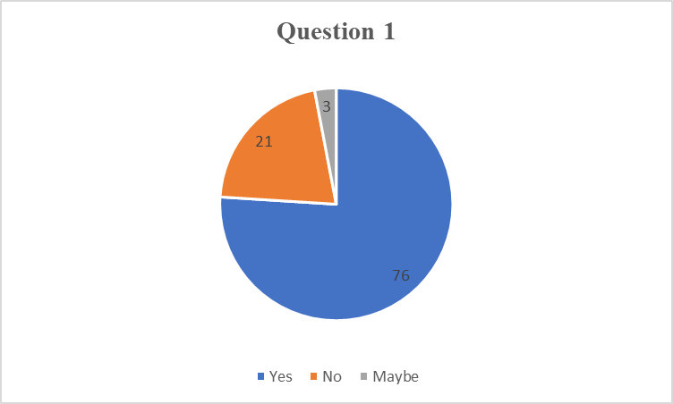
The above graph describes the responses of all the participants (n=100) in the research. 76 participants answered assertively regarding the extent of the appeal of the online promotional approach in the fashion market. Only 21 participants negatively answered the questions. 3 participants answered “Maybe” which identified a stronger appeal of Raymond in the digital promotional content creation.
Q.2. Do you believe, implementing a digital marketing strategy benefited the sales growth of Raymond in the last 2 years?
Total number of Participants | Yes | No | Maybe
100 | 69 | 20 | 11
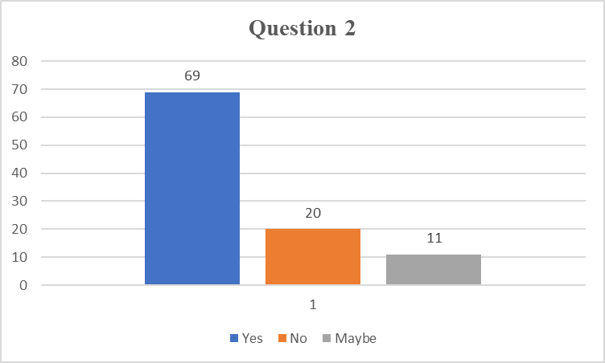
Among 100 participants a total of 69 participants positively believe that the sales growth of Reymond has increased significantly after the digital marketing strategy implication. While 11 participants were not sure about the sales growth and 20 participants responded negatively. This analytical view sheds light on how Raymond needs a more online presence and a transparent digital marketing policy to reach a larger customer base.
Q.3. Do you believe that the Raymond website is mobile-friendly?
Total number of Participants | Yes | No | Maybe
100 | 73 | 18 | 9
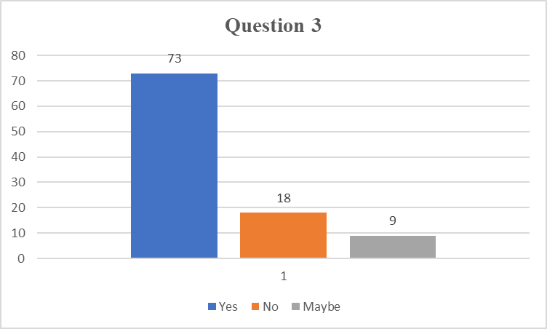
The mobile-friendliness of the website is important to analyze for knowing the user involvement with the digital initiatives. In this question, 73 participants out of 100 participants think that the Raymond website is mobile-friendly. However, 18 respondents were denied the mobile-friendly ness of the Raymond shopping websites. On the other hand, 9 participants did not know exactly about the mobile-friendly ness of the Raymond websites. A large number of participants believed that the mobile-friendly websites of Raymond lead the company towards optimum success in the global fashion market.
Q.4. Do you find Raymond's digital presence informative while making a purchase decision?
Total number of Participants | Yes | No | Maybe
100 | 89 | 8 | 3
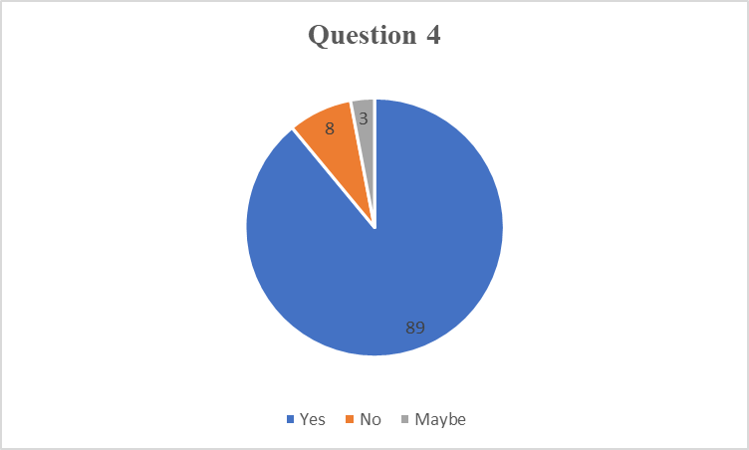
A total of 89 participants believed that the continuous digital presence of Raymond on various social media sites was informative and it significantly led towards positive purchase decisions among the customers. Only 8 participants answered negatively regarding the purchase decision fact. Only 3 participants did not provide any positive or negative comment regarding the fact. This analysis also suggested that the continuous online presence of Raymond positively influenced the purchase decisions of individual customers.
Q.5. Do you believe Raymond benefited by using Google ads for effective digital marketing?
Total number of Participants | Yes | No | Maybe
100 | 81 | 17 | 2
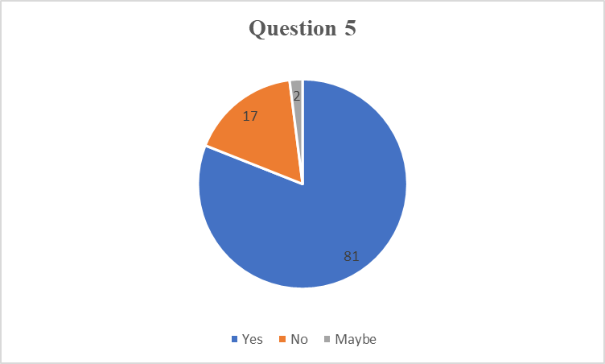
Google ads are one of the biggest platforms that have been used to promote different brands to global audiences. Through the survey, it is seen that a total of 81 participants believed that utilizing Google ads benefited the digital marketing process Raymond in the global competitive fashion market. The total number of participants was 100 in this study; 17 respondents did not believe that Google ads have any contribution to the success of Raymond’s digital marketing strategies on social media sites. Only 2 participants were well aware of the impact of Google ads on Raymond's digital marketing success.
Q. 6. Do you follow daily social media updates of Raymond?
Total number of Participants | Yes | No | Maybe
100 | 87 | 3 | 10
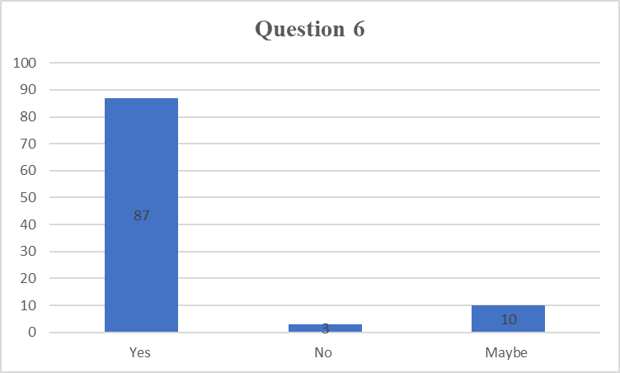
Glowing daily social media updates Raymond portrayed the attachment of customers to the company. In this analysis 87 respondents out of 100 followers daily social media undated Raymonds. However, 3 People never followed the social media handles of Raymond. Only 10 participants among the target population did not follow social media sites of Raymond regularly but sometimes they watched the social media updates and made their purchase decision based on that. It is clear from the analysis that the daily social media update also positively elevates the purchase intention of customers.
Q.7. ‘The Complete Man’ digital campaign of Raymond attracted significant numbers of customers towards the company.
Total number of respondents | Strongly agree | Agree | Neutral | Disagree | Strongly disagree
100 | 47 | 45 | 3 | 3 | 2
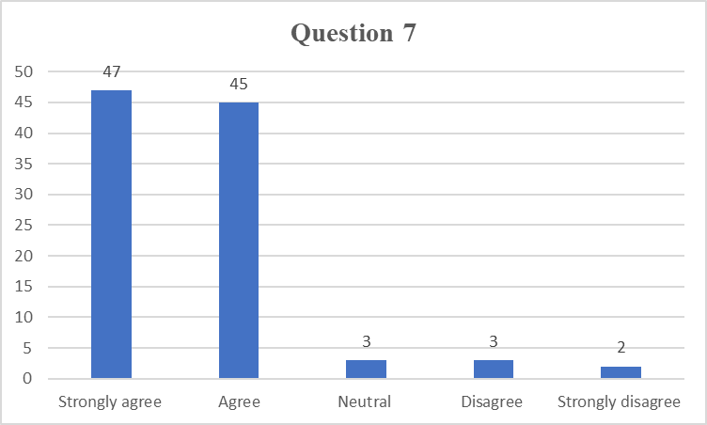
“The Complete Man” digital marketing campaign is one of the effective digital initiatives of Raymond. 47 respondents among 100 participants strongly agreed that the campaign attracts customers towards the company. 45 participants agreed with the customer attraction statement. However, 3 participants were neutral regarding the issue due to their unawareness about the campaign. 3 participants disagreed and 2 participants strongly disagreed with the entire fact. A higher number of credible customers provides stronger insight into the effective campaign developed by Raymond to create productive growth within the company.
Q.8. The Search engine optimization process followed by Raymond accelerated its brand value in the global fashion market.
Total number of respondents | Strongly agree | Agree | Neutral | Disagree | Strongly disagree
100 | 81 | 9 | 3 | 5 | 2
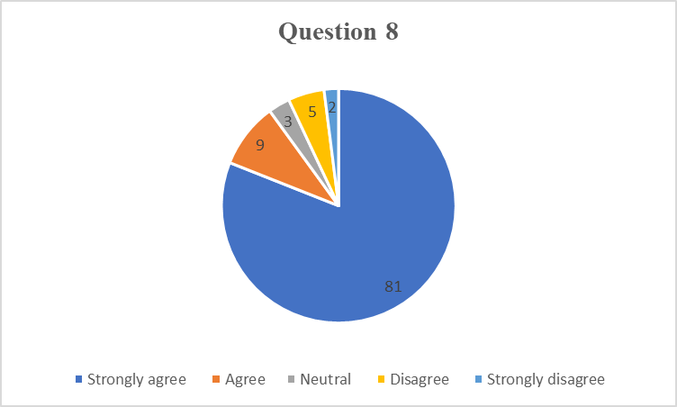
81 respondents among the 100 participants strongly agreed that the search engine optimization process significantly accelerated the brand value of Raymond in the global fashion market. 9 participants also agreed on the fact however 5 participants disagreed and 2 participants strongly disagreed that the search engine optimization process has a greater impact on the brand value of Raymond. Only 3 participants became neutral while answering the question which denoted a lack of clear knowledge about the search engine optimization process of Raymond and its benefits in the digital marketing process. The extremely strong credibility of the respondents provides optimum insight into the beneficial effect of the search engine optimization process in brand value acceleration of Raymond.
Q.9. Sharing frequent eye-catching reels on Instagram attracts more customers towards the company.
Total number of respondents | Strongly agree | Agree | Neutral | Disagree | Strongly disagree
100 | 85 | 11 | 0 | 3 | 1
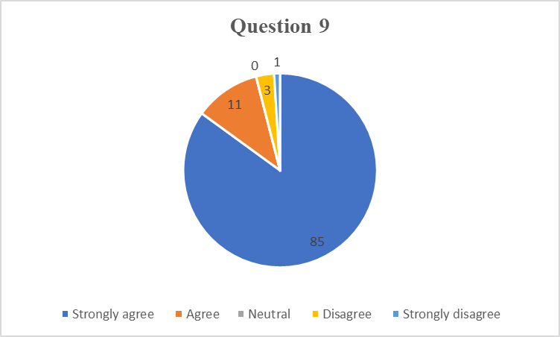
85 participants strongly agreed that sharing eye-catching reels in the social media post mainly in the Instagram profile of Raymond significantly attracts the global customer base. 11 participants also agreed on the fact and answered assertively. However, 3 respondents disagreed about the influence of social media reels on the customer attraction process of Raymond. No participants answered neutrally specifically for this question. It highlighted the implication that daily Instagram reels can attract customers towards Raymond significantly.
Q.10. Raymond's influencer marketing strategy enhances the competitive edge of the company in the global fashion market.
Total number of respondents | Strongly agree | Agree | Neutral | Disagree | Strongly disagree
100 | 49 | 41 | 3 | 2 | 5
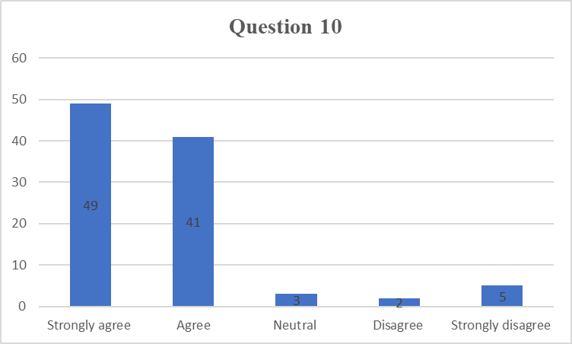
Influencer marketing is one of the effective digital marketing strategies that increases the competitive edge of Raymond. During the survey, 49 participants strongly believed that the influencer marketing approach strategically enhances the competitive edge of Raymond in the global fashion market. 41 respondents also agreed with this statement and responded assertively. 3 participants became neutral about the fact while 5 participants strongly disagreed with the efficiency of influencer marketing in the competitive growth of Raymond. 2 participants also supported this fact and negatively replied to the particular questions.
Q.11. Personalized digital ads developed by Raymond increase product purchase intention of customers in the global fashion market.
Total number of respondents | Strongly agree | Agree | Neutral | Disagree | Strongly disagree
100 | 87 | 5 | 1 | 4 | 3
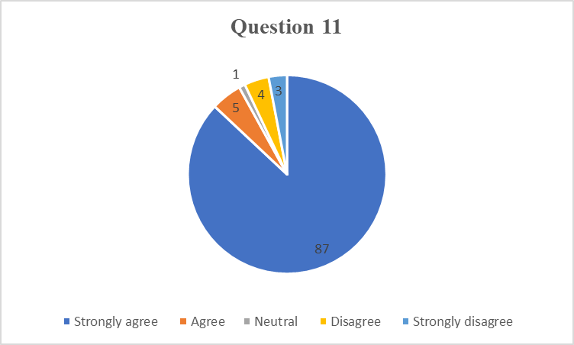
According to the view of 87 participants, personalized digital advertising features of Raymond provide positive purchase intention to the customers that in turn benefits the sales volume of Raymond. 5 participants also agreed with this statement and answered assertively. Only 1 participant became neutral about the fact while 4 participants disagreed and 3 participants strongly disagreed about the association of personalized advertisement with the accelerated purchase intention of customers.
Q.12. Raymond is suffering from a lack of engaging content development in social media.
Total number of respondents | Strongly agree | Agree | Neutral | Disagree | Strongly disagree
100 | 61 | 29 | 4 | 3 | 3
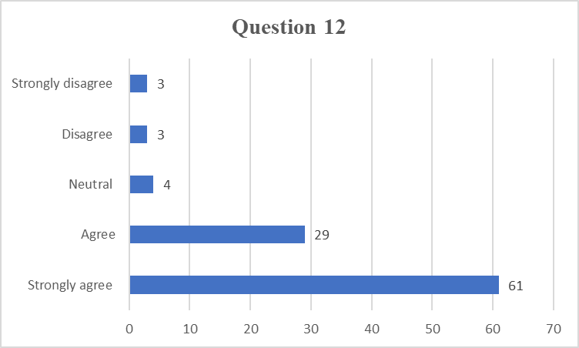
According to the view of 61 participants, lack of engaging content, and development became the most essential challenge faced by Raymond in the global fashion market. Even 29 participants also agreed with the fact that Raymond does not create any engaging content or socially relevant content that attracts customers’ attention. 4 participants became neutral while answering but 3 respondents strongly disagreed about that and they believed the digital content developed by Raymond was engaging. This is again supported by 3 more participants in this research.
Q. 13. Lack of discount offers Raymond reduces the popularity of Raymond in the global fashion market.
Total number of respondents | Strongly agree | Agree | Neutral | Disagree | Strongly disagree
100 | 53 | 11 | 7 | 20 | 9
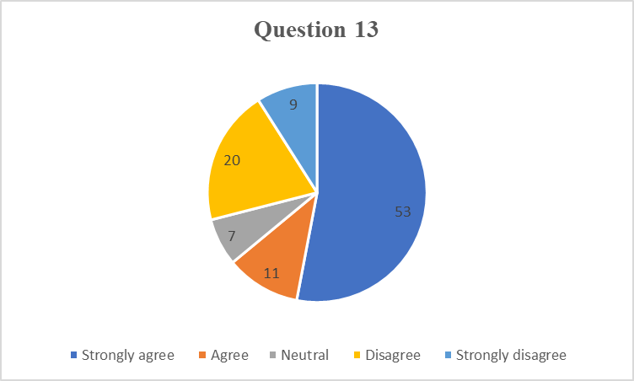
As per the above graph, 53 participants strongly agreed that the lack of discount provided by Raymond reduces the population of the company in the global fashion market. 11 participants also agreed with this statement. While 7 participants were not sure about the impact of discount sales on the popularity of the brand. 20 participants completely disagreed that the poor discounts offered by Raymond reduce the popularity of Raymond in the digital fashion market. 9 more participants strongly opposed this statement.
Q.14. Working on the feedback of customers to improve revenue growth and sales volume of Raymond.
Total number of respondents | Strongly agree | Agree | Neutral | Disagree | Strongly disagree
100 | 68 | 23 | 4 | 4 | 1
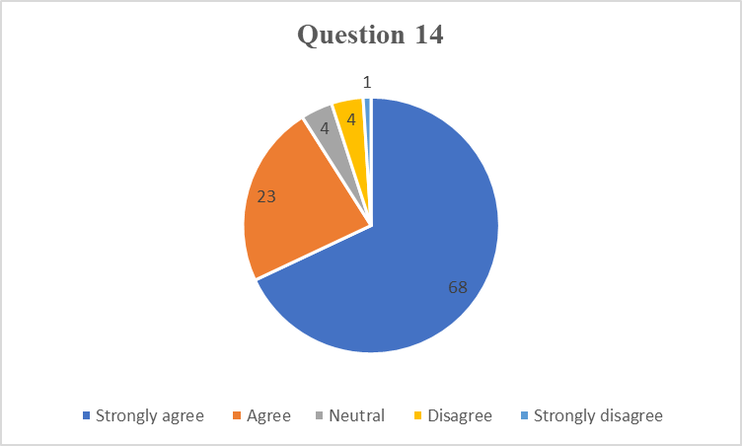
68 participants among 100 strongly agreed that taking feedback from the customers and actively working on the same benefited the year's revenue growth and sales volume of Raymond. 23 participants also agreed about the active engagement of Raymond on the customer feedback to provide customers with need-based product development in the fashion industry. As per the analytical table, 4 respondents become neutral about the feedback-based revenue growth of Raymond. 4 participants disagreed about the digital feedback-based product development strategy of Raymond. 1 respondent strongly disagreed with the above-mentioned fact.
Q.15. Raymond should implement a digital community engagement program to enhance its brand presence in the global competitive fashion market.
Total number of respondents | Strongly agree | Agree | Neutral | Disagree | Strongly disagree
100 | 80 | 14 | 3 | 1 | 2
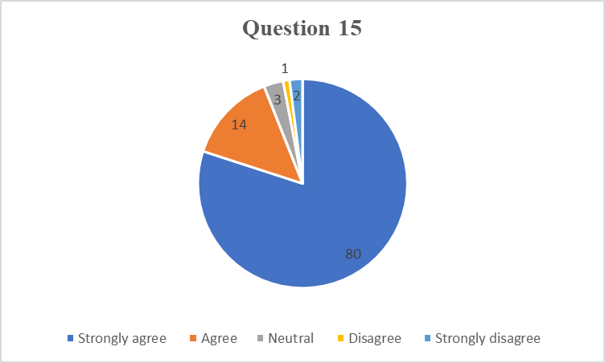
The above graph shows that 80 participants strongly agreed that Raymond's company should implement a direct community engagement program to accelerate brand presence in the global fashion market. 14 more respondents agreed on the fact and answered assertively. On the other hand, 3 participants from the target group also stayed neutral while asking for this suggestive question. 1 participant disagreed about the benefits of the digital community engagement program in accelerating the brand presence of Raymond.

4.4. Secondary Data Analysis & Results

4.4.1. Social Media Marketing Strategy of Raymond
Consistent Presence on Different Social Media Sites
Raymond followed a complete blend of traditional and modern approaches in the marketing process to enhance customer engagement and sales volume within the company. Already Raymond is famous for delivering world-class fabric quality and the active presence of Raymond in the digital medium also exaggerated the success rate of Raymond. The study of Jovanović and Doljanica (2020) stated that Raymond's aesthetic presence on social media platforms creates a stronger market presence for the brand. The omnichannel marketing approach of Raymond also increases the productive ability and digital market presence of the company. On the other hand, the study of Mekonnen and Larner (2021) highlighted that the consistent branding of Raymond in the same colour theme and approach in all the social media handles significantly enhances the brand visibility of Raymond in the global fashion industry. The study of Noris et al. (2021) highlighted that the brand storytelling capacity of Raymond is positively influenced by the conventional digital marketing approach within the fashion industry. Raymond focused on the traditional legacy and unique craftsmanship of the company to connect emotionally with the customers.
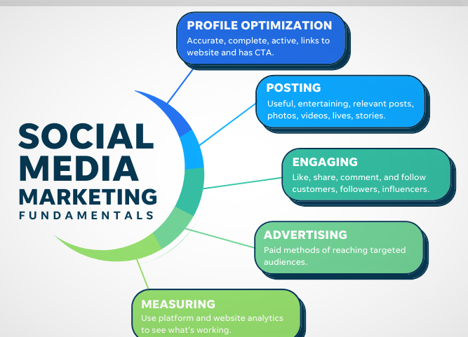
Figure 3: Social media marketing strategy
(Source: Dewi et al. 2022)
Generate Credibility and Trustworthiness through Social Media Sites
The social media handles of Raymond highlighted the fabric manufacturing process from the loom to create trust among the customers. According to the study of Islam et al. (2024), Raymond frequently partnered with regional fashion bloggers to develop an effective influencer marketing approach. According to the study of Dewi et al. (2022), Raymond applied user-generated content in social media sites to increase a positive marketing approach in social media sites. Raymond also emphasized different marketing approaches to make visually appealing content in the social media handles. According to the study of Tarnanidis et al. (2023), effective activation of Instagram focused on visually appealing content while on LinkedIn, Raymond focused on sustainability efforts and leadership ability in the social media sites.
The study of Sommella and Sorrentino (2023), focused on the implication of seasonal campaigns on social media to implement valuable insight into the multi-channel engagement process. Raymond also emphasized seasonal updates and campaigns to boost customer engagement to drive sales volume in the organization. As per the study of Oklander and Kudina (2021), Raymond also accelerates engagement with the customers through comments, interactive story creation and gathering to provide valuable insight into the company. Focusing on the valuable insight of the customers also emphasized by the company to enhance productive engagement in the social media sites.

4.4.2. Personalized Data Analytics-Based Digital Marketing Solution Development of Raymond
Data Retrieval from Social Media Analytics
Raymond also focused on data-driven insight in social media to provide personalized advertisement opportunities in Raymond. As per the study of Kertakova and Efremov (2021), Raymond emphasized the social media-based data-driven insight into the current perception of the customers. The active presence on social media sites increased data-driven insight into customer preferences in the modern fashion industry. According to the study of Panjaitan et al. (2024), social media analytics enhance the behavioural data of customers such as purchase data, customer preference patterns, and user tracking experience of the customers. As per the study of Nobile et al. (2021), Raymond utilized a clustering algorithm of social media sites to optimize the purchase behaviour of customers through their social media engagement. With the help of social media, Raymond can predict future purchase behaviour and preferences of customers.
Predictive Analytics-Based Decision-Making
Utilizing predictive analytics in social media sites enhances digital marketing opportunities in Raymond. The study by Tien et al. (2020) highlighted that customers get more personalized product choices in online shopping sites based on the predictive analytics from the social media handles. On the other hand, real-life feedback from customers on the social media pages also helps to analyze the current feelings of customers towards the brand. Providing personalized choices enhances operational efficiency and the trustworthiness of the customers towards the company. The study of Casciani et al. (2022) also stated that Raymond utilized clustering algorithm techniques in social media to generate effective customer segmentation within the larger target market.
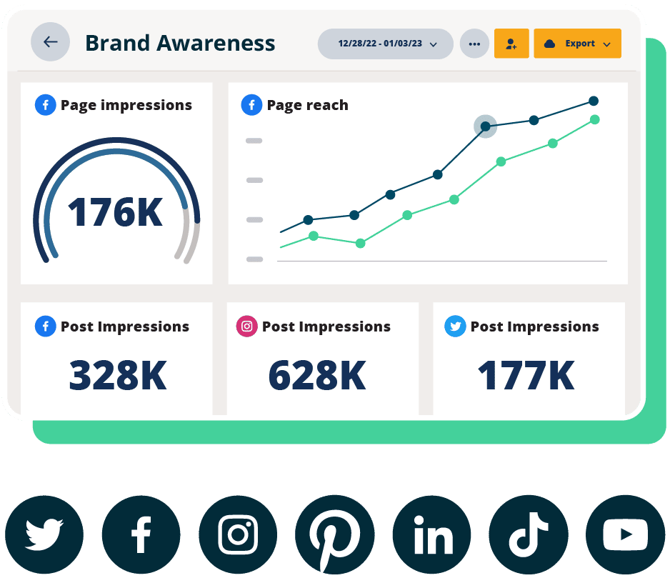
Figure 4: Social media-based data analytics
(Source: Kang and Choi, 2024)
Personalized Promotional Strategy through Data-Driven Insight
Raymond emphasizes promotional strategies based on the personalized choices of the customers to enhance customer satisfaction rates. As per the study of Kang and Choi (2024), Raymond also relied on the automated campaign in the social media handles with a consistency that encourages personalized promotional ground of the company towards the customers. The omnichannel personalization process also enriches productive opportunities in the effective spread of the company. As per the study of Alshurideh et al. (2024), the personalized content development strategy in the digital marketing process Raymond also creates a competitive edge among the customers. Creating personalized content for the customers also enriches effective customer engagement that in turn benefited the operational ability of Raymond. According to the study of Fakhry and Nasr (2023), Raymond also uses a KPI performance tracker and creates feedback loops based on the data retrieved from the social media sites. Intensive use of social media analytics benefited Raymond in navigating customer demand from the company.

4.4.3. Application of Search Engine Optimization Process of Raymond
Keywords Specific Target Audience Attraction Process
Search engine optimization (SEO) is one of the highly used digital marketing strategies of Raymond to target larger customer groups towards the company. Raymond uses SEO techniques to become competitive in the global fashion industry. The study by Langley and Rieple (2021) highlighted that Raymond strategically uses SEO techniques to enhance online visibility and attract a significant number of online traffic to optimize Raymond’s ranking within the online digital marketing platforms. The study of Busca and Bertrandias (2020) stated that Raymond utilizes most searched keywords for men's fashion items to stay relevant in the digital search engine.
On the other hand, the study of Solfa et al. (2023) highlighted that Raymond also analyzed the current SEO strategy of other competitors in the fashion market to generate more influential and relevant keywords in the digital marketing channels. According to the study of Herosian and Samvara (2020), Raymond also used long-tail keywords to attract niche markets in the global fashion industry. It helps to attract a larger number of keyword-specific searches to the target market which significantly enhances operational efficiency and visibility in the digital platforms.
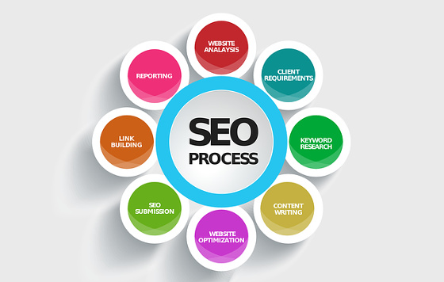
Figure 5: Search engine optimization process
(Source: Chadha and Ahuja, 2020)
User-Experienced SEO Techniques for Increasing Online Visibility
Raymond highly focused on SEO ranking to gain operational efficiency and good visibility of Raymond in digital sites. The study of Chadha and Ahuja (2020) highlighted that Raymond emphasized on the structuring of the online websites to ensure easy accessibility of customers towards the website of Raymond. The website of Raymond is structured in such a way that caters to the user-friendly experiences of the customers. According to the study of Gaur and Sweta (2021), Raymond continuously works on data-driven insight created through customer behaviour to develop conversion pathways for the websites. Continuous optimization of conversion pathways enhances effortless buying behaviour among customers from digital marketing channels, as per the study of Oyedele et al. (2023), Raymond regularly monitors organic traffic and the ranking of the company in the SEO process to stay up-to-date in the digital fashion world.
Technical and Non-Technical Aspects of SEO
The content optimization process is another important aspect that has been followed by Raymond to gain operational efficiency and productive visibility in the digital fashion market. The study by Eze et al. (2020) stated that Raymond continuously posts relevant fashion blogs and posts to stay connected to the larger customer groups. According to the study of Jayawardena et al. (2022), Raymond also focused on mobile-friendly website development that maintains easy accessibility of the company to the global target market. Enhancing the overall experience of the users became one of the essential parameters of Raymond. On the other hand, the study of Morokhova et al. (2023) focused on the website speed and technical performance of the websites to foster a positive user experience for the customers. The study by Nkpurukwe et al. (2020) stated that understanding product price and availability on online sites creates more customer-friendly websites which increases positive purchase intention among the customers. The URL structure of Raymond is also SEO friendly and contains the most searched keywords in the fashion industry that provide quick access and fashion product availability among the target customers.

4.4.4. Digital Content Marketing Strategy of Raymond
Personalized Content Development Strategy
Raymond always focused on the unique content-derived marketing approach in the both digital and traditional marketing channels to attract a significant number of customers towards the company. As per the study of Kaur et al. (2022), Raymond utilizes social media-based data analytics to understand the current fashion trends and behavioural patterns of themselves to develop personalized marketing solutions to. Raymond used personalized e-mail marketing strategy to enhance customer’s involvement with the company. As per the study of Rogers and Song (2023), providing styling tips to the customers based on their choices effectively involves customers which in turn increases purchase intention for themselves. On the other hand, the study of Halkiopoulos et al. (2021) highlighted that Raymond also focused on the unique storytelling approach for different customer groups that enriches the engagement process of the customers with uniquely created content.
As per the study of Nofal et al. (2020), Raymond focused on content-based marketing and developed real-life videos of the fabric fabric-making process to generate trust among the customers. Showcasing fabric manufacturing techniques also provides a unique opportunity to generate a stronger bond between the customers. The study of Indrawan et al. (2022) stated that the sustainable initiatives taken by Raymond were also portrayed in the social media handles of Raymond to promote sustainable practices and the corporate social responsibility of the company.
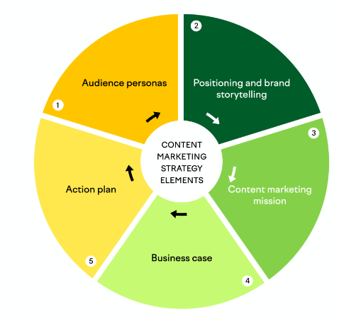
Figure 6: Content marketing strategy
(Source: Indrawan et al. 2022)
Influencer Collaboration and Interactive Content Delivery in Digital Platforms
Raymond strategically focused on effective influencer collaboration that enriched strategic opportunities for the company in the global fashion industry. As per the study of Evianah et al. (2021), Raymond collaborates with fashion bloggers to influence target customers with a personal touch. It strategically amplifies brand reach and recognition to the target market. Creating content based on the needs of the customers provides an innovative opportunity for Raymond to expand into a larger business market. According to the study of Vaziri Gohar and Abdolhoseini (2020), the personal touch of influencers also exaggerated the marketing process and extension within the target market. Influencers create engaging fashion videos review the products and provide their uncut opinion on social media sites that strategically benefit the brand reach of Raymond.
On the other hand, the study of Permata et al. (2023), states that Raymond also establishes a stronger relationship with the customers through interactive quizzes and review sessions in social media sites that highlight the personal preferences of the customers. Raymond introduces personalized fashion styling-based quizzes to the customers to evaluate the preferences and current perception of the customers regarding Raymond’s products. As per the study of Ziółkowska (2021), Raymond also encouraged the use user user-generated content that has been utilized to make a sense of community in the fashion industry.

4.5. Discussion & Justification of Aim
This research aims to evaluate the role and effectiveness of digital marketing strategies in the Indian fashion industry along with strategic recommendations for improving digital marketing strategy of Raymond. This research study utilizes a mixed-method approach to understand the impact of digital marketing efforts in the Indian fashion industry by specifically emphasizing Raymond. Here both primary quantitative and secondary qualitative data have been evaluated which provide critical insight into the current digital marketing strategy of Raymond to gain a competitive edge in the fashion industry. The results from both analyses justified the aim of this research. The primary analysis suggested that a higher number of the target population agreed that Raymond creates appealing digital marketing content that enhances customers' purchase intention (Mekonnen and Larner, 2021). Both primary and secondary results highlighted the use of SEO techniques by Raymond to stay connected and visible in the larger digital market.
On the other hand, mobile-friendly website development is another essential criterion which acts as a digital marketing criterion for Raymond to achieve a competitive edge in the global fashion market. Raymond creates brand awareness and enhances customer engagement through a user-generated approach and personalized brand marketing approach in the digital medium (Dewi et al. 2022). Both primary and secondary analyses suggested that Raymond was consistently involved in social media marketing to achieve productive growth in the fashion industry. Providing daily social media updates on social media is another effective digital marketing strategy for Raymond to stay connected to the larger customer group (Ziółkowska, 2021). Engaging customers towards the company based on developing need-based fashion content also generated a stronger bond with the customers (Ziółkowska, 2021). Digital community engagement initiatives taken by Raymond through an effective customer involvement strategy create effective insight into the competitive edge of the company in the global fashion industry.
As per the primary analysis result, Raymond significantly uses Google Adds to enhance operational efficiency and customer engagement towards the company. Raymond also used data-driven insight to gain critical insight to gain an in-depth behavioural understanding of the customers that in turn changes the sales dynamics and revenue growth of Raymond (Sommella and Sorrentino, 2023). Utilizing data-driven insight from social media sites highlighted the behavioural thinking of the customers to generate productive insight into the personalized solution towards the customers. Raymond also highlighted advanced styling tips to its online customers to generate extensive engagement with Raymond (Ziółkowska, 2021). The consistent presence of Raymond on social media also increases the online visibility and SEO optimization of the company. Omnichannel marketing initiatives of Raymond also increase market presence in the digital marketing platforms (Permata et al. 2023). The business performance of Raymond significantly accelerated with the help of the continuous social media existence of the company.
Collaborating with newly grown influencers effectively influences customer's purchase decisions in the fashion industry. Raymond also develops a user-friendly mobile experience for the customers. Besides, the content marketing strategy applied by Raymond also attracts customers from different geographic segments (Halkiopoulos et al. 2021). Showcasing real-life fabric manufacturing techniques also increases trustworthiness among the customers. Both the result of primary and secondary data analysis techniques provides unique insight into the advanced demand-based content-developing strategy (Jayawardena et al. 2022). Besides, promoting sustainable fabric manufacturing techniques directly via video posting or blogging techniques utilized effective engagement with the customers in the digital medium.
Raymond also engaged with the customers based on the interactive sessions and fashion-based quizzes which directly helped to interact with customers to gain productive insight into the current digital marketing trends in the fashion industry (Solfa et al. 2023). Raymond also focused on sales performance by implementing personalized content for the customers via an e-mail marketing approach to gain a productive approach in the organization. Real-life photos and videos shared by the customers are showcased on the social media handles of Raymond to generate stronger insight into social media-based digital marketing strategy of Raymond (Langley and Rieple, 2021). Providing styling advice to the customers creates a stronger bond between Raymond and the customers. It creates strategic opportunities in the digital platforms to enhance loyal customer numbers towards Raymonds.
Raymond also emphasized the high-quality image delivery in digital platforms to increase the online shopping experience of the customers. The user experience of customers also accelerates the online visibility and popularity of the company on digital sites (Chadha and Ahuja, 2020). Developing engaging fashion tips for the customers also enhances the productive opportunities for Raymond in the global fashion industry. Raymond achieved a higher rank in the case of the informational post-sharing process in social media which enriched customer involvement within the company (Oyedele et al. 2023). Raymond also monitored the conversion metrics by using Google Analytics and another digital data-driven tool to accumulate information regarding the data-driven insight into the research. Besides, developing dynamic content for the larger customer base provides a cohesive influence on their purchase intention which increases sales volume and trustworthy customer groups within the fashion industry (Nkpurukwe et al. 2020).

4.6. Summary
The fourth chapter of this research highlighted the analysis of the primary quantitative and secondary qualitative data sets. A systematic review of the secondary data sets has been developed based on the thematic analysis and primary data sets have been statistically analyzed to gain effective insight into the digital marketing strategy of Raymond. The primary analysis suggested that the mobile-friendly website approach of Raymond attracted a large number of customers. Besides, utilizing Google ads and SEO optimization processes also enhances significant visibility in the online digital market. The result of the thematic analysis also suggested that utilizing data-driven insight into product development and marketing strategy selection is essential for productive growth in the global fashion industry. On the other hand, the primary analysis also suggested that the lack of discount offers promoted by Raymond acts as a major challenge to the strategic growth of the company. Engaging customers towards the teal life fabric manufacturing techniques also attracts customers and increases the number of loyal customer bases within the target market.

Chapter 5: Conclusion

5.1. Critical Conclusion
This research study emphasized the role and extent of contemporary digital marketing strategy extension on the Indian fashion industry by following the business practices of Raymond. Special emphasis has been given to Raymond for understanding specific insight into the digital marketing strategy within the company. The current digital marketing status and challenges of Raymond have been analyzed in this research. The digital content marketing strategy of Raymond is critically acclaimed to gain crucial insight into the SEO opportunity in social media sites. This study adopted pragmatism philosophy, deductive approach and explanatory design to assess the role and relevance of digital marketing strategy for the development of fashion industry’s business value to manage Raymond’s business value. Both primary quantitative and secondary qualitative data have been utilized to generate optimum insight into the research problem. The research findings highlighted that Raymond strongly relied on SEO optimization techniques to attract more customers towards the company. It increased the online visibility and credibility of the company towards the organization which strategically impacts the sales performance and revenue growth of the company. The primary result also highlighted the mobile-friendly website approach Raymond along with the higher search rating-based URL creation strategy to attract larger customers towards the organization.
Apart from that, a unique content marketing strategy has been utilized by Raymond to exaggerated the customer experiences in the market. Personalized content development based on data-driven insight provides a unique opportunity for Raymond. The company also monitor the total reach of the customer and increases the online traffic on digital sites to gain competitive advantages within the global fashion market. It is evident from the above analysis that Raymond believed in real-time evidence through social media platforms to enhance the loyal customer base of the company. On the other hand, poor discount offers of Raymond act as a major challenge that negatively affected the business outcome in the global fashion market.
With the help of social media analytics, Raymond focused on data-driven insight to understand current fashion trends in the market and developed unique strategies based on the data sets. Besides, the consistent presence of Raymond in social media increases positive publicity to the company. Influencers-based digital marketing approach is another unique strategy of Raymond to attract niche markets in society. On the other hand, Eluting customer feedback and engaging themselves in the quizzes increase productive knowledge towards the company. Raymond focused on the positive and loyal community-building process to enhance a competitive edge in the global fashion industry.

5.2. Research Limitations
This research highlighted digital marketing approaches of Raymond based on both primary and secondary data sets. However, it fails to implement inferential statistical analysis within the primary data sets which reduces the extent of usability of the data set in other research settings. The use of statistical analysis will enhance data authenticity and precise review of the real-life customer insight regarding the digital marketing strategy of Raymond. The credibility and vigour of the research significantly increased with the help of statistical analysis of the primary quantities data set. Due to the lack of time and budget, it has not been done in this research. It must be integrated into future research to gain in-depth insight into the digital marketing strategy of Raymond. On the other hand, this research also fails to address the negative publicity of social media sites that significantly affected the sales growth and overall financial performance of the company. These limitations must be mitigated in the future research to generate more accurate insight into the subject matter.

Chapter 6: Recommendations

6.1. Issues & Recommendations
In this research, some issues have been identified during the data analysis process that negatively affected the digital marketing strategy of Raymond that impact on the fashion industry’s business value. The responses collected from the primary analysis critically acclaimed that the lack of discount and promotional offers in the online medium became one of the effective areas of problem for Raymond that reduces the competitive edge of the company within the target market (López-López and Giusti, 2020). The lack of engaging content development for the social media sites is another issue that acts as a challenge for Raymond (Nofal et al. 2020). Both these issues were supported by the result of secondary analysis. Here some strategic recommendations have been suggested to Raymond to ensure productive opportunities within the global fashion industry. These recommendations should enhance the digital marketing trends of the company. The suggested recommendations are-
Conduct Extensive Surveys on Different Segment of Customers
Raymond should allocate larger amount for conducting customer surveys extensively to understand their specific needs and thinking patterns in society. Different segments of the target market must be surveyed differently to gain individualized outcomes regarding the needs of the company (Etuk and Udonde, 2023). Developing a detailed customer persona for each segment of customers is another useful solution for Reymond. Developing engaging content is only possible by understanding the specific needs of customers in the current fashion market. Rigorous analysis of comments and feedback from the customers is also essential for strategically resonating with themselves (López-López and Giusti, 2020). Besides, creating emotional connections with customers is another essential parameter for developing engaging content on social media sites.
Promote Exclusive Online Offers to the Customers
Raymond should provide exclusive online discount offers to the customers to enhance their purchase intention from the digital platforms. Raymond is already focused on the higher price and quality of its products. However, providing seasonal or festive offers attracts more customers towards the digital buying process to the company (Rogers and Song, 2023). It is another competitive advantage for Raymond to sustain longer in the competitive global fashion market.
Promote a Community Engagement Program
Raymond should enhance its direct community-based program and CSR activities towards the needy population to attract more customers towards the company. Involving the community directly into the organizational program is directly linked with the cutters and it is again beneficial for the critical understanding of the needs of the customers (Etuk and Udonde, 2023). It also helps to create trust among the customers which leads towards a long-term loyal customer base within the company. It also shows the social responsibilities of the company which in turn changes the sales volume of Raymond.
Region-Specific Marketing Tactics Development
Raymond must differentiate the needs of each customer segment based on geography and demographic distribution and make a region-specific marketing approach. It helps to connect with the customers easily and enhance operational efficiency in the company. The emotional connection with the customers is enhanced significantly by implementing region-specific marketing tactics generation within the company (Nkpurukwe et al. 2020).

6.2. Future Scope & Recommendations
The present research study must provide a unique opportunity for the marketing management team of Indian fashion industry to take a critical look at its current digital marketing strategy. The suggested strategy must help the marketing management team of Raymond. Besides, the critically acclaimed result of this research also benefited other Indian fashion organizations to adopt new strategies in the digital marketing approach in the fashion industry. The example of Raymond also creates accurate awareness to the customers which enhances operational efficiency and sales volume of different fashion companies along with the accelerating revenue growth of the companies. On the other hand, it also facilitates the policymakers to make useful digital marketing policies for the accelerating growth of digital marketing strategy in the fashion industry.

References
Abdelhady, M.H., Kamal, N.M. and Abd El Samie, H., 2020. Impact of affiliate marketing on customer loyalty. Journal of the Faculty of Tourism and Hotels-University of Sadat City, 4(1/1), pp.50-71.
Alexandrova, E. and Poddubnaya, M., 2023. Metaverse in fashion industry development: applications and challenges. In E3S Web of Conferences (Vol. 420, p. 06019). EDP Sciences.
Almeida, J. and Casais, B., 2022, April. Subject line personalization techniques and their influence in the E-mail marketing open rate. In World Conference on Information Systems and Technologies (pp. 532-540). Cham: Springer International Publishing.
Alnaim, A. and Albarq, A., 2023. Impact of digital marketing on consumer behavior: A quantitative analysis on fast fashion industry in the KSA. International Journal of Data and Network Science, 7(3), pp.1059-1066.
Alshurideh, M., Anagreh, S., Tariq, E., Hamadneh, S., Alzboun, N., Kurdi, B. and Al-Hawary, S., 2024. Examining the effect of virtual reality technology on marketing performance of fashion industry in Jordan. International Journal of Data and Network Science, 8(1), pp.1-6.
Andrews, J.C. and Shimp, T.A., 2018. Advertising, promotion, and other aspects of integrated marketing communications. Cengage Learning.
Assarroudi, A., Heshmati Nabavi, F., Armat, M.R., Ebadi, A. and Vaismoradi, M., 2018. Directed qualitative content analysis: the description and elaboration of its underpinning methods and data analysis process. Journal of research in nursing, 23(1), pp.42-55.
Atkar, A., Pabba, M., Sekhar, S.C. and Sridhar, S., 2021. Current limitations and challenges in the global textile sector. In Fundamentals of Natural Fibres and Textiles (pp. 741-764). Woodhead Publishing.
Bakri, M.H., 2020. The effectiveness of advertising in digital marketing towards customer satisfaction. Journal of Technology Management and Technopreneurship (JTMT), 8(1), pp.72-82.
Bala, M. and Verma, D., 2018. A critical review of digital marketing. M. Bala, D. Verma (2018). A Critical Review of Digital Marketing. International Journal of Management, IT & Engineering, 8(10), pp.321-339.
Behr, O., 2018. Fashion 4.0–digital innovation in the fashion industry. Journal of technology and innovation management, 2(1), pp.1-9.
Busca, L. and Bertrandias, L., 2020. A framework for digital marketing research: investigating the four cultural eras of digital marketing. Journal of Interactive Marketing, 49(1), pp.1-19.
Casciani, D., Chkanikova, O. and Pal, R., 2022. Exploring the nature of digital transformation in the fashion industry: opportunities for supply chains, business models, and sustainability-oriented innovations. Sustainability: Science, Practice and Policy, 18(1), pp.773-795.
Chadha, K. and Ahuja, Y., 2020. Luxury fashion brands embracing the digital: An exploratory study to unfold the success strategy. MANTHAN: Journal of Commerce and Management, 7(1), pp.60-75.
Chaffey, D. and Ellis-Chadwick, F., 2019. Digital marketing. Pearson uk.
Clark, K.R. and Vealé, B.L., 2018. Strategies to enhance data collection and analysis in qualitative research. Radiologic technology, 89(5), pp.482CT-485CT.
De Pelsmacker, P., Van Tilburg, S. and Holthof, C., 2018. Digital marketing strategies, online reviews and hotel performance. International Journal of Hospitality Management, 72, pp.47-55.
Dewi, D., Herlina, M. and Boetar, A.E.M.B., 2022. The effect of social media marketing on purchase intention in fashion industry. International Journal of Data and Network Science, 6(2), pp.355-362.
Dumitriu, D., Militaru, G., Deselnicu, D.C., Niculescu, A. and Popescu, M.A.M., 2019. A perspective over modern SMEs: Managing brand equity, growth and sustainability through digital marketing tools and techniques. Sustainability, 11(7), p.2111.
Dwivedi, Y.K., Ismagilova, E., Hughes, D.L., Carlson, J., Filieri, R., Jacobson, J., Jain, V., Karjaluoto, H., Kefi, H., Krishen, A.S. and Kumar, V., 2021. Setting the future of digital and social media marketing research: Perspectives and research propositions. International journal of information management, 59, p.102168.
Etuk, A. and Udonde, U.E., 2023. The interplay of digital marketing dimensions and customer’s patronage of fast food industries in Akwa Ibom State, Nigeria. European Journal of Business and Innovation Research, 11(3), pp.70-97.
Evans, D., Bratton, S. and McKee, J., 2021. Social media marketing. AG Printing & Publishing.
Evianah, D.I., Mustikorini, D.N. and Nuraini, D., 2021. The Influence of Digital Marketing, Promotion and Prices on Online Purchase Decisions in the Era of the Covid-19 Pandemic. Budapest International Research and Critics Institute-Journal (BIRCI-Journal), 4(4), pp.9275-9281.
Eze, S.C., Chinedu-Eze, V.C., Okike, C.K. and Bello, A.O., 2020. Critical factors influencing the adoption of digital marketing devices by service-oriented micro-businesses in Nigeria: A thematic analysis approach. Humanities and Social Sciences Communications, 7(1), pp.1-14.
Fakhry, N.A.M. and Nasr, M.M., 2023. Metaverse and brand experience in fashion digital marketing. International Design Journal, 13(3), pp.331-344.
Gaudenzi, B., Mola, L. and Rossignoli, C., 2021. Hitting or missing the target: Resources and capabilities for alternative e-commerce pathways in the fashion industry. Industrial marketing management, 93, pp.124-136.
Gaur, A. and Sweta, M., 2021. Digital Marketing: A Conceptual Framework. DR. DY PATIL B-SCHOOL, PUNE, INDIA, p.197.
Guercini, S., Bernal, P.M. and Prentice, C., 2018. New marketing in fashion e-commerce. Journal of global fashion marketing, 9(1), pp.1-8.
Halkiopoulos, C., Antonopoulou, H., Gkintoni, E. and Giannoukou, I., 2021. An expert system for recommendation tourist destinations: An innovative approach of digital marketing and decision-making process. International Journal of Innovative Science and Research Technology, 6(4), pp.398-404.
Hamdani, N.A., Muladi, R. and Maulani, G.A.F., 2022, July. Digital marketing impact on consumer decision-making process. In 6th Global Conference on Business, Management, and Entrepreneurship (GCBME 2021) (pp. 153-158). Atlantis Press.
Herosian, M.Y. and Samvara, M.A., 2020. The Effect of the Use of Digital Marketing and the Ease of Access of Online Shopping Application Services in Improving Purchasing Power of the Community of the Medan City in the Era Revolution of the Marketing Industry 4.0. Jurnal Ilmiah Bina Manajemen, 3(1), pp.10-26.
Huynh, P.H., 2021. Enabling circular business models in the fashion industry: The role of digital innovation. International Journal of Productivity and Performance Management, 71(3), pp.870-895.
Ijomah, T.I., Idemudia, C., Eyo-Udo, N.L. and Anjorin, K.F., 2024. Innovative digital marketing strategies for SMEs: Driving competitive advantage and sustainable growth. International Journal of Management & Entrepreneurship Research, 6(7), pp.2173-2188.
Indrawan, M.I., Ritonga, H.M. and Sari, D.S., 2022. Entrepreneurship Education and Digital Marketing for Improving the Welfare of the Community–A Case Study on Gada Village, Gunungsitoli Regency, Nias. International Journal of Humanities Education and Social Sciences, 1(5).
Islam, T., Miron, A., Nandy, M., Choudrie, J., Liu, X. and Li, Y., 2024. Transforming Digital Marketing with Generative AI. Computers, 13(7), p.168.
Jadhav, G.G., Gaikwad, S.V. and Bapat, D., 2023. A systematic literature review: digital marketing and its impact on SMEs. Journal of Indian Business Research, 15(1), pp.76-91.
Jain, M., 2022. Human resource issues and challenges prevailing in Indian textile & garment industry. International Journal of Home Science, 8(3), pp.227-232.
Jain, S. and Mishra, S., 2020. Luxury fashion consumption in sharing economy: A study of Indian millennials. Journal of Global Fashion Marketing, 11(2), pp.171-189.
Jayawardena, N.S., Boe, J., Rohoia, A. and Sharma, P., 2022. Promoting SMEs in pacific island countries through effective marketing strategies: a systematic literature review and a future research agenda. Journal of Electronic Commerce in Organizations (JECO), 20(2), pp.1-24.
Jovanović, S. and Doljanica, S., 2020. Social Media in Fashion Industry: Empirical Study of Customer Buying Behaviour. Int. Thm. Monogr, 8, p.332.
Kang, J.Y.M. and Choi, D., 2024. Artificial intelligence-powered digital solutions in the fashion industry: a mixed-methods study on AI-based customer services. International Journal of Fashion Design, Technology and Education, 17(2), pp.162-176.
Katsikeas, C., Leonidou, L. and Zeriti, A., 2020. Revisiting international marketing strategy in a digital era: Opportunities, challenges, and research directions. International Marketing Review, 37(3), pp.405-424.
Kaur, R., Singh, R., Gehlot, A., Priyadarshi, N. and Twala, B., 2022. Marketing strategies 4.0: Recent trends and technologies in marketing. Sustainability, 14(24), p.16356.
Kaushik, V. and Walsh, C.A., 2019. Pragmatism as a research paradigm and its implications for social work research. Social sciences, 8(9), p.255.
Kertakova, M. and Efremov, J., 2021. Fashion during the digital era period. KNOWLEDGE-International Journal, 49(6), pp.1301-1309.
Khan, F. and Siddiqui, K., 2023. The importance of digital marketing. An exploratory study to find the perception and effectiveness of digital marketing amongst the marketing professionals in Pakistan.
Khandual, A. and Pradhan, S., 2019. Fashion brands and consumers approach towards sustainable fashion. Fast fashion, fashion brands and sustainable consumption, pp.37-54.
Kingsnorth, S., 2022. Digital marketing strategy: an integrated approach to online marketing. Kogan Page Publishers.
Kumar, A.R., 2021. A study on the effectiveness of digital marketing. South Asian Journal of Marketing & Management Research, 11(11), pp.135-140.
Langley, P. and Rieple, A., 2021. Incumbents’ capabilities to win in a digitised world: The case of the fashion industry. Technological Forecasting and Social Change, 167, p.120718.
Lista, A.P., Tortorella, G.L., Bouzon, M., Mostafa, S. and Romero, D., 2021. Lean layout design: a case study applied to the textile industry. Production, 31, p.e20210090.
López-López, D. and Giusti, G., 2020. Comparing digital strategies and social media usage in B2B and B2C industries in Spain. Journal of Business-to-Business Marketing, 27(2), pp.175-186.
Lorenzo-Romero, C., Andrés-Martínez, M.E. and Mondéjar-Jiménez, J.A., 2020. Omnichannel in the fashion industry: A qualitative analysis from a supply-side perspective. Heliyon, 6(6).
Madhav, S., Ahamad, A., Singh, P. and Mishra, P.K., 2018. A review of textile industry: Wet processing, environmental impacts, and effluent treatment methods. Environmental Quality Management, 27(3), pp.31-41.
Majumdar, A. and Sinha, S., 2018. Modeling the barriers of green supply chain management in small and medium enterprises: A case of Indian clothing industry. Management of Environmental Quality: An International Journal, 29(6), pp.1110-1122.
Mekonnen, A. and Larner, L., 2021. Digital marketing in luxury fashion: from crisis to strength. The Art of Digital Marketing for Fashion and Luxury Brands: Marketspaces and Marketplaces, pp.199-219.
Morokhova, V., Batyrbekova, Z.H.Y.L.D.Y.Z., Bondarenko, O.L.E.N.A., Ustik, T., Saiensus, M. and Travin, V., 2023. Digitalization Strategies for Marketing Communications to Build Relationship Marketing: Modern Solutions in Brand Management. WSEAS Transactions on Environment and Development, 19, pp.1231-1245.
Muniesa, R.L. and Giménez, C.G., 2020. The importance of the loyalty of fashion brands through digital marketing. Journal of Spatial and Organizational Dynamics, 8(3), pp.230-243.
Nkpurukwe, B.I., Musa, U.M., Wali, A.F. and Nwuju, L.M., 2020. Direct Marketing Strategy and effective customer service delivery. International Journal of Business and Society, 4(8), pp.156-161.
Nobile, T.H., Noris, A., Kalbaska, N. and Cantoni, L., 2021. A review of digital fashion research: before and beyond communication and marketing. International journal of fashion design, technology and education, 14(3), pp.293-301.
Nofal, M.I., Al-Adwan, A.S., Yaseen, H. and Alsheikh, G.A.A., 2020. Digital marketing effect to intention to domestic tourism during COVID-19 in Jordan. Periodicals of Engineering and Natural Sciences, 8(4), pp.2471-2483.
Noris, A., Nobile, T.H., Kalbaska, N. and Cantoni, L., 2021. Digital fashion: A systematic literature review. A perspective on marketing and communication. Journal of Global Fashion Marketing, 12(1), pp.32-46.
OGANJA, J.A., 2020. Critical Analysis of Opportunities and Challenges of FDI in Textile Industry in India. Vidhyayana-An International Multidisciplinary Peer-Reviewed E-Journal-ISSN 2454-8596, 6(3).
Oklander, M. and Kudina, A., 2021. Channels for promotion of fashion brands in the online space. Baltic Journal of Economic Studies, 7(2), pp.179-187.
Olbrich, R., Schultz, C.D. and Bormann, P.M., 2019. The effect of social media and advertising activities on affiliate marketing. International Journal of Internet Marketing and Advertising, 13(1), pp.47-72.
Olson, E.M., Olson, K.M., Czaplewski, A.J. and Key, T.M., 2021. Business strategy and the management of digital marketing. Business horizons, 64(2), pp.285-293.
Oyedele, O.M., Enose, A.M. and Alewo, O.S., 2023. We Need it: How Digital Marketing Tactics Influence the Purchasing Behaviour of Nigerian Millenials. Konfrontasi: Jurnal Kultural, Ekonomi dan Perubahan Sosial, 10(2), pp.91-105.
Ozuem, W. and Ranfagni, S., 2021. Art of Digital Marketing for Fashion and Luxury Brands. Springer International Publishing.
Pandey, J., 2019. Deductive approach to content analysis. In Qualitative techniques for workplace data analysis (pp. 145-169). IGI Global.
Panigrahi, C.M.A., Ashutosh, K., Mehta, S. and Pasricha, S., 2020. Impact of coronavirus outbreak on Indian textile sector. Journal of Management Research and Analysis, 7(2), pp.76-83.
Panjaitan, D., Sudiantini, D., Tusadiah, I.H., Fauziyah, J. and Sahra, J.F., 2024. Catalyzing Growth: The Influence of Digital Marketing Strategies on H&M's Fashion Business. IJM: Indonesian Journal of Multidisciplinary, 2(5), pp.134-140.
Parra, J.D., 2023. Realist evaluation and its role in the stages of explanatory research based on critical realism. Journal of Critical Realism, 22(5), pp.859-881.
Patrick, Z. and Hee, O.C., 2019. Factors influencing the intention to use affiliate marketing: A conceptual analysis. International Journal of Academic Research in Business and Social Sciences, 9(2), pp.701-710.
Pearse, N., 2019, June. An illustration of deductive analysis in qualitative research. In 18th European conference on research methodology for business and management studies (p. 264).
Permata, A., Hermawan, A. and Suharsono, N., 2023. Analysis of Marketing Strategy in Micro, Small and Medium Enterprises (MSMEs) in the Digital Era. Journal Of Economics, Finance And Management Studies., 6.
Peter, M.K. and Dalla Vecchia, M., 2021. The digital marketing toolkit: a literature review for the identification of digital marketing channels and platforms. New trends in business information systems and technology: Digital innovation and digital business transformation, pp.251-265.
Putri, F.I., Tajuddin, R.M. and Noh, L.M.B.M., 2024. Factor Influencing Purchase Intention among Indonesian towards Yogyakarta Fashion Product via Digital Marketing. International Journal of Business, Law, and Education, 5(2), pp.1957-1965.
Rathnayaka, U., 2018. Role of digital marketing in retail fashion industry: A synthesis of the theory and the practice. Journal of Accounting & Marketing, 7(02).
Rathore, B., 2021. Fashion Transformation 4.0: Beyond Digitalization & Marketing in Fashion Industry. Eduzone: International Peer Reviewed/Refereed Multidisciplinary Journal, 10(2), pp.54-59.
Raymond, 2024. Trust, Quality, Excellence. Available at:https://www.raymond.in/[Accessed on:17th August, 2024]
Rogers, J. and Song, A., 2023. Digital Marketing in the Legal Profession: What's Going on and Does It Matter?. Law, Tech. & Hum., 5, p.134.
Rosário, A.T., 2021. E-mail marketing: research and challenges. International Journal of Online Marketing (IJOM), 11(4), pp.63-83.
Roy, M., Sen, P. and Pal, P., 2020. An integrated green management model to improve environmental performance of textile industry towards sustainability. Journal of Cleaner Production, 271, p.122656.
Sahai, S., Goel, R., Venaik, A. and Garg, V., 2019. Impact of digital commerce on fashion industry to gain customer loyalty. International Journal of Engineering and Advanced Technology, 8(5), pp.730-740.
Shahi, S.K., Shiva, A. and Dia, M., 2021. Integrated sustainable supply chain management and firm performance in the Indian textile industry. Qualitative Research in Organizations and Management: An International Journal, 16(3/4), pp.614-635.
Sileyew, K.J., 2019. Research design and methodology (Vol. 7). Cyberspace.
Simpson, B., 2018. Pragmatism: A philosophy of practice. The SAGE handbook of qualitative business and management research methods, pp.54-68.
Solfa, F.D.G., De Oliveira, S.C. and Simonato, F.R., 2023. Stimulating E-Business Capabilities and Digital Marketing Strategies on Business Performance in E-Commerce Industry. International Journal of Computations, Information and Manufacturing (IJCIM), 3(2), pp.1-12.
Sommella, E. and Sorrentino, A., 2023. Digital customer relationship management (e-CRM) in the fashion industry. In The Garment Economy: Understanding History, Developing Business Models, and Leveraging Digital Technologies (pp. 287-305). Cham: Springer International Publishing.
Statista, 2024. Digital tools used to engage with customers by fashion companies worldwide in 2022. Available at:https://www.statista.com/statistics/1361020/fashion-companies-digital-engagement-tools/[Accessed on: 17th August, 2024]
Stieglitz, S., Mirbabaie, M., Ross, B. and Neuberger, C., 2018. Social media analytics–Challenges in topic discovery, data collection, and data preparation. International journal of information management, 39, pp.156-168.
Tarnanidis, T., Papachristou, E., Karypidis, M. and Ismyrlis, V., 2023. How social media affects consumer behavior in the fashion industry. In Social Media and Online Consumer Decision Making in the Fashion Industry (pp. 324-337). IGI Global.
Thomas, J.J. and Johny, C., 2018. Labour Absorpton in Indian Manufacturing: The Case of the Garment Industry.
Tien, N.H., Jose, R.J.S., Mai, N.P., Dung, H.T., Oanh, N.T.H. and Phuoc, N.H., 2020. Digital marketing strategy of GUMAC and HNOSS in Vietnam fashion market. International journal of multidisciplinary education and research, 5(4), pp.1-5.
Vaziri Gohar, H. and Abdolhoseini, R., 2020. Applying new technologies and digital marketing to engage audiences in education. Quarterly journal of Industrial Technology Development, 18(41), pp.51-64.
Veleva, S.S. and Tsvetanova, A.I., 2020, September. Characteristics of the digital marketing advantages and disadvantages. In IOP Conference Series: Materials Science and Engineering (Vol. 940, No. 1, p. 012065). IOP Publishing.
Vincent, M.P.R. and Aurangabadkar, S.T., 2023. An Impact Of Cultural Factors On Marketing Strategy And Performance In It Companies. Journal of Survey in Fisheries Sciences, pp.1405-1410.
Xue, Z., Li, Q. and Zeng, X., 2023. Social media user behavior analysis applied to the fashion and apparel industry in the big data era. Journal of Retailing and Consumer Services, 72, p.103299.
Ziółkowska, M.J., 2021. Digital transformation and marketing activities in small and medium-sized enterprises. Sustainability, 13(5), p.2512.

APPENDIX
Participation Consent Form
University of Wales Trinity Saint David (c

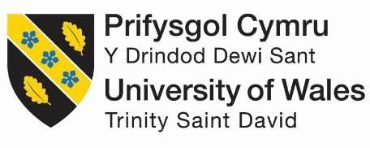
 | Participant Identification Number: |  | 222246517  22
PARTICIPATION CONSENT FORM
(for researcher to fill)

Project Title: Comprehending the role and extent of Digital Marketing within the Fashion Industry: The Case of Raymond brand in India
Name of Researcher: Rupali Patidar |  | Name of Supervisor: Prof Amare Desta
Email of Researcher: _2246517@student.uwtsd.ac.uk
Aim of Research: The aim of this research is to explores the role and extent of digital technology in the Indian fashion industry and investigate the activity by following the case of the Raymond. It is providing insights and recommendations for optimizing digital marketing efforts to enhance brand presence, customer engagement, and business performance.

(for participant to fill) |  |  |  |  | YES |  | NO
1 | I confirm that I have read and understood the information sheet dated 14/10/2024 for the above study.
2 | I understand there are no material benefits for participating.
2 | I have had the opportunity to consider the information, ask questions and have had these answered satisfactorily.
3 | I understand that my participation is voluntary and that I am free to withdraw at any time, without giving any reason.
4 | I understand that any information given by me may be used in future reports, articles or presentations by the researcher.
5 | I consent for my name and title to be used within this study.
 | Where applicable, I understand that my details will not be anonymous.
6 | I agree to be recorded (audio and/or audio-visual video).
7 | I agree to take part in the above study.
Researcher’s Name (Print) |  | Rupali Patidar | Signature | Rupali Patidar | Date | 14/10/2024
Participant’s Name (Print) |  |  | Signature | Rupali Patidar | Date | 14/10/2024

You may decline to participate in this study. You may end your participation in this study at any time. All data generated from this or any interview will remain confidential. For more information, please view the university’s Research and Data Management Policy.

When completed please email a copy to the below address to be kept on the file of the researcher and retain a copy for yourself.

Subject Title: Comprehending the role and extent of Digital Marketing within the Fashion Industry: The Case of Raymond brand in India
Email: 2246517@student.uwtsd.ac.uk

