  Component One: Student Journal (learning log) 750 words +/- 10%  Contribution to Overall Module Assessment: 25% | Student No: | 2244785
 | Module Title: | Hotel Administration & Front Office Operations
 | Module Code: | BMIH4004
 | Lecturer: | Ben Chong

Student Journal

Gibbs's model of reflection
According to Adeani et al. (2020), Gibbs's model of reflection is a framework that is used for the purpose of reflecting on past experiences. The model consists of six phases which have been applied as follows:
Description
I was placed at Premier Inn Evesham and was required to undertake and manage a range of responsibilities at the organisation. Front office areas at the hotels are vital as it the first counter of the visitors to the hotel (Barten, 2024). The range of duties that I was required to perform during the placement were, calling the customers and ask them regarding booking any table on restaurants and any other queries. Assist them in pay bills and prices of their hotel stay. Help customers deal with their lost products during their stay at the hotel. Help them register a table at the restaurant or a car. Answer phone calls in the front office section of the hotel. According to Tewari (2009), the front office is vital in managing the experiences of the customers. Performing these tasks contributes towards ensuring that customers are aware of the facilities which can be fully utilised by them resulting in the enhancement of customer experience and satisfaction.
Feelings
Although I was very excited to be working in the front office areas of Premier Inn, Evesham, the tasks and responsibilities were challenging. Premier Inn is the most popular hotel brand in the UK as of the third quarter of 2023 (Statista, 2023). In this regard, it can be said that the front office area can be considered to be very busy which depicts a highly fast-paced working environment for me working in the front office area. According to Majigamkar (2023), the front office is responsible for checking in and checking out guests. There were times when it was challenging for me to explain to the customers about the requirements and hotel fee structure. These were some challenges that I faced during my tenure at the front office of Evesham, Premier Inn.
Evaluation
I think I performed daily well during my tenure at Premier Inn while working in the front office department. I was able to resolve the problems of the guests effectively. This is reflected in my problem-solving skill audit test in which I scored 48 [Refer to appendix 1]. According to Jordan and Troth (2021), problem-solving ability has been related to high efficiency in conflict resolution. However, at times of peak, I was required to multitask while ensuring that a range of different tasks and queries of customers were effectively addressed. The tasks included booking cabs for customers, ordering water and room service facility and greeting all guests while assisting them with check-out or check-in. It further corresponds with the Cognitive Load theory states that working memory at a specific time can hold a single piece of information (Mindtools, 2023). In this regard, there were times when I mixed up information regarding customers which were some of the negatives of my performance at Premier Inn.
Analysis
At first I used to think that people working in the front office had limited accountability and duties. However, my experience has made me realise that front-office people coordinate the whole process towards customer satisfaction at hotels like the Premier Inn. According to Forbes, communication with customers is impactful towards businesses (Forbes, 2021). During the interaction with customers, I understood that there were times when the first impression at the front office had a major impact on the overall perception of the customer. My communication skill test was noted to be 42 [Refer to Appendix 2]. In this regard, the front office at hotels like Premier Inn can be considered to be vital. It is important to acknowledge that there is a wide range of customers from different cultural backgrounds that visit the Premier Inn at Evesham.
Conclusion
From this experience, I have learned that the hotel front office is important for ensuring a high level of customer experience. I have also gained awareness regarding improving my communication skills. My perception towards the front offices in the hotels has changed considerably while acknowledging the various tasks they had to manage at one time.
Action Plan
Specific | Measurable | Achievable | Relevant | Time-Bound
Enhance my communication skill | I can measure my communication skill by reflecting on the effectiveness through which I have been able to communicate my ideas while interacting with my customers | I will enrol in communication courses to enhance my communication skills | Enhancing communication skill can help me develop prospects of having a successful professional career. | 6 Months
Develop skills and knowledge regarding front office area in the hospitality sector | This can be measured by the way I plan my working in the front office area | I will induct myself in an internship of front office job role in a hotel | This aligns with my study course and hence can be considered relevant. | 12 Months
Table 1: Action Plan
(Source: Self-Developed)

Component Two
Contribution to Overall Module Assessment
Trip Advisor Review Response

Response to review
Dear Megan,
Thank you for your positive feedback on our services. According to Peifer et al. (2020), positive feedback enhances performance and learning performances. We are extremely pleased to hear that our services have met your expectations and served you well throughout your stay at our premises. We as a team thank you for selecting Premier Inn at Evesham for your stay and we are happy to have stood up to your expectations. We are also thankful to you for entrusting us as your stay partner and we ensure to serve the customers during their stay at every possible interval and in every manner to ensure that their stay is of high quality and without any obstacles. Our team at Premier Inn, Evesham is eager to welcome you again at our premises and provide more enhanced services at your disposal.
Thank you,
Bianca Beatrice Matal

Screen shot of referenced Trip Advisor review used:
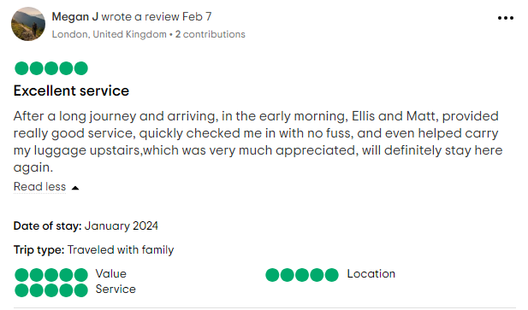
Figure 1: Positive Review for Evesham Premier Inn
(Source: Traveladvisor, 2024)
Letter of complaint response
February 12th, 2024
Subject: Response to the Letter of Complaint

Dear Johanna Blake,
We are sorry to have found that your stay at Premier Inn was filled with such obstacles and you had to go through these incidents. However, we at Premier Inn assure you that we are committed to providing service of utmost efficiency to our customers. According to the customer focus theory, understanding and satisfying customer needs are vital in achieving business success (AC, 2022). In this regard, we have considered your complaints and have undertaken a range of steps to ensure that these issues are resolved and not repeated during your next stay in our hotels. We have initiated a CleanProtect in which a rigorous cleaning method is used in our hotels in the UK and Ireland (PremierInn, 2024). This initiative will ensure that the rooms and bathrooms are cleaned properly while also maintaining standards of cleanliness in the hotels.
On the other hand, 65% of the guests in a report in Statista, have reported loud noise from other guests (Russel, 2021). Hence, we acknowledge that noises from other rooms are a concern in this industry which affects the level of customer service. It is also important to acknowledge there are many other sources of external noises which include traffic, air conditioning and other appliances. In this regard, we are considering insulating our walls and ceilings which allows the reduction of sound from one floor to another. For this, we have consulted architects and it is estimated that the work would start as soon as possible.
Another major issue that has been found is the slow speed of the WIFI. It is understood that Wi-Fi plays a major role in the current lives of people and hence is important for people who stay at Premier Inn. According to Ovide (2023), hotels are stuffed with WIFI-blocking obstacles such as walls, and equipment While it is also understandable that there are hundreds of people at one time that share a single connection which can slow down the Wi-Fi connection. In this regard, we are considering the use of Surfsonix HSIA gateway solutions to ensure consistency in the speed of internet connection that is provided to the people across our hotels. Surfsonix HSIA is a next-generation solution that is specifically designed for hotels and resorts and provides reliable, fast and secure Wi-Fi to guests (LinkedIn, 2023). The solutions allow manageable options to the hotels in which they can manage the users and identify areas where improvement can be made to enhance Wi-Fi speed.
We are also very disappointed that you find our staff unresponsive. However, we ensure that all our staff are trained, and encouraged and are wholly committed to serving our guests to their utmost efficiency. A range of reasons can be attributed towards this unresponsiveness which can include a low number of staff available during peak seasons which can result in such cases. In this regard, we at Premier Inn have recruited staff and enhanced our staff capacity. This will ensure that enough staff are available that ensure responsiveness in addressing customer grievances.

Thank you for your attention. Hope to see you again.
Sincerely,
Bianca Beatrice Matal

Component Three:
Contribution to Overall Module Assessment: 50% (1000 words +/- 10%)

Introduction
The front office is the first and foremost department which comes into guest contact and performs various functions such as reservations, reception, registration and settlement (Mallia, 2022). In this component, the key skills needed to work within the hotel’s front office operation will be identified. Along with this real industry examples will be provided related to the identified skills.

Engage with relevant and current literature to describe and evaluate the key skills that are required to work within the hotel’s front office operation.
The main function of the front office in the hotel is to get in touch with the customers. The front office executives interact with the customers on arrival, departure and during their stay in the hotel. As opined by Hu et al. (2022), front desk executives can create first impressions, increase customer satisfaction and build a positive reputation for the hotel.
Technical skills:
The hotel front office executives need to have effective technical skills to be able to work on computers which can help in managing software and other systems to manage financial transactions (Indeed, 2023a). With the help of strong technical skills, the executives can keep the customer's record effectively. For example, Kensington Hotel has been effectively keeping the personal records of the customers which shows the effective technical skills of the staff (Kensingtongardenshotel, 2024).
Teamwork:
Teamwork is an effective skill set which is required for front desk employees to collaborate with their colleagues and managers (Oteshova et al. 2021). Effective teamwork skills can help in discussing the problems of the customers exploring ideas and implementing them to solve the issues. Homan’s theory of group formation can be aligned in this case which states that the interaction between the team members shapes the behaviour of the group and the outcome (Olofu et al. 2020). In this regard, the interaction and coordination between the front desk executive and other hotel staff can lead to customer satisfaction. For example, Marriott International's management team are inclusive and supports team culture by working together as a team to improve their exclusive services to the customers (Indeed, 2024).
Leadership:
Effective leadership skills are required for front desk employees to manage busy shifts (Khan et al. 2020). The executives can ensure hotel operations and customer experiences by utilising leadership skills. The contingency theory of leadership can be applicable in this case which states that the ability to adapt and lead the situation can be most important in the workplace (Shala et al. 2021). Thus, the hotel front desk executives need to adapt every citation and lead the team effectively to manage the customers. For example, Travelodge has been facing issues regarding employee and customer management due to a lack of leadership skills at the higher level of management (Glassdoor, 2024).
Key Skill 1 – Customer Service Skills

Customer service skill comes with some special and specific characteristics that help to provide quality service to clients and make them satisfied by providing service according to their demands (Indeed, 2023b). It is also known that 34% of clients prefer to pay more for excellent service which also increases the importance of customer service skills in the hospitality industry (Statista, 2022). As an example, Marriott International always prefer to handle their clients with the most special treatment and try to understand their needs which makes those clients more satisfied (Hyken, 2022). Oliver's theory of customer satisfaction indicates that consumers make clear senses about the fulfilment of goals, desires and needs that make a pleasurable experience for the customers (Mariani and Borghi, 2023). Through this, it comes to know that in managing the front office operations it is most important to balance effective customer service skills to make them satisfied and happy.
Key Skill 2 – Communication Skills

The front office executives need to have good communication skills to talk to customers in person and over the phone (Indeed, 2023a). Strong communication skills help the executives to solve the problems of the customers and identify the areas of improvement. In this regard, the transactional model of communication can be aligned which objectifies the delivery of a message and creates meaningful relationships with the communicators through the effective exchange of thoughts and emotions (Dias et al. 2024). Thus, the front office executives can create meaningful relations with the customers by communicating effectively. It has been identified that the management of Hilton Group has been providing on-site training, online training and classroom training programs for their employees to improve their abilities including communication skills for effective customer service (Hilton, 2024).
Key Skill 3 – Organisational Skills
Organisation skills mean maintaining an effective ability to manage all the tasks effectively according to time to achieve all the goals that help to provide quality service to the customers and make them happy in the hospitality industry. It also comes to know that 70% of hospitality companies offer training facilities to their employees to develop the management and operations skills that help to provide excellent service to the target clients (GovUK, 2019). Hilton Hotels and Resorts always prioritise and support their employees because they believe that how they treat their employees, they treat their guests. This directly connects with the concept of providing quality service to make customers satisfied and happy (Bova, 2020). Hirschman's exit-voice theory indicates that employees or customers have two alternative ways to show their dissatisfaction, one is to exit and another is to raise their voices (Gutiérrez-Sastre et al. 2023). This theory makes a clear perception that employees and customers both have the right to raise their voices and take a step forward to get effective service from the company.
Key Skill 4 – Problem Solving Skills

Problem-solving skills are most important for managing customer satisfaction because as front office operation managers, they face different questions from the customers and give proper answers that solve the issues and make them satisfied. It is also known that around 29% of employees in the hospitality industry can solve complex problems to provide excellent service according to customer needs and demands (GovUK, 2019). As an example, Travelodge faced some issues in problem-solving and it caused a crisis that this company unable to provide quality service (Indeed, 2020). It also makes it more difficult for the employees to solve any complex situation without proper support.

Conclusion
From the above assignment, it can be concluded all the essential skills that required in the hospitality industry to provide quality service to the potential clients and make them satisfied. It makes a discussion on required skills for front office operations and then analyses all the different skills with proper real-life examples that increase the value.

Reference List
AC, 2022. Customer Focus Theory. Available at: https://open.ncl.ac.uk/academic-theories/5/customer-focus-theory/ (Accessed: 9 February 2024)
Adeani, I.S., Febriani, R.B. and Syafryadin, S., 2020. Using GIBBS’reflective cycle in making reflections of literary analysis. Indonesian EFL Journal, 6(2), pp.139-148.
Barten, M., 2024. Front Hotel Department In Hotel. Available at: https://www.revfine.com/front-office-department-in-hotel/ (Accessed: 10 February 2024)
Bova, T., 2020. Salesforce BrandVoice: How Hilton Uses The Golden Rule To Drive Commercial Success. Forbes. Available at: https://www.forbes.com/sites/salesforce/2020/11/05/how-hilton-uses-the-golden-rule-to-drive-commercial-success/?sh=6d39ae2b733c (Accessed: 6 February 2024).
Dias, J.C., Mineiro, A. and Damen, S., 2024. A novel approach to prevent social isolation in people with severe disability.
Forbes, 2021. Nine Important Lessons Leaders Have Learned About Customer Communication. Available at: https://www.forbes.com/sites/theyec/2021/10/19/nine-important-lessons-leaders-have-learned-about-customer-communication/?sh=6582998072f4 (Accessed: 7 February 2024)
Glassdoor, 2024. Travelodge Hotels (UK). Available at: https://www.glassdoor.co.in/Reviews/Travelodge-Hotels-UK-lack-of-training-Reviews-EI_IE39978.0,20_KH21,37.htm (Accessed: 7 February 2024).
GovUK, 2019. Hospitality and Tourism workforce landscape A research report mapping the sector workforce landscape for the Department for Digital, Culture, Media and Sport Hospitality and Tourism workforce landscape |. Available at: https://assets.publishing.service.gov.uk/media/5d67a363ed915d53b4904899/Hospitality_and_Tourism_Workforce_Landscape.pdf (Accessed: 7 February 2024).
Gutiérrez-Sastre, M., Rivera-Navarro, J., González-Salgado, I. and Franco, M., 2023. Beyond exit, voice, and loyalty: the role of urban resistance in a deprived neighborhood of Madrid. Journal of Housing and the Built Environment, pp.1-24.
Hilton, 2024. HR & Training: Hilton. Available at: https://managementservices.hilton.com/en/support-services/hr-training/ (Accessed: 9 February 2024).
Hu, F., Trivedi, R. and Teichert, T., 2022. Using hotel reviews to assess hotel frontline employees’ roles and performances. International Journal of Contemporary Hospitality Management, 34(5), pp.1796-1822.
Hyken, S., 2022. Customer Service The Marriott Way. Forbes. Available at: https://www.forbes.com/sites/shephyken/2022/07/17/customer-service-the-marriott-way/?sh=b9b99c678074 (Accessed: 3 February 2024).
IHG Development, 2024. Holiday Inn. Available at: https://development.ihg.com/hotel-brands/holiday-inn (Accessed: 4 February 2024).
Indeed, 2020. Travelodge Hotels (UK) Employee Reviews for Duty Manager. Available at: https://uk.indeed.com/cmp/Travelodge-Hotels-(uk)-1/reviews?fjobtitle=Duty+Manager (Accessed: 8 February 2024).
Indeed, 2023a. Essential Hotel Front Desk Job Skills (With Examples). Available at: https://au.indeed.com/career-advice/career-development/hotel-front-desk-job-skills (Accessed: 8 February 2024).
Indeed, 2023b. Customer Service Skills: Examples, Definition and How to Demonstrate. Available at: https://uk.indeed.com/career-advice/career-development/customer-service-skills (Accessed: 1 February 2024).
Indeed, 2024. Marriott International Culture reviews. Available at: https://uk.indeed.com/cmp/Marriott-International/reviews?ftopic=culture (Accessed: 7 February 2024).
Jordan, P.J. and Troth, A.C., 2021. Managing emotions during team problem solving: Emotional intelligence and conflict resolution. In Emotion and Performance (pp. 195-218). CRC Press.
Kensingtongardenshotel, 2024. Privacy & Cookie Policy. Available at: https://kensingtongardenshotel.co.uk/privacy-and-cookie-policy/ (Accessed: 8 February 2024).
Khan, N.A., Khan, A.N., Soomro, M.A. and Khan, S.K., 2020. Transformational leadership and civic virtue behavior: Valuing act of thriving and emotional exhaustion in the hotel industry. Asia Pacific Management Review, 25(4), pp.216-225.
LinkedIn, 2023. The Impact of High-Speed WiFi on Hotel Guest Satisfaction. Available at: https://www.linkedin.com/pulse/impact-high-speed-wifi-hotel-guest-satisfaction-surfsonix/ (Accessed: 9 February 2024)
Majigamkar, N., 2023. Hotel Front Office staff work ethics. Available at: https://www.linkedin.com/pulse/hotel-front-office-staff-work-ethics-nirav-majigamkar/ (Accessed: 7 February 2024)
Mallia, A., 2022. The Competency Levels and Occupational Standards in the Hospitality Industry: A study of the Receptionist role in 5 Star Hotels in Malta. The Online Open Access Repository of the Institute of Tourism Studies (Malta).
Mariani, M.M. and Borghi, M., 2023. Artificial intelligence in service industries: customers’ assessment of service production and resilient service operations. International Journal of Production Research, pp.1-17.
Mindtools, 2023. Cognitive Load Theory. Available at: https://www.mindtools.com/aqxwcpa/cognitive-load-theory (Accessed: 10 February 2024)
Olofu, P.A., Kanu, N.O. and Ugochigborugu, K.M., 2020. Understanding the dynamics of group formation and its application in educational administration in Nigeria: The perspective of interaction and balance theory.
Oteshova, A.K., Niyazbayeva, A.A., Prodanova, N.A., Sabirova, R.K. and Zayed, N.M., 2021. The effect of teamwork on employee productivity. Academy of Strategic Management Journal, 20, pp.1-8.
Ovide, S., 2023. Hotel WiFi can be terrible. Here are four tips to deal with it. Available at: https://www.washingtonpost.com/technology/2023/03/14/why-hotel-wifi-is-bad/ (Accessed: 10 February 2024)
Peifer, C., Schönfeld, P., Wolters, G., Aust, F. and Margraf, J., 2020. Well done! Effects of positive feedback on perceived self-efficacy, flow and performance in a mental arithmetic task. Frontiers in Psychology, p.1008.
PremierInn, 2024. Premier Inn CleanProtect™. Available at: https://www.premierinn.com/gb/en/why/cleanliness.html (Accessed: 08 February 2024)
Russel, 2021. How To Reduce Noise In Hotel Rooms. Available at: https://www.hushacoustics.co.uk/how-to-reduce-noise-in-hotel-rooms/ (Accessed: 10 February 2024)
Shala, B., Prebreza, A. and Ramosaj, B., 2021. The contingency theory of management as a factor of acknowledging the leaders-managers of our time study case: The practice of the contingency theory in the company Avrios. Open Access Library Journal, 8(9), pp.1-20.
Statista, 2022. UK: customers willing to pay for excellent service. Available at: https://www.statista.com/statistics/1291591/customers-willing-to-pay-for-excellent-service-uk/ (Accessed: 2 February 2024).
Statista, 2023. Holiday Inn brand profile UK 2022. Available at: https://www.statista.com/forecasts/1335696/holiday-inn-hotels-brand-profile-in-the-uk (Accessed: 5 February 2024).
Statista, 2023. Most popular hotel brands in the United Kingdom (UK) as of the third quarter of 2023. Available at: https://www.statista.com/statistics/951262/most-popular-hotel-brands-uk/ (Accessed: 8 February 2024)
Tewari, J.R., 2009. Hotel front office: operations and management. Oxford University Press.
Traveladvisor, 2024. Premier Inn Evesham Hotel. Available at: https://www.tripadvisor.com/Hotel_Review-g186422-d570641-Reviews-Premier_Inn_Evesham_Hotel-Evesham_Worcestershire_England.html#REVIEWS (Accessed: 10 February 2024)

Appendices

Appendix 1: Problem-solving skills
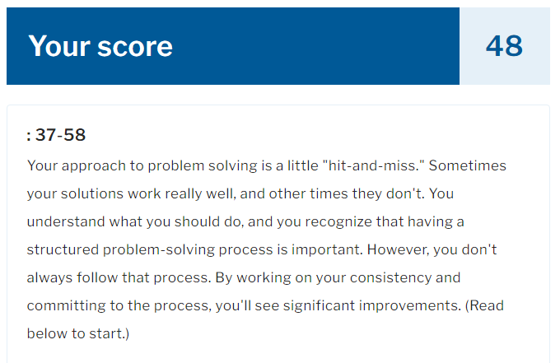
(Source: https://www.mindtools.com/aoubxrt/how-good-is-your-problem-solving)

Appendix 2: Communication skill test
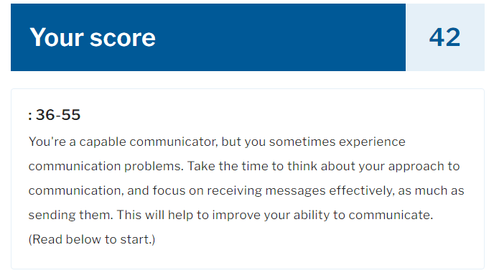
(Source: https://www.mindtools.com/a3y5cte/how-good-are-your-communication-skills)

