21/11/2025
LDL Assignment 1
e- PORTFOLIO
e- PORTFOLIO LINK : https://2513629.wixsite.com/mysite
Mustafa Ay (2513629)
Module CODE: 4025
Group 4
LEcturer’s name: dipo dunsin

Contents
Skills Required for Work and Employment 2
Task 1A 2
Task 1B 3
Task 2 4
Task 3 5
Forming a Team 5
Teamwork Activity 5
Individual Reflection 6
References 7
TASK 4 8
……………………………………………………………………………………………………………………12

Skills Required for Work and Employment

Task 1A
In today's world, many necessary competencies are required to perform successfully in one's work. Businesses today are seeking to hire workers who either function well as teams and can communicate well, or both. Teamwork and communication is an important part of business today. Communication skills, teamwork and problem-solving are essential employability skills in the digital era.​ [1]
Many are being hired today who not only have a business sense, but also personal and social competence. Success today requires strong communication, social skills, teamwork, and the ability to collaborate effectively.
These are perpetual skills that would enhance their performance in their job functions and are fundamentally required to be successful.​ [2]
Another role is entrepreneurship, which is a core competency. Entrepreneurship is about developing new ideas, taking risks, and creating new business projects. Entrepreneurial competencies include opportunity recognition, innovation, and the ability to create new ventures.​ [3]​ Learning and development are core strengths in today's business framework. Entrepreneurship requires continuous learning, creativity, and the development of new capabilities.​ [4]
With all of the technology at our disposal today, digital fluency is an imperative skill. Individuals must know how to use technology, social media, etc. in their jobs. Digital literacy is now a foundational competency as technology shapes nearly every business role.​ [5]​ Because I work in digital marketing, I would like to take this area and advance in my career in this area. I already sell items on eBay. For example, we live in a generation where social media espically tiktok has a huge influence on purchasing products. One of my marketing strategy will be paid sponsorships to enhance my product appearance on desired social media for you page, or as I have already done in the past is sending samples of my products to o influencers to broaden my target audience.
I believe that this experience will help me better understand my customers and when they buy my products.
I will also learn to leverage search engine optimization (SEO) more effectively to have my products show up when someone searches online. I believe this experience will aid in providing value to my clients with high-quality content.
I also expect to develop many new skills: handling and solving issues, making effective and appropriate decisions, working with and supporting others, and I believe those will contribute to creating and building a successful business moving forward. I want to grow in my career and leverage my skills to help any business
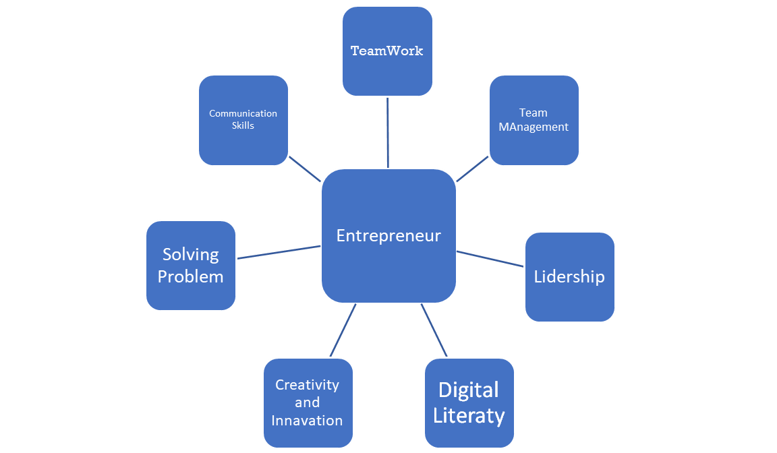

Task 1B
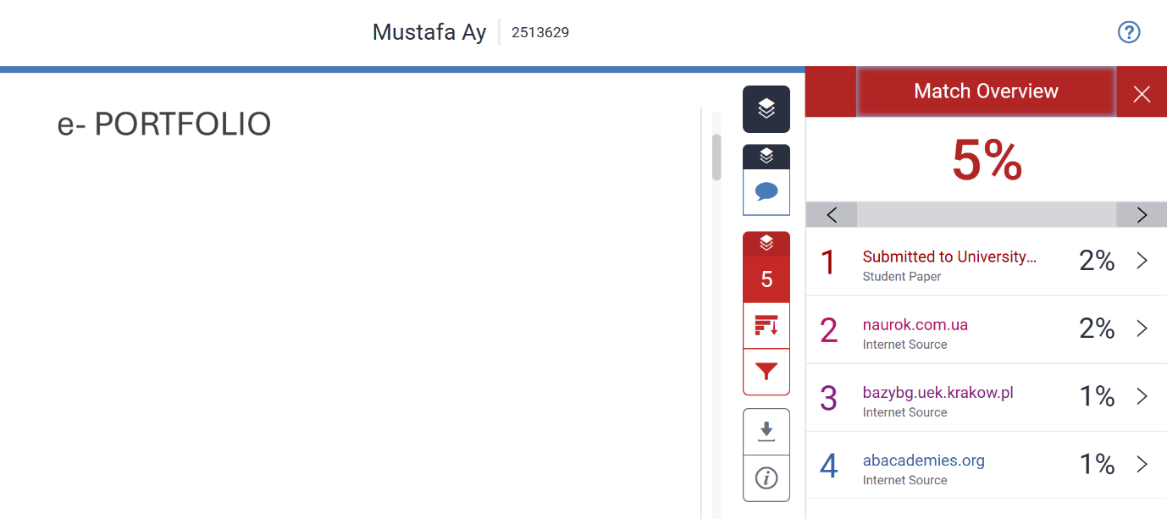
I uploaded my task to Turnitin for check the similarity. It was %5 from AI. This looks low but I will try to reduce it more than %5 will do it with my own English because I used some hard words I translated from Turkish. I can give myself fewer points because of I used translate. Next time I will improve my score. I will get help from English videos I will try to use English research. Other things all true; IEEE academic reference and other skills words are from my own my thinking and research.

Task 2
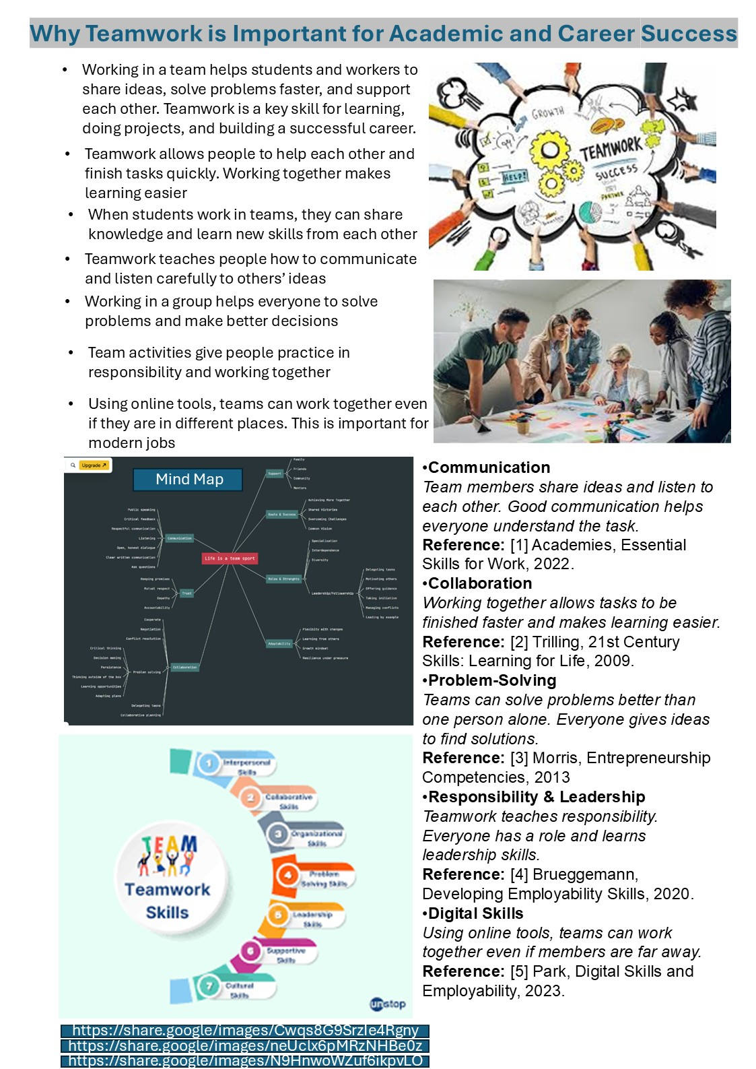

Task 3

Forming a Team
- People provide support for each other. They motivate each other to share ideas, offer suggestions, and assist friends who encounter troubles. Helping each other increases the happiness and strength of the team.
- People are aware of others' feelings. They give attention, try to assist, and care about the feelings of others in the team. Awareness of others' feelings is essential to working together.
- People try to think positively. They make kind remarks, remain happy, and motivate each other. Thinking positively supports the team in problem solving and completing work easier.
- A team can help each other learn new content. Everyone can share their knowledge, and they all can learn something from the others. Learning together promotes improvement in work and study.
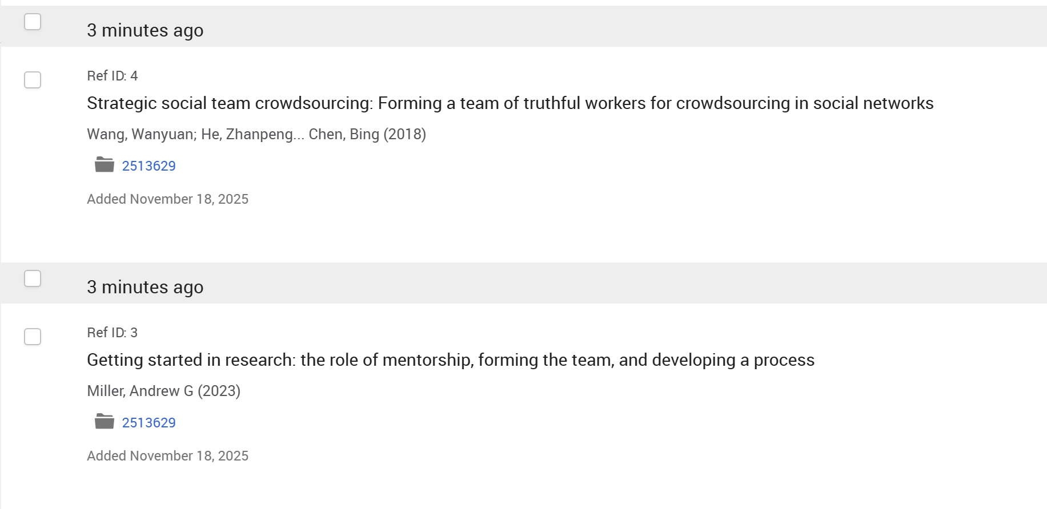
- The team can complete large complex projects and tasks. In a team environment, they will be able to finish their work quicker, increase the quality of those projects and tasks, and completion of goals.

Teamwork Activity
- Working together is really helpful. People share their thinking and assist each other to do work. When people assist each other, it makes people feel good and helps with the work.
- Everyone listens to each other. Team members try to understand other people's thinking and feel embarrassed. Listening helps the team to avoid mistakes and oversights.
- Everyone can offer thinking. When everyone contributes ideas, the team becomes a more creative team that will develop better solutions.
- People now work together to complete the project. Teamwork means everyone works together as a whole to complete work faster and better.
- Teamwork helps people learn difficult people learn skills. Teamwork is problem solving, and making good decisions, and it is supporting one another. Cohesive teamwork means team success.
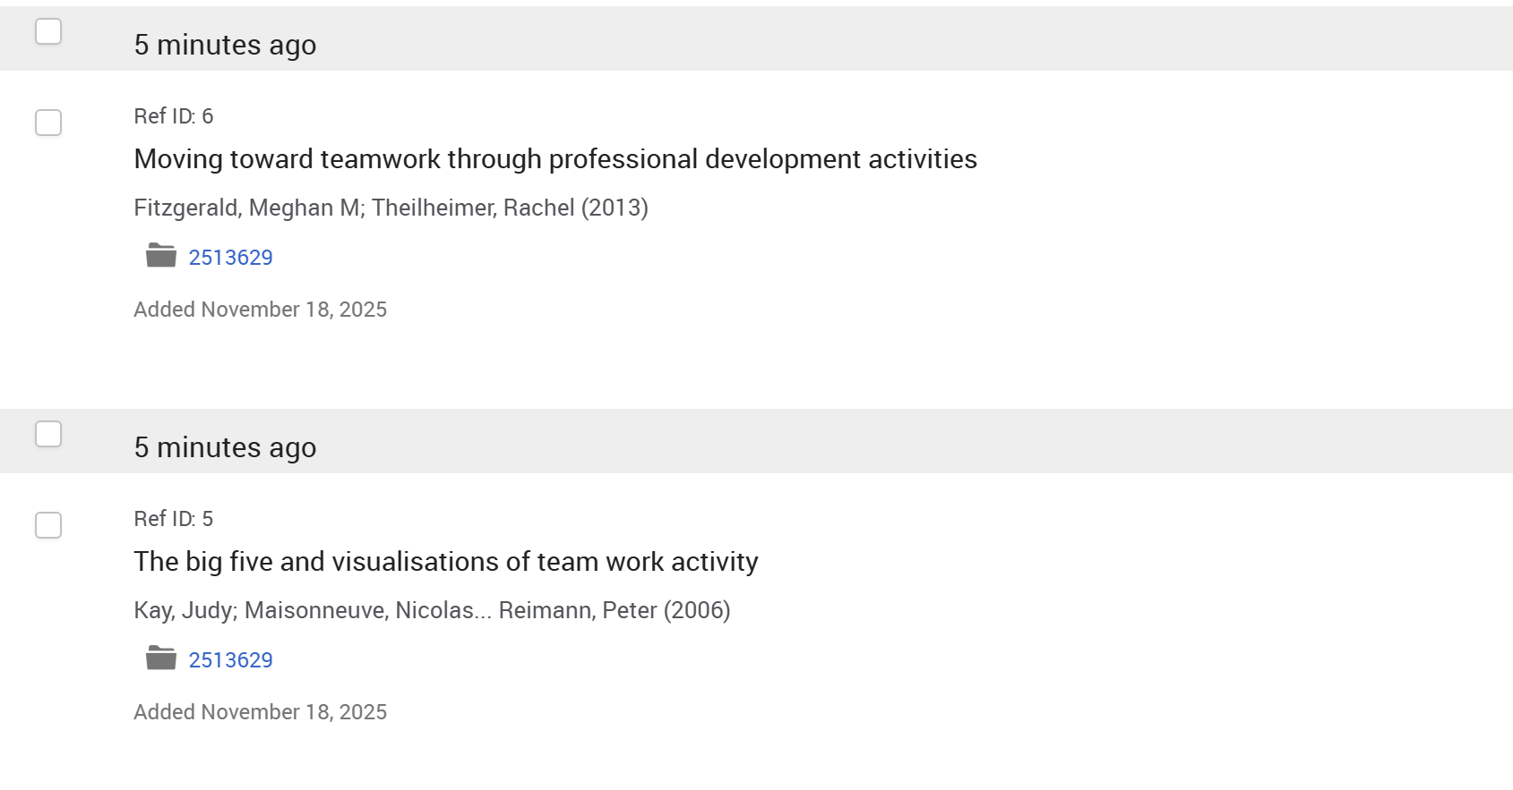

Individual Reflection

- I've learned a lot from collaborating with a team. I was able to bring forth my own ideas and opinions, all while listening to others, which made me more aware of their perspectives.
- I experienced first-hand moments of how nice it was to support others. When people were contributing to a role of support, productivity was optimal and everyone appeared to have fun.
- I made an effort to remain and promote a positive framework of outlook. My state of positivity helped to remain clear-minded when my teammates and I faced dilemmas or challenges.
- I practiced adding to my catalogue of skills and aids, a potential friend to work with, a potential support in guiding decision making, to potential support to the process.
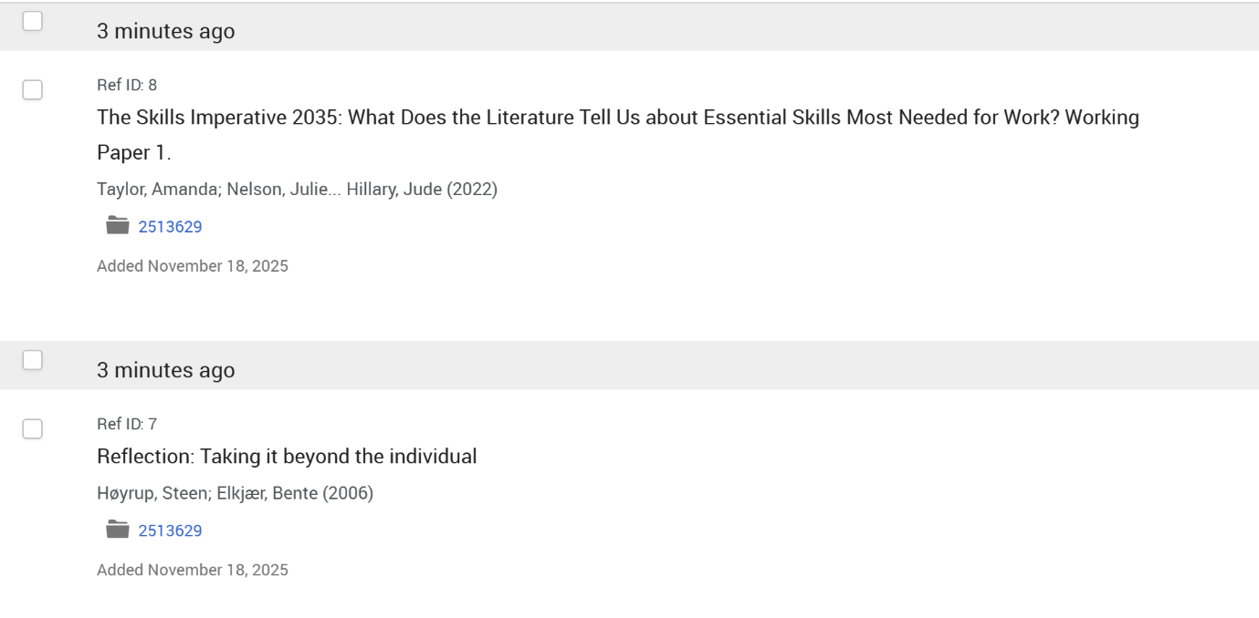
- I think I can use these skills as I pursue my own studies and work beyond this experience journey. I am very proud of my citizenship and team contributions. I hope to carry these contributions with me today and moving forward to assist myself and others.

References

[1] | A. Academies, “Employability and Entrepreneurial Skills in the Digital Era,” 2022. [Online]. Available: https://www.abacademies.org/articles/employability-and-entrepreneurial-skills-in-the-digital-era-a-critical-review-15049.html.
[2] | B. F. C. Trilling, 21st Century Skills: Learning for Life in Our Times, San Francisco: Jossey-Bass, 2009.
[3] | M. H. Morris, “A Competency-Based Perspective on Entrepreneurship,” Journal of Small Business Management, pp. 1-12, 2013.
[4] | R. F. M. C. H. Brueggemann, Innovation and Entrepreneurship: A Competency Framework, London: Routledge, 2020.
[5] | J. Park, “Entrepreneurial Competencies in the Era of Digital Transformation,” Journal of Digital Science, 2023.

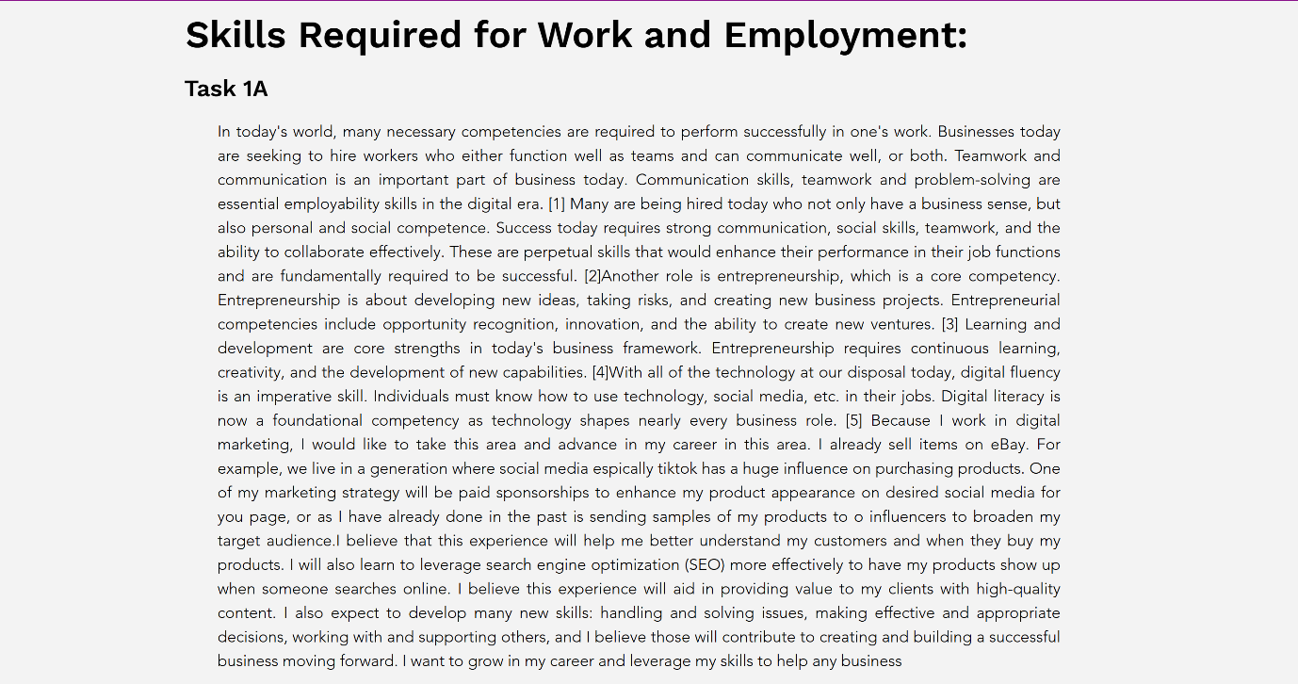
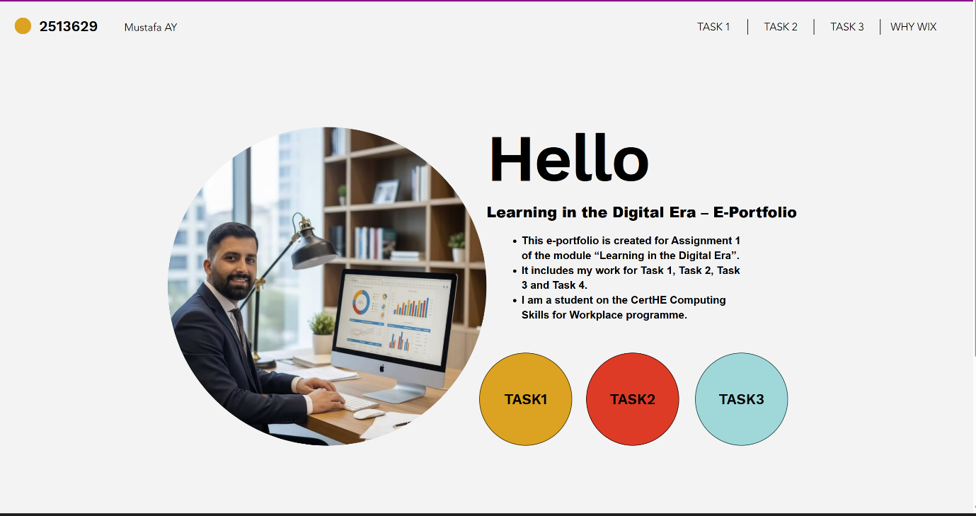
TASK 4




