

BMSW4002
EFFECTIVE TEAM WORKING & COMMUNICATION
PRESENTATION
DR GULNAR ALI

Group Three Members And Roles

- Roland Nwaosu(1917495) Benefits of Team Working

- Charmaine Roach(1913890) Team Roles

- Gladys Makuchete(1916558) Managing Conflict

- Valerie Amgbore (1917491) Successful Team Development

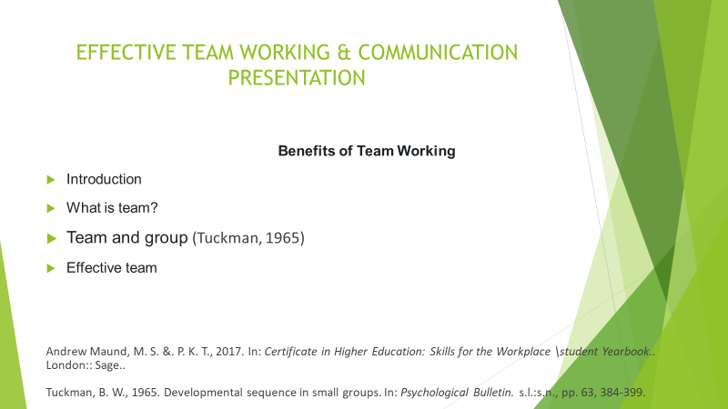

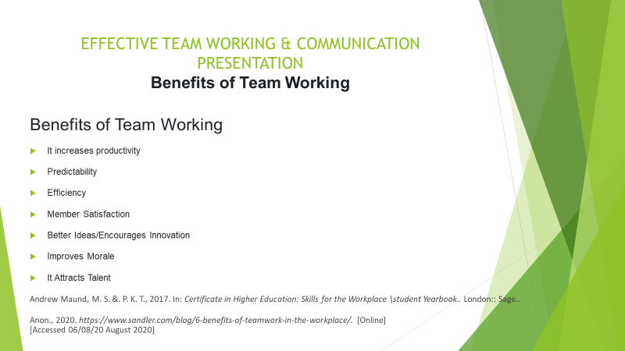

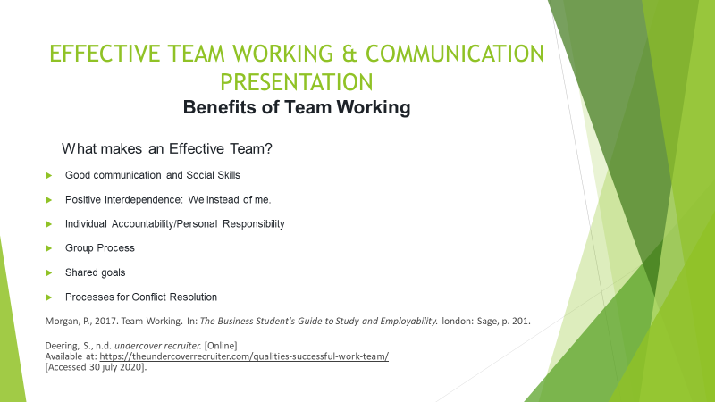

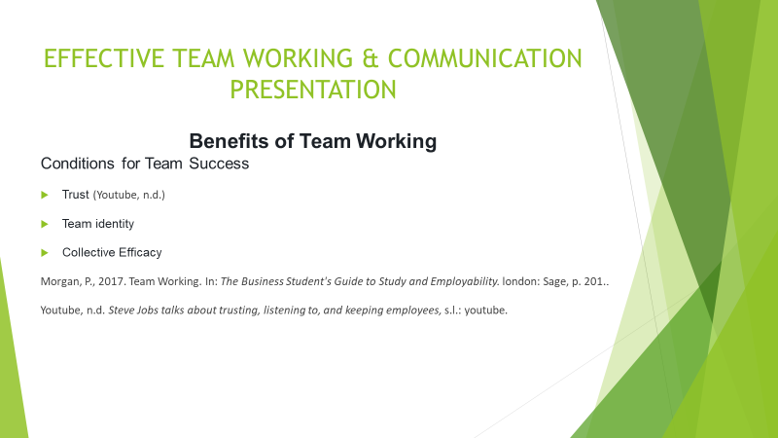

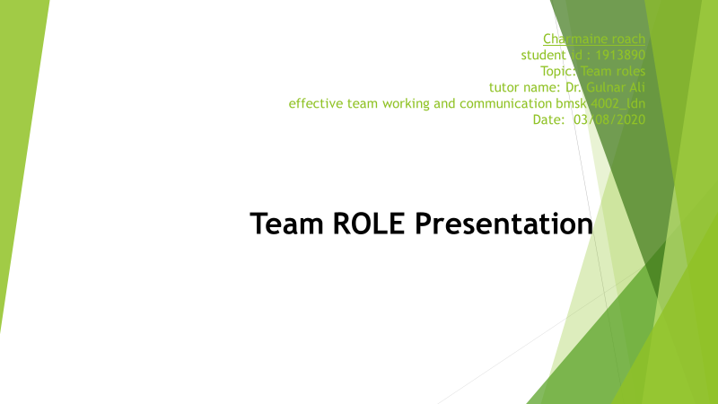

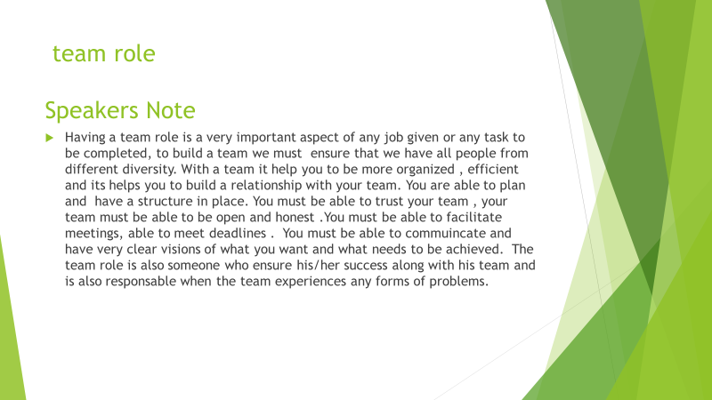

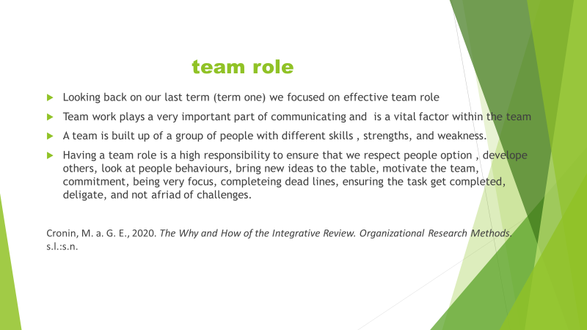

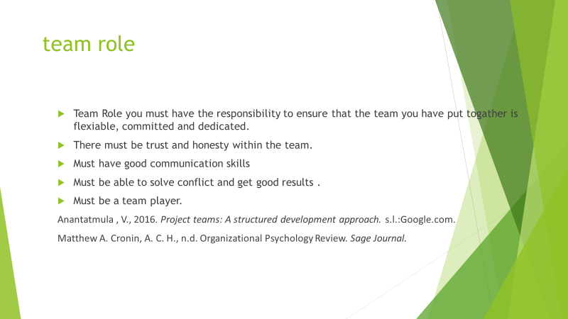
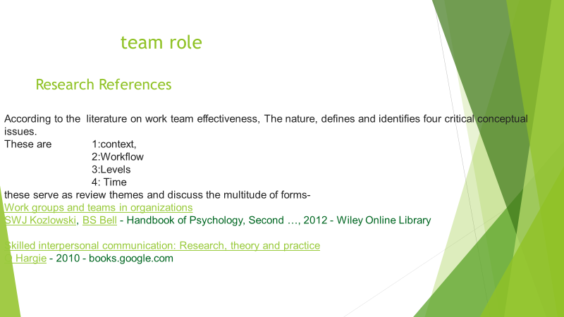

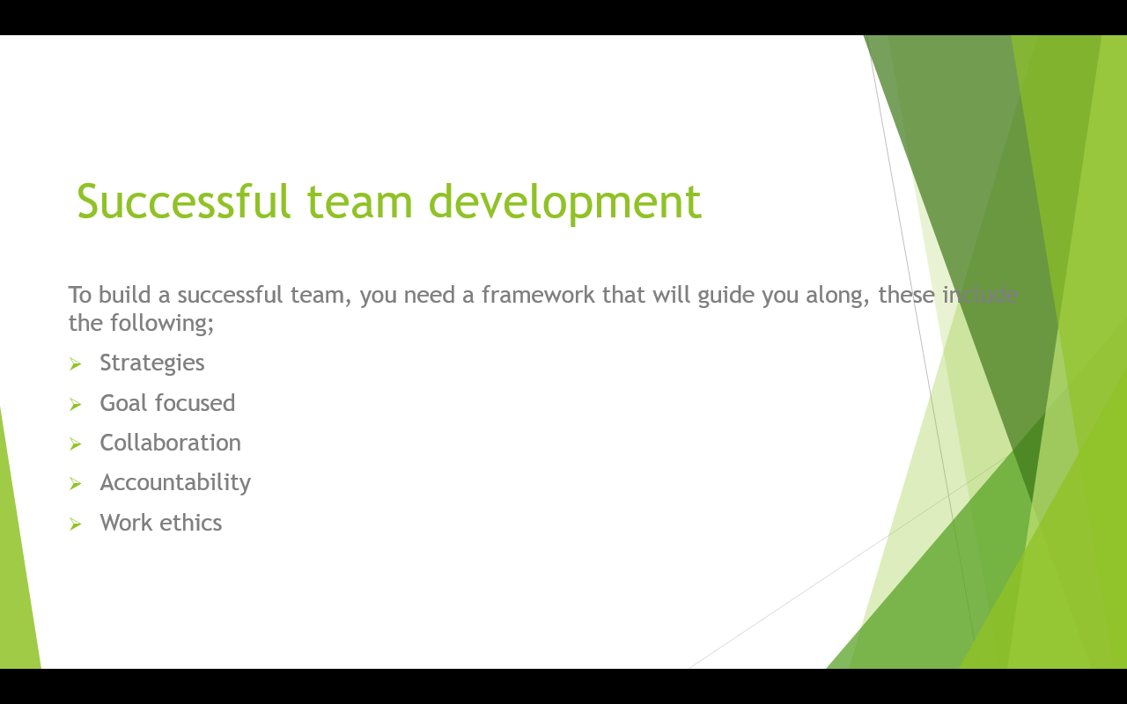

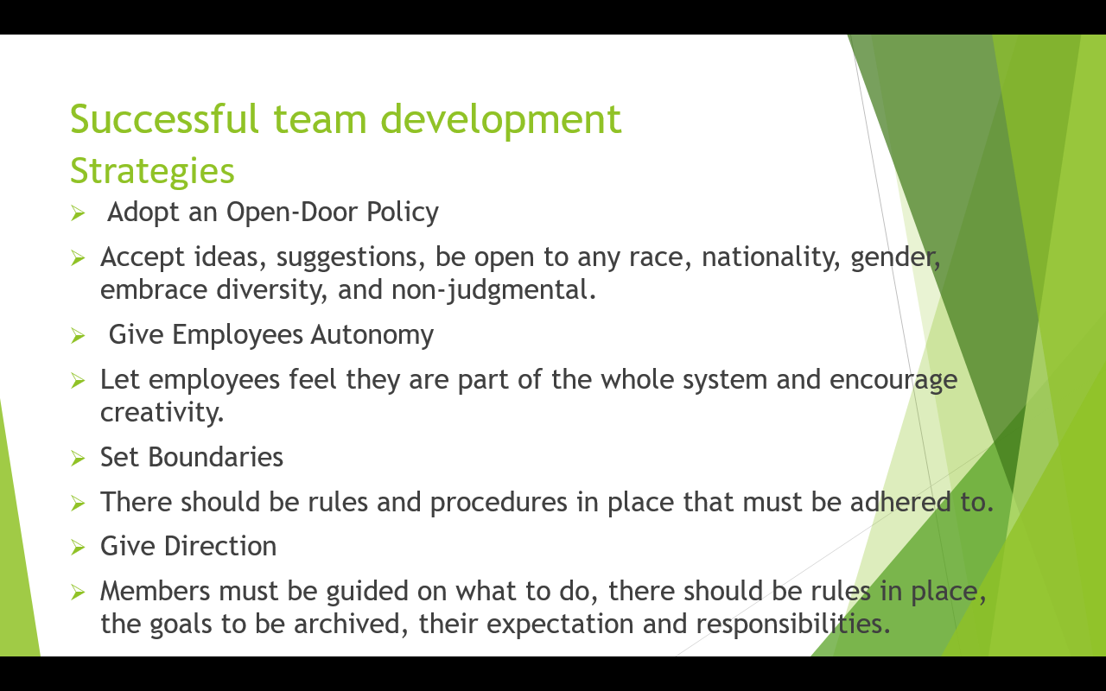

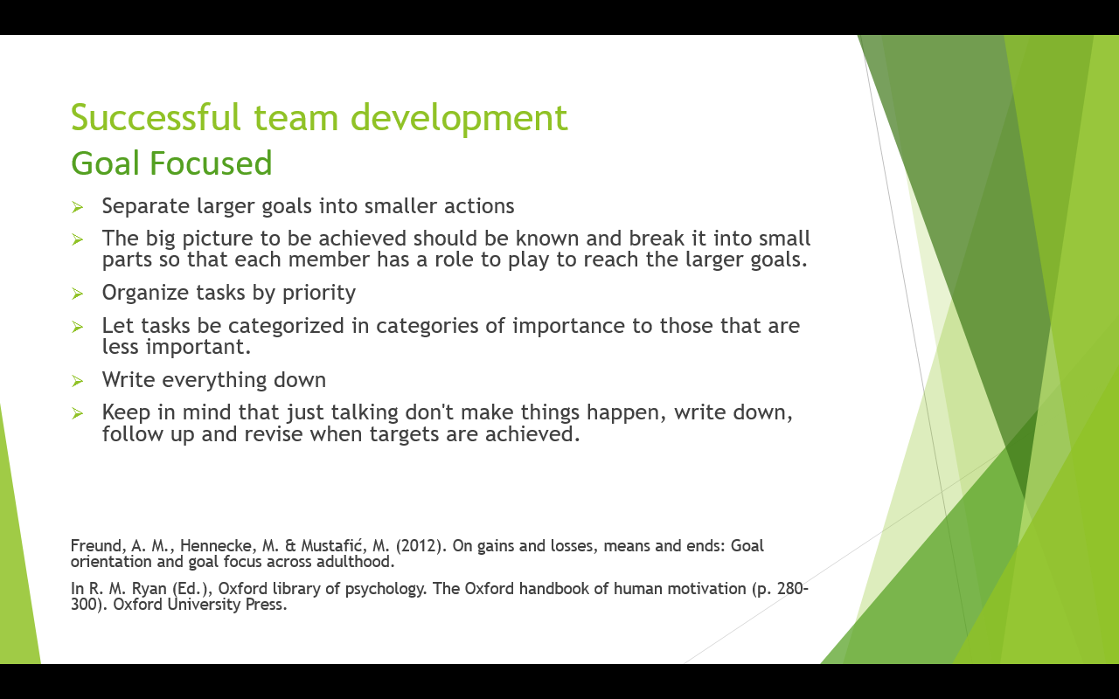

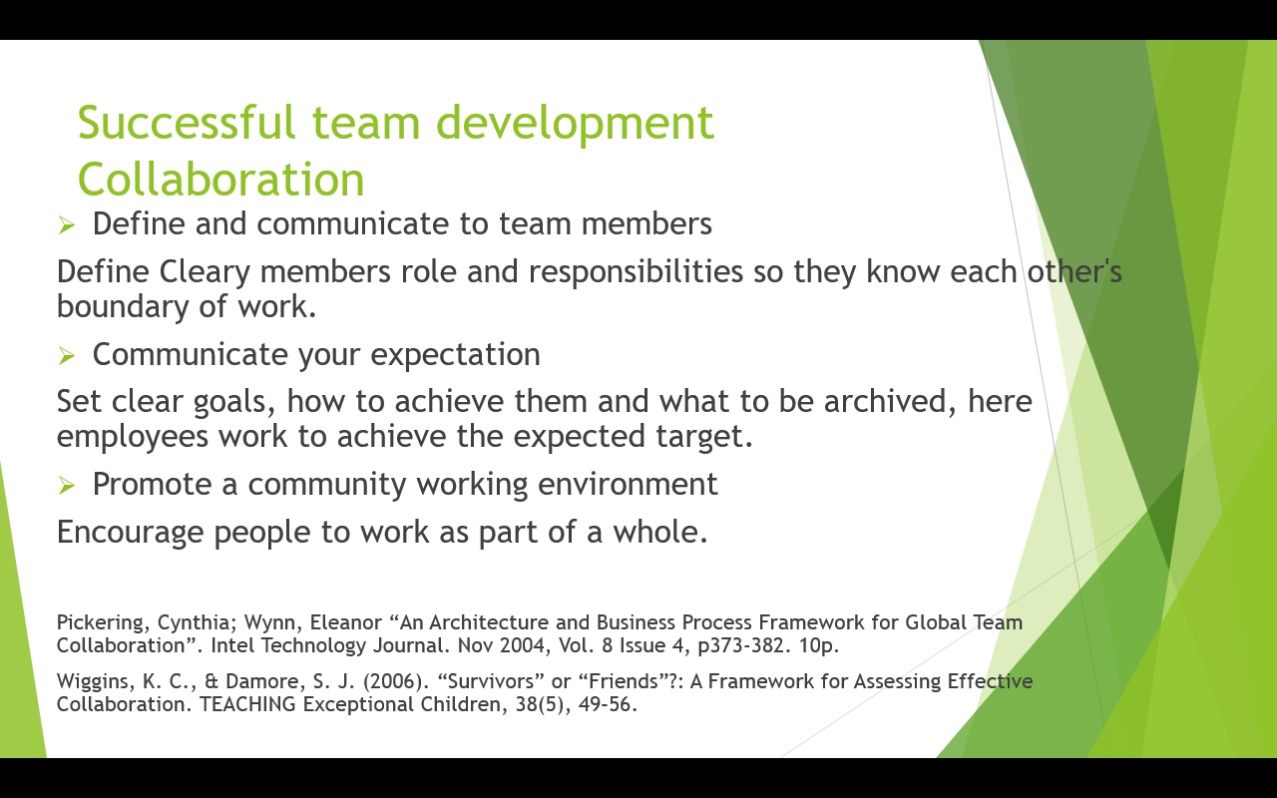

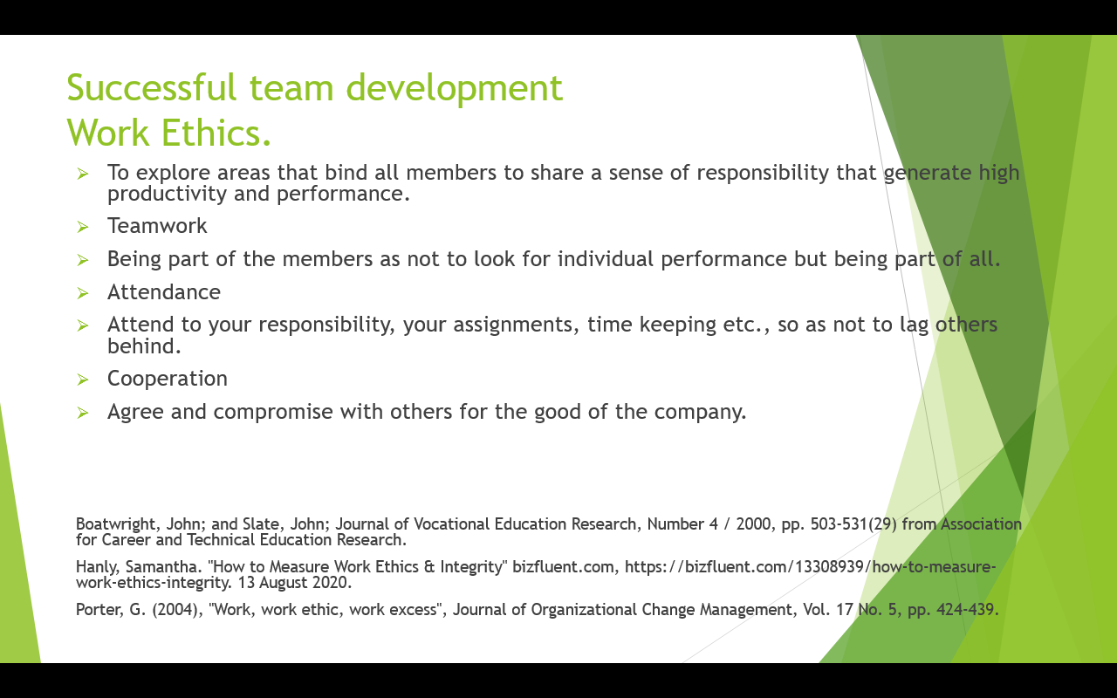

References
Anantatmula , V., 2016. Project teams: A structured development approach. s.l.:Google.com.
Andrew Maund, M. S. &. P. K. T., 2017. In: Certificate in Higher Education: Skills for the Workplace \student Yearbook. London: Sage.
Andrew Maund, M. S. &. P. K. T., 2017. In: Certificate in Higher Education: Skills for the Workplace \student Yearbook.. London:: Sage..
Anon., 2020. https://www.sandler.com/blog/6-benefits-of-teamwork-in-the-workplace/. [Online]
[Accessed 06/08/20 August 2020].
Belbin, R., 1981. Management Teams – Why they Succeed or Fail. Oxford: Butterworth-Heinemann.
Cronin, M. a. G. E., 2020. The Why and How of the Integrative Review. Organizational Research Methods. s.l.:s.n.
Deering, S., n.d. undercover recruiter. [Online]
Available at: https://theundercoverrecruiter.com/qualities-successful-work-team/
[Accessed 30 july 2020].
Matthew A. Cronin, A. C. H., n.d. Organizational Psychology Review. Sage Journal.
Morgan, P., 2017. Team Working. In: The Business Student's Guide to Study and Employability. london: Sage, p. 201.
Tuckman, B. W., 1965. Developmental sequence in small groups. In: Psychological Bulletin. s.l.:s.n., pp. 63, 384-399.
Youtube, n.d. Steve Jobs talks about trusting, listening to, and keeping employees, s.l.: youtube.

