Understanding Employment Law
1.1 (635 words)
It may be assumed that employers and employees have an equal relationship, however, the balance of power has shifted with different governments, in 1997 the Labour Government introduced measures to rebalance that power, Daniels, (2019), because at that time employers had a much stronger position, some felt that had always been the case, Taylor & Wilkinson, (2016), this left employees open to exploitation, discrimination and a variety of unfair practices.
Employment law seeks to regulate the relationship between employers and employees by the implementation and governance of legislation which regulates the employment process throughout the employee life cycle, ensuring consistency, equality and fairness to all, without employment law some employers may fail to meet basic rights such as equal pay and maternity rights, Taylor & Wilkinson, (2016) it also provides the structure required for Human Resources professionals to remain compliant when making their decisions.
Throughout 2019 and 2020, there are some scheduled major changes in employment law, such as, CIPD, (2019);
- Modern Slavery Statement, Naming and Shaming
- Pay Slip Changes
- Brexit
1.2
Employment law sets the rules and boundaries of employment which are enforced through tribunals and the court system and is formed by:
Statutes
Statutes are made up of Acts or regulations formed under Acts, such as the Equality Act 2010 and Agency Worker Regulations 2011.
Common Law
Law made by judges on points of principle that have evolved over time and are referred to as case law when a precedent has been set. Contract law that regulates the employer and employee relationship is a good example of that.
European Directives
Directives agreed in the European Union and given effect in British Law, such as the Working Time Directive which became the UK Working Time Regulations 1998.
The UK Court Hierarchy
In the UK the court system is hierarchical, with a right to appeal (on a point of law) a case to a higher court, demonstrated below, Daniels, (2019). Rulings made in higher courts become points of law, new laws are created and become binding through the lower courts.
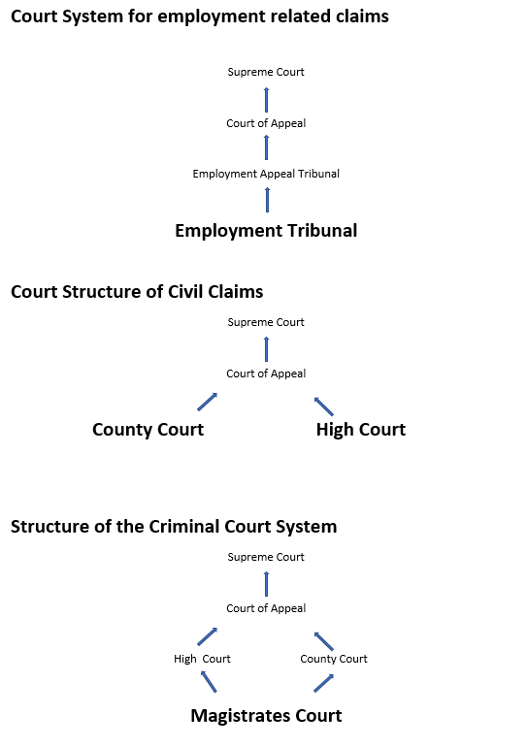

The employment tribunal is a judicial body established to resolve disputes brought by employees against their employers, with regard to their employment or termination of their employment and governed both by the law of contract and by statute law. Contractual disputes can be dealt with by either the tribunal or by ordinary civil courts (High or County Court), with the majority of decisions and judgements made at the Employment Tribunal.
Tribunal case examples are, CIPD, (2019):
- unfair dismissal
- wrongful dismissal
- discrimination
- equal pay
- deductions from wages.
Civil court examples are, CIPD, (2019):
- accidents at work
- restrictive covenants
- Breach of Contract
  - non-payment of wages
  - benefits owing,
  - pay in lieu of notice
- wrongful dismissal/damages arising out of the termination of employment.
Although few employment cases are governed by criminal law it should not be ruled out examples are, Daniels, (2019):
- Corporate manslaughter
- Racial hatred

Financial penalties
Employment Law is further enforced by the penalties laid down to losing employers, by the Employment Tribunal and the Court System who will be able to order employers to pay a penalty on top of any award made to the claimant.
ACAS
ACAS (Advisory, Conciliation and Arbitration Service) provide free impartial advice to employers and employees on all aspects of workplace relations and employment law when things go wrong, and in a bid to avoid cases going to the Employment Tribunal or Court they help by providing early conciliation, (ACAS, 2001-2009).

At the outset of a dispute employees must contact ACAS with a view to resolving the dispute through early conciliation, if an agreement is not reached or either party chose not to take part, ACAS will issue an ET1 (claim form) to allow the case to move to the Employment Tribunal.

2.1 (681 Words)
(CIPD, 2017) “The Equality Act 2010 makes it unlawful for employers to discriminate against job applicants because of a protected characteristic”, which are;
- Age
- Disability
- Gender Reassignment
- Race
- Religion or Belief
- Sex
- Sexual Orientation
- Marriage & Civil Partnership
- Pregnancy & Maternity
To comply with this, employers must ensure that the recruitment process, associated communications and documentation does not discriminate in any way, unless it is objectively justified or is a proportionate means of achieving a legitimate aim, discrimination can be, Daniels, (2019);
- Direct
- Associative
- Perceptive
- Indirect
- Harassment
- Victimisation
- Discrimination connected to disability
- Duty to make reasonable adjustments
(Taylor & Wilkinson, 2016), Additional EU Law includes protection for;
- Part-time and fixed-term workers
Additional UK Law includes protection for;
- Union/no union membership
- Ex-offenders
For example, job advertisements for a particular age group, sex, or gender, such as a ‘young dynamic Salesman’ would be direct discrimination on the grounds of age and sex. In the case of Noah v Desrosiers t/a Wedge (2008) ET 2201867/107, the hairdresser's advertisement for ‘funky and trendy’ hairdresser was found to be indirect discrimination against Muslim (religion) women (sex) whose hair would not be on display and therefore not able to work in the salon, (Daniels, 2019).
To avoid any form of discrimination in the recruitment & selection process employers are required to;
- Have a transparent recruitment policy, which includes equality and diversity
- Advertise internally and externally
- Use inclusive language in job advertisements and role profiles
- Avoid unconscious bias, CIPD, (2018), by using,
  - application forms
  - a set objective scoring criteria
  - data gathering
  - more than one person in the decision process
- Have a consistent approach to all candidates
- Concentrate on the candidate's competence to fulfil the role
2.2
Employment contracts are established when an employee agrees to work for an employer in exchange for pay, (ACAS, 2014) over time several tests have been used to determine this relationship, today the courts use the multiple test, (Daniels, 2019);
- Control
  - How and where the work is carried out?
- Organisation
  - Is integral in the business?
- Ordinary person
  - Would the ordinary person understand the meaning?
- Economic reality
  - How is payment made and what is included such as deduction of tax?
- Mutual obligation test, both to determine the nature of the relationship, (Daniels, 2019).
When the employee, employer relationship is established the legal requirement to provide a statement of terms and conditions or employment contract is established, as demonstrated by, Daniels, (2019), “The rights of employees, workers and the self-employed”.
The contract itself may be either expressed (in writing) or implied, given verbally or assumed or stemmed from other sources, but neither can overrule statutory rights, the contract must contain everything considered crucial to the employment relationship as defined in sections 1 to 7 of the Employment Rights Act 1996, Daniels, (2019), and is drawn from several sources, Lewis & Sergeant, (2017);
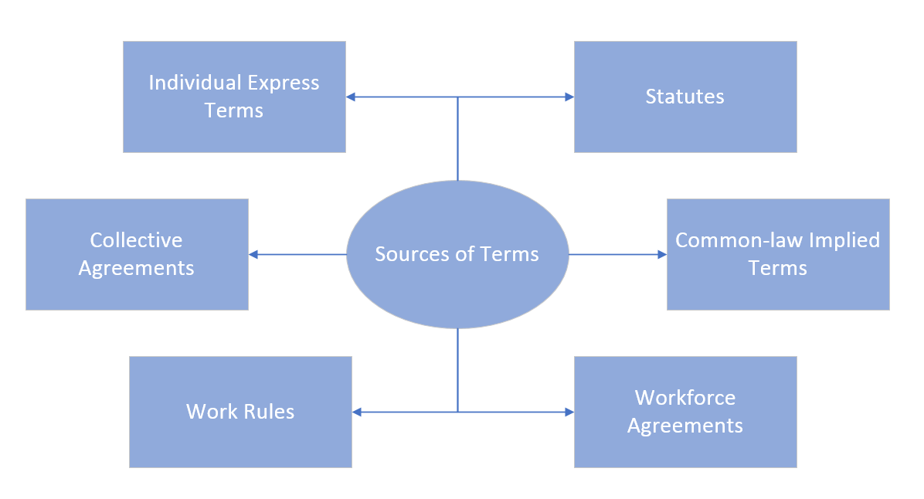
Reference to some of the information contained in accompanying sources is permitted, such as an employee handbook, grievance procedures or pension scheme, Daniels, (2019), Lewis & Sergeant, (2017).
Express Terms; In Keeley v Fosroc International Ltd [2006] EWCA Civ 1277 the court of appeal found that a not contractual reference in an employee handbook had become an expressed term, with Keeley ultimately winning his case for enhanced redundancy pay.
Implied Terms that arise from custom and practice can be unclear, Christmas Bonuses are an example of this, payment criteria should be clear and fair, equal payments ought to be stated as discretionary as failure to pay in a year following several years of payment could give rise to a claim of none payment, on the basis that the bonus had become custom and practice (Fuller, 2014).
In addition to implied terms both the employers and employees have additional obligations by law, Daniels, (2019);
Employer:
- Pay Wages
- Provide Work
- A duty of care with References
- Health and Safety
- Indemnify liabilities
- Act against bullying
- Make employees award
- Privacy
- Deal with Grievances
- Maintain Trust and Confidence
Employee:
- Obey Reasonable Instructions
- Co-operate
- Fidelity
- Take reasonable care

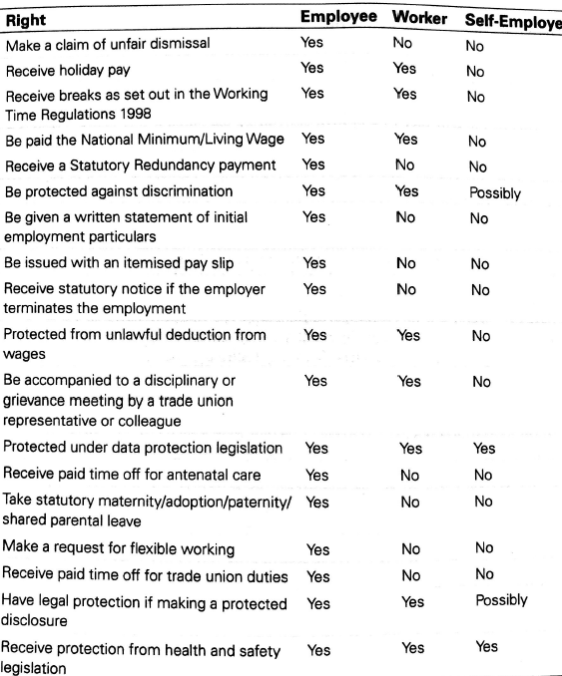
(Daniels, 2019) The rights of employees, workers and the self-employed.

3.1 (823)
An employment contract is legally binding for employee and employer, flexibility clauses in the contract may allow minor changes, but that requires care to avoid breaching the contract and a subsequent claim for constructive dismissal.

The law recognises that employers must be able to make changes for a sound business reason, Taylor & Wilkinson, (2016), however, changes require the agreement of both parties through consultation.
Changes can be agreed individually for less than 20 employees, for 20+ employees via a collective agreement with employee representatives, which can be either employee nominated or trade unions. Proposed changes require a full explanation for the change, employees are more likely to agree on changes if they understand the reasons for them and have the opportunity to have their say through the consultation process.
Employees affected by the proposed changes can:
- Stand for election as a representative
- Vote for representatives
Before any changes take effect the minimum consultation per number of employees is :
- 1 - 19 no minimum time period
- 20 to 99 – 30 days
- 100 or more - 45 days

It is hoped that during consultation agreement will be reached, but if not and the employee works in line with the new terms without making a protest it can be interpreted that the employee has agreed. If a protest is made and the employee doesn’t work in line with the new terms things may become difficult, negotiation is always the preferred option, failing that, other options are available, however, they do carry risks of employees claiming unfair dismissal/constructive dismissal dependent on the route chosen, one of those options could be to terminate employment for ‘some other substantial reason’ (SOSR) and re-employ under the new terms, (Daniels, 2019).
Where a variation has been agreed that is fundamental to the written statement of terms and conditions, the employer should give written notification of the change to the employee, within a month of the effective date of change, (ACAS, 2014).

3.2

Employers must firstly satisfy section 139 of the employee relations act (ERA) 1996 that redundancy applies.

Consultation
Employers must then consult with employees with regard to why there are proposed redundancies and whether there are any alternatives to redundancy, failing to consult may result in employees making a claim through the employment tribunal.
If there are proposed redundancies of 20+ employees with a 90 days period; collective redundancy rules must be followed in line with the Trade Union and Labour Relations (Consolidation) Act (TULRCA) 1992 and Notify the Secretary of State of the proposed redundancy (HR1 form). Consultation should take place between the employer and the representatives (employee elected or Trade Union). For fewer than 20 proposed redundancies no set rules apply, however it is good practice to fully consult employees and their representatives.
Consultations must include:
- The number of/why there are proposed redundancies
- Categories of employees and number in those categories
- How employees will be selected (a request for voluntary redundancies may be included, but no legal obligation, Daniels, (2019))
- How redundancies will be carried out
- How redundancy payments will be calculated
  - Statutory (as set out in the below table)
  - Company enhancement
  - Notice Period
- Any suggestions for avoiding redundancies
- How redundancies can be kept to a minimum
- How the effects can be limited, such as re-training
The minimum consultation per number of employees is (.GOV.UK, 2019) :
- 20 to 99 redundancies - at least 30 days + HR1 before any dismissals take effect
- 100+ redundancies - at least 45 days + HR1 before any dismissals take effect
During individual consultation meetings employees have the right to be accompanied and the right to appeal.

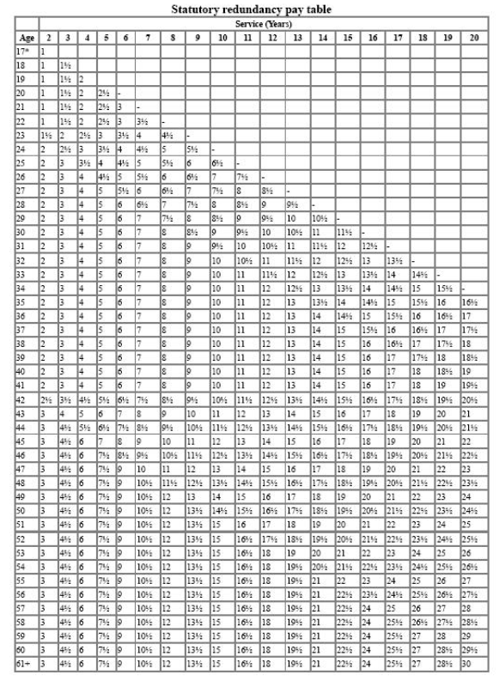

3.3
Currently, the Transfer of Undertakings (Protection of Employment) (TUPE) is governed by the regulations set in 2006, with some minor adjustments in 2014.
TUPE regulations protect the employment rights of employees whose employment is transferred to a new owner, in the transfer all contractual rights and obligations contained in the contract, transfer to the new employer, variations will be void unless for an ETO reason (Economic, Technical, organisational), Taylor v Connex South Eastern Ltd (2000) EAT 1243/99, Daniels, (2019), is an example of that. The definition of a transfer is set out in the 2006 regulations and broadly states (Daniels, 2019);
- Transfer of an economic entity that retains its identity
- A change of the provision of a service
The legislation places obligations on both the incoming and outgoing employers to provide employees with meaningful consultation, that includes (ACAS, n.d.):
- Confirmation that the transfer is taking place
- Why the transfer is necessary
- When it is going to happen
- Employee Implications
- Any Actions the new employer may take post transfer
28 days prior to the transfer the outgoing employer must also provide ELI to the incoming employer, details of the incoming employees :
- Name & Age
- Statement of particulars s1ERA 1996
- Collective Agreements
- Disciplinaries/Grievances/legal action in the last two years
Acas breaks this down into four stages (Acas, 2019):
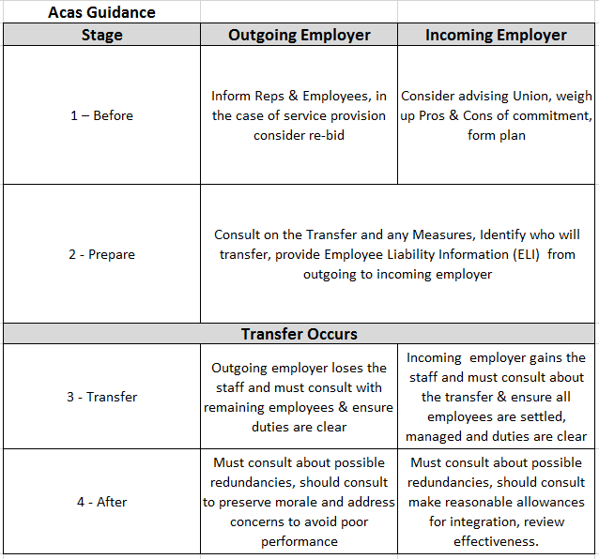
4.1 (608)
The Working Time Regulations 1998, sets out an employees entitlement with regard to (amongst other things), working hours, pay, holidays and rest periods, (Daniels, 2019).
In Daniels, (2019) “The rights of employees, workers and the self-employed” (provided in 2.2), are listed’;

Those rights are defined as, Government, (1998), (Daniels, 2019):

Maximum weekly working time

Employee working hours will not exceed an average of 48 per week in any 17 week period, (under 18, 40 hours)

Employees may waive these rights (in writing) and not suffer a detriment for not opting out

Night workers have additional protection

Work is defined as;

Carrying out duties at the employer's disposal

Training

Work defined in regulation 2

Rest Breaks

Stand downtime of 12 for under 18’s and 11 hours for 18+ in every 24 hour period

24 hours uninterrupted rest in a seven-day period (can be averaged over 14 days)

20-minute rest break if working 6 hours or more (30 minutes for under 18’s)

“Employers must take active steps to provide rest breaks” Grange v Abellio London Ltd (EAT) (Personnel Today, 2016).
Payment of Wages
- Payment for work carried out in employment
- Payment of National Minimum Wage and National Living Wage (Government, 2019)
- Guaranteed Payments in the case of layoffs & short time working (Government, 2018)
- Lawful deduction from wages - agreed in writing/contract/ or legislation
- Itemised pay statement
- Statutory sick pay, payable from the fourth consecutive sick day and for up to 28 weeks in any 12 month period.
Annual Leave & Pay
- 28 days paid leave per annum or 5.6 weeks paid pro rata for part-time and/or part-year employment.
- Accrual of holiday during most periods of leave such as sick leave and maternity leave
- Holiday pay calculation should include overtime and commission payments, Lock v British Gas Trading Ltd (2014) IRLR648 ECJ
4.2
Employment rights linked with Maternity, Paternity and other family-focused statutory rights are commonly brought together in a single document named “Family Friendly Policies” a phrase used by most employers, ACAS, ACAS, (n.d.) and The CIPD, CIPD, (n.d.), statutory payments and qualifying periods are set out on the Government Website, Government , (n.d.) and linked here https://www.gov.uk/maternity-paternity-calculator the major rights linked with Childbirth and Adoption being, (ACAS, n.d.);
- Time off to attend antenatal appointments
- Maternity Leave (SML)and Pay (SMP) set out as follows;
  - 26 weeks Ordinary Maternity Leave (OML)
  - 26 weeks Additional Maternity Leave (AML)
  - Statutory Maternity Pay (SMP) payable for 39 weeks
  - Keeping in touch days (KIT)
- Paternity Leave and Pay (SPP)
  - 2 weeks payable with 56 days of the birth
- Adoption Leave (SAL) and Pay (same as SMP)
  - Ordinary (OAL) and in some cases Additional (AAL)
- Shared Parental Leave (SPP) sharing leave with a partner, an alternative to SML or SAL.
Other major statutory rights set out in family-friendly policies are;
- The right to request Flexible Working, requests must (ACAS, 2014);
  - be in writing
  - be considered and decided upon within three months of the request
  - have a sound business reason for rejecting
  - have only be requested once in any 12 month period.
- Parental Leave
  - Following one year service
  - Up to 18 weeks per child, up to age 18
  - Remains employed and have the right to return to same or equal role
- Time off for Dependants enables employees to make emergency arrangements for, (Daniels, 2019);
  - Sick or injured dependants
  - Death of a dependant
  - Childcare arrangements
Family Friendly Policies are governed by:
Maternity & Paternity Regulations 1999, The Employment Rights Act 1996, The Work and Families Act 2006, The Employment Act 2002, Shared Parental Leave Regulations 2014

5.1 (678)
Employees and Employers have duties and responsibilities under the main statute ‘The Health and Safety at Work Act (HASAWA) 1974’ this statute is governed by criminal law, enforced by the Health and Safety Executive and is supported by other legislation, focusing on specific areas of Health and Safety, Daniels, (2019), such as;

- Reporting of Injuries, Diseases and Dangerous Occurrences Regulations (RIDDOR) 1995, which requires the reporting of death or an injury that requires hospital treatment and/or absence from work of more than seven days, (HSE, 2013)
- Personal Protective Equipment Regulations 1992, (PPE); employers must provide suitable PPE and the appropriate training to keep employees safe, PPE must also be maintained, (HSE, 2013)
- Control of Substances Hazardous Health (COSHH) Regulations (amended 2002), which sets out the regulations for storage, use and risk assessment of hazardous material, (Rospa, n.d.)
Specific employer responsibilities are a duty to provide Health, Safety and Welfare at work and the provision of (Daniels, 2019)
- Safe and effective plant/equipment
- Safe premises and/or place of work
- Competent and safe fellow employees
- Safe Systems of Work
- The HSE approved poster in a prominent position at each workplace or provide each worker with a copy of the approved leaflet outlining health and safety law (HSE, n.d.)
Section 7 of HASAWA states employees have a duty to, (Daniels, 2019);
- Take reasonable care of themselves and others
- Co-operate with their employer and Health and Safety policies and procedures
- Ensure PPE is correctly used
- Follow safe systems of work
- Inform the employer of any serious Health and Safety breaches and imminent danger.
5.2
The Equality act 2010 replaced numerous pieces of legislation, such as Sex Discrimination Act 1975, Race Relations Act 1976, Disability Discrimination Act 1995, Government, (2015), and was introduced to protect rights and provide protection from discrimination of individuals in nine main protected characteristics;
- Age
- Disability
- Gender Reassignment
- Marriage/Civil Partnership
- Pregnancy/Childbirth
- Race
- Religious Belief
- Sex
- Sexual Orientation
(Taylor & Wilkinson, 2016), Additional EU Law includes protection for;
- Part-time and fixed-term workers
Additional UK Law includes protection for;
- Union/no union membership
- Ex-offenders

Discrimination comes in various forms and arises when an individual is subject to detrimental treatment directly or indirectly or because of a perceived or associated connection to a person within the list of protected characteristics, or from harassment, victimisation or failure to make reasonable adjustments, one example of this is, Daniels, (2019); in the case Archibald v Fife Council (2004) IRLR 651, HL, in brief, an employee became disabled and applied unsuccessfully for 100 alternative roles within the council, eventually she was dismissed on the grounds of capability, her employer ought to have made reasonable adjustments due to her disability and failed, Archibald won her case.

5.3
Implied terms and duties are those unspoken or unwritten, terms that form part of the contract of employment, working practices that may be too obvious to require documenting, or perhaps ‘reading between the lines’ for example ACAS, (n.d.),:
- You would not expect a contract to say that an employee will not steal
- A valid driving licence if you are employed as a driver
- Practices that have become established over time, such as an annual bonus or time off in lieu of extra hours worked.
Terms implied by the ‘common law’, for example, matters which the employer/employee would have intended or assumed when they entered into the contract, such as CIPD, (2019);
Employee Perspective
- Be available to work
- Taking care of the employer's property
Employer Perspective
- Provide work and pay for work done
- Trust and confidence between parties
Employment terms set out in statute or legislation would be too numerous to document, so it is implied that both parties will operate under the legislation and will be implied into every contract of employment, such as, CIPD, (2019);
- Minimum wage
- Health and safety

Implied terms are still part of the contract of employment and are continually evolving, (CIPD, 2019). In Acas' experience, ACAS, (n.d.), what is or what is not in a contract is one of the main causes of employment tribunal claims.

6.1 (823)
Unfair dismissal (UDL) occurs when an employer dismisses an employee without a fair reason to do so or when the correct process has not been followed, with the exception of Police, Armed Forces and Fisherman who operate under separate legislation, UDL applies to employees that work in the UK, have a valid contract of employment and have served a minimum of two years’ service. Dismissal is automatically unfair and therefore does not require two years service, for the following reasons (Section 94 of the ERA 1996), (Daniels, 2019);
- Membership/non-membership of a Trade Union
- Pregnancy/maternity
- Refusal to work on a Sunday (retail)
- Activities related to H&S
- Asserting statutory rights
- Making a protected disclosure
- Asserting the right to National Minimum Wage
- Disclosing fraud/corruption
Claims for UDL must be brought to the Employment Tribunal within three months of the event, less anytime spent in ACAS early conciliation, if early conciliation is not successful or either party chooses not to engage, ACAS will issue an AC Certificate to take the case forward to tribunal, (ACAS, 2018).
Dismissing an employee is usually fair if the employer can demonstrate that it was for one of the following reasons, (Section 98 of the Employment Rights Act 1996), (Daniels, 2019) and with the exception of Gross Misconduct the appropriate notice period has been provided, (contractual or statutory whichever is the greater).
Employee Conduct, e.g., unauthorised absence or persistent lateness, initially this should be dealt with via an informal discussion, however, if misconduct continues the employee may be dismissed using the disciplinary process. In the case of Gross Misconduct, such as stealing or assault, employees may be summarily dismissed without any notice period.
In all cases, a fair process must be followed and the employer must demonstrate that they have acted reasonably, carried out a full investigation and took a reasonable course of action, referred to as acting within the ‘range of reasonable responses’, (Daniels, 2019), in British Home Stores v Burchall (1980) IRLR 379, after initially winning her case, the EAT overturned the decision, believing the employer had a reasonable belief, based on a reasonable investigation, the EAT applied several points that ought to be used, this became known as the Burchall test, which continues to be used today, (Medhurst, 2018).
Capability or qualifications, i.e. having the ability, desire or appropriate academic training. Throughout the recruitment process and during employment, it is the employer's responsibility to ensure that the employee understands the qualifications, skills and abilities required for the role, where appropriate provide training and ensure that any potential sanctions for poor performance are fully explained, (Daniels, 2019).
Ill health may also affect an employees capability to carry out the role, in this case, the employer must also consider the Equality Act 2010.
Redundancy, occurring when the business ceases to trade, trade in the place, carry out the same work or ceases to require the employee/s for the purpose in which they were hired, (Daniels, 2019).
A Statutory Ban; it becomes illegal for employment to continue, such as a right to remain in the UK or a work permit expires.
Some other substantial reason (SOSR), this ought to be used with caution but may arise from a breakdown in the working relationship, (Daniels, 2019).
The Grievance process provides an employee with a structured process to follow if they have a complaint that has not been resolved informally, such as with their line manager and allows both parties the opportunity to resolve the matter and avoid recource through the employment tribunal (CIPD, 2018).
Employees who wish to raise a grievance should follow the ACAS Code of Practice, (ACAS, 2018), which sets the process out in three stages;
- Employee must raise their grievance in writing
- Employer must arrange a meeting with the employee to discuss the grievance and explain any decisions, following;
  - A full investigation
  - Considering the grievance
  - Considering the appropriate action (if any).
- The employee right to appeal against the decision/response
As with all Disciplinary and Grievance Meetings employees have a statutory right to be accompanied by a work colleague or Trade Union Representative. Failure to resolve an employee grievance may result in the employee claiming the employer has committed a ‘repudiatory breach’ of contract, resign because they feel they can no longer continue to work in those circumstances and claim constructive dismissal, for that to be effective the resignation has to be immediate, otherwise the employer may claim that by continuing to work they ‘affirmed’ the breach, (Landy, 2017)
Employee does not have to raise the grievance with the employer prior to the Employment Tribunal.
The ACAS code of practice Discipline and grievance - Acas Code of Practice sets out best practice guidance, whilst employers are not legally bound by this guidance the Employment Tribunal will use this to establish whether a fair process has been followed, alongside the employers own documented process, i.e. has the employer followed their own policies and procedures.

