

Assessment 1
Title: Comparative Marketing Analysis of IKEA in Sweden vs India

Name: Shaunakkumar Patel
Student ID: 2504923
Module Name: International Marketing: Principles and Practices
Module Code: LCMB7026_LON
Lecturer’s Name: Tushara Balendran
Word Count: 6251

Term 2
Table of Contents
Section 1 2
1. Introduction 2
3. The Macro environment 5
3.1 PESTLE 5
3.2 The Hofstede Cultural Dimensions 7
4.1 Segmentation 11
4.2 Targeting 12
4.3 Positioning 14
5. Marketing Mix (7Ps) 17
6. Ansoff matrix 24
6.1 Ethical Marketing Issues 26
6.2 Recommendation 26
7. Conclusion 29
Section 2: Reflective Account 30
2.1 Description 31
2.2 Feelings 31
2.3 Evaluation 31
2.4 Analysis 32
2.5 Conclusion 32
2.6 Action Plan 33
2.6 Summary and Conclusion 34
References 35

Section 1

1. Introduction
IKEA is a globally well-known furniture retailer and is known for its affordable, functional, Scandinavian-style home furnishing. The following report presents a comparative marketing analysis of the firm, IKEA, a home furnishing retailer of Sweden. The analysis is between its home country, Sweden, and the host country, India. This report discusses the PESTLE analysis and Hofstede Cultural Dimension. The strategy adopted by IKEA in marketing, along with the marketing mix, has been studied based on the STP Strategy and Marketing Mix (7Ps). and the Ansoff matrix to understand the market environment and its impact on the business operations done by IKEA, with the recommendation and reflection part by Gibbs Model in both the chosen markets. This is a detailed study that highlights the marketing strategy adopted by IKEA in both Sweden and India. The ethics involved with the marketing strategy have been discussed in detail.
2. Background of IKEA
IKEA was founded by Ingvar Kamprad in 1943 in Sweden, and its headquarters are located in the Netherlands (Lewis, 2024). The brand is specifically known for its ready-to-assemble furniture, which is affordable and makes transportation more efficient. In 1994, IKEA launched a new furniture series for children, that give a huge profit to them.
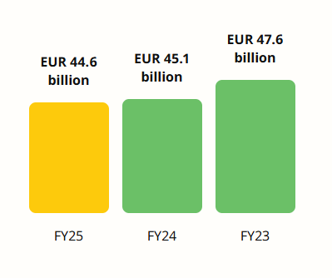
Figure 1: Total Revenue in FY23, FY24, FY25
(Source: IKEA, 2025)
The total global retail revenue of IKEA is approximately €26.3 billion in the financial year 2025, which helps to maintain its position as the world’s largest furniture retailer (IKEA, 2025) (Refer to Figure 1). As per the 2024 financial report, IKEA’s products are environmentally friendly. IKEA’s goal is to “become people and planet positive” by 2030 with its co-workers. The three main focuses of IKEA are “healthy & sustainable living”, “circular & climate positive”, and “fair & equal” (IKEA, 2024). IKEA has around 222,000 co-workers worldwide with 66 new sales locations in the 2025 financial year (IKEA, 2025). Their direct employees, the extended supply chain involves hundreds of thousands more workers worldwide.
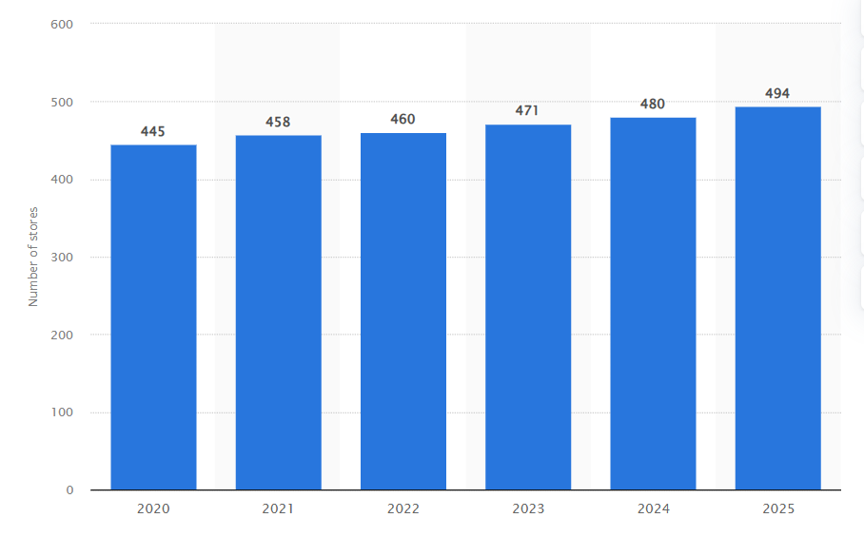
Figure 2: Number of traditional stores of IKEA worldwide
(Source: Statista, 2025)
As of 2025, there were approximately 494 IKEA stores worldwide (Statista, 2025). A year ago, the number of IKEA stores was 480 (Refer to Figure 2). Thus, it has been understood that the growing number of stores indicates the positive growth of the company in the global market.
Mission: The mission of IKEA is to “Offer a wide range of well-designed, functional home furnishing products at prices so low that as many people as possible will be able to afford them” (IKEA, 2025).
Vision: The vision statement of IKEA is “To create a better everyday life for the many people” (IKEA, 2024).

3. The Macro environment

3.1 PESTLE
A PESTLE Analysis was studied for the analysis of external factors such as Political, Economic, Technological, Legal, and Environmental, that can influence an organization (Refer to Figure 3). According to Christodoulou and Cullinane (2019), this tool is used for strategic planning of a business.
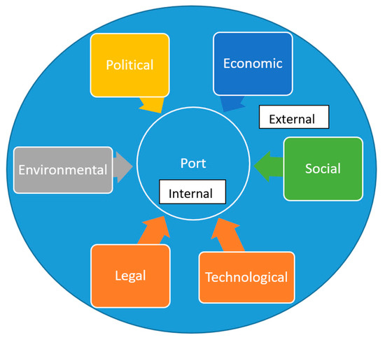
Figure 3: PESTLE Analysis
(Source: Christodoulou and Cullinane, 2019)

PESTLE Analysis of Sweden and India
Political:
Sweden: Sweden's parliamentary decisions, government bills, and motions established their democracy in chronological order. Sweden's movements and other incidents have an impact on the establishment of democracy (Riksdagen.se, 2026). The political stability index of Sweden highlights 0.6 points with -2.5 weak and +2.5 strong aspects. This shows a stable political index (The Global Economy, 2026). The political rights show 1 point in 2024, which also shows a stable political right for Sweden (The Global Economy, 2026). (Favourable)
India: In 2025, Budgen on Union increased the sectoral cap of the insurance sector to 100% from 74% (Pib, 2025). Political stability index scores -0.79 with -2.5 weak and +2.5 strong values, which is highly unfavourable (The Global Economy, 2025). (Unfavourable)
Economic:
Sweden: The labour cost in Sweden increased 169.60 points from 169.20 points in December 2025, which shows an increase in production cost (Trading Economics, 2026). In recent times, Sweden’s economic growth decreased in 2% from 2.5% in the financial year 2025 (The Global Economy, 2025). Annual inflation in Sweden also decreased in 2.05% from 2.24% (The Global Economy, 2025). (Favourable)
India: Low labour costs in India are due to economic, multiple structural, and institutional factors that combine to reduce employers’ per-worker wages and the total cost of employment (Quora, 2019). Economic growth, change in quarterly real GDP is 7.34% in 2025, which is an increase from 6.89% (The Global Economy, 2025). (Favourable)
Social:
Sweden: Sweden supports Gender equality, ranking first in the gender equality index in the EU with 83.8 out of 100 points. They have high female employment (Europa, 2023). Consumer spending increased in 744967 SEK Million from 738375 SEK Million in the fourth quarter of 2025 in Sweden (Trading Economy, 2026). High consumer spending helps in improving businesses operating in Sweden. (Favourable)
India: The social impact index highlights multiple social indicators of India, such as Education (25%), Health (45%), and Employment (30%), to measure the national relationship with workers, populations, and communities (World Economy, 2025). (Favourable)
Cultural:
Sweden: Swedish culture is characterised by high individualism and a consensus orientation that is also very feminine (Gurval, 2023). (Favourable)
India: Indian culture is a highly diverse and ancient culture with high hierarchical levels, characterised by high power distance and collectivistic values with a long-term orientation (Gurval, 2023). (Unfavourable)

3.2 The Hofstede Cultural Dimensions
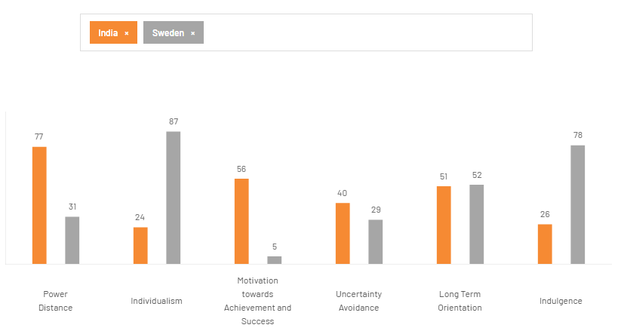
Figure 4: Hofstede cultural comparison between India and Sweden
(Source: Theculturefactor.com, 2020)
Power Distance: The power distance index of India is 77, which is found to be much higher than the average of 59 at a global level (Tripathi and Vijayan, 2020). This power distance of India ultimately indicates a high level of inequality of both power and wealth, which is mainly in the society. While Sweden’s power distance is only 31, which reflects the society of Sweden that values equality and informal relationships. It has been identified that almost 80% of the women which are 20 to 64 are working (Sweden, 2023). The approach of Sweden to gender equality has been reflected in its labour market policies.
Individualism: Individualism mainly measures the degree to which people prioritise personal independence rather than prioritising any social structures. India has only a 24 score in Individualism, that in indicating less independent culture. On the other hand, the score of Sweden in Individualism is 87, that is highlighting a strong society that prioritises individuality (Gurval, 2023). In India, there is a great emphasis on collectivism, which is found to be evident within the strong family. There has been a tension between collectivism and individualism.
Motivation Towards Achievement and Success: This dimension is very crucial in reflecting the degree to which society values achievement as well as success. In this dimension, India has 56 score and Sweden has a very low score, which is only 5. In India, it has been seen that success and career advancements are considered to be a significant part of their cultural values.
Uncertainty Avoidance: Uncertainty avoidance is very crucial in accurately measuring the extent to which society may feel discomfort with any uncertainty or may also feel uncomfortable with any ambiguity. In this aspect, India has a score of approximately 40, while the score of Sweden is 29. The score of these countries ultimately indicates low uncertainty avoidance in both countries.
Long Term Orientation: Long term orientation is ultimately reflecting the specific degree to which society prioritises future planning and long-term advantages which is over short-term profits. in this respect the score of India is 51 while the score of sudden is 52. This balanced approach is very precious in supporting the long-term sustainability strategy of IKEA.
Indulgence: Indulgence is about the degree to which society allows free desires as well as enjoyment. In this area, the score of India is only 26, while the score of Sweden is very high, at 78. This difference may directly impact the behaviour of the consumers, and that is why. In India, spending is found to be cautious and is further impacted by the social expectations as well as financial responsibility. So, IKEA even sells its cheapest sofa at around 10,000 rupees (Biswas, 2022). IKEA even visited more than 2,000 households to effectively verify the incomes in different cities.
Advantages of the Hofstede Model: This model is very crucial, as it may assist in effectively enhancing cultural knowledge and insights. In addition to that, this also assists in accurately promoting global collaboration (Wale, 2025). This may further assist the multinational companies to get a clear understanding of the behaviour of the customer, even across countries.
Disadvantages of the Hofstede Model: Apart from multiple advantages, there are a few disadvantages of this model, and one of them is that it does not accurately capture the whole social culture. The model does not define cultures as per recent times, and it may also oversimplify the cultural aspects, which is another drawback of this model (Wale, 2025). This also mainly relies on the past and historical data that may not be sufficient in accurately reflecting the modern and recent cultural changes within societies.

Technological:
Sweden: Sweden is the leader in digital innovation and the world’s stable and advanced digital economy (International Trade Administration, 2024). The latest value of the innovation index in Sweden is 62.60, which shows a high stability in technology (The Global Economy, 2026). (Favourable)
India: The innovation index of India is increasing day by day; the latest increase in the innovation index is 38.20 in the 2025 financial year (The Global Economy, 2026). India’s populations are highly adapting to digital technologies, with a start-up ecosystem and new skills. (Favourable)
Legal:
Sweden: Highly protective labour regulations (ICLG, 2025) Legal rules adopted by Sweden to improve the furniture retail industry are Swedish national laws and European Union (EU) directives (Europa, 2024). This law is used for transportation and EU goals in national legislation (Europa, 2024). (Favourable)
India: Complex Tax Systems (Startupindia.gov.in, 2025). The Indian Government is imposing various taxes to maintain the economic status, including direct tax (Income Tax Act, Wealth Tax Act, Gift Tax Act, Expenditure Tax Act, and Interest Tax Act) and indirect tax (sales tax and service tax). (Unfavourable)
Environmental:
Sweden: Strong Sustainability Culture. Greenhouse gas (GHG) emissions in Sweden are the lowest per capita and per unit of GDP, which is the lowest in the European Union (OECD, 2025)
India: Growing Environmental Awareness. The 5 biggest environmental issues in India are air pollution, water pollution, food and water shortage, waste management, and biodiversity loss (Igini, 2024).
Similarities And Differences: The PESTLE analysis of Sweden and India reveals both similarities and differences in various parameters. In terms of economics, there is positive economic growth in both countries due to the development of technology. On the social level, both nations have an eye on development. However, gender inequality is prevalent in India, but there is no such issue in Sweden. The political climate of Sweden is stable due to lawfulness, while that of India is unstable due to complicated tax laws. Swedish society is open to individualism and equality, while Indian society is collectivist in nature. There are no environmental problems in Sweden because of the sustainability practices.

4. Segmentation, targeting, and positioning (STP)
The STP (Segmentation, Targeting, and Positioning) model is an effective marketing strategy that assists in developing an accurate marketing mix. This is essential in getting a clear understanding of the behaviours of the consumers and selecting an appropriate target market for the company's products (GeeksforGeeks, 2023). It assists in telling the business about the target market, which allows them to give specific focus on the right audience.

4.1 Segmentation
Psychographic:
Sweden: Eco-conscious customers and small households. The Swedish consumers are seeking good quality and even demanding unique interior solutions.
Values: Sustainability, high quality and functional design
Attitudes: Environmentally conscious, pragmatic too.
Lifestyles: Modern people are active and favour Scandinavian designs
India: Urban middle class and multiple young nuclear families. Indians mostly preferred closed storage, mainly due to dust (Biswas, 2022).
Values: Value from money, social status and durability
Attitudes: Price-conscious but can pay for features like durability
Lifestyles: Upper middle class and welcome the modern blend with a traditional touch.
Geographic:
Sweden: The people who mostly buy the products of IKEA are mainly from dense populations, including Stockholm, Malmo and Gothenburg (IKEA, 2024).
India: IKEA has been successful in its strong sales performance mainly in Hyderabad, Mumbai and in Bengaluru, and the other two hubs are Worli and West Delhi (Khan, 2025).
Demographic:
Sweden: Younger adults (20 to 35 years old) and first-time home buyers are a major group that is mainly focusing on affordable, stylish and even well-functional future for new houses.
India: The majority of its buyers are between the ages of 20 and 35. This age group is mainly referred to as young adults or young professionals.
Behavioural:
Sweden: The average disposable income within Sweden is expected to rise to nearly 270,000 SEK per capita in the future, which is a further reflection of an almost 3% increase from the past year (Kenresearch, 2026). This increase in disposable income is allowing customers to invest more in quality furniture and home decor.
India: The preferences and solutions are dissimilar in each Indian city. Shoppers in India are really enthusiastic and are welcoming IKEA’s products. More stores are also expected to come up in Delhi and in Bangalore as IKEA is going ahead with its investment of nearly $1.5bn in India (Biswas, 2022).
The average disposable income within Sweden is expected to constantly rise, which is one major reason behind the increasing use of stylish furniture. On the other hand, in India, the customers are mainly from cities like Delhi and Bangalore. While the similarity that has been identified are that in both India and Sweden, there is a great enthusiasm and customers to use IKEA’s products.

4.2 Targeting
In India
Riya Gupta is a 26-year-old female who works as a teacher. She earns an income of Rs. 25,000 per month.
Story & Profile: Riya Gupta is a young teacher living in Bengaluru. She has moved into a new rented apartment with her family. As a working woman, she used to prefer a well-organised and modern home that reflects her way of living an dry lifestyle. Riya searched online for new home decor idea and she discovered IKEA while searching on social media. The multinational solution for furniture by IKEA assists her in maintaining a stylish home interior.
Needs: She is in in needs of affordable furniture for her house with a modern design. She needs convenient services like furniture assembly and home delivery of the products. Compact furniture that suits her small home.
Motivation: She aims to create a stylish and modern home environment. She wants to use the furniture that save space. Buying the required furniture for an international brand that is trustworthy and offers good quality products.
Pain Points: There are almost no living spaces within the urban apartments. There are high prices for any premium brand of furniture within India. There is no sufficient time to visit different stores due to busy work schedules.

In Sweden
Soffie Madde is a 28-year-old female businesswoman with an income of SEK 42,000.
Needs: She requires durable, sustainable, and comfortable products. She needs furniture that suits her lifestyle and is affordable too. She needs better and high-quality future solutions.
Motivations: She aims to accurately maintain an o organised home environment. She also wants to purchase the sustainable furniture that is particularly made from eco-friendly materials. She also supports a trusted brand from Sweden.
Pain Points: There is no sufficient space within the urban areas. There is also a high cost of any premium designer furniture in Sweden. A desire for the products that has less negative impact on the environment.

4.3 Positioning
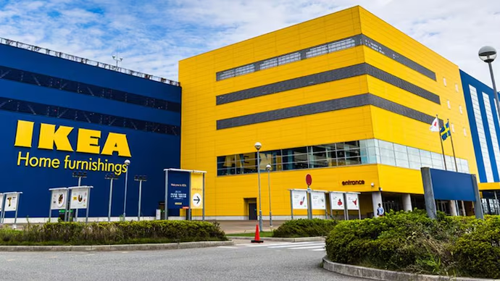
Figure 5: IKEA’s store at Gurugram
(Source: India Today, 2026)
The company has been successful in beginning work on its Gurugram store, which is mainly after the successful opening of IKEA stores in Mumbai and Bengaluru, as shown in Figure 5 (India Today, 2026).

India
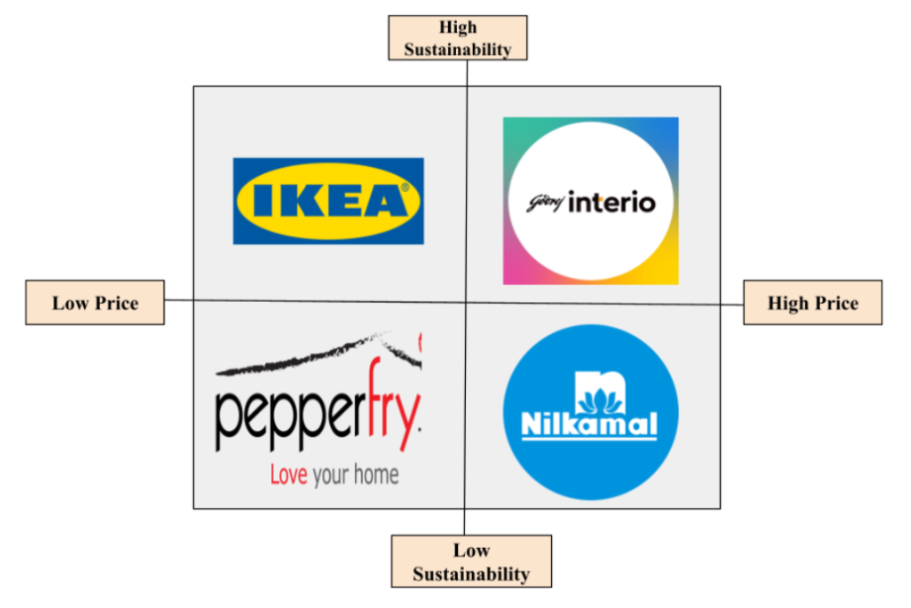
Figure 6: Positioning Map
(Source: Self-Created)
The above positioning map shows the major competitors of IKEA within India that are Godrej Interio, PepperFry, and Nikamal. IKEA is the brand that prioritised sustainability, and they also believe that people feel empowered to live more sustainably (IKEA, 2025). The company is prioritising sustainability programs, goals, and actions in order to effectively create a more sustainable future each day.
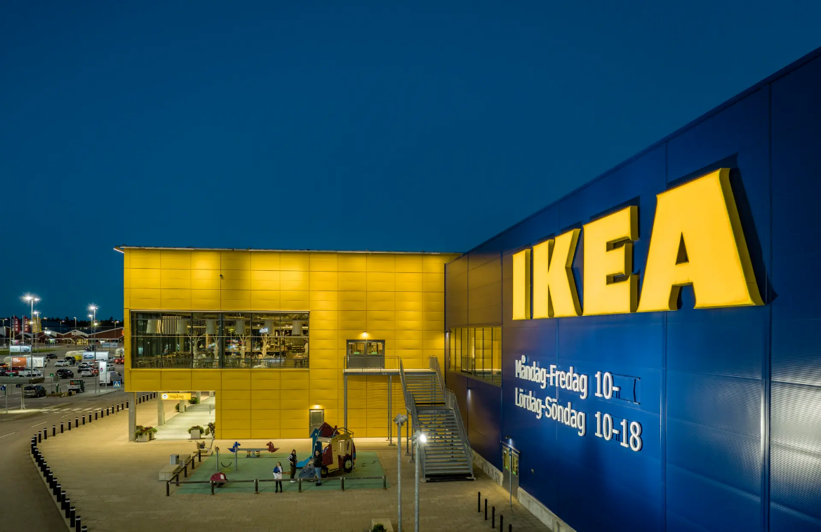
Figure 7: IKEA’s store Sweden
(Source: Si, 2026)
Sweden
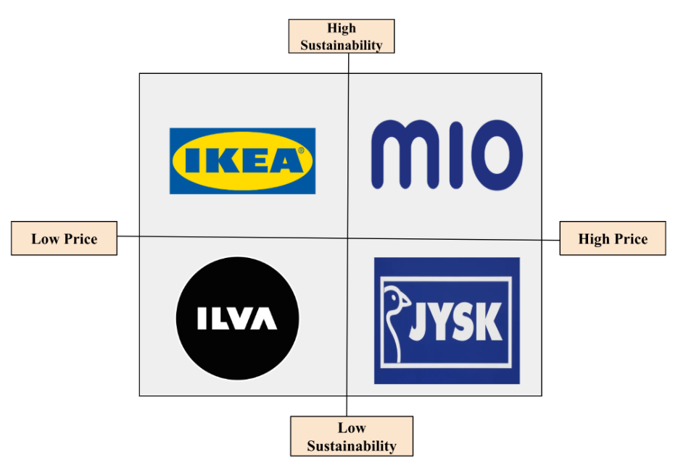
Figure 8: Positioning Map
(Source: Self-Created)
IKEA is a global brand whose vision is to create an everyday life for different people. They also aim to keep the prices low through manufacturing huge quantities of the products that are sold by them (IKEA, 2024). This indicates that the company ensures that the product maintains good quality, good functionality, a low price, and is always sustainably made. Its major competitors of IKEA in Sweden include ILVA, MIO, and JYSK.
The STP analysis has identified both similarities and differences between Sweden and India. The similarity that has been identified from the STP Analysis of IKEA in Sweden and India is that both young adults in Sweden and India are trying to find designer furniture for their homes. While the difference is that the customers of Sweden are searching for sustainable products, the customers of India is mainly prioritising the affordable ones.-

5. Marketing Mix (7Ps)
According to DeVilliers (2022), marketing is described as the process of comprehending, forecasting, and satisfying the demands of customers so as to gain profits by offering value to the customer (Refer to Figure 7). The term marketing includes any processes which involve promoting, selling, and distributing goods or services to customers.
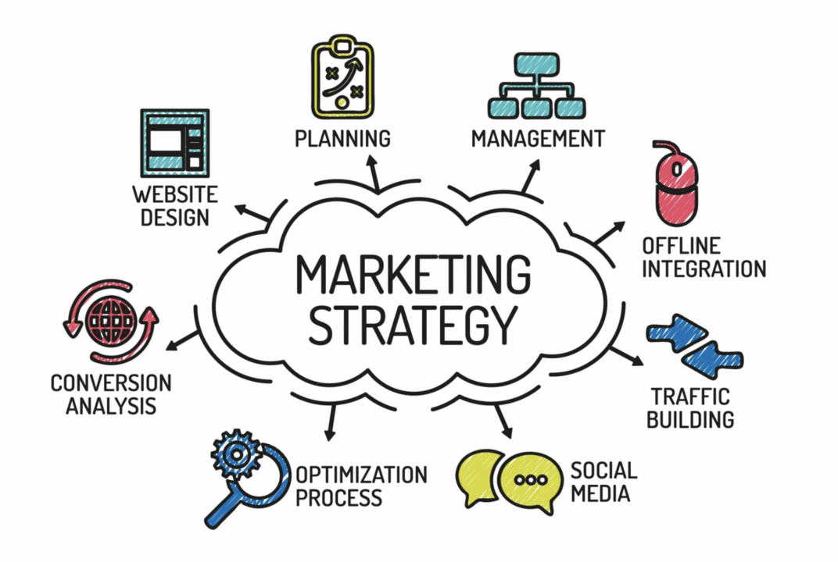
Figure 9: Marketing Strategy
(Source: DeVilliers, 2022)
Product: IKEA Sweden provides customers with an array of affordable home furnishings that include furniture, textiles, lighting, kitchenware, and home decor. Some of the key product offerings include the iconic bookcase, the Billy bookcase, and the Klippan sofa (IKEA, 2026). Apart from that, IKEA offers a variety of over 6,500 affordable home furnishing products in India, including home furniture, home decor, kitchenware, and lighting products. Some of the key products available at IKEA are sofas, beds, storage products like BILLY and IVAR, and home textiles like coconut coir mattresses, non-stick kitchenware, and idli makers (IKEA, 2023). IKEA Sweden products are 40 to 80cm wide and 58-60cm deep (IKEA, 2025). Sweden has well-structured Scandinavian designs, and India has multiple adapted products (EBSCO, 2023). The selling of the Klippan sofa in the Indian market can give them more profitability.
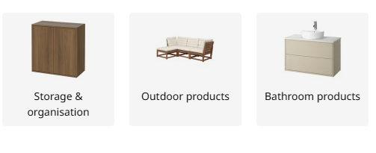
Figure 10: IKEA Products in Sweden
(Source: IKEA, 2026b)
The home furnishing products offered at IKEA Sweden are diverse in nature, ranging from furniture to decorative pieces, kitchenware, and special products that are highly durable, such as the IVAR storage units, PAX wardrobes units, and POÄNG armchairs (IKEA, 2026b). The range of products offered by IKEA Sweden includes various Scandinavian products, as well as some eco-friendly special products for summer. IKEA Sweden products are 50-100cm wide, and 35-58cm deep (IKEA, 2026).

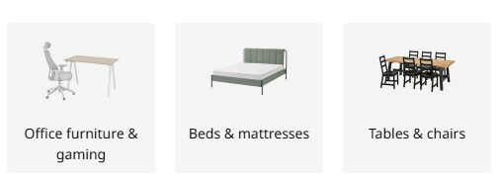
Figure 11: IKEA Products in India
(Source: IKEA, 2026a)
The IKEA store offers a range of useful and buffet-friendly furniture and accessories of Scandinavian origin to Indian consumers, which includes sofas, beds, kitchen cabinets, storage units, and many others (IKEA, 2026a). They can choose between purchasing their goods online through the company’s website or app, or going to any of its stores located in Hyderabad, Navi Mumbai, and Bengaluru.
Price: IKEA in Sweden sells their product in an affordable price, their price started from 169 SEK; however, in India, the lowest price of IKEA products is 399 (IKEA 2026). IKEA starts their pricing strategy with competitive but the purchasing power is high. In India local sourcing strategy is adopted by the IKEA store to maintain affordability and attract consumers across the nation. Overall, India adopted a local sourcing strategy, but Sweden's pricing strategy is more competitive, and their purchasing power is high.
Place: IKEA operators have 22 stores in Sweden in 2025, most stores are available in Malmö in the south to Haparanda in the north, and they also prefer online stores in Sweden. Their other stores are present in Göteborg, Borås, Kristianstad, Halmstad, Luleå, Lund, Skellefteå, Norrköping, Stockholm (Täby), Skövde, Varberg, Östersund, and Växjö (IKEA 2026). IKEA is present in 6 major locations in India, such as Hyderabad, Mumbai (Worli), Navi Mumbai, Bengaluru, Nagasandra, and Delhi (Tagore Garden) (IKEA, 2026). IKEA has a huge warehouse in Sweden along with online stores, and also in India Ikea has a wide range of city-based shops with a strong e-commerce presence.
Distribution Channels
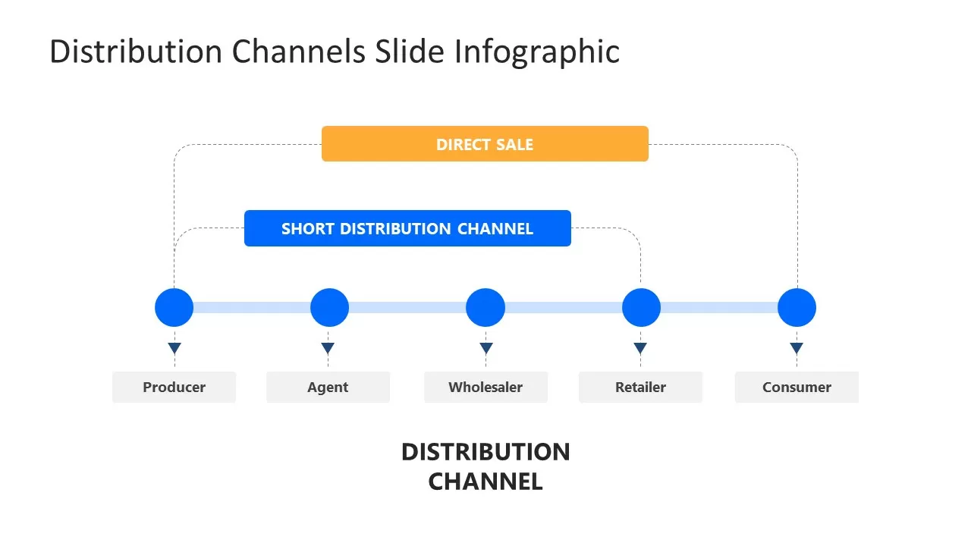
Figure 12: Marketing distribution channel structure
(Source: Model, 2022)
- Sweden: mainly direct distribution through IKEA stores, large warehouses, click-and-collect, and the website/app for online ordering.
- India: a mix of IKEA stores, e-commerce, home delivery, and assisted selling because customers often prefer convenience and support for furniture purchase and assembly.
- Omnichannel approach: customers can browse online, visit stores, order online, and use delivery or pickup, which improves accessibility in both markets.
- Local adaptation: India needs more delivery-focused and city-based channels, while Sweden can rely more on established stores and digital self-service.
IKEA uses a direct and omnichannel distribution strategy in both Sweden and India. In Sweden, the company mainly distributes products through its stores, warehouse-style outlets, online platform, and click-and-collect services, which suits a mature and digitally advanced market. In India, IKEA combines physical stores with e-commerce, home delivery, and assisted services to meet the needs of urban customers who value convenience, affordability, and support with furniture assembly. This channel strategy helps IKEA reach customers efficiently while adapting to differences in shopping behaviour across the two markets.
Promotion: One of the most popular expansions to IMC is "Integrated Marketing Communications." This can be said to be a marketing approach that makes use of many different marketing instruments, such as advertising, social media, and public relations. IKEA is promoting their brands, products, and sustainability initiatives in Sweden through the Campaign, IKEA family loyalty program, "Långbord" Event, and Second-hand Marketplace (INKGA, 2025). IKEA is promoting their products and brands in India through localised production, campaigns, influencers, collaborators, and investors (Reuters, 2020). Whereas the IKEA corporation in Sweden focuses on design, lifestyle, and sustainability, IKEA in India adopts the “Scandi-Indian” approach by focusing on design and affordability, availability of food inside the store, and do-it-yourself workshops (Islur, 2026). Sweden specifically focused on campaign-based promotion on sustainability, but India value for money.
People: IKEA Industry in Sweden is a key component of IKEA's global manufacturing activities, where IKEA specialises in producing wooden furniture products employing 20,000 people globally, with a substantial presence in Sweden (IKEA, 2024). IKEA works with 48-65 suppliers in India and employs 45,000 direct employees and over 400,000-500,000 people in its indirect supply chain for its global and local business activities (IKEA, 2021). The main strategies in India include employing females in non-traditional jobs, such as forklift driving, providing parental leave for 26 weeks, offering day care facilities at the workplace, and creating a safe environment. IKEA have high skilled and trained employees in Sweden and structured management in India.
Process: IKEA followed the “Democratic Model” in Sweden for implementing their business by offering functional, sustainable, and well-designed home furnishing at an affordable price (IKEA, 2025). In case of any complaints regarding IKEA India, customers may call at the number 1800 419 4532 between 9:00 am and 9:00 pm or email them at customer.support.in@ikea.com or use the contact form available on their website. For damaged goods, contact IKEA India via their contact form within 48 to 72 hours to receive a response. The business model of IKEA in India is a "glocal" version of the global business model of IKEA, which is known for providing low-cost do-it-yourself furniture to customers around the world (Kumar and Shekhawat, 2020). Sweden has a self-service model, whereas India has an assisted service model.
Physical Evidence:
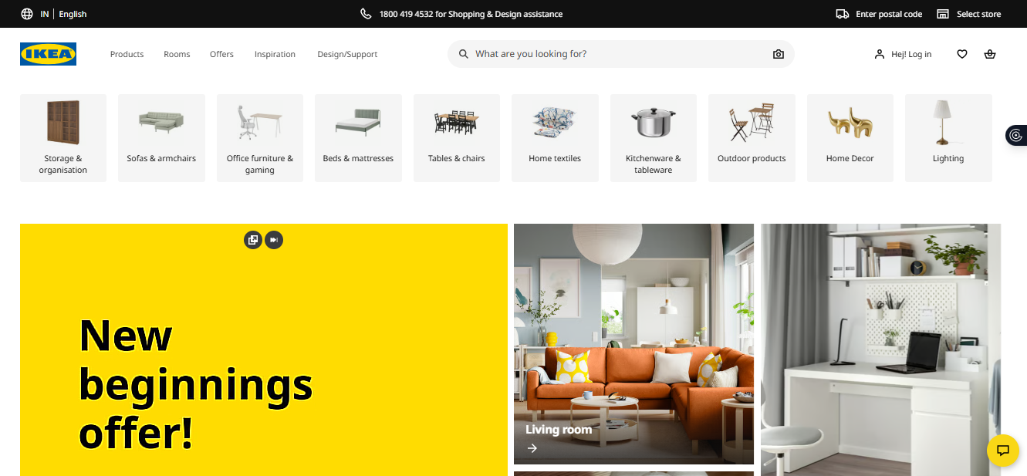
Figure 13: IKEA Website in India
(Source: IKEA, 2026)
IKEA is extremely popular in Sweden and has retained its position as Sweden's most valuable brand for ten consecutive years, with a value of 135.9 billion Swedish Krona in 2025 (IKEA, 2026). IKEA is growing rapidly in popularity in India, with a revenue of ₹1,860.8 crore in FY25, a 6% increase over FY24, and almost 110 million customers visiting IKEA physically and virtually (Reuters, 2020). IKEA has a huge store identity in Sweden, but in India, IKEA has a particular zone highlighting Indian homes.
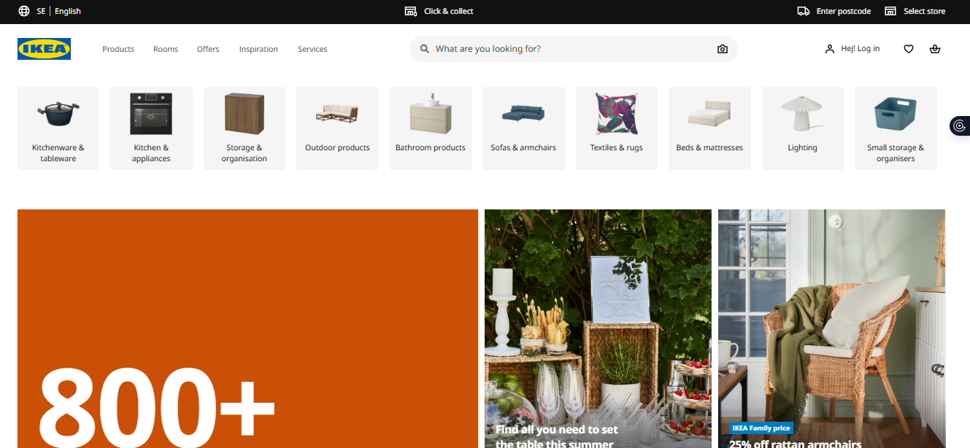
Figure 14: IKEA Website in Sweden
(Source: IKEA, 2026)

6. Ansoff matrix
The Ansoff Matrix is also regarded as the Product/Market Expansion Grid, which is a framework (Peterdy, 2025). This assists in planning and helps in evaluating the required opportunity for growth.
Market Penetration: Increasing the marketing effort and loyalty efforts for the members of IKEA.
Product Development: Adapting the specific product designs that meet the local tastes while also maintaining the core concepts of IKEA.
Diversification: Develop new products that blend cultural and modern aspects and expand to rural areas as well. The brand will make available the products that will meet the requirements of the customers.
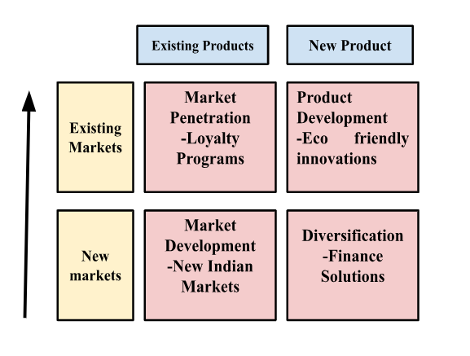
Figure 15: Ansoff Matrix
(Source: Self-created)
Market Development in India: IKEA within India is representing one significant example of the Market development. This mainly involves selling the products that already exist to the new markets (IBEF, 2026). This will help IKEA to not wholly complete its business model, but it may adapt its design by using minor localisation. In India, IKEA welcomes nearly 300+ million online as well as offline visitors, and even more than 2.7 million IKEA family members (IKEA, 2026). Almost 30% of the sales are recently coming from online, which is ultimately making e-commerce a powerful and even almost fast-growing channel for IKEA in India. IKEA has been successfully sourcing from India, which is for around 40 years, with experience and working with nearly 65 suppliers. There are 48,000 direct employees and more than 500,000 people within the supply chain in India, who are ultimately producing for the IKEA stores throughout the world (IKEA, 2026). The advantages of the Ansoff matrix include a strong foundation for sourcing, adapting to omni-channel adaptation and valuing the product design. While the disadvantages include cultural misalignment, high operational costs and chances of financial losses.

6.1 Ethical Marketing Issues
The ethical issues in India include unprofessional staff conflict, false claims for doubt, and direct refusal to accept any legitimate complaints (Olšiaková and Loučanová, 2025). While the ethical issues in Sweden include the higher dependency on the high-risk countries, precarious labour situation and environmental impact as well (Axfoundation, 2024). The examples of ethical marketing in India include Surf Excel and Tata Tea, while the unethical include Alcohol and Misleading Products that claim to decrease weight and beauty products. In Sweden, the ethical marketing is Spotify and Coop Group, while the unethical are Higher Marketing of Influencer and Greenwashing by fashion brands.
In India, it has been seen that there is a high level of inequality of both power and wealth. However, this condition is found to be not mainly imposed upon the overall population, but rather accepted as a specific cultural norm. There is a top 10% of the earners of earners who are capturing around 58% of the national income. While there is a bottom 50% who are receiving around 15% (Iyer, 2025). Another issue is that there is a higher cost of the raw material, and the transport and logistical costs within India are also found to be higher (IKEA, 2021). This is further depended of the locally available materials, and it even depends on the uncertified raw materials as well.

6.2 Recommendation
Recommendation in India
Focus on sustainability: One important recommendation for IKEA in India is to focus on sustainability. In India, almost 92% of Indians are found to be concerned about the environment (Ipsos, 2024). IKEA should effectively use the materials that have less impact on the environment, such as renewable materials, energy efficient process, and recycling.
Invest in developing smaller stores: Another effective strategy for IKEA is to invest in developing smaller stores within India. The company needs to invest in smaller urban stores that will mainly focus on product display. These stores will also focus on digital ordering and services like customer consultations. This strategy may be crucial in making the products accessible to a huge number of customers.
Increase the product customization: The homes of Indians are not the same, and they are found to be different as per their size, and their cultural preferences are also different. Due to that, IKEA needs to expand the customization of products and give options to the customers. The options may be about an adjustable storage system and also about modular furniture for the Indian customers.
Recommendation in Sweden
IKEA needs to focus on specific instructions on accurately accelerating the interfaces that will be helpful in enhancing the digital personalisation (Ingka, 2026). Next, the company needs to expand its accessible city centre stores and invest more in sustainable materials.
6.3 NEW STP Strategy
In order to further strengthen the marketing presence of IKEA within India, IKEA needs to adapt the following strategies, including this new STP strategy.
Segmentation
Psychographic | Value the aspirational customers who prefer a modern lifestyle and demanding, stylish home interiors.
Geographic | Focus on multiple cities like Delhi, Hyderabad, and Pune.
Demographic | Focus on young professionals, small nuclear facilies and newly married couples
Behavioural | Consumers who prefer affordable, durable and space-saving furniture
Table 1: Segmentation in India
(Source: Self-Developed)
Targeting: IKEA can target the lower-middle-income people of India and focus on smaller units of furniture sets for the targeted customers. IKEA can even adopt a particular differentiated targeting strategy through strongly focusing on lower-middle and may also focus on upper-middle-income customers.
Positioning: The company can position itself by greatly focusing on smaller units of furniture sets. The company can greatly emphasize affordability and sustainability within its products.
New product idea: Easy-to-Assemble furniture, Festive Utility Kits, Vertical Organiser Series
Pricing strategies: Bundle pricing
Physical evidence improvement: Small Stores in City for Experience Centres
Recommendations: Implementation of the Digital-first approach to enter popular cities
New targeting strategy: Sustainable Lifestyles People and Nuclear Families
New STP configuration: A companion that decreases any physical or financial barriers

Figure 16: Store of IKEA in India
(Source: Business-Standard, 2024)

7. Conclusion
The business operations of IKEA within Sweden and India have been analysed. Sweden has represented a mature market, while India offers growth potential by using effective strategies. From the above report, it has been identified that in India, there are multiple reasonable international brands that are appealing to the people. But the low cost and sustainability aspects of IKEA have been crucial in attracting a huge range of customers for its products. There is a constantly growing urban middle-income customer base within metro cities. While in Sweden, it has been seen that there is an affordable and sustainable lifestyle brand, and a wide middle-class market. The report has identified multiple factors of Sweden that have a direct impact on the business operations of IKEA. In India, economic, technological, and legal factors have been beneficial for IKEA’s business. In addition to that, it has been identified that sustainability and affordability are found to be the major aspects that have been prioritised by IKEA. A new STP strategy has been suggested for IKEA business operations, in which it has been suggested that it is beneficial for IKEA to prioritise building sustainable, durable, and affordable products.

Section 2: Reflective Account
Gibbs Reflective Cycle
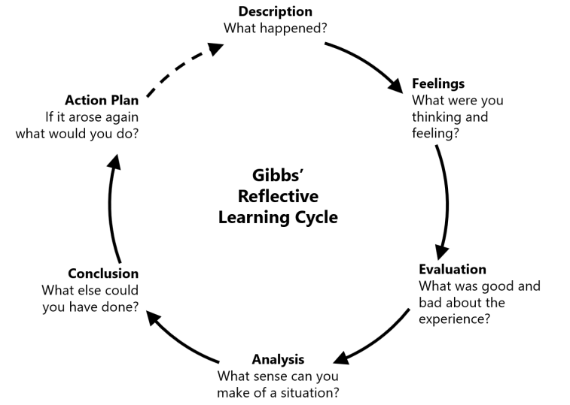
Figure 17: Gibbs Reflective Cycle
(Source: Harithuddin, 2021)
Learning from past experiences is referred to as the major definition of reflective learning. This reflective cycle mainly consists of six key stages, and these key stages include description, feelings, evaluation, analysis, conclusion, and action (Refer to Figure 17). The stages of this cycle are very crucial, and these are worked with the specific questions in order to guide the learner which is throughout the cycle (Harithuddin, 2021). This mainly has a concept which is about the theme of learning, which is even from failure, and this has been constructed to focus on any negative experiences. These negative experiences have been noted, and then with the help of the stages of the reflective life cycle, all these negative steps will change into positive areas in order to gain positive outcomes in future.

2.1 Description
I have prepared a comparative marketing analysis of the company IKEA, which is mainly between its home country, that is Sweden, and the host country, which is India. The aim of the report, which has been done by me, was to critically analyse how the company is operating between these two countries' markets. It was also about how the different external factors are directly impacting the marketing strategies of the company. I have used different marketing frameworks like PESTLE Analysis, Hofstede Cultural Dimensions, STP, as well as the Ansoff Matrix. All these frameworks have been key areas in assisting me to get a clearer understanding of the different external environments.

2.2 Feelings
At the beginning of the of doing the assignment, I was feeling both nervous and excited. The main reason behind my nervousness was that I had to find out the exact factors that have a direct impact on the business efficiencies of IKEA. Another thing about my nervousness is that there were two countries, and I have to find out the factors and then compare those factors. But I was also interested in this topic as IKEA is a well-known global brand and uses several strategies in different countries. I feel overwhelmed while analysing how the company is changing and diversifying its product, which is mainly based on the economic differences.

2.3 Evaluation
I have identified, while completing the assignment, that there have been both positive and negative aspects. One positive thing was that I was almost able to accurately apply the different marketing frameworks which have been learned during the module. All these models have been the key area that has assisted me in accurately structuring the report and analysing the strategies of IKEA in a clear way. For example, PESTLE analysis has assisted me in getting a clearer understanding of the different political, economic, social, technological, legal, and environmental factors that have a direct impact on the company.
Another positive aspect of the comparison is mainly between the home country and the host country. These have assisted me in getting a clear understanding of how the companies may adapt the different strategies as per the requirements of the different markets. Apart from these positive aspects, I have dealt with multiple issues, which are about finding the accurate information that is required to make the paper more informative. There was a lack of sufficient data and updated information, which were required to make the paper longer and more informative. Lack of required numerical information has caused issues in completing the assignment. However, other major gaps existed in me, which were a lack of critical thinking skills, data analysis skills and time management skills.

2.4 Analysis
This assignment has been the key area that has assisted me in gaining an understanding of the importance of research analysis within the international market. While doing this assignment, I have been able to realise that the company cannot use the same marketing in every country. After completing this assignment, I have been able to know that it is very essential for the company to have a clear understanding of the cultural areas and different aspects of the people in which the company is operating. I have also been able to gain information about the significance of localisation, which is a very crucial element in international marketing. The analysis of the cultural differences was also found to be very important, which has been crucial in highlighting the information regarding the Swedish and Indian markets' cultural areas. However, throughout the process of doing this assignment, I have successfully enhanced my ability to analyse multiple business strategies. In addition to that, I have also been successful in gaining the ability to accurately connect the multiple theoretical concepts with the real-life examples.

2.5 Conclusion
Completing this assignment was very significant for me, which have been very important in enhancing my learning experience. This assignment has been significant, which has been the key area in developing a deep and clear knowledge in me about international marketing. At the same time, it has also allowed me to gain a clear understanding of the challenges that are faced by companies at a global level. Furthermore, I have also developed important knowledge and skills that are essential for my academic pursuits and even in a future job role. This study assisted me in developing my referencing skills, academic writing skills, research skills. I have also learned about how to effectively use the different marketing frameworks to analyse the strategies used by the business. This assignment is very beneficial for me as it has allowed me to identify different factors that may impact the business decisions of any firm.

2.6 Action Plan
Areas to be Improved | Actions taken for Improvement | Responsible Person to Support | Time Required
Critical thinking skills | I will practice evaluating multiple business cases and read academic articles | Module Tutor | 2 months
Data analysis skills | I will enhance my ability to accurately interpret statistical data and use basic analytical tools | Academic Mentor | 3 months
Time management skills | I will prepare a timetable, strictly follow it, and set deadlines by myself | Self managed | 3 months
Table 2: Actions considered for improvement

2.6 Summary and Conclusion
Completing this assignment was very significant for me, which have been very important in enhancing my learning experience. This assignment has been significant, which has been the key area in developing a deep and clear knowledge in me about international marketing. At the same time, it has also allowed me to gain a clear understanding of the challenges that are faced by companies at a global level. Furthermore, I have also developed important knowledge and skills that are essential for my academic pursuits and even in a future job role. This study assisted me in developing my referencing skills, academic writing skills, and research skills. I have also learned about how to effectively use the different marketing frameworks to analyse the strategies used by the business.

References
Axfoundation. (2024). Ethical Trading Initiative - a platform for responsible business. Available at: https://www.axfoundation.se/en/projects/eti [Accessed 13 Apr. 2026].
Biswas, S. (2022). How Ikea tweaked its products to woo India’s shoppers. 21 Mar. Available at: https://www.bbc.com/news/world-asia-india-60256867.
Business-Standard (2024). Ikea looking for next phase of investments in India, plans smaller stores. Available at: https://www.business-standard.com/companies/news/ikea-looking-for-next-phase-of-investments-in-india-plans-smaller-stores-124090900744_1.html.
Christodoulou, A. and Cullinane, K. (2019). Identifying the Main Opportunities and Challenges from the Implementation of a Port Energy Management System: a SWOT/PESTLE Analysis. Sustainability, 11(21), p.6046. doi:https://doi.org/10.3390/su11216046.
DeVilliers, M. (2022). How would you define marketing? [online] www.linkedin.com. Available at: https://www.linkedin.com/pulse/how-would-you-define-marketing-marius-devilliers-mba [Accessed 20 Apr. 2026].
EBSCO. (2023). Scandinavian design | Research Starters | EBSCO Research. Available at: https://www.ebsco.com/research-starters/visual-arts/scandinavian-design.
Europa (2023). Gender Equality Index 2020: Sweden. European Institute for Gender Equality. Available at: https://eige.europa.eu/publications-resources/publications/gender-equality-index-2020-sweden [Accessed 5 Mar. 2020].
Europa (2024). National legislation | European e-Justice Portal. Europa.eu. Available at: https://e-justice.europa.eu/topics/legislation-and-case-law/national-legislation/se_en [Accessed 5 Mar. 2026].
Fourment, U. (2025). Sweden Cashless Transition: Is the Country Going Fully Digital? Available at: https://sbs-software.com/insights/sweden-cashless-revolution/.
GeeksforGeeks (2023). STP Marketing Segmentation, Targeting, and Positioning. Available at: https://www.geeksforgeeks.org/marketing/stp-segmentation-targeting-and-positioning/.
Gurval, C. (2023). Collectivism vs Individualism in India: How it shapes the culture. Available at: https://cgurval.medium.com/collectivism-vs-individualism-in-india-how-it-shapes-the-culture-f001abdc0108.
Harithuddin, A.S.M., 2021. A first experience of using failure report as a reflective tool in engineering education. International Journal of Emerging Technologies in Learning (Online), 16(18), p.23. https://www.researchgate.net/profile/Viorelia-Lungu/publication/356843846
IBEF (2024). E-commerce in India: Industry Overview, Market Size & Growth| IBEF. Available at: https://www.ibef.org/industry/ecommerce.
IBEF (2026). Ikea plans to double India investment to more than US$ 2.20 billion in 5 years. Available at: https://www.ibef.org/news/ikea-plans-to-double-india-investment-to-more-than-us-2-20-billion-in-5-years.
ICLG (2025). The UK’s gender pay gap remains stubbornly persistent. Available at: https://iclg.com/practice-areas/gambling-laws-and-regulations/singapore.
Igini, M. (2024). 5 Biggest Environmental Issues in India in 2022. Earth.org. Available at: https://earth.org/environmental-issues-in-india/ [Accessed 5 Mar. 2026].
IKEA (2021). IKEA India partners with Tata STRIVE. Ikea.com. Available at: https://www.ikea.com/in/en/newsroom/ikea-india-partners-with-tata-strive-pub0b8393b0/ [Accessed 5 Mar. 2026].
IKEA (2023). Affordable, Quality Furniture & Home Furnishings. Ikea.com. Available at: https://www.ikea.com/in/en/ [Accessed 5 Mar. 2026].
IKEA (2024). About IKEA. Available at: https://www.ikea.com/in/en/this-is-ikea/about-us/. [Accessed 27 Feb. 2026].
IKEA (2024). How can IKEA maintain high quality while keeping prices low? - IKEA Sweden. Available at: https://www.ikea.com/se/en/customer-service/knowledge/articles/g4248445-b7g3-4e8g-99g6-09fe1411f75b.html.
IKEA (2024). Our sustainability strategy for 2030. Ikea.com. Available at: https://www.ikea.com/in/en/this-is-ikea/about-us/the-ikea-sustainability-strategy-making-a-real-difference-pubb5534570/ [Accessed 5 Mar. 2026].
IKEA (2024). Working at the IKEA Group. Ikea.com. Available at: https://www.ikea.com/in/en/working-at-the-ikea-group/welcome-to-the-ikea-way-of-working-pubbc667ec1/ [Accessed 5 Mar. 2026].
IKEA (2025). IKEA culture and values. www.inter.ikea.com. Available at: https://www.inter.ikea.com/en/how-we-do-business/ikea-culture-and-values [Accessed 5 Mar. 2026].
IKEA (2025). Page Restricted. Ikea.com. Available at: https://www.ikea.com/global/en/our-business/how-we-work/year-in-review-fy25/ [Accessed 5 Mar. 2026].
IKEA (2025). Performance. www.inter.ikea.com. Available at: https://www.inter.ikea.com/en/performance [Accessed 5 Mar. 2026].
IKEA (2025). The story of IKEA – IKEA Global. Available at: https://www.ikea.com/global/en/our-business/how-we-work/story-of-ikea/.
IKEA (2025). What are the internal dimensions of METOD frames? - IKEA Sweden. [online] Ikea.com. Available at: https://www.ikea.com/se/en/customer-service/knowledge/articles/5g03d6cb-4ed3-4g4c-bd6d-52033730g335.html [Accessed 20 Apr. 2026].
IKEA (2025). What is IKEA doing in terms of sustainability? - IKEA India. [online] Available at: https://www.ikea.com/in/en/customer-service/knowledge/articles/858g1170-gc43-4g99-b4ef-97eb1e602gf3.html.
IKEA (2026). What sizes do PAX wardrobes come in? - IKEA India. [online] Ikea.com. Available at: https://www.ikea.com/in/en/customer-service/knowledge/articles/8971fe62-2520-4623-g473-5cc963d89ecg.html [Accessed 20 Apr. 2026].
IKEA (2026a). Affordable, Quality Furniture & Home Furnishings. [online] Ikea.com. Available at: https://www.ikea.com/in/en/ [Accessed 13 Apr. 2026].
IKEA (2026b). IKEA - Home furnishing ideas & affordable furniture. [online] www.ikea.com. Available at: https://www.ikea.com/se/en/ [Accessed 13 Apr. 2026].
IKEA 2026. IKEA stores & plan and order. Available at: https://www.ikea.com/se/en/stores/ [Available on 5th March 2026]
IKEA 2026. Our lowest prices. Available at: https://www.ikea.com/in/en/cat/lowest-price/ [Accessed on 5th March 2026]
IKEA 2026. Where are IKEA stores located in India? Available at: https://www.ikea.com/in/en/customer-service/knowledge/articles/99c4002b-64gd-48c9-8282-2890862064fd.html [Available on 5th March 2026]
India Today (2026). IKEA to open its first store in Delhi-NCR by 2025. [online] India Today. Available at: https://www.indiatoday.in/cities/delhi/story/ikea-open-first-store-delhi-ncr-1988625-2022-08-16.
Ingka (2026). IKEA expands second-hand marketplace to Sweden, now active in five countries | Ingka Group. Ingka Group. Available at: https://www.ingka.com/newsroom/ikea-expands-second-hand-marketplace-to-sweden-now-active-in-five-countries/ [Accessed 5 Mar. 2026].
IKEA, (2024). Find your IKEA store. Available at: https://www.ikea.com/se/en/stores/. [Assessed on: 5th March, 2026]
IKEA, (2021). Strategic Roadmap for Furniture Sector of India. https://www.ikea.com/in/en/files/pdf/78/62/78623ce0/thought-leadership-paper_full_strategic-roadmap-for-furniture-sector-of-india.pdf
IKEA, (2026). IKEA answers the call to “When is IKEA coming to North India” with the launch of online deliveries. Available at: https://www.ikea.com/in/en/newsroom/corporate-news/ikea
INKGA, 2025. IKEA brings people together at a shared table in more than 200 stores. Available at: https://www.ingka.com/newsroom/ikea-brings-people-together-at-a-shared-table-in-more-than-200-stores/ [Available on 5th March 2026]
International Trade Administration (2024). Sweden - Digital Economy. International Trade Administration | Trade.gov. Available at: https://www.trade.gov/country-commercial-guides/sweden-digital-economy [Accessed 5 Mar. 2026].
Ipsos (2024). 92% Indians concerned about the environment; misplaced awareness emerged for impactful actions: Ipsos India Sustainability Segmentation Survey 2024. Available at: https://www.ipsos.com/en-in/92-indians-concerned-about-environment-misplaced-awareness-emerged-impactful-actions-ipsos-india.
Islur, S. (2026). Adosh Sharma on how IKEA India is reshaping its marketing to capture dreams that begin at home. [online] SocialSamosa. Available at: https://www.socialsamosa.com/marketing-shorts/adosh-sharma-ikea-india-marketing-capture-dreams-begin-home-11092918 [Accessed 13 Apr. 2026].
Iyer, K., (2025). The Hidden Cost of India’s Economic Boom: Inequality At Historic High, As Wealth & Income Growth Leave Out Millions. Available at: https://article-14.com/post/the-hidden-cost-of-india-s-economic-boom-inequality-at-historic-high-as-wealth-income-growth-leave-out-millions--693b8b0d6e810
Kenresearch (2026). Sweden Furniture Market | 2019 – 2030 | Ken Research. Available at: https://www.kenresearch.com/sweden-furniture-and-interiors-market.
Khan, A. (2025). IKEA India aiming to turn profitable in two years. Available at: https://www.newindianexpress.com/business/2025/Nov/11/ikea-india-aiming-to-turn-profitable-in-two-years.
Kumar, A. and Shekhawat, D.S. (2020). IKEA in India: Glocalisation, Expansion Strategy and Challenges | the Reformist. www.thereformist.co.in. Available at: https://www.thereformist.co.in/posts/ikea-in-india-glocalisation-expansion-strategy-and-challenges-2 [Accessed 5 Mar. 2026].
Lewis, R. (2024). IKEA Swedish company. Available at: https://www.britannica.com/money/IKEA. [Accessed 27 Feb. 2026].
Model, S. (2022) Distribution channels PowerPoint Template, Slide Model. Available at: https://slidemodel.com/templates/distribution-channels-powerpoint-template/ (Accessed: 21 April 2026).
OECD (2025). OECD Environmental Performance Reviews: Sweden 2025. OECD. Available at: https://www.oecd.org/en/publications/oecd-environmental-performance-reviews-sweden-2025_91dcc109-en.html [Accessed 5 Mar. 2026].
Olšiaková, M. and Loučanová, E., 2025. Unethical Practices in Furniture Sales: Consumer Experiences and Recommendations for Responsible Business. Drvna industrija, 76(4), pp.455-464. https://hrcak.srce.hr/file/492514
Peterdy, K. (2025). Ansoff Matrix. [online] Corporate Finance Institute. Available at: https://corporatefinanceinstitute.com/resources/management/ansoff-matrix/.
Pib (2025). India offers a transparent, predictable and comprehensive FDI Policy Framework for investments. Pib.gov.in. Available at: https://www.pib.gov.in/PressReleasePage.aspx?PRID=2101785®=3&lang=2 [Accessed 5 Mar. 2026].
Pib.gov.in. (2025). FDI Policy Under Continuous Review to Maintain India’s Attractiveness as an Investment Destination. Available at: https://www.pib.gov.in/PressReleasePage.aspx?PRID=2197654®=3&lang=1.
Quora (2019). Why is the labour cost in India cheaper than Western countries? Quora. Available at: https://www.quora.com/Why-is-the-labour-cost-in-India-cheaper-than-Western-countries [Accessed 5 Mar. 2026].
Reuters, 2020. IKEA plans to double India investment to more than Rs 20,000 crore over five years. Available at: https://economictimes.indiatimes.com/industry/services/retail/ikea-plans-to-double-india-investment-to-more-than-rs-20000-crore-over-five-years/articleshow/126771686.cms [Available on 5th March 2026]
Riksdagen.se (2026). The development of democracy in Sweden. Available at: https://www.riksdagen.se/en/how-the-riksdag-works/the-history-of-the-riksdag/the-development-of-democracy-in-sweden2/.
Si (2026) IKEA and the Flatpack Revolution, sweden.se. Available at: https://sweden.se/work-business/business-in-sweden/ikea-and-the-flatpack-revolution (Accessed: 21 April 2026).
Startupindia.gov.in (2025). Tax System. Available at: https://www.startupindia.gov.in/content/sih/en/international/go-to-market-guide/tax-system-india.html.
Statista. (2025). Traditional IKEA stores worldwide 2025| Statista. Available at: https://www.statista.com/statistics/1060053/number-of-ikea-stores-worldwide [Accessed 27 Feb. 2026].
Sweden (2023). Sweden and gender equality. Available at: https://sweden.se/life/equality/gender-equality.
The Global Economy (2025). India Economic growth, percent change in quarterly real GDP, September, 2021 - data, chart. TheGlobalEconomy.com. Available at: https://www.theglobaleconomy.com/India/gdp_growth/ [Accessed 5 Mar. 2026].
The Global Economy (2025). India economic indicators. TheGlobalEconomy.com. Available at: https://www.theglobaleconomy.com/India/ [Accessed on 5th March 2026]
The Global Economy (2025). Sweden Economic growth, percent change in quarterly real GDP, September, 2025 - data, chart | TheGlobalEconomy.com. TheGlobalEconomy.com. Available at: https://www.theglobaleconomy.com/Sweden/gdp_growth/ [Accessed 5 Mar. 2026].
The Global Economy (2025). Sweden Inflation, annual percent change in the CPI, November, 2024 - data, chart | TheGlobalEconomy.com. TheGlobalEconomy.com. Available at: https://www.theglobaleconomy.com/Sweden/inflation_annual/ [Accessed 5 Mar. 2026].
The Global Economy (2026). Sweden economic indicators | TheGlobalEconomy.com. Available at: https://www.theglobaleconomy.com/Sweden/ [Accessed 5 Mar. 2026].
Theculturefactor.com (2020). Country comparison tool. [online] Theculturefactor.com. Available at: https://www.theculturefactor.com/country-comparison-tool?countries=india%2Csweden.
Trading Economics (2026). Sweden Labour Costs. Available at: https://tradingeconomics.com/sweden/labour-costs.
Trading Economy (2026). Sweden Consumer Spending. Tradingeconomics.com. Available at: https://tradingeconomics.com/sweden/consumer-spending [Accessed 5 Mar. 2026].
Tripathi, R. and Vijayan, U. (2020). Power Distance: An Indian Perspective. Available at: https://www.iimb.ac.in/turn_turn/power-distance-indian-perspective.php.
Wale, H. (2025). Hofstede’s Cultural Dimensions Theory. Available at: https://corporatefinanceinstitute.com/resources/management/hofstedes-cultural-dimensions-theory/.
World Economy (2025). India. World Economics. Available at: https://www.worldeconomics.com/ESG/Social/India.aspx [Accessed 5 Mar. 2026].

