
CERTIFICATE OF HIGHER EDUCATION FOR WORKPLACE

MODULE: Digital Skills and Research Methods MODULE ID: BMSK4003
STUDENT NAME: SONIA WELBECK

STUENDT ID: 1714747
LEVEL: 4

DEADLINE FOR SUBMISSION: 4th September, 2018, 2PM

UNIVERSITY OF WALES TRINITY St. DAVID LONDON

Contents
Effectiveness of Social Media Networks as a Strategic Tools for Organisational Marketing Management 3
Introduction 3
The symbol of Social Media Platform 3
Scholars Review on the Impacts of Technology and Social Media Marketing 4
Impact of Mobile Technologies on Businesses 5
Impact of Webinar Technologies on Organisation Performance 6
The Use of LinkedIn for Organisation Marketing 6
Adding LinkedIn to Marketing Strategy:. 7
LinkedIn Passive and Proactive Marketing Methods 7
LinkedIn Passive Marketing Approach 8
LinkedIn Proactive Marketing Approach 8
The Impacts of Social Media Network on Organisation 9
Contents: 9
Engagement: 9
Skills: 9
Consistency: 9
Recommendation 10
Reference 11
Appendix 13

Effectiveness of Social Media Networks as a Strategic Tools for Organisational Marketing Management

Introduction
Social media was invented from the two different words ''Social and Media''. Thus, Social, in this framework, basically stand for communication between persons of same purpose, a group, or even an organisation. While media on the other hand means, medium, avenue, channel, or platform that provides ways of exchange information from one party to another. Social media have gained extensive recognition in less than two decades since its inception (Holmes, 2015).
With the global society at the centre of modern technologies and social media adoption, it is quite clear that social media such as linkedIn, Skype, twitter, instagram, MySpace, Facebook etc., are commonly used for communication reasons within and outside workplace (Baruah, 2012). Among significant purpose of social media in workplace is the online exchange of information, skills acquisition and sharing of knowledge amid diverse groups of people most especially work colleague and society at large to promote and market the image of companies around the world. See Appendix 1:
Thus, this research will be analysing the impacts of smart phone and webinar in work place a well as the advantages and limitation of social media network as a calculated instruments for organisation promotion operation and also explains the advantages and challenges that has taken control of business management and wrap up with very important recommendations.

The symbol of Social Media Platform
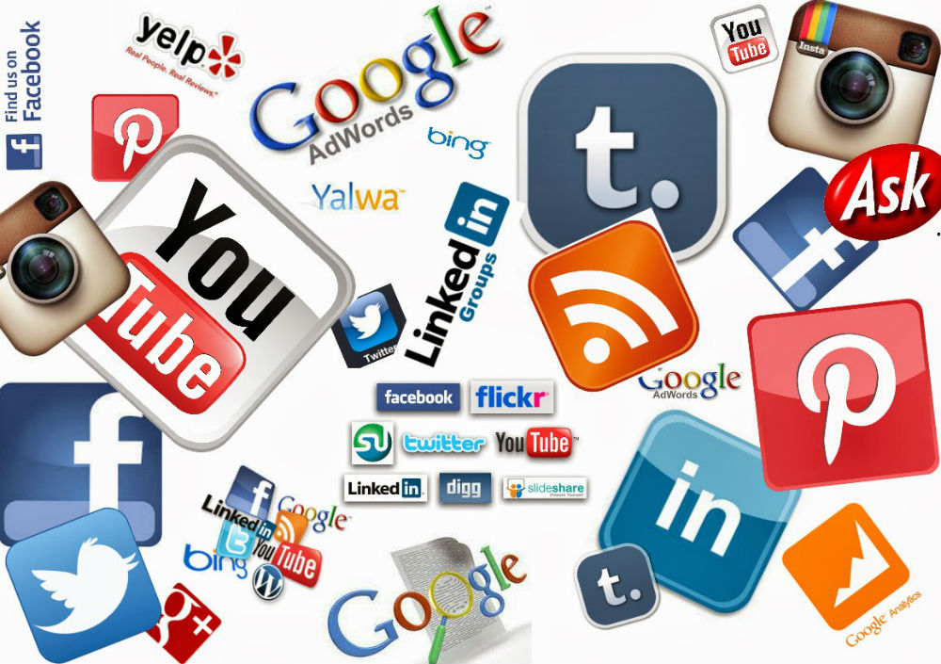
Figure:1 Source: Procurious (2016)
Social media and modern technology has not only improves communication skills in numerous means, but also promotes inter-cultural and environmental values within workplace and outside (Kanter & Fine, 2010). Online sharing information enhance communication skills among employees in the place of work and higher learning environment. However, some scholars argues that despite the enormous advantages of social medial, it is packed with challenges as well.

Scholars Review on the Impacts of Technology and Social Media Marketing
There has been various debate on the important of technology in workplace and means of getting adequate knowledge of the nature of technology and general understanding of technology. Consequently, technology has been defined as "science or knowledge put into practical use to solve problems or invent useful tools" (Carroll, 2017).
Social media networks are podiums that smooth the progress of providing business interaction between individuals and organisations of different business orientation and create opportunities for them to distribute significant interest, actions in real-life relationship. It is the means to socialising and marketing globally nowadays, the surplus of social media platform are one of the biggest advantages accessible to organisational marketers for their propose to connect with current and potential clients.
According to (Forbes, 2017) Social networks are comfortably built online by individuals and organisations with the combination of highly classy and accessible communication technologies to provide interactive means. It signified how individuals find out or researches and share news, information and contents of products and services from certain producers and marketing firms known as B2C to their various target audient. Social network applications enhance users with series of methods of empowerment and avenue for information sharing, which gives customers means of giving feedback to company about their products and services through online communication and exchanging information.

Impact of Mobile Technologies on Businesses
In recent years, the global adoption of mobile devices and applications such as mobile phones and tablets have brought about big cultural, political and economic improvement to world stage. The impacts of technologies can be seen in different areas of organisation setup including education, engineering, healthcare, business and the public sector (Brockmann, 2013).
Mobile marketing is a reasonably modern way of promoting and marketing organisation image known as two way marketing communication between organisations and customers which conducted through the use of mobile phones or tablets. The effectiveness of using modern technology in workplace for communication objectives and marketing promotion has improved greatly, which mostly used to gain the attention of target customers in other attracts them to patronise goods and services that contributed to company's productivity and increase profits (Ninčević, Krajnović, & Bosna, 2015).
Mobile marketing has a huge effects on all basics of the marketing mix that gives room for organisations to develop products which outline the quality of their products and attracts both existing and potential customers. In addition, mobile phones marketing provide full control on pricing and distribution of goods and services which also offer huge promotional opportunities with the use of mobile devices in direct marketing, sales promotion and advertising. It has been playing an important role in mobile marketing operations which signify the importance of multiplatform advertising like tv, iPhone and iPad.
According to the study conducted by the Institute for Society and Communications (2014), it was established that by 2016 more or less one billion smart phones will be in operation globally and more than 40% will be use for business purposes, while the use of tablets will follow the same trend. Similarly, the Accenture Research Institute (2014) predicted that the use of mobile technology as a marketing tools to promotes organisation marketing will rise from 27% to over 45% in 2016.
Mobile applications (apps) have huge impact on organisation communication system since it was launched in 2008, thus, various apps providers including Google and Microsoft are also recognised in the competitive market places, establishing over 100billion downloads with the most commonly used store for the Android mobile operating system.

Impact of Webinar Technologies on Organisation Performance

Webinars is an interactive valuable technological tool used in distributing information to targeted customers online with the use of internet and video-conferencing software commonly provided by the operating organisation.
Webinar enhance employees skills in an organisation operations and promoting stakeholders in achieving company’s targets sales and financial objectives most important increases company's productivity and income (Bunzel, 2016). The tools always provide avenue for new employees to properly inducted in to the organisation operational system in other to know their roles and responsibilities among the co-workers. When eventually promotes employees commitment and support loyalty in the organization, increase workers and technical know-how results in a higher level of performance that will absolutely contributes to organisational revenue (Brown, 2017).
The use of webinar improves the communication leadership skills and support teamwork and organised system in the organisation that results to increased efficiency and profit. The cordial relationship between different departments will leads to cooperation, simplify operations at the same time decreases costs operation while also improving customer service (Amos, 2016). For instance, established relationship among customer service and accounting department can be improves the awareness of financial performance and cash flow issues to reduce lag period of accounts payable and wrongdoing, resulting in increasing cash flow and a better bottom line.

The Use of LinkedIn for Organisation Marketing
LinkedIn is a mobile applications (apps) and websites for business and employment services, for the purpose of professional networking where potential employees shares their CVs on the mobile apps for employers, while employers also advertising their vacant positions for professional jobs seekers. At the same time respond to questions, and create leadership notion thus helping to build professional trust among people. The major source of income is from the sales of information about the recruiters as well as sales professionals details to employers. The account holder can simply find out information about people employed by particular company as well as the employment history of employees (Hussain & Turner, 2011).

Adding LinkedIn to Marketing Strategy: The use of LinkedIn to business marketing strategy will develop a professional image of the business, contribute to the business expansion network and discover potential customers. LinkedIn as a networking resource can provide connections that can bring about publicity, and other huge business rising opportunities. Below is the link and screen short of LinkedIn account created for the purpose of this study.
https://www.linkedin.com/feed/?trk=nav_back_to_linkedin
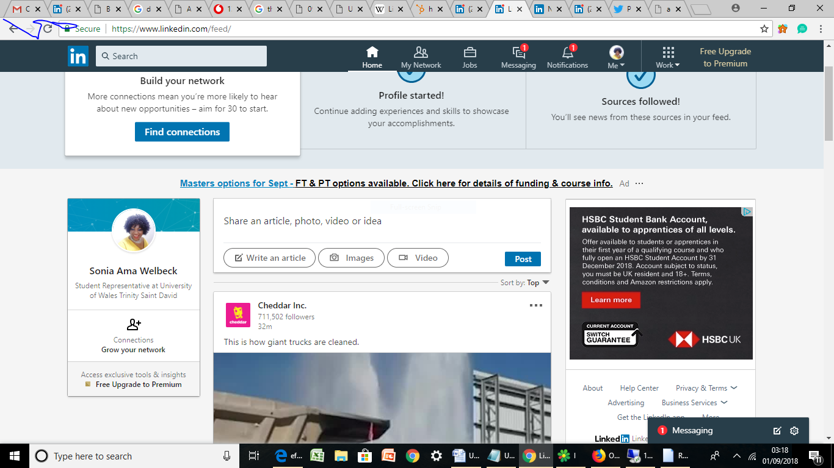
Figure: Source -Mona (2018)

LinkedIn Passive and Proactive Marketing Methods
The two most important ways to promote organisation business via LinkedIn are passive approach and proactive action. This is more or less like other marketing strategies used to promote business, which depend on the efforts and time contributed into the LinkedIn marketing plan hence, the more the commitment, the bigger the results.

LinkedIn Passive Marketing Approach
Basically, creating a LinkedIn profile and establish connections with constant updates which will create awareness of customers, prospective clients, enterprises, influencers and joint-venture partners. The passive approach can be of advantage in many ways which includes:
- LinkedIn's search features can create avenue for company publicity to people that are in need of goods or services.
- Depending on how attractive and informative the LinkedIn page look like, the business connections can link you with business and potential clients around the globe that one might not otherwise be able to reach.
- The recommendations given by business partners and colleagues on LinkedIn will build confidence of unknown or potential clients to establish relationship with your business for credibility which will increase productivity and profit (Carter, 2013).

LinkedIn Proactive Marketing Approach
Like other business strategy, there is need for adequate commitment for effective and quicker the results, in other to make use of LinkedIn's business advantages to support the business:
- To always update the business page status, in other to advertise their products and services including their business partner and the goals of the organisation to targeted customers who are always waiting for new information.
- Be active in most group events and activities related to the business, which can make you to be fully recognised in the industry and give you competitive advantage over other rival. At the same time discus what your business can offer your prospective customers.
- As newly established business in the industry you need to send messages and invitations to those in the same industry on your network including other related, with the aim of establishing professional relationship to be an avenue to grow in the industry.
- LinkedIn marketing system will help the business to be ahead of others competitors fast and prompt in the presence of their customers (Forbes, 2017).

The Impacts of Social Media Network on Organisation

The two advantages of social media marketing includes improves exposure as well as increase traffic between marketing companies and their targeted audient. In reference to (Bank, 2015) report on impacts of social media on organisation shows that considerable 92% of all marketers signified that all their efforts on social media have produced additional publicity for their businesses. Traffic increase was the second major advantage, with 80% reporting constructive results (Baruah, 2012). Presently, there is no single competitive organisation without solid social media department to promotes and interacts with current and potential customers, particularly Facebook, Twitter, LinkedIn and instagram. "As at March 2015, there were 288 million monthly active users on Twitter and 1.415 billion active users on Facebook which are mostly targeted by different organisations as a potential customer (Baruah, 2012). For any of the organisation to achieve this, they must focus on 4 significant point. Which are:
Contents: is the strength of social media. Up to date important information must always be pass across to customers at all time for them to be willing to visit the page often for interesting and social information.
Engagement: the nitty-gritty of a flourishing social media marketing is customers engagement. Organizations that interact with their online viewers are usually seen as pleasant and open that resulted in the increase of sales, patronage, and always win customer loyalty (Boot Camp Digital, 2010).
Skills: There are various skills required to promote a lively social media page starting from photo graphics, updated information about goods and services, research, designs, analytics, and continuous monitoring of customers response and feedback. Publishing wrong or outdated information on organisation social media page could be misleading resulting in losing customers one after the other without adequate knowledge could catastrophe (Solaris, 2014).
Consistency: Employing qualified social media professionals to handle the interactive section is very important. Doing the right thing at the appropriate time to have a pleasing social media presence and warranty success on daily basis. (Boot Camp Digital, 2010). If not, it could lead to online failure of public figures and multinationals companies, with huge financial back up on social media.

Recommendation
As both businesses and customers are clamouring for the safety and security of data. The study would recommend that government should provide strict regulations that will give individual strong platform on social media to conduct their various businesses without fare of identity theft like that of Ubah attack , where millions of data of customers are hacked including their financial details. If this could be established the remaining 19% of companies in the survey conducted by, that are not into social media business will sure join the moving train. For effectiveness of social media networks as a strategic tools for organisational marketing management, this study recommends there is need for:
- To develop appropriate arrangement and abide by it at all time.
- Treat each social media outlet as a independent body.
- Adopt the use of social media for outstanding customer service.
- Prepare for social media crisis and find a means to manage it accordingly.
- Monitoring of social feedback and work to improve on it.

Reference

Bibliography
Amos, A. (2016). Developing a Collaborative Workplace: Changing the Way we Work WEBINAR. Learn. Network. Connect , 1-3.
Bank, v. d. (2015, May 02). African Journal of Hospitality, Tourism and Leisure. Retrieved July 26, 2018, from http//: www.ajhtl.com: http://www.ajhtl.com/uploads/7/1/6/3/7163688/article_17_vol4(2)july-nov_2015.pdf
Baruah, T. D. (2012). Effectiveness of Social Media as a tool of communication and its potential for technology enabled connections: A micro-level study. New York: International Journal of Scientific and Research Publications.
Boot Camp Digital. (2010, May 26). www.bootcampdigital.com. Retrieved July 28, 2018, from Bootcampdidgital: https://bootcampdigital.com/81-of-firms-are-using-social-media-for-marketing-cmo-survey/
Brockmann, S. S. (2013). Impact of Mobile Technologies on Enterprises. Institute for Society and Communication , 1-30.
Brown, J. (2017). Social Media in the Workplace. NSW Government Industrial Relation , 1-28.
Bunzel, T. (2016). Using Webinars to Engage Employees and Drive. South California: West LA College Extension.
Carroll, L. S. (2017). A Comprehensive Definition of Technology from an Ethological Perspective. mdpi , 1-20.
Carter, B. (2013). Praise forLinkedIn for Business: How Advertisers, Marketers, and Salespeople Get Leads, Sales, and Profits from LinkedIn. Oxford: Pearson Education.
Forbes, D. (2017). Professional Online Presence and Learning Networks: Educating for Ethical Use of Social Media. Cambridge: International Review of Research in Open and Distributed Learning.
Holmes, W. (2015). Crisis Communications and Social Media: Advantages, Disadvantages and Best Practices. Califonia: Solr.
Hussain, A., & Turner, J. (2011). HOW TO USE LINKEDIN FOR BUSINESS: A BEGINNER’S GUIDE. HubSpot , 1-30.
Kanter, B., & Fine, A. (2010). The Networked NonProfit: Connection Socail Media to Drive Change. San Francisco: Jossey-Bass.
Ninčević, Š., Krajnović, A., & Bosna, J. (2015). THE ROLE AND IMPORTANCE OF MOBILE MARKETING IN THE SYSTEM OF MARKETING MANAGEMENT. Zadar: University of Zadar.
Rosh, M. A. (2015). Social Media: How the Most Influential Marketing Tool in Today’s Society Can Benefit and Enhance Developing Companies. New York: University at Albany, State University of New York.
Solaris, J. (2014). Social Media for Events. London: Media Market.

Appendix
twitter Page
https://twitter.com/SoniaWelbeck
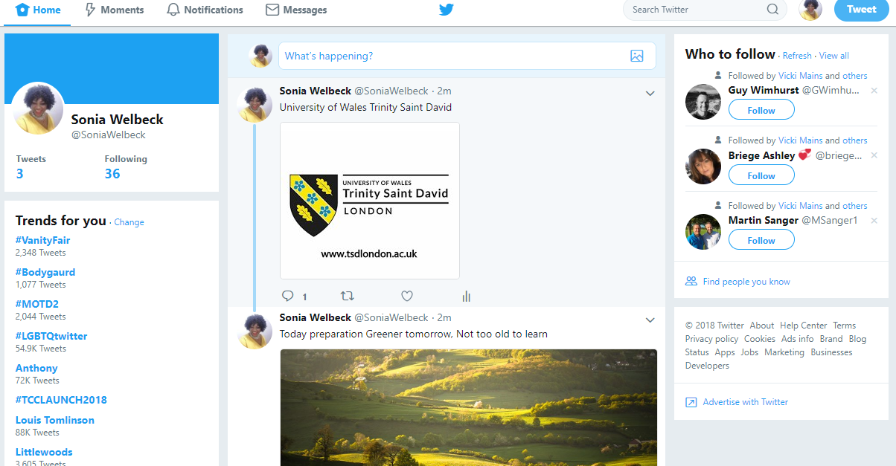

Facebook Page
https://www.facebook.com/sonia.welbeck.568
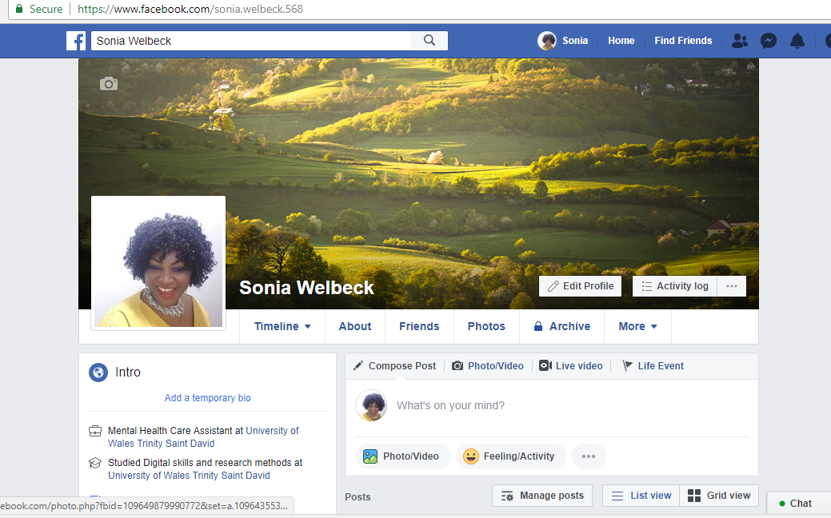

Instagram
https://www.instagram.com/sonybeck/


