
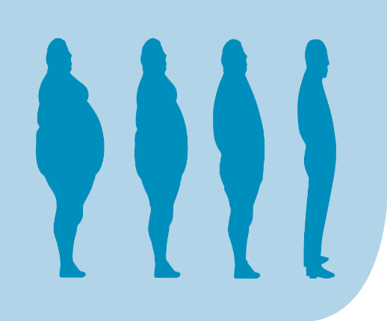
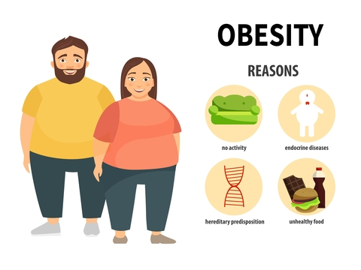
Obesity management strategies
Obesity is not caused overnight. Therefore, it requires time to get rid of extra weight. There are two options to choose from many strategies. The first one is food habit change and the second one is freehand exercises.
Introduction
The world is moving fast and people are getting everything within the range of their hand. Smart devices and internet have been affecting the entire world with its combined force. Physical movement has been reduced drastically. On the other hand, the tendency or trend of eating high sugary items as well as deep-fried items increased at the same pace. The body requires burning this excess amount of bad cholesterol. A study from the WHO presented that around 28% of the total global population do not exercise. Calories do not burn as its own. As a matter of consequences, these are stored in the body and causes obesity.
Reasons for obesity
There are some major reasons causing obesity. The major ones are:
a) Working in desk without breaks: The first reason is working in an office desk without any break. Physicians suggest taking rest after every 20-35 minutes and make some physical movements. Otherwise, the body keeps being tired and fatigue increases (O’Brien, 2013). This is a reason for increasing amount of obesity in corporate world.
b) Deep fried foods: Fast foods are mainly prepared by frying them in deep oil. While dipping the food in the oil, it creates mono-saturated fatty acid (O’Brien, 2013). This is another factor inviting obesity in lifestyle.
c) Sugary items: Sugar is the white poison for people. It is synthetically prepared. White sugar is a major reason to cause obesity. It is hard to burn the calorie prepared by sugar. Also, it creates obstacle in the body from being active (Meyer, 2016). Thereby, there is a consistent tiresome and boredom. The lack of activity raises the risk of obesity.
d) Endocrine diseases: Obesity is often caused by the imbalance in endocrine system. The hormonal imbalance may raise the weight.
Apart from the last reason, all the other three reasons are caused from lack of care and concentration. This is where the person starts feeling inactive, calorie remains unburnt, and fatty acids keep building layer after layer. The weight increases and exceeds above the normal weight.
CASE STUDY OF PATIENT WITH OBESITY


Effects of Obesity
Obesity was declared as the global epidemic in 1997. There are several aftermaths of obesity or overweight.
a) Hypoventilation syndrome: The first effect of obesity is the complication of inhaling. Hypoventilation syndrome is caused by creating excessive fat in the internal respiratory system. Obese people cannot breathe properly and it reduces their energy several times. The outcome is severe.
b) Stroke: The chance of stroke increases for an obese person. The blood pressure remains high and it is the reason for brain stroke. There are certain areas where the obese person cannot access the right health benefit due to weight. It creates tension. Tension brings inactivity in muscles. The consequence is loss of blood in brain and stroke (Wittert, 2011).
c) Metabolic syndrome: Acidity and ineffective metabolism are two main effects suffered by obese people. The metabolism is significantly hampered. Therefore, the person cannot take proper food. Hunger increases and it creates a cycle of storing fat in the body (Pietilainen, 2019).
d) Body fat abnormality: The next complication from obesity is the increment of body fat. Fat in body is highly disliked by people around the world. Abnormality reduces the energy and pace. When body fat keeps increasing, physical inactivity enhances. As a result, the body becomes ineffective for any type of physical work.
e) Diabetes: A reason for obesity is sugar consumption. The consequence of sugar consumption is type-2 diabetes. When the person increases sugar intake and reduces physical movement, it hampers the entire body. Pancreas cannot release enough insulin to process the eaten part. The sugar level increases and it causes diabetes.
f) Cardiac disease: The last and the most fearsome effect of obesity is cardiac disease. When heart’s arteries and veins are jammed with cholesterol, it causes chest pain. Cardiac arrest and failure are the severe results from obesity.

Food habit change or effective diet plan
The first option includes identifying food items which are obsessive for the patient. For example, cake and fried chicken can be two major parts of every meal of the person. After identifying the hampering ones, the person will need to eliminate them from the entire meal plan. This is to ensure that the fat will not return after burning the calorie. The diet plan must include vegetable and protein in a balanced approach. Both are required. Following an inappropriate diet may reduce the person’s energy (SHRAPNEL, 2010). It has further consequence such as eating disorder. Therefore, the diet will need all options with a balanced amount.

Definition
Obesity is defined by World Health Organisation. The excessive accumulation of fat which increases health risks and damage is called obesity (WHO, 2021).




Freehand exercise
There is no better way to manage obesity but to practice freehand exercise such as Yoga, Power Yoga, Walking, Jogging, etc. Instrumental exercise are effective for reducing weight quickly. But the sustainability is low. Also, the body may not take the pressure of sudden exercise. The right approach is to practice freehand exercise. This is the key to improve the result. Day by day intention of burning calorie will change the entire result. Rather than overnight reduction of weight, it will continue burning calorie.

To conclude the poster, the patient will need to look closely to the daily habit. There must remain some areas which can be changed. The right change will be the key to right life. Obesity management or prevention requires perseverance and consistent effort. This is the key to manage this global epidemic and increase activity among people.

References

Meyer, S. (2016). Further reasons why alcohol and stress don’t-and shouldn’t-mix. Advances in Obesity, Weight Management & Control, 5(3).
O’Brien, K. (2013). Reasons for and consequences of weight-related stigma. Obesity Research & Clinical Practice, 7, p.e9.
Pietilainen, K. (2019). Metabolic effects of acquired obesity–lessons from twin studies. Obesity Research & Clinical Practice, 13(3), p.272.
SHRAPNEL, B. (2010). Is energy density a useful concept for understanding and preventing obesity? Nutrition & Dietetics, 67(4), pp.281–286.
WHO (2021). Obesity and overweight. [online] World Health Organization. Available at: https://www.who.int/news-room/fact-sheets/detail/obesity-and-overweight [Accessed 26 Jul. 2021].
Wittert, G.A. (2011). Effects of obesity in males. Obesity Research & Clinical Practice, 5, pp.2–3.

Speaker’s Notes
Introduction
Welcome to the poster presentation on the Introduction to physiology. There were a plenty of health issues to choose from. However, I have selected Obesity as the main topic to discuss. The poster presentation may begin with defining the concept with the definition from the World Health Organisation.
Definition
Obesity is referred as the excess accumulation of fat that increases the risk for one’s health. When the excessive accumulation of fat increases the person’s weight, it keeps deteriorating physical performances. When the physical performance keeps deteriorating, this enhances the health risk (WHO, 2021). Therefore, obesity causes some health risks. And this is why WHO included both factors in the definition.
As I have introduced obesity, now I to focus on three areas. The first one is the reasons or causes of obesity. The second one is the effects or consequences from obesity. The final one is the obesity management strategy.

Reasons for obesity
A person may increase the fat accumulation due to a variety of reasons. The first reason is daylong desk job. In the 21st century, the corporate worlds are limited inside a particular office. There is not much scope for traveling around or wandering around. While working from 9am to 5pm, a person does not get much time to roan around. This reduces physical movements (O’Brien, 2013). Though doctor suggest to take breaks during jobs, majority of workers in corporate world forget to take a break. This causes the person to remain inactive. As a result, the outcome increases the chance of obesity.
The next reason for obesity is deep-fried food items or fast foods. Fast food are generally remain frozen. Therefore, the cook has to dip them in hot oil again and again. The mono-saturated fatty acid in the oil keeps creating bad cholesterol. When an individual consumes the food, it increases the amount of calorie intake. However, there is not enough scope to burn the calorie. As a consequence, the calorie remains unburnt. Fatty acid in body reduces energy. Calorie creates fat. Obesity comes towards the person at a high pace.
Similar to the deep fried foods, sugary food items are reasons for obesity. Sugar is white poison for body. When someone consumes them, the calorie remains unburnt like the mono-saturated fatty acid. Therefore, the body grows weight. At a particular point, the body starts expanding in size and overweight is caused (Meyer, 2016).
The last reason is a completely involuntary issue. Some people may have endocrine issues. These diseases are often reasons for causing obesity. However, new treatments such as laser technology are highly effective for reducing the aftermath of endocrine diseases.

Effects or aftermaths of obesity
Till now, we have discussed the known facts of obesity. The WHO announced it as a global epidemic. There are several reasons for such declaration. The aftermath of obesity is severely affecting for majority of patients. If not treated timely and properly, death is imminent. The complications from obesity are as follow. But they are not limited to these consequences only.
a) Hypoventilation syndrome: Firstly, the breathing system gets severely affected when someone acquire weight. Hypoventilation syndrome affects the body system and energy flow in the body (Wittert, 2011). Overweight or obesity affects in the very first phase.
b) Stroke: A severe consequence of obesity is stroke. The patient may not get balanced blood pressure. The brain cannot handle the lack of oxygen and blood supply due to the fat stored in veins and arteries. It causes stroke more often. Paralysis due to obesity is a result from stroke.
c) Affected metabolism: Metabolism and digestion are severely affected for obese patients. Acidity is a common factor. By taking plenty of antacid to reduce acidity, a person reduces the normal digestion capacity (Pietilainen, 2019). The metabolism gets seriously affected due to such factor. As a matter of fact, the person loses the strength to overcome metabolism. Large amount of food intake hampers the digestion system and metabolism.
d) Abnormal body fat: Obesity is physically experienced by body fat. In every corner of the world, abnormal body fat is considered as unfitness. When a person is unfit, it gets hard to blend in specific lifestyle. Bullying and other consequences are also possible in such situation. Excessive body fat reduces the chance to gain a better life. Also, osteoporosis and arthritis are two diseases caused by abnormal body fat.
e) Diabetes: Large amount of food consumption hampers the metabolism as well as the acidic reaction. Type-2 diabetes is a common aftermath of obesity.
f) Cardiac diseases: The most lethal outcome from obesity is cardiac disease. The body does not burn calorie. As a result, the heart’s arteries and veins get jammed. Cholesterol and body fat reduces blood flow. Cardiac arrest and cardiac failure are major consequences resulted from obesity.

Obesity management
Now I move to the management process. For any patient suffering from obesity, there are two options to consider. The first option is to change the diet plan. The second option is to do freehand exercise. The obesity management and prevention will be successful when the person will understand that obesity did not cause overnight. Therefore, it will take time to remove fat from body.
Diet plan change: The food habit is easy to change. Therefore, it will require focusing on the harmful foods such as fried ones and sugary ones. Cakes and similar items are needed to be eliminated completely. Oily and spicy foods are harmful for the body in the long run. This is also needed to be changed. When the bad ones are removed, it is necessary to introduce the good ones. Green vegetable and colourful veg items must be enriched in the diet chart (SHRAPNEL, 2010). Also, there requires including some protein and good cholesterol items. By changing the diet plan, the patient can prepare himself for a healthy lifestyle.
Freehand exercise: The next change is to use freehand exercise. This should be regular and efficiently applied. When freehand exercises are practiced, the person will start using the focus to remove body fat. The obesity will be gone eventually for day to day work.

We can reach to the conclusion now. Obesity is harmful and bad for health. Any young person will need to bring control on tongue and lifestyle. Regular activity is the biggest prevention technique for obesity management.

