Business Plan
UWTSD

Kevin Guerrero García (2426552)
Managing Enterprise BMSW4011
Module Lead: Mel Squire
Final submission: 28 Nov. 25

Company concept:
The idea is to create a youth-oriented nightclub with an urban concept, where young people and students can have a great time in a welcoming and exclusive space, enjoying an experience full of Latin flavor and pop music.
We plan to offer our customers a Latin and tropical atmosphere and will also offer a wide variety of drinks, including cocktails and beers, in a space where they can dance and have fun.
Customer satisfaction is our priority; we want our customers to have a place to enjoy themselves while also feeling safe (Young P, 2007)
We will call this place "MANGO Discotec Bar", mango in reference to the fruit and its tropical flavour (Mango.ORG, 2018)
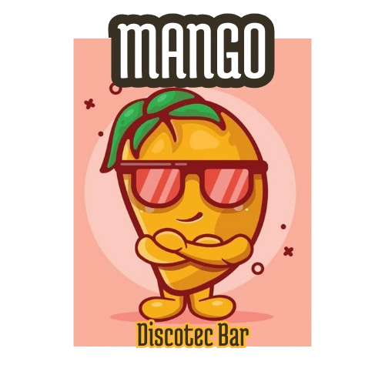

Mission statement:
To be the meeting point between fun and tropical flavor, providing a vibrant and authentic experience through music.
Business History:
This idea stems from observing the limited variety of concepts in Cardiff's nightclubs and bars; London, on the other hand, boasts a wide range of nightclub concepts, with many more Latin clubs and clubs of other styles.
According to Google, most nightclubs with a Latin atmosphere are in London, which is why we decided to develop our project in Cardiff.
Seeing that Cardiff has a large Latin American and Spanish population, I see a great opportunity to offer our service. Also, based on observations and conversations with owners of Latin American food businesses, many Welsh people enjoy going to these places to relax and meet others.
Legal Identity:
(GOV.UK, 2018) Partnership; with my partner who has experience in the nightlife entertainment industry. This is because the amount of money needed to start is too large; my partner has the capital to invest, but not the time to manage it. In this way, we both contribute the same amount of money, but he contributes his experience, and I contribute my time. might be the best option to protect your legal interests. This business structure allows two or more individuals to co-own and operate a company for profit (Megastelum, 2025).
Business Aims:
Being a nightclub focused on a tropical atmosphere and pop music, but including Latin rhythms such as reggaeton and salsa; offering drinks to our guests with a wide variety of cocktails and drinks, and for those who prefer, we will also have a variety of bottled and draft beers and ciders, so that customers can have fun, enjoy themselves and spend as much time as possible in our venue, consuming and enjoying the music that brightens their nights.

Business Objectives:
There are four key points to consider when opening a nightclub:
First, we'll open a nightclub in a strategic, central location. To do this, we need to find a large space and decorate it with a tropical theme. The decor should be organic, not cluttered or forced. We'll install dynamic lighting with effects that complement the space. We could also add elements like palm trees and flags to evoke a summery feeling for our customers.
We need to make sure the venue is comfortable and has at least 600 square meters of space for dancing, so people have enough room to enjoy themselves. We must ensure the dance floor is where the sound reaches best, and we can also add smoke machines around the dance floor.
Another important aspect of a nightclub's atmosphere is the music, as most people are drawn to a specific type of music. We need two experienced DJs who know what young people want to hear, and who are knowledgeable about pop and Latin music. We will acquire a good sound system to ensure our customers have the best possible experience.
We will need to stock a wide variety of liquors and beers; we must contact the most competitive suppliers on the market to offer the same selection as our competitors. It is also important to have at least two bartenders experienced in cocktails and mixed drinks.
In addition to these four points, we must consider security. We need security personnel and must also obtain all the necessary permits and licenses to avoid any legal issues.
SMART Objectives:
Increase the number of followers on the company's social media accounts by 1000 every 6 months, with content aimed at young people to attract more customers through Digital Marketing (SPREP, 2022).

Phisical location:
We'll be in the city center, next to other bars and nightclubs. We can't do it anywhere else because the music and noise would be a problem, but the main advantage of being located in the city center is the foot traffic.

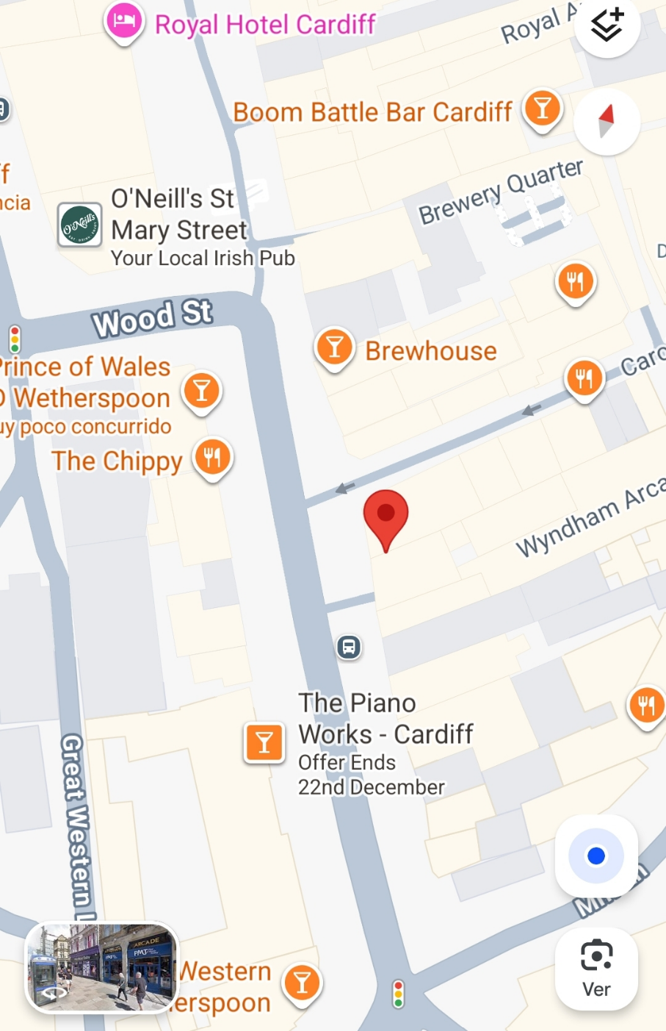
The nightclub should be located in an easily accessible place so that customers can arrive without difficulty. A central location, near residential or commercial areas, with good public transport connections and adequate parking can attract more people (ParaleloEstudio, 2023)

Human Resourses:
We need to create a work team where the team members have previous experience because we are a growing business, we need staff to take care of the bar, cleaning, security and cash management.
To start, we don't need a lot of staff to keep costs down, so we'll hire:
2 bartenders
1 security guard
1 DJ
1 cleaner
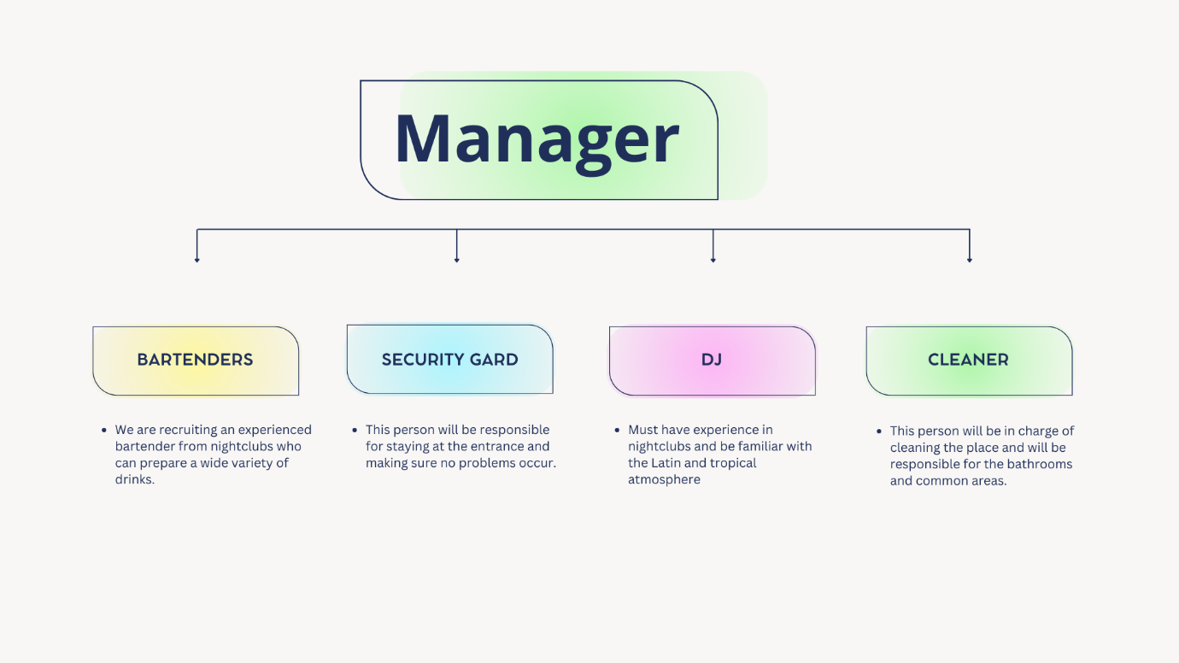

Effective human resource management has a direct impact on:
Customer service quality.
The operational efficiency of the establishment.
Employee satisfaction and retention.
The profitability and sustainability of the business (CETYS, 2025)

Marketing activities:
Nightclub marketing stands out as one of the best ways to attract more customers and ensure repeat business at nightlife and entertainment venues (Suarez, 2025).
We can make flyers and on them we can give away free tickets or drinks.
We will create accounts on all social media platforms to promote our events and parties.
We can pay influencers to create a positive reaction to our place.
We can partner with other businesses in the area to promote customer traffic. On slow days, such as Monday through Thursday, we can offer free entry, and we can also hold bottle raffles to attract more customers, not forgetting that special dates are a great opportunity to attract more customers.

Market Research:
We researched the Latin population in the UK; they are our potential clients, although not the only ones.
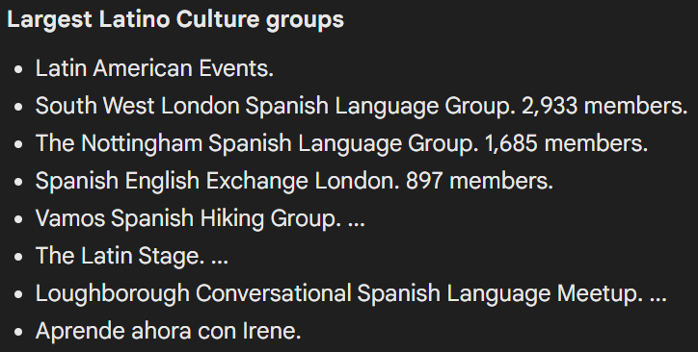

We realized that most nightclubs with a Latin atmosphere are in London and that's why we have a better opportunity to start a business here in Cardiff because we don't have much competition.
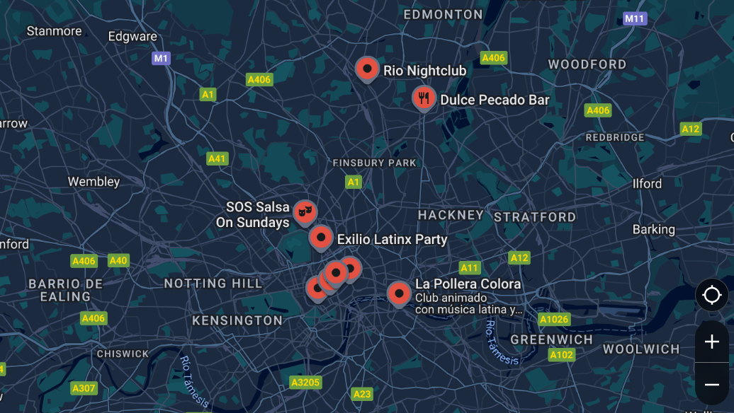

We have also noticed that there are events almost every weekend in Cardiff, which are very popular with the Latin community and many Welsh people come to have a good time.
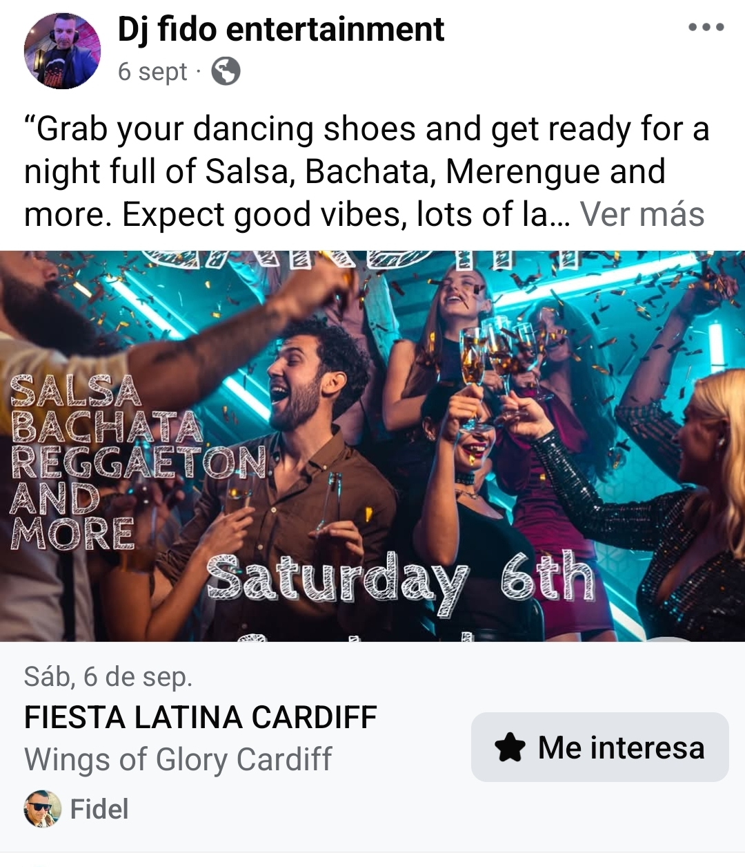

Financial resources:
The way we will finance this initiative is with our own funds; my partner and I will contribute equal amounts, these amounts will come from our savings.
The founding partners are usually the first to invest their own capital and time to launch the company.
This type of entrepreneurship is highly driven by passion and tends to be linked to some personal experience from the partners' past, so it's common to involve family members in financing the project, especially at the beginning (CaixaBank, 2023).
Pricing Strategy:
On days with higher foot traffic, such as Friday, Saturday, and Sunday, we can charge an entrance fee of £5 per person. This price is lower than our competitors but is still profitable for us, and the "ticketing" method will be the same as other nightclubs (a stamp in your hand).
Speaking of the price of drinks, it will be in line with the competition's price, trying to keep prices down so that people don't feel that the price of drinks is an impediment to entering our establishment, but we can't lower the price because people are willing to pay for the drinks if the atmosphere is good.
SWOT Analysis:
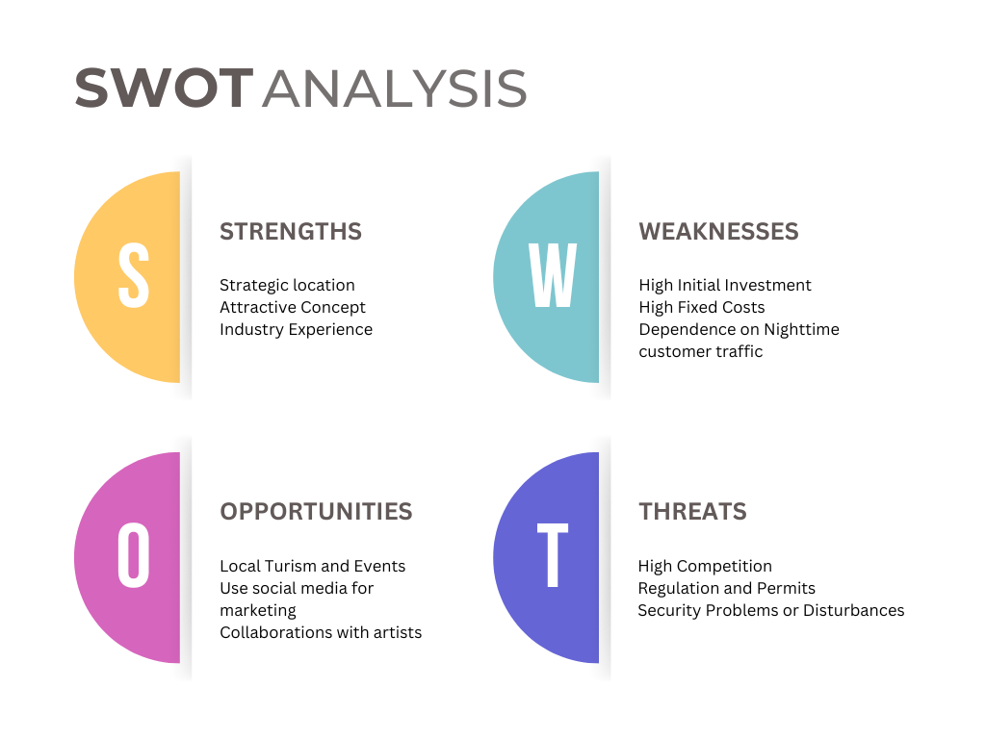

References:
- Young, P. (2007) Business plan. 1st ed. Chandni Chowk, Delhi: Global Media.
- Evans, V. (2022) The FT Essential Guide to Writing a Business Plan. Third edition. Harlow, England: Pearson Education, Limited
- Mango.ORG. (2025). All About Mango. [Online]. MANGO.ORG. Available at https://www.mango.org/es/hechos-del-mango/#:~:text=Bot%C3%A1nicamente%2C%20el%20mango%20es%20una,una%20ciruela%2C%20cere. [Accessed 26 November 2025].
- GOV.UK. (2018). Choosing the right business structure. [Online]. GOV.UK. Last Updated: 18 July 2018. Available at: https://companieshouse.blog.gov.uk/2018/07/18/choosing-the-right-business-structure/ [Accessed 26 November 2025].
- Megastelum. (2025). What are the characteristics of a general partnership?. [Online]. Meg International Counsel. Last Updated: 2025. Available at: https://en.megastelum.com/faqs/what-are-the-characteristics-of-a-general-partnership-or-gp-.cfm [Accessed 27 November 2025]
- Secretariat of the Pacific Regional Environment Programme (SPREP) (2022) FACTSHEET: A Guide to Developing “SMART” Objectives. Secretariat of the Pacific Regional Environment Programme SPREP
- PARALELOESTUDIO. (2023). The importance of a suitable venue for your nightclub. [Online]. Paralelo Estudio. Last Updated: 16/07/2023. Available at: https://paraleloestudio.com/blog/la-importancia-de-un-local-adecuado-para-tu-discoteca/#:~:text=La%2 [Accessed 24 November 2025].
- CETYS University. (2025). Human resource management in restaurants and bars: keys to success. [Online]. CETYS. Last Updated: 24/07/2025. Available at: https://www.cetys.mx/educon/gestion-de-recursos-humanos-en-restaurantes-y-bares-claves-para-el-exito [Accessed 24 November 2025]
- Pablo M. Suarez. (2025). 12 Marketing Strategies for Nightclubs and Discos. [Online]. SEONET. Last Updated: 01 March 2025. Available at: https://www.seonetdigital.com/es/blog/marketing-para-discotecas [Accessed 27 November 2025]
- CaixaBank. (2023). How to finance your social enterprise: self-funding, crowdfunding and other useful formulas. [Online]. Caixa Bank. Last Updated: 29/08/2023. Available at: https://www.caixabank.com/es/esfera/content/financiacion-empresas-sociales#:~:text=Friends%2C%20fami [Accessed 27 November 2025].
My Reflection:
I learned several ways to make a business plan, but this plan I made based on what is asked of us in the handbook, I took reference from the cover of a business plan and its structure.
you provide, and the importance they will place on certain items of information. You will learn how to be persuasive and effective when presenting your business plan, and how to be confident and informed as you navigate the competitive world of business.
This module has helped me a lot in learning how to develop a business plan, and in understanding all the things that need to be taken into account when creating a business plan (Finch B.2022)
Now my thinking has changed, my life plan is to start a business, always keeping a job but also starting a business to have an extra source of money, this way I don't depend only on my job but I have my own project, as Mel told us: that will be our baby.
Other reasons for starting a business highlighted by innovators worldwide include the desire to make a difference in the world, build wealth, continue a family tradition, or earn a living in an alternative way in the face of an uncertain job market, according to the latest Global Entrepreneurship Monitor (GEM). Multiple motivations behind the same goal: achieving personal, professional, and social success through one's own project (BBVA, 2024)

I've enjoyed this business development plan so much that I've learned more by researching and watching YouTube videos about how companies are financed.

I'm super excited because I feel like I now have the tools to start my own business. I've enjoyed it so much that I've become interested in learning all about the stock market and investment funds, and with all this knowledge, I think I have the courage to take the plunge and start my own business soon.
In recent days I've been encouraged to cook at home and sell to my close friends, partnering with someone who has a great talent in the kitchen, and I've been able to apply what I've learned in this module to this small business venture (Swamidass P.2016). What exactly are you selling, then?Why should anyone buy from you?; Getting it all to the consumer; Dealing direct with the public (Morris M. 2011)

My wish is to continue my studies next year, and I feel that this module has prepared us enough to continue advancing in our careers so that we can manage our own business or integrate into the job market more easily because today we know how companies and employability work thanks to all the topics covered throughout this term.

This term has been very exciting for me, I can't wait to start my BA next year. I thank my tutors for sharing all their knowledge with me, and I believe that in this business plan and reflection I haven't fully expressed all my thoughts, but I've summarized them as much as possible so it wouldn't be too long.

References:

- Young, P. (2007) Business plan. 1st ed. Chandni Chowk, Delhi: Global Media.
- Finch, B. (2022) How to write a business plan : win backing and support for your ideas and ventures. Seventh edition. London ; Kogan Page.
- Swamidass, P.M. (2016) Engineering entrepreneurship from idea to business plan : a guide for innovative engineers and scientists. First edition. New York: Cambridge University Press
- Morris, M.J. (2011) Starting a successful business : choose a business, plan your business, manage operations. 7th ed. London ; Kogan Page.
- Hazelgren, Brian J.. Your First Business Plan : A Simple Question and Answer Workbook Designed to Help You Write a Plan That Will Avoid Common Pitfalls, Secure Financial Backing, and Create a Blueprint for Your Business, Sourcebooks, Incorporated, 2005. ProQuest Ebook Central, http://ebookcentral.proquest.com/lib/trinity/detail.action?docID=360365.
Created from trinity on 2025-11-28 15:24:46.
- BBVA. (2024). Five reasons to start and create a successful business. [Online]. Entrepreneurship and startups. Last Updated: 26/08/2024. Available at: https://www.bbva.com/es/innovacion/cinco-motivos-para-emprender-y-crear-un-negocio-con-exito/ [Accessed 28 November 2025]

